BUSE – Beyond User-in-the-Loop: User-in-the-Service
-- Final Report

Gabor Fodor, School of Electrical Engineering, Royal Institute of Technology

This document summarizes the results and engineering insights of the Wireless@KTH seed project BUSE – in cooperation with Ericsson Research -- that was running during 2016-2017. The key results of BUSE are summarized in five IEEE journal and magazine articles [1-5], while the most recent results are summarized in a submitted manuscript under submission [6]. Further information about the BUSE project is available at the BUSE webpage [BUSE]. The preliminary results of BUSE were presented in the form of posters in 2016 and 2017 at the Wireless@KTH days.

BUSE: Background, Research Questions and Objectives
The objective of the BUSE project was to explore the ideas of social aware device-to-device communications and user-in-the-loop (UIL) [7], with the purpose of suggesting the idea of user-in-the-service (UIS).
The UIL idea builds on the observation that a majority of human users show willingness to shape their service demands in space/time if they recognize some benefit associated with such behavior. For example, a behavioral survey reported in [8] indicates that more than 50% of mobile users are willing to move around 40 m in indoor or outdoor environments provided they receive a level of discount in the order of 20%-40% on regular charges of certain services. A related trend suggests that some users – typically belonging to the same social group -- take part in distributed device-to-device (D2D) caching technology based video content distribution as long as security concerns are properly addressed [9].
The UIS idea of the BUSE model expands the UIL concept and suggests involving users of advanced smart mobile devices in the cellular infrastructure and provisioning of broadband wireless services, including video content distribution, D2D based relaying, temporal/spatial demand shaping and social proximity services. While in the UIL model the user devices are considered as receivers of services, the BUSE model allows for and incentives users getting involved in wireless service provisioning and/or becoming part of the wireless infrastructure. In the future, such new cooperation between users and network operators can be feasible on various carrier frequencies such as the “Innovation Band” or higher frequency bands as well as on entirely network controlled cellular frequencies using network assisted D2D communications. That is, BUSE treats the evolving wireless infrastructure, available spectrum and user devices as cooperating “ecosystem” by finding win-win points in this system.
The UIS idea is motivated by the fact that mobile operators and service providers face the difficulties of meeting exponentially increasing demands for broadband and content services which may exceed the supply at some locations and during some periods of time. At the same time, the increasing capabilities of user owned and operated devices in terms of storage capacity, processing power and wireless physical layer capabilities, including multiple antennas, enable such devices to contribute to the service experience of peer wireless devices owned either by the same user or peer users. For example, an advanced cellular device (phone) may easily serve as a semi-static relay node or wireless router in a home or small office environment towards a 5G cellular network [4].

Results and Engineering Insights
The contributions of the BUSE project are two-fold, that correspond to the two layers – the sociality and the technology realms -- addressed by the project. In the BUSE model, the social ties between users reinforced and shaped by human relations, such as friendship, professional or business relations and common interest interact with the underlying technology layer. This lower – technology – layer enables users to discover one another by energy efficient and social aware D2D discovery procedures and to share storage, processing or battery resources. The discovery procedure and the subsequent engagement in helping out each other depends on the social ties in the upper layer and other incentives provided by the cellular operator. Indeed, due to the existing infrastructure, spectrum ownership and customer base, the operator is in the unique position of creating such incentives for the mutual short or long-term benefits of the mobile network operator and the end users. Thus, the first contribution of BUSE is our proposed model and performance analysis of bridging these two layers representing the technology and sociality realms [1].
On the higher layer of BUSE – the sociality realm – we found that it is useful to distinguish between five types of human user relationships and relate them to typology (whether the relationship is user-driven or device-driven) and an associated trust level (see Table 1). The trust level can be captured by the abstract notion of trust value, which is modeled in BUSE as a real scalar number between 0 and 1. We believe that in refined models by follow up activities of the seed project BUSE finer grained models of trust can be developed.
Table I: Social relationship factors between devices, possible applications and the associated trust value
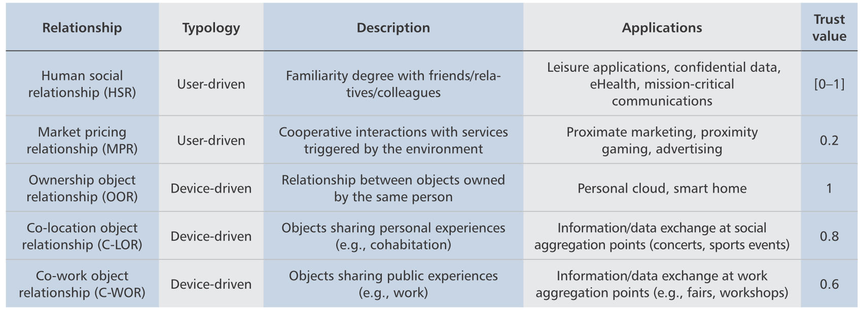
To understand and quantify the impact of the sociality layer, BUSE developed a coalition game model, in which players utilize various D2D technology enablers that operate at the radio resource management and the physical layers to form coalitions whose stability depend on the social ties (as in Table I) in the social layer. The coalition game model, although built on some abstractions that can be refined and improved in future works, allowed us to analyze the network throughput using a realistic system simulator (Figure 1). Indeed, this figure indicates that higher level of trust and social ties between users can significantly increase the aggregate effective throughput.
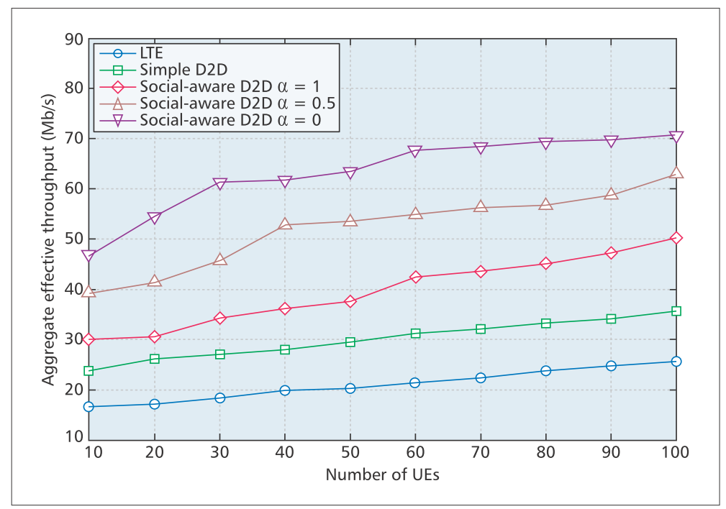
Figure 1: Social-aware D2D communication can significantly increase the aggregate throughput of a cellular network that does not support D2D communication or where D2D communication is supported without exploiting social awareness [1].
It is important to point out that the underlying technology layer plays an important role in reinforcing and supporting the user demands that can increase due to trust and social relations. Indeed, socially close user tend to communicate more, share more content, and help one another in case some users are at the cell edge or out-of-coverage of the cellular infrastructure. Therefore, we also identified and analyzed some key technology enablers in the technology realm of the BUSE model [2-5]. Among these, we found that directional communications (enabled by the evolving multi-antenna capabilities of contemporary and future user equipment) helps to efficiently utilize the spectrum by allowing very tight frequency reuse schemes within the cells of cellular systems [3]. Also, full duplex communication has the potential of further improving the spectral efficiency and system capacity in hot spots, in which users use both D2D and cellular communication links [2], [4].

BUSE Next Steps: Beyond User in the Service
We believe that BUSE points at an emerging new global utility [6], in the sense that service providers, network operators and end users will tend to find win-win points of the mobile ecosystem. For example, it may be more cost efficient and ultimately offer a better long term utilization of the spectrum if end users, -- utilizing their social ties and trust relationship of different levels – become part of the cellular infrastructure and service provisioning. We call this concept “keeping people in the loop” [6], that can be elaborated and analyzed in future works.

References
- A. Ometov, A. Orsino, L. Militano, D. Moltchanov. G. Araniti, E. Olshannikova, G. Fodor, S. Andreev, T. Olsson, A. Iera, J. Torsner, Y. Koucheryavy, T. Mikkonen, "Towards Trusted, Social-Aware D2D Connectivity: Bridging Across Technology and Sociality Realms", IEEE Wireless Communications, Vol. 3, Issue 4, pp. 103-111, August 2016. [IEEE Xplore] [Diva]
- J. M. B. da Silva, G. Fodor and C. Fischione,” Spectral Efficient and Fair User Pairing for Full-Duplex Communication in Cellular Networks”, IEEE Transactions on Wireless Communications, Vol. 15, Issue 11, pp. 7578-7593, August 2016. [IEEE Xplore] [Diva]
- F. Boccardi, H. Shokri-Ghadikolaei, G. Fodor, E. Erkip, C. Fischione, M. Kountouris, P. Popovski, and M. Zorzi, “Spectrum Pooling in mmWave Networks: Opportunities, Challenges, and Enablers”, IEEE Communications Magazine, Vol. 54, Issue 11, pp. 33 - 39, November 2016. [IEEE Xplore] [Diva]
- G. Fodor, S. Roger, N. Rajatheva, S. B. Slimane, T. Svensson, P. Popovski, J. M. B. da Silva, S. Ali, ”An Overview of Device-to-Device Communications Technology Components in METIS”, IEEE Access, Volume 4, pp. 3288-3299, June 2016. [IEEE Xplore] [Diva]
- A. Orsino, A. Ometov, G. Fodor, D. Moltchanov, L. Militano, S. Andreev, O. N. C. Yilmaz, T. Tirronen, J. Torsner, G. Araniti, M. Dohler, and Y. Koucheryavy, "Effects of Heterogeneous Mobility on D2D- and Drone-Assisted Mission-Critical MTC in 5G",
IEEE Communications Magazine, Vol. 55, Issue 2, pp. 79-87, February 2017. [IEEE Xplore] [Diva]
- V. Petrov, K. Mikhaylov, D. Moltchanov, S. Andreev, G. Fodor, J. Torsner, H. Yanikomeroglu, M. Juntti, Y. Koucheryavy, “When IoT Keeps People in the Loop: A Path Towards a New Global Utility”, under submission, arXiv:1703.00541, [arXiv link]
- Y. Li, T. Wu, P. Hui, D. Jin and S. Chen, “Social-Aware D2D Communications: Qualitative Insights and Quantitative Analysis”, IEEE Communications Magazine, pp. 150-158, June 2014.
- R. Schoenen and H. Yanikomeroglu, “User-in-the-Loop: Spatial and Temporal Demand for Sustainable Wireless Networks”, IEEE Communications Magazine, February 2014. pp. 196-203.
- N. Golrezaei, A. F. Molisch, A. G. Dimakis, and G. Caire, “Femtocaching and Device-to-Device Collaboration: A New Architecture for Wireless Video Distribution”, IEEE Communications Magazine, pp. 142-149, April 2013.

