# 14th ICOLD International Benchmark Workshop on Numerical Analysis of Dams

Every second year, the Technical Committee A (Computational Aspects of Dam Analysis and Design) of ICOLD organizes an international benchmark workshop on numerical analysis of dams. The purpose of these benchmarks is to share knowledge and experience within dam safety, planning, design, construction as well as operation and maintenance of dams.

The design and maintenance of existing dams represent a challenge for the whole engineering community. In this context, the ICOLD Committee on Computational Aspects of Dam Analysis and Design is making a noteworthy contribution by organizing the series of recurring Benchmark Workshops with the aim of offering dam engineers and researchers the opportunity to share knowledge in the proper use of numerical analyses.

In 6 to 8th of September 2017, the 14th Benchmark Workshop was held in Stockholm, the capital of Sweden. It was hosted by KTH Royal Institute of Technology, Sweden’s largest technical research and learning institution and one of Europe’s leading technical universities. For the 14th workshop in this series, four themes where been predefined which represent topics of great interest for the dam community,

* Theme A: Cracking of a concrete arch dam due to seasonal temperature variations.
* Theme B: Static and seismic analysis of an arch-gravity dam.
* Theme C: Embankment dam behaviour – prediction of arching and cracking potential
* Theme D: Risk Analysis–assessment of reliability for concrete dams

In addition to these themes, one additional open theme was also available which allowed for participants to present their own topics and projects within the field of numerical analyses of dams.

|  |  |
| --- | --- |
| Theme A) | Theme B) |
| Theme C) | Theme D) |

Figure 1 Illustration of the four cases studied in theme A to D

The formulators for each theme had prepared a case study where all basic data (geometry, material properties, loads etc.) were described and participants volunteered to submit their solutions to these case studies. Since several solutions are presented, it is possible to see how different assumptions and modelling aspects influence the result and it is possible to benchmark newly developed constitutive models etc. This an important part in spreading knowledge in the use of numerical methods and modelling tools for hydropower and dams and to highlight their advantages and/or disadvantages.

The benchmark workshop was a great success with 127 participants and 52 presented papers with solutions to theme A to D or contributions to the open theme. During the first two days, the technical presentations of the benchmark workshop took place and on the third day a technical tour was arranged.

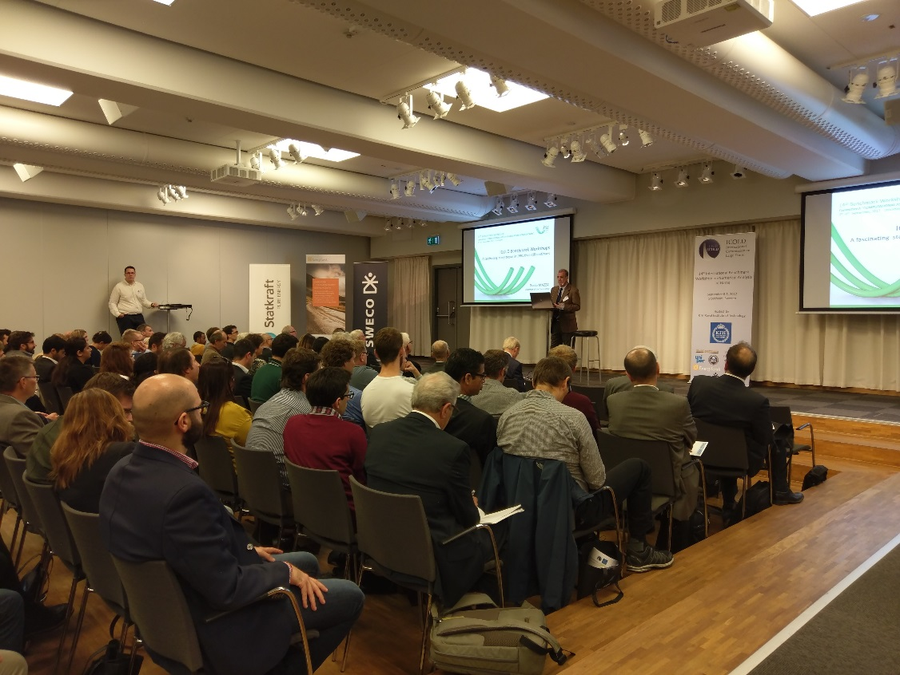

Figure 2 Chairman of Committee A, Guido Mazzá gives his keynote lecture. Photo: Helena Tirri Stålbo

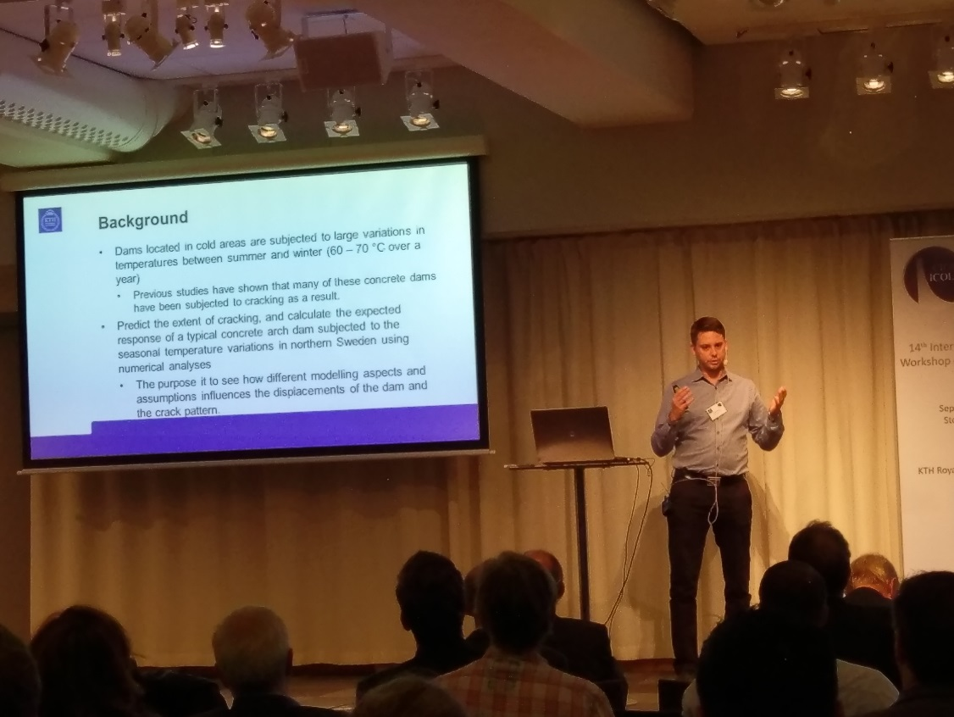

Figure 3 Main formulator of theme A and chairman of the local organizing committee, Richard Malm presents theme A. Photo: Helena Tirri Stålbo

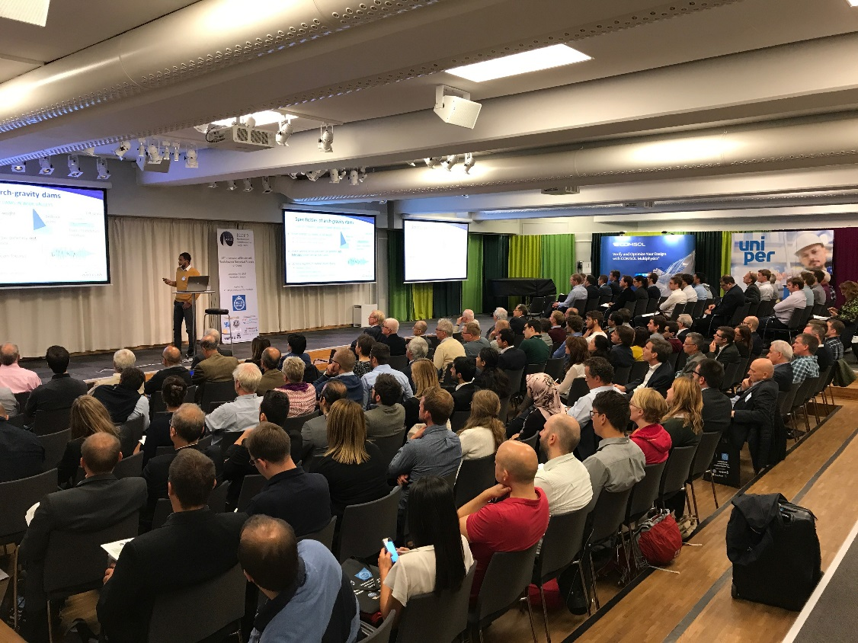

Figure 4 Main formulator of theme B, Frédéric Andrian presents theme B. Photo: Richard Malm

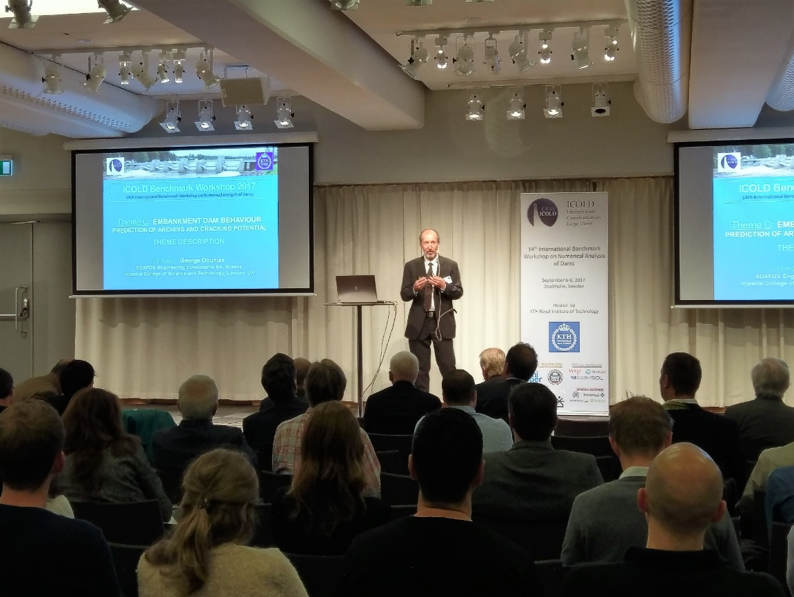

Figure 5 Main formulator of theme C, George Dounias presents theme C. Photo: Helena Tirri Stålbo

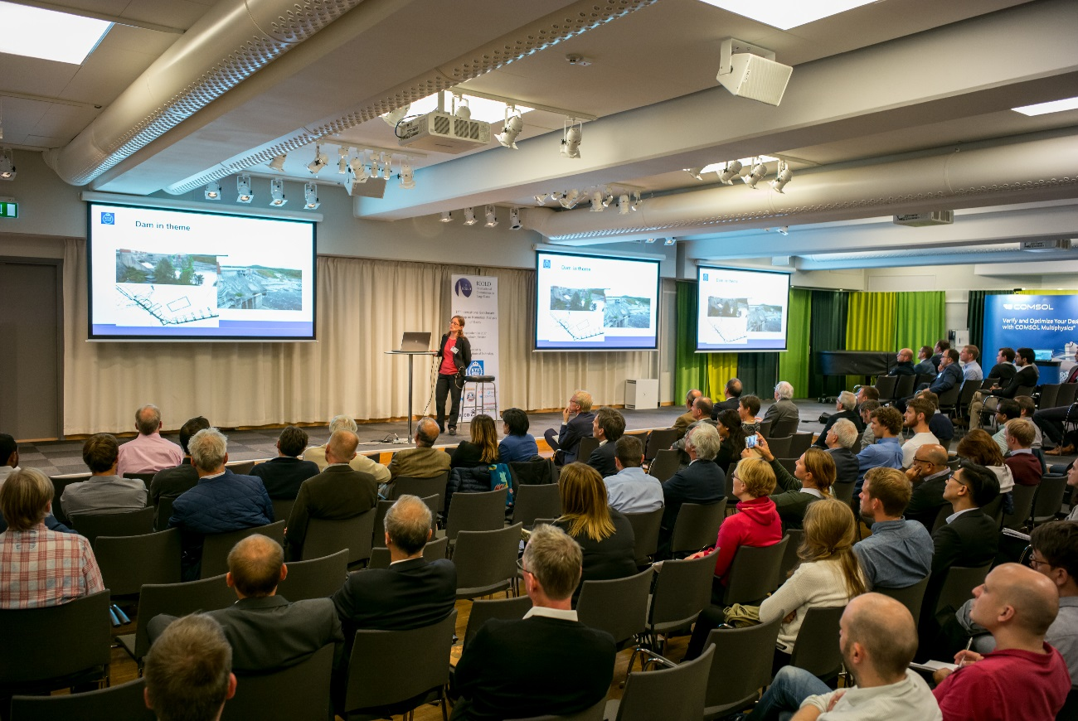

Figure 6 Main formulator of theme D, Marie Westberg-Wilde presents theme D. Photo: Edwin Staudacher

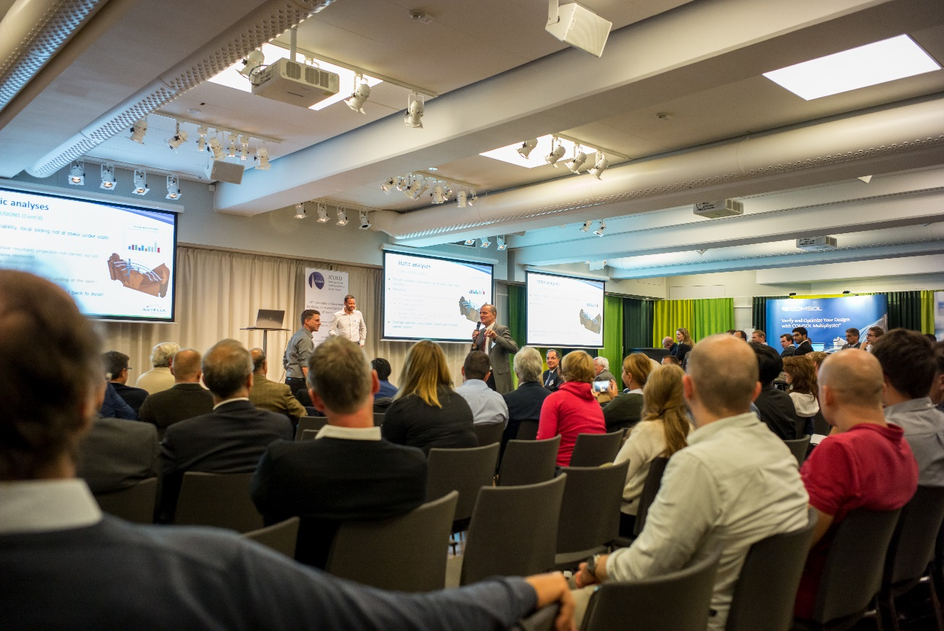

Figure 7 Gerald Zenz (vice chairman of Committee A) in a discussion during the summary of theme B. Photo: Edwin Staudacher.

The Welcome reception started with a guided tour of the Vasa Museum where we learned about the Vasa warship that was salvaged after laying 333 years under the sea, and ended with a three-course dinner with typical Swedish cuisine. The Closing dinner started with a ferry cruise to the Stockholm archipelago consisting of 24 000 islands where a three-course dinner was served in the Vaxholm Citadel.

|  |  |
| --- | --- |
|  | https://www.icold-bw2017.conf.kth.se/wp-content/uploads/sites/7/2017/06/waxholm-300x199.jpg |

Figure 8 Guided tour and dinner at the Vasa Museum for the Welcome reception (left), Ferry cruise and dinner at the Vaxholm Citadel for the Closing dinner (right).

On the third day of the Benchmark Workhop, a technical tour was arranged to the beautiful areas around the river Dalälven north of Stockholm. The lower parts of the Dalälven river is the cradle of Swedish hydropower with several hydropower facilities from the early 20th century. During the technical tour, we visited the hydraulic laboratory of Vattenfall Research and Development in Älvkarleby.

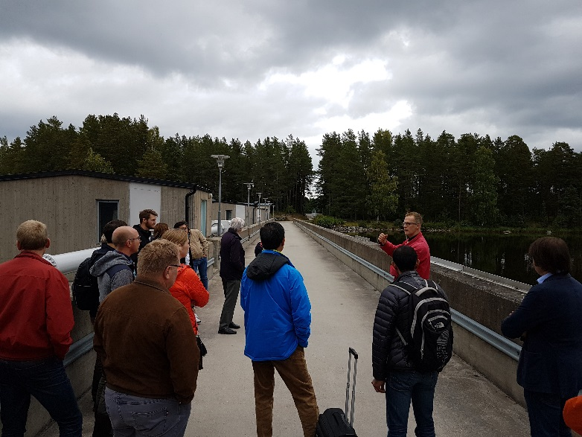

Figure 9 Guided tour of the concrete dams in Älvkarleby. Photo: Richard Malm

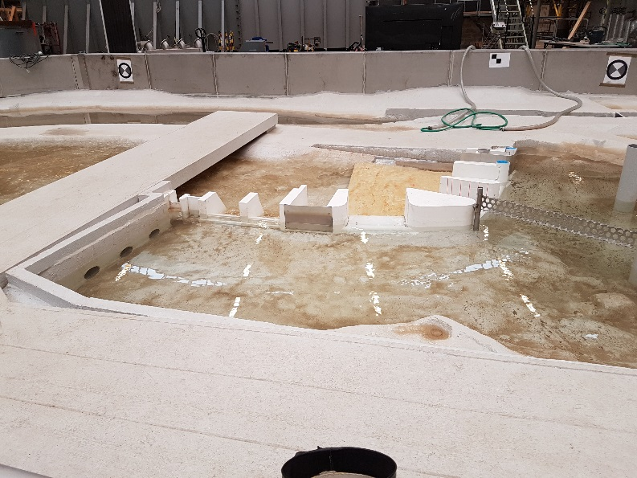

Figure 10 One of the hydraulic models in the Vattenfall hydraulic laboratory. Photo: Richard Malm

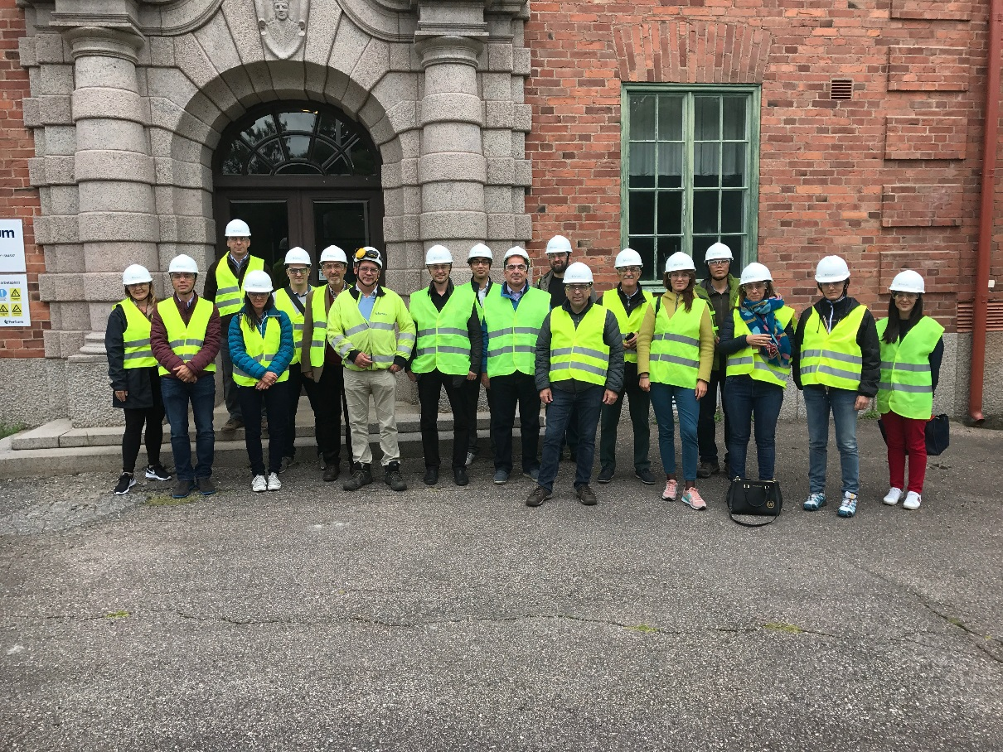

Figure 11 One of the technical tour groups in front of Untra hydropower plant.

|  |  |
| --- | --- |
| C:\Users\serima\Box Sync\ICOLD BW\Foton\Bild 2017-09-11_10-38-54-705.jpg | C:\Users\serima\Box Sync\ICOLD BW\Foton\Bild 2017-09-11_10-38-54-850.jpg |

Figure 12 Pictures inside the power house of Untra hydropower plant. Photo: Richard Malm

The 14th ICOLD International Benchmark Workshop addressed the current challenges regarding design and maintenance of existing dams and improved the understanding of these by exchange of experience on the use of numerical modelling for design, performance evaluation and safety assessment of dams.