General rules for using a lab computer
- Use the user account ‘LabStudent’ on the PCs and also on the virtual machine.
- The password for the user account ‘LabStudent’ on the PC in the lab is: 2015EH2741.
- The virtual machine that you are going to be using is called: EH2745VM
- The password for the virtual machine is: 2015EH2745
- You don’t need to shut down the PC or the virtual machine after your work is finished. You can just leave the PC as it is.
Installation Java JDK SE 8
- Download Java SE Development Kit 8 for your operational system (you need to accept licence agreement before loading)
http://www.oracle.com/technetwork/java/javase/downloads/jdk8-downloads-2133151.html
- Install Java JDK SE 8 on your computer. Follow the instructions.

Notes. All programs for the course will be developed in JavaSE1.8 environment, so to avoid future problems please program and develop your code in the same JRE environment.
Installation Eclipse SE
- Download Eclipse IDE for Java Developers (not Java EE Developers):
http://www.eclipse.org/downloads/packages/release/Luna/SR2
- No need for installation, just unpack the archive and run eclipse.exe file.
Notes. There are a few releases of Eclipse. There is no preference from our side. Luna package is most popular.
Creating a class
- Run eclipse.exe file. Click on Package Explorer.
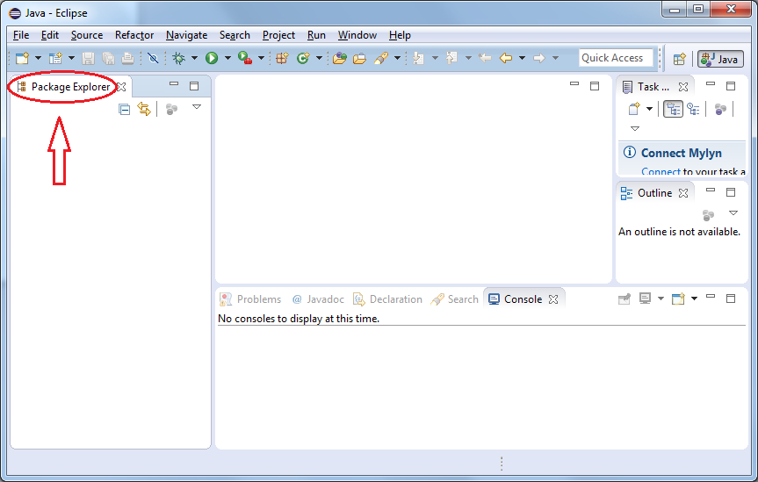
- Right-click in Package Explorer and choose NEW -> Java Project. Provide a name for new Java project.
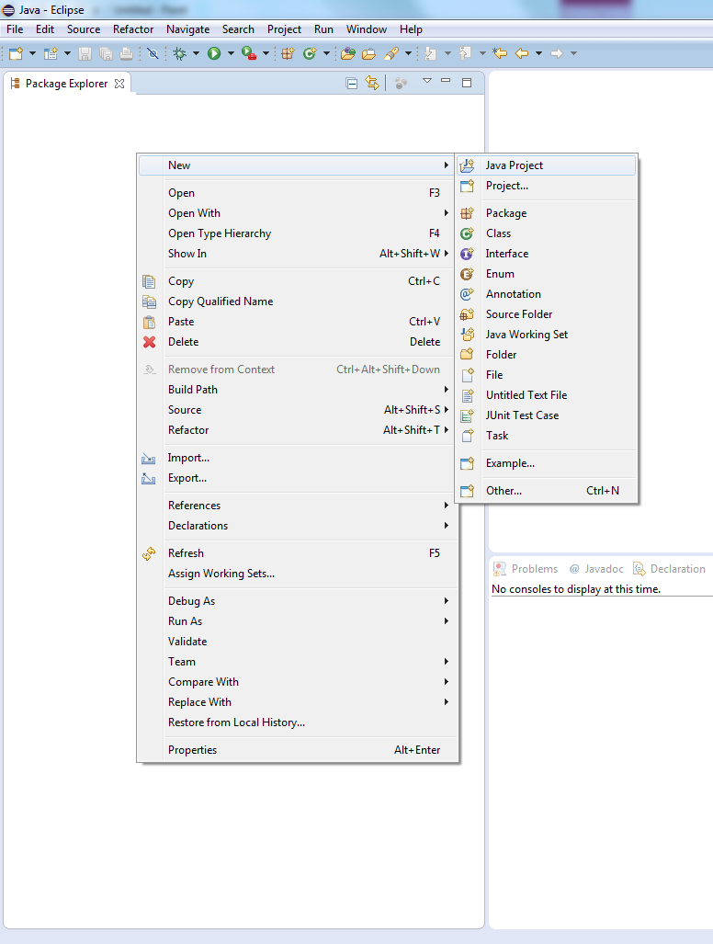
- Open the created project and right-click on src package. Choose NEW -> Package. Name a new package.
- Right-click on the created package and choose NEW -> class. Name a new class. Remember to tick an option “public static void main(String[] args)”.
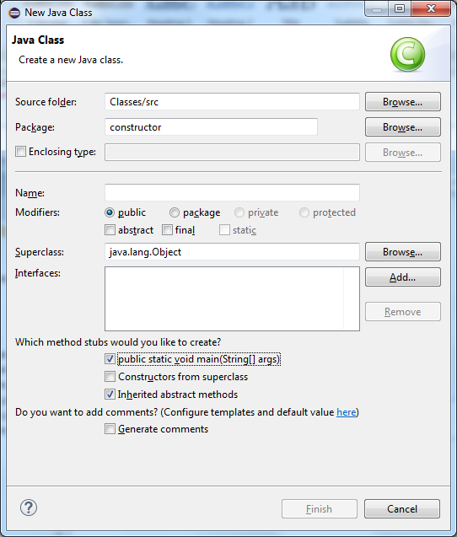
- Copy and paste the following code inside the created class:
public static void main(String[] args) {
System.out.println("Hello EH2745 class"); }
- Run it in Eclipse (Run → Run As → Java Application).
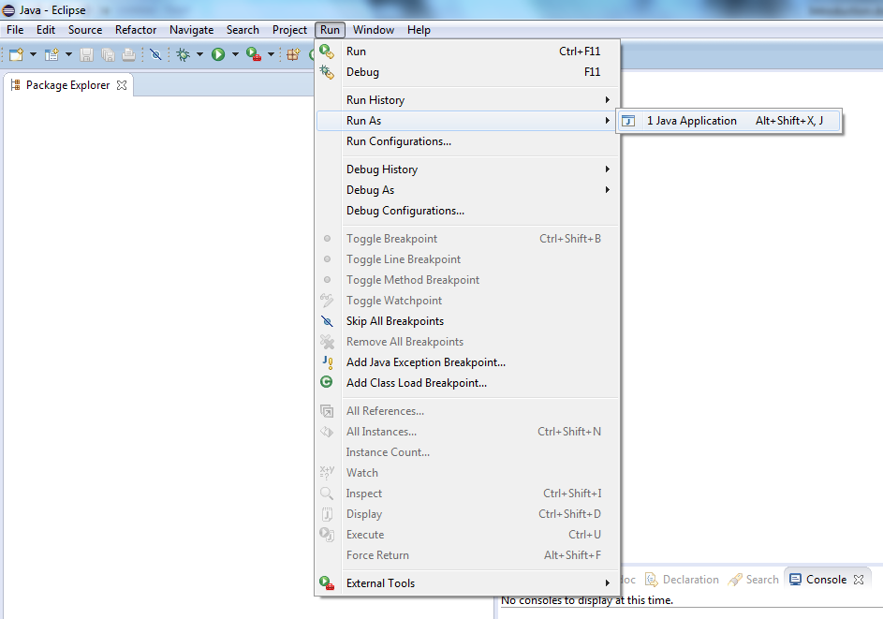
Exporting a class
- Open Eclipse. Right-click in Package Explorer and choose Import. In a pop-up window choose General -> Existing projects into Workspace.
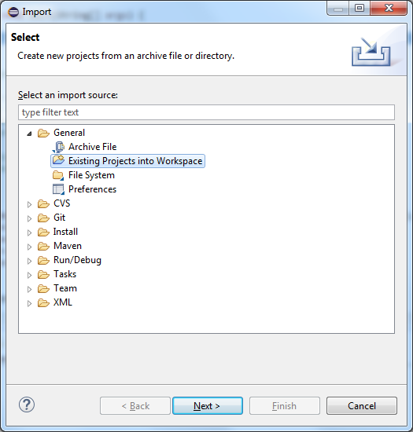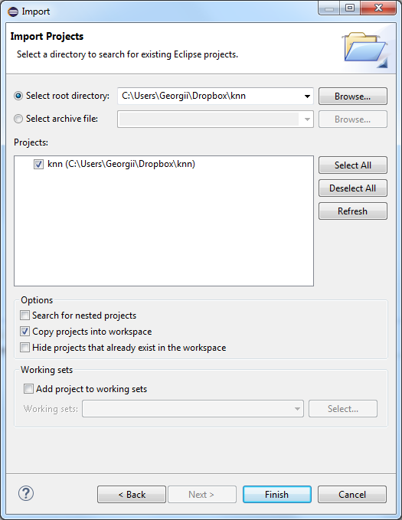
- Browse to the folder with the project and import it in the workspace.

