

Thesis Title: Scaling IoT Simulation (IoT)
Improved Software Testing Tools for Internet of Things

Description of the units:
The Networked Embedded Systems (NES) group at SICS Swedish ICT is a part of the Computer Systems Laboratory. The current research focus is on wireless sensor networks and the Internet of Things. Among the group's key technologies are the Contiki operating system, uIP stack, COOJA/MSPSim, ContikiRPL and the IoT cloud service SICS^{th}Sense. The NES group conducts projects together with industry and academic partners from Sweden and across the world.
Thesis description:
As the Internet of Things (IoT) is rapidly moving from the research stage to commercialization, the tools for evaluating and testing devices, protocols, and software is becoming more and more important. In this thesis project, the objective is to improve the MSPSim emulator that is a part of the COOJA simulation tool. COOJA is a widely spread tool for simulating sensor network and IoT software for resource constrained IoT devices. These improvements are focused on emulation speed to ensure that COOJA can simulate larger IoT networks than it can today. In case of a highly successful project, the student’s work may be developed into an academic paper.
SICS will provide both background information and all source code libraries needed for the thesis project. The tasks of the Masters student for this thesis are:
- Study different approaches to improve emulation speed of the IoT device emulator MSPSim.
- Evaluate what parts of the code in typical embedded IoT software consumes most simulation time (Contiki OS software).
- Implement and evaluate relevant parts of the speed improvements in MSPSim.
- Change / optimize the IoT applications and OS to speed up simulation.
- Document the results as a thesis document.
Competence:
We are looking for a bright MSc student who has fulfilled the course requirements. Good Java and C programming skills are required, as is good spoken and written English. Experience in assembly language is of high value.
Applications should include a brief personal letter, CV, and recent grades. In your application, make sure to give examples of previous programming or other projects that you consider relevant for the position. Candidates are encouraged to send in their application as soon as possible. Suitable applicants will be interviewed as applications are received.

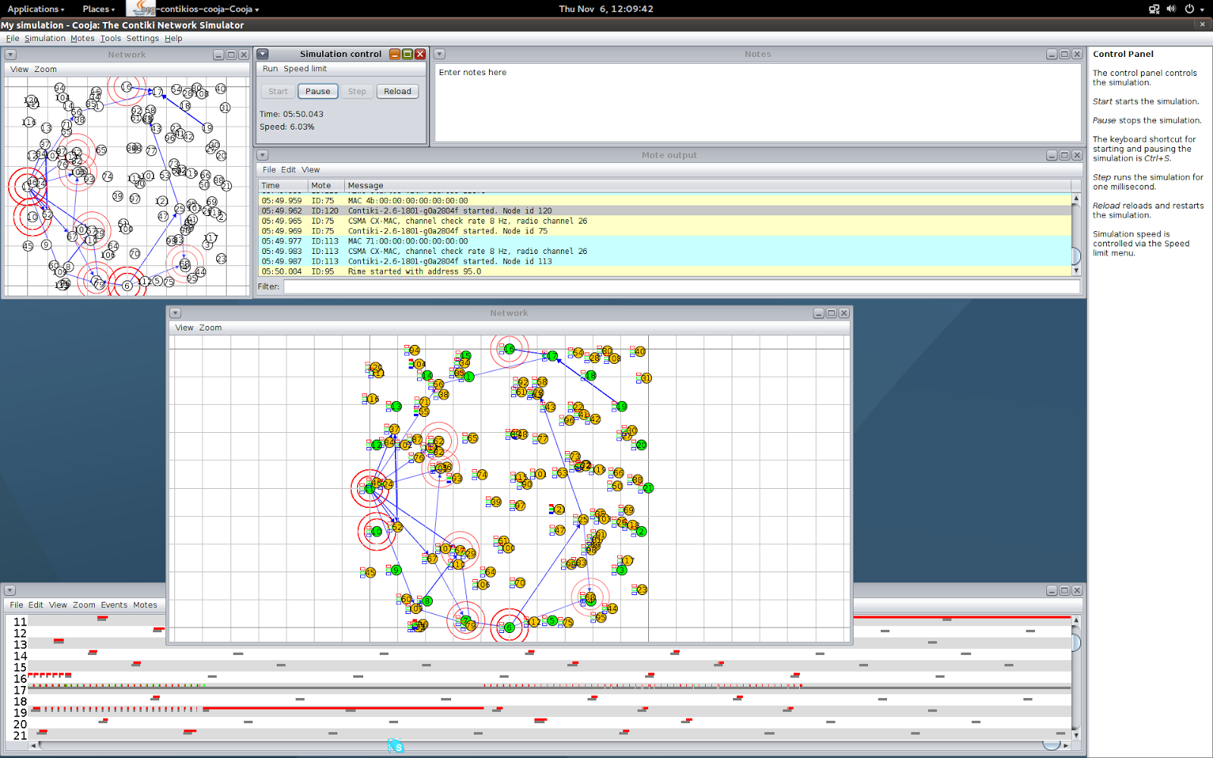
Start time: As soon as possible

Location: SICS Swedish ICT Kista, Stockholm

Contact person:
Joakim Eriksson, Ph.Lic & Senior Researcher, SICS
E-mail: joakime@sics.se
Nicolas Tsiftes, Ph.D & Senior Researcher, SICS
E-mail: nvt@sics.se
SICS Swedish ICT AB
Networked Embedded Systems Group,
Electrum Building,
Isafjordsgatan 22
SE-164 40 Kista, Stockholm

