Assessment template Bachelor of Science and Bachelor of Science in Engineering (Civil engineer), Year 3 Degree projects, 170516

Guidelines for quality criteria for assessment of degree projects

The degree project is assessed with the criteria: Process, Engineering-related and scientific content, and Presentation. For each criterion there is one or more objectives with the guidelines for quality assessment. The assessment of each objective is either of very high quality (VHQ), good quality (GQ) or insufficient quality (IQ). Observe that a degree project, where one subsidiary objective is considered to be of insufficient quality cannot receive a passing grade.

For more information about the goals, see higher education ordinance:
https://www.uhr.se/en/start/laws-and-regulations/Laws-and-regulations/The-Higher-Education-Ordinance/
Degree of Bachelor of Science [Bachelor examina] (Kandidatexamen)
Degree of Bachelor of Science in Engineering [Civil Engineering examina] (Civilingenjörsexamen)

For more information about the KTHs criteria, see:
https://intra.kth.se/polopoly_fs/1.147277!/Menu/general/column-content/attachment/Bedomningsgrunder%20och%20kriterier-eng.pdf

For more information about the Higher education ordinance - Swedish, see:
https://www.riksdagen.se/sv/Dokument-Lagar/Lagar/Svenskforfattningssamling/Hogskoleforordning-1993100_sfs-1993-100/?bet=1993:100

Assessment of achievement of objectives is carried out by describing how the objectives have been achieved and where, in the degree project report, the different objectives are included. This information will be presented in the table below. The assessment must be carried out individually. When the degree project report is completed, it must be handed over to the supervisor. The supervisor checks that the assessment template is filled-in, correctly, and presents own assessments of the objectives, especially if discrepancies exist between the assessments of the student and the supervisor.

Appendix A contains tables for Active listeners and for presentation seminar and opposition seminar. Appendix B contains support material for assessment of the written material.

Student name:

Education programme, Year:

Supervisor:

Examiner:

Reviewer:

Table of Contents

Assessment of the achievement of objectives, Student 3
Process, P1 - P3 3
Engineering-related and scientific content ES1 – ES7 4
Presentation, Pres1 5
Course objectives according to the course plan Bachelor of Science and Bachelor of Science in Engineering (Civing), year 3 6
Assessment for the achievement of objectives, Examiner’s assessment 7
Summary of the achievement of objectives 8
Appendix A. Tables for Active listeners and for presentation seminar and opposition seminar 9
Active listeners 9
Presentation seminar 9
Opposition seminar 9
Appendix B. Support material with assessment criteria that is used when assessing degree projects, Bachelor of Science in Engineering, year 3 and Bachelor of Science 10
Process, P1 – P3 10
Engineering-related and scientific content, ES1 – ES7 11
Presentation, Pres1 14
Appendix C. Bedömningsmall för examensarbeten med betyg P/F ( alternativet finns fr o m hösten 2015 i nya kurser) (Swe) 16

Assessment of the achievement of objectives, Student
The degree project is assessed with the criteria: Process, Engineering-related and scientific content, and Presentation. The table below, Table 1, is divided according to these criteria. The table begins with objectives for process, P1-P3 and continues with Engineering-related and scientific content, ES1-ES7. It ends with the presentation objective Pres 1.

For help with assessing different qualities: very high quality (VHQ), good quality (GQ) or insufficient quality (IQ), for each objective, please see Appendix B.

Student’s self-assessment | Achievement of objectives | Reference | Supervisor’s assessment
Objectives | Here the student describes the self-assessment of the objective.  Substantiate statements with arguments | Refer to the section and the page number in the degree project where the assessment is described | Supervisor presents own assessment -  especially the differences in student’s assessment must be clear

Process, P1 - P3

Objective P1
Demonstrate knowledge and understanding in the main field, including knowledge of the area's scientific basis, knowledge of applicable methods in the field, deepening in any area of ​​the field, and information on current research and development work

Objective P2
Demonstrate the ability to identify the need for additional knowledge and to develop own skills

Objective P3
Demonstrate ability to critically discuss phenomena, issues and situations, as well as model processes, based on relevant information

Engineering-related and scientific content ES1 – ES7

Objective ES1
Demonstrate ability to independently identify, formulate and solve problems as well as analyze and evaluate various technical solutions

Objective ES2
Demonstrate ability to plan and implement tasks within predetermined parameters

Objective ES3
Demonstrate ability to, in collaboration, plan, implement and report given tasks;

Demonstrate ability to search, collect, evaluate and critically interpret relevant information in a problem statement

Objective ES4
Demonstrate ability to integrate and use knowledge

Objective ES5
Demonstrate ability to describe and develop simple proposals for products, processes and systems with regard to people's conditions and needs as well as society's goals for economics, social and ecological sustainable development

Objective ES6
Demonstrate the ability to (in the main subject of education) make assessments with regard to relevant scientific, social and ethical aspects

Objective ES7
Demonstrate insight into the role of knowledge and technology in society and on people's responsibility for how these are used

Presentation, Pres1

Objective Pres1
Demonstrate ability to, in English or in Swedish, verbally and in writing, report and discuss information, problems and solutions in dialogue with different groups

In the table, the students describe the self-assessment of the objective by substantiating statements with arguments, see column 1. The students also refer to the section and the page number in the degree project where the assessment is described, see column 2.

The supervisor presents own assessment - especially the differences in student’s assessment must be clear. Otherwise the column can be left without any comments.

Course objectives according to the course plan Bachelor of Science and Bachelor of Science in Engineering (Civing), year 3

- Demonstrate knowledge and understanding in the main field, including knowledge of the area's scientific basis, knowledge of applicable methods in the field, deepening in any area of the field, and information on current research and development work
- Demonstrate ability to search, collect, evaluate and critically interpret relevant information in a problem statement
- Demonstrate ability to independently identify, formulate and solve problems as well as analyze and evaluate various technical solutions
- Demonstrate ability to integrate and use knowledge
- Demonstrate ability to plan and implement tasks within predetermined parameters
- Demonstrate ability to critically discuss phenomena, issues and situations, as well as model processes, based on relevant information
- Demonstrate ability to describe and develop simple proposals for products, processes and systems with regard to people's conditions and needs as well as society's goals for economics, social and ecological sustainable development
- Demonstrate ability to, in collaboration, plan, implement and report given tasks
- Demonstrate ability to, in English or in Swedish, verbally and in writing, report and discuss information, problems and solutions in dialogue with different groups
- Demonstrate the ability to (in the main subject of education) make assessments with regard to relevant scientific, social and ethical aspects
- Demonstrate insight into the role of knowledge and technology in society and on people's responsibility for how these are used
- Demonstrate the ability to identify the need for additional knowledge and to develop own skills

Assessment for the achievement of objectives, Examiner’s assessment
Date:

 | Examiners assessment | Subject-knowledgeable teacher (that reviews the thesis) assessment, evaluation | Final assessment of the achievement of objectives
 | Here the examiner gives assessment of the objectives – especially differences compared to the supervisors assessment should be pinpointed | If the reviewer, who is the knowledgeable teacher, has different opinion than examiner, it will be reported here.
Achievement of objectives: |  |  | Final assessment for achievement of objectives:
Process (P)

P1
P2
P3
Engineering-related and scientific content (ES)

ES1
ES2
ES3
ES4
ES5
ES6
ES7
Presentation (Pres)

Pres1

Summary of the achievement of objectives

Criteria for grades based on assessment template

Summary of assessment template
Process |  | Engineering-related and scientific content |  | Presentation
 | Final assessment |  | Final assessment |  | Final assessment
P1 |  | ES1 |  | Pres1
P2 |  | ES2
P3 |  | ES3
 |  | ES4
 |  | ES5
 |  | ES6
 |  | ES7

Appendix A. Tables for Active listeners and for presentation seminar and opposition seminar
Student Name:
--------------------------------------------

Active listeners
Active listener is actively participating in other students’ seminars. The active listener should have read the thesis in beforehand and must ask, at least one relevant question during the seminar.

Seminar  Date | Title of the thesis and date of presentation | Name of the presenting student | Signature of the presenting student’s examiner (must be signed at the seminar)
Seminar 1, Date

Seminar 2, Date

Presentation seminar
Presentation  Date | Name of the student that oppose | Name of the opponent’s examiner | Signature of the presenting student’s examiner (must be signed at the seminar)

Opposition seminar
Opposition  Date | Name of the student that presents | Name of the examiner for the presenting student | Signature of the presenting student’s examiner (must be signed at the seminar)

OBSERVE! Do not forget to fill in the opposition report and hand it in, not later than the day before presentation day. Hand over the opposition report to the examiner of the student, that is presenting the thesis, and to your own examiner. You can also send it to the student (author of the thesis).

Appendix B. Support material with assessment criteria that is used when assessing degree projects, Bachelor of Science in Engineering, year 3 and Bachelor of Science
For each objective that is based on Higher education of ordinance, in this assessment template, there is a correspondence to KTH assessment criteria. The degree project is assessed with the criteria: Process, Engineering-related and scientific content, and Presentation. This material is a support when assessing very high quality (VHQ), good quality (GQ) or insufficient quality (IQ).

Process, P1 – P3

P1. Assessment template: Demonstrate, with a holistic approach, the ability to critically, independently and creatively identify, formulate, analyse, assess as well as deal with complex phenomena, issues and situations even with limited information (Corresponds to objective 1 in course plan for Bachelor and Bachelor of Science in Engineering)

Assessment criteria
GQ | The work has a clear and distinct question that can be answered, adequately. There should be a clear link between the question formulation, results and conclusions. Work conclusions are well-founded and accurate.  Good ability to independently identify, formulate, analyze, assess and deal with complex phenomena.  Show good ability to put yourself in another's work and formulate relevant and constructive criticism.
VHQ | Additionally, the question (or problem statement) has been sophisticated formulated and the work demonstrates a holistic approach, by having the question formulation (or problem statement) and/or methods extracted from several subjects.  Very good ability to and, with a holistic view, critically, independently and creatively identify, formulate, analyze, assess and handle complex phenomena and question formulation (or problem statement) even with limited information
IQ | The work has an unclear or missing question formulation (or problem statement) or goal formulation. Irrelevant (a) method(s) are used. The work does not report an answer to the question or the result is not related to the case. The conclusions are incorrect.

P2. Assessment template: Demonstrate the ability to plan and with adequate methods undertake advanced tasks within predetermined parameters, as well as the ability to evaluate this work (Corresponds to objective 12 in course plan for Bachelor and Bachelor of Science in Engineering)
Assessment criteria
GQ | An elaborated and realistic plan for the work has been formulated. The plan’s schedule (time frame with milestones), which has been communicated and agreed upon, has been followed during the implementation of the work.  If adjustments have been necessary during the implementation of the work, these have been documented and communicated.  Independently plan and execute work within agreed time frames, show initiative and be open to supervision and criticism (feedback).
VHQ | In addition, the student has demonstrated very good planning and compliances of milestones.  Very good ability to plan and carry out advanced tasks within predetermined parameters. Selecting and applying appropriate methods to evaluate this work.
IQ | Planning has failed and appropriate methods are missing. The plan and the contents have not followed the announced and established schedule (time frame with milestones). Documentation of the relevant factors for the deviations is not reported.

P3. Assessment template: Demonstrate the ability to integrate knowledge critically and systematically, as well as the ability to identify the need for additional knowledge (Corresponds to objective 6 in course plan for Bachelor and Bachelor of Science in Engineering)

Assessment criteria
GQ | Obtain relevant knowledge and methods and applied them appropriately.  Independently identify own needs for new knowledge and acquire those skills.
VHQ | The evaluation is detailed (for example, several alternative methods are used) and the results are analyzed openly and critically.
BK | Areas of relevance to the work are not reported or are not used. Selected and acquired knowledge is not reported in a clear way and lacks justification.

Engineering-related and scientific content, ES1 – ES7

ES1. Assessment template: Demonstrate considerably advanced knowledge within the main field of study/the specialisation for the education, including advanced insight into current research and development work (Corresponds to objective 3 in course plan for Bachelor and Bachelor of Science in Engineering)
Assessment criteria
GQ | Demonstrate a significant and deeper insight into current research and development in the main field.  The work utilizes knowledge from advanced studies in the main field. A comprehensive review of existing literature, as well as a reflection on the work linked to the frontiers of knowledge in the main field is present.  This work contributes to a clearly recognized way to new knowledge in the main field. The work demonstrates the ability to make an independent contribution to the field.  A written review of existing literature, as well as a reflection on the work linked to the frontiers of knowledge in the main field is presented.
VHQ | Additionally, the literature contains a clearer synthesis of past and current research and / or development work that is relevant to the work.
IQ | Work linked to the main field is weak or missing. Knowledge from advanced studies in the main field is not utilized. Summary and of the literature, as well as reflection on the work linked to the associated area of expertise is lacking.

ES2. Assessment template: Demonstrate specialised methodological knowledge within the main field of study/the specialisation for the education (Corresponds to objective 5 in course plan for Bachelor and Bachelor of Science in Engineering)

Assessment criteria
GQ | Demonstrate a deeper methodological knowledge in the main field / focus of the education programme. The relevant engineering or scientific theories and methods have been identified. A well-motivated choice of theories and methods has been made. Selected theories and methods have been applied in an innovative and accurate way.  The degree project including written material uses a deep and broad knowledge of methodologies.
VHQ | In addition, selected theories and methods have been applied and / or combined in a more innovative way.
IQ | Selected theories and methods for the work, are irrelevant. The student has not demonstrated that the selected theories, methods are mastered.

ES3. Assessment template: Demonstrate the ability to participate in research and development work and so contribute to the formation of knowledge (Corresponds to objective 8 and objective 2 in course plan for Bachelor and Bachelor of Science in Engineering)

Assessment criteria
GQ | From problem statement and methodology, show very good ability to systematically apply engineering and scientific skills like problem formulation, modeling, analysis, development and evaluation.  Involved in research and development work and contribute to the development of knowledge by clearly report the contribution to research or development work.
VHQ | In addition, the work contributes to the significance knowledge (it should, for example, after processing together with the supervisor, be able to be published in a peer-reviewed conference, or to apply it in practical use for engineering).
IQ | The work is of such character, where it is difficult to be linked to research or development work.

ES4. Assessment template: Demonstrate ability to create, analyse and critically evaluate various technological/architectural solutions, (only for master of engineering students - Corresponds to objective 4 in course plan for Bachelor and Bachelor of Science in Engineering)
Assessment criteria
GK | Good ability to create, analyze and critically evaluate different technical / architectural solutions. The work will demonstrate new solutions that are critically and adequately analyzed and evaluated. Moreover, alternative solutions have been developed, analyzed and presented in a relevant and comprehensive manner.
VHQ | -
IQ | The work has not been reported clearly. Alternative solutions are lacking.

ES5. Assessment template: Demonstrate the ability to, within the framework of the specific degree project, identify the questions/issues that need to be answered in order to observe relevant dimensions of sustainable development (Corresponds to objective 7 in course plan for Bachelor and Bachelor of Science in Engineering)

Assessment criteria
GK | Identify the question formulations that must be addressed to be able to consider relevant dimensions of sustainable development.  Report and motivate the work and discuss results from a perspective with a focus on sustainable development.
VHQ | -
IQ | Not take this aspect into account, despite the fact that the examiner considered to be of importance for the current thesis. This learning outcome can in some cases be irrelevant.

ES6. Assessment template: Demonstrate the ability to, within the framework of the degree project, assess and show awareness of ethical aspects on research and development work with respect to methods, working methods and the results of the degree project (Corresponds to objective 10 in course plan for Bachelor and Bachelor of Science in Engineering)

Assessment criteria
GK | Where it is relevant to the task, show awareness of societal and ethical aspects, including economically, socially and ecologically sustainable development.  Good ability to assess and demonstrate awareness of ethical aspects of research and development work regarding methods, procedures and results of the thesis.  Reports ethical implications of the performed work.
VHQ | -
IQ | Takes no account of the ethical aspects, despite the fact that ethical aspects are considered to be relevant for the work.

ES7. Assessment template: Demonstrate the ability to, within the framework of the degree project, identify the role of science and the engineer in the society (Corresponds to objective 11 in course plan for Bachelor and Bachelor of Science in Engineering)

Assessment criteria
GK | In an independent way, identify science and engineer's role in society. Implement the degree project course without extraordinary support or adjustments or otherwise required extra large resources for carrying out the work.
VHQ | -
IQ | Cannot by him- or herself prove science and the role of the engineer in society. Requires great need of support during project implementation.  These supports have been too broad to ensure that students can work independently after graduation.

Presentation, Pres1

Pres 1. Assessment template: Demonstrate the ability to, in English and/or in Swedish, clearly describe and discuss the conclusions and the knowledge and arguments on which these are based (Corresponds to objective 9 in course plan for Bachelor and Bachelor of Science in Engineering)

Assessment criteria
GQ | Written report. Show a very well written and well disposed report, with a clear statement of work and results, clear analysis and well substantiated arguments, as well as good language processing, formal and scientific accuracy.  Oral presentation. Show ability to orally present with clear reasoning and analysis, and good ability to discuss work.  The written material treats the selected area with a relevant and correct language.  Opposition. The Opposition protocol (opposition report) is clearly and fully completed. Respondent's report has been valued critically, with strengths and weaknesses identified. Relevant and constructive suggestions for improvement have been given.  The written opposition also has been given such relevant and realistic suggestions for improvement that the report clearly can be improved if they are followed. Estimates of the report is thorough and reviewing work methods, results and evaluation in a way that demonstrates the opponent's own in-depth knowledge in the main field.
VHQ | -
IQ | The work lacks essentially adequate language processing, which makes the work difficult to understand, or poorly judged based on the report.

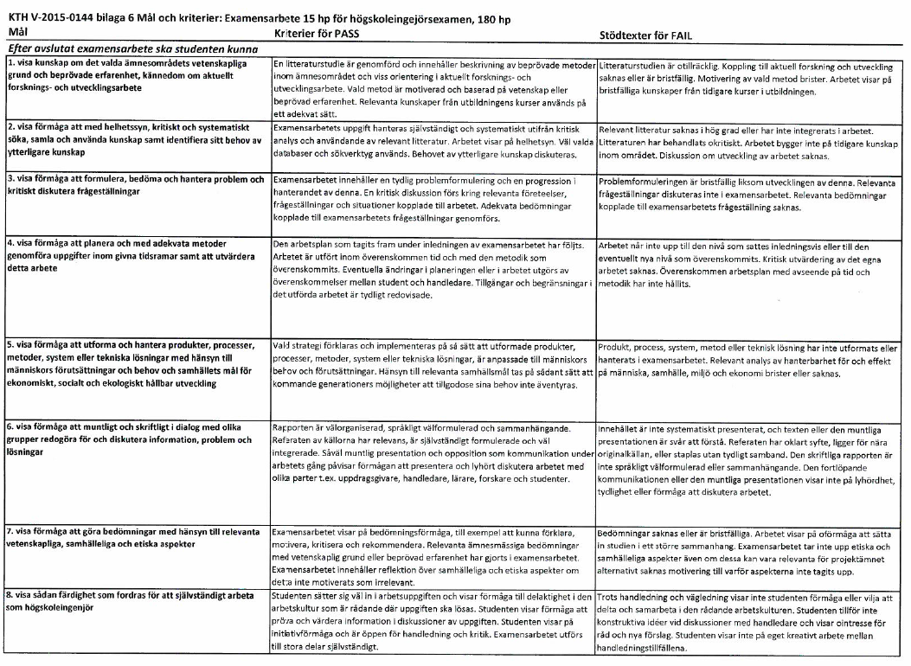
Appendix C. Bedömningsmall för examensarbeten med betyg P/F ( alternativet finns fr o m hösten 2015 i nya kurser)

