Conductive coatings
- Location: Beckers Industrial Coatings, Märsta, and KTH
- Duration: 20 weeks, full time
- Compensation: 50 000 kr divided in 2 paymets. 50% at the beginning of the project, 50% at the end
- Industrial supervisor: Susana Torron
- Contact: Susana.torron@beckers-group.com
About Beckers:
Beckers is a leading worldwide supplier of industrial coatings and the global market leader of coil coatings. We are focused on developing sustainable coatings – our vision is to become the most sustainable industrial coatings company in the world. Our expertise is based on our long history dating back over 150 years. Today, our organization is global, ensuring fast service to customers from 24 locations in 19 countries with worldwide around 1,800 employees.
About the project:
Automotive Plastics Exteriors is a market that demands strong technology to comply with OEM requirements and tailor made solutions to fit the efficiency requirements of our customers paint lines. Due to the extremely high standards of the automotive industry in terms of appearance, durability and resistance, a combination of different coating layers is commonly required. In this multilayer system, every coat has different and multiple roles e.g. enhance the adhesion to the substrate or carry the pigment particles.

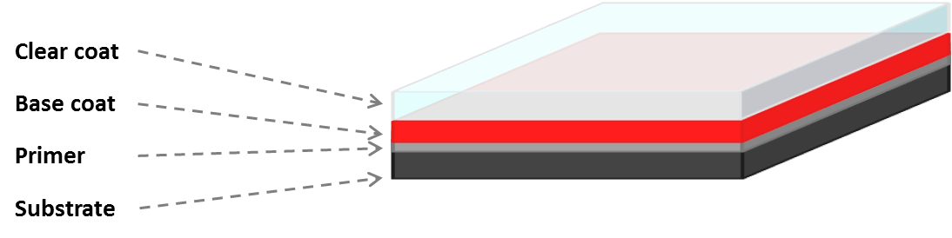
Scheme 1. General composition of a coating for the automotive industry
This project will focus on the first and undermost layer in contact with the plastic substrate: the primer. This layer not only ensures good adhesion between the substrate and the upper layer, but also confers conductivity which helps to reduce losses during the application of the paint.
The main goals of this project will be:
- Nowadays in order to have a conductive layer, Carbon-black is added to the coating. Are there any other non-black conductive pigments or conductive particles that would help to confer conductivity to the coating? Is graphene a feasible alternative? Is it possible to modify the surface a particle for increasing conductivity?
- Is it possible to induce or increase the conductivity of the coating by modifying the resin?
About the candidate:
In order to succeed with this project you need to be result-oriented, flexible and creative. You are methodical, organized and communicative. You have technical interest and willingness to stay current in your technical knowledge. You are fluent, both written and verbal in English.

