Handbook for
Master’s students in

Transport and Geoinformation Technology

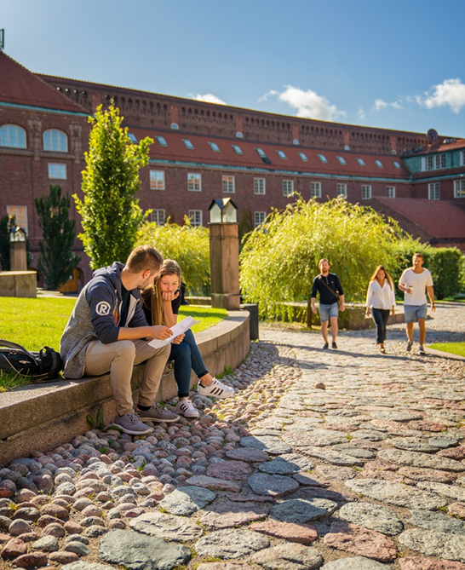

School of Architecture
and the Built Environment
2019

CONTENTS:

CONTACT INFORMATION 2
MASTER’S DEGREE REQUIREMENTS 3
COURSE SELECTION (FROM SECOND TERM ONWARDS) 4
COURSE REGISTRATION 4
REGISTRATION FOR EXAMINATIONS 4
CANVAS 5
SCHEDULE 5
KTH PLACES 5
HOW TO CHANGE A COURSE 5
COURSES OUTSIDE OF YOUR PROGRAMME 6
EXTRA COURSES 6
LANGUAGE COURSES 6
CREDIT TRANSFER 7
CERTIFICATES AND TRANSCRIPTS 7
INDIVIDUAL STUDY PLAN 7
EXCHANGE STUDIES 8
STUDY LEAVE 8
RIGHTS AND RESPONSIBILITIES 8
FUNKA – SUPPORT FOR STUDENTS WITH DISABILITIES 9
IT-SUPPORT 10
ALARM INSTRUCTION IN CASE OF EMERGENCY ON CAMPUS 11




CONTACT INFORMATION

Programme Directors:
Milan Horemuz
Email: milan.horemuz@abe.kth.se
Phone: 08-790 7335

Per Näsman
Email: per.nasman@abe.kth.se
Phone: 08-790 7530

SCHOOL’S OFFICE OF STUDENT AFFAIRS

Master’s coordinators: Mia Kim and Viktoria Tidlund
Service: general questions related to your studies, course admission, individual study plans, study breaks, course transfer, transcripts of records and registration certificates etc.
Email: masterprogram@abe.kth.se
Visiting address: Teknikringen 74 C
Phone: 08-790 8029/08-790 6486
Visiting Hours: Tuesday and Thursday 12.30-14.30

International coordinators: Erika Charpentier and Marta Parzonka
Service: questions related to exchange studies
Email: international.exchange@abe.kth.se
Visiting address: Teknikringen 74 C
Phone: 08-790 8064/08-790 8074
Visiting Hours: Tuesday and Thursday 12.30-14.30

STUDENT’S OFFICE AT EACH DEPARTMENT

Service: help with course registration, results, exams, Canvas
studentexp.fob@abe.kth.se

MASTER’S DEGREE REQUIREMENTS
To obtain a Master's Degree you must have passed courses of at least 120 ECTS credits, of which the following must be included:

- at least 60 ECTS credits from courses that are included in the Master’s programme (including an approved course of the mandatory Theory and Methodology of Science);
- in addition is allowed:
  - a maximum of 30 ECTS credits of entirely elective courses
- A programme related 30 ECTS credit Master’s Degree Project

Please be aware that courses which show a considerable degree of content overlap may not be included simultaneously in the same degree.

It is your responsibility to make sure that the courses you take will fulfill the degree requirements.

COURSE SELECTION (FROM SECOND TERM ONWARDS)
You will select and apply for courses through universityadmissions.se in November (for Spring term courses) and May (for Autumn term courses). Notification of Admission is sent out from universityadmissions in December (for Spring) and August (for Autumn).

More information and detailed instructions will be emailed out prior to the application period every term.

COURSE REGISTRATION
You need to register for the courses you are admitted to at the start of each study period through the personal menu on KTH.se.
Course registrations represent your intention to study on the programme and the selected courses. It is your responsibility to make sure that you are correctly registered.

Registration is necessary to be able to register for examinations and for the results to be reported in the system.

It is easy to see in the Academic overview in the personal menu on KTH.se if you are correctly registered.

REGISTRATION FOR EXAMINATIONS
Registration is compulsory for all scheduled written examinations. You register your intent to sit the examination through the personal menu on KTH.se. Registration periods for each exam period are common throughout KTH and are decided for each new academic year.

Course registration is necessary to be able to register for the examination and for the results to be reported. If you are not able to register for an examination it may be because you are not admitted and/or registered for the course.

If you have any questions or problems regarding examination registration, please contact the course administration at the relevant department.

CANVAS
Canvas is the main learning platform that KTH uses for most courses. You can access Canvas through the personal menu on KTH.se.

Through Canvas students can:
- Find course material and guides uploaded by the teachers
- Keep track of course news/events
- Keep in touch with teachers and fellow students
- Hand in assignments

If you do not have access to Canvas for one of your courses you must contact the teacher or the course administration at that department. Your Master’s coordinator cannot help you with Canvas access.

SCHEDULE
You can see an overview of all your timetables under the My Schedule link in the personal menu. You can also search for any schedules (www.kth.se/schema), for example if you are interested in comparing the schedules of courses to avoid clashes.

KTH PLACES
To find a building, lecture room or computer lab on campus visit www.kth.se/places.

HOW TO CHANGE A COURSE
If you want to change a course, you need to do so within 3 weeks of course start:
- Remove the course you have chosen:
- If you have not yet registered for the course decline your place on universityadmissions.se
- If you have already registered on the course make an ”termination of course” through the personal menu on KTH.se
- Choose a new course:
- Contact your Master’s coordinator by email (masterprogram@abe.kth.se)

Try to make up your mind in the first week to avoid missing too much from the course.
It is your responsibility to make sure that you are correctly registered on the courses you are taking and not registered for any courses you have dropped.

COURSES OUTSIDE OF YOUR PROGRAMME
Courses outside of the programme can only be taken subject to eligibility, space and timetable compatibility.

How to apply for a course from a different programme at KTH:
- Contact the course responsible teacher for written approval that you may take the course
- Forward their confirmation to masterprogram@abe.kth.se
- Remember to check the timetable to make sure it works for your schedule

Use your elective credits for subjects which complement your programme studies. This is your chance to give your education a unique profile, not an opportunity to make up for missed credits or take “easier” courses.
Please be aware that courses which show a considerable degree of content overlap may not be included simultaneously in the same degree.

Do bear in mind that not taking a programme course may make you unqualified for following courses (progression / competence profiles).

EXTRA COURSES
According to the President’s decision (UF-2012/0301) concerning recommendation on how many credits that a programme student may take, a student is not guaranteed more credits than the programme he/she has been admitted to include. For example 120 ECTS credits for Master’s Programme students.
- Students liable to pay tuition fee cannot take any extra courses (without being liable to further fees)

A maximum of two 7,5 ECTS credit courses (15 ECTS credits total) during the two-year programme may be allowed.
- Not allowed in the first term
- ONLY applicable to students who are doing well and completing their courses

LANGUAGE COURSES
The Unit for Language and Communication offers credit-giving Swedish language courses. Information about the courses and application will be emailed to you before the deadline every term (November and May). It is not possible to take any Swedish courses in the first term.
- Students liable to pay tuition fee cannot take any language courses without including them in their future Master’s Degree

CREDIT TRANSFER
Credit transfer means that courses taken at another university, in Sweden or abroad, may be included as part of your programme and your degree. Please note that courses included in your Bachelor’s degree cannot be included in the Master’s degree since the Bachelor’s degree is a requirement for obtaining a Master of Science degree.

To apply for credit transfer you need the following:

- Application form (collect from the School’s office of Student Affairs)
- Official transcript of records
- Course description

Hand in your application to your Master’s coordinator.

It can take up to 3 months from application to decision.

CERTIFICATES AND TRANSCRIPTS
If you need an official signed and stamped certificate or transcript please contact your Master’s coordinator.

You can also print official certificates and transcripts from the personal menu on KTH.se. These documents are digitally verifiable.

INDIVIDUAL STUDY PLAN
You must have completed a certain number of credits each academic year to be able to move up to the next level. If the requirements are not met you will need to make an individual study plan with your Master’s coordinator. The main purpose of the individual study plan is to ensure that students will be able to manage the remaining course elements during the following academic year/term. The remaining course elements and suitable courses from the next academic year/term shall be included in the study plan.

EXCHANGE STUDIES
As a Master’s student at KTH, you have the opportunity to spend one term at one of KTH’s partner universities abroad, without extended study time. It is only possible to go abroad during the Autumn term in the second year.

Students with a scholarship need an approval from their scholarship provider before applying.

- You apply in a database which opens in November, and the deadline is mid-December.
- Places are allocated based on grade average.
- More information will be provided during the Autumn term.

Please be aware that exchange studies may lead to additional costs. Students going abroad usually need to apply for a visa which can lead to extra work and costs.

If you have questions about exchange studies, please contact the International coordinators at the School’s office of Student Affairs.

STUDY LEAVE
An approved leave from studies allows students to take a temporary break from their studies. If you do not intend to study for one period or more, it is very important that you apply for study leave. To be guaranteed to keep your space on the programme, you need to have been granted study leave in advance.

If you want to discuss or apply for study leave, please contact your Master’s coordinator.

RIGHTS AND RESPONSIBILITIES
KTH is a public authority. This means that KTH is governed by the laws and regulations of the Swedish Higher Education Act and Higher Education Ordinance.

As a student, it is your responsibility to make sure that you know what rights and obligations you have according to Swedish law.

KTH’s Rights and Responsibilities website provides a guide to the regulations concerning for example plagiarism, examinations, student influence, personal injury insurance and disciplinary actions.

FUNKA – SUPPORT FOR STUDENTS WITH DISABILITIES
Students at KTH with a permanent disability can get extra support in their studies.

There are many different types of disabilities and even more variations within the same disability (for example ADHD, Asperger’s Syndrome, Asthma and allergies, Dyslexia, Deafness, Impaired hearing, Psychological disabilities, Physical disabilities, Impaired sight, Whiplash)

The most common support measures are
- Note-taking help – a course mate takes notes and gives copies to the student.
- Longer writing periods for exams and tests
- Opportunity to take tests in a private room

For more information concerning support measures, please contact the coordinator for disabled students: +46 8790 70 98, funka@kth.se

IT-SUPPORT
Service: Help with e-mail/computer account, password, photocopying, wifi access etc.

Email: it-support@kth.se
Address: Drottning Kristinas väg 4, KTH Entré
Phone: 08-790 6600
Visiting hours: Monday- Friday 8.00-16.30

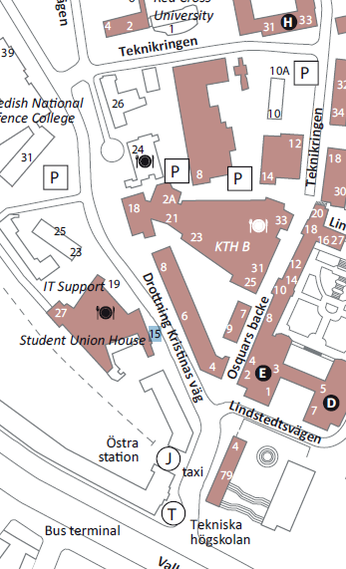



ALARM INSTRUCTION IN CASE OF EMERGENCY ON CAMPUS
1. Call 112 in the case of an incidence where external help such as ambulance, fire brigade or police, is needed
- Inform them that that you are calling from KTH, state address and cause of the alarm
- Then always call KTH’s alarm number 08 – 790 7700.
- State cause of alarm, address and telephone number on which you can be reached in order for KTH’s Security Group to call you back.
2. For events that do not require help from ambulance, fire brigade or police; only alert KTH’s alarm number 08-790 7700, round-the-clock.
- State cause of alarm, address and telephone number on which you can be reached in order for KTH’s Security Group to call you back.
3. Via KTH’s alarm number, contact can be conveyed round-the-clock to:
- KTH’s management team for crisis management
- KTH’s Security Manager
- KTH’s IT security manager
- KTH:s Security Group on KTH Campus
- KTH’s security guards on KTH Campus and Campus Kista, only during security guard operational hours

