 | REport |  | Date |  | Place
 | Periodic review of research 2012-2020 |  | 2021-04-06 |  | Stockholm
 | Created by
 | Panel 9

Panel 9

Physics and Applied Physics
  - 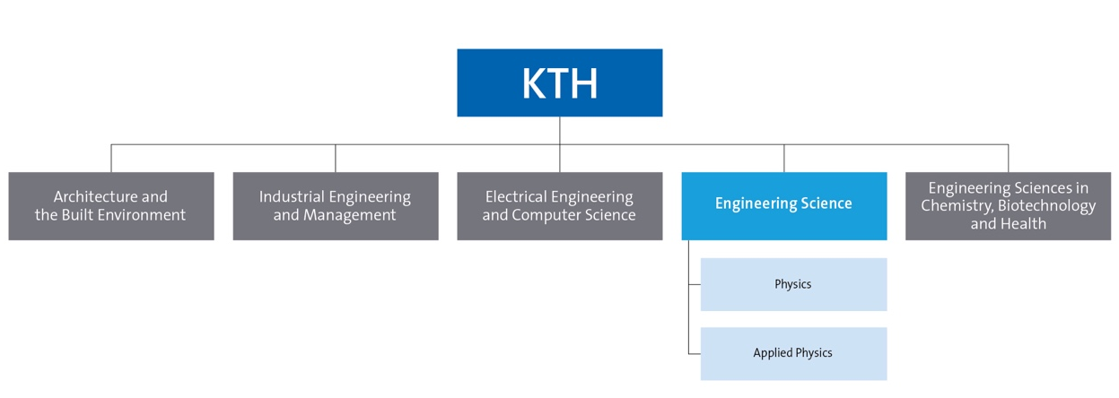

Summary
This self-evaluation report covers the Physics Department and the Department of Applied Physics. The two departments together correspond to about half of the School of Engineering Sciences (SCI), where Applied Physics is the larger of the two with 41 faculty and in total > 200 employees, while the Physics department has 31 faculty and ~ 130 employees. The two departments are the result of merger processes in 2017 where Physics and Theoretical Physics combined into the present Physics Department and where the Material and Nano-physics and Photonics divisions from the ICT school merged into the Applied Physics Department. Both departments, with the exception of the Biophysics division of Applied Physics, are located at AlbaNova.
Description of the research field of the departments included in the research panel
The Department of Physics comprises six divisions: Condensed Matter Theory; Nuclear Engineering; Nuclear Physics; Nuclear Power safety; Particle- and Astroparticle Physics and Physics of Medical Imaging. The research covers a wide range from basic science to applied engineering with experiment, theory, modelling and simulation in almost all of the fields. The experimental research, depending on the field, is performed at a range of locally developed laboratories, small, medium and very-large scale international facilities.
The Department of Applied Physics is organized in seven divisions: Biomedical and X-ray Physics; Biophysics; Nanostructure Physics; Laser Physics; Photonics, Materials and Nano-Physics and Quantum and Biophotonics. A focus is interdisciplinary research in three core fields Bio, Opto and Nano. Significant areas include confocal microscopy, cell-biology, fluorescence correlation spectroscopy, single molecules, x-rays (sources, optics, and microscopes), ultrasonic trapping, microfluidics, solid-state laser sources, quantum optics, nanomaterials, bio-imaging, nanophysics, spintronics, surface physics, device physics and quantum materials.
Description of the self-evaluation process for the research panel
The two departments have independently prepared their respective self-valuation. The process of preparing the self-evaluations started in winter 2020 but was abrupted due to the Covid pandemic. Based on an early draft the two departments agreed on harmonization of styles for the document. The work was mainly driven by the heads of the two departments in collaboration with the two panel coordinators and support from the division heads. Video-conference workshops where faculty was invited to discuss the content of the self-evaluations were created. The faculty has been given the opportunity to comment and contribute text through web-based tools.
Identified research panel synergies
Several timely developments will lead to exciting improved synergy effects between the departments of Physics and Applied Physics. The main development is the significantly improved academic environment resulting from the recent merger of the three physics departments and two divisions from the ICT school into two departments, and in particular with the ongoing move of the Material Physics and Photonics division to the AlbaNova campus.
The establishment of the divisions in the new campus building, called House 3, in 2020 is enabling a significantly enhanced scientific environment and strengthened synergy effects between and within the physics and applied physics departments.
This physical and structural unification will enable and inspire extended collaboration between different groups working in the materials, nanoscience, condensed matter
and nuclear physics, and various applications such as imaging for medical and related purposes. Furthermore, the ongoing establishment of a Quantum Technology Hub
(QTH) involving both departments and other relevant research at KTH is driven by synergy gains and developing mutual scientific interests in basic quantum physics and its timely applications. Fruitful collaborations between several research groups have already started and more is planned.

Table of Contents
Summary 2
I. Department of Physics 7
I.1. Overall analysis and conclusion; strengths and development areas 8
a. Limited SWOT-analysis 8
b. Summary statement on contributions of department on impact, infrastructure and sustainable development. 9
I.2. Research profile 10
a. General information of the department 10
b. Central research questions and themes, knowledge gaps addressed, main research activities and composition of research team(s) 11
d. Quality and quantity of contributions to the body of scientific knowledge 27
f. Follow up from previous evaluations 37
I.3. Viability 39
a. Funding; internal and external 39
b. Academic culture 40
c. Current faculty situation 41
d. Recruitment strategies 42
e. Infrastructure and facilities 43
I.4. Strategies and organization 45
a. Goals for development 5–10 years ahead 45
c. Leadership structure and collegial structure 47
d. Strategies for high quality 48
I.5. Interaction between research and teaching 49
I.6. Impact and engagement in society 50
a. Relevance of research to society at large 50
b. Research dissemination beyond academia 51
c. Sustainability and the United Nations’ Sustainable Development Goals (SDG) 53
d. Impact cases 53
e. Structure for increased impact 53
II.Department of Applied Physics 55
II.1. Overall analysis and conclusion; strengths and development areas 56
a. Limited SWOT-analysis 56
b. Summary statement on contributions of department on impact, infrastructure and sustainable development 56
II.2. Research profile 57
a. General information of the department 57
b. Central research questions and themes, knowledge gaps addressed, main research activities and composition of research team(s) 60
c. Contributions to the advancement of the state of the art within the research fields of the department 67
d. Quality and quantity of contributions to the body of scientific knowledge 74
e. Engagement in national and international research collaboration within academia and its outcomes 77
f. Follow up from previous evaluations 83
II.3. Viability 84
a. Funding; internal and external 84
b. Academic culture 85
c. Current faculty situation 86
d. Recruitment strategies 87
e. Infrastructure and facilities 89
II.4. Strategies and organization 91
a. Goals for development 5–10 years ahead 91
b. Congruence with university-level goals for research as set out in “A leading KTH - Development Plan 2018-23” and with the school(s) development plan(s) respectively. 93
c. Leadership structure and collegial structure 93
d. Strategies for high quality 94
II.5. Interaction between research and teaching 95
a. Interaction between research and teaching at all three levels (BSc, MSc, PhD) of education 95
II.6. Impact and engagement in society 96
a. Relevance of research to society at large 96
b. Research dissemination beyond academia 98
c. Sustainability and the United Nations’ Sustainable Development Goals (SDG) 99
d. Impact cases 100
e. Structure for increased impact 101
ANNEX A. IMPACT CASES 102
I. IMPACT CASES from PHYSICS 102
Case 1) The discovery of the Higgs boson 102
Case 2) Quantum computing and quantum sensing with superconductors 103
Case 3) Photon-Counting X-ray imaging 105
Case 4) Containing the Fukushima accident 106
Case 5) Neutron-Gamma EmissionTomography 107
Case 6) Advanced nuclear reactor development in Sweden 108
II. IMPACT CASES from APPLIED PHYSICS 111
Case 1) Excillum and Exciscope 111
Case 2) Supercapacitors clean water 113
Case 3) Development and application of fluorescence-based super-resolution microscopy for cellular diagnostics and to understand the origin of cellular diseases 115
Case 4) GROMACS: Moving Molecular Life Sciences from the Lab to Supercomputers 118
Case 5) Optical 3D microscopy can enable more effective diagnosis of kidney diseases 121
Case 6) Using nanotechnology for probing exosomes – a liquid biopsy tool for monitoring cancer 123
Case 7) Bispecific antibodies for treatment of leukemia 125

- Department of Physics

Self-evaluation
Head of Department: Professor Pär Olsson
Deputy Head of Department: Josefin Larsson

Included divisions:

Condensed Matter Theory
Head of Division: Assoc Prof Jens Bardarson

Nuclear Engineering
Head of Division: Assoc Prof Pavel Kudinov

Nuclear Physics
Head of Division: Prof Bo Cedervall

Nuclear Power Safety
Head of Division: Prof Sevostian Bechta

Particle and Astroparticle Physics
Head of Division: Prof Bengt Lund-Jensen

Physics of Medical Imaging
Head of Division: Prof Mats Danielsson

I.1. Overall analysis and conclusion; strengths and development areas

a. Limited SWOT-analysis
 | Strengths | Weaknesses
Research | - High impact research at state-of-the-art level across the Department, yielding a strong publication record in top-ranked journals.  - Mix of synergetic applied and basic research encompassing experimentation, modelling, simulation and theory.  - Strong international presence and reputation in multiple fields with leadership roles in international projects.  - Participation in strong research centres (MedTechLabs, OKC, SKC, Space Centre, SUNRISE)  - Excellent record of attracting external funding,including individual prizes  - The Department’s faculty are highly-skilled, highly-motivated and dedicated! | - Low level of internal funding. Consequently the research agenda is dictated by external funding – the availability of which varies considerably between subject areas in the Department. This complicates long term planning, commitments and curiosity-driven research.  - Ph.D. student and postdoc positions are entirely financed by external sources.  - Essential local infrastructure and technical staff are almost exclusively funded by external sources, which leads to difficulties in maintaining staff and expertise between time limited projects.  - High level of administrative load on faculty and researchers.  - The non-traditional subject composition for a Physics Department makes establishing common themes and practices challenging
Organisation | - Following the Department reorganisation, research Divisions have improved critical mass.  - The Department is engaged in excellent education programs with the highest national rankings  - AlbaNova environment – collaborations and synergies with other Departments at KTH, as well as with SU and Nordita.  - Efficient local administration, shared with Department of Applied Physics  - Through leadership assignments within KTH, membership of learned societies and other duties within the broader scientific community, the Department benefits from external influences. | - Poor gender balance in faculty and management.  - The Tenure Track sysem results in a top-heavy faculty  - Lack of career development path for permanent research staff and engineers.  - Lack of department-centralized technical support, apart from the AlbaNova mechanical workshop.  - Implicit instead of explicit central financial support for teaching efforts in the doctoral education programmes.

b. Summary statement on contributions of department on impact, infrastructure and sustainable development.
The department generates significant impact in research, education, training and in society. Research impact is mainly generated through publications, of which the department produces some 300 peer-reviewed articles per year. Publication impact is on an increasing trend and more than 50% of the publications are published in journals that are among the top 20% in terms of impact (KTH bibliometrics, Scopus data). The department has about 50 PhD students and graduates close to 10 PhDs per year. Graduates from the department continue in international academic careers as well as in national and international industries, governmental institutes and in policy making. The applied research carried out in the department is focused on nuclear and on medical technologies. Research activities of the former often leads to media attention in the form of television, radio, newspaper and other media interviews, debate and participation. The medical technology development has led to multi million dollar spin-off activities in medical technology and to significant impact in terms of improved human health. Patents are emanating from the applied research fields, with the major share in medical technology of nearly 40 patents since 2012.
Regarding infrastructure, the department has several local specialist laboratories that are used to drive state of the art research, often for participation in larger international projects and collaborations. A significant fraction of the experimental research is also carried out at very large international facilities such as CERN, and in medium size ones such as AGATA and ISS. There is thus a wide range of topics, a wide range of infrastructure needs and usage and a wide range of academic traditions. This diversity is generally enriching but also leads to a larger fraction of external collaborations than internal ones between the research divisions.
More than half of the activity of the department is related to the UN sustainable development goals. For the applied science research, essentially all activities can be mapped to the SDG’s, while for the basic science research, a smaller fraction can be thus related. Nuclear energy is a key ingredient in a sustainable global society and state of the art medical technology is necessary for improved health. Basic science drives sustainable development in terms of education and safeguarding strong institutions.

I.2. Research profile

a. General information of the department
In its present form, the Department of Physics was formed in 2018 in a merger between the old Department of Physics and the old Department of Theoretical Physics. Some researchers from the former Theoretical Physics Department joined the Particle and Astroparticle Physics division, some moved to the Applied Physics Department and the rest formed the division for Condensed Matter Theory.
The department consists of six research divisions as listed below
Division name  Total number of staff | Head of unit | Faculty
Condensed Matter Theory  Temp. researchers, postdocs and PhD stud: 15  Total staff: 31 | Assoc Prof Jens Bardarson | Prof. Egor Babaev,  Prof Patrik Henelius,  Prof Edwin Langmann,  Prof Mats Wallin,  Prof Anatoly Belonoshko,  Assoc Prof Jack Lidmar
Nuclear Engineering  Temp. researchers, postdocs and PhD stud: 6  Total staff: 31 | Assoc Prof Pavel Kudinov | Prof Henryk Anglart,  Assoc Prof Jan Dufek,  Prof Pär Olsson,  Prof Jan Wallenius  Permanent researchers: 3
Nuclear Physics  Temp. researchers, postdocs and PhD stud: 13  Total staff: 21 | Prof Bo Cedervall | Assoc Prof Torbjörn Bäck,  Prof Ayse Nyberg,  Assoc Prof Chong Qi
Nuclear Power Safety  Temp. researchers, postdocs and PhD stud: 4  Total staff: 24 | Prof Sevostian Bechta | Assoc Prof Ma Weimin  Permanent researchers: 3
Particle and Astroparticle Physics  Temp. researchers, postdocs and PhD stud: 13  Total staff: 36 | Prof Bengt Lund-Jensen | Assoc Prof Mattias Blennow  Prof Sandhya Choubey,  Prof Christer Fuglesang,  Assoc Prof Josefin Larsson,  Prof Tommy Ohlsson,  Prof Mark Pearce  Prof Felix Ryde  Assoc Prof Jonas Strandberg  Permanent researchers: 2
Physics of Medical Imaging  Temp. researchers, postdocs and PhD stud: 3  Total staff: 6 | Prof Mats Danielson | Assist Prof Mats Persson
Table 1 List of faculty and umber of staff in March 2021 of the different divisons.
The department at present has 2 (1 female) affiliated faculty, 21 (1 female) researchers, engineers and technicians, about 28 postdocs and temporary researchers, and about 50 (17 female) PhD students. There are 19 active emeriti professors and researchers. Gender balance is an issue, as across most of KTH, with the same balance as the rest of the School of Engineering Sciences for the PhD students and postdocs, but with below-average female representation among the faculty and permanent research staff.
The research within the department spans from basic science to applied engineering, with experiments, theory, modelling and simulation in basically all the fields of research. There is significant experimental activity at very large, medium and small international facilities as well as in locally developed specialist laboratories.
The department is co-located with the Applied Physics department and with the Physics and Astronomy departments of Stockholm University, as well as with Nordic Institute for Theoretical Physics (Nordita) in the AlbaNova University Centre. Several laboratories are located on the main campus. A common mechanical workshop supports the research activities. The department is hosting the Swedish Nuclear Technology Centre (SKC) as well as the KTH Space Centre and the SUNRISE Centre for sustainable nuclear technology, and has recently, together with Applied Physics, started a quantum technology hub (QTH). The department is actively engaged in the Oskar Klein Centre (OKC) for cosmology, astrophysics and particle physics.

b. Central research questions and themes, knowledge gaps addressed, main research activities and composition of research team(s)
The department is active in a wide array of research fields and the central issues in these fields are addressed below, presented per research division:

Condensed Matter Theory (CMT)
Faculty members of the CMT division lead their independent research groups, as is the norm internationally, generally consisting of the PI together with postdocs and PhD students. Collaborations between groups, especially at the level of postdocs and PhD students is encouraged and common, though the major collaborations are with other groups both nationally and internationally. The major research focus of the division is broadly on quantum matter, covering the full range from fundamental theory to application in material science and device design in quantum technology, with further smaller activity in biophysics and complex matter. The division has expertise in quantum many-body numerical techniques (Monte Carlo, exact diagonalization, DMRG, etc.) in addition to a strong history in mathematical physics including in integrable quantum systems. Ultimately the research aims at developing theoretical tools for understanding and finding new physical phenomena and materials, and thus contributing to future applications of such findings. The division is a frequent user of large-scale computer facilities and also runs a medium size local computer cluster network. The Condensed matter theory division is active in research in, among others, the following fields:
Superconductivity and Magnetism:
- Superstates of matter. Superconductivity. Ultracold atoms. Phase transition and topological excitations in multicomponent gauge theories.
- Effects of frustration. Structure formation in soft matter. Spin ice and related frustrated magnetic systems.
Modelling of quantum devices and qubits. Transport and fluctuation effects in superconducting electric circuits, with application to superconducting nanowire single photon detectors (SNSPD).

Strongly correlated materials:
- Phase transitions, classical and quantum critical phenomena.
- Disordered systems and glasses.
- Monte Carlo and molecular dynamics simulations. Development of new effective simulation methods optimized for complicated energy landscapes.
- Modelling and simulation of matter under extreme pressure.

Topological quantum matter:
- Weyl and Dirac semimetals; anomalies and their experimental realizations.
- Topological qubits in superconducting topological nanowires.

Mathematical physics, thermalization and integrability:
- Many-body quantum dynamics, localization and thermalization.
- Mathematical Physics: Quantum many-body system; exactly solvable systems; analytical and topological methods.

Future research directions have a strong focus on quantum physics. In addition to furthering the research in the above fields new activities include:
- Generalizing the recent breakthrough in computational condensed matter physics: Diagrammatic Monte-Carlo, to nuclear physics and multimessenger astrophysics.
- Open quantum systems, both many-body and interplay with topology.
- Strengthening collaborations with KTH math department with joint projects on foundations of quantum thermalization and integrability.
- Strengthening collaboration with SU condensed matter on topics such as topological quantum matter.
There are great opportunities for strong collaborations on quantum physics in Stockholm including with Nordita, Stockholm University and both the applied physics and math departments at KTH. This includes establishing common research environments and centers in addition to potential for collaborations in education.

Nuclear Engineering (NE)
Research at nuclear engineering aims to develop new sustainable nuclear power technologies and improve existing ones. There are several teams lead by PIs in the following research fields:
- Reactor physics – including neutronics, reactor design, transient analysis and advanced Monte Carlo method development.
- Nuclear materials science – including radiation damage studies, novel structural steels, nuclear fuel development, modelling, testing and characterization.
- Thermal hydraulics – including experimental and computational fluid dynamics, multiphase phenomena, supercritical water experiments and modelling, coupled neutronics – thermal hydraulics and thermo-mechanics.
- Nuclear safety – including integrated deterministic-probabilistic safety analysis (IDPSA), modeling of multiscale and multiphysics accident phenomena.
There are ever growing links between different research areas and respective teams. Key researchers often contributing as co-applicants and co-supervisors to different projects from “other” areas. Further strengthening of internal collaboration and leverage on external expertise (other schools at KTH, Swedish Universities and EU partners) is achieved though development of large scale projects such as SUNRISE (see below), and new research directions such as nuclear energy solutions for climate. Our expertise in development of new designs, materials, building large scale and separate effect experiments, model and code development and validation, and risk assessment is central for success of success of such large scale and highly collaborative projects. Examples of most active research directions are highlighted in nuclear engineering are highlighted here:
Generation IV reactor designs, such as Lead Fast Reactors (LFR) and Supercritical Water Reactors (SCWR). Central research questions are concerned with the key technological breakthroughs needed for deployment of Generation IV systems.(a) New reactor designs with focus on small modular LFRs; (b) Reactor physics transient analysis code to support reactor design development; (c) Nitride fuel development, testing and modelling for LFR; (d) Radiation damage of components in LFR systems; (e) Novel structural Pb-corrosion resisting steels (we are the world leaders here in collaboration with Surface and Corrosion Science at KTH and Sandvik/Kanthal); (f) HWAT (High-pressure WAter Test) loop is currently updated for supercritical conditions to support SCWR and high pressure small modular reactor designs. Note that (c-e) is a collaboration area between reactor design and material teams.
Sustainable Nuclear Energy Research in Sweden (SUNRISE) is a large scale (59 MSEK) center supported by Swedish Foundation for Strategic research (SSF). The center is coordinated by Nuclear Engineering at KTH and includes Uppsalal Univesity, Luleå University. In total, twelve senior researchers lead a group of ten PhD students and two postdocs. SUNRISE is a step towards the construction of a Swedish lead-cooled research reactor in Oskarshamn. The reactor will provide commercial and research services and will be also a demonstration for an advanced nuclear power technology that can be commercialized on a large scale. Main tasks to be addressed are: (a) Design and safety analysis of the research reactor; (b) Advanced steels, materials and radiation damage; (c) Nuclear fuels development and characterization; (d) Testing and modeling of reactor structural component performance against flow accelerated corrosion/erosion in prototypic conditions. It is a highly collaborative project which engages all research directions in the division and is expected to further strengthen Sweden’s role in the European research on Generation IV reactor technology.
Monte Carlo methods for linear and non-linear neutron transport in modelling of nuclear reactors. Particular emphasis is given to the development of optimisation methods for Monte Carlo criticality, kinetic and burnup problems that are needed in design and safety related R&D of current and Gen-IV reactors.
Risk Oriented Accident Analysis Methodologies (ROAAM+) for complex systems with significant uncertainties in phenomena and scenarios. Main application areas are severe accidents in light water reactors (LWRs). This development is actively monitored by regulators in Sweden and Japan and is used in their inquiries to the nuclear industry. Extension of ROAAM+ application to Generation IV reactors is foreseen in the ongoing projects such as SUNRISE.
Containment thermo-hydraulics with emphasis on the performance of the pressure suppression pool, became of international interest after the Fukushima accident in Japan where thermal stratification in the pool significantly increased containment pressure. We provide analytical support to OECD/NEA projects such as HYMERES (Hydrogen Mitigation Experiments for Reactor Safety) and its continuation HYMERES-2 where large scale facility PANDA at PSI (Paul Scherrer Institute) is used to investigate relevant phenomena and provide data for code validation.
Code validation with uncertainty quantification and application, e.g. to the Gen-IV metal cooled reactors. Together with NPS, we designed the TALL-3D facility (lead–bismuth eutectic loop) in EU THINS and SESAME projects in order to demonstrate application of the validation process to standalone and coupled system and computational fluid dynamic (CFD) codes. Several benchmarks were arranged based on the TALL-3D data in the EU projects.
Nuclear energy solutions for preventing the climate change catastrophe. This is a new research direction that aims to couple of nuclear power (including existing and Generation IV reactors) with CO2 negative technologies such as production of bio fuel, char and direct air capture of CO2. The ultimate aim is to make Sweden the first net-negative greenhouse gas emission society in the world by 2040.

Nuclear Physics (NP)
The Nuclear Physics Division carries out research in a broad range of experimental and theoretical nuclear physics together with applications in nuclear safeguards and security, environmental radiation measurements, hadron therapy, radiation dosimetry as well as environmental radon research. The experimental research is performed in international collaborations at large-scale research facilities in Europe and around the world, as well as in specialised laboratories at KTH, the Swedish Radiation Safety Authority (SSM) and the Skandion Proton Therapy Clinic in Uppsala. Our experimental activities combine the designing, running and analysis of experiments for fundamental physics and applications with development of instrumentation and methods. Theory activities include model development in basic nuclear physics and applications for nuclear astrophysics and proton therapy as well as code development. One of the strengths of the Nuclear Physics Division is the longstanding and strong synergy between experiment and theory.
The experimental nuclear physics team performs spectroscopic studies of nuclei near the limits of existence with respect to isospin (i.e. neutron/proton ratios), angular momentum and deformation with a special emphasis on effects of nucleon-nucleon pair correlations in the nucleus. Experiments at the international frontline at large-scale accelerator facilities like GANIL, France, GSI-FAIR, Germany, RIKEN, Japan and MSU-FRIB, USA is combined with instrumental developments preparing for the enhanced experimental access to exotic nuclear species to be available from the mid 2020s the Facility for Antiproton and Ion Research (FAIR), a European Strategy Forum for Research Infrastructures (ESFRI) flagship project. We focus on precision spectroscopy and lifetime measurements in exotic nuclei far from stability, using, in particular, the “Advanced GAmma-ray Tracking Array” (AGATA), which is operated in conjunction with various auxiliary selective devices.
In the future, our main experimental research topics will include:
- Nuclear pairing modes and their isospin properties
- Emergent phenomena like deformation and collective excitations
- Evolution of nuclear shapes
- Measurements relevant for nuclear astrophysics, i.e. of r-p and r-process nuclei
- Structure of hypernuclei, i.e. nuclei containing one or more strange hadrons
We target experimental cases where predictions of nucleonic correlations and the decomposition of the nucleon-nucleon interaction into its key components can be used to maximally constrain state-of-the-art nuclear models. The instrumentation advances driven by this work and the knowledge gained by those involved is relevant for a wide range of medical, industrial and environmental applications (see below).
The nuclear theory team focuses on the development of advanced nuclear many body models that are important not only from a theoretical point of view but also for the development of the physics programmes for the next-generation large-scale radioactive beam facilities. We will focus on:
- Novel large-scale universal Configuration Interaction (CI) approach for studying the structure and decay properties of exotic nuclei
- Shell model in the complex energy plane, role of the continuum in nuclear spectra
- High accuracy mass and level density calculations for nuclear structure in exotic nuclei
- Radioactive decays of exotic nuclei, and (v) r-process and neutron star merger calculations.
Applied nuclear physics research at KTH is aimed at nuclear safeguards and security, radiation dosimetry, hadron therapy and environmental studies. The nuclear safeguards and security team which was started by the Nuclear Physics Division in 2017, develops instrumentation and methodologies to aid in the global efforts against the proliferation of nuclear weapons and to counteract nuclear terrorism. Applications for environmental radiation detection imaging and nuclear accident emergency response are also included in the research programme. The foundation for this research is laid by the cutting-edge expertise in advanced radiation detection coming from the research activities in fundamental nuclear physics within the Division of Nuclear Physics. This applies in particular to detection systems for gamma radiation and fast neutrons developed for studies of exotic atomic nuclei far from the beta-stability line, providing interesting synergies and also opportunities for spin-off from the basic research to its applications. An example of the latter is our project in nuclear security for development of radiation portal monitors (RPMs) with enhanced sensitivity for detecting and imaging special nuclear materials, e.g. plutonium. It is currently receiving support from the technology transfer centre KTH Innovation and from Vinnova. Adapting techniques used in experimental nuclear physics, the team has developed the use of fast time and energy correlations between neutrons and prompt -rays emitted in fission to detect, characterise and image special nuclear materials, a critical task for nuclear safeguards and security applications.
The current main research topics include:
- Development of instrumentation and techniques methods for Nuclear Security - RPM applications.
- Method development in Nuclear Safeguards - Spent Fuel Verification. Both PWR and BWR spent fuel assemblies inside their transport casks as well as in the copper canister designed for encapsulation in the Swedish final spent fuel repository are studied.
- Method development in Nuclear Material Accountability and Control for Gen-IV fuel cycle applications. The project focuses on development of a Non Destructive Assay (NDA) technique that is able to quantify minor actinide and plutonium mass that is adapted for the Gen-IV fuel cycle conditions
- Development of instrumentation and methods for Environmental Radiation Monitoring and Nuclear Emergency response.
The experimental micro- and nanodosimetry team (which started in 2015) performs measurements of radiation-induced ionization in small volumes. Such measurements can provide information on how radiation of different types and energies affect biological tissue at the scale of cells- or even the DNA molecule. The research project is a collaboration between KTH and SSM and is based on measurements using the proton therapy beam at the Skandion clinic in Uppsala, Sweden and at SSM. The main direction for the next few years is to perform nanodosimetry measurements in both gamma- and proton radiation fields.
Another activity of Nuclear Physics at KTH aims at studying radon as earthquake precursor. The aim is to develop a reliable and effective earthquake warning system using a dense sensor network combined with real time data collection, supported by analysis using artificial intelligence, and networking methods to provide daily risk assessment and analysis. Testing and development of gamma-ray based measurement techniques for radon and thoron gases are carried out, preferably in water. For the first measurements, we have assigned a pilot region which is on the faults along the Apennine Mountains in Italy.

Nuclear Power Safety (NPS)
The central research questions at the NPS division are driven by the remaining emerging issues important for risk of operating nuclear power plants, with the goal to ensure that nuclear power plants have the highest achievable safety level, and that the public and environment has an adequate protection against nuclear accidents.
This include addressing the following knowledge gaps:
(i) governing physics of reactor accident phenomena in light water reactors, including thermal-hydraulics, neutron-kinetics coupled with thermal-hydraulics, design basis accidents, severe accidents and related phenomena, such as reactor core degradation and relocation, fuel coolant interactions, debris formation, steam explosion, debris re-melting, melt pool convection and heat transfer, reactor vessel failure, and melt spreading;
(ii) uncertainties in quantification of accident consequences;
(iii) validity of severe accident management and efficiency of safety systems;
(iv) standalone and coupled deterministic/probabilistic methodologies and codes for reactor safety analysis;
(v) safety of future nuclear power including Generation IV or small modular reactor (SMR) technologies.
The NPS division has three research teams for experimental investigation, analytical study and reactor safety analysis. There is a strong synergy among the three teams each led by highly competent researchers. Experimental investigation on reactor accident phenomena and associated heat and mass transfer brings knowledge for development of models used in analytical study, and for validation of codes for reactor safety analysis. The analytical study ranges from model development to CFD simulation. The reactor safety analysis is informed from calculations with system codes of various reference scenarios of design basis and severe accidents.
Future research perspectives are currently visible in development of accident-tolerant fuels and clads for light water reactors, SMR and reactor systems of the next generations including fast reactors with various alternative coolants, systems for minor actinide transmutation and research reactors.
NPS research activities are in the multidisciplinary field that combines scientific disciplines and approaches of reactor physics and nuclear chemistry, engineering subjects of reactor technology but also social sciences of risk management in the society and public safety. The scope of research includes perception, assessment and management of risk of rare but high-consequence events, which ranges from design-basic accidents to beyond design-basis accidents and severe accidents. Consequently, the multi-disciplinarity plays an important role in nuclear power safety and strongly motivates internal and external collaborations.

Particle and Astroparticle Physics (PAP)
The division conducts research in particle physics, high-energy astrophysics and astroparticle physics, with both experimental and theoretical activities. Research is centered around the ATLAS experiment at the CERN Large Hadron Collider (LHC), underground neutrino experiments, and ground- and space-based instruments for astrophysical observations.
The overarching strategy of the division is to combine design and development of instrumentation with data analysis and theory. This approach has allowed the group to assume leading roles in prominent international projects. A recent and welcomed development in the research division is the merger with the Theoretical Particle Physics group in 2018. This has led to fruitful interdisciplinary discussions where common interests are starting to be exploited.
The ATLAS group at KTH is making significant contributions to the experiment in various physics analyses and through involvement in the operation of the current detector and developments targeting an upgraded ATLAS detector. The activities aim at finding evidence for physics which is not described by the Standard Model (SM). This is achieved through contributions in two areas, analysis of ATLAS data and upgrades of the detector in order to reach the best attainable sensitivity. The detector upgrades will be installed in 2026-2027, after which the High-Luminosity phase of the LHC (HL-LHC) will commence, where the luminosity of the accelerator will be increased by an order of magnitude compared to the current operation. The HL-LHC will remain the flagship facility for particle physics for the coming decades.
- Physics analysis focus: Evidence of physics beyond the SM can be obtained either through precision measurements of already known particles, or through direct discoveries of new particles which are not part of the SM. Precision measurements of the Higgs boson are especially sensitive to the effects of new physics, and the group has a long-standing involvement in measurements of Higgs bosons which decay to two W bosons. Recently the group also started an analysis effort searching for the simultaneous production of two Higgs bosons, so called di-Higgs searches. This process will be the first time we can directly probe the Higgs boson self-interaction, which determines the shape of the Higgs potential and thus the vacuum state of the universe. Di-Higgs processes are extremely rare and a discovery will only be possible with the dataset from the HL-LHC. The group also searches for new particles and processes beyond the SM that could explain the dark matter (DM). With a suite of searches targeting signatures with long-lived particles, we have excluded several interesting theoretical scenarios and signatures that often arise in beyond-SM models with good DM properties. These searches targeting unconventional event topologies can enjoy substantial gains in sensitivity with an increased data set and the upgraded detector at the HL-LHC.
- Instrumentation focus: The group plays a key role in the development the High-Granularity Timing Detector (HGTD). The HGTD is a silicon-based timing detector, using novel Low Gain Avalanche Detectors (LGAD) providing a time resolution of 30 ps per charged-particle track. Together with a completely new central tracker, the HGTD will allow ATLAS to separate particles from different simultaneous proton-proton collisions happening in the centre of the experiment in both the space (by the central tracker) and time (by the HGTD) dimensions. The low occupancy of the HGTD, and its excellent time resolution, also makes it an ideal detector for measuring the luminosity of the LHC accelerator. This functionality of HGTD was proposed by the KTH group, and KTH is the leading institute behind the luminosity measurement developments.

A major research theme within the PAP Division is the study of cosmic explosions and compact celestial objects. Analysis of observational data is complemented by instrument development, allowing the group to play a leading role in the development of the field. The type of explosions studied are core collapse supernovae (SNe), which mark the death of the most massive stars in the Universe, and gamma-ray bursts (GRBs), which can form in connection with SNe and when compact objects merge. These events eject matter at extremely high velocities, while also leaving behind compact objects in the form of stellar-mass black holes and neutrons stars, which may form binary systems. Supermassive black holes, located in the centres of galaxies, referred to as active galactic nuclei (AGN), are also studied. All these phenomena play a crucial role in their galactic ecosystems and also offer an opportunity to probe extreme physical conditions, e.g., strong gravity and magnetic fields, that cannot be recreated in laboratories on Earth, which provides a link to fundamental physics.
The four “astro-” faculty (and associated students, postdocs, researchers, and engineers) have varied and synergetic specialisations, and aim to answer key unsolved questions regarding explosions and compact objects. The main research questions can be broadly broken up into three areas: (i) The origin and location of the high-energy emission. This is a long-standing question for GRBs, pulsars (magnetised rapidly rotating neutron stars) and AGN in particular; (ii) The explosion mechanism in SNe. The mechanism that leads a collapsing star to explode is still unclear, in particular for the most energetic types of explosions; (iii) The physical properties of the compact objects, including their connection with the type of explosion and the progenitor star.
These questions are tackled through analysis of observational data, which are compared to state-of-the art theoretical models. The observations cover most of the electromagnetic spectrum, with a particular focus on highly energetic X- and gamma-ray emission, which places the group in a unique position in Sweden. The main facilities used include The Fermi Gamma-ray Space Telescope, all the major X-ray telescopes (XMM-Newton, NuSTAR, Swift, Chandra), as well as balloon-borne X-ray polarisation missions developed within the group (PoGO+, XL-Calibur). As well as developing active missions, the group also has a significant activity in the general development of space instrumentation and studies for future missions.
A related research area in the Division concerns cosmic rays, which are accelerated in the extreme environments described above. Previously, activities centred around the PAMELA mission which studied cosmic-ray antiparticles (2006-2016). Now-a-days, the focus is the JEM-EUSO mission for space-based observations of ultra-high-energy cosmic rays (UHECR). The group studies the observing background - UV light from the night side of Earth. Theoretical investigations on the origins of UHECR are also conducted, in particular for GRBs as possible sources.
Research within theoretical and phenomenological particle and astroparticle physics focuses on physics beyond the standard model. The research benefits from interdisciplinary discussions with the experimental part of the Division, and with the IceCube group at Stockholm University. The members of the Division collaborate with other world-leading experts and receive international recognition. The central research activities are:
- Neutrino oscillation phenomenology: Predictions of the sensitivity of forthcoming neutrino oscillation experiments, in particular ESSnuSB, DUNE, INO, and T2HK. The strategy involves participation in the determination of the fundamental neutrino oscillation parameters and probing the capabilities of these experiments to testing new physics scenarios.
- Beyond the Standard Model physics: Different extensions to of the Standard Model to incorporate neutrino masses and dark matter candidates. The observable effects of these models with respect to current data from different particle physics experiments are studied and evaluated with the aim to develop theoretical understanding of such frameworks.
- Dark matter phenomenology: The behaviour and the resulting detection signals of dark matter in astrophysical systems, and the interplay with other dark matter signals. Phenomenological constraints on different dark matter models are studied. This includes several types of experimental bounds coming from observations of the early Universe, direct and indirect detection experiments, and collider experiments such as the ATLAS and CMS experiments at the LHC.
- Astroparticle phenomenology: Ultra-high energy neutrinos coming from astrophysical sources, such as active galactic nuclei, are a major player in multi-messenger astronomy. The phenomenology of ultra-high energy neutrinos at IceCube is studied in the context of neutrino oscillations and beyond the Standard Model physics.
- Other particle physics and fundamental symmetries: Studies of other particle physics involve searching for mass models of exotic hadrons (such as tetraquarks and pentaquarks). In connection to fundamental symmetries, non-Hermitian Hamiltonian and PT-symmetric quantum systems are also investigated. These studies are closely related to research areas like atomic, molecular, and optical physics. The strategy for the fundamental symmetries is to better understand how non-Hermitian systems work for realistic systems with applications.

Physics of Medical Imaging (PMI)
The overarching research goal for the Physics of Medical Imaging division is to devise new medical x-ray imaging techniques based on novel detectors and optics and bring these into routine clinical use, leading to improved diagnostic image quality, novel imaging techniques and ultimately saved human lives. This research is highly multidisciplinary and involves semiconductor device physics, integrated circuit development, image reconstruction and clinical applications.
The main focus is on photon-counting spectral computed tomography (CT) based on a silicon-strip detector invented within the division. Having developed this detector to the point where it is installed in a clinical CT scanner and is ready for clinical trials, this research project is entering a phase in which the new technology will be evaluated for a wide range of imaging scenarios, meaning that there is potential for a number of publications with high impact for healthcare. To accomplish this, the plan is to deepen the current collaboration with the Karolinska Institute and Karolinska University Hospital within the MedTechLabs center. To fully understand the benefits and applicability of the new technology, there is also a need for developing detailed simulation models, so that virtual clinical trials can be carried out, and novel image reconstruction methods, to make the best possible use of the new image information. In particular, the division is currently doing research into image reconstruction methods based on deep learning, which shows very promising results for improving image quality. An additional focus is developing metrics and measurement techniques for photon-counting CT to compare different scanner models and protocols and optimize future hardware versions.
For the future, the plan is to focus on understanding the possibilities and limitations of deep-learning-based image reconstruction, in order to use the new, image-resolved data in the best possible way. The combination of highly energy-resolved data with novel deep-learning image reconstruction methods will be applied to a variety of clinical tasks, such as determining diseased brain tissue in acute stroke, enabling ultra-low dose pediatric imaging and visualizing bone fractures in trauma imaging. The ability of photon-counting CT to generate more reliable, quantitatively accurate images is particularly promising for the ability to characterize tumors, opening possibilities for personalized medicine. Another topic of interest is how the energy-resolved information can be combined with advanced motion compensation to allow improved imaging of the heart and blood vessels, which can allow better treatment or risk prediction for myocardial infarction. The division also works on automated analysis of covid-19 lung patients, and the follow-up examination of long-term covid patients is an application where the high spatial resolution of the novel CT technology is expected to be beneficial.
On the hardware development side, a new Compton-tracking detector with micrometer resolution is being developed, promising greatly improved image quality. This high spatial resolution can also allow dose-efficient phase-contrast imaging without an analyzer grating, with a promising future potential to take phase-contrast imaging to the level where it can be routinely used in the clinic. This line of research is a highly promising future research direction for the division. Another foreseen research project is the application of an x-ray lens developed within the division for developing imaging systems with improved quality, both in medical imaging and x-ray astronomy.

c. Contributions to the advancement of the state of the art within the research fields of the department

Condensed Matter Theory
The following list exemplifies advances from the condensed matter theory division:
Superconductivity and magnetism: A new kind of mixed collective mode in three-band superconductors with broken time reversal symmetry; prediction of anomalous metallic state breaking time reversal symmetry; the notion of metallic and superconducting superfluids and their realisation in hydrogen and deuterium at ultrahigh pressure; introduction of new vortex viscosity mechanism; demonstration of glass formation and Non-Meissner electrodynamics in multiband superconductors; hopfions in superconductors and superfluids; Generalization of FFLO states to the case of unconventional pairing; new non-topological states leading to surface superconductivity in metals and new superface superconducting states; Microscopic theory of magnetic response of non-centrosymmetric superconductors; new kind of magnetic order in antichiral ferromagnetism; finding chiral magnetic skyrmions with arbitrary topological charge.
Strongly correlated materials: new approaches for analyzing quantum phase transitions and disordered systems; the Accelerated Weight Histogram (AWH) method for enhanced sampling and free energy calculations in Monte Carlo and molecular dynamics simulations; modelling of thermal and quantum phase slips in superconducting nanostructures; first numerical method that allows to obtain with controlled accuracy sphaleron solutions in gauge theories.
Topological quantum matter: coupling of domain-wall motion in Weyl semimetals with axial anomaly with applications in spintronics; entanglement spectrum and bulk-boundary correspondence in non-hermitan quantum system; fermi-arc mediated transport in Weyl semimetal nanowires; established a lattice interpretation of consistent and covariant anomalies in presence of fermi-arc states.
Mathematical physics, thermalization and integrability: discovery of new integrable systems; development of solutions methods; applications of known mathematical results to physics; physics of many-body localisation transition and quantum thermalisation; entanglement structures;

Nuclear Engineering
The division has contributed major advances in different areas of nuclear engineering research with the aim to support existing or develop new nuclear power technologies.
- New advanced steels (FeCrAl-based) that can withstand Pb-corrosion up to 800°C for extended periods of time have been developed in collaboration with Surface and corrosion science. This is a critical development for materials to be used in GenIV lead fast reactors.
- A range of small modular reactor designs based on LFR technology (ELECTRA, SEALER, SEALER-UK, SEALER-E, SUNRISE research reactor) which have been enabled after the above developments of materials and fuels. The spin-off company LeadCold has been created.

- Development of state of the art direct dynamic studies of radiation damage methods which are cruicial for addressing performance of new materials in new reactor designs. A paradigm shift in the studies of radiation damage phenomena has been introduced by going beyond the previously canonical approach of using static quantum mechanics (density functional theory level) to predict key parameters, and then build semi-empirical classical models.
- Advanced nuclear fuels with focus on nitrides and silicides. UN pellets with substancially improved oxidation restistance, microstructure and grain size control were obtained through spark plasma sintering. This development is another world level crucial element for deployment of Generation IV designs.
- ROAAM+ framework and coupling with commercial software RiskSpectrum for probabilistic safety analysis of power plants. This development is an important step forward in safety analysis of light water reactors and is planned to be applied in the design and licensing certification process for Generation IV reactors.
- Effective heat and momentum source models that have enabled simulations of steam injection into large scale water pools for analysis of containment thermal-hydraulics. This is important for realistic assessment of containment performance in light water reactors and is expected to contribute to power plant safety analysis.
- The corium debris bed formation and coolability code DECOSIM has been a significant part of phenomenological model development and validation for severe accident analysis. It has relied on an extensive experimental program.
- A comprehensive steam explosion risk analysis model was another critical element in, and first-of-a-kind approach for, adequate risk quantification using deterministic models for chaotically behaving systems.

Nuclear Physics
The KTH Nuclear Physics group plays a leading international role in the study of nuclear structure with a focus on collective phenomena and on nucleon-nucleon pair correlations. We have been at the international forefront in the exploration of nuclear superfluidity in its more exotic isospin degrees of freedom in the last decade. Following the discovery of excited states in the rare, self-conjugate, nucleus 92Pd which was published in Nature1, and which indicated a new, isoscalar, spin-aligned pairing scheme in the ground states and low-lying states of the heaviest atomic nuclei with equal numbers of protons and neutrons we have continued our studies of extremely neutron deficient nuclei with a focus on nuclear pairing modes and their interplay with the collective degrees of freedom. The isoscalar spin-aligned pairing scheme suggests a new, beyond textbook physics, phenomenon in such exotic nuclei, originally proposed by Prof. Jan Blomqvist, KTH. The theory behind was described in more detail in a subsequent article in Physical Review C by the KTH group2. The discovery was also featured in popular science media, e.g. in the quarterly journal of the Swedish Physical Society3. It remains a topic of large scientific interest in the community with around 10 and 5 citations per year for the Nature and Physical Review article, respectively (Web of Science).
In 2018, we discovered (B. Cederwall et al., Physical Review Letters 121 (2018) 022502) a pattern of transition strengths (related to state lifetimes) in the ground state bands of extremely neutron deficient isotopes of the transitional W-Os-Pt elements that indicates an unexpected phase transition between seniority symmetry (which is closely related to strong nucleon-nucleon pair correlations) and a collective vibrational regime.
This was followed by the recent discovery of evidence for isoscalar pairing in the self-conjugate nucleus 88Ru (B. Cederwall et al., Physical Review Letters 124 (2020) 062501) which for the first time provides evidence for effects of isoscalar neutron-proton pair correlations in a deformed rotating nucleus.
In the recently started work on nuclear safeguards, security and related applications we are setting a new standard for sensitive detection and imaging of special nuclear materials. A new method, originating from our experimental approach to studies of exotic neutron deficient atomic nuclei was described in a recent publication (Trombetta, Klintefjord, Axell, and Cederwall, Fast neutron and gamma-ray coincidence counting for nuclear security and safeguards applications, Nuclear Instruments and Methods in Physics Research A, 927, 119 –124 (2019) and in a patent application which has recently passed successful evaluation in the international PCT stage (B. Cederwall, application No PCT/SE2019/050609).
The theory team has developed open-source codes and databases:
- PairDiag: Exact pairing solver based on diagonalization (fortran)
- Richardson equation solver (python and mathematica)
- Variational pairing solver (python)
- Large-scale shell model with seniority truncation (fortran)
- Neutron star merger simulator
- Nuclear mass table from TRS and HFB calculations with improved pairing

Nuclear Power Safety
The NPS research results generated during the last years helped to elucidate several risk-significant phenomena in reactor safety, including
- Melt interaction with porous debris during in-vessel and ex-vessel debris re-melting
- Turbulent natural convection and heat transfer in molten corium pools affecting thermal loading of reactor pressure vessel
- Reactor vessel behavior under melt attack setting initial conditions for ex-vessel accident progression
- Core melt underwater spreading and risk of stratified steam explosion
- Debris formation during fuel-coolant interactions affecting debris bed properties instrumental for coolability
- Steam explosion energetics setting a risk of reactor containment failure
- Oxidation of Zr and Zr-Fe droplets in water and associated heat and hydrogen generation
- Debris bed coolability and risk of debris re-melting
- Spray cooling as an advanced safety option for several reactor designs, including ex-vessel cooling system for in-vessel melt retention
The impact of the research results (1) through (3) is instrumental to the assessment of in-vessel melt retention (IVR) strategy of light water reactors (e.g. AP1000 and HPR1000); while the items (4) through (8) are paramount to the safety assessment of Nordic BWRs whose severe accident management strategy (SAMS) employs cavity-flooding action (ex-vessel cooling) to arrest the corium; and the item (9) is crucial to apply the in-vessel melt retention strategy to high power reactors. Experimental results generated at NPS are used for model development and validation of several computer codes used in reactor safety analyses. Results of the modelling and the related safety analyses enforced safety of presently operating and new BWRs, PWRs and VVERs. The outcome also has implications for new reactor designs, such as the sodium cooled fast reactor ASTRID developed at CEA, the reactor part of Accelerator Driven System (ADS), the lead/bismuth cooled reactor MYRRHA (Multi-purpose hYbrid Research Reactor for High-tech Applications) developed at SCK and several other designs. NPS research also contributed to combined deterministic/probabilistic analysis of reactor safety.

Particle and Astroparticle Physics
The ATLAS group at KTH has been at the forefront of the activities in the ATLAS collaboration, contributing to big discoveries, improved knowledge of the dark matter, and to a detector which performs beyond its design capabilities. In a collaboration with over 3,000 members, recognition for outstanding contributions are awarded through leadership positions and prestigious conference talks. Despite the small size of the KTH ATLAS group compared to other universities, we have been involved in a disproportionate number of leadership roles, often coordinating teams with hundreds of participants. Selected examples of such roles are:
- A group member led the Higgs to WW analysis, which was one of the three analyses that contributed to the discovery in 2012. The work continued with measuring the properties of the Higgs boson. The Higgs boson discovery is one of the most cited papers of all time, and the impact of the discovery on society is highlighted in as one of the impact cases in appendix A.
- Another member is currently coordinating the whole ATLAS physics program which is preparing for the HL-LHC upgrades. He previously led the DM working group in ATLAS, which produced some of the most stringent constraints on the DM to date.
- A group member has been coordinator of the data preparation activity area in ATLAS, overseeing the data reconstruction and luminosity measurements which underpins all the ATLAS physics analyses.
- All group members have leadership roles in the development of the HGTD detector, currently as electronics coordinator, luminosity coordinator, software coordinator and institute board chair person. Our involvement was instrumental in getting the detector approved as an ATLAS upgrade project. The HGTD will push the performance as a timing and luminosity detector over the current state-of-the-art.
Our engagement in the analysis work and detector upgrades will ensure that we are able to continue to tackle physics questions at the forefront of particle physics in the future.
The astrophysics group has a central role in advancing both observational and experimental high-energy astrophysics. The group’s work is routinely published in prestigious international journals, regularly attracts external grants, and is often allocated time at major observing facilities. All the group’s faculty have been recognised nationally, e.g. through awards/recognition from The Royal Swedish Academy of Sciences. Group members have leadership roles in international Collaborations. Recent research highlights include:

Observational tests of the explosion mechanism in SNe. Unique constraints on the explosion mechanism have been obtained from analysing the 3D geometry of the ejected material (Larsson et al., ApJ 2016; 2019) and from the hard X-ray signal produced by radioactive decays (Alp et al., ApJ 2019). A comparison with 3D neutrino-driven explosion simulations show that the models can explain the main observed features. Novel constraints on the connection with the progenitor star have also been obtained from the identification of the SN shock breakout in soft X-rays (Alp & Larsson, ApJ 2020).

The origin of the gamma-ray emission in GRBs. We have made advances in the theory of the jet photosphere (e.g. Ryde et al., MNRAS 2017). Our non-dissipative (Ryde et al., MNRAS 2019, Acuner et al., MNRAS 2019) and dissipative models (Ahlgren et al., MNRAS 2019a) can be fitted directly to data and extend into the X-ray range (Ahlgren et al., ApJ 2019b; Valan & Larsson, MNRAS 2021). We find that ~25% of GRBs have non-dissipative emission episodes (Acuner et al., ApJ 2020), which sets strong constraints on the jet properties.

Polarimetric studies of X-ray emission. Pioneering observations were made using a balloon-borne telescope (“PoGO+”) developed in-house. For the black-hole binary Cygnus X-1, systematically new constraints were placed on the geometry of the hot plasma in the vicinity of the black hole event horizon (Chauvin et al., Nature Astron, 2018). Emissions from the vicinity of the Crab pulsar were found to be highly polarised (Chauvin et al., Nat Sci Rep, 2017), providing new information on the nature of the magnetosphere. A follow-on mission (“XL-Calibur”) is currently being built, allowing order-of-magnitude improvement in performance (Abarr et al., Astropart Phys 2021). A new satellite for GRB polarimetry has been developed at Phase A level (Pearce et al., Astropart Phys 2019).

Development of techniques to observe UHECRs. New methods for studying weak and ultrafast UV phenomena in the atmosphere have been developed. This has resulted in key contributions to the proof-of-concept experiment (“mini-EUSO”) currently operating on the ISS for precision studies of the UV background to UHECR observations (Capel et al., JATIS 2019; Bacholle et al., ApJS 2021) We have also shown that GRBs cannot be the main sources of UHECRs (Samulesson et al., ApJ 2019; 2020.

Members of the group have been strong contributors to the theory and analysis of three-flavour neutrino oscillations, as well as non-standard physics effects in oscillations. The group has produced open software for the purpose of analysing neutrino oscillation data and scanning the neutrino oscillation parameter space. The group has also been active in dark matter research, notably in terms of analysing indirect signals from dark matter in the form of neutrinos coming from the Sun and astrophysical properties.

Physics of Medical Imaging
The main current research focus of the physics of medical imaging division is photon counting (CT) based on a “deep silicon” technology, invented in the division. The long-term goal of this research project is to develop photon-counting computed tomography based on this technology to the point where it can be adopted in routine clinical use at a large number of medical centers around the world. This is expected to lead to improved diagnostic performance through the better spatial resolution, better contrast-to-noise and improved energy resolution of this new technology compared to the current state of the art, and in the long run to saved human lives. Consequently, the research focus during the reporting period has been a focused effort to develop a prototype photon-counting detector and evaluate its imaging performance. At this point, the detector has been integrated into a clinical CT gantry which is being installed at Karolinska University Hospital for clinical evaluations. There are currently only a handful of photon-counting CT prototype scanners in the world, and the one is unique in being based on a silicon detector with important advantages in terms of energy information and capability to deal with high x-ray fluence rates. These studies have demonstrated the ability of the detector to separate contrast agent from calcium in an excised anatomic specimen end superior visualization of the fine structures of the temporal bone in human volunteers.
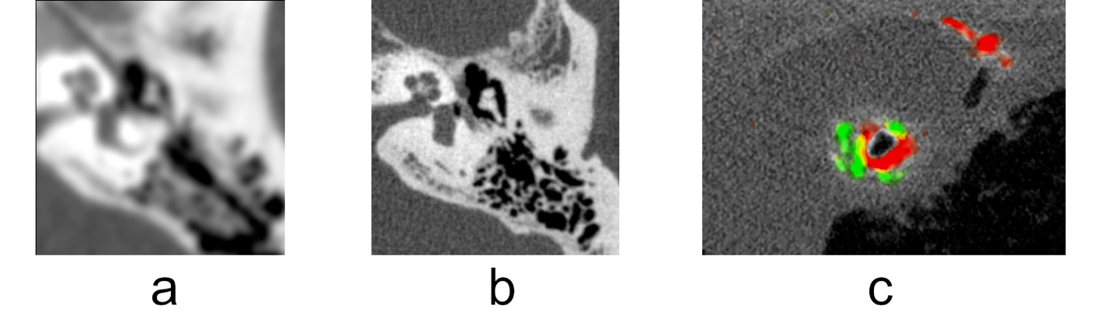
Figure 1 : (a) Inner ear of a human volunteer imaged with a current state-of-the-art CT scanner. (b) The same inner ear imaged with the photon-counting CT prototype. Showing much improved spatial resolution. (c) Detail of excised heart specimen from a deceased patient imaged with the photon-counting CT prototype. With the energy information available in the new detector, it is possible to separate calcium (green) can iodinated contrast agent (red).
The development of the new x-ray CT equipment has been carried out in close collaboration with a startup company, Prismatic Sensors AB, formed as a spin-off from the physics of medical imaging division. The close collaboration between the research division and the start-up company has allowed pursuing the dual goals of publishing important scientific results while at the same time developing the new technology towards the goal of a commercial product that can be widely adopted in the clinic. An important step towards this goal has been taken with the acquisition of Prismatic Sensors by GE Healthcare in December 2020 (impact case X).
In addition to the research into photon-counting computed tomography, the division has also developed a refractive lens for hard x-rays with an innovative manufacturing method based on UV lithography with a custom-made UV lens. Such a lens has been shown in simulations to be able to improve resolution drastically for single-photon emission computed tomography and enable a novel concept for phase-contrast mammography. In addition, a concept for an x-ray telescope based on this lens was published in Nature Astronomy.
Other research topics pursued within the group during the reporting period include the evaluation of a photon-counting spectral tomosynthesis system in collaboration with Philips Healthcare, a feasibility study of an x-ray fluorescence computed tomography system and investigation of CT dosimetry techniques.

d. Quality and quantity of contributions to the body of scientific knowledge
The department is one of the most prolific at KTH in terms of number of associated publications. It is very difficult to make a small but representative selection of papers to exemplify the impact and wide reach of the research performed at the department. Nevertheless, we here list a selection of papers. They are chosen in an attempt to represent the broad range of topics and to exemplify the high quality of publications emanating from the research performed at the department. Department-affiliated authors are indicated in bold font.
- ATLAS collaboration, “Observation of a new particle in the search for the Standard Model Higgs boson with the ATLAS detector at the LHC”, Physics Letters B 716 (2012) 1.
- W. Villanueva, C.T. Tran, and P. Kudinov, Coupled thermo-mechanical creep analysis for boiling water reactor pressure vessel lower head, Nuclear Engineering and Design 249 (2012) 146.
- T. Ohlsson, “Status of non-standard neutrino interactions”, Rep. Prog. Phys. 76 (2013) 044201.
- H.M. Revell, L.R. Yaraskavitch, J.D. Mason, K.A. Ross, H.M.L. Noad, H.A. Dabkowska, B.D. Gaulin, P. Henelius, J.B. Kycia, “Evidence of impurity and boundary effects on magnetic monopole dynamics in spin ice”, Nature Physics 9 (2013) 34.
- M. Persson, B. Huber, S. Karlsson, X. Liu, H. Chen, C. Xu, M. Yveborg, H. Bornefalk, M. Danielsson, “Energy-resolved CT imaging with a photon-counting silicon-strip detector”, Physics in medicine and biology 59 (2014) 6709.
- M. Blennow, S. Choubey, T. Ohlsson, D Pramanik, S.K. Raut, “A combined study of source, detector and matter non-standard neutrino interactions at DUNE”, Journal of High Energy Physics 8 (2016) 090.
- B.V. Svistunov, E.S. Babaev, N.V. Prokof'ev, “Superfluid states of matter”, (2015 Crc Press).
- P. Olsson, C.S. Becquart, C. Domain, “Ab initio threshold displacement energies in iron”, Materials Research Letters 4 (2016) 219.
- A.B. Belonoshko, T. Lukinov, J. Fu, J. Zhao, S. Davis, S. Simak, “Stabilization of body-centred-cubic iron under inner core conditions”, Nature Geoscience 10 (2017) 312.
- B. Cederwall, Ö Aktas, A Ertopak, R. Liotta, C. Qi, H. Liu, S. Matta, P. Subramanian et al, “Lifetime Measurements of Excited States in Pt-172 and the Variation of Quadrupole Transition Strength with Angular Momentum”, Physical Review Letters 121 (2018) 022502.
- M. Chauvin, H.-G. Florén, M. Friis, M. Jackson, T. Kamae, J. Kataoka, T. Kawano, M. Kiss, V. Mikhalev, T. Mizuno, N. Ohashi, T. Stana, H. Tajima, H. Takahashi, N. Uchida and M. Pearce (PoGO+ Collaboration), “Accretion geometry of the black-hole binary Cygnus X-1 from X-ray polarimetry”, Nature Astronomy 2 (2018) 652.
- C. Qi, R. Liotta, R. Wyss, “Recent developments in radioactive charged-particle emissions and related phenomena”, Progress in Particle and Nuclear Physics 105 (2019) 214.

Reflection on the department’s bibliometric performance

The full count of publications from the department over the period of assessment is show in table 1, as obtained from the KTH library.
DiVA publication type | 2012 | 2013 | 2014 | 2015 | 2016 | 2017 | 2018 | 2019 | Tot. | WoS cov. | Scopus cov.
Article, peer review | 249 | 215 | 219 | 287 | 354 | 317 | 337 | 288 | 2266 | 97,4% | 98,4%
Conf paper, peer review | 36 | 41 | 37 | 63 | 34 | 35 | 26 | 38 | 260 | 39,2% | 39,2%
Book, book chapter | 2 | 4 | 2 | 2 | 2 | 2 | 1 | 1 | 16 | 0,0% | 28,6%
Doctorate thesis | 14 | 6 | 8 | 7 | 10 | 5 | 12 | 7 | 69 | 0,0% | 0,0%
Licentiate thesis | 6 | 3 | 3 | 3 | 6 | 4 |  | 3 | 8 | 0,0% | 0,0%
Patent, approved | 1 | 4 | 3 | 2 | 3 | 3 | 12 | 16 | 46 | 0,0% | 0,0%
Table 1 – Peer reviewed publications, books, theses and patents in DIVA, total count

The number of peer reviewed articles lie stably at around 300 per year, of which around 100 are ATLAS publications. The numbers for 2012 to 2017 do not include publications by the groups from the former Theoretical Physics department. The average number of doctoral theses are about 9 per year. The publishing tradition varies significantly between the different research fields of the department. In large international collaborations, like the ATLAS experiment, publications are signed by the full collaboration, resulting in a large number of authors based on that all have to contribute their share to the work and that it is not possible to single out a subset of people that are responsible for achieving the published results. The outcome of KTH library author normalized fractions is that some of the most important publications within the field like the discovery of the Higgs boson, with at present close to 16000 citations, hardly count in the library statistics although KTH faculty have made essential contributions.
The author-fraction normalized number of peer reviewed publications per year during the evaluation period is shown in Figure 2. The fractionalized number of peer reviewed publications is roughly stable around 60 articles and 20 conference papers per year. The highly international character of the department is reflected in the co-publishing as visible in Figure 3. 85-90% is internationally co-published, while only between 5-10% are co-authored with Swedish non-universities.
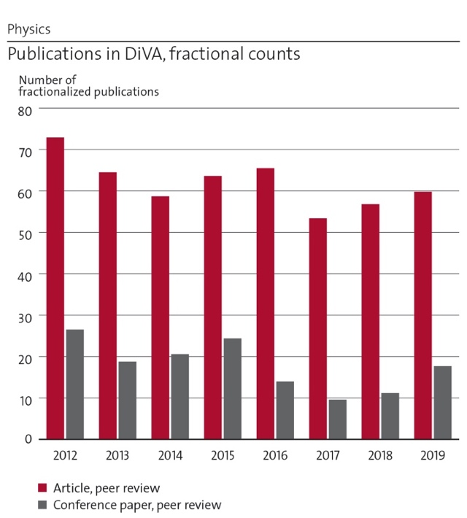 | 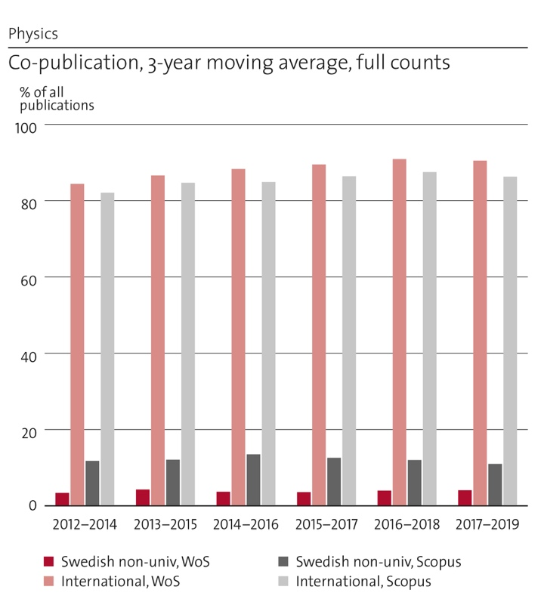
Figure 2 Peer reviewed publications in DiVA, fractional count, for the period of evaluation | Figure 3 International and Swedish non-university co-publications, full count (3-year moving window).

The publishing strategy varies between and also inside the divisions depending on the sub-field publishing tradition. While most publish predominantly by peer reviewed article, peer reviewed proceedings have important roles for some divisions. Proceedings are better covered by Scopus than WoS. The average publication impact factor obtained using Scopus is 1.33 as seen in Figure 4.

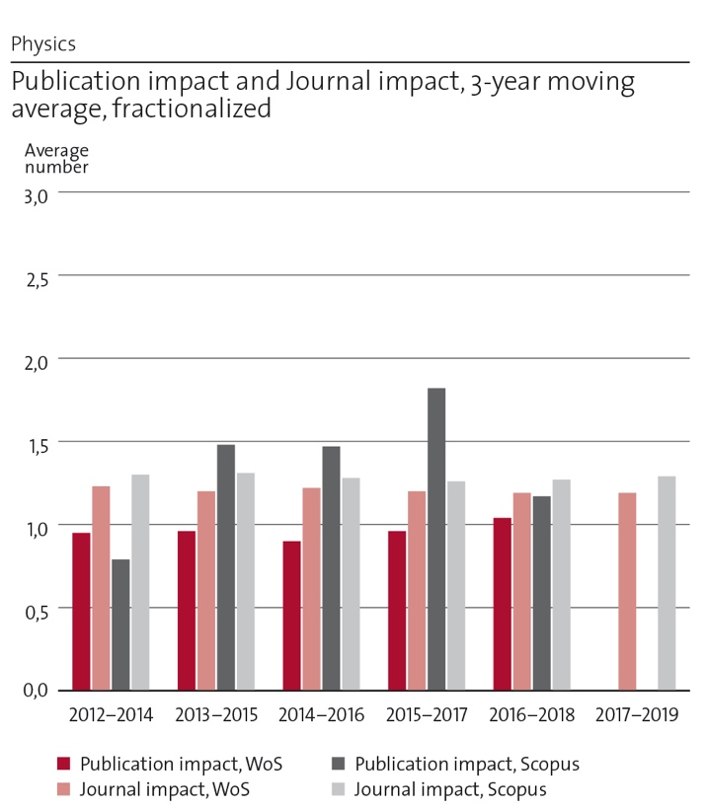 | Figure 4 Fractional publication and journal impact in 3-year moving windos.

e. Engagement in national and international research collaboration within academia and its outcomes.

The researchers and research groups at the department are all engaged in national and international collaborations. For certain divisions, the local environment at AlbaNova – with KTH Physics, KTH Applied Physics, Stockholm University Physics and Astronomy, and Nordita – is a major source of collaboration. For other divisions, most collaborations are found outside of KTH.
For Condensed Matter Theory, one main collaboration that is becoming more formalized is within quantum technology and the QTH (Quantum Technology Hub), which is an initiative to coordinate all quantum technology research at KTH. The plan is to launch the center in 2021. The mission is to bring together academia and industry to share and generate innovations in the expansive area of emerging quantum technology. The research is organized into four focus areas: 1. Sensing, nanofabrication, and communication. 2. Quantum computation. 3. Quantum phenomena in biomedical research. 4. Quantum Materials.
The division is involved in large Wallenberg projects on the topics of dynamic quantum matter (together with Nordita, Stockholm University and Uppsala), quantum sensors (together with KTH applied physics) and functional quasicrystals (together with Stockholm University, ESS, and Uppsala University), in addition to an industrial collaboration with Microsoft station Q on the topic of topological quantum computing. Further joint activities with the KTH math department include hosting a guest professor from Japan funded by the Wallenberg foundation. These activities demonstrate the broad activities of quantum technology, covering the range from fundamental theory to direct applications.
We further have long standing collaborations on various projects with individual researchers in universities around the world, including, but not limited to, Leeds University, Russian Academy of Science Novosibirsk, South Florida, Livermore National Lab, University of Massachusetts Amherst, MIT, Tokyo University, Oslo university, Copenhagen university, NTNU Trondheim, Tel Aviv University, and University of Grenoble
For Nuclear Engineering, the main collaborations are external to KTH, but there are many active and intense local collaborations as well, mostly with the Department of Chemistry and with the Department of Engineering Mechanics.
There has been intense collaboration with different departments at Chalmers university of Technology, EDF R&D in France, Uppsala University, Linköping University, CEA Saclay, CEA Cadarache, PSI Switzerland, Luleå Technical University, VTT Technical Research Centre of Finland and Lappenranta University of Technology, to mention a few. There is also a growing role for collaboration with national safety authority (SSM) and industry. Nuclear Engineering often work in large collaborative research projects, both nationally and internationally. On the national stage, the largest current projects are the SSF SAFETY (Development of accident tolerant fuels), which is coordinated by Chalmers and where Uppsala University is also engaged; and most notably the SSF SUNRISE centre which started in 2020, that focuses on design, safety analysis, development and testing of materials and fuels for the planned commission of a Swedish lead cooled research reactor.
Nuclear Engineering collaborations are extensive and multifaceted (see some examples below). A typical strategy for engagement is to use internal (KTH) and national (SSM, industry, other universities) collaboration in order to develop unique abilities and establish a strong research profile that helps to engage with international cooperation activities. Quite often Nuclear Engineering provides analytical support (model and code development) to large scale international experimental programs (e.g. under OECD). We expect that Nuclear Engineering will further develop its experimental infrastructure to provides unique data to national and international partners.
On the international level, the division has been leading and participating in numerous international projects, especially on the European scene. During the EC Framework program 7 (FP7), we were involved in the projects (“outcome” means “NE-KTH outcome”):
- GETMAT, led by KIT, Germany, from 2008-2013. Focus: FeCr- and similar alloys for GenIV reactors. Outcome: a range of seminal papers describing FeCr alloys stability and defect properties from first principles through multiscale modeling, establishing KTH as a leader in the nuclear materials modeling community. Has since been followed by MATISSE and M4F projects, see below.
- PELGRIMM, led by CEA, France, from 2012-2016. Focus: minor actinide bearing fuels for Gen-IV reactors. Outcome: a reference fuel design for minor actinide burning.
- MAXSIMA, led by SCK-CEN, Belgium, from 2012-2018. Focus: safety aspects of the MYRRHA reactor concept. Outcome: a Lead Fast Reactors (LFR) safety simulator for mobile platforms.
- MARISA, led by SCK-CEN, Belgium, from 2013-2016. Focus: preparation of a consortium for the MYRRHA reactor. Outcome: establishing a legal organisation of MYRRHA.
- ARCADIA, led by ICN, Romania, from 2013-2016. Focus: LFR development in Eastern Europe. Outcome: a training program for LFRs.
- ESNII+, led by CEA, France, from 2013-2017. Focus: Generation IV reactors in Europe. Outcome: training program for ELECTRA.
- MATISSE, led by KIT, Germany, from 2013-2017. Focus: materials for Generation IV reactors. Outcome: development and qualification of steels for lead-cooled reactors.
- EFDA (European Fusion Development Agreement), was a pan-European consortium over 1999-2013 in which KTH participated in modeling radiation damage in materials. This organisation was later transformed into EUROfusion, from 2014 onwards, and NE at KTH has been ramping up its participation and contribution significantly over the last 6 years. Focus: radiation damage in materials. Outcome: first principles methods that can be directly used to study radiation damage phenomena, instead of relying on classical approximation models.
Since 2014, the research and development instrument in Europe has changed to the 8th framework program (Horizon 2020). In this program we have been involved in the following projects:
- SOTERIA, led by EDF R&D, France, from 2015-2019. Focus: safe long term operation of current generation reactors. Outcome: modeling tools and paradigms for RPV steels and discovering how kinetics drive the formation of particular solute clusters that can cause embrittlement over long operation times.
- McSAFE: “High-Performance Monte Carlo Methods for SAFEty Demonstration - From Proof of Concept to realistic Safety Analysis and Industry-like Applications”, led by KIT, Germany, from 2017-2020. WP leader. Outcomes: time-dependent Monte Carlo methods and algorithms for massively parallel simulations.
- M4F, led by CIEMAT, Spain, from 2017-2021. Domain leader. Focus: models for radiation induced embrittlement in materials of common interest for both fusion and fission communities.
- GEMMA, led by ENEA, Italy, from 2017-2021. Focus: materials for GenIV reactor systems to maturity, ranging from advanced cladding to main structural steels.
- IL TROVATORE, led by SCK-CEN, Belgium, from 2017-2021. Focus: fast track development and qualification of cladding materials for accident tolerant fuels in light water reactors. The project notably includes extensive neutron irradiation campaigns.
- INSPYRE, led by CEA, France, from 2017-2021. Focus: mixed oxide fuels and associated materials (fuel-cladding interaction) for deployment in GenIV reactors.
The most recent EU projects include PATRICIA, PASCAL and McSAFER that address safety aspects of heavy metal cooled and small modular reactors respectively. For nuclear materials research, the new ENTENTE and NM-ORIENT H2020 projects have recently started.

For Nuclear Physics, the experimental group is mainly conducting research at large-scale international research infrastructures. The necessary detector instrumentation is due to its complexity typically also developed within the framework of large international collaborations where each university or research institute each contributes a different expertise. Experiments are proposed in strong competition to the international programme advisory committee (PAC) at the research infrastructure by teams of scientists led be a PI/spokesperson. Approved experiments are then carried out by teams (consisting of typically 10-50 participants from one to ten international research groups). It is normally the group of the PI that takes the main responsibility for running the experiment and takes the lead in the subsequent data analysis, dissemination of results etc. KTH has been active mainly at the following research infrastructures the last eight years:
- GANIL – The French national heavy ion accelerator complex (Caen)
- RIKEN Radioactive Ion Beam Factory (RIBF), Japan
- University of Jyväskylä cyclotron accelerator laboratory, Finland
- National Superconducting Cyclotron Laboratory, Michigan Sate University, USA
We are also heavily involved in developing detector instrumentation for:
- FAIR – Facility for Antiproton and Ion Research, Darmstadt, Germany.
- for which we are mainly involved in the DESPEC germanium detector array DEGAS and AGATA. While DEGAS is designed for decay spectroscopy of exotic nuclei AGATA is designed to carry out in-flight gamma-ray spectroscopy of relativistic nuclei. AGATA is constructed in phases and deployed for physics campaigns at different European accelerator facilities like GANIL and LNL Legnaro before the full FAIR facility is ready for experiments in 2026. In the meantime, the FAIR-0 physics campaign has started 2020 with Cederwall as co-P.I. for one out of three NUSTAR experiments.
The main external experimental collaborations are with:
- University of Liverpool, UK; University of Padova, Italy; Legnaro National laboratory, Italy, University of Jyväskylä, Finland; GSI, Darmstadt, Germany; Darmstadt University, Germany; Argonne National Laboratory, USA; Lawrence Berkeley Laboratory, USA; University of Paris Sud, Orsay, France; CEA Saclay, France; Uppsala University; University of Warsaw; Osaka University, Japan; University of Tokyo, Japan.
The nuclear safeguards and security team carries out most of the research in-house but also has important external collaborations with SSM, JRC Ispra Italy, JRC Geel, Belgium and UC Berkeley USA as well as many other groups within the framework of the European Safeguards Research and Development Association. The microdosimetry team collaborates with SSM.
The nuclear theory team has a strong collaboration with international experts in the field. We would in particular like to mention the collaboration with the University of Tokyo code from 2017 which became possible thanks to a funding from KTH through its strategic partnership with University of Tokyo. We work together on large-scale shell model calculations on intermediate nuclei and on the development of new shell model algorithms. A large-scale shell model code with a novel seniority truncation has been developed. We have also extended our study to two-neutrino/neutrioless double-beta decay studies together with the Tokyo group.

For Nuclear Power Safety, the national collaboration with Chalmers University of Technology has been established in the SSM project TSO-DSA for design-basis-accident safety analysis of Swedish NPPs, the VR project GENIUS dedicated to research for lead-cooled reactors and the series of VR projects supporting Swedish-French collaboration on the development of ASTRID SFR and Jules Horowitz research reactor (MTR). NPS also has a close collaboration with Chalmers University of Technology within the APRI program.
NPS has strong international collaborations with many organizations from different countries, such as CEA, IRSN and EDF in France; KIT and GRS in Germany; PSI and ENSI in Switzerland; ANL, SNL, NCSU and NRC in USA; NRA, JAEA, CLADS and University of Tokyo in Japan; KAIST, POSTECH and KAERI in Korea; SCK-CEN in Belgium; UJV in Czech Republic; Fortum and VTT in Finland; EK in Hungary; NRG in Netherlands; OECL in Canada; KI, NITI and LETI in Russia; CNPE and CIAE in China. These collaborations were created under coordination of EU/OECD/IAEA projects, SARNET network of excellence and NUGENIA association in EU for reactor safety research. Recently NPS together with other six large EU nuclear research centers became a part of Pan-European Laboratory of Severe Accident Research created in the EU project SAFEST. Some examples of specific collaboration areas and research outcomes are given in the following table.
Partner | Area of collaboration | Main outcomes
Karlsruhe Institute of Technology (KIT), Germany | Melt natural convection experiments  Experiments on melt interaction with concrete  Degradation of overheated reactor core and its quenching | Concept of SIMECO-2 facility developed at KTH  MOCKA experiments carried out at KIT with Swedish types of reactor concretes  QUENCH-SSM tests carried out at KIT with BWR bundle mock-up
Le Commissariat à l’énergie atomique et aux énergies alternatives (CEA), France | SA research for Gen IV systems  Sodium fast reactor ASTRID  FCI and steam explosion | PIRT and research roadmap  Several research projects at KTH complimenting ASTRID reactor safety  MISTEE experiments at KTH with single molten drops to study steam explosion and Zr oxidation during FCI
Institut de Radioprotection et de Sûreté Nucléaire (IRSN), France | Thermodynamic modelling of corium  Modelling of steam explosion | NUCLEA TD database used at KTH in safety analyses and further developed  Several MC3D code developments at IRSN and applications at KTH
EU Join Research Centre (JRC), Karlsruhe | Phase diagrams and physical chemistry of corium | Laser flash melting/crystallization experiments with BWR specific compositions carried out at JRC for SSM, Sweden
Nuclear Regulatory Authority (NRA), Japan | Ex-vessel corium coolability | DEFOR, PULIMS and REMCOD tests carried out at KTH for model development at NRA
Swiss Federal Nuclear Safety Inspectorate (ENSI), Switzerland | APRI national program in Sweden | Research results of the program
Collaborative Laboratories for Advanced Decommissioning Science (CLADS), Japan | Severe accident research roadmap between Japan and EU  Fukushima-related OECD projects | Roadmap published  Best estimate accident analyses of unit 1 and various contributions in plant decommissioning
Korea Atomic Energy Research Institute (KAERI), Korea | Behaviour of RPV bottom penetration during late phase of severe accident | Experiments carried out at KAERI on penetration failure with chemically prototypic corium melt
Pohang University of Science and Technology (POSTECH), Korea | Two phase flows | Educational course developed at KTH
Argonne National Laboratory (ANL), US | Melt spreading under the water | Experiments with simulant melts to be carried out at KTH to support ROSAU OECD tests with prototypic corium at ANL

Members of the Particle and Astroparticle Physics Division, play a leading role in scientific collaborations, both internationally and on the national and local environment level:
- The ATLAS project at CERN:
- Physics studies are focused on Higgs decay studies and the search for beyond standard model particles.
- The HGTD upgrade where KTH is the lead group for the development as luminometer.
- The di-Higgs network between KTH, Lund, Uppsala and Stockholm universities to promote collaboration between experimentalists and theorists.
- The Oskar Klein Centre (OKC) – recently named as one the top three Linnaeus Centres of Excellence in Natural Sciences after an international review commissioned by the Swedish Research Council. A member of the Division was co-founder
- The KTH Space Center, which provides an interdisciplinary platform at KTH for space-related activities, including the creation of a space technology laboratory infrastructure.
- The International Space Station and the JEM-EUSO misison.
- The X-ray polarimetry group collaborates internationally, e.g:
- PoGOLite/PoGO+ Collaboration. (~2004-2019). KTH is PI since 2009 for a Collaboration which has included members from Sweden, Japan, USA, and Russia.
- XL-Calibur collaboration. (2019-) KTH is Co-I. Involves groups from KTH, USA, and Japan.
- The SPHiNX mission (2016-2019) was a collaboration within the KTH Space Centre including collaborators from Japan, which proposed a national satellite for GRB polarimetry. KTH was PI.
- The XIPE mission for X-ray polarimetry. Proposed to the European Space Agency as a medium-class (M4) mission. KTH lead the working group which studied measurement backgrounds, and was a member of the mission core team.
- The Fermi Gamma-ray Space Telescope Collaboration. KTH has the Swedish PI of the international collaboration of the Large Area Telescope, lead from Stanford University and he is member of the Senior Scientist Advisory Board. The Swedish effort includes Stockholm University and KTH. We are also active as members of the Gamma-ray Bursts Monitor science group, lead from Hunstville university, Alabama, USA.
- On the theory side, the group is involved in the long baseline neutrino collaborations: ESSnuSB design study, DUNE, T2HK and INO; and the European Networks: Invisibles, Elusives and Invisibles+, as well as regular collaborations with the international high-energy physics theory community.

The Physics of medical imaging division has a long-standing collaboration with the Karolinska Institute and Karolinska University hospital. This has resulted in a jointly supervised PhD thesis in clinical medical physics and several joint publications with medical researchers who contribute with their expertise in the evaluation of new medical imaging technologies developed ad KTH. This collaboration has recently been deepened through the formation of MedTechLabs, a joint research center that brings together engineering researchers from KTH and medical researchers and practitioners from Karolinska in order to develop new technologies to address relevant clinical needs. This collaboration is expected to be intensified in the near future as a prototype photon-counting scanner resulting from the research in the division is currently being installed at the Karolinska premises, giving ample opportunity to joint studies of the clinical applications of the new technology. In another long-standing collaboration, the division is working together with the Department of Electrical Engineering (ISY) at Linköping University in in order to develop readout electronics for novel x-ray detectors, resulting in a cutting-edge application-specific integrated circuit for detector readout used in the photon-counting prototype CT as well as publications exploring design options for a future readout circuit currently under development.
A particularly close collaboration has been developed with the startup company Prismatic Sensors AB, founded by members of the division. By developing a closely-knit team encompassing both the research group and the startup company, it has been possible to combine the best of the academic and industrial worlds, leveraging the research competence and networks available at KTH and the development experience and funding available to a company to achieve both important science and a potentially commercializable product. An informal collaboration is still active after the acquisition of Prismatic Sensors AB by GE healthcare in 2020 and this is expected to become formalized in the near future. Other industrial collaborations include a past collaboration with Philips Healthcare around an industrial PhD project in the field of photon-counting mammography, and examination of MSc theses localized at medical technology companies in the Stockholm region.
With regards to international collaboration, the division has close connections with the department of radiology at Stanford University, CA, USA, with a fruitful exchange of expertise in x-ray detector simulation and performance modeling. The connections to Stanford University and General Electric have also been strengthened by the recruitment of Mats Persson as assistant professor after his postdoctoral tenure at Stanford University and GE Research Center in Niskayuna, NY. Other international collaborations during the reporting period are a clinical evaluation of novel mammography equipment with Cambridge Biomedical Research Centre, UK, and Radboud University Medical Centre, NL; detector modeling together with the US Food and Drug Administration and comparison of x-ray readout circuit designs with the department of radiological sciences at UCLA, CA, USA.

f. Follow up from previous evaluations
In the last RAE, of 2012, the different divisions that make up the Department were evaluated in three different panels instead of a common one, as it will be in the RAE of 2021. Therefore, we list the follow up of the previous evaluation per division:

Condensed Matter Theory
The main development since last RAE is the merger of the Physics and Theoretical physics departments. The merger was mainly motivated by the too large number of physics departments and divisions where three departments and one division were merged into two departments. The gain of merging the Physics and Theoretical physics departments is building a bigger and stronger unit, which can lead to closer collaboration between the department divisions. The condensed matter theory division has strengthened its work on quantum matter broadening the work on strongly correlated matter to include various topological phases of matter.

Nuclear Engineering
NE is a new division since last RAE in 2012, formed by merging Reactor Physics and Reactor Technology during the department merger in 2017-2018. This was in part a suggestion from the last RAE and has led to improved synergy between the researchers in the division.
RAE 2012 also suggested that “closer integration is recommended into the overall energy community”. NE is an active member of the KTH Energy Platform initiative and is establishing new links with KTH groups that are addressing issues of sustainable transformation of the energy industry.
A limited mobility of research staff between academia and industry was indicated by RAE 2012. Currently NE has two affiliated faculty members from nuclear industry.
Generation IV research was deemed essential in RAE 2012, while acknowledging that it will require “substantial focusing of resources as well as partnering across KTH, nationally and internationally”. NE is very active in development of lead cooled fast reactor technology and is collaborating with major EU partners in several Euratom projects.

Nuclear Physics
The previous RAE pointed out that the team was rather small and the impact on technology is rather long term. The Nuclear Physics Division has grown by approximately 50% since 2012 and has now more than 20 members. The major contributions to this increase are due to two additional senior staff members in the nuclear safeguards and security team and a larger number of PhD students and postdocs. Significant progress has been made in applied nuclear physics studies and in technology development in particular within nuclear safeguards.

Nuclear Power Safety
Addressing the comment of RAE-2012: “The UoA seems to be in some way isolated at KTH and a closer integration is recommended into the overall energy community for example through the KTH Energy Platform initiative”, NPS division enforced internal collaborations at KTH coordinated by various platforms. Some recent examples are:
- Collaborative project with the Division of Wood Chemistry and Pulp Technology (WCPT) entitled “High temperature carbonization of wood-derived polymers for sustainable energy applications” in frames of the Call ”Energy Pairs 2020”;
- Collaboration with the Division of Laser Optics on development of Fiber Bragg Grating optical sensors for nuclear industry, safety related systems and potentially other industrial applications;
- Measurements of contact angles between Sn/Bi eutectic melt and different substrate materials in the Department of Materials Science and Engineering planned for the nearest future with NPS participation
- Collaboration on mechanical analyses of reactor pressure vessels with the Department of Mechanics and on high performance computing of turbulent convection with PDC at KTH.
The internal collaborations are economically limited by the low fraction of internal funding . More than 80% of the division budget comes from the external sources; consequently, NPS has more external collaborations than internal ones.

Particle and Astroparticle Physics
The previous RAE concluded that “The unit is doing work at the very forefront and is in a leading position in several different areas”. A concern was however raised that “the research environment is fragile, because the teams in experimental physics are quite small relative to peer institutions”. In the merger between the Physics and the Theoretical Physics departments, the theoretical particle physics group joined the division giving a stronger environment which now spans both experiment and theory which has already resulted in common funding requests. To further strengthen the division, two faculty in astrophysics and two permanent researchers, one in experimental particle physics and one in astrophysics, have been recruited. The researchers are external funded.

Physics of Medical Imaging
In RAE 2012, the Physics of medical imaging division was evaluated as part of the Applied Physics and Medical Imaging UoA and received a very positive evaluation. Therefore, the focus of this division has been to further develop the strengths identified in the previous assessment. The combination of scientific excellence with entrepreneurial spirit highlighted in RAE 2012 has been further developed by a close collaboration with the startup company Prismatic Sensors AB founded as a spin-off from the group and resulted in the development of a prototype photon-counting CT scanner and 69 granted patents in different countries during the evaluation period. As the importance of providing opportunities to young researchers was stressed in the previous evaluation, the division has been able to secure the external funding that enabled the recruitment of Mats Persson as assistant professor in 2020.

I.3. Viability

a. Funding; internal and external
The department has a total turnover of about 130 MSEK, whereof the research finance is about 105 MSEK. About 130 staff members work at the department, not counting emeriti and diploma students. We have an excellent track record in attracting external funding, as shown by the fraction of external vs internal funding, of about 65 % external, which is what allows for financing of PhD students, postdocs and researchers, as well as necessary co-financing of the faculty. The balance of internal vs external funding has been fairly stable with a ratio of roughly 1 to 2 over the last years. The main external contributors are currently the Swedish Research Council (VR), EU, the Swedish Foundation for Strategic Resesarch (SSF), the Swedish Nuclear Technology Centre (SKC), the Swedish Radiation Safety Authority (SSM), the Göran Gustsfsson foundation, the Knut and Alice Wallenberg Foundation (KAW) and the Swedish Space Board (Rymdstyrelsen).
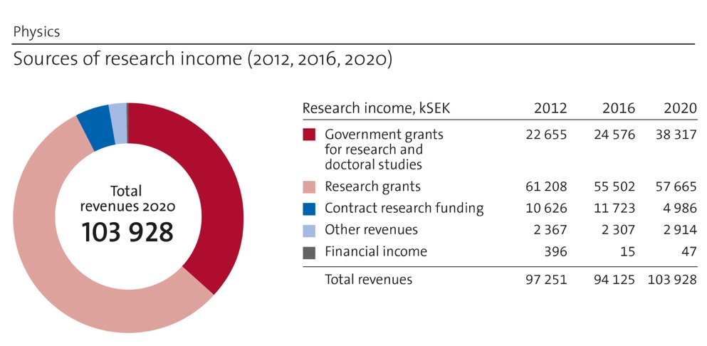 | Figure 5. Sources of income 2012, 2016 and 2020. The numbers from 2012 and 2016 do not include the groups from the former Theoretical Physics Department.

When teaching activity and support is included in the finances, the total external vs internal funding levels are close to 50/50. The ratio of internal to external support is strongly varying between the research divisions. From 80/20 (NPS) external/internal to 40/60 (NP) at the extremes. Handling this large variation within the Department is a challenge.
A clear issue with the current funding model is that not even faculty salaries are fully covered by internal faculty funds plus teaching. All faculty have to actively work to find external sources of funding. Other staff is funded almost exclusively by external sources. The strong dependence on external funding prevents efficient and reliable long-term strategic planning. It is particularly difficult to find sustainable funding for instrumentation, laboratories and technical staff.
Over the last years, the growth of the department (aside from the growth due to the merger in 2018) has almost exclusively come through external funding. Notable exceptions are three called professors (Ayse Atac, Christer Fuglesang and Sandhya Choubey) whose inclusions in the faculty have been partially supported centrally by increased levels of faculty funding.

b. Academic culture
It is important to stress that the department has many academic cultures; not necessarily partitioned the same way as the research divisions. This is first and foremost a strength in terms of diversity, but unavoidably leads to some difficulties in quantifying certain parameters, such as impact, bibliometry, publication strategies, et cetera. The spread in academic culture is a consequence of the width of the subject fields that make up the department. One example is experimental particle physics, which has a very different academic culture, especially as regards publication tradition, compared to most others in the department.
The working culture in the department is very international. The general working language in all groups is English. All groups have regular seminars and meetings, either at division level or smaller research group level. The department is part of the organisation in the AlbaNova environment of weekly high-profile colloquia in physics that often boast truly world-leading experts, including the occasional Nobel laureate.
PhD students follow journal clubs outside of their curriculum. There are good facilities at division level for spontaneous meetings and discussions in the corridors and local rooms for coffe and lunch breaks. For the department as a whole this is less well organized since the different divisions are located in different parts of the main AlbaNova building. A planned post-covid development to enhance interactions between groups and departments in AlbaNova has been initiated by the new AlbaNova Director, Prof Mats Wallin (who is a faculty member in the Condensed Matter Theory division). For the future Colloquia, there will be well-organized “fika” before each event aiming to promote social and academic interactions within AlbaNova.
During the Corona crisis, the meeting culture has changed drastically in the sense that only a small part of the staff works on-site while most work from home, since March 2020. The meeting culture has inevitably changed during this time; generally leading to more planned meetings and almost eliminating spontaneous ones.
All staff regularly participate in international workshops and conferences, and the department organises a few major conference or workshops per year. Remote participation has skyrocketed during the Corona crisis and we assume it will continue to be frequently used in the future as well, to avoid unnecessary travel. Nevertheless, physical participation in conferences and workshops is such an important part of the academic culture and creative process that we do not envisage, nor plan for, a decrease in such participation in the coming years. We do plan for a strategic use of online meeting tools to minimize travel, carbon footprint and efficient use of working time where it does not impact the quality of work. We will capitalize from the digitalization boom that has been enforced during the pandemic and the infrastructure that has been necessary to acquire. We can now actively promote the use of online meeting tools for international project progress meetings and other short engagements that would otherwise require air travel, where the benefit of social and spontaneous meetings are less important than at conferences.

c. Current faculty situation
The staff at the department in 2012, 2016 and 2020 divided into categories is shown in Figure 6.
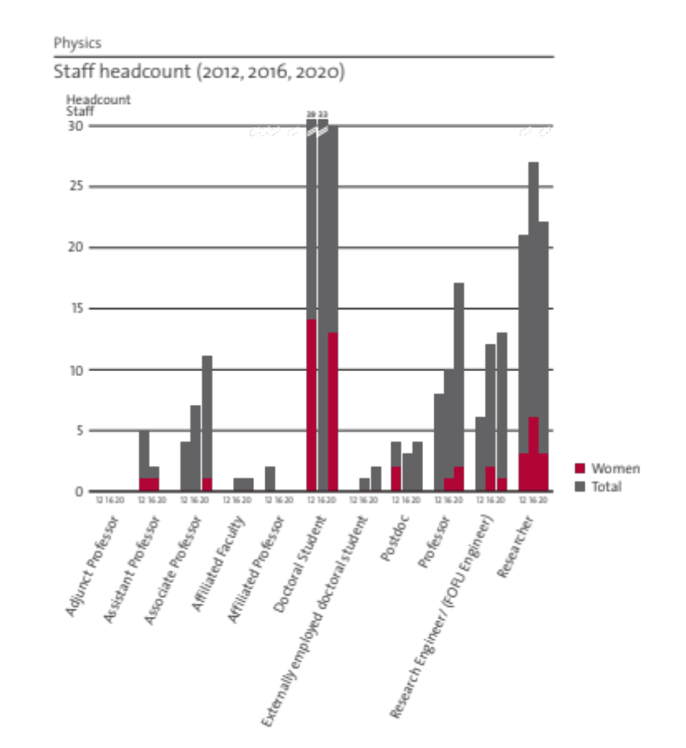
Figure 6 Number of employed staff in different categories in 2012, 2016 and 2020. Members of the former Theoretical Physics Department are not included n 2012 and 2016 data. The PhD student and postdoc statistics for 2016 has failed to split into gender. The true number of female PhD would be around 13 women. Furthermore, scholarship holders (postdoc and PhD) are not included.
The current number of faculty in the different research divisions is detailed in the table below. Numbers within parenthesis indicate how many, out of the total, are female.
Total (female) | CMT | NE | NP | NPS | PAP | PMI
Professor | 4 | 3 | 2 (1) | 1 | 6 (1) | 1
Associate professor | 3 | 2 | 2 | 1 | 3 (1) | 0
Assistant professor | 0 | 0 | 0 | 0 | 0 | 1
Affiliated faculty | 0 | 2 (1) | 0 | 0 | 0 | 0
Emeriti | 7 | 1 | 3 | 3 | 5 (1) | 0

The most striking issue is the clear gender imbalance, with only 10% females in the faculty (at the PhD and postdoc level the fraction is near 30%). This is clearly problematic for the department. The overall trend over time is a slow improvement in gender balance across the department as a whole. In the management group, there has not been any females in the last years, except for the head of the physics administration and PhD student representatives. This was changed in 2020 with the appointment of associate professor Josefin Larsson as Deputy Head of the department
The larger fraction of professors over associate- and assistant professors is a natural consequence of the KTH tenure track system with its promotion regulations and procedures. The major part of a normal faculty career will be spent as professor, as long as the faculty is sufficiently active in all areas needed to fulfill the promotion criteria. A central strategy at the department is to ensure that all faculty are clearly aware of the criteria and what is expected of them before they can apply for a promotion. This has been recently enacted by the establishment of a procedure, , started at the department and now implemented across the school, with a local committee that receives a statement of intent from a faculty member seeking promotion. The local committee interviews that faculty member well in advance of the formal KTH process, discusses the relevant promotion criteria and how they match the staff member’s experiences. This system allows faculty to be reviewed informally to obtain useful feedback in advance of their application for promotion or receive recommendations on what aspects to develop and strengthen for a future application.
Lastly, one can note that the number of faculty positions in the different research groups has stronger variation than the sizes of the groups. Generally, the more applied research groups have more staff in the permanent Researcher category, which is fully externally funded.
The number of permanent researchers, engineers and technicians in the department is quite significant (28), whereof 1 female. These contribute with extremely important specialist competences. Some of the research staff also contribute significantly to teaching. One concern regarding the non-faculty research staff is the lack of clear career paths at KTH. Such possibilities would be welcome changes of the KTH policy.

d. Recruitment strategies
The department recently recruited an assistant professor in physics of medical imaging financed by MedTechLabs, and has over the period 2012-2020 recruited 5 faculty members at the assistant professor level in condensed matter theory, nuclear engineering, nuclear physics, particle physics and astroparticle physics, as well as three professors that have been called to their positions by the president of KTH.
One main issue of concern regarding recruitment is the government imposed rule of a seniority limitation of not more than 5 years from PhD for recruitment of assistant professors. In many fields it is normal to do 5 years of postdoc before starting to look for faculty positions, and for KTH it is then too late. A potential solution for KTH, to circumvent the central problem with this rule, would be to allow open rank recruitment, as is often done internationally in leading institutes. Then, recruitment focused on potential rather than achievement would remove the most troublesome issue.
There is an ongoing faculty renewal process that has been initiated during 2019 in order to set a department wide strategy for recruitment, enabled by three upcoming retirements (1 in CMT, 1 in NE, 1 in PAP) during 2022. The faculty renewal process has as a central goal to attract the best possible candidates with international advertisements and broad profiles – and with active search committees tasked with attempting to ensure a gender balance-improved pool of applicants. The department has good hope that at least two out of three new appointments will be female, thus potentially improving the gender balance in the faculty by another 7-10%. All future retirements have been mapped out and informs the recruitment strategy.
Apart from retirements, it is very difficult to have an aggressive and efficient recruitment strategy at KTH given the low level of internal faculty funding. However, inviting excellent faculty from other universities into guest professorships has proven to be an effective means to attract excellent female faculty directly into the professor level.
Apart from faculty recruitment, it is proving more and more difficult to recruit PhD students and postdocs. Not because of poor candidate availability, but because of the rapidly increasing salary cost of PhD students notably. Even with a successful grant from e.g. VR, it is far from certain that a PI is able to recruit a student, since part of the grant is often needed (and expected) to cover part of the PI salary.
The department would welcome central initiatives to bring forth internal funding for PhD students; possibly in a similar vein as the excellence programme that existed many years ago. It would be important for successful competition on the international arena where PhD students often come to supervisors with their own grants.

e. Infrastructure and facilities
The AlbaNova in-house mechanical workshop is a common facility used by the experimental groups within the department.

The CMT division runs a medium size computer cluster with about 500 CPU cores locally which gives valuable quick and easy access to computer resources. To stay competitive, we plan to keep this cluster useful by required additions and updates.
Nuclear Engineering has two main laboratories, detailed below, and rely otherwise mostly on high-performance computations with support from large national and international facilities (PRACE, SNIC, CINECA, etc). The division has yearly allocations of about 70 million core-hours used for modelling and simulation.
The experimental facilities are:
- HWAT loop: high-pressure water test loop for PWR, BWR and SCWR thermal-hydraulic investigations with pressure range up to 25 MPa, total flow 1 kg/s and total power 1 MW.
- LOFAT: low-pressure fuel-assembly test facility for detailed laser-doppler measurements of turbulent flow structure in nuclear fuel assemblies with spacer grids.
- Advanced nuclear fuel laboratory: built from scratch and continuously developed since 2009. Furnaces for synthesis and for sintering, glove boxes, gas analysis, element analyzer, particle size analyser. Capacity for manufacture of low-activity actinide compound powders and pellets. Characterization using optical and electron microscopy, TGA, XRD, etc in collaboration with Materials science and with Surface and corrosion science.
- SUNRISE laboratory: Laboratory under construction for the SUNRISE centre, with focus on large scale lead fast reactor facilities for component and materials testing, as well as heavy liquid metal fluid dynamics experiments.

Nuclear physics is a partner in FAIR – Facility for Antiproton and Ion Research is an ESFRI international flagship project under construction in Darmstadt, Germany with Sweden as shareholder (together with Finland) via the Swedish Research Council (VR). The construction budget is around 3 billion € with commissioning planned for 2025. The KTH Nuclear Physics group is partner of the Swedish FAIR consortium with a dedicated funding from VR for detector systems in the nuclear structure, astrophysics and reactions (NUSTAR) pillar for FAIR of around 11 MSEK.
AGATA – the Advanced GAmma Tracking Array2 is a joint European project to build the next generation gamma-ray spectrometer for experiments at the leading European nuclear physics facilities, with an aim towards deployment at FAIR starting around 2026. It is designated a research infrastructure of national interest by the Swedish Research Council.

The infrastructure and research facilities at NPS are generally composed of the SWECOR platform with severe accident research facilities, the TALL loop for thermal-hydraulic investigation of heavy liquid metal (HLM) coolant, and facilities for basic research on multi-phase flow as well as a machining workshop. The examples of specific facilities are:
- CONMT infrastructure: A reinforced concrete containment (4×4×4 m³) designed to accommodate high-temperature high-pressure energetic experiments in severe accident study.
- INDUC infrastructure: High- and middle-frequency induction furnaces employed for melt generations of various simulants of corium in melt-coolant interaction and coolability experiments (e.g., DEFOR and PULiMS).
- MISTEE facility: An X-ray radiation-shielding room (3×6×3 m³) and high-speed (up to 100 000 fps) visualization system with simultaneous X-ray radiography and photography used to investigate opaque multi-phase flows (e.g. liquid metals), and energetic micro-interactions in steam explosion.
- TALL facility: A seven meter tall heavy liquid metal (HLM) loop to study the thermal-hydraulics in HLM- cooled systems (e.g. accelerator-driven system for transmutation and lead-cooled fast reactors).
- SIMECO-2 facility: A scaled down lower head of reactor vessel in the dimensions of internal diameter × height × width = 1×0.5×0.12 m³ to study turbulent heat transfer of stratified melt pools.
- MrsPOD facility: A vertical tube furnace with a 1300 mm x 120 mm cylindrical quartz tube and 3 heating zones to investigate melt penetration, solidification and remelting, and relocation in a multi-component and multiphase porous debris bed.
- SPAYCOR facility: An electrically heated downward-facing specimen of 120mm x 80mm area cooled by the spraying of a 3x2 array nozzle assembly.
- MICBO facility: A well-instrumented platform designed to study thermal-hydraulics of boiling phenomenon at micro scales.

Infrastructures used by the Particle and Astroparticle Physics division are:
- CERN with the Large Hadron Collider and the ATLAS experiment.
- The Fermi and Swift Space Telescopes
- The group has been successful at obtaining observation time at several telescopes: Hubble and Very Large Telescope (visible) and Chandra, NuSTAR and XMM-Newton (X-ray)
- The Space Technology Lab of the KTH Space Centre
- ESSnuSB, DUNE, and T2HK for neutrino oscillation research

Physics of Medical Imaging, has access to experimental CT scanners and electronic

I.4. Strategies and organization

a. Goals for development 5–10 years ahead
We aim to be an internationally leading centre for physics research and to attract excellent researchers and teachers in our upcoming recruitments. We aim for high levels of impact in research, education and outreach, and for actively aiding the development of a sustainable society.
Department wide strategies are focused on central issues such as teaching, faculty funding and working conditions, gender balance, equal treatment, working environment, infrastructure and outreach actions. The goal is to steadily improve in all areas. The immediate focus is gender balance and the upcoming recruitment of three new faculty members offers a perfect opportunity to improve this aspect.
Our core activities are to provide excellent teaching at all levels; to perform world-leading research in physics, and to communicate with the public and with society. Our most important goal for the coming 5-10 years is to keep developing our strengths and to work to eliminate any troublesome issues in these three pillars. Feedback from this RAE will be a useful tool to help with this process.
A An important but currently unreachable goal for the department is to fully cover faculty salaries with internal funding.
Infrastructure is an important aspect which merits attention at department level, and to bring this aspect to the attention of KTH centrally. There is a central KTH initiative that supports certain infrastructures but this is focused on laboratories that are wider rather than focused and can thus attract many users from across KTH. The specialist laboratories in the department are generally not such facilities but are nevertheless essential tools in order for us to be competitive internationally. Even though the department experimental activities in basic research are mostly carried out at large international facilities, a fair share of the experimental research is conducted in the specialist laboratories in the department and they need constant support, both in terms of infrastructure and personnel investments, to stay active and develop the state of the art. We aim to work extensively at creating synergies in technical work between laboratories to capitalize on the local expertise.
All research groups aim to extend and enhance collaborations with their strategic partners. We aim to continue our good work and continue pushing boundaries. We always strive to improve the quality of education and more recently to enhance the digitalisation aspects. Bounds and leaps in this arena have been taken in the last year due to the forced urgency of the Corona crisis. We aim to capitalize fully on these developments. In our applied research fields, we aim to start more spin-off companies and bring these to market to enhance our societal impact and public outreach. KTH Innovation is a central resource that we will utilize more. We aim to work at the department to affect the establishment of simple guidelines to avoid bias and conflicts of interest that may arise.
We hope KTH can work centrally to simplify legal procedures and contract formulations, because this is an aspect of our daily life that is consuming too much time and detracting from our core activities. It is, however, difficult to directly affect at department level, and thus needs lobbying towards school and central level. Recent progress in streamlining contract procedures is promising but highlights the importance of having the right people in the right place, and this is a vulnerability that should be possible to avoid with better general procedures.

The department aims in the near future to enhance multidisciplinary collaborations in areas of strategic interest for KTH, nationally and internationally. Quantum technology, embodied in the formation and activities of the Quantum Technology Hub (QTH), is a cross-cutting collaborative effort in this direction, described above. The KTH Space centre hosted by the department connects many research groups across KTH and has close links to society and industry. The development of a novel initiative to connect nuclear and bio-chemical climate technologies in order to fast-track the development of a carbon-neutral society, described in more detail in section 2b under Nuclear Engineering, is another. Several collaborations in machine learning, use of artificial intelligence and deep learning are planned and ongoing, in particular with the Department of Mathematics, but also with Computer Science and with many external actors.

b. Congruence with university-level goals for research as set out in “A leading KTH - Development Plan 2018-23” and with the school(s) development plan(s) respectively

There is general good agreement between the department’s development and the university-level goals.
- The department works in both applied and basic research – and has many synergies and ongoing cross-fertilizations.
- The department actively works in an international context, has been leading digitalization in both learning and research with early development of digital teaching and examination in e.g. the Nuclear Energy Engineering master program and several ground-breaking research applications of artificial intelligence and machine learning. A majority of the research is directed towards the development of a sustainable future society, in line with with the UN sustainable development goals. We are actively promoting equal opportunity and has been developing routines together with HR experts to ascertain that the recruitment process is fair and unbiased.
- The research is carried out using state of the art infrastructure facilities, internationally as well as locally.
- Staff in or near management positions are given opportunity to be trained in professional leadership through a number of courses.
- The department has dedicated teaching staff and continues to strive for excellence. The two Master programs coordinated by the department received the highest ranking in the latest evaluation by the national University Chancellor Office. Experimental teaching has been further developed since 2012 with a clear strategy in mind to prepare students for practical work. This is showcased in a course in Applied Modern Physics where a range of new teaching lab exercises were designed and in the construction of a Makerspace together with Applied Physics. Research projects in the educational programs (at Bachelor, Master and PhD levels) are all using and developing research infrastructure, experimental as well as computational.
- Teachers and staff from KTH should be visible in the social discourse according to the Development Plan. The department is very visible in media, both in Sweden and internationally. Research is in significant parts funded by other Swedish government agencies, such as SSM and Rymdstyrelsen, exemplifying that the research we conduct has high relevance to society.
- The department has a fair share of cross-fertilization with industry, through affiliation of industrial researchers, hiring staff directly from industry, and starting spin-off companies.
- The department has a large share of its external funding from the EU, exemplifying the large degree of internationalization. We collaborate in many large international organisations, such as CERN, IAEA, OECD, etc.

c. Leadership structure and collegial structure
The department is led by a management group consisting of the Head and Deputy Head, each division head, the director of the doctoral program, the director of undergraduate education, the head of the physics administration and two PhD student representatives. The management group meets monthly under normal circumstances. The responsibility includes general strategy at department level, including faculty renewal and department economy, discussion and dissemination, as well as discussing and supporting the decisions by the Head. A subsection of the management group, consisting of the head, vice head, director of doctoral program and director of undergraduate education handles more pragmatic management issues which may not merit the attention of the full management group. The minutes of the department management meetings are published on the internal web within a week after each meeting in order to enhance transparency and engagement in the management of the department.
Each research division is led by a division head and typically contains a number of research leaders, either as faculty or senior researchers. The division heads have division economy and personnel responsibility. The research leaders (mostly faculty) manage research teams consisting of researchers, postdocs, PhD students and research engineers, including technicians. Each division has their own flavour of collegial structure, mostly depending on the staff composition and working traditions. Inclusivity, equity, diversity, openness and fairness are leading principles for all.

d. Strategies for high quality
The most important aspect of quality strategy is to focus intensely on recruitment. We believe that excellent staff embedded in a dynamic and inspiring environment is a recipe for success. Therefore we work on providing such an environment and to reach far out in our recruitments in order to attract the best people. Routines and guidelines for improved quality are second or third order compared to those two aspects. We work therefore vigorously with the recruitment process, to make sure we hire the best possible people for our positions at all levels, and with the academic, social and infrastructure aspects of our own environment.

One critical issue with recruitment that has been growing is the rising difficulty in financing and hiring PhD students due to difficulties in securing sustainable resources for the entire PhD project period. This has recently led to an increased fraction of postdocs than previously. This is troublesome but beyond the control of the department to influence. The main issue is the lack of internal support, the relatively rapidly rising salary cost of PhDs and the slower increase of average grant allocations.
For publication and dissemination, we have a number of different traditions in the department that are subject specific and we have no ambition and see no need to change that. The only benefit would be for easier measurements and consistent metrics, but the subject field traditions are so entrenched that there is no real possibility to affects this, even if we would have wanted to. With recent central support from the KTH library through the BIBSAM consortium, we can now publish essentially all papers in open access form, which improves the quality of dissemination. This is and will be encouraged across the department, and is about to become necessary anyway due to changing rules from many funding agencies. Bibliometry in its current form cannot be usefully applied to the department as a whole because the field normalization simply does not work for certain fields, such as experimental- nuclear and particle physics. One glaring example is that the ground breaking discovery of the Higgs boson counts for essentially nothing in the bibliometric counters.
The department houses a number of Editors of prestigious journals, including Physical Review Letters, Nuclear Physics B, SciPost and Nuclear Materials and Energy, as well as a former board member of ArXiv. There are courses given for Master ad PhD students that discuss publication traditions, pitfalls and trends – and how to spot and avoid predatory publishers and conference organisers.
For our collaboration structures, we promote formation of executive committees instead of relying on single individuals, so as to improve dialogue and diminish dependence on particular persons. One example is the Doctoral program which has a program council with one member from each research division, and a PhD student representative, led by the director of the doctoral program. There is a doctoral student council under construction, representing the different divisions, that will advice the main student representative. Another example is the Outreach committee, which has members from each division and is lead by the department Deputy Head.
For the basic education there is an executive education committee, including the Head, the Deputy Head, the Director of study and the Bachelor thesis coordinator. Periodically, there are education colloquia or workshops where all staff can participate to discuss educational developments and strategies.

I.5. Interaction between research and teaching
At the Physics department we have a strong tradition in promoting the connection between research and education. It is a clear strategy at the department that all faculty are active in research and teaching. Most PhD students are also enlisted as teaching assistants in different courses at the BSc and MSc level, increasing the exposure of students at that level to personnel active in research. In this way, there is a natural contact between the (BSc and MSc) students and (both senior and young) scientists at the department.
At the Bachelor level, the courses coordinated by the physics department (around 20) are typically not so specialized, but we do have a number of activities at this level designed to encourage contact with research. A few examples are given here. Since a number of years we have invited some of our staff to hold "popular science" evening lectures for the students in a Bachelor level course (Modern Physics, bachelor year 2). This is a way to connect the course content (e.g. quantum physics or special relativity) to current research activities. In another course (Applied Modern Physics, bachelor year 3) we arrange summer research projects at Zhejiang University in Hangzhou, China. Other student research projects in the same course are arranged in the local research divisions at the Physics Department at KTH. The bachelor diploma projects (15 ECTS), performed by the third year students, is another great opportunity to introduce the student to our research environments. The bachelor diploma projects are typically related to one of the ongoing research projects, and consists of a well defined research task. Although not the norm, there are examples of the results from bachelor projects directly leading to publications in scientific journals. There is an experimental teaching facility under construction, in collaboration between Physics and Applied Physics, where students will be able to develop their projects and manufacture complex experimental tools and structures - the AlbaNova Makerspace.
The courses at Master (MSc) level (around 45) are often by design connected with the research performed at the Department; the examples of research connections in the education at this level are too numerous to list here. We teach mainly in two KTH master programmes, Engineering Physics and Nuclear Energy Engineering. The Master Diploma project is usually performed in one of the research divisions at the department, but can also be performed at a research lab abroad, or at an external company. Although not a requirement, it is not uncommon that the results from master diploma projects lead to published scientific results. The master programs listed above have two compulsory courses in research methodology. One of these courses is tailor made by our department to establish a better understanding of important aspects in practical research work. In this course the students analyse scientific articles, and make oral presentations in a conference-like environment. We also invite active PhD students who meet the MSc students and talk with them about their daily life as research students.
Once per year we arrange an Open House day for Bachelor and Master students, in collaboration with the Applied Physics Department. This activity is especially designed to put BSc and MSc students in contact with the research faculty, PhD students, and other research staff. Here we present our research, hold demonstrations, and arrange lab visits.
At the PhD level, the interaction between research and teaching is always present. PhD students work with their supervisors on front-line research projects in their fields and are expected to produce a number of publications over the course of the PhD studies. Overall, the PhD students contribute with a large portion of the department’s research output through research done together with their supervisors and other collaborators.
Within the PhD programs in Physics and in Applied Physics, PhD students are also actively engaged in the education of students in other fields through the common compulsory program course where students present their work to students of other specializations during a course conference. The course also includes an ethics workshop and engages the students in popular scientific presentations, connecting their own front-line research to dissemination activities. The doctoral program also offers 32 other courses at research level. The composition of the course part of the doctoral studies is generally discussed between the supervisor and the student with the intention of constructing a study plan that is as beneficial as possible for the student’s research. There is also flexibility in accrediting summer schools or other learning activities to the program and such activities are typically directly applicable to the student’s own research.
The lifelong learning is rapidly getting a stronger focus at KTH and in the society at large. At Physics Department we see a growing potential in collaboration with the industry (e.g. the nuclear industry) to design tailor-made online teaching in specialist research areas. In basic physics, we also take our role as educators for the general public seriously. One example of this is our online course in special relativity that has already generated a large interest and has examined several thousand external students over the last years.

I.6. Impact and engagement in society

a. Relevance of research to society at large
The department core activities are teaching, research and outreach. These contribute intrinsically to society at large. From education we have our largest societal impact with all the graduated engineers and PhDs. From basic curiosity-driven research we push the boundaries of knowledge; and from our applied research we always have a societal application and receiver. On the basic research side, our involvement in international facilities, such as CERN, FAIR, ESS and ISS, which are well-known in society, is an important part of the identity of KTH. We work with many types of outreach activities, some of which as directly related to gender imbalance in our research fields, such as “Girls do Physics”.
We have an entire spin-off division from basic science in Physics of Medical Imaging, with its roots in high-energy physics and detector development, as an example of where basic science can lead to drastic societal impact. We are developing state of the art medical technology that will have immense benefit to society and human health.
Our research into quantum technology will most certainly have implications for the future. Many companies are involved in this push and thus the basic research is mixed with applications. We have staff that work as consultants for internationally leading high-tech companies, such as Microsoft.
Our research in nuclear physics and its applications have direct impact on important areas for the society at large. The research in nuclear safeguards and nuclear security is conducted in collaboration with SSM and in the European network ESARDA. In the efforts to counteract nuclear terrorism and to prevent the diversion of nuclear materials from the nuclear fuel cycle and proliferation of nuclear weapons it directly serves to make the world safer for the current and future generations. Nuclear Physics applied to nanodosimetry is important for enhancing the outcome of clinical medical radiation therapy and reducing its side effects on the patients. The research into radon as a possible indicator of earth quakes also has a potential societal impact.
A large fraction of our research portfolio is directed to sustainable energy production, with Nuclear Power Safety and Nuclear Engineering producing not only world-class relevant research, but also importantly experts that are available for the nuclear industry and regulatory bodies to hire. We have direct connections to both industry and regulator and have built up great experience in balancing these aspects, both at the national and international arena. The division of Nuclear Power Safety is fulfilling in Sweden a large part of the role that a Technical Support Organisation (TSO) would do in another country, such as SNL in the US, IRSN in France, VTT in Finland.

b. Research dissemination beyond academia
The department is generally very active in outreach and dissemination beyond academia. We are producing a number of patents every year and have started a few spin-off companies since the last RAE in 2012. Prismatic Sensors AB in 2013 (bought by GE in 2020), LeadCold Reactors AB in 2013, Royal Schedule AB in 2018, Quantum and Classical Solutions in 2020. We are visible in mass media several times per year in newspapers, television, radio, podcasts, with children’s books, on milk cartons, in social media and with press releases at the KTH website. We give popular lectures and seminars and are often invited by society at large to talk about our research. As part of our outreach strategy the PhD students have to present their research in a popularized fashion during their studies as part of a mandatory course.
Some examples from the research divisions follow.
From Particle and Astroparticle Physics, we give and participate in Masterclasses, high school classes and Master projects at CERN. The KTH Space Center activities are very often publicized. It also organizes a well-attended termly Space Meeting which attracts particiants from the entire country. A member of the division operates the “cosmic radiation” project for high school students in collaboration with Vetenskapens Hus. Furthermore, different members of the division write popular science articles and books, give several popular science talks each year and often appear in media. Other examples are outreach activities in connection with the discovery of the Higgs boson (described later) and activities organised in connection with the 2018 PoGO+ flight, e.g. blog and Twitter campaigns, school visits and media interviews.
Members of the Nuclear Physics group are engaged in several outreach projects. We are frequently engaged in supervision of high school student projects. We have a collaboration with UC Berkeley and Lawrence Berkeley National laboratory in the Dosenet project where a worldwide network of silicon-based radiation sensors continuously measuring the ambient radiation background placed at high schools (including for example Asaka high school in the Fukushima region and Norra Real in Stockholm) and other academic institutions are connected to the internet. The nuclear physics group also maintains the frequently visited Radioactive Orchestra popular science web site which provides an innovative connection between fundamental nuclear science and music. The group also contributes with articles in popular science media like the quarterly journal from the Swedish Physical Society, Fysikaktuellt.
Condensed Matter Theory has example contributions with:
- Invited lecture on NASDAQ on quantum technology.
- Article on Quantum computing in one of the main Swedish newspapers, SvD.
- Focus stories in Physical Review Focus, Science Magazine’s ScienceNOW, PhysicsWorld and PhysicsWeb.
- Popular science article “Kvantmätningar och termalisering” in Kosmos, the yearbook of Svenska Fysikersamfundet.
Physics of Medical Imaging has had many publications at KTH facebook and web with many views. A new x-ray telescope idea featured 3.5 min on prime time national TV in the summer of 2019.
Nuclear power Safety maintains an informative website for research dissemination. For the severe accident research at NPS, regular semi-yearly seminars aka “MSWI project meetings” are organized in June and December of every year, and meeting proceedings and minutes are distributed to end-users. The audience of the seminars are all from nuclear industry, including the members of the project reference group. Therefore, effective reflection/feedback and knowledge flow between the end-users and NPS research are secured. NPS also actively participates in Nationella Strålsäkerhetsdagarna with 2-3 presentations showcasing main research results, which is a 2-day conference every two years called by SSM, and open to the public with the purpose of highlighting current issues in radiation safety and current research in the subject area.
At Nuclear Engineering, the small lead-cooled reactor designs of LeadCold, a spin-off company from the department, have been evaluated for commercial power production by the province of Ontario (2016), as well as by the UK government (2019). The company has attracted media attention all over the world, including articles and interviews in Forbes Magazine.
The research on Generation IV nuclear reactors made by the department has been the topic in a vast range of different media, such as television, radio, newspaper, web news and podcasts, among them several science programs on Swedish national television see the impact case 6 in Appendix A.I. In particular, Vetenskapens Värld has covered the research and the debate it fosters on the role of nuclear energy in Sweden. The research of the nuclear engineering division has been covered by more than 100 radio and newspaper interviews since 2012.

c. Sustainability and the United Nations’ Sustainable Development Goals (SDG)
A substantial fraction of the research activities at the department are related to the UN SDG’s. For the whole department, we estimate that 60-80% of the research activities can be related to sustainable development. For the basic research activities, it is non-trivial to assign a percentage. Main factors there are related to education (SDG4) and strong institutions (SDG16).
For the applied research, essentially all such is directly related to the UN SDG’s. As examples, research and development of sustainable nuclear technology, which is the focus of the major fraction of applied research in the department are related in some ways to all the UN SDG’s according to the UN itself (UNECE report, “Use of nuclear fuel resources for sustainable development”, 2021). In particular the research is strongly related to SDG’s 7 (Affordable and clean energy), 9 (Industry, Innovation and Infrastructure), 11 (Sustainable cities and communities), 12 (Responsible consumption and production), 13 (Climate action), while the applied nuclear physics research on safeguards and the activities of the nuclear power safety division responds very strongly to SDG’s 15 (Life on land), 16 (Peace, Justice and strong institutions) and 17 (Partnership for the goals). The applied medical technology research is directly addressing SDG 3 (Good health and well-being).
As such, fully half of the staff of the department is working directly with SDG-related research and the other half has links with the SDG’s in some of their activities.
For the teaching, sustainable development aspects have been introduced in the education system in a systematic way across all the education programs of the School.

d. Impact cases
Impact cases are presented in Appendix A.I.

e. Structure for increased impact
- To continue to develop teaching and our education system for the most important Impact aspect: graduated engineers and PhDs available for society.
- Capitalize on the experience gained during the Covid remote teaching to develop excellent online courses.
- To promote Physics into undergraduate teaching programmes at KTH.
- To continue to do excellent research and push boundaries; and to publish in Open Access form as much as possible.
- Develop synergies in the growing AlbaNova environment.
- A dedicated Outreach committee was formed in 2021 at the department.
- To reach out to the public and society at education and research levels: Open house events, high-school student fairs, etc; writing debate articles in mass media; appearing in news and giving public seminars.
- The department has a number of spin-off companies started since 2012 that generate impact together with the department and divisions. We encourage this development and aim to simplify related routines for future enhancement of impact.
- Increase the number of innovations and patents.

 | REport |  | Date |  | Place
 | Periodic review of research 2012-2020 |  | 2021-03-15 |  | Stockholm
 | Created by
 | Panel 9

II.Department of Applied Physics
Self-evaluation
Head of Department: Professor Oscar Tjernberg
Deputy head of department: Professor Carlota Canalias

Biomedical and X-Ray Physics
Head of Division: Assoc. Prof Peter Unsbo

Biophysics
Head of Division: Prof. Hjalmar Brismar

Laserphysics
Head of Division: Prof. Fredrik Laurell

Materials and Nano- Physics
Head of Division: Prof. Mats Götelid

Nanostructure physics
Head of Division: Prof. David Haviland

Photonics
Head of Division: Prof. Saulius Marcinkevicius

Quantum and Biophotonics
Head of Division: Prof. Jerker Widengren

II.1. Overall analysis and conclusion; strengths and development areas

a. Limited SWOT-analysis

 | Strengths | Weaknesses
Research | - Successful in attracting external funding  - International network  - Sustainability and impact  - True interdisciplinarity  - Entrepreneurial spirit  - State of the art experimental infrastructure including world leading in-house developments | - Citation rates are close to world average and have been falling in recent years  - The large volume of experimental infrastructure is very difficult to maintain in terms of investment and manpower.  - Relatively low volume of teaching.  - Low level of internal funding.
Organisation | - Localization at the intersection between KTH, SU and KI  - The bio-opto-nano concept  - An efficient and well working local administration. | - Recruitment and Gender balance needs improvement. The department has no assistant professors at present. The slow (1-2 years) recruitment process at KTH hinders recruitment of the most talented applicants. Inability to offer sufficiently attractive working conditions is also problematic in view of attracting top minority talent.  - The departments divisions are somewhat rooted in history and personal preferences rather than on subject matter and organizational efficiency.  - A central administration that seems focused on risk minimisation rather than on cost effectively supporting research ang teaching.

b. Summary statement on contributions of department on impact, infrastructure and sustainable development
The impact of the department can be categorized in three main areas: Publications, training of persons and spin-offs. Applied physics publishes > 300 peer reviewed journal articles per year in relevant research journals. 35% of these are in journals that belong to the top 20% in terms of impact (KTH bibliometric statistics). The department has approximately 80 PhD students and 25 postdocs employed and thus graduates some 20 new Doctors per year and contribute to the training of 10-15 new junior scientists per year. A large fraction of publication and students are in areas with clear focus on sustainability such as materials and devices for energy conversion (solarvoltaics and heat exchange, battery materials, thermoelectric materials), processes and devices for energy efficient information processing, transfer and storage (spintronics, magnetism, quantum technologies) and nanostructures for sustainability (catalysis, water cleaning, anti-fouling and degradation of plastics). The publication and training impact of the department is on par with what is expected from a research department of this size. The department stands out more in innovation and entrepreneurial activities with a large number of patents and spin-off companies. During the last two decades, some 60 patents have been granted and 15 companies started by staff from the department. The spin-off companies have at present a turnover of more than 150 MSEK and a few select are rapidly growing. The departments activities in the Biophysics division has a special standing in terms of impact in view of the focus on research related to the diagnostics and treatment of various diseases. The impact from this research is expected to considerable in the mid to long term.
In terms of contributions to infrastructure, the department has a rather unique standing. With the responsibility for 600 m² of central KTH facilities such as the Nanofabrication facility, the KTH laser lab and the Advanced light microscopy facility, the department shoulders a considerable part of KTH’s central research infrastructure. On top of that, the department has 2000 m² of specialized laboratories were unique and many times in-house developed research infrastructure is run. The department also carries a very important role in KTH’s presence and involvement in national and international infrastructure. Research groups from the department have for a long time been deeply involved in the development of Max IV and ESS with our faculty being part of various beam line groups and taking responsibility for developing instruments. Our faculty also occupies various positions on boards and committees at the national facilities as well as international synchrotron, free electron laser and neutron facilities.

II.2. Research profile

a. General information of the department
The Applied Physics Department belongs to the School of Engineering Sciences (SCI) at KTH. It consist of ~230 people, and represents ~30% of the turn-over of the SCI school.
As of May 2020, the departments divisions that were formally located in Kista are now relocated to the Albano campus.
The department has more than 2600 m² of experimental facilities: 2000 m² are specialized labs, and 600 m² consists of National- and KTH- infrastructure.
The Department Head is Prof. Oscar Tjernberg and the deputy head is Prof. Carlota Canalias.
Financials
An overview of the financial numbers for the department is given below (research only). It is worth noting that internal funding accounted for approximately 35% of the department’s research funding in 2020 and that the majority of external funding comes from private foundations. The amount of external, private and international funding has been increasing in recent years. The budget for 2021 indicates that internal research funding will this year account for less than 30%.
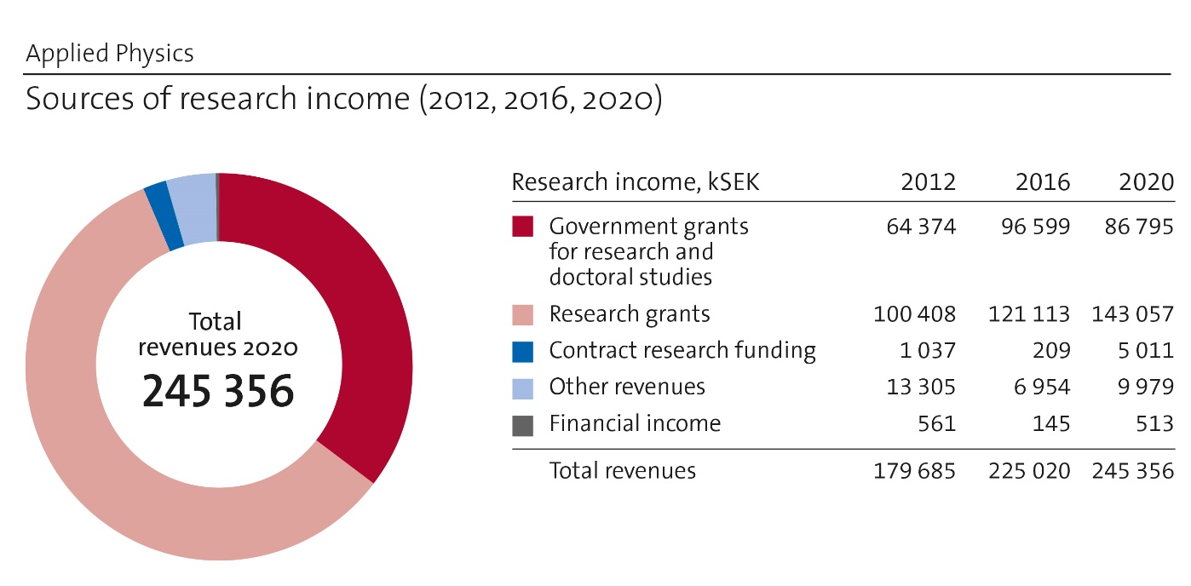

Staff
An overview of the headcount for the department is given below. Worth noting is that for years before 2017 the staff belonging to the Kista divisions are not included. The apparent strong increase in staff count from 2016 is thus false. The departments head count has been increasing in recent years but on the level of a few percent. Numbers for 2020 are presumably correct and reflects reasonably well the present head count and gender (in)balance of the department.
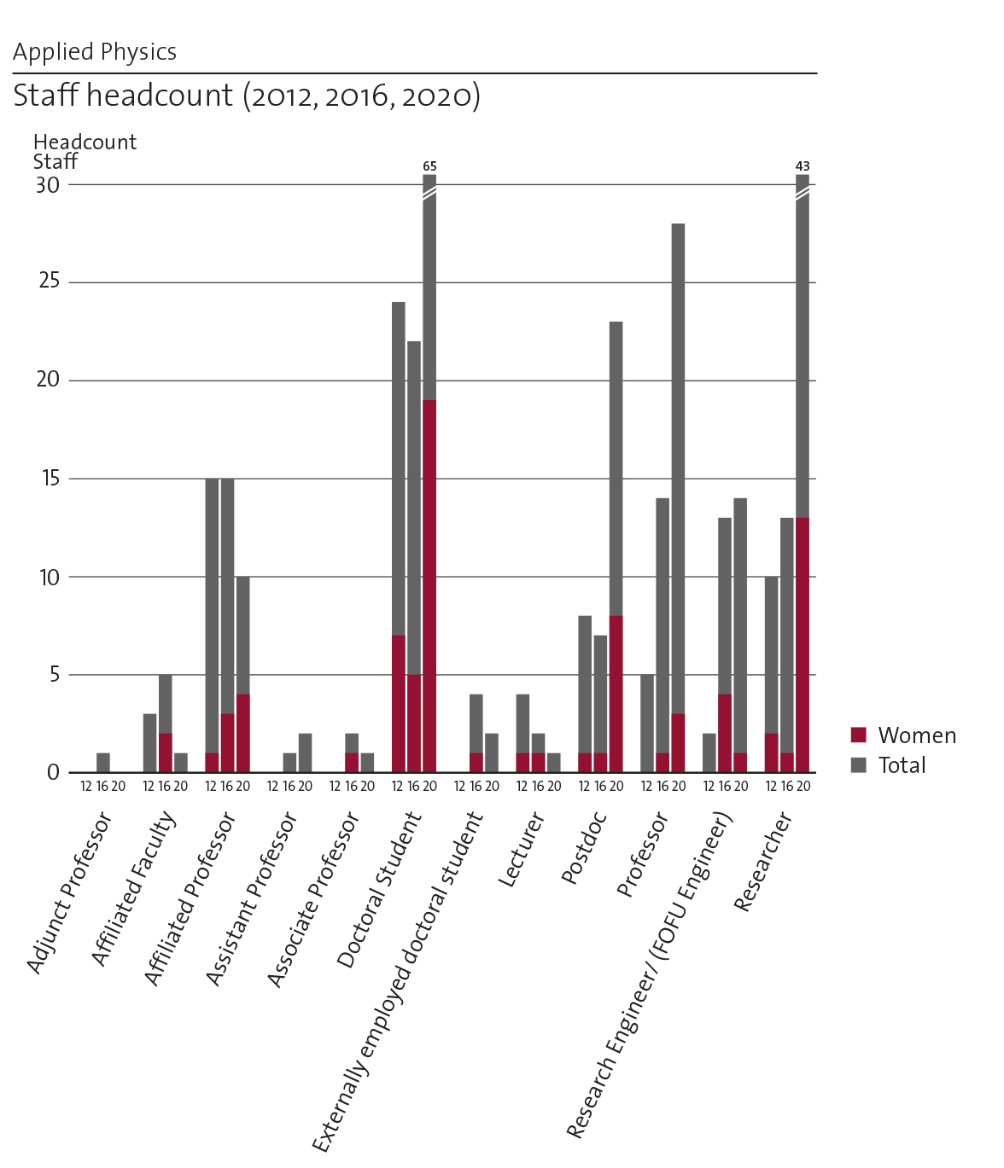

Division name, Location,  Total number of staff | Head of division | Faculty
Biomedical & X-Ray Physics (BioX)  Albanova  People:35 | Assoc. Prof. Peter Unsbo | Prof. Hans Hertz  Prof Muhammet Toprak,  Prof. Martin Viklund,  Prof.Ulrich Vogt,  Assoc Prof Anna Burvall,  Assoc Prof Linda Lundström,  Assoc Prof Göran Manneberg  Assoc Prof Jonas Sellberg,
Biophysics  SciLifeLab  People: 43 | Prof. Hjalmar Brismar | Prof. Berk Hess  Prof. Erik Lindahl  Prof Björn Önfelt  Assoc Prof Lucie Delemotte  Assoc Prof Ilaria Testa
Laser Physics  Albanova  People:25 | Prof. Fredrik Laurell | Prof.Carlota Canalias  Prof. Valdas Pasiskevicius,  Assoc Prof Michael Fokine
Material and Nanophysics  Albanova  People:28 | Prof. Mats Ahmadi Götelid | Prof. Anna Delin  Prof Joydeep Dutta  Prof. Oscar Tjernberg  Prof Jonas Weissenrieder  Prof Johan Åkerman  Assoc Prof Magnus Andersson  Assoc Prof Martin Månsson
Nanostructure Physics  Albanova  People: 11 | Prof. David Haviland | Prof. Vladislav Korenivski
Quantum and biophotonics  Albanova  People: 35 | Prof. Jerker Widengren | Prof Gunnar Björk  Prof Katia Gallo,  Prof Val Zwiller,  Assoc. Prof Ali Elshaari,  Dr. Marcin Swillo
Photonics  Albanova  People: 27 | Prof. Saulius Marcinkevicius | Prof. Srinivasan Anand  Prof. Jan Linnros  Prof Sebastian Lourdudoss  Prof Sergei Popov  Prof. Urban Westergren,  Assoc Prof. Ilja Sytjugov  Dr. Yantin Sun,  Dr Max Yan.

b. Central research questions and themes, knowledge gaps addressed, main research activities and composition of research team(s)
The research of the department is primarily experimental and multidisciplinary, and spans the full range from biological and medical physics over optical physics to materials physics with quantum physics as a major part in many of the areas (“bio-opto-nano”). Significant areas include confocal microscopy, cell-biology, fluorescence correlation spectroscopy, single molecules, x-rays (sources, optics, and microscopes), ultrasonic trapping, microfluidics, solid-state laser sources, quantum optics, nanophysics, spintronics, surface physics, device physics and quantum materials. The broad range of activities include synthesis and processing of novel materials, nanostructures, and devices to advanced characterization with synchrotron radiation, free electron lasers, neutron and muon sources, short pulse lasers, electron and scanning probe microscopy. Development of new experimental techniques and methods is at the core of the department and has been a central theme for a long time.
Below we specify some of the central questions addressed in each of the areas

BIO
The BIO area at dept of Applied Physics covers a broad field of biomedical and biophysical research. Research is performed in 11 highly active and internationally well recognized research groups located at the Albanova and the SciLifeLab campuses. Topics include development of biophysical measurement technology in particular within spectroscopy, microscopy and imaging, development of computational methods for biomolecular analysis, protein structure determination, cellular biophysics, and applications in cell biology, immunology, neuroscience and visual optics.
The research groups are cross-disciplinary with several non-physicists in the teams (biologists, MDs, chemists), there are frequent collaborations and interactions between the teams, in particular via the shared laboratory resources, where competence is also shared in a natural and synergistic fashion. The teams are international with representation from >12 different nationalities and there is also an almost equal gender balance.
Central research questions:
X-ray science and technology: Several research groups within the department work on x-ray science and technology (development of sources, optics and image analysis) with focus on biological applications. We develop and utilize compact liquid-jet x-ray sources and apply x-ray microscopy, phase-contrast imaging and x-ray fluorescence imaging methods. This has resulted in multiplexed bioimaging in vivo with minimum radiation dose. We also use coherent x-rays produced by 4th generation synchrotrons and free-electron lasers to study mesoscale structures (nominally 10 nm to 1 μm) and ultrafast dynamics (nominally 100 fs to 1 µs) in soft matter, which has led to several stepping stones toward imaging single proteins using x-rays. (Hans Hertz and Jonas Sellberg)
Visual Optics: The competence in optics and image quality analysis of the department is also applied to the area of visual optics, in which close collaborations with optometrists and ophthalmologists enable studies of how peripheral optical errors of the eye affect our vision and ocular health. A direct application of this work is the development of optical designs of spectacles, contact lenses, and intraocular lenses that can improve peripheral vision. Such designs can be used, for example, to compensate for loss of the central visual field, or to halt the increasing prevalence of nearsightedness in the world. (Linda Lundström and Peter Unsbo)
Acoustofluidics: At the department we develop microscale acoustofluidic, miniaturized fluidic systems where ultra-sonic radiation forces are used for manipulation of cells and particles, with the aim of tissue engineering. Here, ultrasound has found an important use for high-throughput production of in-vivo-like models of solid tumors. (Martin Viklund)
The Biophysics unit is located at Science for Life Laboratory. The unit is responsible for operation of the microscopy infrastructure. This infrastructure is a national infrastructure with funding from the Science Council (VR), Science for Life Laboratory as well as KTH, the microscopy laboratory is also a node in the European Infrastructure EuroBioImaging-ERIC.
Research in the Biophysics division is performed in six research groups. The groups have a good gender balance (39% female) and broad international composition (63% international). Research questions span from the sub-molecular to the organ level and from theoretical studies of proteins to practical developments of new microscopy. The unit has extensive national and international collaborations. Several of the faculty have also dual affiliations with Karolinska Institutet and Stockholm University.
The Biophysics division secured funding from the strategic research area Molecular Biosciences (SciLifeLab) for recruitment of two junior group leaders in 2015 (microscope development) and 2016 (computational biology). Both were internationally recruited in a highly competitive process. They have been outstandingly successful within their tenure tracks (both are now on assoc prof level, active in teaching, faculty activities and research) and by attracting external funding (ERC, VR, SSF, etc) and significant international recognition.
Method development is a common theme for the groups in Biophysics. New methods are developed driven by needs identified in applied studies. All groups are strongly multidisciplinary in between biology, medicine, chemistry and physics. The applied studies are identified and defined by the individual PIs research interests in medicine and biology that include e.g. immune therapy, renal physiology, neuroscience and neuropharmacology. The groups are also actively involved in larger research community projects coordinated by SciLifeLab and the research facilities that are supported by the Biophysics unit (the ALM microscopy facility and the Cryo-EM facilitiy).
Important development during later years includes a massively parallel analysis method for single cell functional analysis based on a microchip platform and automated confocal imaging, developments of super-resolution RESOLFT microscopy and also multifocus SIM microscopy. The unit has developed some of the world’s most used tools for modelling biological systems (GROMACS) with applications to membrane proteins and techniques for drug design. The groups has also made important contributions to the RELION code which has led to the rapidly increasing resolution and dynamics obtained with cryo-EM (through affiliation with SU and the Cryo-EM facility at Science for Life Laboratory).
The research within Quantum and Bio-photonics encompasses development of advanced fluorescence spectroscopy/imaging techniques and their applications for fundamental biophysical studies and towards biomedical and diagnostic applications, nonlinear and quantum photonics research with development of ferroelectric and photonic technologies for switching, communication and sensing, as well as nanoparticle research with applications in biosensing and for solar cell development. Within the unit, but also within several joint projects involving external partners on both a national and international level, synergies between these research fields are successfully exploited.
The experimental biomolecular physics (EBP) group belongs to the pioneers of fluorescence-based single-molecule detection (SMD) and fluorescence correlation spectroscopy (FCS), and the research group is still in the forefront in this field. The group was among the very first to establish fluorescence-based super-resolution microscopy (SRM), with so-called stimulated emission depletion (STED) imaging, and its use for sub-cellular characterization and diagnostics. By the so-called transient state (TRAST) imaging technique developed by the group, highly environment-sensitive fluorescence blinking events of fluorescent molecules can be visualized in biological samples, and it is now used to open new areas for cellular and molecular characterization and screening. With development of fluorescence-based ultrasensitive and ultrahigh resolution spectroscopy/microscopy techniques as a starting point, the group is active in several interdisciplinary collaborations, where the SMD, FCS, STED and TRAST techniques and further developments thereof are applied for biomolecular and cellular studies.
The research within the nonlinear and quantum photonics (NQP) group brings together the fields of ferroelectric and photonic sciences. Using lithium niobate as a model system, the group leverages the tools of nanotechnology and integrated optics to study the fundamental physics of interactions involving spontaneous polarisation and light in classical and quantum regimes, and explore their implications for information processing, optical sensing and actuation. The research activities of the group cover the entire spectrum from modelling over fabrication to experiments, and also include applications in the biomedical field, merging concepts for optical resonators, waveguides and plasmonic enhancement, with molecular spectroscopic techniques based on fluorescence and Raman scattering.
During last year, the division has strengthened its research in nanophotonics, with a senior researcher with expertise in the field of so-called upconversion nanoparticles (UCNPs) recruited to the unit. UCNPs lend themselves to be well studied by the fluorescence techniques developed and used by the EBP group, and this is taken as a starting point for the development of UCNPs as probes in bioimaging and for solar cell applications.
Overall, the research of the division benefits strongly from bringing together research from different disciplines. This takes place both within the unit, by interactions with groups in theoretical physics and mathematics, and not the least by collaborations with research groups in the biomedical field.

OPTO AREA
A large part of our activities is oriented towards semiconductor materials and nanostructures, and their application for photonic devices. The main driving force in this area is increase of the energy efficiency of light emitting devices, such as semiconductor lasers and LEDs, and photovoltaic devices, e.g., solar cells. In many cases, the energy efficiency of these devices is directly related to material properties; thus, gaining a detailed understanding of the material properties contributes to the increased efficiency of the devices.
Devices that we focus on are based on a variety of semiconductor materials, starting from the ones with the band gap in the near infrared (Si, InP) to wide band gap materials, e.g. GaN and Ga2O3. In the area of phosphides (InP, GaP) the main activities are: 1) Buried heterostructure mid-infrared quantum cascade lasers (QCL) for high power, high beam quality, high speed modulation and free space communication, 2) orientation-patterned GaP (OP-GaP) nonlinear optical crystal for quantum photonics and 3) III-V/Si heterojunctions for phonic integration and multijunction solar cells. Studying of these devices are enabled by exploiting hydride vapour phase epitaxy (HVPE) as other epitaxial techniques are less suitable and thereby address the knowledge gaps in semiconductor processing technology for optical communication and renewable energy.
Research on the phosphide-based semiconductor nanostructures is conducted with focus is on utilization of photonic semiconductor nanostructures for light manipulation and enhanced light matter interaction for applications in optics, optoelectronics and sensing.
The work on infrared and quantum cascade lasers is closely related to their application in telecommunications. In this area, we aim to enhance the data transmission rate of fiber-optical and wireless-optical links to meet the increased demands in capacity, considering the constraints regarding energy consumption and cost. This is done by optimizing the components, the modulation formats and coding/decoding algorithms.
In the IR spectral region, we also perform research on integrated photonics, where we work on the design of nanostructured materials and develop fabrication technologies for mid-IR generation and wave manipulation towards ubiquitous gas sensing and information transfer. These devices are mainly built on the silicon platform. The same technology set is also exploited for integrated photonics at telecom wavelengths.
Silicon-based nanostructures and nanoparticles are being studied with several applications in mind. The fabrication of these structures utilizes the Electrum and the Nanolab clean-rooms for ordinary Si processes combined with electron beam lithography, respectively. Silicon quantum dots are explored with the goal to use them in sensors, light emitters and for photovoltaics. Fundamental studies using single-dot spectroscopy and quantum yield measurements have contributed largely to the understanding of the light emission mechanism from Si quantum dots, but has also been used for characterization of novel perovskite quantum dots. A new direction is the fabrication of single or arrays of nanopores in a Si membrane. These are used for studies of translocation of single bio molecules, detected optically by fluorophores or electrically. The Si platform is also exploited to develop silicon-chip based biomolecule sensing technology and devices. The latter applications unite all three core areas of Applied Physics, namely Opto, Nano and Bio. The sensing technology is applied towards detection of exosomes which are small extra cellular vesicles secreted by all cells. The aim is to profile specific surface proteins which can be used as markers for particular cancer forms. This project involves cross-disciplinary collaboration with Karolinska Institutet as well as with KTH biotechnology groups.
In the area of wide band materials and photonic devices, we focus on fundamental material properties GaN and related quantum well (QW) structures (GaN/InGaN, GaN/AlGaN) that find applications in UV and visible LEDs and laser diodes. We are studying properties like carrier transport, recombination and localization, all critical for an efficient LED and laser diode performance. Recently, our attention gas been focused on green-emitting LEDs, which are a missing link for RGB lamps and displays. In our research, we are using advanced time-resolved and near-field spectroscopy techniques providing information on the materials and device properties on the 100 nm and 100 fs scale. Our recent studies allowed revealing critical issues for an efficient interwell carrier transport in LEDs, the role of extended defects on recombination, and determining several basic material parameters for GaN and Ga₂O₃.
The work in domain-engineered ferroelectrics is at the international forefront and our periodically poled samples, primarily made in LiNbO₃ and KTP, are integrated as nonlinear devices in lasers and quantum devices to provide tailored wavelength, pulse or spectral response. With KTP we have demonstrated the largest apertures, for use in high energy lasers, and bulk nanodomain gratings to be able to study backward nonlinear processes. This has not been possible in any other lab world-wide. By spatially tailoring the χ2-nonlinearity we demonstrated efficient fs-pulse compression and octave-spanning continuum generation in single-pass devices. The crystals can also be engineered for THz generation and our samples will be used in the high-profile ACHIP project, where a laser-driven, chip-based particle accelerator will be built. Other addressed applications include environmental gas spectroscopy (LIDAR) for ground-based, air- and space-borne missions, as well as entangled sources for quantum communication.
Recently a complete laser-based laboratory for additive and subtractive manufacturing of glass has been constructed at the department. Here we custom fabricate preforms in silica to make special optical fibers and develop semiconductor-core optical fibers (Si, Si/Ge) with combined opto-electric functionality, and for use as mid-IR and THz transmission lines. We can form both gratings and graded-index structures in these fibers, obtained record-low IR transmission loss and very recently we demonstrated THz transmission in these fibers, for the first time. This has potential applications in medicine, sensing and the next generation telecommunication (6G). Furthermore, our laser-assisted glass fabrication allows printing of complex 3D structures from powder and from fiber.
In our multifunctional fibers we integrate fluid, gas and electric fields with light guidance, and apply them in life-sciences and optoelectronics. Recent focus work has been in biopsy and therapy of pancreatic cancer and the development a compact virus detector for COVID-19.

Photonics is identified as a key-enabling technology by the European union, which addresses major societal challenges (https://www.photonics21.org/). In the Laser physics group, we work with one foot in pure photonics and one in material science, with a focus on functionalizing optical materials. Our novel structures are used in lasers, nonlinear optics, and other photonic applications addressing contemporary quests. Emphasis is on ferroelectrics, diode-pumped solid-state and fiber lasers, special optical fibers and in additive and subtractive processing of glass. For this we develop new material engineering and characterization techniques.

NANO
Our research activities within the Nano area are broad and covers growth, synthesis patterning, devices and characterization as well as basic science related to surface physics, interfaces and quantum materials. A common theme is the relationship between properties such as optical, electrical and magnetic on one hand and size, structure, shape and composition on the other. The research is often interdisciplinary and connect areas such as condensed matter physics, chemistry, optics and biology. A majority of the conducted research is connected to and driven by sustainability topics such as energy conversion, storage and efficient use or decreased environmental impact and pollution reduction.
X-ray nano imaging with synchrotron radiation: The department has a close connection to the NanoMAX beamline as well as several other beamlines at the Swedish synchrotron radiation facility MAX IV. Together with partners from Lund University we proposed and built the NanoMAX beamline and currently we are involved in the development of a new zone-plate-based x-ray microscope end station at NanoMAX. We also design and manufacture diffractive zone plate optics with diffraction -limited resolution in the 10 – 100 nm range. The long-term goal is 3D x-ray nano imaging experiments on the 10 nm resolution level with synchrotron radiation.
Nanochemistry for nanomaterials: At the department there is a group with strong Nanochemistry profile focusing on development of fabrication strategies for nanomaterials. The applications are in bio-medicine, as contrast agents, and harvesting waste heat via thermoelectric materials, besides materials designed for heat-transfer surfaces/fluids as well as water-remediation. One of the main focuses of the group is green chemical process development for energy and resource effective synthesis as well as scale-up of various nanomaterials. Currently collaborates with the Hertz group on the development and implementation of nano-contrast agents for x-ray fluorescene bio-imaging; with Vogt’s group on the fabrication of x-ray zone plates using top-down solution chemical process; with Popov’s group on the synthesis and implementation of optically active organic and inorganic materials in plasmonic and optofluidic devices.
Research activities carried out in the division for Nanostructure Physics address a variety of areas, mostly related to electronic device physics. Work on nanomagnetism and spintronics focuses on small devices formed from magnetic multilayers, where electric current can induce magnetic torque to manipulate the magnetic ordering in the device. Spin vortices and thermal switching based on RKKY exchange interactions are studied. Work in the section also uses superconductivity to study quantum effects of microwave circuits and electro-mechanical devices. Nonlinear dynamics is a unifying theme of research on both electrical and magnetic circuits, as well as in the development of new modes of Atomic Force Microscopy. Simulation is a key part of the research effort, used in nearly all projects to compare physical models with data from measurements. The division also develops measurement instrumentation and techniques that exploit state-of-the-art digital signal processing, extending to microwave frequencies. This latter effort has led to spin-off commercial activity.
Recent research advancements in the division for Nanostructure Physics includes: The understanding of spin current relaxation in Antiferromagnetic spin-valves. The development of several modes of Intermodulation AFM, an information-rich technique where nonlinear cantilever dynamics is measured via frequency mixing to reveal tip-surface forces. Presently the group is adapting these AFM measurement methods to study quantum entanglement in microwave frequency combs, generated by nonlinear superconducting circuits that are driven by multiple frequencies.
The research at Materials and Nano physics (MNF) is focused on basic understanding of electronic, magnetic, optical, and chemical properties of quantum materials, surfaces, thin films, and nano structured materials combining experimental and theoretical methods for development of new materials within electronics, catalysis, spintronics, batteries, environment, energy and communication technology.
A large and successful activity is development of new functional nanomaterials. This includes material fabrication, development of new methods, sample analysis, testing and verification. Technological areas of interest are medical applications, energy production and environmental remediation; water cleaning, photocatalytic degradation of microplastics. anticorrosion-self healing coatings water splitting for hydrogen production and blue energy generation.
The area of materials physics includes studies of quantum materials where quantum effects play a dominating role at the macroscopic level as in the case of superconductors, topological insulators, metal-insulator systems, and magnetic systems. One of the main experimental tools in this area is photoelectron spectroscopy and in particular Angle-Resolved PhotoElectron Spectroscopy (ARPES). An ongoing activity is the development of a new laser based high-harmonic source for time-resolved ARPES with high energy resolution (<15 meV). This source will be exploited to study the effects of lattice distortions on the electronic structure of quantum materials in general and in topological and superconducting materials in particular. Some of the more impactful results achieved since the last RAE are related to topological insulators. The discovery and characterization of the first topological crystalline insulator (TCI) and the demonstration of the first order nature of the topological phase transition in this system are examples of high impact results achieved within this area.
A special focus is on multifunctional materials, where one example is the A₂TM₂TeO₆ honeycomb series of compounds that are both novel sustainable battery cathode materials at room-temperature, as well as display potential Kitaev quantum spin liquid behavior at low temperatures.
Further, studies on surface structures and reactions of relevance for catalysis and corrosion with atom resolving microscopy and synchrotron radiation-based spectroscopy. Our ultra-fast electron microscope (UEM) is one of very few such set-ups worldwide and can resolve atomic motion on the femtosecond time scale.
Development of computational methods for spin dynamics and spin-lattice dynamics, angular momentum transfer between spin system and lattice. In addition, physics of spintronics and development of components are done in collaboration with Göteborg University.
A very important part of our experimental research involves using large scale facilities; synchrotron radiation and free-electron laser-based spectroscopy as well as material analysis using neutrons and muons. But also includes important development of methods and experimental facilities. The division has been involved in construction and development at MAX-I, MAX-II, MAX-III and MAX-IV. MNF plays a key role on the development at ESS beamlines and is a prominent developer of methods for advanced materials analysis at large-scale facilities, using neutron, muon and synchrotron techniques. A multidisciplinary approach concerning materials, collaborators and techniques is a central aspect of our research.
Gender and ethnic diversity do not play a direct role in the research, but the composition of the groups is very diverse. Students originate in China, India, Iran, Sweden, Italy, Chile. Post-docs and researchers are from Europe, China, India, USA, Iran, Sweden. The gender balance on these levels is good, with a slight male dominance. On the faculty level Swedish origin and male dominates. The scientific background is mainly from physics, but chemistry, material science and microelectronics are also represented.

c. Contributions to the advancement of the state of the art within the research fields of the department
X-ray science and technology: The department pioneered the soft x-ray liquid-jet laser-plasma source (1992) and were the first to demonstrate the tin liquid-jet source (2004), which is now the source in EUV lithography (>900 people work on this today). We have reached early-bending magnet brightness in the water-window (2012) and the source is the cornerstone for our laboratory soft x-ray microscopy. We demonstrated the first sub-visible-resolution laboratory water-window x-ray microscope (2000), the first “real” applications (soil science, 2009) and the first lab 3D cryo-tomography of intact cells (2011). Recent work is on autophagy, NK-cell interaction (2018) and virus progression (2021).
The department pioneered the liquid-metal-jet-anode hard x-ray source (2003). This electron-impact source allows for up to 1000x higher brightness than any existing laboratory microfocus x-ray tube. The technology is now successfully commercialized by our start-up company (www.excillum.com). We demonstrated the first high-resolution phase-contrast imaging with liquid-metal-jet sources 2006. To our knowledge this is the only laboratory arrangement that has potential for high-resolution (cellular!) phase imaging in whole-body small-animal objects with short exposure times at an acceptable dose. Present emphasis is on whole-body mouse CT (2012), micro-angiography, and tumor imaging. The method has potential for cellular and sub-cellular-resolution imaging in thick tissue, a long-standing goal of bio-imaging, as recently demonstrated on zebrafish (2015) and coronary arteries in human heart (2018). The same research group were the first to identify a viable path for x-ray fluorescence imaging imaging to produce molecular and functional 3D imaging in mice with 10x better resolution than present methods (PET and SPECT). We rely on liquid-metal-jet sources in combination with target-seeking specially designed nanoparticles and photon-counting detectors.
The coherent x-ray scattering group brings x-ray free-electron laser science to KTH in general and BIO in particular, where we extend the wide range of imaging techniques to coherent diffractive imaging. Although this is still a young technique that requires expert knowledge and continuous development, it has the potential to reach sub-nanometer resolution on micron-sized living cells without staining or sectioning and could eventually make macromolecular movies of biomolecules a reality. We also study fluctuations and crystallization in liquids and solutions using coherent x-ray scattering, where we recently participated in determining water’s isothermal compressibility (2018) and specific heat capacity (2021) upon deep supercooling.
Fig 1. Peripheral vision analysis system
Visual Optics: The visual optics group at Applied Physics has established methods to quantify and analyze peripheral optical errors (aberrations) and given proof of that peripheral vision can be improved by optical correction, which has inspired industry to develop optical aids with improved peripheral image quality. We have performed one of the two first population studies of peripheral image quality. We have collected data and filed a patent on manipulating peripheral image quality to reduce the progression of myopia, which has inspired a company in Russia to develop a new type of spectacles for children becoming myopic.

Acoustofluidics: The acoustofluidics group at the department has recently made progress in transferring the technology for acoustofluidics cell manipulation from bulky and expensive equipment, to simple, compact and extremely inexpensive (Fig. 2). We collaborate with theoretical experts at DTU-Copenhagen, and with oncologists at Karolinska Institute and Hospital. Most important, we collaborate internally with Önfelt’s group who use the acoustofluidic technology in combination with advanced light microscopy for immuno-therapy research. The combination of acoustofluidics and advanced light microscopy methods have resulted in a novel platform for producing and characterizing tumor models in 3D with high spatial and temporal resolution.
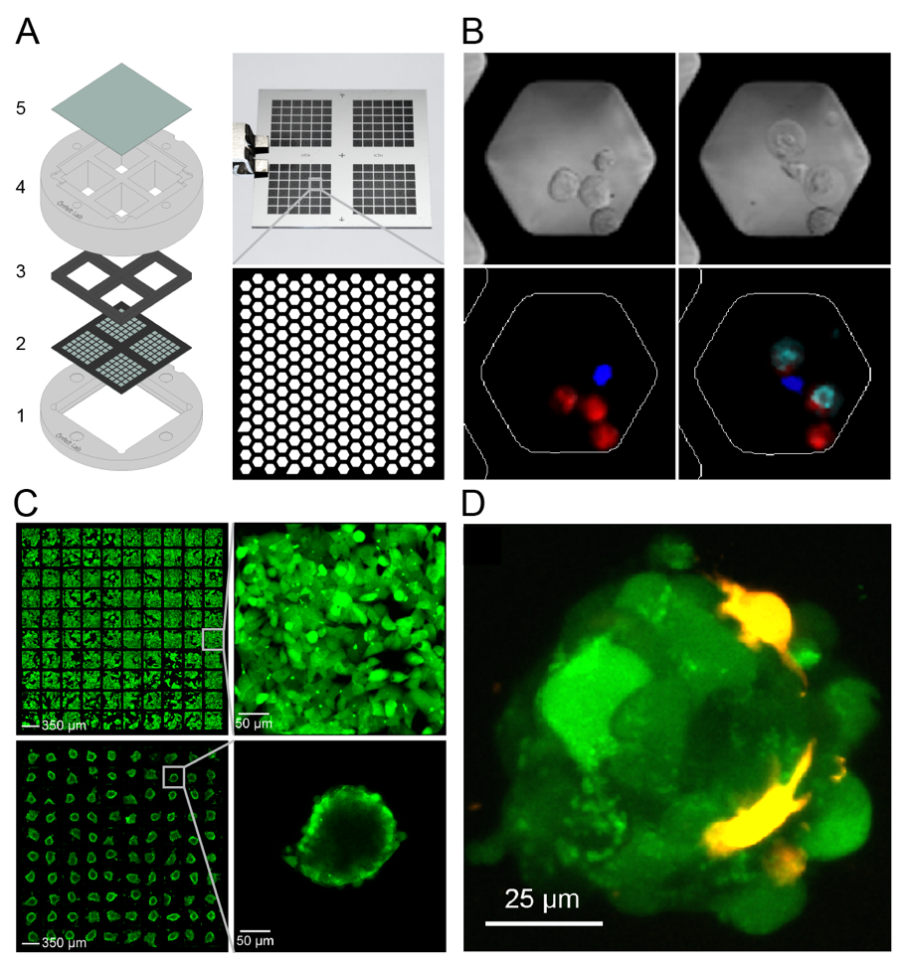
Fig 2. Microchip platform. Screening of NK and T cells reactivity at the single cell level. Microwells (60 μm) are etched in a microchip made of silicon and glass, which is fitted in a custom-made holder enabling exchange of media and CO₂ for long-term live cell imaging.
X-ray nano imaging with synchrotron radiation: The MAX IV synchrotron radiation facility is the first so-called diffraction limited storage ring. It offers a much higher brightness than traditional facilities, which is of special benefit for x-ray nano imaging experiments. The NanoMAX beamline is the first beamline that fully exploits this fact and offers superior imaging performance for users from many different research fields. The beamline was proposed and developed in close collaboration with researchers from our department.
Sustainable chemistry for functional nanomaterials: The work on the synthesis and processing of nanoengineered thermoelectric materials at the department has been pioneering in the field of energy harvesting materials, attracting significant attention. The nanochemistry group has demonstrated the capacity to develop scalable green chemical synthesis techniques, based on microwave-assisted heating, and high thermoelectric figure of merit in state-of-the-art thermoelectric materials based on chalcogenides (Cu_{2-x}Se, Bi_{2-x}Sb_{x}Te₃). Currently hybrid films are developed to offer thermal energy harvesting capacity in the presence of even few degrees temperature gradients.
The same research group also developed a library of x-ray fluorescent nanoparticle-based contrast agents for in vivo biomedical imaging, designed to match the energy of the pencil beam x-ray source developed at the department. These nanoparticles have been tuned for their size and surface chemistry, and have been demonstrated as promising materials for pre-clinical research for in-vivo x-ray fluorescence computed tomography (XFCT) bio-imaging. Current work is focusing on targeting strategies of these nanoparticles with affibodies. This is one of the pioneering interdisciplinary works joining many disciplines together.
The group for immune cell biophysics develops microchip platforms and methods to assess migration and immune cell cytotoxicity on the single cell level (Figure 2). The chip platform can be combined with ultrasound actuation to generate 3D tumor spheroids that are used as model systems for immunotherapy of solid tumors. Light sheet microscopy methods have been developed to study the evolution of tumor spheroids and the dynamics of T-cells attacking the cancer cells. We have a wide international network in the immunotherapy field and collaborate other leading groups through performing experiments with our unique assays or by sharing the microchip platform with other research groups. In several cases we have educated students and postdoc in our lab about how to use the platform before exporting the technology to other labs.
The Biophysics unit has during the past 20 years contributed to the development of advanced microscopy methods for studies of membrane proteins, in particular of Na,K-ATPase. Imaging methods have been developed to identify feedback mechanisms that regulate Na,K-ATPase and also to unravel how Na,K-ATPase is a signal transducer acting via slow calcium oscillations that activate Nf-kB and alter the signal balances in apoptosis (Fig. 3). We have demonstrated the medical impact of those findings for diseases associated with massive apoptosis. We have developed methods based on STED, STORM and PALM to identify and quantify Na,K-ATPase membrane densities and the colocalization-clustering with regulating proteins in neurons. We have also developed methods for single particle tracking to analyze local dynamics of membrane proteins and the functional consequences in neurons. Lately, methods based on light sheet and pioneering work on lattice light sheet microscopy has been important for dyanimc analysis of living systems at different scales (from subcellular junction formation to development of embryos)
Fig. 3. Combined PALM/STORM of Na,K-ATPase and NR2B in a hippocampal neuron.
The super-resolution microscopy development in the group is on the absolute international fore front and attracts significant funding and produce high-impact publications. We have worked to create new imaging approaches that enable recording of a completely new set of super resolution data based on time lapse imaging not possible before. The new microscopes enable observations in previously impossible samples, such as highly scattering brain tissues, with a spatial-temporal precision never achieved before. No other methods can acquire whole volumetric movies in living brain slice with < 60 nm in 3D. Our microscopy innovation enables new observations, which trigger novel and better questions with the ultimate goal of creating new science.
The computation biophysics groups develop new methods and apply them in various configurations. The biomolecular simulation program GROMACS, developed in the unit, has become the most used open source code on supercomputers in the world, enabling hundreds of high-impact advances by other teams. The group is also engaged in cryo-EM computational method development, in particular for the RELION code, which has contributed greatly to the rapidly increasing resolution and dynamics obtained with cryo-EM (Fig. 4).
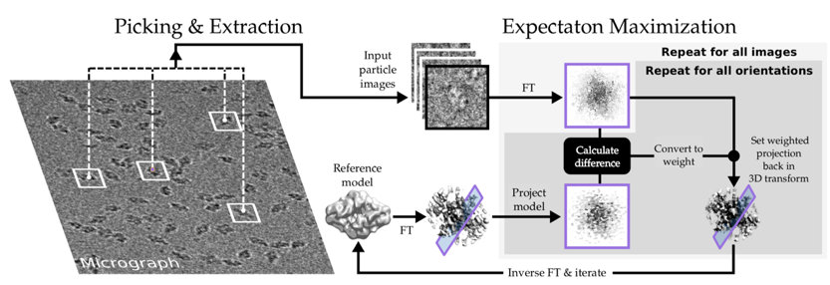
Figure 4. The resolution revolution in cryo-electron microscopy would not have been possible without large efforts to create new methods that are able to both reconstruct 3D densities from noisy micrographs. Our work has also made it possible to use the diverse raw data to predict the flexibility of molecules, and fit molecular models into 3D densities. Illustration by Björn Forsberg.
The group were the first to propose and identify the dual binding sites in ligand-gated ion channels and have determined a number of new ion channel structures. We have explained the molecular mechanisms of allosteric modulation, how poly-unsaturated fatty acids influence the gating of voltage-gated ion channels (with direct treatment impact) and used both cryo-EM and simulations to determine structure, formation and barrier properties of human skin (see Fig. 5).
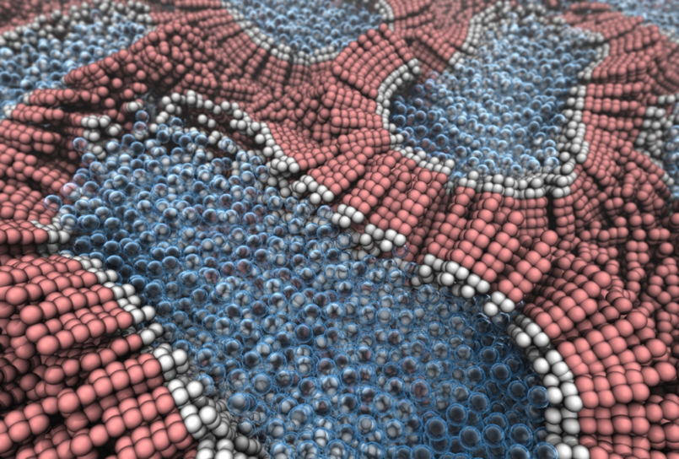
Figure 5. By involving teams both from KTH, KI, SU and the KS hospital, it has been possible to capture cryo-EM data of the formation of the horny layer of skin, the stratum corneum, and use molecular dynamics simulations to explain the process on molecular level. Illustration by Christian Wennberg.

We have also provided a host of new algorithms for MD simulations. This development has been stimulated by and made possible studies of the activation mechanism of HCN channels, the electromechanical coupling in Kv channels and in KCNQ1, into the transport cycle of the malarial parasite hexose transporter and the activation mechanism of the beta2 adrenergic receptor (Fig. 6).
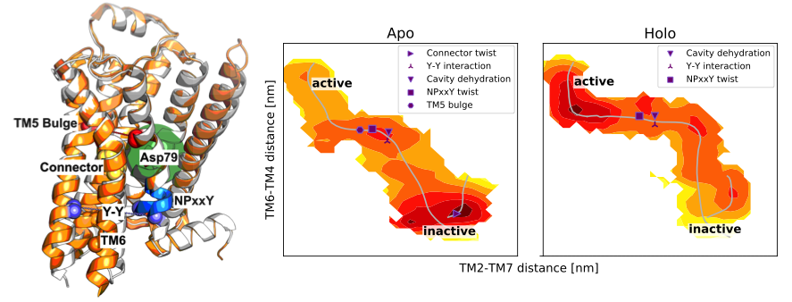
Figure 6: Activation path of the beta adrenergic receptor highlighting the sequential flip of microswitches along the path, in a manner that depends on ligand binding.
Single molecule spectroscopy: We have a strong cluster of research groups active in fluorescence spectroscopy and imaging at the department. Based on a long and strong track record in single-molecule and fluorescence correlation spectroscopy (FCS), Widengren’s group contributes with important critical mass to the cluster. Current research has a focus on exploiting photophysical and photochemical information for cellular and biomolecular studies, as well as to drive the development and use of the fluorescence methods towards clinical applications and to understand origin of diseases on a molecular level.
Immune cell biophysics: In this area, the group working on immune cell biophysics has developed a microchip platform and methods to assess migration and immune cell cytotoxicity on the single cell level. The chip can also be combined with ultrasound actuation to generate 3D tumor spheroids that we use as model systems for immunotherapy of solid tumors. Our group also have wide network and collaboration with world leading groups in immunotherapy. We have collaborated through performing experiments with our unique assays or shared the microchip platform with other research groups. In several cases we have educated students and postdoc in our lab about how to use the platform before exporting the technology to other labs.
Scanning near-field microscopy: The multi-mode scanning near-field optical microscopy system is a unique facility allowing spatially- time- and polarization resolved characterisation of structural, optical and electronic material properties. Among the highlights, one can mention studies of carrier transport InGaN quantum wells, refined band structure parameters of GaN, revealed novel ultrafast effects in Ga₂O₃, etc.
Engineered ferroelectric nonlinear optical materials: The work on engineering ferroelectric nonlinear optical materials is world leading and the relevant research group is the only one that can make bulk domain structures with sub-micrometer features. Besides the domain writing capacity several unique characterization techniques have been developed. These structures are used for quasi-phase matching (QPM) nonlinear interaction devices novel frequency conversion schemes to be realized, both in bulk and waveguide format. The hybrid nano-waveguides under development holds promise for compact entangled sources for quantum communication and quantum information processing.
Large aperture, high-energy narrowband optical parametric sources employing domain- structured nonlinear ferroelectric materials have been space flight qualified for use in global CO₂ monitoring. Similar crystals have been used for high energy infrared supercontinuum generation and self-compression and functional ferroelectric meta-surfaces for THz beam handling. Nanoengineered ferroelectrics is developed for high-energy backward-wave optical parametric oscillators.
Nanoengineered thermoelectric materials: The work on the synthesis and processing of nanoengineered thermoelectric materials has been pioneering in the field of energy harvesting materials, attracting significant attention. The group has demonstrated the capacity to develop scalable green chemical synthesis techniques, based on microwave-assisted heating, and high thermoelectric figure of merit in state-of-the-art thermoelectric materials based on chalcogenides (Cu_{2-x}Se, Bi_{2-x}Sb_{x}Te₃). Currently hybrid films are developed to offer thermal energy harvesting capacity in the presence of even few degrees temperature gradients.
X-ray fluorescent contrast agents for in vivo biomedical imaging: In this area a library of x-ray fluorescent nanoparticle-based contrast agents has been developed. The contrast agenst have been designed to match the energy of the pencil beam x-ray source developed by the X-ray group. These nanoparticles have been tuned for their size and surface chemistry, and have been demonstrated as promising materials for pre-clinical research for in-vivo x-ray fluorescence computed tomography (XFCT) bio-imaging. Current work is focusing on targeting strategies of these nanoparticles with affibodies. This is one of the pioneering interdisciplinary works joining many disciplines together.
The division has for many years played a very active role in synchrotron radiation-based science and is at present involved in the development of three beamlines at MAX-IV; ambient pressure XPS at HIPPIE, angle resolved photoelectron spectroscopy at Bloch and RIXS at Veritas. In addition, the division has been involved in the construction of the hard X-ray “Swedish beamline” at DESY in Hamburg.
Materials and Nanophysics has a leading position in Sweden for work using neutrons and muons, of central relevance in connection to the construction of ESS. The Swedness program finances 40 doctoral students. Important collaborations include large car and battery manufacturers in Japan.
Materials and Nanophysics is currently the only Swedish research division that utilizes the unique μ⁺SR (Muon Spin Rotation/Relaxation) technique for studying both quantum and energy materials. Further, the division has developed and pioneered a novel and world-leading μ⁺SR method for studying ion dynamics in energy related materials (batteries, photovoltaics and hydrogen storage materials). This method has gained a lot of international attention (e.g. Gordon Research Conference) and has opened a new completely unique path for studying ion diffusion in energy materials both in bulk as well as at surfaces and across buried interfaces (Figure 7). The use of this method has generated a large number of research articles and press releases/highlights during the last 5 years.
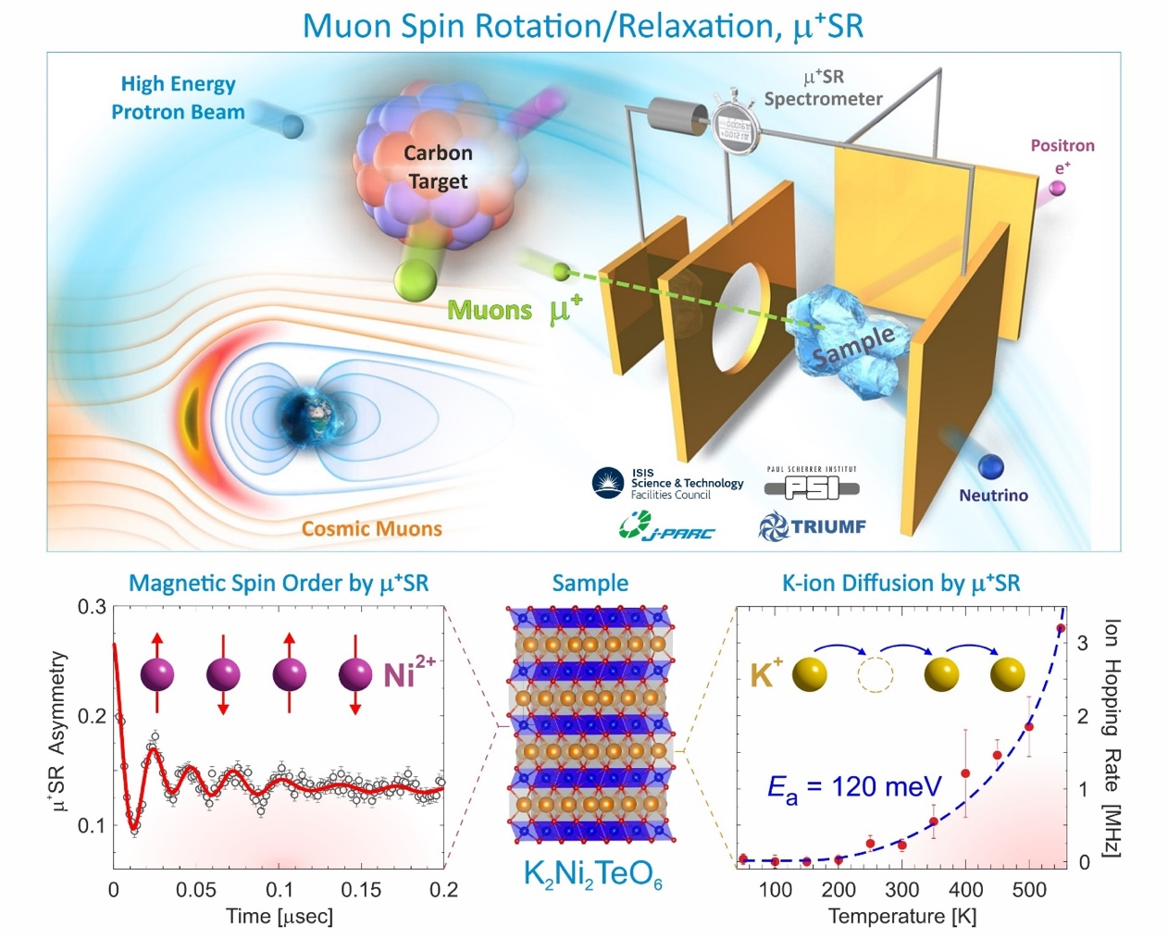
Figure 7: The unique muon spin rotation/relaxation (μ⁺SR) technique allow us to study both low-temperature spin order in quantum materials as well as room-temperature ion diffusion in energy materials. See for instance: N. Matsubara, et al., Scientific Reports 10, 18305 (2020).
Materials and Nanophysics is also at the international forefront with experimental developments in the area of time and angle-resolved photoelectron spectroscopy tr-ARPES (BALTAZAR) as well as in the area of time resolved electron microscopy UEM. Both of these labs are unique for Sweden and among very few worldwide.
The Materials and Nanophysics division is also leading or at the forefront in the development of functional nano-structured materials. This research has contributed to both detection and removal impurities in water, drug delivery and catalytic degradation of plastics.

d. Quality and quantity of contributions to the body of scientific knowledge
The department publishes more than 300 peer reviewed research articles per year. This is a substantial volume and amounts to approximately one and a half published article per person and year. Approximately 30% of these articles are in high impact (top 20%) journals according to KTH bibliometric numbers. These numbers are known to be wrong, but the general trends are most likely correct. The corresponding field normalized journal citation number is 1.24 but the corresponding field normalized citation rate is 0.98 for the 2016-2018 period. These numbers could indicate that the research results of the department do not get cited to the extent that they deserve or that we are very successful in getting our results published in leading journals. Citations numbers for the staff which is currently employed at the department that have recently become available indicate a journal citation number of 1.28 and an article citation rate of 1.17 These numbers that do not include staff which has left or retired from the department could possibly indicate that we can expect improvements in the bibliometric indicators going forward. Without accurate data available on the division level it is at present difficult to understand and evaluate the variation among disciplines and divisions, the result of different practices and trends.
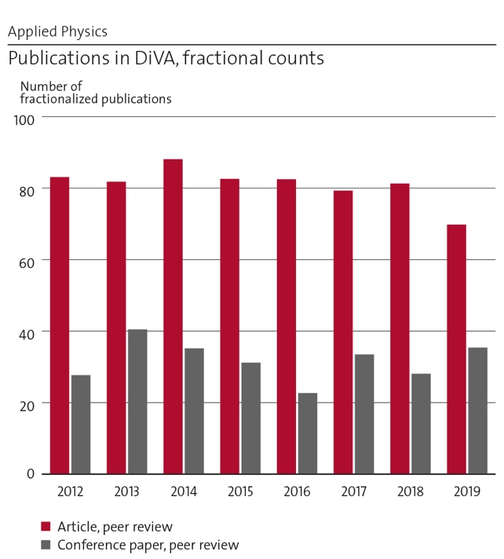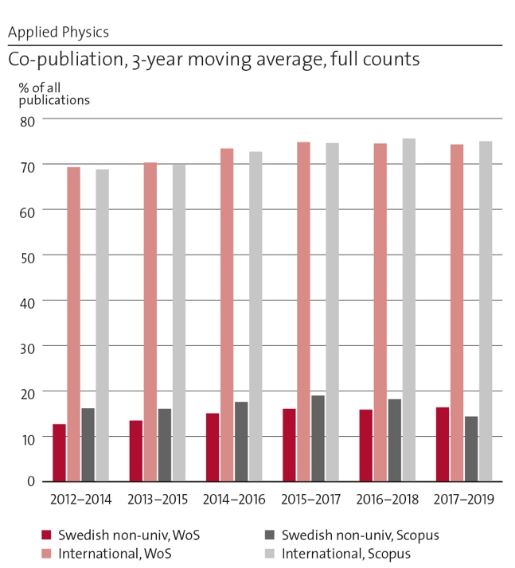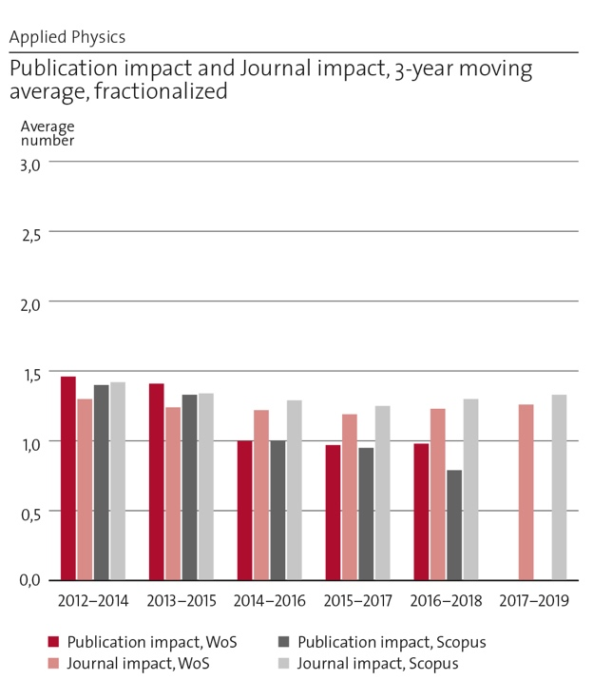

Below are a few examples of particularly noteworthy publications since the last RAE in 2012.
Laser restructuring and photoluminescence of glass-clad GaSb/Si-core optical fibres
S. Song, K. Lønsethagen, F. Laurell, T. Hawkins, J. Ballato, M. Fokine, and U. J. Gibson, Nature Communications, 10, 1790 (2019), /doi.org/10.1038/s41467-019-09835.
Atomically dispersed iron hydroxide anchored on Pt for preferential oxidation of CO in H₂
L Cao, W Liu, Q Luo, R Yin, B Wang, J Weissenrieder, M Soldemo, H Yan, Y Lin, Z Sun, C Ma, W Zhang, S Chen, H Wang, Q Guan, T Yao, S Wei, J Yang, J Lu, Nature 565 (2019), 7741

Topological crystalline insulator states in Pb1−xSnxSe
P. Dziawa, B. J. Kowalski, K. Dybko, R. Buczko, A. Szczerbakow, M. Szot, E. Łusakowska, T. Balasubramanian, B. M. Wojek, M. H. Berntsen, O. Tjernberg, and T. Story
Nature Materials 11 (2012) 1023–1027
Direct Measurement of Nanoscale Lateral Carrier Diffusion: Toward Scanning Diffusion Microscopy
M. Mensi, R. Ivanov, T. K. Uždavinys, K. M. Kelchner, S. Nakamura, S. P. DenBaars, J. S. Speck, S. Marcinkevičius,, ACS Photonics 2018, 5, 2, 528-534, 2018.

High performance micro-flow cytometer based on optical fibre
S. Etcheverry, A. Faridi, H. Ramachandraiah, T. Kumar, W. Margulis, F. Laurell, and A. Russom, Scientific Reports 7, 5628 (2017).

All-dielectric KTiOPO₄ metasurfaces based on multipolar resonances in the terahertz region
J. Tian, Y. Yang, M. Qiu, F. Laurell, V. Pasiskevicius, and H. Jang, Opt. Express 25, 24068-24080 (2017).

Supercontinuum generation and soliton self-compression in χ(2)-modulated KTiOPO₄
A-L. Viotti, R. Lindberg, A. Zukauskas, R. Budriunas, D. Kucinskas, T. Stanislauskas, F. Laurell, V. Pasiskevicius, , Optica, 5, 711, (2018).

A 1.57 µm Fiber Source For Atmospheric CO₂ Continuous-Wave Differential Absorption Lidar
X. Yang, R. Lindberg, J. Larsson, J. Bood, M. Brydegaard, and F. Laurell,. Opt Express, 27, 10304 -10310, 2019.

Narrowband, tunable infrared radiation by parametric amplification of a chirped backward-wave OPO signal
A.-L. Viotti, A. Zukauskas, C. Canalias, F. Laurell and V. Pasiskevicius, , Opt Express, 27, 10602-10610, (2019).

Optically Transparent Wood: Recent Progress, Opportunities, and Challenges
Li, Y., Vasileva, E., Sychugov, I., Popov, S. & Berglund, L.. Advanced Optical Materials. 10.1002/adom.201800059. (2018).

Carbohydrates on the Size and Shape of Gold and Silver Nanostructures.
Yazgan, I.; Gümüş, A.; Gökkuş, K.; Demir, M. A.; Evecen, S.; Sönmez, H. A.; Miller, R. M.; Bakar, F.; Oral, A.; Popov, S.; Toprak, M. S. On the Effect of Modified Nanomaterials 2020, 10 (7), 1–17. https://doi.org/10.3390/nano10071417.

Nitric Oxide-Dependent Biodegradation of Graphene Oxide Reduces Inflammation in the Gastrointestinal Tract.
Peng, G.; Montenegro, M. F.; Ntola, C. N. M.; Vranic, S.; Kostarelos, K.; Vogt, C.; Toprak, M. S.; Duan, T.; Leifer, K.; Bräutigam, L.; Lundberg, J. O.; Fadeel, B. Nanoscale 2020, 12 (32), 16730–16737. https://doi.org/10.1039/d0nr03675g.

Modeling, Design, and Synthesis of Gram-Scale Monodispersed Silver Nanoparticles Using Microwave-Assisted Polyol Process for Metamaterial Applications. Lalegani, Z.; Ebrahimi, S. A. S.; Hamawandi, B.; La Spada, L.; Toprak, M. S. Opt. Mater. (Amst). 2020, 108. https://doi.org/10.1016/j.optmat.2020.110381.

Composition Tuning of Nanostructured Binary Copper Selenides through Rapid Chemical Synthesis and Their Thermoelectric Property Evaluation.
Hamawandi, B.; Ballikaya, S.; Råsander, M.; Halim, J.; Vinciguerra, L.; Rosen, J.; Johnsson, M.; Toprak, M. Nanomaterials 2020, 10 (5). https://doi.org/10.3390/nano10050854.

Optical and X-Ray Fluorescent Nanoparticles for Dual Mode Bioimaging.
M. Saladino, G.; Vogt, C.; Li, Y.; Shaker, K.; Brodin, B.; Svenda, M.; M. Hertz, H.; S. Toprak, M. ACS Nano, 0 (0). https://doi.org/10.1021/acsnano.0c10127.

e. Engagement in national and international research collaboration within academia and its outcomes

BIO
Karolinska institutet
KTH and Karolinska institutet (KI) are long-term strategic partners in research and university education in the Stockholm area. The department of Applied Physics have many collaborative research projects together with KI on biomedical applications. These collaborations cover a wide range of bioimaging, analysis and measurement techniques.
In x-ray phase-contrast methods for 3D resection margin assessment, department of Applied physics provides the technology, KI/KS provide human samples, we do the imaging, they do the classical histology, and we compare. In the x-ray fluorescence molecular imaging project on cell-biological foundations KI provides expert biomedical advice and are responsible for ethical permits. KI also provides lung radiology expertise in the computational phase-contrast lung-imaging project at the department. KTH and KI collaborate in virtual x-ray histology of human coronary arteries with our department providing technology and performing the imaging of samples provided by KI and then the results are analyzed jointly.
(KTH: Bio and X-ray imaging. KI: Dept. of clinical pathology and cytology, Dept. of laboratory medicine, Dept. of surgery, Dept. of microbiology, tumor and cancer, Dept. of molecular medicine and surgery and Dept. of clinical sciences.)
The nanochemistry group at the department also has long term interaction in the characterization of some aspects of nanomaterials studied at KI.
(KTH: Bio and X-ray imaging. KI: Dept. of environmental medicine.)
In optometry and ophthalmology we are collaborating with KI on several research projects related to the development of nearsightedness in children. Here KTH provides technical competence on how to measure and analyze the image quality of the eye in different angles as well as on how to evaluate peripheral vision and KI () provides clinical experience on working with children and using different types of contact lenses to affect the accommodative state of the eye. We also perform joint studies on the remaining peripheral vision for people with age-related macular degeneration and possible improvements through optical correction.
(KTH: Bio and X-ray imaging. KI: Dept. of clinical neuroscience.)
In acoustofluidics, KTH and KI collaborate in projects where ultrasound, microscopy and microchip technology are used for immuno-therapy research, in particular for investigating and optimizing the cytotoxic effect of natural killer cells and T cells on solid tumors. Here, KI provides patient materials and relevant cell cultures, as well as know-how and methods in immunology and oncology.
(KTH: Biophysics as well as Bio and X-ray imaging. KI: Dept. of oncology-pathology, Dept. of clinical science, intervention and technology, Dept. of medicine.)
Max IV
The Swedish national synchrotron radiation source MAX IV laboratory is a national infrastructure of strategic importance for the department of Applied Physics. The x-ray optics and nano-imaging group at Applied physics is a long-term collaborator of the NanoMAX beamline at the MAX IV. Staff at the Bio and X-ray imaging division together with colleagues from Lund University wrote the successful proposal to fund this flagship beamline as one of the first seven beamlines at MAX IV. The beamline opened its first experimental station for both Swedish and international users in 2018. Currently, we are involved in the design and construction of the second endstation at NanoMAX for 3D nano-imaging with highest resolution, down to the single-digit nanometer regime. This endstation will use diffractive zone plate optics developed and fabricated by us in the AlbaNova nanofabrication laboratory. The department is also strongly involved in the Species, Bloch and VERITAS beamlines where staff from the department are part of the beamline groups. A dedicated endstation for SX-ARPES is currently under construction at the VERITAS beamline by staff from the department. It is also worth noting that Prof. Weissenrieder from the department is the chairman of the user organisation at MAX-IV
The coherent x-ray scattering group is also collaborating closely with MAX IV. The group leader Jonas Sellberg is a board member of the synchrotron radiation users association at MAX IV since 2018 and co-responsible for two work packages in the conceptual design report (CDR) of a soft x-ray laser (SXL) beamline at MAX IV. The CDR was recently submitted to the KAW foundation, which has co-funded the SXL project since 2018. This is big stepping stone toward a Swedish free-electron laser, a large-scale x-ray infrastructure integral to the research of the coherent x-ray scattering group at which a majority of the group’s publications have been performed. Currently, the SXL working group will organize workshops to gather research interest and update the science case for an SXL beamline based on the results of the CDR. This will serve as a basis for future funding toward a technical design report (TDR) and an eventual construction of a unique x-ray infrastructure at MAX IV in Sweden.
The QBP division benefits from extensive interdisciplinary collaborations, both on a national and international level. The collaborations cover the coordination of an interdisciplinary research environment (VR, Optical Quantum Sensing) and of the national Quantum Communication pillar in the Wallenberg centre for Quantum technlogyy (WACQT), a newly started H2020 project (described separately), and participations in several interdisciplinary research projects, research environments and exchange programs (financed by SSF, Vinnova, STINT, EU H2020, and KAW).
For example, the EBP group has successfully collaborated with groups at Karolinska institutet, applying super-resolution STED imaging to identify and understand mechanisms behind early cancer development and bacterial infections (see [1]). Together with the group of Gert Auer, KI, the role of platelets in early cancer development have been studied and new features of the interplay between platelets and tumor cells on a nanoscale level have been revealed, which possibly also can form the basis for new diagnostic and therapeutic approaches (see e.g. [3]). With the group of Birgitta Henriques-Normark, KI, using a combination of advanced fluorescence techniques, the EBF group has also studied how virulence and invasiveness of bacteria (pneumococci) depend on the distribution patterns of specific bacterial proteins on the surface of the bacteria (see e.g. [2] and [4]). The latter collaboration has recently led into a H2020 project, coordinated by the QBP unit (described further below).
- Blom H, Widengren J, Chemical Reviews, 117(11), 7377-7427, 2017
- Pathak A et al, Nature Comm. 9, 3398, 2018
- Bergstrand J et al, Nanoscale, 11(20), 10023-10033, 2019
Sender V et al, Proc. Natl. Acad. Sci. 117(49), 31386-31397, 2020
The Biophysics division has constructed and operates the cellular and molecular imaging platform at Science for Life Laboratory since 2013. In this platform we operate the Advanced Light Microscopy facility (ALM) which is a node in the national microscopy infrastructure as well as a node in the European infrastructure EuroBioimaging-ERIC. KTH (via the Biophysics unit) is the main site for the for the national infrastructure and is Swedish coordinator for the international infrastructure.
The mission of the ALM facility is to give access and expert support in state-of-the-art fluorescence microscopy techniques to Swedish researchers. A strong focus is on super-resolution microscopy. In 2017, two new staff scientists were recruited and the repertoire of techniques was broadened by the introduction of light sheet microscopy and advanced FCS analysis in the facility.
Support in Lightsheet microscopy at ALM has attracted several new research groups with a need to image larger samples, model organisms, and also for studies of cleared tissue samples. In parallel to the introduction of new imaging techniques the facility has developed sample preparation protocols and gives now advanced support that includes clearing and expansion techniques. Single molecule dynamics studies in correlation spectroscopy have been established as a core technology in the facility and there is a continuously increased use and broadened interest for those techniques.
The focus on advanced light microscopy, in particular super-resolution, is nationally unique and highly competitive internationally. Important is the combination of state-of-the-art instruments and expert support that our staff scientist give users. ALM has been selected as one of the first sites world-wide for the Lattice Light Sheet built by Carl Zeiss (AIC Janelia Farm and Betzigs lab is the first). Our in-house development of MFM-SIM further broaden our support for live-cell super-resolution microscopy projects. The nanoscale dynamical STED-FCS platform and its connected in-house competence is nationally unique and internationally competitive.
The ALM facility is associated with and supported by the Biophysics unit at the dept of Applied Physics, KTH. The Biophysics unit is located at SciLifeLab and has 57 active researchers working in development of biophysical measurement and analysis techniques, including the development of new super-resolution imaging. The research environment includes two SciLifeLab research fellows, Ilaria Testa, KTH developing super-resolution RESOLFT and related techniques, and Erdinc Sezgin, KI, developing methods in STED-FCS.

OPTO
The department is running the KTH Laserlab which is part of Laserlab Sweden (http://laserlab-sweden.se/) a network including KTH, Chalmers, and the universities in Uppsala, Lund, Gothenburg and Umeå. The Laserlab as well as the network promotes cross use and experimental collaboration as educational work, co-use equipment and organize a yearly PhD course in experimental laser physics.
There are collaborative projects within the opto area with the European Space Agency, the European Defence Agency, the French aerospace lab, ONERA, and US Naval Research Labs on ground and airborne LIDAR for airborne environmental gas monitoring and the development a space mission roadmap.
Additionally – national and international collaboration
RISE-(Research Institute of Sweden), Science for Life Laboratory -Swedish Defence Agency (FOI), Linköping – joint work on development of highly sensitive mid infrared imaging using frequency upconversion correlated photon counting.
DESY Hamburg (Germany) and Nation Tsinghua University Taiwan. Light sources for particle acceleration. NTNU (Norway) and Clemson University. Semiconductor Core fibers, THz physics.
Within the area of wide band gap semiconductors and light emitting devices, we have a long-standing (~10 years) collaboration with University of California, Santa Barbara (UCSB). The group headed by Profs. James. S. Speck and Shuji Nakamura (Nobel Prize in Physics 2014) are among the world leaders in GaN-based LED and laser diode technology. The core of our collaboration, documented in many research papers, is complementary competences of KTH and UCSB researchers. The UCSB excels in the growth technology and structural characterization. At KTH, we have unique experimental techniques for time- and spatially-resolved optical measurements, which allow studying fundamental physical properties of the materials and nanostructures and identify critical issues for the improvement of device performance.
In the area of telecommunication research, we have a long-term collaboration with Chalmers University of Technology, RISE Acreo, II-VI Incorporated (former Finisar Sweden), Infinera Sweden and FOI. The international collaboration is currently within the EU projects TWILIGHT and cFLOW together with many European universities and companies. Concerning the laser modeling and design, we have collaboration and support from a dozen companies and universities around the world.

NANO
Several groups in the department are involved in WACQT (Wallenberg Center for Quantum Technology). Digital microwave electronics developed at KTH is deployed at Chalmers and KTH measures samples fabricated at Chalmers, collaborating closely with both experimental and theory groups working on superconducting quantum circuits.
Other collaborations are with (very few most significant listed) KTH groups in biomolecular and condensed matter physics via the Optical Quantum Sensing VR research environment; EU ITN Marie Curie MICROCOMB (integrated optical frequency combs); Oak Ridge National Labs (Centre for Nano Material Science) on nano-ferroelectrics; IBM-Research in Yorktown Heights, NY; NTNU-Trondheim, Norway; Anton Zellinger’s group in Vienna, Austria; European Quantum Technology Flagship Consortium S2QUIP.

- Martin Månsson is Director of Studies for the Swedish national graduate school in neutron scattering financed by SSF. He is the leading persons in building a stronger Swedish neutron community. This task is directly initiated by the Swedish Government in relation to the investments at ESS.
- Linneaus center “Advanced optics and photonics”, 2008-18. Was central to establish new collaborations in the area of photonics between KTH groups. Besides several high impact scientific results from the center, out-reach activities included public exhibitions, Opto-pubs, Industry-academia interactions. The collaborations have also resulted in other large scale national research projects beyond the center’s funding period. (Anand).
- EU Network of excellence - Nanophotonics for Energy efficiency (2010-2015).
New collaborations in the area of solid state lighting and photovoltaics were established.
Outcome: Industry-Academia workshops conducted in Sweden resulted in new links with Swedish industry engaged in these sectors. Example is a cooperation agreement with Midsummer AB who is also a partner in a solar cell project recently funded by the Swedish energy Agency. Specific collaboration between KTH and LETI-Grenoble resulted in a 2 year sabbatical of a senior researcher from LETI to KTH and subsequent collaborative projects funded by the Swedish Energy Agency (Energimyndigheten) on LEDs. In a joint work, the teams developed a simple method to add-on surface structures by direct printing on pre-fabricated LEDs and demonstrated state-of-the-art results on light extraction enhancement. (Anand)
- Functional Materials collaborates with a wide network of institutes and research groups within Sweden as well as in the EU (Greece, Italy, France), Europe (Switzerland), USA, Latin America (Chile, Argentina), China, India, south-east Asia (Thailand, Indonesia, Philippines, Singapore, Malaysia) and the middle-east (Oman, Qatar, Saudi Arabia). This has resulted in research projects including CLAIM (Horizon 2020), HESAC (EU-ERANET), GOPELC (EU Erasmus+ CBHE action), STINT (China) and TERRACLEAN (MISTRA). (Dutta)
- International collaboration with III-V Labs, Paris and ETH, Zurich within EU project (FP7) Mirsense and with Harvard University, Boston, USA on QCLs resulted in high power QCLs and buried photonic crystals QCL’s. This paved the way for the benchmarking the technology for buried heterostructure QCLs.on via EU project. Recently we have an ongoing EU project (Horizon 2020) cFlow with III-V Labs, Paris, France and FOI (Swedish Defence Research Agency) where we develop QCLs for free space optical communication (Sun-Doss)
- Have led a five-year national collaborative project between 5 universities (KTH, UU, LiU, Lund and CTH) focusing on thermoelectric materials and devices funded by the Swedish Foundation for Strategic Research (SSF). This led to participation in EU Project Agrisensact, where the developed thermoelectric materials and devices were demonstrated to harvest low grade heat for powering sensors -aimed for precision farming. Link to SPS facility at SU via collaboration is also of significance for progressing the field of nanostructured thermoelectrics. This has led to several publications (collaborators from USA, Denmark, Germany, Italy, Poland, and Turkey) and provided us with the competence for attracting EU funding. Currently, the group is engaged in a H2020-FET Project (starting Jan 2020), coordinated by collaborating group in Spain (partners from Spain, UK, France) focusing on novel interfacial phenomena for improving power factor of thermoelectric materials and devices. (Toprak)
- Academic research collaboration with Karolinska Institute is of utmost importance in order to establish safety protocols and safe use of nanomaterials for biomedicine. This led to several publications -and book chapters, on nanomaterials, characterization, bio-degradation mechanism, and cytotoxicity. With the interdisciplinary projects we are making stronger ties to KTH-Biotechnology, where some active targeting molecules are developed that will be used for targeting of nano-particles for in-vivo bio-imaging. (Toprak)
- Large collaboration with China (joint research grants and publications with several groups, exchange PhD students, full time CSC PhD students). Longstanding collaboration with Charles University in Prague (visiting researchers, postdocs, joint publications). Collaboration with University of Alberta in Canada (joint publications). Domestic collaboration with Wood Science Center, KTH, for wood property enhancement by integration with nanoparticles (joint postdocs, PhD students, publications). (Sytjugov)
- In the field of biosensing, we have long-standing collaboration with Protein- and Gene Technology departments at KTH, with Karolinska Institutet, with Uppsala University and with RISE ACREO research institute. (Linnros)
- Uppsala University magnetism research groups. (Delin)
- Neutron Scattering & SwedNess – Swedish Neutron Education for Science & Society
SwedNess is the national graduate school in neutron scattering. It is a strategic investment for strengthening the Swedish neutron scattering community in connection with the development of the world-leading neutron facility, the European Spallation Source (ESS) that is currently being constructed in Sweden (Lund). SwedNess is a strong collaboration between six of Sweden’s strongest Universities, including KTH and Chalmers, along with Uppsala Stockholm, Linköping, and Lund Universities. It is fully funded by the Swedish Foundation for Strategic Research (SSF) where 220 MSEK is allocated (2016-2026) to fund 40 PhD students as well as running/development costs for the school and curriculum. The school is administratively managed from Uppsala University with the operative lead as well as Director of Studies (Martin Månsson) located at KTH, Applied Physics. In total KTH receives approximately 37 MSEK in funding from SwedNess, which includes 7 fully funded PhD students. The graduate school supplies an extensive course catalogue (10 different courses) that is fully open and free of charge for Swedish academia and industry. Here KTH is responsible for 4 of the courses, namely: Introduction to Neutron Scattering, Neutrons for Energy, Neutrons for Engineering Materials, and Neutrons for Magnetism. During the first 4 years, SwedNess has had over 500 registered course participants.
Altogether, the SwedNess program has had, and will have, a significant and positive impact for KTH/Aphys within several important aspects for a long time to come.

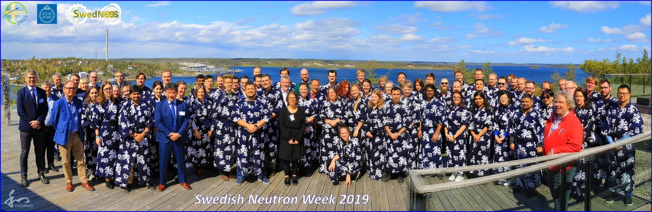

Swedish Neutron Week 2019 organized by KTH and SwedNess ( www.neutronweek.se/2019 ) hosting 120 participants from 32 different organizations (academia, industry, funding agencies, large-scale infrastructures & institutes).
- KTH/NORDITA/Chalmers/Paul Scherrer Institute/University of Zürich/ESS/DESY: This collaboration covers technical developments related to both the European Spallation Source (ESS) in Lund as well as PETRA III at DESY in Hamburg. The scientific area is novel quantum materials and involves the development of in-situ uni-axial pressure devices along with the organic materials database (OMDB).
- KTH/AIST/J-PARC/Toyota CRDL/University of Tokyo: A Sweden/Japan collaboration on sustainable energy materials with partners from both academia and industry (AIST, National Institute of Advanced Industrial Science and Technology + Toyota CRDL). The main focus of this project is sustainable batteries including lithium/potassium/sodium-based materials and devices. (Månsson)
- KTH/ETH Zürich - Materials and Device Engineering Group/Paul Scherrer Institute: A Sweden/Switzerland collaboration concerning neutron and muon characterization of nano-structured (particles as well as thin films) energy materials. (Månsson)
- ARTEMI - Atomic Resolution TEM Infrastructure network of Sweden (Weissenrieder)
- Cem4Mat – Centre for Microscopy for Materials Science, Stockholm-Uppsala (Weissenrieder)
- Photoemission consortium at the european XFEL and beamtimes at FLASH (DESY)
- SAXS and WAXS at DESY, Martin Månsson-Stephan Roth
- Joint China-Sweden Mobility. Financed by STINT. KTH- Hefei
- SFC (Svenska Förgasningscentrum). A collaboration between KTH, Luleå TH, Lund Univ for recycling biomass into new chemicals, from biomass to syngas. (Göthelid)

f. Follow up from previous evaluations
The previous RAE2012 resulted in a very positive feedback concerning the UoA as a whole. The societal impact in general and the spin-off part was particularly highlighted. The integration of activities across the UoA was seen as very positive as was the strengthening of core research areas. Much of the work since the last RAE has therefore focused on continuing the already started developments and in particular to join the activities within the UoA into a factual department. This has been a core focus during recent years and has resulted in two divisions (Photonics, Materials and Nano Physics) from the EECS school in Kista being integrated into the Applied Pysics department in 2017. As of May 2020 these two divisions have moved to a new building at the Albano campus and the process of integration and collaboration across the Bio-Opto-Nano domains has thus continued and will continue.
The main weaknesses identified during the last RAE concerned low internal funding, lack of technical and administrative support and an unsatisfactory gender balance. The low fraction of internal funding remains and continues to slightly decrease. At the same time, the department has increased substantially in volume since 2012 (now ~230 people and 275 MSEK in turn over) The administrative support has been solidified and streamlined thus providing rapid and qualified support without generating excessive economic overhead. The technical support has been somewhat improved by the hiring of a dedicated and highly qualified support technician. Technical support is however still an area of concern. The unsatisfactory gender balance remains even though it is slowly improving as can be seen among younger faculty. Continued work on improving the gender balance remains a focus area going forward together with improved recruitment processes.

II.3. Viability

a. Funding; internal and external

The Applied Physics activities are heavily focused on research with 90% of its activities related to research and postgraduate education, and 10% in undergraduate education. 65-75% of the department’s research revenue comes from external grants. (see Fig. under 2.a above)
Since 2012 our funding has been increasing roughly 5-10%/year. There is an apparent large increase in 2016 when the divisions from Kista (Materials and Nanophysics + Photonics) merged with Applied physics. The growth is primarily driven by a significant increase in external funding, nearly all coming from sources directed towards basic science and obtained in competition, such as the Swedish research council (VR), the European Union (EU), and the Knut&Alice Wallenberg foundation. The department is mainly externally funded and is heavily dependent on funding from the sources listed above as well as from the Erling Persson foundation, the Foundation for strategic research, the Swedish energy agency and other private and government funding bodies. The life science related parts of the department also have a large proportion of targeted basic funds, known as SFO funds. The institution's large turnover (a total of SEK 275 million in 2020) and its large dependence on external financing constitute a substantial financial risk. Our worry with the low fraction of the faculty funding remains, the external-to-faculty funding ratio is projected to be even lower in 2021 than in 2012. Furthermore, the increasing internal costs related to salaries, social fees, rent, administrative over-head etc. make the situation even more difficult and as a result, the internal funding covers an even lower fraction of the salaries of the faculty. Another area of considerable concern is the financing of infrastructure. The experimental infrastructure at the department requires large financial streams to run, maintain and upgrade. Dramatic changes in the way infrastructure is supposed to be financed has taken place in Sweden since 2012.
A striking example is KAW's financing of infrastructure. Previously, KAW was responsible for the majority of infrastructure investments at the department but decided a few years ago to completely stop supporting infrastructure investments. VR has also stopped supporting infrastructure and left the responsibility to the universities. At KTH, there is so far only very limited support for a few key infrastructures, which means that most of the research infrastructure currently lacks financial support. The strategic significance and consequences in the next few years will be very large. This example clearly shows the great risks that exist in current financing and how changes in external players can have a very big impact on our activities. Earmarking of internal funding and numerous internal and external special initiatives further complicate matters. A continuation of the current situation is likely to have dramatic effects on the department but also on experimental science in Sweden as a whole.
Despite the challenges outlined above, the department has continued to developed positively in the years since the last RAE. External funding has increased substantially and the department has grown by 10% per year over the last 10-year period. After the merger with the Department of Materials and Nanophysics from Kista in 2017, Applied Physics is now KTH's second largest department.

b. Academic culture
Academic culture implies an open exchange of ideas and knowledge, as well as open discussions on policies and ethical issues related to research and research practices.
The academic culture is fostered by daily discussions, project meetings and seminars. A thriving academic culture is crucial to high quality teaching and research but is also a resource and important factor in society at large. During the present pandemic this has been seen clearly in the many examples of University faculty participating in discussions surrounding research on the pandemic, Covid virus and vaccines that have been ever present in media.
Seminars
Each research group/division has its own specialized seminars that are run ad hoc or on a regular bases.
Two representative examples of those are:
At SciLifeLab the Biophysics groups have monthly minisymposia, where PhD students and postdocs present “work in progress”. Those are 4-6 15-minute presentations each time, given with an aim to foster cross-group discussions and stimulate spontaneous interaction between students and faculty from the Biophysics groups (7 PIs from Applied Physics are at SciLifeLab). The group is also extended with our affiliated research groups at SU and KI.
The Albanova Nanolab (ANL) is an open access facility that we manage. Our highly successful model fosters new ideas and open engagement. Our Nanolab-seminars that we run every Friday contribute to and take part in fostering scientific exchange and nurturing students.
We also have high quality scientific presentations at seminar series with more general scope such as the Albanova colloquium and the APHYS Thursday seminars, which are important to follow science more broadly. For the latter it is gratifying to see that so many of the senior staff realize the seminars’ importance and set an example for the Ph.D. students who often, at least initially, have a rather narrow focus on their own research and research field.
Participation in international conferences and workshops.
Highly fruitful meeting places for presenting and discussing research results and to initiate and germinate science are international conferences and workshops. Often one encounters new ideas and trends there and has the opportunity to discuss about these ideas with the originator, or someone deeply involved with the issue. Virtually all the PIs in the department are involved in technical committees, and chairs at the most important international conferences in their fields. Sometimes, we even host some of these conferences in Stockholm. As a recent example, the group of Prof Linnros organized the IEEE-NMDC conference in October 2019. Prof Toprak is in the organizing committee for the International Congress on advanced ceramics and composites -ICACC series held annually in the USA.
As part of their training, PhD students are always encouraged not only to attend, but to present at international conferences and workshops. There they get to meet prominent researchers in the field as well as to create their own network.
Informal meetings
We have a very friendly atmosphere is our department where virtually all of us have open-door policy. Thus, scientific ideas and questions that arise when grabbing coffee are always welcome and enthusiastically followed up. During the last year, these daily exchanges have unfortunately almost ceased to exist. Videolink and teleconferences are now used frequently to collaborate with external as well as internal partners. The lack of random and informal exchanges is as well as the creation of social glue is, however, a substantial loss.

c. Current faculty situation
The faculty of Applied Physics consists of 28 professors (3 female +25 male), 3 guest or affiliated professors (1 female+ 2 male), 10 Assoc Prof (4 females +7 males), 1 Ass Prof (male), 42 researchers (12 female + 30 male), and 23 Post-docs (8 female + 15 male), and 83 PhD students (female + male). See staff figure under 2.a.
Faculty vs Researchers
Since the activities related to undergraduate education are relatively limited, the number of tenure-track teacher positions is relatively low in relation to the turnover at the department. However, the strong external funding for research means that the need for both permanent and temporary researcher positions is relatively large. Researchers with a permanent position are a large portion of the department’s personnel. (42 faculty, 25 researchers (5 women + 20 men). Of those roughly 10 have duties that resemble those of an Assoc Prof.
The large proportion of permanent researchers is dictated by the need to ensure excellence and know-how on the experimental activities.
We identify a clear need of career development plan for our researchers. For all permanent researchers, KTH should offer a clear career and development plan. The researcher position should be prestigious and attractive as well as offer possibilities to salary development. In parallel, the department should develop internal strategies for how to benefit researchers’ expertise as assets for the whole department.
Faculty balance
The department has relatively few assistant and associate professors and younger faculty, compared with the large number of professors. This can be partly explained due to the fact that almost all the faculty are research active and qualify for promotion to professor after a certain period of time. On the other hand, the department is lagging behind with the recruitment of new faculty and needs to pro-actively work to advertise attractive faculty positions at the Ass Prof or Assoc Prof level in strong research areas.
Given the current promotion system and retirement age, around 10-15% of the faculty should consist of assistant professors (if all recruitment is done at this level and the faculty is to have a sustainable age distribution). The department is lagging behind with recruiting new faculty and currently has no ongoing recruitments.
Given the current retirement age of 68 years and other known conditions, a total of 8 permanent staff are retiring over the next five years. The coming 15-year period will see an average retiring rate of 1.2 faculty per year.
Gender Balance
The number of female faculty (tenure-track) has been increasing during the last 10 years and it is now 22%. (At the professor-level is 11%, at the Assoc Prof is 40%)
For post-docs and researchers, the percentage of female personnel is 35% and 29%, respectively. Of the PhD students, 30 % are female.
Although there has been a gender balance improvement over the last 10 years, the gender balance is far from acceptable. Furthermore, there is a risk of keeping it still unless pro-active measures are taken during recruitment. (see next section).

d. Recruitment strategies
Faculty recruitment
The department shall develop a strategy for recruitment at the Assis. Porf. or Assoc Prof level. At this moment, the process is too slow from start to end (both at the department level and at the KTH-central level), and there is a large risk that the best candidates choose another university simply because they do not get a response from KTH.
In order to make the positions attractive, a good starting package should be offered. The department, together with the school, should work on strategies to recruit excellent female researchers for faculty positions. Otherwise, there is a large risk that the gender balance that we have right now at the assoc prof level becomes an anecdote.
Applied physics should review how the internal institution process for developing subject areas for new faculty services is implemented. At present, the responsibility rests heavily with the research departments who both propose areas and are fully responsible for the new faculty as well as carry out the administrative work with the actual establishment of the service and recruitment. In some cases, there is a need for clearer institutional joint financial responsibility for the first four-year period and support from both the school and the institution in the administrative parts. We are currently working on a strategy at the institution level.
In order to further promote equality and diversity one needs to ensure the applicants cover as broad a spectrum as possible and that requires active and long-term work outside the call opening, addressing also minorities and diversity. A good strategy is to keep that in mind and actively encourage, advise and support good candidates whenever one comes across them (through teaching, our network of collaborators, meetings, even LinkedIn). Even if this does not necessarily mean that you shall succeed in recruiting them to your own group, this is likely to make them apply to available jobs in our department. There is also a cascade-effect, if we manage to get diverse representation in our groups and make people thrive in them, it will be our own PhDs, postdocs & researchers who will “advertise” us and encourage people to apply.
Given the strong development for the research area, Applied Physics intends to recruit on average one to two assistant (or associate) professors per year over the next few years. Adjusted for retirement, this would mean that the faculty will remain approximately stable. The main focus is to recruit at the assistant professor level, as it has proven from experience to provide very strong candidates who can in a good way adapt their activities to the conditions in the experimental research infrastructure. at KTH, while supplementing and renewing the research. Recruiting younger researchers also leads to better age distribution within the department.
Recruitment of researchers
In order to conduct experimental research at an internationally leading level̊, laboratories with the most modern equipment and cutting-edge personnel are required in order to make the best use of the equipment. The strong local research infrastructure within the department with its specialist laboratories is a direct prerequisite for successful research. A constant renewal and development of the infrastructure is necessary in order to continue to attract large research grants of the kind mentioned above. Further development of equipment, continuity and implementation of experience made requires permanent staff in the form of researchers or advanced research engineers working in the laboratories, not just doctoral students. In order to meet the growing need for such "intellectual research infrastructure" and to compensate for retirement retirements and other foreseen changes, the department intends to recruit, on average, a new permanent researcher / research engineer every other year.
Recruitment of PhD students and Post-Docs
Recruitment is done with guidance from the HR group who has acquired experience from
many more recruitments than each of us have. They help in writing adds and often take part in interviews.
All positions are advertised on the KTH home page and candidates are selected among applicants. A preferred recruitment channel for PhD students has been courses given on a master level and Master projects. A quick evaluation and providing of the offer is very important. For postdocs/researchers: provide longer contract from the start, at least 2 years, and provide a dynamic, supportive and collaborative environment.
To support gender balance, equal number of women and men are invited for interview, since research has shown that, statistically in the written CV/application men are more likely to “slightly overstate their abilities” while women instead “are more modest”. Furthermore, a female contact person will attract more female applicants.
All positions are announced openly and we advertise on European wide sides for example Quantum Flagship. Special consideration is given to female candidates, as there is are unfortunately relatively few women in our field, and women who apply.

e. Infrastructure and facilities
Below we detail the largest infrastructures and facilities that the department houses as well as some national infrastructures to which we contribute. Research infrastructure is at the core of the departments activities and is sometimes even the raison d’être. Considerable resources are necessary to develop, maintain and run the infrastructure. Within the current financing situation where dedicated infrastructure financing from external sources such as VR and KAW has been terminated it has become increasingly difficult to maintain and develop research infrastructure. This is particularly the case with our spear head laboratories. The central KTH facilities now receive some funding for investment in new infrastructure but there are no such funding available for the spear head laboratories that constitute the vast majority of our infrastructure. A measure of the necessary investments to maintain the infrastructure is given by the yearly write offs. During 2019 the write offs at the department amounted to 18 MSEK. In view of the current difficult funding situation which has resulted in lagging upgrades and limited development this figure is certainly lower than what is needed to keep the infrastructure at the international forefront. A more realistic number is probably closer to 25 MSEK but a thorough evaluation and cost estimate would have to be done on the laboratory level to give a proper estimate of the investments needed.
Spearhead labs
BALTAZAR.
BALTAZAR is a world leading facility for tr-ARPES (time resolved angel resolved photoelectron spectroscopy). The upgraded laboratory is currently undergoing commissioning at the new Albano location. The facility has been upgraded with a completely new light source including a tunable pump source. The goal is to approach the transform limit in the versatile region of 200 fs time resolution with an energy resolution of 10 meV. The targeted photon energy is 6 - 32 eV and the pump wavelength 0.6 - 9 micron. The pulse repetition rate is ≥ 250 kHz for the complete energy range in order to allow for sufficient count rates. The XUV pulses are generated through High Harmonic Generation (HHG) in a high-pressure gas jet.
UEM. Ultrafast electron microscopy.
Jonas Weissenrieder contributed to the construction of the first generation UEM and published the very first results using time resolved UEM. UEM combine ultrafast lasers and TEM to facilitate atomic-scale spatial and femtosecond temporal resolutions. The KTH UEM is the only such microscope in Sweden. Since, information may be gathered by real-space imaging, Fourier-space diffraction, and energy loss spectroscopy, UEM offers abundant information for the study of transient processes. With imaging electron energy loss analyzers in the UEM, it provides information of changes in the electronic structure, directly correlated with changes in atomic structure.
Matslab. Two scanning tunneling microscopes (STM) with sample preparation in UHV and Raman spectroscopy.
The FNM group runs a complete lab for synthesis, characterisation and testing of nano materials. The lab also includes one SEM with EDX.
Bio-sensing and advanced optical characterisation. Electron beam lithography, chemistry lab facilities are combined with advanced optical characterization tools. A “biosensing lab” has been set up for handling biological samples, microfluidics and electrical instruments for multiplexed sensing.

KTH central infrastructure
During recent years, KTH has established centrally supported research infrastructures. The applied physics department has three of these infrastructures which are described below.
The Albanova Nanolab
The Nanostructure Physics group, with a very active participation by the Quantum-Bio-Photonics, Biomedical Physics, Laser Physics, and a number of other groups at KTH, SU, and elsewhere in the Stockholm region, run the Albanova Nanolab (director prof. Korenivski). ANL’s mission is open and fair access to frontline research infrastructure and technical support for fabrication and characterization, with nanometer scale precision. The Lab is regionally unique, benefiting the high-tech environment in and around Stockholm and thereby the economic and societal development of the region. We are planning a substantial expansion of the lab to support emerging quantum technologies. Such expansion would lay a foundation for future high-tech growth in the Stockholm region. ANL is a member of the National Swedish Network for micro- and nano-fabrication MYFAB. (see below)
Nano electronics and photonics, quantum optics, quantum computing, nanomaterials, and many other activities currently advanced using the Albanova Nanolab, are important for the Stockholm region to stay competitive in the global knowledge society of today and tomorrow. Academic research at the cutting edge of science and technology moves very fast, with new directions emerging every year. It is important that the relevant infrastructure provides enough flexibility to accommodate to these rapid changes and adapt to conditions that change as new grants are secured and new research directions emerge. The scientific agenda of the Nanolab is user-driven; our vision is to act as a conduit for collaboration on expensive infrastructure that can be shared by many users and to provide an atmosphere that fosters such collaboration.
The KTH laserlab
KTH Laser Lab is a KTH Research Infrastructure established at the Department Applied Physics, comprising well-equipped labs with a broad variety of lasers, coherent sources and necessary instrumentation. It is an open facility available for users from KTH, external partners and the industry. As partners in Laser-Lab Sweden we maintain an extensive national collaboration network, and we get access to any necessary additional equipment and qualified support to meet existing needs and challenges. https://www.kth.se/sci/2.14290/aphys/kth-laser-lab
The advanced light microscopy infrastructure
The Advanced Light Microscopy (ALM) Laboratory is a KTH research infrastructure at Science for Life Laboratory. ALM provide access and user support in light microscopy. The laboratory is one of the nodes in the national microscopy infrastructure and also a member of the european infrastructure EuroBioimaging.
At ALM the following techniques are available:
- STED microscopy
- STORM/PALM microscopy
- SIM microscopy
- Light sheet microscopy
- FCS

National labs
µFab network - The Electrum lab and Nanolab at Albanova.
Electrum Laboratory and Albanova Nanofabrication Facility are the two laboratories operated within the KTH node of Myfab. In Kista, the Electrum Laboratory is outstanding for fabrication and characterization of devices based on Si, SiGe, GaAs, InP, GaN and SiC for electronics/photonics/micro-mechanics in the nano and micro scale. Electrum Laboratory supports also the whole chain from education, research and development, to prototyping and production. The Electrum Laboratory is certified according to the international ISO 9001:2015 Quality Standard. It is also certified according to the international ISO 14001:2004 Environmental Standard.
HVPE is the key infrastructure for development of high performance optoelectronic device structures. The HVPE reactor itself is unique in the world and can produce III-V epitaxial materials at high growth rate with high selectivity. Swedish, EU and international projects collaborating with industrial partners (Intel, III-V Lab, Thales, MIRSENSE) were implemented by this HVPE. The reactor was installed in 2017. In order to extend the lifetime and keep KTH’s leading position in this field, an upgrade of the reactor is currently in progress.
Large-scale Research Infrastructures
Sweden is currently making unprecedented investments in large-scale research facilities for advanced materials characterizations with the development and construction of the European Spallation Source (ESS) and the MAX IV synchrotron. The department and especially the Materials and Nanophysics division are undoubtedly the strongest KTH user group of both X-rays (ESRF, SPring-8, SLS, PETRA III/XFEL, SOLEIL) and neutron/muon sources (ILL, ISIS, J-PARC, SNS, PSI, TRIUMF) around the world. Here the department is running a very wide and high-impact scientific program, covering energy materials, catalysis, biomaterials, superconductivity, magnetism, surface science and topological matter as well as other topics. Finally, the department is also highly involved in technical developments at several of the facilities including ESS, MAX IV, PSI and DESY. This makes Applied physics one of the most active large-scale research departments in Sweden, and in specific areas, in the world.
Computing infrastructure: we depend on the SNIC facilities. Smooth functioning of the computing resources, and access to application experts and research engineers is vital.

II.4. Strategies and organization

a. Goals for development 5–10 years ahead
Applied physics is a department with great drive and momentum, which benefits greatly from the interdisciplinary environment. The department conducts experimentally oriented, multidisciplinary research within the “Bio-Opto-Nano” area and the combination of basic research and entrepreneurship has been very successful. We have internationally leading research groups collaborating on multidisciplinary projects, taking the results all the way from basic science to applications and spin-off companies. We have 120 PhD students engaged in a broad, active and productive research education. We also have a strong engagement in undergraduate education, with many specialized master courses connected to our research areas and 20 basic physics courses with labs for nearly all engineering programs at KTH.
Our vision is that Applied Physics continues to be an internationally renowned research institution within our core research areas and that the department continues to play an important role for developing and providing high quality physics education at all levels at KTH.
For the next 5-10 years the department will continue to focus on current core research areas, keep and strengthen its internationally leading position within the special areas of the respective research groups and integrate to exploit the department’s unique combination of multidisciplinary competences and collective resources to address even more complex research questions.
Focus: The “Bio-Opto-Nano” area is still only at the beginning of its development potential. Scientifically as well as industrially we foresee a significant growth both nationally and internationally. A central theme that covers many areas of the Bio-Opto-Nano concept is quantum physics and technology. Many groups within the department are very active in this area and we see a large development potential in research related to quantum technologies. This development has already started and the department is already growing its activities in this area but further development is foreseen. The EU Quantum Flagship (1 bn EUR, 10+ years) and the national Wallenberg Centre for Quantum Technology (1 bn SEK, 10+ years), both funding programs started in 2018, are illustrations of this growth and examples of areas where Applied Physics is playing an active role. The department is therefore well positioned from this standpoint and we will continue to focus on our core research areas related to quantum technologies. A key ingredient in this strategy is the establishment of the Quantum Technology Hub at KTH (QTH@KTH) together with research groups in the Physics department.
Keep and strengthen: The research within the divisions’ special areas is generally on a very high international standard and attract substantial external research funding. To further strengthen the research within our core areas, strategic faculty renewal and recruitment, with gender balance and diversity in mind, is crucial. To be able to attract and recruit top faculty members of the future we need to be able to offer attractive conditions. We see that relevant starting packages as well as stable long term funding for new positions is important. Possibly this is even extra important to recruit excellent female researchers with competing offers from other international universities.
Experimental research at an internationally leading level also requires laboratories with the most modern equipment and highly qualified staff to make the best use of the equipment. The strong local research infrastructure within the department with its specialist laboratories as well as our KTH research infrastructures is a direct prerequisite for successful research. The lack of funding agencies for local infrastructure is the major threat to the department. Substantial KTH-support for not only the currently established KTH research infrastructures, but also for specialized labs and equipment, is essential. The KTH leadership must take the responsibility to redistribute more of the internal research funding to specifically support experimental research. Otherwise, much of the excellent research and teaching based on local laboratories at KTH will (slowly) vanish.
Integrate: Maintaining a world-leading activity in experimentally oriented, cross-disciplinary research and education, requires a constant pursuit of improving and integrating the scientific environment. This applies to both the intellectual and laboratory environment. Central to the environment are the department’s three KTH infrastructures: NanoLab located in AlbaNova, Advanced Light Microscopy at SciLifeLab (both established) and KTH Laser Lab at AlbaNova (interim).These are already well-functioning central facilities that serve not only KTH but the entire Stockholm area. Furthermore, our specialist labs attract many external users, both national and international. In addition to access to first-class equipment, these various laboratories are natural meeting places where new interdisciplinary ideas are born.
We want to further develop and strengthen our open laboratory environment. As far as possible, we will continue our efforts to organize the department’s equipment and laboratories as joint research infrastructures open to all at KTH and to external users. In addition, Applied Physics has the opportunity to take the integration process one step further, now that the research divisions in Kista finally moved to the new AlbaNova building in May 2020. The new building also helps to relieve the acute office and lab space shortage experienced by some divisions located in the original AlbaNova building.

b. Congruence with university-level goals for research as set out in “A leading KTH - Development Plan 2018-23” and with the school(s) development plan(s) respectively.
The department’s goal of conducting world leading, cross-disciplinary, applied research within an field with almost unlimited applications to many of today’s societal challenges, is perfectly aligned with KTH:s goal of a leading, international university as well as the development plan for research for the School of Engineering Sciences. Our intention of taking our research results all the way from basic science to applications and collaboration with industry partners, as well as our open research infrastructures, contributes to a visible, integrated and open KTH. Applied Physics is very much a diverse environment, with more than 60 % of the employees having an international background, and the objective of the department is always to give equal opportunities to all.

c. Leadership structure and collegial structure
The department is formally divided into seven divisions. The department has a head of department and one deputy head of department. The work load of leading the department on a daily basis is shared between the head of department and the deputy. Specific areas are attributed to one of the two but important questions and decisions are handled jointly. Each of the divisions have a division head and a vice head. The division heads together with the department heads form the management group of the department. All major and long-term decisions made at the department are brought up at the monthly department management meetings. The management group also contains representation from the PhD students and the young faculty group as well as the director of graduate education, the director of undergraduate education and the head of the local administration.
A guiding principal of the department organization is to delegate the authority and responsibility to take decisions at the level that they concern i.e. the divisions have substantial autonomy to manage their economy and personnel. This means that all internal funding is distributed to the divisions and the use of the funds are entirely decided at the division level. All non-permanent staff decisions are also taken at the division level and only permanent staff recruitment is handled at the department level. The formal management structure goes hand in hand with the leadership structure for research. The choice of research topics and research direction is to a very large extent done at the division and group level even though the heavy reliance on external funding in practice means that the external funding agencies are setting the research agenda. The very strong focus on experimental research and method development at the department requires large amounts of infrastructure which in turn is costly and requires large external grants. This has at least to some extent both driven collaborations around available infrastructure but also been an incentive for cross division and cross disciplinary research thus created a collegial structure of interchange, sharing and cross fertilization. This collegial structure is also manifested in and enhanced by common activities such as the Aphys day and the Aphys seminar series. A testimony to the effectiveness of this collegial structure (more than the formal structure) is the large number of KAW project grants that the department has received.

d. Strategies for high quality
The applied physics department’s activities are to 90% research. The department’s faculty live and breathe research and have high quality research as the leading star. For most, the daily focus is on research success. The breakthrough result is what everyone is working for. In an applied project this can be a goal stated from the beginning but in many areas it is not even obvious what it will look like and part of the skill of high quality research is to learn how to recognize an important result when it shows up. Many measures of high quality research can be put up in terms of publications in leading journals, obtained research time at large scale facilities, external grants, invited talks a top conferences, appreciation from colleagues, interest from colleagues, spin-offs, patents etc. Using these measures with caution can give an indication as to the quality of the research and the department monitors these indicators to pick up positive as well as negative change. The derivative being more important than the current value as in most circumstances were a long term vision is maintained. The use of these indicators in the department quality strategy comes in both at the management group where they are discussed as well as at the division level during the regular division meetings. The topic is also reoccurring in the yearly development conversations.
The formal verification of research result published is through peer review as has been the tradition for a long time. The department has no formal internal review process of results before publication nor is there a plan to implement such a process. Accidental mistakes in research is best spotted by experts within the field and deliberate fraud is in general also difficult to spot. It would be highly burdensome and also detrimental to the internal culture to try to implement internal quality and fraud checking protocols. Instead, the department focuses on fostering a high quality culture including research ethical behavior. Considering the high and ever increasing internal as well as external publish or perish pressure, the department leadership intends to increase the awareness around these issues.
It is on the other hand important to realize that high quality research is mostly something connected to training, talent and an almost unstoppable personal drive. Most highly successful researchers have a very strong focus and self-motivation for their work. As a result, the key to high quality research lies in recruitment and training much more than in internal documents, plans, procedures and checks. The main strategy for high quality is therefore to recruit the best possible researchers and have them train the most talented and best motivated PhD students and postdocs that we can find.

II.5. Interaction between research and teaching

a. Interaction between research and teaching at all three levels (BSc, MSc, PhD) of education
The department has courses at the three levels of education.
BSc level:
The Department of Applied Physics teaches a large number of basics classical physics courses for different programs at KTH. A common content for all courses is electromagnetism and optics, and much of the department’s research is in these areas. Many of these courses include also labs, since we want to introduce the students to experimental and applied physics. About 800 students per year attend these labs. A majority of the teachers in our basic courses are active researchers, moreover, many PhD students are involved in the teaching as lab supervisors or calculation excise leaders.
MSc level:
Our department is involved in two Master programs: Engineering Physics and Nanotechnology. We are responsible for three tracks (i.e., study specialization) in the Engineering Physics Master program, and one track in the Nanotechnology Master program. Here we teach about 60 different courses, which are often very specialized and reflect the research interest and activities of different research units. Teachers are active researchers in the field and develop their courses continuously in order to include the newest research trends. An example for this is the development of a track previously called “Nanotechnology” into a new track with the name “Applied Quantum Physics” in order to reflect a new strategic research area on Quantum Technology in our department. Courses have normally about 10 –20 students and often include some lab work within our research labs. We also offer “project courses”, which are very popular. In this course, the students can work individually on a real research question with an individual supervisor in one of our research groups. Finally, about 20 – 40 students each year choose a group in our department for their Master thesis. Here the students become active members of a research group and work on relevant projects, which often result in a publication.
PhD level:
Teaching at research level is made for the students within projects at the department and courses are designed especially for them. There is a very close connection between doctoral education and research.
The Department of Applied Physics hosts one doctoral program ”Applied Physics” with two education subjects; Physics and Biological Physics. At present there are ca 120 students active within the program. The average study time is just a little over the stipulated 4 years. The connection between research and education on PhD level is very close. The doctoral education consists of two parts: research training and courses. The research training is, without any exception, done within a research project, normally funded by external grants earned in tough national competition. Here we really feel that the research interests of the faculty is a perfect ground for teaching the graduate student the tricks of the trade. In addition to the individual and daily/weekly advisor/student contacts the graduate studies are guided by the study plan. This plan is revised annually in a formal advisor/student meeting and then accepted by the dean of graduate studies. The student carries a large part of the responsibility for the progress of the project resulting in publications, patents and new discoveries. A minimum of four publications is required to earn a PhD, but the average is between 6 and 7. The quality of the work is of high international standard set by the research journals. The course package contains more than 50 courses delivered by the research groups. There is a continuous renewal of the course list to ensure quality and relevance for students within the program.
It is worth mentioning that we have a mandatory course for all our students on “Width and Ethics in Physics” 7.5 credits, that covers among other things, research methodology and ethics, the peer-review system, and gender-equality mainstreaming. Futhermore, the doctoral students are organized have a PhD council that serves as a network and gives feedback to the program regarding course content, program structure, etc.
It is worth mentioning that our department is also highly involved in the Swedish national graduate school for neutron scattering (SwedNess). This is a wide Swedish collaboration between KTH, Uppsala University, Stockholm University, Linköping University, Chalmers and Lund University. The school holds 20 (and soon 40) fully financed (SSF, 220 MSEK) PhD student projects within a broad scientific scope covering life-science, functional materials and engineering as well as fundamental physics/chemistry.

II.6. Impact and engagement in society

a. Relevance of research to society at large
One of the most important impacts that we have on society is the people that we educate. We pride ourselves in educating independent and self-reliant PhDs with a broad knowledge base. They have the basis for to setting the agenda based on facts and visions. To date 75-80% of our PhDs have continued their careers in industry. We expect that our PhDs will be equally attractive for industry also in the future and that the fraction will remain equally high, thereby helping to renew industry and to keep its technological edge.
The departments focus is on basic and engineering science, with a 10-20 year time perspective. That means that if the projects are successful, we hope to see substantial impact inside or outside of academia in 10-20 years. This impact can be in terms of techniques, devices and applications in academia, industry as well as in government services such as health care. Examples of impact from our research in the health care area are given below and we expect this impact to grow further in the future. The departments track record in producing impact in terms of spin-off companies is quite impressive. A few examples of these spin-off companies that have been created in recent years are described below. It is worth noting that KTH as a university has a quite ambivalent attitude to spin-off companies. On the one hand there is a KTH-innovation office tasked with supporting spin-offs from staff and students. KTH is also in general quite proud of successful spin-off and highlight these on various occasions. In practice, on the other hand, when it comes to supporting the crucial first period of a spin-offs, KTH has the opposite attitude and does not allow subletting of space and puts barriers to prevent renting of laboratory equipment.
Within the BIO area, our research has as an ultimate goal to generate knowledge that support, stimulate and drive development of new treatment strategies for human diseases. The goal is thus to improve health and to generate benefit to mankind both by wellbeing and by well understanding life. A simple example of this can be the research conducted by Lundström and Unsbo, which is important to optometric and ophthalmic industry manufacturing spectacles, contact lenses and intraocular lenses. Optimum design of these products is beneficial for the young generation to reduce the progression of myopia and for the older to improve their remaining vision. Another example is the technology developed by Widengren which Strategically, ultrasensitive and ultrahigh resolution fluorescence spectroscopy/microscopy is a key technology for fundamental biomolecular and cellular studies, and also for clinical diagnostics, biotechnology and drug development. As an expert group in the field, we can strongly promote neighbouring biological and biomedical research areas by interdisciplinary collaborations, stay updated, and actively contribute to the technique development. From a national point of view, with respect to both basic science and commercial interests, it is very important that leading competence in this field is maintained within Sweden, is independently supported, and further developed. By developing new imaging systems, The Testa group constantly enable new science by allowing better observation. The new images can foster biomedical studies from basic to more clinical studies. Our systems are constantly used in collaboration with biologists and medical doctors to achieve a molecular understanding of sub cellular processes such as memory formation and metabolic dysfunction in the brain.
Delemotte’s research is at the basis of structure-based drug design, understanding molecular basis for function and modulation of membrane proteins is key to successful structure-based drug design.
Energy/environment/sustainability/health are the most important scientific/societal problems of our time. Almost all our research has its origin in those societal needs and technological developments; smarter materials and more efficient processes. Even though some of our work is not directly useful in an industrial setting, the potential applicability is always clear in our research.
Research on renewable energy (solar cells, hydrogen, blue energy, thermoelectrics), energy storage and fuel cells are of direct relevance to modern society and has implications on both photovoltaic industry as well as in smart integration in the built-environment where aesthetics has to be combined with energy efficiency. (Dutta, Anand, Månsson, Sun, Doss, Göthelid, Weissenrieder, Sytjugov, Toprak)
We have developed key water technologies including removal of ions, microplastics, arsenic, microorganisms and/or prevention of these contaminating the resources is key to our societal relevance. (Dutta)
Another area where impact on new technologies is expected to be high in coming years is quantum technologies (Gallo, Zwiller, Haviland). Right now, we are in a transition time when the technology for manipulating and measuring a single atom, ion, molecule, or photon has reached the stage to transit from research labs to industrial applications. This has certainly been noticed on the international level, with related large investments in Europe, USA, China and Japan. In Sweden the WACQT-program is a national manifestation of this fact. This program, with its important node at KTH, will serve as a vehicle to train quantum engineers and transfer know-how and technology to (mainly Swedish) industry.
We perform research, which will be crucial to develop secure communication, based on the laws of quantum mechanics. Quantum communication will protect our society of eavesdropping, enable secure digital authentication. We are currently working together with Eriksson AB to build a test-bed quantum link between Albanova and Ericsson lab in Kista (Zwiller).
In the last decade, the impact of optics and photonics has been extraordinary in most fields of science and technology, https://www.photonics21.org/ . Several of our national funding agencies are specifically focusing on the usefulness of science and the possibilities for exploitation. Our department has a strong tradition in work along these lines through collaboration with leading industries and we have successfully spun out several ideas in start-up companies, mostly with help from KTH Innovation and Stockholm Innovation and Growth (STING). We work extensively with RISE, (Research institute of Sweden) who almost exclusively work in projects related to Swedish industry and government institutions. Financed through SSF we have had Michael Fokine working 50% of his time at Northlab Photonics AB implementing one of his inventions in their products. The group has key contributions to the establishment of laser technology in Sweden. Almost all (>85%) of former students are working in industry at leading positions, mostly in the fields of optics and photonics, close to 30 % are women.
For instrument-oriented research, it does not matter how much you talk – true impact comes when the many use our tools to improve their processes. That means that the tools need to be made available to the world – which requires an industrial engagement. This also provide the real test on the value of your ideas – do people out there want to pay for it?
Therefore, commercialization is a prime tool for impact and several of the developments made at the department have been commercialized. Examples are Excillum (X-ray sources), Cobolt (Lasers), Intermodulation Products (AFM) and Single Quantum (Photon detectors).
We work on new pharmaceutics to treat (colorectal) cancer (Vinnova project, with a company – Oblique therapeutics – SLU and Karolinska). From the longer term perspective, we expand into Optical Quantum Sensing for advanced biomolecular and environmental studies (VR Res Envir); applications of nonlinear and quantum LN nanotechnology for better (faster), lower-energy-consumption communications and sensing

b. Research dissemination beyond academia
Impact on dissemination
We support and encourage contacts with journalists in traditional media – newspapers, TV, and radio. Good opportunities to reach out were given at the Nobel Price 2014 (super-resolution microscopy) and 2017 (cryo-EM) when radio and TV made interviews at SciLifeLab.
Several groups are also active in social media (Twitter and Instagram), as a mean to easy reach out beyond the traditional audience, this is particularly attractive for imaging based research where the images can convey appealing messages (or just be beautiful).
We also actively encourage science teachers (via personal contacts) to bring their students and visit the laboratories. (The microscopy infrastructure at SciLifeLab has recently applied for a VR grant to give access for schools to the infrastructure).
Lundström: Joint white-paper publication to the stakeholders in myopia-prevention (e.g. clinicians and politicians). Popular science presentations to ophthalmologists, optometrists and patient organizations on the importance of proper optical correction also with age-related macular degeneration (generally thought to be of less importance).
Prof. Viklund: Contributions to the public debate about safety in using ultrasound technology in medical engineering and biotechnology. He is continuously using his expertise for teaching purposes, such as radiology nursing and sonography clinical programs; workshops for medical doctors and for ultrasound technology companies (including engagements in ultrasound technology companies in Sweden and USA).
Prof. Dutta have been very active in contacts with high schools having arranged full-day visits of in total 180 students from a local high school. 7 of those did their high school degree projects at the Functional Materials group. More than 65% of those students were girls. This is the way to improve gender balance in technical sciences.
Prof. Björk appears frequently in the Swedish media. He contributes quite often to newspapers, Swedish Radio and Swedish television, about research and technology pertaining to quantum optics and related fields. Through Vetenskapens hus he engages with students aged 13-18, in the hope that they will become attracted to science and technology.
Prof. Gallo reaches out to high school students in Sweden and, in particular, to girls via e.g. Lise Meitner’s lectures, mentoring every year two RAYS high school students, and doing other activities. We are planning to do more press releases, highlights for industry, and other dissemination activities, in partnership with Chalmers (for WACQT) and EU consortia (MICROCOMB).
Prof. Korenivski teaches two large, net-based, nation-wide courses on Modern Physics and Environmental Physics, running in both Fall and Spring, which is another way to disseminate and promote science as well as sustainable development. The student audience is as diverse as the society itself – students of all backgrounds, schoolteachers, engineers, retirees, managers, artists, diplomats, and even inmates.
Prof. Laurell is a co-founders, and Prof. Canalias a board member, of PhotonicSweden, the national platform in Photonics, that includes all leading universities and more than 50 companies in the field. Together with them we arrange evening lectures once a month, open to the general public. We were the local organizers of the International year of Light events (http://www.light2015.org/Home.html) and the celebration of Lasers 50 years (http://www.laserfest.org/). We have participated in several national radio and TV programs and debates, related to our research, the Nobel prizes and others (see for example https://www.iva.se/en/tidigare-event/the-future-is-light/). Prof. Laurell is heading the division for Basic and Interdisciplinary Engineering Sciences at the Royal Swedish Academy of Engineering Sciences.
Prof. Pasiskevicius has written a Popular science article on pioneers in Raman lasers for World of Physics. We have been involved in writing whitepapers for policymakers at EU agencies (ESA, EDA and EU commission) on the status of European non-reliance in key mid-infrared technologies.

c. Sustainability and the United Nations’ Sustainable Development Goals (SDG)
Ca 80% of our research is related to sustainable development. Research on materials for solar cells, batteries, hydrogen production and storage, waste heat harvesting, LEDs and fuels cells directly relates to SDG7 (Affordable and clean energy) and SDG13 (Climate). The research leads to more efficient energy harvesting, storage and use. New materials are non-toxic and earth-abundant. Spintronics and spincaloritronics are technologies that use much less power than conventional electronics. Integration of photo voltaics in buildings targets SDG 9 and 11. Research on bio-medicine addresses SDG3.
Access to clean water is a key to peace and development. One of our objectives is to devise tools to decentralize water treatment and water re-use, and demonstrate how it can be done safely and sustainably, considering the social, environmental and economic dimensions. This works addresses SDG1 (ending poverty), SDG17 (international partnerships). Without water, food would be scarce (SDG2). Without clean water, maintaining health is doubtful (SDG3). Gender aspects (SDG 5) are intertwined with water across cultures and SDG6 deals with drinking water and sanitation. The list also includes SDG7, SDG9 (industry and innovation), SDG11 (cities), SDG12 (consumption), SDG13, SDG14 and 15 (ecosystems in the ocean and on land) and SDG16 (peace).
Sustainability and green chemistry aspects are integrated not only to our research but also to the educational programme (several courses taught in Nanomaterials and Chemistry) addressing SDG4.
Some examples of recent projects with clear SDG focus:
- 2 projects on III-V solar cells and 1 on LEDs from the Swedish energy agency.
- 2 projects from the Swedish energy agency to develop Si based multi-junction solar cell.
- Project on development of hybrid thermoelectric materials and devices (FET-OPEN, H2020)
- Project on the development of quantum-limited resonant mechanical force sensor for AFM (FET-OPEN, H2020)
- Project on project on building-integrated photovoltaics (Swedish Energy Agency). It is run together with a commercial company (Mercene Labs AB).
- Advanced nano-therapy and diagnostics (biomolecular sensing)
- Project on compact and low cost LIDAR system applied to CO₂ monitoring (with Lund University) as well as OPO system for global CO₂ monitoring (in EU project)
- Optical powering and communication system for grid control of wind mills

d. Impact cases
Impact cases are presented in Appendix A.II.

e. Structure for increased impact
The department is working along several avenues to increase its impact:
- In the research that we perform, we are actively pursuing topics that align with our core competences as well as with the goal of being either of fundamental scientific importance, of high application value or of direct importance for a societal topic such as health or sustainability. This selection of research topics is a guiding principal for achieving research results that are of strong interest to the surrounding society and thus has great impact.
- The research that is performed in the department is published in journals that have the highest possible impact. Well known, well reputed, international and peer reviewed.
- The department leadership is dedicated to supporting patents and spin-offs by direct encouragement, mentorship through the large number of staff with experience in spin-offs and by constantly working to increase KTH support for spin-off companies as well as to remove unnecessary bureaucratic hurdles.
- The department fosters a culture of exchange and engagement with society in general by encouraging participation in radio and TV broadcasts as well as other popular media such as popular science journals and social media. The department also actively outreach activities and in particular towards students. We involve students in outreach activities, for example at school visits and open house. We accept summer students from junior high school and up who are interested in research. Particularly popular has been for the younger ones to “play” in the 3 D printing laboratory. Rays for excellence is a national program for scientific training for last year high school students. We have one or two of those each year.
- Another avenue for outreach is opinion building and broad public education. An example is our exhibition and lectures in the Dome of Vision, during the year of light 2015.
- We are increasing our impact by running open facilities that are heavily used by researchers in other departments, other universities, and companies. These labs are presently increasing in size and usage. For example, our department hosts the Albanova Nanolab where our unique AFM modes instruments are available, including training courses. The national imaging lab that the department runs at Scilife lab is another unique infrastructure that has users outside the department as well as KTH. In this way our specialized instrumentation and practical user-knowledge has impact far beyond our own research groups.

ANNEX A. IMPACT CASES

IMPACT CASES from PHYSICS

Case 1) The discovery of the Higgs boson
The Higgs boson discovery in 2012 was the first of the major breakthroughs in fundamental science in the past decade. It made the headlines in media all over the world, and created a surge of interest from young people in basic science. In the years following the discovery, we saw a doubling of the number of students selecting courses in particle physics at the master level. KTH was the only university in Sweden that was directly involved in the analyses that led to the discovery, and in the years that followed we were involved in numerous activities aimed at disseminating our understanding of the subatomic world to the general public. Examples of such activities are:
A particle physics tour in 2014, going from Stockholm to Sundsvall, Umeå, Luleå and back south to Uppsala with a van loaded with exhibition material. At each stop, there were open lectures for the students at the university, exhibitions, and open lectures in the evenings open to the general public. This was especially appreciated at the universities where there are no particle physics groups, and generated a noticeable increase in Swedish applications to student programs at CERN.
A recurring yearly charity auction for a private full-day visit to CERN, organized since 2016. Connected to a yearly fund-raising event by Swedish public service radio and TV. This has reached a very wide audience and generated lots of interest for particle physics research. As organizer of this we had a chance to talk about our research on live broadcasts to tens of thousands of viewers several of the years. It has also up to now generated a total of over 23 kEUR to charity.
Numerous other outreach activities, for example: A full-hour interview in Sweden’s biggest morning radio show, with ~600k listeners, and a popular podcast version published by the Swedish public service radio channel. Serving as guides for 10s of groups of students from Swedish schools and universities, politicians, and other parties to the facilities at CERN.
Disregarding spin-off effects generated from detector and computing developments related to particle physics, such as medical imaging and the World Wide Web, it is generally true that breakthroughs in basic science need longer time scales to be commercially relevant. History clearly shows however that our advances in the understanding of the world around us are pivotal to progress in society. The theories of quantum mechanics and relativity were considered to be of purely theoretical interest when they were developed a hundred years ago, but today they are critical to technological advances in e.g. micro-electronics, medicine, and high-precision positioning devices. The future will tell when and where, but not “if”, the Higgs boson discovery transitions from something that mainly satisfies the human desire to understand the universe into a theory which underpins technological advances in society.

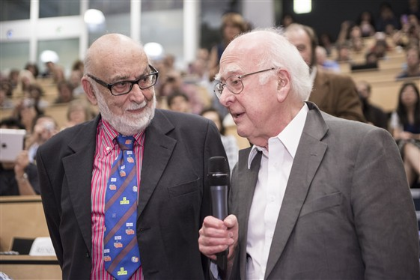
Higgs boson discovery announcement on 4 July 2012. CERN auditorium. Photographer: Maximilien Brice
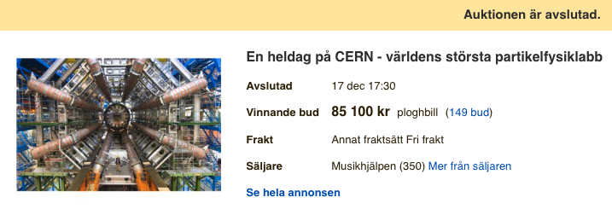
“A full day at CERN” generated 85.100 SEK for charity in 2017.

Case 2) Quantum computing and quantum sensing with superconductors
Quantum technology promises revolutionary advances in many aspects of society, such as in secure communication, ultraprecise sensing, quantum computing with near term applications to climate modelling, materials development and quantum chemistry. The importance and far-reaching promise of quantum technology is reflected in the EU quantum flagship.
The condensed-matter-theory division’s research on quantum matter ranges from fundamental theory with long-term impact---including the theory of topological quantum matter---to direct development of near-term and promising quantum technology, including quantum sensing with superconducting single photon detectors and quantum computing on platforms based on unconventional topological superconductivity. Detailed modeling and computer simulations of the properties of the relevant quantum materials play an essential role in realizing the promise of quantum technology, as devices cannot be reliably developed without such input. World-leading detailed microscopic simulations of unconventional superconductivity resulted in the Babaev group taking up consulting to Microsoft Station Q in their quantum computing pursuits.
The Babev group developed unprecedented capabilities to model superconducting quantum devices using a hierarchy of macroscopic (e.g., Ginzburg-Landau) and microscopic (e.g., fully self-consistent Bogoliubov-de Gennes) models. This allows efficient simulation of superconducting correlations and current patterns in superconducting devices, which is essential for reliable design of quantum circuits for quantum computing and had remained a challenging bottleneck for simulations. This development allows for advantageously applying these methods to other problems in quantum technology utilizing superconducting devices. This includes superconducting nanowire single photon detectors, developed in the Applied physics department, with further theoretical understanding provided by the Wallin and Lidmar groups.
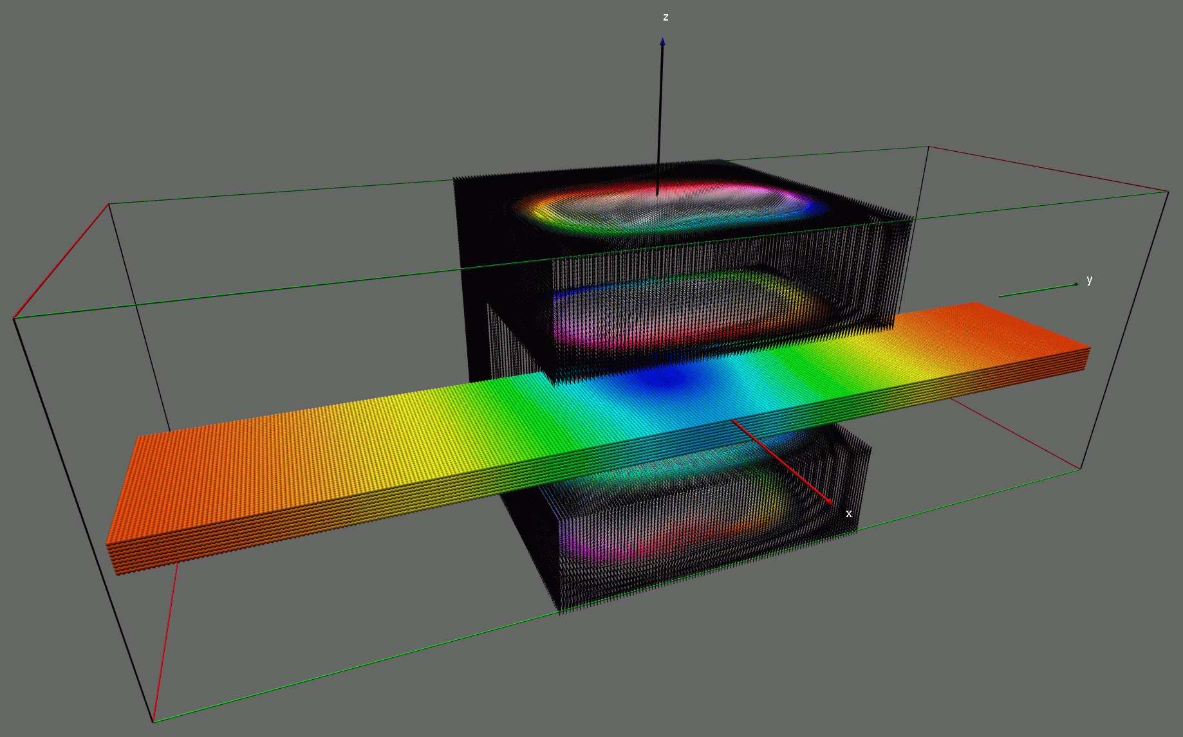
The impact is corroborated through:
- Spin-Orbit Protection of Induced Superconductivity in Majorana Nanowires, Editor’s Suggestion in Phys. Rev. Lett. 122, 187702 (2019).
- VR Research Environment on optical quantum sensing together with applied physics.
- Wallenberg Project Grant on Quantum Sensors together with applied physics.
- Spin-off company founded: Quantum and Classical Solutions International AB http://quantumandclassical.com

Case 3) Photon-Counting X-ray imaging
The research into medical x-ray imaging with photon-counting detectors at the department originally grew out of fundamental particle physics research. Silicon-strip detectors have been used since the 1980’s for tracking particles generated in high-energy particle collision experiments. Since the late 1990’s these detectors have been adapted for use in medical x-ray imaging by Mats Danielsson, now professor and head of the physics of medical imaging division. Silicon-strip detectors measure x-ray interacting directly in the semiconductor material, thereby achieving detection speed fast enough to count individual photons and measure their energy. This gives photon-counting silicon strip detectors significant advantages over conventional detectors in terms of noise performance and spatial resolution and allows measuring tissue composition based on the x-ray energy distribution.
The physics of medical imaging division pioneered the research field of photon counting x-ray imaging, authoring the first scientific papers in this area both explaining the theory and performing the first experiments. Over the years the group has generated more than 100 granted patents in different countries, covering electronics, detectors and methods for data processing and image reconstruction and published a large number of scientific articles. The first spin-off company emerging from this research was Sectra Mamea AB. The company adopted the photon counting technology to early breast cancer detection and diagnosis providing lower radiation dose for the patients, which is an important feature since the female breast is sensitive to radiation and a significant fraction of the population is being screened in national mammography programs. The system branded as “MicroDose Mammography” was the first product for medical photon counting x-ray imaging that was approved by the US Food and Drug administration (FDA). It achieved 40% lower radiation dose than conventional digital mammography at equal or better diagnostic image quality and was installed in at around 1000 hospitals in 40 countries.
From 2008 on, the division has been adapting this technology to x-ray computed tomography (CT). CT is one of the most common medical examinations with around 100 million scans being done every year only in the US and a very important tool in emergency rooms for trauma patients and for diagnosing stroke, cancer, cardiovascular disease and lung diseases such as covid-19. The group at KTH built one the first full-field prototypes in the world and demonstrated significantly higher spatial resolution as well as improved contrast and/or reduced radiation dose compared to today’s state-of-the art CT scanners. When presenting the technology 2018 at European Congress of Radiology, the largest conference in Europe in this field, we received the award as best scientific presentation in medical physics. To commercialize the technology in CT, Prismatic Sensors AB was started in 2012, and after expanding to 25 employees in 2020, the company was acquired by GE Healthcare in December 2020. One important reason for this success is the close integration between the company and the Physics of Medical Imaging research division at KTH, with several persons holding dual appointments with both the company and KTH, allowing rapid implementation of innovations generated within the research division and continuous feedback on the real-world relevance of the research.
The photon-counting technology and the acquisition by GE healthcare has generated attention in Swedish and international media outlets such as Dagens Industri, Bloomberg and CNBC. After the acquisition the development of the new technology is as intense as ever, and including subcontractors at least 50 full time employees is currently working on this development and manufacturing only in the neighborhood of Stockholm. The next prototype is currently being prepared for installation in the Karolinska Hospital at MedTechLabs for clinical evaluations.
Below is an image of the inner ear for the first patient compared to state-of-the-art “dual energy” CT. The higher spatial resolution for the new spectral photon counting technology is evident, as shown for example by the visibility of the ear drum (yellow arrow).

Case 4) Containing the Fukushima accident
After the notorious accidents which occurred in Fukushima Daiichi Nuclear Power Station (FDNPS) in Japan, Nuclear Power Safety at KTH (NPS) immediately participated in the international efforts to assess the accidents and to learn its lessons. Taking advantages of NPS in-house expertise built during the previous projects supported by SSM, NPS performed quick analyses of the Fukushima accidents [Chen & Ma (2012): MELCOR simulation of SBO scenario of Fukushima Daiichi-3 BWR, Proc. of NUTHOS-9, 2012; Chen & Ma (2014): Simulation of station blackout accident in Fukushima Daiichi-2 BWR, Proc. of ICAPP 2014]. Later on, the newly established Collaborative Laboratories for Advanced Decommissioning Science (CLADS) in Japan came to NPS for collaboration and had invited NPS experts to give technical talks at CLADS workshops. In close collaboration with CLADS, NPS researchers has developed Post Fukushima EU/Japan research roadmap [Bechta, S., Ma, W., Miassoedov, A., et al. On the EU-Japan roadmap for experimental research on corium behavior (2019) Annals of Nuclear Energy, 124, pp. 541-547.] Meanwhile, under the auspices of Nuclear Regulation Authority in Japan (NRA), NPS have been carrying out experimental investigations on severe accident phenomena important to build-up of predictive capabilities at NRA for stringent regulatory needs in Japan [Hotta, A., et all. Experimental and Analytical Investigation of Formation and Cooling Phenomena in High Temperature Debris Bed (2019) Journal of Nuclear Science and Technology, Article in Press.] Moreover, NPS is the partner of a series of OECD/NEA projects dedicated to Fukushima accidents: TCOFF, PreADES and ARC-F, standing shoulder-to-shoulder with large national laboratories and TSO such as CEA and IRSN from France, SNL and NRC from USA, and VTT from Finland. In the TCOFF project, a thermodynamic analysis for corium compositions in the lower head in the FDNPS Unit 1 [Komlev et al (2019): Thermodynamic characterization of fuel debris and fission products based on scenario analysis of severe accident progression at Fukushima Daiichi NPP, Technical Report] indicated the possible improvement of the MELCOR code which is one of the workhorses for severe accident simulation, calling for an ongoing efforts at SNL in collaboration with NPS. The PreADES project supplied results of preparatory studies on fuel debris retrieval in FDNPS. Based on the on the competence of NPS on debris bed coolability, NPS is responsible for building an analytical table for maintaining cooling function during corium debris cutting, removal and decommissioning of FDNPS, and report [Ma et al (2019): On cooling function during removal, transport and storage of debris from FDNPS, Technical Report] was well received by the community. NPS research in the ongoing ARC-F project has a focus on best estimate modelling of severe accident progression in specific reactors of FDNPP plant using code inputs developed by the project partners. The results will be used in Fukushima decommissioning activities but also for safety improvements of the existing and future reactors.
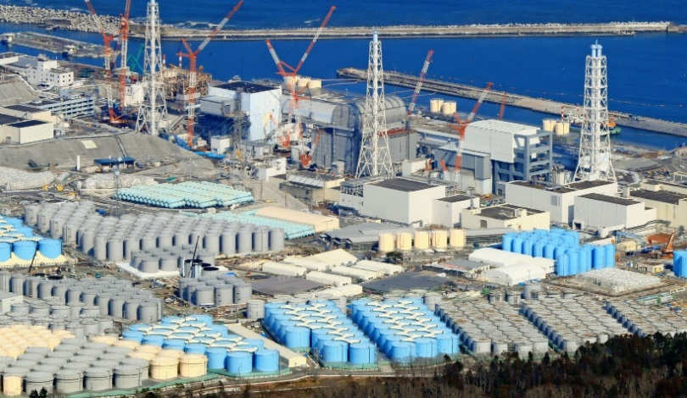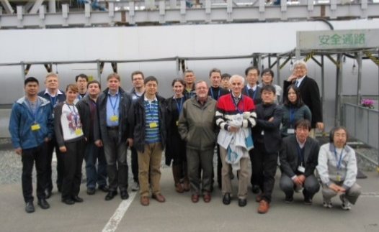
Fukushima Daiichi site today (left) and OECD/NEA TCOFF experts visiting the site (right)
An example of our recent developments and practical applications, which can have strong impact on reactor safety and will influence NPS future research agenda, is new safety system invented for light water reactor by NPS division members [S. Bechta, W. Ma, A. Komlev, L. Manickam, A. Konovalenko, W. Villanueva, S. Roshan, A. Karbojian. A safety system of a nuclear reactor for stabilization of ex-vessel core melt during a severe accident. International PCT Application No. PCT/SE2018/050333. Publication number WO 2019/190367. Published:
03.10.2019].

Case 5) Neutron-Gamma EmissionTomography
Case study concerning impact of research/impact of education: Research
Summary of impact

A novel technique for rapid 3D imaging and characterization of special nuclear materials like weapons grade plutonium and uranium, neutron-gamma emission tomography (NGET), has been developed at the Division of Nuclear Physics. The technique is adapted from fundamental nuclear physics research conducted at the Division and represents a conceptually new approach to detection and imaging of small quantities of such materials. Measuring the characteristic fast time and energy correlations between particles emitted in nuclear fission processes in real time in conjunction with modern machine learning and image reconstruction techniques provides unprecedented imaging efficiency and spatial resolution. This new imaging modality addresses global security threats from terrorism and the proliferation of nuclear weapons. It is versatile and can readily be adapted to different detection geometries in different applications for nuclear security, public safety, nuclear accident scenarios and radiological surveying in various contexts. The IP rights¹ have been transferred to KTH Holding AB with patent applications in the next phase to US, EU and China.
Underpinning research
An outline of what the underpinning research was, when this was undertaken and by whom.
Techniques for studies of exotic atomic nuclei in fundamental nuclear physics experiments have been developed at the Div. of Nuclear Physics, KTH for decades, see Ref. 2 for a recent example. The new technique is an invention² based on the same type of hardware and described in Ref. 3.
Sources to corroborate the impact
- Cederwall, B., Int. PCT Patent application No PCT/SE2019/050609
- B. Cederwall, et al., Phys. Rev. Lett. 124, 062501 (2020)
- J. Petrovic, A Göök, and B. Cederwall, arXiv:2012.12793v1 [physics.app-ph] Science Advances, in press.

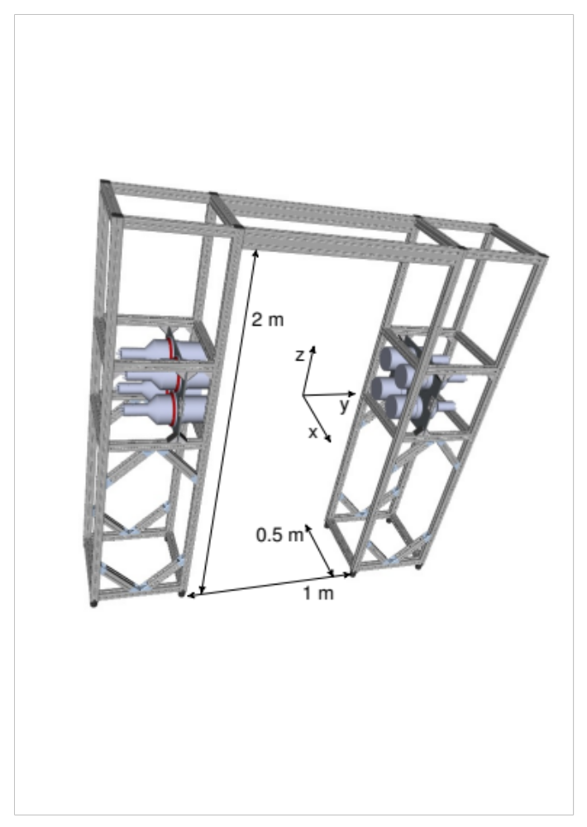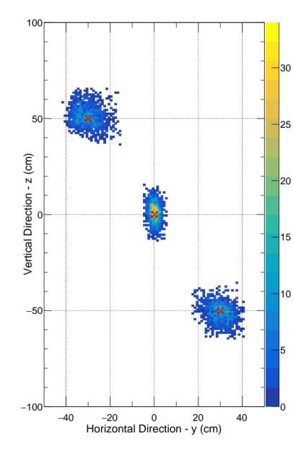
Fig. 1. Left: CAD model of the prototype RPM system including its mechanical support structure. Right: Results of repeated measurements for three different placements of a 3.2 10⁻⁹ g encapsulated Cf-252 spontaneous fission source. See Ref. 3) for details.7

Case 6) Advanced nuclear reactor development in Sweden
The nuclear engineering research at the physics department has been causing significant ripples in Swedish society for decades. There have been several reactor designs and large scale projects aiming at a future nuclear energy development in Sweden. Nuclear energy is a hot political topic and has been so since the 1980’s. It has been dividing the political parties, which explains the many strange twists and turns in policy and law. Researchers in Nuclear Engineering are often involved in the public debate on energy and climate policy.
In the summer of 2020 Nuclear Engineering won an unprecedented 50 MSEK research grant from the Swedish Foundation for Strategic Research (SSF) with the SUNRISE centre application focused on leading the national program for development of sustainable nuclear energy technology towards the construction of a Swedish lead-cooled research and demonstration reactor. This sparked intense media attention, political debate and industrial interest. There were over 20 interviews in radio, newspapers, internet news sites and more, even before the centre was started.
After the submission in the spring of 2021 of an application for the next stage of SUNRISE: SOLSTICE – a large scale electrically heated LFR prototype demonstrator, to the Energy Agency together with Uniper and LeadCold, the PIs involved have appeared in even more interviews on national television, newspapers, radio, web news and podcasts. The Swedish minister for the environment, Per Bolund, who replied with open criticism regarding the proposed technology in an interview in one of the two largest newspapers, was subsequently reported by a liberal opposition politician to the Swedish constitutional council for potential improper use of ministerial influence.
The recent media ripples even extend beyond the Swedish borders, as the story of how small modular reactor research is looking for funding in Sweden has appeared in Le Monde, World Nuclear News, etc. From the general public, the amount of direct questions to the PIs about advanced nuclear technology has increased significantly. This type of attention has been directed to the nuclear engineering researchers on and off since many years.
The underpinning research that drives the development of advanced reactor systems is in reactor physics, design, control, safety and materials – with particular focus on advanced alumina-forming steels and high-performance nuclear fuel. A spin-off company, LeadCold Reactors, has been founded in 2013 and has been appearing in media all across the world with its proposed reactor technology focused on small modular lead fast reactors.
Selected recent media sources:
Le Monde – 2021-02-19: En Suède, un coup de froid relance le débat sur le nucléaire
Energy Global News – 2021-02-17: LEADCOLD, KTH AND UNIPER TO BUILD THE NUCLEAR REACTOR OF THE FUTURE
Dagens Nyheter (one of two major national newspapers) – 2021-02-15: Kan svenska minikärnkraftverk lösa energiutmaningarna?
World Nuclear News – 2021-02-15: Joint venture formed to spur SMR deployment in Sweden
Swedish national television – 2021-02-15: Ett steg närmare ny forskningsreaktor i Oskarshamn – ansökan inskickad
Svenska Dagbladet (one of two major national newspapers) – 2019-02-16: Debate article: Ny kärnkraft skulle spara minst 1 000 miljarder

IMPACT CASES from APPLIED PHYSICS

Case 1) Excillum and Exciscope: X-ray start-ups from Biomedical and X-Ray Physics
Summary of impact:
Excillum started 2008 and is now a profitable 65+ person company with a turnover of >130 MSEK/y and 30+% annual growth. It builds and sells liquid-metal-jet and other high-end microfocus x-ray sources, inventions coming from BIOX (cf below). More than 130 sources are in operation world wide (still not Africa and Antarctica). It is presently primarily an OEM product for x-ray scattering, diffraction and imaging. Customers range from research institutions to the semi industry. Excillum aspires to be the global leader in high-end x-ray sources.
Exciscope started 2020 and received its first round of financing in September 2020. Exciscope will build and sell high-resolution phase-contrast x-ray imaging systems, in particular for low-Z (soft) materials, building on our extensive research experience with such imaging. The system offers a unique combination of speed, resolution and contrast and aims to put x-ray imaging into the hands of new industrial settings (food, packaging, histology). It is presently building its first in-house system and hopes to have its first orders within the next 12 months.
Both companies were started by Hans Hertz and teams of PhD students that did the underpinning research. For Excillum they were Oscar Hemberg, Mikael Otendal and Tomi Tuohimaa and for Exciscope William Twengström, Jakob Larsson and Jenny Romell.
Underpinning research
Excillum: Not much had happened to x-ray sources since 1929 (rotating anode) when we came up with the liquid-metal-jet-anode concept year 2000 [1,2]. The invention was stimulated by our previous research in soft x-ray liquid-jet laser-plasma sources, the transition of our community toward higher energies, and the insight that the source was the limiting factor in much of x-ray imaging. The following years three PhD students (first Oscar Hemberg and then Mikael Otendal and Tomi Tuohimaa) investigated the source and also did the first phase-contrast imaging [3,4]. Excillum started 2008.
Exciscope: When Excillum was out the door, we returned to our original interest and the original motivation for the liquid-metal-jet invention: biomedical imaging. Here we soon tried phase-contrast imaging using the new source on a wide range of samples (kidney, mice, zebrafish, biopsies, mummies [5-8]), starting 2011. The key observation was that we could achieve cellular- and sub-cellular-resolution imaging with reasonable contrast, first proved by W. Vågberg, now Twengström. Jenny Romell refined the system for different applications and Jakob Larsson joined the team with his background in x-ray fluorescence imaging systems. Exciscope started 2020.
References
H. M. Hertz and O. Hemberg, “Method and apparatus for generating x-ray and EUV radiation and use thereof” WO 02/11499: (2000) (cited: )
O. Hemberg, M. Otendal, and H. M. Hertz, “Liquid-metal-jet anode electron-impact x-ray source”, Appl. Phys. Lett. 83, 1483 (2003) (citation: 178)
M. Otendal, T. Tuohimaa, U. Vogt, and H. M. Hertz, “9 keV liquid-gallium-jet electron-impact source”, Rev. Sci. Instr. 79, 016102 (2008) (citations 75)
T. Tuohimaa, M. Otendal, and H. M. Hertz, “Phase-contrast x-ray imaging with a liquid-metal-jet-anode microfocus source”, Appl. Phys. Lett. 91, 074104 (2007) (citations 85)
U. Lundström, D. H. Larsson, A. Burvall, L. Scott, U. Westermark, M. Arsenian Henriksson, and H. M. Hertz, ”X-ray phase contrast CO2 angiography of sub-10 µm vessels”, Phys. Med. Biol. 57, 7431–7441, (2012) (citations 23)
W. Vågberg, D. H. Larsson, M. Li, A. Arner, and H. M. Hertz, “X-ray phase-contrast tomography for high-spatial-resolution zebrafish muscle imaging”, Sci. Rep. 5, 16625 (2015) (citations 34).
W. Vågberg, L. Szekely, J. Persson, and H.M. Hertz, “Cellular-resolution 3D virtual histology of human coronary arteries using x-ray phase tomography”, Sci. Rep. 8, 11014 (2018) (citations 20)
J. Romell, W. Vågberg, M. Romell, S. Häggman, S. Akram, and H.M. Hertz, ”Soft-tissue imaging in a human mummy: propagation-based phase-contrast CT “, Radiology 289, 670-676 (2018) (citations 13)
Sources to corroborate the impact:
Excillum: See www.excillum.com. See user’s stories, world-wide sales etc etc.
Exciscope: See www.exciscope.com. Significant funding raised but still too early to judge commercial success. Please come back in a year!

Case 2) Supercapacitors clean water
Summary of the impact
Access to safe water is a fundamental human right but our world is fast running out of fresh water supplies. The world is facing a growing shortage of fresh water sources due to climate change and resource depletion. The policies and strategies adopted by governments across the globe to conserve water resources and to improve clean water availability has made water treatment a multi-billion-dollar industry. There is a constant push to improve the currently used treatment technologies to enable water re-use and make the water treatment processes more energy, cost and water resource efficient. Reverse Osmosis technology is by far the most predominant one in the market but has significant drawbacks in terms of water recovery and energy requirements. The core contribution has been in developing flexible electrode-based devices using three electrodes instead of the classical two electrode systems in standard electrochemical cells leading to enhanced charge efficiency of ion removal. This membrane free and modular concept developed by Dutta can potentially lower application specific costs and real estate requirements offering lower CAPEX that will make it possible to assist the needs of even impoverished people across the globe. The concept of this water cleaning device is to provide single technology to provide safe and controlled salinity drinking water to recycling industrial and municipal waste water- somewhat like the office 365 of water treatment.
Underpinning research
The focus of the research was to build cost-effective membrane free water treatment solution using the super-capacitor concept. This research has led to a device to efficiently clean water through sustainable, chemical-free, reliable and cost-effective systems to care about the well-being and health of millions. The solution is a unique membrane-less capacitive deionization (CDI) system that is efficient in removing dissolved ions from water using a novel three-electrode configuration to reduce power consumption and improve operational flexibility. Capacitive Deionization (CDI) is an electrochemical technology for removing charged species like ions of salt from water. Fundamentally it works on “capacitive ion storage”, a phenomenon where in response to energy applied as voltage or current across CDI electrodes, ions of salt are accumulated and stored capacitively as electrical double layers (EDL) at the surfaces of CDI electrodes (similar to a capacitor or battery). Since the accumulation of ions is dominated by physical phenomena (no chemical reaction), it is a reversible process with systems based on CDI technology being characterized by low energy requirements, reduced maintenance and a long service life. Furthermore, Dutta’s research on membrane-free process of deionization leads to lower fouling of electrodes and the simple design of the device (rolled up supercaps using flexible carbon electrodes) allow low-pressure operation and the technology is scalable and solar power driven process to treat required quantities of water simply by adding multiple devices like a “LEGO” for sustainable water treatment in circular economies. Furthermore, the electrodes when modified with “redox-couples” can lead to advanced oxidation processes- leading to new applications in the energy-water nexus. The research addresses United Nations (UN) development coals namely, SDG 6.1-6.4 for sustainable drinking water provision to populations, reduction in production costs, water consumption and treatment costs (SDG Targets 8.2 and 8.4), eventually contributing to poverty reduction (Goal 1 and 8) and improving health (Goal 3). Appropriate technology for future clean water provision can address vulnerable societies (SDG 11) while safe and clean drinking water will reduce preventable deaths among children (SDG Target 3.2).
Currently three PhD students are working in related projects, one focusing on electrode modification for enhanced operation (Esteban Alejandro Toledo Carrillo), another of water oxidation (María Isabel Alvarado Ávila) while the third student is focusing on modeling of these devices (Johan Nordstrand). A post-doc is dedicated to develop metal-organic-framework structures for enhancing ion exchange during charging and discharging of the capacitor (Xingyan Zhang).
Some illustrative publications from the group in this area of research over the last two years are:
- Desalination 500: 114842 (2021), https://doi.org/10.1016/j.desal.2020.114842; Journal of The Electrochemical Society 168: 013502 (2021), https://doi.org/10.1149/1945-7111/abd82f;
- Cleaner Engineering and Technology 1: 100016 (2020), https://doi.org/10.1016/j.clet.2020.100016;
- Joydeep Dutta & Karthik Laxman Kunjali, Patent US20200180982A1, June 11, 2020, https://patents.google.com/patent/US20200180982A1/en
- Frontiers in Chemistry 8: 774 (2020), https://doi.org/10.3389/fchem.2020.00774;
- Electrochimica Acta 358: 136939 (2020), https://doi.org/10.1016/j.electacta.2020.136939;
- Journal of Physical Chemistry A 123(30): 6628-6634 (2019), https://doi.org/10.1021/acs.jpca.9b05503.
- Desalination 449, 111-117 (2019), https://doi.org/10.1016/j.desal.2018.10.021
- Joydeep Dutta & Karthik Laxman Kunjali, Patent SE 540976, Feb 1, 2019, https://tc.prv.se/spd/pdf/AKEGQhRp2qfWS3oljenFlQ/SE540976.C2.pdf
Sources to corroborate the impact
Johan was nominated by KTH and selected for the 9th edition of the Global Young Scientists Summit (GYSS) which was held virtually on 12 – 15 January 2021. Dutta was selected amongst 50 other research projects for IVA project Research2Business, R 2B, by the The Royal Academy of Engineering Sciences (IVA).
https://intra.kth.se/sci/skolinformation/interview-with-johan-nordstrand-1.1044299
https://www.iva.se/projekt/research2business/ivas-100-lista-2020/nanowater/
https://www.kth.se/water/about/news/kth-water-research-in-the-iva-100-list-1.963511
Two Patents have been granted (SE Patent 540 976 C2; WO/2018/234386). The PCT patent has been extended to country specific applications in the EU, USA, India, China and GCC for further exploitation by Stockholmwater Technology AB (SWT), which is a spin off from this research. SWT where Dutta is the chief scientific advisor, has started commercial production and has customers in Sweden, Austria, France, India and Saudi-Arabia.
https://www.kth.se/en/om/innovation/om/nyheter/kth-bakom-17-av-sveriges-100-mest-innovativa-forskningsprojekt-1.963128
https://stockholmwater.com/about/
https://eit.europa.eu/sites/default/files/press_release-eit_awards_2020_winners.pdf

Case 3) Development and application of fluorescence-based super-resolution microscopy for cellular diagnostics and to understand the origin of cellular diseases.
Summary of impact:
We have developed and pioneered fluorescence-based super-resolution microscopy (nanoscopy) for cellular diagnostics (see [1] for a review). Differences in spatial distribution patterns of specific proteins within individual cells can be uniquely resolved, as a basis for early cancer diagnosis, and to reveal central mechanisms for bacterial virulence and invasiveness. Early cancer diagnosis is key to a successful treatment. We have shown that nanoscopy analyses from a few sampled cells, from e.g. a small early tumor, can be used to identify cancer cells, and that nanoscale protein distribution patterns in platelets can reveal early-stage tumor-platelet interplay, which can form the basis for new diagnostic and therapeutic procedures. For pneumococci bacteria, a major global killer, we have shown by nanoscopy that the distribution patterns of their specific surface proteins provide important explanations to their virulence and invasiveness, which also opens new paths for diagnostics and treatments.
Underpinning research:
From a strong research background in fluorescence-based single-molecule and fluctuation spectroscopy, we entered into this research via two EU projects, the first one developing super-resolution concepts (2006-2008, SW Hell coordinator), the second one developing subcellular cancer diagnostics based on the techniques (2008-2012, J Widengren coordinator). Following the two EU projects (2011-), supported by KTH-SLL, SSF and Cancerfonden, and together with collaborators at Karolinska Institutet, we have further adapted and used nanoscopy for platelet and bacterial studies, as outlined above (see e.g. [2-8]).
With our KI collaboration partner, and world-leading companies and institutes in Germany and Switzerland, we have now recently been granted a H2020 project (2021-2024). In a lead application, further pushing the characterization bacteria-host cell interactions, we will at the same time strongly promote photonics and microscopy research in Europe (see project summary below).
The H2020 project NanoVIB:
A new H2020 project coordinated by QBP, called "NANO-scale VIsualization to understand Bacterial virulence and invasiveness - based on fluorescence NANOscopy and VIBrational microscopy", or NanoVIB (www.biomolphysics.kth.se/NanoVIB), has recently been granted by the European Commission.
This highly multidisciplinary four-year project is an exciting extension of the collaboration with the Henriques-Normark group from KI (partner in the project), as referred to above, and with world-leading researchers in Germany. The project takes as a starting point the recent remarkable development of fluorescence-based super-resolution microscopy, and the prospects this development gives to better understand the origins and mechanisms of cellular diseases. More specifically, the six partners in this project will:
- construct prototypes of a next-generation fluorescence super-resolution microscopy platform for biomedical research and development, offering one order of magnitude higher spatial resolution than current state-of-the-art super-resolution microscopes.
- develop new single-photon detector arrays with enhanced sensitivity.
- develop a pulsed, narrow-linewidth, multi-line laser for cellular imaging based on label-free coherent Raman scattering.
- integrate the developed lasers and detector arrays into the prototypes of the super- resolution microscopy platform, offering a broadened wavelength range for imaging, faster image acquisition, lower background, and allowing correlative super-resolution fluorescence and label-free imaging of cells.
- as a lead demonstration for this platform, resolve nanometer scale localization patterns of specific proteins in bacteria and host cells, providing overlaid morphological and chemical images of the bacteria, representing key information on the mechanisms underlying virulence and invasiveness of the bacteria.
With the developed microscope platform and by this lead application, the partners expect to take a decisive step towards better diagnostics, effective treatments and prevention of severe bacterial infections causing significant morbidity and mortality world-wide. The expectation is also that the ability to resolve nano-scale localization patterns in cells, correlated to their morphology and sub-cellular environments, will open new means to understand, diagnose and prevent many other diseases. The development of laser, single-photon detector and super-resolution imaging technologies in this project, as required to reach these expectations, will strengthen Europe’s position on the market for microscopes, lasers and detectors, and Europe’s photonics community as a whole.
Figure: Image of pneumococcal bacteria, taken by Stimulated Emission Depletion (STED) super-resolution microscopy, showing the spatial distribution patterns of two pneumococcal surface proteins (PSPC1 and PSPC2). In a recent study by two of the partners (KI and KTH) it was found that the spatial distribution patterns of these proteins, as resolved by STED, play an important role for how the bacteria can withstand the immunological response of the host. (For further details, see Pathak et al, Nature Comm, 2018). With the microscope system to be developed in the NanoVIB project, the resolution can be increased by another order of magnitude, further increasing the understanding of how these proteins determine the virulence and invasiveness of the bacteria, i.e. how harmful they are to infected humans.
References:
- Blom H, Widengren J, Chemical Reviews, 117(11), 7377-7427, 2017.(WoS: #cit 98, IF 60,4)
- Mellroth P et al, J Biol Chem, 287(14), 11018-11029, 2012. (WoS: #cit 77, IF 4,2)
- Rönnlund D et al, Adv Healthcare Mat, 1(6), 707-713, 2012. (WoS: #cit 19, IF 7,0)
- Rönnlund D et al, ACS Nano, 5, 4358-4365, 2014. (WoS: #cit 17, IF 15,2)
- Iovino F et al, J Exp Mede, 214(6), 1619-1630, 2017. (WoS: #cit 30, IF 12,0)
- Pathak A et al, Nature Comm. 9, 3398, 2018. (WoS: #cit 11, IF 12,1)
- Bergstrand J et al, Nanoscale, 11(20), 10023-10033, 2019. (WoS: #cit 5, IF 7,3)
- Sender V et al, Proc. Natl. Acad. Sci. 117(49), 31386-31397, 2020. (WoS: #cit 0, IF 10,6)

Case 4) GROMACS: Moving Molecular Life Sciences from the Lab to Supercomputers
Summary of the impact
The development of GROMACS has contributed to the establishment of a new generation of computational microscopes used by researchers all over the world. A key reason for the success was the decision to make the source code available as open access, which has enabled thousands of researchers to build on the work and form a worldwide community. As indicators of the academic impact, the first paper describing the new parallel algorithms (1) has been cited over 13,000 times, the work introducing GPU accelerated simulations (2) was the most cited Swedish scientific publication in 2014, and the 23rd most cited in the world. Together with a later publication (3), there is on average a new scientific publication citing this work roughly once every 70 minutes.
Underpinning research
Computational Biophysics is an area that involves extensive research both in physics, computer science and biological applications. The Swedish e-Science Research Center has established a cross-disciplinary research environment led by Prof. Erik Lindahl (KTH, Stockholm University) and Prof. Berk Hess (KTH), with additional contributions by Prof. David van der Spoel (Uppsala University), which over the last 10 years has developed the GROMACS molecular simulation code into the most widely used open source supercomputer application in the world.
Life Science has transformed into a molecular field of research. Large efforts in structural biology mean we have access to atomic-detail structures for many of the protein molecules in our cells, and with the success of high-throughput genomics we have access to the building-block sequences for virtually all of them. To understand biology on the molecular level it is frequently not sufficient with static snapshots of structures – proteins in cells achieve their function by moving between different conformations and also interact with other molecules, such as the lipids forming the cellular membranes, which is typically not possible to investigate with methods in traditional structural biology. Over the last few decades, this has led to another approach where we start from fundamental laws of physics and use computers to calculate the interactions between atoms and simulate how molecules move. It has been a tremendous challenge to write algorithms and software that is accurate and fast enough to span from femtosecond motions in water molecules to millisecond dynamics of proteins comprising a million atoms.
The single greatest challenge was how to make simulations fast enough, requiring algorithms that can spread the work over thousands of closely connected processors in supercomputers. However, even traditional supercomputers do not provide sufficient performance to simulate systems such as membrane proteins. To break those barriers the Stockholm team was among the first in the world to invent new methods that could use graphics processor unit (GPU) accelerators to speed up simulations by an order-of-magnitude. This work requires state-of-the-art expertise also in computer architectures that was achieved by close collaboration with Prof. Erwin Laure at the PDC Center for High Performance Computing, which led to the establishment of a new joint Center-of-Excellence for accelerator software development in Sweden and Europe. This also led to another high impact development of three-dimensional image reconstruction algorithms for cryo-electron microscopy (4).
References to the research
- Hess, B., Kutzner, C., van der Spoel, D., and Lindahl, E. (2008) GROMACS 4: algorithms for highly efficient, load-balanced, and scalable molecular simulation. J. Chem. Theory. Comput. 4, 435-447 citations: 13231
- Pronk, S., Pall, S., Schulz, R., Larsson, P., Bjelkmar, P., Apostolov, R., Shirts, MR., Smith, JC, Kasson, P, van der Spoel, D., Hess, B., and Lindahl, E. (2013) GROMACS 4.5: A high-throughput and highly parallel open source molecular simulation toolkit, Bioinformatics 29, 845-854. Citations: 5182
- Abraham, M.J., Murtola, T., Schulz R., Pall, S., Smith, J.C, Hess, B., Lindahl, E. (2015) GROMACS: High performance molecular simulations through multi-level parallelism from laptops to supercomputers. SoftwareX 1, 19-25 Citations: 6269
- Zivanov, J., Nakane, T., Forsberg, B., Kimanius, D., Hagen, W.J.H., Lindahl, E., Scheres, S.H.W. (2018) RELION-3: New tools for automated high-resolution cryo-EM structure determination. eLife 7, e42166 Citations: 1227
Sources to corroborate the impact
The large user base has led to significant impact in the field of high-performance computing. According to the Intersect 360 market update at the Stanford 2018 HPC Conference, GROMACS is the single most used of all generally available HPC applications in the world. This has had additional major impact for the vendors developing the CPU and GPU hardware that form the core of supercomputers, since improved molecular simulation performance can correspond to hundreds of millions of dollars of savings in hardware and power worldwide.
“Several of our users perform great research using molecular dynamics. GROMACS is critically important to them, because it scales and runs efficiently on our GPU-accelerated system Piz Daint, which is current the largest supercomputer in Europe”. Maria Grazia Giuffreda, Associate Director, CSCS Swiss National Supercomputing Center
In particular NVIDIA and Intel, but also other vendors, have long collaborated closely with us to improve the impact both for academic and industrial customers. Several vendors now both provide full-time staff and contribute funding to further improve the code base.
“GROMACS was one of the very first GPU-accelerated codes, it remains one of our most important HPC applications, and we are delighted to continue our close collaborations with the Biophysics team in Stockholm.” Ian Buck, General Manager and vice President of Accelerated Computing, NVIDIA.
However, by far the most important impact of the GROMACS research is that the work has enabled both us and thousands of other researchers worldwide to increasingly use simulations for data-driven life science.
”Lindahl's work on GROMACS has had tremendous impact on our biomedical research at IRB Barcelona, and enabled us to perform simulations explaining a number of important diseases mechanisms that would otherwise not have been possible". Modesto Orozco, Professor of Biochemistry & Molecular Biology, Institute for Research in Biomedicine, Barcelona
There is a very large number of industrial applications using GROMACS to calculate binding affinities, a recent good open access publication (independent of us) reporting on significant success at Janssen Pharmaceutica and Boehringer Ingelheim is:
Gapsys V, Pérez-Benito L, Aldeghi M, Seeliger D, van Vlijmen H, Tresadern G, de Groot B. (2020) Large scale relative protein ligand binding affinities using non-equilibrium alchemy. Chem Sci. 11, 1140-52

Case 5) Optical 3D microscopy can enable more effective diagnosis of kidney diseases.
Summary of the impact
By exploring the strong entanglement between tissue-clearing and optical imaging technologies, we have established a new method for kidney diagnostics. The method is based on our recent development sample preparation techniques and fluorescence microscopy from the nanometer to the millimeter scale in kidney tissue. The new method makes clinical diagnostics of kidney disease faster, cheaper and more accurate.
Kidney disorders have a large health care cost in the modern society. Patients that get sick at young age (even at birth) suffer from a life-long condition of deterring kidney function (i.e. the possibility to filter/purify the blood). High blood pressure and diabetes are diseases that negatively impact the kidney. Until 2030 it is projected that several hundreds of millions humans will get diabetes. In diabetes the kidney filtration function slowly deteriorates over time. Better methods for kidney diagnostics, including improved knowledge to prevent and possibly also treat different filtration disorders is thus asked for. This is the aim in our research and development.
Today, kidney diagnostics of human biopsies is done using a combination of electron microscopy analysis (for the nanoscale) and light microscopy (for the macroscale). Morphological diagnostics of kidney pathology with electron microscopy and conventional light microscopy suffers a ‘mismatch’ in scales, and imaging of ultrathin and sliced tissue can potentially skew disease classification.
We have developed an all-optical diagnostic method by combining advanced 3D tissue-clearing preparation with high-resolution fluorescence microscopy. Our diagnostic development complements and even exceed the possibilities of today’s investigations, especially regarding amount of 3D sample volume visualized, and the possibility to investigate a plethora of essential (fluorescently labelled) functional kidney proteins (see image below for a comparison).
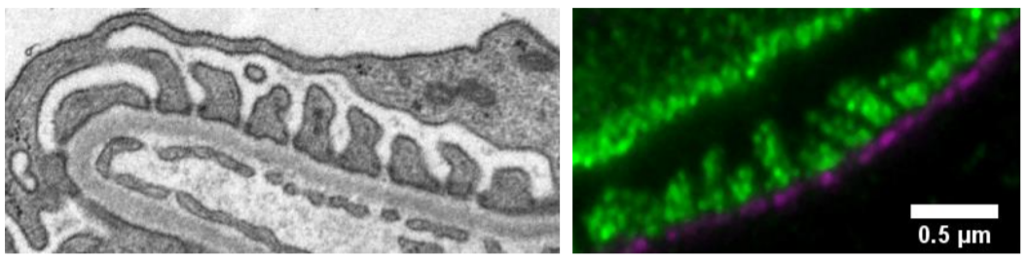
Image (Left) Electron microscopy image of the glomerular filtration unit, with podocyte foot-processes on top of the glomerular basal membrane and opposite a fenestrated blood capillary. (Right) high-resolution fluorescence microscopy image of the same structures (green = podocyte foot-processes; magenta = glomerular basement membrane). Scale bar 0.5 µm.
Underpinning research and sources to corroborate the impact
The research project started out as a KTH Master Thesis project in 2014 and was then continued as a PhD research project (presented and defended in the spring 2019). From 2020 the project has been supported by a Region Stockholm-KTH collaboration grant to validate the method with kidney researchers and pathologists at Karolinska University hospital in Huddinge.
Below are listed research publications (with number of citations from Google Scholars) as well as documents and web pages that corroborate the impact of the case.
Kidney International (2016) 89:243-247; Unnersjö-Jess et al. Super-resolution stimulated emission depletion imaging of slit diaphragm proteins in optically cleared kidney tissue. Cited 47 times.
Kidney International (2018) 93:1008-1013; Unnersjö-Jess et al. Confocal super-resolution imaging of the glomerular filtration barrier enabled by tissue expansion. Cited 27 times.
Kidney International (2020) https://doi.org/10.1016/j.kint.2020.10.039; Unnersjö-Jess et al. A fast and simple clearing and swelling protocol for 3D in-situ imaging of the kidney across scales. Cited 1 time.
Towards all-optical kidney pathology? David Unnersjö Jess. https://analyticalscience.wiley.com/do/10.1002/was.000400088
KTH news. https://www.kth.se/en/aktuellt/nyheter/optisk-3d-mikroskopi-kan-effektivisera-diagnos-av-njursjukdomar-1.1039573
KTH case. https://www.kth.se/en/om/stod-kth/cases-for-support/diagnos-av-njursjukdomar-blir-enklare-och-sakrare-med-ny-3d-teknik-fran-kth-1.995776

Case 6) Using nanotechnology for probing exosomes – a liquid biopsy tool for monitoring cancer
Summary of the impact
Despite major progress in tumor detection and in targeted therapy approaches, cancer continues to be a major cause of death. This is largely due to the metastatic spread, often occurring already at the time of the initial diagnosis, resulting in a poor prognosis for the patient. Reliable and sensitive methods to analyze cancer markers in an easily accessible patient sample, e.g. a blood sample, are highly needed. Given that the methods would be inexpensive and fast they could also serve to monitor therapy on a frequent basis during tumor progression. The “liquid biopsy concept”, i.e. a direct measure of tumor in blood/plasma has therefore attracted a large interest as a way for non-invasive diagnostics but also for treatment monitoring. Methods to detect and monitor cancer have therefore shifted to blood-borne entities such as circulating DNA and small Extracellular Vesicles (EVs) or exosomes. In particular exosomes, being 30 – 150 nm in size, are released both by ordinary and cancer cells in large numbers and are used for communication and transporting cargo between cells. They carry surface proteins that uniquely identify them with their parent cells. Thus, by detecting and monitoring exosomes with a specific protein surface expression, one may monitor tumor progression and the response to targeted therapies.
Micro- and nanotechnology enables miniaturization of fluidics and sensors on a silicon chip to establish a micro laboratory. This would enable multiple parallel sensing of several markers in a fast and cheap way. The detection principle could be electrical or optical and specificity would be accomplished by functionalizing sensor surfaces by affinity probes (antibodies).
At the Department of Applied Physics, the group of Prof Linnros and Dr Apurba Dev has developed an electrical sensor technology using capillaries, functionalized with antibodies for specific proteins, to detect exosomes related to cancer tumors. The sensing is multiplexed to analyze a palette of different proteins to accurately attribute the origin of the exosomes to a specific cancer form. The microchips are fabricated using an Si platform and are capable of detecting multiple biomarkers from a small amount of body fluid. A development of a prototype is also planned for the operation of the device in clinics. Once validated in larger clinical studies, the technology has the potential to be commercialized and also applied for liquid biopsies of different cancer types once a set of relevant surface protein markers have been established. The method has been applied to a small cohort of lung cancer patients, that have been subjected to different treatment courses. A larger clinical study involving more than 80 patients is planned for in the coming years.
The research is presently supported by the Family Erling Perssons Foundation and involves 6 partners: KTH – Applied Physics, KTH – Protein Technology, KTH – Gene Technology, Uppsala University – Ångström Laboratory, Karolinska Institute – Department of Oncology and RISE/ACREO Research institute.

Underpinning research
The research group of Prof Linnros originated from the Solid State Electronics department in Kista, a heavy user of the Electrum cleanroom laboratory. The focus was on silicon nanotechnology in general where one activity was devoted to electrical sensing of biomolecules using nanowires. These work like field-effect-transistors (FET) where the functionalized nanowire acted as a base electrode open to the liquid sample volume. For protein sensing, contacts were made to Prof Eriksson-Karlström at Protein Technology of KTH. Together with ACREO research institute a 3-year large grant was received from Vinnova. By the time K A Wallenberg’s foundation launched new calls for projects, the team including new partners at KTH and with Prof Lewensohn and Dr Viktorsson at Karolinska Institute, submitted a proposal for detection of circulating tumor cells in cancer patients. Thus, a 5-year grant was received (2012 – 2016), the first project granted from KAW at KTH.
Circulating tumor cells are however very rare and extremely difficult to catch in a normal blood sample. At the same time the FET sensing principle was plagued by large inherent difficulties. Taking an entirely new approach, a novel method for bio-detection was then developed by Apurba Dev. The method utilizes electrokinetic phenomena in a micro-channel and allows sensing of multiple biomarkers from a small amount of body fluids. During the course of the project, a new direction for monitoring cancer in body fluids was proposed based on exosomes and a new proposal based on exosome detection was submitted to the Family Erling Persson Foundation. The 5 year project was granted and the project is now in a phase where real samples from patients are analyzed to prove the sensing technology.
Interestingly, ~20 years have now passed from the first initial steps towards using micro/nano-technology for sensing of biomolecules until todays application of monitoring the progression of cancer on patients. This has been possible only by cross-disciplinary collaboration, a difficult but rewarding endeavour that involves surmounting a high language barrier.
- N. Elfström, A. E. Karlström and J. Linnros, Nano Letters 8, 945-949 (2008). (229 citations)
- A. Dev, J. Horak, A. Kaiser, X. Yuan, A. Perols, P. Björk, A. Eriksson Kralström, P. Kleimann and J. Linnros, Biosensors and Bioelectronics, 82, 55-63 (2016). (9 citations)
- S Cavallaro, J Horak, P Hååg, D Gupta, C Stiller, SS Sahu, A Gorgens, H K Gatty, K Viktorsson, S El Andaloussi, R Lewensohn, A E Karlström, J Linnros, A Dev, ACS sensors 4 (5), 1399-1408, 2019 (13 citations)
- SS Sahu, C Stiller, S Cavallaro, AE Karlström, J Linnros, A Dev, Biosensors and Bioelectronics, 112005, 2020 (2 citations)
- S. Cavallaro, F. Pevere, F. Stridfeldt, A. Görgens, C. Paba, S. S. Sahu, D. R. Mamand, D. Gupta, S. El Andaloussi, J. Linnros, A. Dev, Small, (2021) DOI: 10.1002/smll.202008155

Sources to corroborate the impact
The technology is presently at test on samples from patients at the Karolinska Hospital. A larger clinical study involving more than 80 patients are planned in the coming years. Depending on the outcome of such studies, the technology could be refined and sensor chips could be further developed for fast and parallel sensing of several markers. Finally, commercial aspects of the technique should be investigated.

Case 7) Bispecific antibodies for treatment of leukemia and preconditioning before allogeneic hematopoietic stem cell transplantation
Summary of impact
We have developed a concept based on bispecific T or NK cell engagers (BiTEs or BiKEs) that can reduce the need for cytostatic drugs prior to allogeneic hematopoietic stem cell transplantation (HSCT). This could reduce human suffering from side effects caused by currently used harsh treatment which would reduce treatment costs and increase the number of patients eligible for HSCT. For this we have been granted an European patent and have an ongoing patent process in the US. We have also started the company ImmuneCond Therapeutics AB to commercialize the concept.
Background
Hematological malignancies are currently often treated by high doses of cytostatic drugs, that eliminate both the patient's tumor cells and hematological stem cells (HSCs), followed by allogeneic HSCT. However, posttransplant complications such as graft versus host disease (GVHD) increases with tissue damage caused by cytostatic drugs, and, particularly in children, the use of cytostatic drugs has severe long-term side effects e.g., mental retardation, hormonal misbalance and infertility. Thus, effective pre-treatment with decreased risks of side effects may have long-term beneficial effects and also open up the field of HSCT to include diseases not eligible for HSCT today, e.g. autoimmune and chronic diseases. The cell surface protein CD34 is shared between HSC and several hematological malignancies, e.g. myelodysplastic syndromes (MDS) and acute myeloid leukemia (AML). Around 50% of all patients with MDS or AML have CD34-expressing tumor cells. Together these two malignancies make up approximately 50% of all patients undergoing allogeneic HSCT worldwide today. According to public statistics that corresponds to approximately 12000 HSCTs yearly. Thus, development of new treatment strategies for these patients can have a large impact on human life.
Antibody based immunotherapy is today a clinical reality in the form of e.g. Mabthera (rituximab) which is a monoclonal antibody directed against CD20 expressed on a variety of B cell malignancies. Recently new waves of antibodies have been engineered with dual specificity, so called bispecific antibodies or bispecific T cell engagers (BiTes) or natural killer (NK) cell engagers BiKEs. One such drug, Blinatumomab (Amgen), belonging to a novel class of BiTEs, which redirect T cells to attack cancer cells. It comprises two single chain variable fragments (scFvs) that bind CD3 and CD19, respectively. Upon simultaneous binding of both targets, Blinatumomab brings a T cell and a target cell in close proximity, which leads to T cell activation and subsequent killing of the target cell. Other targets except CD20 such as epidermal growth factor (EGFR) and CD19 have been tried in animal models and in vitro experiments but none have reached as far as Blinatumomab.
A novel strategy is to combine the powers of immunotherapy and HSCT. There have been previous attempts to target HSCs by BiTes directed against CD45 and myosin light chain but these molecules are expressed broadly across several cell types. Since CD34 is expressed on both HSCs and many tumor cells it is a way to directly target leukemic cells, cancer stem cells and healthy HSCs. Thus, in step one the bispecific antibody trigger T cells to kill the patient’s HSCs and leukemic cells, preparing for step two where a new donor-derived immune and hematopoietic system repopulate the patient.
Research and commercialization efforts
We have developed bispecific antibodies targeting the cell surface protein CD34 at one end and the immune cell activating receptors CD3 or CD16 at the other end. In projects financed by both the Swedish foundation for strategic research (SFF) (1) and Vinnova (2) , these antibodies have been tested for immunological function in in vitro experiments with human tumor cells as targets and human T cells or NK cells as effectors. These experiments have shown that the bispecific antibodies are potent mediators of redirected immune response against both tumor cells and stems cells. This has been further corroborated by experiments performed in mouse models indicating that the BiTEs may have a clinical effect without severe side effects. Thus, the concept is viable. The results are currently summarized in a manuscript targeting a high impact journal (3).
Based on these positive results a broad patent for the concept of targeting CD34 has been granted in Europe (4). In the US a more specific patent is granted (5), and current efforts are focused on widening this to a more conceptual coverage. The company, ImmuneCond Therapeutics AB has been formed for commercialization of the concept and is currently raising capital.
In parallel, the project is pursued in labs in the inventors and co-founders’ labs at Applied Physics, KTH, the Karolinska Institute and University of Totonto, Canada. At Applied Physics we are using microchip-based techniques to investige how BiTEs and BiKEs affect the ability of individual immune cells to recognize and kill tumor cells.
References
1. Single cell assays for immunotherapy. Önfelt, B et al. 2013-2020, Bioenginnering Grant, Swedish Foundation for Strategic Research .
2. Development of CD34/CD3 bispecific antibodies for treatment of leukemia and preconditioning before allogeneic hematopoietic stem cell transplantation. Uhlin, M et al. 2017-2019, Vinnova.
3. Bispecific antibodies for treatment of leukemia and preconditioning before allogeneic hematopoietic stem cell transplantation. Arruda, L et al: Manuscript in preparation.
4. Uhlin, M et al. Bispecific antibodies for use in stem cell transplantation . EP3105252B1 Europe, 2019.
5. Uhlin, M et al. Bispecific antibodies for use in stem cell transplantation. US10106623B2 United States of America, 2018.

