 | REPort |  | Date |  | Place
 | Periodic review of research 2012-2019 |  | 2021-03-12 |  | Stockholm
 | Created by:
 | Panel 1

Panel 1 Architectural & Built environment (ABE)
  - Research Assessment Exercise (RAE) 2021,
self-evaluation
Created by: Johan Silfwerbrand
Coordinator: Prof. Johan Silfwerbrand
Vice-coordinator: Prof. Mats Wilhelmsson

Organisation

Organisation schedule
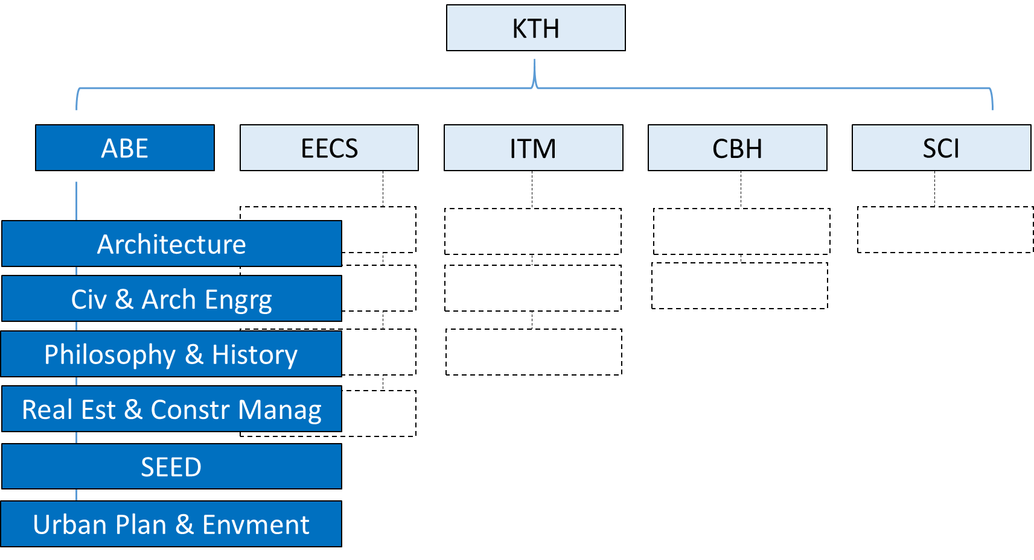
Figure 1: Panel’s position in KTH’s organisation

Involved units
- Schools: Architecture& Built environment (Assoc Prof. Muriel Beser Hugosson, Dean)
- Departments:
- Architecture (Prof. Katja Tollmar Grillner)
- Civil & Architectural Engineering (Dr. Annika Gram)
- Philosophy & History (Assoc. Prof. Sabine Höhler)
- Real Estate & Construction Management (Dr. Ina-Lill Söderberg)
- Sustainable Development, Environmental Science & Engineering (SEED) (Assoc. Prof. Maria Malmström)
- Urban Planning & Environment (Assoc. Prof. Maria Håkansson)
- Divisions:
1a Architecture (Katja Grillner)
1b Architectural Lighting Design (Per Fransson)

2a Building Materials (Prof. Magnus Wålinder)
2b Concrete Structures (Prof. Anders Ansell)
2c Constructional Engineering & Design (Dr. Annika Gram)
2d Soil & Rock Mechanics (Prof. Stefan Larsson)
2e Structural Engineering & Bridges (Prof. Raid Karoumi)
2f Sustainable Buildings (Prof. Folke Björk)
2g Transport Planning (Assoc. Prof. Erik Jenelius)
3a History of Science, Technology & Science (Assoc. Prof. Sabine Höhler)
3b Philosophy (Prof. John Cantwell)
4a Real Estate Business& Financial Systems (Dr. Andreas Fili)
4b Real Estate Economics & Finance (Dr. Abukar Warsame)
4c Geodesy & Satellite Positioning (Assoc. Prof. Milan Horemuz)
4d Construction & Facilitates Management (Prof. Tina Karrbom Gustavsson)
4e Real Estate Planning & Land Law (Prof. Peter Ekbäck)
5a Sustainable Assessment & Management (Dr. Ulrika Gunnarsson Östling)
5b Strategic Sustainability Studies (Assoc. Prof. Maria Malmström)
5c Water & Environmental Engineering (Assoc. Prof. Maria Malmström)
5d Resources, Energy & Infrastructure (Prof. Anders Wörman)
6a Geoinformatics (Prof. Yifang Ban)
6b Transport & System Analysis (Prof. Anders Karlström)
6c Urban & Regional Studies (Assoc. Prof. Maria Håkansson))

Table of Contents
Organisation 2
Organisation schedule 2
Involved units 2
Part A: Introduction of panel 6
Description of the research field of the departments included in the research panel 6
Description of the self-evaluation process for the research panel 7
Identified research panel synergies 7
Part B: Report for each department 7
Department of Architecture 9
1. Overall analysis and conclusion; strengths and development areas 9
2. Research profile 10
3. Viability 16
4. Strategies and organization 20
5. Interaction between research and teaching at all three levels 21
6. Impact and engagement in society 21
Department of Civil & Architectural Engineering 24
1. Overall analysis and conclusion; strengths and development areas 24
2. Research profile 24
3. Viability 29
4. Strategies and organisation 33
5. Interaction between research and teaching at all three levels (BSc, MSc, PhD) of education 34
6. Impact and engagement in society 34
7. Other (optional) 36
Department of Philosophy & History 38
1. Overall analysis and conclusion; strengths and development areas 38
2. Research profile 39
3. Viability 44
4. Strategies and organisation 47
5. Interaction between research and teaching 48
6. Impact and engagement in society 49
7. Other 50
Department of Real Estate & Construction Management 52
1. Overall analysis and conclusion; strengths and development areas 52
2. Research profile 53
3. Viability 60
4. Strategies and organization 63
5. Interaction between research and teaching 64
6. Impact and engagement in society 64
7. Other 66
Department of Sustainable Development, Environmental Sciences and Engineering (SEED) 68
1. Overall analysis and conclusion; strengths and development areas 68
2. Research profile 69
3. Viability 74
4. Strategies and organization 76
5. Interaction between research and teaching at all three levels (BSc, MSc, PhD) of education 78
6. Impact and engagement in society 78
Department of Urban Planning and Environment 81
Overall analysis and conclusion; strengths and development areas 81
Research profile 82
Viability 86
Strategies and organisation 89
Interaction between research and teaching at all three levels (BSc, MSc, PhD) of education 91
Impact and engagement in society 91

Part A: Introduction of panel

Description of the research field of the departments included in the research panel
The overall vision of the School of Architecture & Built Environment (ABE) is to develop sustainable solutions to societal challenges. This applies to education as well as to research and in collaboration with society. Within research, the goal is state-of-the-art research but also research that is visible and makes a difference. This means, among other things, that the school is working systematically with the global sustainability goals and ultimately to increase its ranking. To accomplish this, the school collaborate both nationally and internationally.
Panel 1 consists of the six departments included in the School of Architecture & Built Environment. The School’s research covers a very wide field of science including architecture, economics, engineering, humanities, natural sciences, and social sciences. None of the other four KTH schools can show such a variety in research areas. The ABE School is a result of a series of merges where the common denominator is rather the surrounding sector of construction and build environment than similarities in research areas.
Due to the large width in the ABE School’s research field, it is impossible to describe it in a few lines in this introduction. Instead, the reader is referred to the following six Department reports. However, there are also things that unify the various Departments, e.g., sustainability, digitalization, selection of research projects, and co-operation with the a number 0f stakeholders in the society and business.
Almost all of the ABE Schoool’s on-going research projects are devoted to sustainability in one or another aspect. Among the Division names above, you will find Sustainable Buildings, Sustainable Assessment & Management and Strategic Sustainability Studies but research on sustainability is not limited to these Divisions, it is the opposite. As stated above, most of our research is applied research and we try to solve problems in the construction and build environment sector. Both companies, organizations and authorities focus on sustainability and, consequently, we are researching sustainability problems. Large funding agencies, e.g., Energimyndigheten, Formas, and Vinnova include always sustainability aspects in their calls. Examples of sustainability aspects could be more environmental friendly construction materials, improved durability and prolonged service life, recycling, LCA, water, and sustainable cities.
Digitalization is important for the construction and build environment sector and is also included in a number of on-going projects. Terms as Artificial Intelligence, Building Information Modelling, Digital Twins, Machine Learning, and Structural Health Monitoring are objects of research in a number of projects. The pandemic has brought about major changes in our way of doing teaching at a basic and advanced level but also to the advanced level of the education and in research projects. The past 12 months with Zoom lectures, meetings, seminars, workshops, conferences and even doctor’s defences have made everyone familiar with new ways of working. This may also affect our way of conducting research and disseminating research results in the post-pandemic era to come.
A vast majority of the ABE School’s research projects are performed in close co-operation with the surrounding society. The free faculty money is limited and it is hardly possible to run a research project solely on faculty money. Consequently, we need to apply research money from various research agencies. A large amount of governmental research money are devoted to so called Strategic Innovation Programs (SIP). Three important ones are Smart Build Environment, InfraSweden 2030 and Viable Cities. They have all in common, that the project needs to be run in co-operation with other research environment(s) and that 50 % of the funding ought to come from other sources. Also other research sponsors, e.g., Trafikverket, require co-funding. Most researchers and teachers at the ABE have close connection with people in the surrounding society but the current research financing situation makes the co-operation even closer and more important.
Finally, it can be stated that none of the other KTH Schools have such a high number of researchers and teachers taking an active part in the public debate and participates with their expertise in government investigations (remisser) and other parts of our society's decision-making process.

Description of the self-evaluation process for the research panel
The real work with the self-evaluation started in February 20-21, 2020, with a two-day workshop in Näsbypark, 15 km north of Stockholm. The workshop participants consisted of the Dean and Deputy Dean of the School, the Department Heads, and a couple of other people working with the self-evaluation process at Department levels. The workshop was devoted towards SWOT analysis, impact cases, biometric and other data and how to interpret them, and the process itself.
The various Departments have worked in different ways. Most ones have organized workshops to develop the SWOT analysis. Teachers and researchers have been encouraged to participate and share their experiences and views. Draft reports have been circulated among the same teachers and researchers.
The pandemic resulted in a closedown of the entire process with an execution in form of an internal KTH evaluation week in August 2020. The self-evaluation process restarted in the beginning of 2021 with a new two-day workshop (this time on Zoom) on February 11-12. This workshop focused on three items: (i) case studies, (ii) peer review of draft reports, and (iii) early planning the Experts’ visiting week in August 23-27, 2021.
After this workshop, the self-evaluation has continued at Department level. Before submitting the final version of the Department reports, the RAE coordinator will read them and give some feed-back to the Department report editors.
During 2020, Prof. Mats Wilhelmsson acted as RAE coordinator of the ABE RAE process. He was replaced by Prof. Johan Silfwerbrand in the beginning of 2021.

Identified research panel synergies
As described in the first section of this introduction, the field of the ABE School’s research is very wide. This is not limited to subjects but also research methods. The similarities, that despite this exist, have also been described in the same section. By working more closely together, an increasing number of research projects have involved people from two or more Departments, but there is a potential to increase the co-operation across the Departments.
The efforts to reduce climate change and contribute to different aspects of sustainability are important drivers in our research and education. In recent years, an increasing interest has been given adaptation. Here, fruitful discussions have been initiated to develop a new KTH centre addressing adaptation to climate change. Researchers from at least four of the ABE Departments have taken active roles in the creation of such a centre.

Part B: Report for each department

Department of Architecture

Self-evaluation

Head of Department and main-editor: Prof. Katja Grillner
Co-editor: Dr. Frida Rosenberg

Included divisions:
Architecture
Lighting Design

Research area profiles:
Architectural Design, Technology and Representation
Architectural Theory, History and Critical Studies
Urban Design and Urban Theory

Research Department Council:
Assoc. Prof. Anders Bergström, Assoc. Prof. Ute Besenecker, Prof. Katja Grillner (chair), Prof. Ulrika Karlsson, Docent Daniel Koch, Prof. Ann Legeby, Prof. Helena Mattsson, Assoc. Prof. Meike Schalk. PhD-student representatives: Janek Ozmin and Lenastina Andersson.

This report has been written by Head of Department Katja Grillner with editing support by Frida Rosenberg. All members of the Department Research Council have been actively involved in the process since January 2020 and have also contributed directly with edited input to different sections. All staff have been invited to open research meetings where aspects of the strategic analysis, SWOT and the research profile divisions have been discussed. All staff have contributed through surveys with input on recent research output.

Department of Architecture

1. Overall analysis and conclusion; strengths and development areas

a. Limited SWOT-analysis

Research - Strengths | Research - Weaknesses
- Prominent faculty with high quality research and good international standing.  - Strong international research publications.  - High quality production of PhD-theses.  - Research environment - collaborative and generous academic culture.  - Widespread international and national networks.  - Highly developed discourse – strong sense of societal relevance and aspiration towards renewal of ideas.  - In recent years, improved uptake of research grants for societal impact and innovation.  - Strong foundation in research towards gender equality, diversity and inclusion. | - Difficult to secure long-term funding towards basic research and PhD-student positions.  - Need to strengthen research-based faculty and supervisory capacity in architecture technology.  - Low rate of peer-review journal publications. Current emphasis on high quality peer-review book-chapters, monographs and edited volumes.  - Research collaborations with architectural design practices and professional organisations need to be strengthened.  - Research communication need to improve through coordination and strategic direction to increase external visibility and accessibilty.
Organisation - Strengths | Organisation - Weaknesses
- On-going transition towards greater stability and clarity in strategic leadership and organisation  - Collaboration across research profiles and research groups is enabled by a department organisation without academic administrative sub-divisions.  - Regular cross-departmental seminars presenting current research on PhD- and senior levels.  - Physical environment (after relocation in 2015): social areas in the workplace and on campus have improved the sense of research community and increased collaborations. | - Limited administrative support restricting efficient project handling.  - Staffing and recruitment processes for externally funded research projects are slow and inflexible.  - Structural imbalance with 25% research / 75% education - overlap and integration need to improve.  - Physical environment (after relocation 2015 and 2019): Current facilities offer only open landscape office setting. The lack of differentiated spaces for research project teams and individual work spaces is challenging.

Development areas:

- Organisation and administration – continue to improve structure and strategic research leadership (dept.-level) and research project support (dept.-, school- and central KTH-levels)
- Funding – improve strategic efforts to secure funding for basic research and for PhD-positions (including increased industry research collaboration)
- Education – integrate research into and develop research output from educational settings, for example design-based research integrated in 2nd cycle studio teaching.
- Facilities – improve and adapt physical work-place to better suit differentiated needs.
- Dissemination - improve research publication strategy and external research communication

b. Summary statement on contributions of department on impact, infrastructure and sustainable development

Impact-cases: Shared City and Feminist Futures. See impact-cases, separate chapters, and 6e.
Infrastructure: Digital Fabrication Lab (established), Lighting Design Lab (planned). See 3e.
Sustainable development: See 6c.

2. Research profile
a. General information of the department

The Department of Architecture at KTH pursues education and research in architecture and urban design. It is one of four schools in Sweden educating architects. The department has ca 550 students in basic and advanced levels of education. It runs a five year professional program in architecture (3 yr B.Arch.+ 2 yr M.Arch.); a 2 yr M.Sc. in Architecture; a 1 yr M.Sc in Lighting Design. It shares the responsibility within ABE for the cross-departmental 2 yr M.Sc. in Sustainable Urban Planning and Design. On a doctorate level the department runs two PhD-programs: Architecture and Art, Technology and Design. There are currently 25 active PhD-students in both programs. The gender balance (w/m) among PhD-students were in 2020 70/30 and among teaching and research staff 50/50. In 2020 the annual budget totalled at 98 million SEK with a balance between research and education of 25 to 75 %.

In 2020 the department had 105 members of staff of which 65 were part-time. 26 long term staff have a research degree (PhD) and/or is currently engaged as project leaders in research projects (see fig. 1).

Arch. Design, Technology and Representation | Arch. Theory, History and Critical Studies | Urban Design and Urban Theory
Prof. Thordis Arrhenius  Prof. Ulrika Karlsson  Assoc. prof. Ute Besenecker  Assoc. prof. Erik Stenberg  Res. Christina Bodin-Danielsson (20%)  Res. Pablo Miranda  Res. Oliver Tessman (20%)  Lecturer Per Fransson  Lecturer Frida Rosenberg | Prof. Katja Grillner  Prof. Helena Mattsson  Prof. Hélène Frichot (20% until 21-06, KTH faculty 2011-2019)  Assoc. Prof. Anders Bergström  Assoc. Prof. Jennifer Mack  Res. Victor Edman  Lecturer Brady Burroughs  Lecturer Sepideh Karami (50%)*  Lecturer Christina Pech (50%) | Prof. Ann Legeby  Adj. Prof. Björn Hellström (50%)  Assoc. Prof. Catharina Gabrielsson  Assoc. Prof. Meike Schalk  Res. Daniel Koch  Res. Alexander Ståhle (50%)  Lecturer Bojan Boric  Lecturer Hanna Erixon (60%)  *Currently on leave for post-doc

Fig. 1 Current long-term members of staff with research degree (PhD) and/or project leaders for active research projects (post-docs not included). Research profile differentiation in this figure does not reflect formal staff or economy divisions but is an indication of principal research focus and background.

b. and c. Central research questions and themes, contributions to the advancement of the state of the art within the research fields of the department

Introduction and department overview

The core of research activities at the department are within architecture and urban design which is also the main focus of this report. The research environment is as such rather compact with around 26 long-term staff engaged in, or with formal qualifications for, research, and around 20 staff engaged for limited time as PhD-students, post-docs or research engineers. The formal staff organisation of the department does not reflect academic subject divisions or research groups and there is in general a strong cross-departmental research culture. Three research areas have recently been introduced as new sub-divisions within the PhD-program in architecture, a condensation from previously five sub-divisions:
- Architectural Design, Technology and Representation
- Architectural Theory, History and Critical Studies
- Urban Design and Urban Theory
These are not staff or economic divisions but rather strategic, curricular and communicative frames for research education, practices and projects at the department. In this report research outcomes will be presented through these three profile areas. There are however important overlaps where for example crucial development of critical design research methodologies, as well as critical and historical case studies take place and involve collaborations across and in between the three research areas.

In addition to Architecture, the department has since 2014 hosted a PhD-program in Art, Technology and Design (the KTD-programme) which is the result of a collaboration between KTH and Konstfack. While the PhD-program itself is scheduled to close once all current students have been examined (around 2025), KTH is since 2019 developing a new integrated research environment in art, technology and design with the centre formation of NAVET. Hosted by the media technology department at the EECS-school, and in collaboration with three art universities (Konstfack, Stockholm University of the Arts, and Royal College of Music), a new research platform is developing where the architecture department and the KTD-programme is very actively involved. There is among the architecture faculty, across the three profile areas, a high level of expertise in arts- and designbased research methods and practices applied to both architecture research and a broader arts- and design field.

The division of Lighting Design moved to the department in 2017 and is currently expanding its research activities significantly. Its research activities are presented below within Architectural Design, Technology and Representation.

Research development in architecture and urban design: summary overview

Over the past decade the quality and visibility of research produced at the department have developed strongly and reinforced its high international standing. A number of significant research grants together with sustained efforts by faculty, researchers and doctoral students, as well as successful faculty recruitments, have contributed to this positive development. Research within urban design, critical studies and architectural history and theory have made the department internationally recognized in relation to research on spatial configuration and urban segregation, contemporary history of architecture in the welfare state, feminist and gender studies in architecture, and critical design research methodologies. The latter concerning in particular an internationally leading position in developing explorative and norm-breaking forms of academic writing. Architectural design and technology have also shown a strong international development of research into digital fabrication and production, and with the integration of the division of Lighting Design and through recent faculty recruitment, there is currently a significant development of funded research in this area. A developing research area is also housing – production, design, regulations and policy-matters.

Research area: Architectural Design, Technology and Representation

Architectural Design, Technology and Representation (ADTR), produces, develops and communicates knowledge in the field of architecture with a specific focus on method and materialisation. The research and education topics include architectural design, architectural technology, architectural representation, architectural sustainability, lighting design, and related architectural theories. Research practices combine different methodologies and approaches, including architectural theory and practice, artistic research, research-by-design, case study research and innovation. Activities span between research, teaching and practice, contributing to the following fields of research and development: design processes, critical theory, sustainability and re-use, architectural lighting, digital methodologies and fabrication, architectural experimentation and media.

The research field critically and practically engages and researches practices, opportunities and limitations related to several different topics. These include, for example, technology, sustainability and structural systems of architecture, such as urban housing, and the architect's role in the construction of the built environment, including processes of participation. Other topic areas of research are computational architecture and design, including developing literacy and new design languages related to digital fabrication, new means of building and automation, and the economic and social aspects of manufacturing processes, as well as techniques of architectural representation and design media, with their histories, theories and material translations, coding and information. Also, across architectural design, theory and history there is a strong profile studying the relation between architecture, museum, and the curatorial aspects of preservation, as well as the role of the architectural exhibition in the reception of modern architecture in Scandinavia. More recently, lighting design has been integrated into this research field investigating topics related to how architecture and light affect the perception, behavior, performance, experience, satisfaction and well-being in different built environments and contexts. The medium of light is explored as an agent for visual and visceral experience of spatial environments in architecture and urban design.

Examples of current research output from Architectural Design, Technology and Representation is presented below in Fig.6, publications a, h, i, j, k, l.

Research area: Architectural Theory, History and Critical Studies

Architectural Theory, History and Critical Studies (ATHC), produces, develops and communicates knowledge in the field of architecture from a cultural-historical and socially critical perspective. The research methods are interdisciplinary and relate to a broader field of humanities and artistic research practices, as well as to technology and social sciences. The theory and history of architecture and the built environment is studied as an historical process where contemporary conditions are contextualised as part of a longer development, and deepens the understanding of architecture as a spatial, aesthetic and social practice. In critical studies architecture is studied as profession, discipline and cultural expression, including effects of different ideological systems and power structures on architecture, as well as how architecture reproduces or counteracts such systems or structures in different contexts.

In theory and history research the focus is on 20th century and the recent pasts of architecture, nature and landscape. It is internationally recognized for its development of research on the role of architecture in the dismantlement of the welfare state and the role of architecture in the dismantlement and neoliberalisation of the welfare state, and on social change and the built environment, effects of migration, standardization and difference. Another important strand concerns the history of the architectural profession and relations between education, research and deisgn practice. Across history and theory and architectural design research the department has particular strengths also in museum architectures of the 2oth century, architecture exhibitions and historiography in relation to built heritage and preservation. Research carried out in critical studies has gained an international reputation for its experimental approach to the relay between architectural practice and theory, and its prominent position in feminist and intersectional architectural criticism. Key-studies involve architectural interpretation and enactment through feminist, queer and performative events and explorations, experimentation with critical fictions and/or ficto-criticism in architecture, transdisciplinary approaches to the relationship between architecture and philosophy, creative approaches to writing about architecture and landscape and participatory and dialogical approaches to site mapping and place production.

Examples of current research output from Architectural Theory, History and Critical Studies is presented below in Fig.6, publications a, b, c, d, j.

Research area: Urban Design and Urban Theory

Urban Design and Urban Theory (UDUT) are complex fields, bridging between theory and practice, entwining societal processes and forces with professional concerns that are combined and made manifest in the built environment. It incorporates critical, norm-breaking and imaginative ways of dealing with conflicting interests, norms and ideals. Architectural research in urban design and urban theory generates new knowledge on cities by combining practice and theory, in relation to interconnected and multi-scalar processes of change concerning social, cultural, political, economical, and ecological aspects. It is currently developing along three strands: 1) Architecture and urban design in conjunction with feminist theory and practice, political philosophy, gender studies, intersectionality studies and questions of equality, diversity and inclusion, including studies of public space related to democracy, power and agency, including historical studies of the recent past, collective and participatory action and design-based research and critical assessments of spatial production and aestethics. 2) Spatial configuration studies interrelated to cultural, social, economic, ecological, and political phenomena, including relations to segregation, unequal living conditions, power and gentrification. Developments include modeling and software prototyping for morphological analysis, data-collection, -structuring and -analysis, as well as for design work. 3) Studies of and active engagement in urban development processes, including models for governance, management, inclusive tools for citizen participation, as well as critical studies of relations between urban form and planning processes.

Current research includes speculative and future oriented studies that advance new solutions and approaches to contemporary situations, but that is also able to challenge the underlying assumptions and ideals that posit ‘the City’ as the answer to our current and future environmental challenges as well as our future urbanities. A concrete and urgent challenge is the need to broadly reinforce competence responding to the fast escalation of housing developments in urban areas in Sweden, and counter risks of long-term negative effects such as poorer housing standard, segregation, misunderstood role, effect and potential of dense developments, and negative climate and environmental impacts.

Examples of current research output from Urban Design and Urban Theory is presented below in Fig.6, publications a, b, c, e, f and g.

d. Quality and quantity of contributions to the body of scientific knowledge

Publications Architecture 2012-2019  The bibliometric output presented in the first diagram are gathered from the Diva database to which staff report their publications manually. The diagram shows only journal publications and conference papers. In both categories there seem to be a decreasing trend.  The publication pattern at the department of architecture can be studied by searching Diva in this same period including all registered kinds of publications.  On average per year 2012-2019 the department published:  16,25 journal articles  17,25 book chapters  22 conference papers  2 books (monographs and dissertations)  1,4 edited volumes (books or thematic journal issues)  Limiting the search to 2017-2019 to assess the decreasing trend one can see that the average number of book chapters per year have increased to 20,3 but journal articles have decreased to 14,6. Conference papers have decreased to 12,3 per year. The average number of books remain the same but edited volumes have increased to 2,0.  Link to searches:  Architecture 2012-19 Diva  Architecture 2017-19 Diva  Fig.2 | Fig. 3

Fig 4 | Fig 5

The publication pattern from the architecture department include a higher degree of edited books, edited journal issues and book chapters than what a conventional publication pattern in science or engineering would show with its dominant emphasis on journal articles and/or conference papers. PhD-dissertations are often monographs or hybrid compilations including both journal articles, book chapters and in some cases design project presentations. Edited book volumes by academic publishers are important venues for research dissemination in architecture internationally and often find their way into teaching as course books and to design practitioners. Monographs are also an important format for presenting in full depth the complex case studies that are often pursued in architectural and urban history, theory and critical studies. Exhibitions provide another important dissemination format for architecture research with contributions both to exhibited material and to catalogue entries. Selecting a few publications from the department output over the last decade is challenging. The ambition is to show the relative proliferation of publication types, contexts and to point to different research areas. PhD-dissertations have not been included:

a) Architecture in Effect – Vol 1: Rethinking the Social in Architecture: Making Effects - Vol 2: After Effects: Theories and Methodologies in Architectural Research. (Eds: Vol 1: S. Gromark, J. Mack, R. van Toorn. Vol 2: H. Frichot with G. Sandin and B. Schwalm). Actar publisher, 2020 (2018). Staff contributions: Co-edited by Hélène Frichot and Jennifer Mack. With individual chapters by Thordis Arrhenius, Anders Bergström, Brady Burroughs, Hélène Frichot, Catharina Gabrielsson, Katja Grillner, Katja Hogenboom, Sepideh Karami, Daniel Koch, Meike Schalk, Erik Stenberg, Tijana Stevanovic, and former Post-doc Karin Reisinger, former PhD-students Luis Berriòs Negron, Hannes Frykholm, Helen Runting and Erik Sigge.  b) Neoliberalism on the Ground - Architecture and Transformation from the 1960s to the Present (Eds. K. Cupers, H. Mattsson and C. Gabrielsson). University of Pittsburg Press, 2020. Staff contributions: Co-edited, introductory and individual chapters by Catharina Gabrielsson and Helena Mattsson.  c) Feminist Futures of Spatial Practice : Materialisms, Activisms, Dialogues, Pedagogies, Projections (Eds. M. Schalk, T. Kristiansen, R. Maze), AADR, Spurbuchverlag, 2017. Staff contributions: Co-edited by Meike Schalk and with individual chapters by Brady Burroughs, Hélène Frichot, Katja Grillner, Helena Mattsson, Meike Schalk and former PhD student Helen Runting.  d) The Construction of Equality – Syriac Immigration and the Swedish City, University of Minnesota Press, 2017. Staff contribution: Monograph publication by Jennifer Mack.  e) “Street Interaction and Social Inclusion” in Suburban Urbanites: Suburbs and the Life of the High Street, edited by Laura Vaughan, London: UCL Press, 2015, pp.239-262. Staff contributions: Chapter by Ann Legeby and former staff Meta Berghauser Pont and Lars Marcus (presently both at Chalmers).  f) “On Architectural Space and Modes of Subjectivity: Producing the Material Conditions for Creative-Productive Activity” (Urban Planning3(3), 2019, pp.70-82). Staff contribution: Article by Daniel Koch. | g) “Suburbs and Power: Configuration, Direct and Symbolic Presence, Absence, and Power in The Swedish Suburb Gottsunda” in: Proceedings of the 12th Space Syntax Symposium (pp. 264-2:1-264-2:21), 2019. Beijing: Beijing Jiaotong Univ. Staff contribution: Published conference paper by Daniel Koch, Ann Legeby and Pablo Miranda Carranza.  h) Plots, Prints, Projections – Displaced (Curator. U. Karlsson/ Project leader T. Dumon Wallsten) Exhibition and exhibition catalogue for the 16th International Architecture Exhibition - la Biennale Architettura 2018 in Venice. It was exhibited in 3 additional venues around Sweden. Staff contributions: Curation by Ulrika Karlsson, individual chapters and exhibition contributions by Ulrika Karlsson, Pablo Miranda Carranza, Cecilia Lundbäck and Veronica Skeppe.  i) Design Transactions - Rethinking Information Modelling for a New Material Age (Ed B. Sheil, M. Ramsgaard Thomsen, et. al.). UCL Press 2020. Staff contributions: Individual chapters by Ulrika Karlsson, Vasily Sitnikov and Helena Westerlind.  j) Flying panels: How Concrete Panels Changed the World (Eds. Pedro Ignacio Alonso and Hugo Palmarola). DOM Publishers 2020 (2019). Staff contributions: Individual chapters by Erik Stenberg and Jennifer Mack. Exhibition contributions by Erik Stenberg, José Hernandez Vargas, Helena Westerlind, and former PhD-student Erik Sigge.  k) “Investigating Visual Mechanisms Underlying Scene Brightness” in Lighting Research & Technology 49(1): 16–32, 2017. Besenecker, Ute C., and John D. Bullough. Staff contributions: Co-authored article by Ute Besenecker.  l) Experimental Preservation (Eds. Arrhenius, Langdalen, Otero-Pailos), Lars Mûller Publisher, Zurich 2016. Staff contributions: Co-edited and with individual chapter by Thordis Arrhenius.
Fig 6. Selection of publications (a-l)

e. Engagement in national and international research collaboration within academia and its outcomes

National academic collaborations

KTH Department of Architecture is an initating partner for the national collaboration between the four schools of architecture (UMA (Umeå), LTH (Lund), CTH(Gothenburg) and KTH). The four schools have a structured collaboration through the Architecture Academy since around 2005 and developed, with program funding from Formas (80 million SEK), two strong research environments and a research school from 2011-2017. Since 2019 the collaboration between the four architecture schools together with the landscape architecture school at SLU, have focused on developing fora for strengthening societal impact. This has resulted in open meetings with policy makers and public sector professionals to support the realisation of the national architecture policy on designed life environments (Gestaltad livsmiljö). Further there are within research projects many interdisciplinary collaborations with national research environments in for example urban planning and design, sustainability studies, geography, preservation, housing research, art and design studies, philosophy and history at Stockholm University, Gothenburg University, University of Arts, Craft and Design, Södertörn University, Blekinge Technical University, Luleå Technical University, University of Gävle.

International academic collaborations

The research school ResArc continues to offer core courses for PhD-students in Architecture on national level. KTH is currently together with Chalmers developing these collaborations on research training in Europe through a partnership with TU Munich, ETH Zurich, UCL London and TU Delft. These four institutions are among the absolute top-ranked architecture education and research environments and we are very pleased that we have been able to develop close collaborations with them in this and in a number of other on-going research projects. An additional growing collaboration is with MIT where, in addition to the involvement in the KTH MIT Senseable Stockholm Lab, the department now have two former PhD-students developing post-doc research.

EU-partnerships: The Department have just recently concluded, in architecture technology, the Marie Curie ETN Innochain in academic partnership with the Danish Academy of Arts, UCL Bartlett, University of Stuttgart, and University of Vienna. In theory and history the department is currently engaged in the Marie Curie ETN TACK in academic partnership with among others TU Delft, ETH Zurich, Oslo School of Architecture, University of Antwerp and UCL London. Further a large Horizon 2020 project Re-Create is starting in collaboration with civil and arch.engineering at KTH including partners at TU Eindhoven, Tampere University and TU Cottbus Senftenberg. The department is also engaged in JPI Urban Europe with two new projects, ProSHARE and MAPURBAN, involving collaborations with among others with UCL, University of Sheffield, Goldsmiths, University of Kassel, Freie Universität Berlin, Technical University of Vienna.

f. Follow up from previous evaluations

In the RAE 2012 report it was noted that our unit demonstrated “research output quality that is internationally excellent/…/ (but not ‘world leading’).” Specific research contributions were especially commended “the work of the space syntax design group and the architectural history and theory group in relation to welfare state architecture and to feminist critique has become internationally renowned and is of extremely high quality.” The unit was finally recommended to develop “a more focused and structured research vision. A clearer strategy in terms of hierarchy of research topics and prioritizing aims and objectives would enable the UoA to define its short-, medium- and long-term goals.”
In the first period following the RAE 2012 the majority of research activities at the department were connected to the national strong research environments and research school funded by Formas from 2011-2017. KTH hosted the strong environment Architecture in Effect – Rethinking the social in architecture which was concluded with the two volume publication referred to above (Fig.6, a). Researchers from across the department were heavily involved in both the Effect environment and the environment hosted by Chalmers – Architecture in the Making. In 2017 the two environemnts hosted a concluding exhibition and conference MakingEffect at the Swedish Architecture and Design Center ArkDes. The continued research development in the areas commended in RAE 2012, spatial configuration, welfare state architecture, architecture and feminist critique have been very successful, as can be shown by publications, conferences and successful grant capture. This development has been accompanied by a strong development of research into digital tools and fabrication, housing production, sustainable urban development, and most recently lighting design.
The strong research environment organization did up until around 2016 in many ways offer the more structured research vision and strategy for research activities at the department that was recommended in RAE 2012. In the period after, 2016 up to the present, the department has been engaged in several other large collaborative research projects characterized more by interdisciplinary, public sector and industry networks (for example Decode, Shared City, Innochain, TACK, Grön Bostad, funded by Vinnova, Mistra, Eu Marie Curie, EU Structure funds respectively). Both periods have been very successful in terms of the department contributing to architecture research moving its positions forward in both theory and methodology development, and engaging in more applied research for sustainable development in our field. The latter development has also presented the department with new challenges for the internal research organization. While the success has been largely due to excellent efforts by individual research leaders or research teams responding to arising opportunities, and the organization has been able to support these initiatives in growth and development, it is crucial that the department leadership develops a greater readiness to act in strategic and coordinated ways for research development in our field. Since January 2020 a department research council has been formed to develop a clearer organization that is better prepared to act strategically. See further 3b and 4c.

3. Viability
a. Funding; internal and external
Research and research education accumulate to 25% of the total revenue at the department, and education on basic and advanced levels to 75%. The balance between internal funding for research and research education and external research grants fluctuates from year to year. It has on average been 50/50 over the last five years. Internal funding has notably increased since 2019. Part of the increase in 2020 is support for two internally funded post-doc positions (12 months) and starting grants for new associate professors recruited since 2018. It is also an effect of temporary central support for our costly educational facilities which hamper development opportunities for research and education.
Fig. 7. Sources of research income. The relative increase of government grant 2020 is partially due to temporary support for costly educational facilities.

In the period 2011-2017, the department was engaged in the extensive Formas programme for strong research environment and research school in architecture theory and methodology (in total a grant of 80 million SEK coordinated by the four schools of architecture). This allowed the department to have several PhD-positions funded and to support additional research time for researching staff to develop and publish new and innovative research as well as important course and curriculum development for the PhD-programme. Over the last five years major providers of research funding have been EU (Marie Curie Training network and structure funds), national research councils such as VR, Formas, Vinnova, and private research foundations such as Bertil and Berit Svensson Foundation for Lighting research, and the Arwidsson Foundation.

While funding bodies such as Vinnova and Mistra typically support co-financed projects and are based on collaborations with other actors in society, both VR and Formas support independent research projects for individual researchers. The funding from the Arwidsson foundation is tied to a professorship and research program in Applied Urban Design which currently funds a professor, a post-doc and two PhD-students. Funding from the Svensson foundation provides strategic support to the development of lighting research and education. The collaborative aspect of research in the intersection of societal needs, innovation design and academia has become an important factor for the progression of our research and educational output. Co-financed research also guarantees a large societal network, which is important for both advancing existing research as well as improving practice-based research.

The majority of senior research faculty and researchers are currently engaged, as part their position, in externally funded research projects. Some areas (presently Urban Design and Architectural Technology) are facing issues with under-capacity, i.e. more grants have been secured than what current staffing can manage. Internal funding is mainly used to allocate time for faculty engagement in PhD-supervision and training, in academic responsibilities for KTH as well as for the national and international research community, and for co-financing of external grants. The majority of faculty and researchers are further engaged in teaching on basic and advanced levels between 10-50% of their position.

It is difficult to secure larger grants allowing for recruitment of PhD-students. This is a major challenge since national regulations stipulates that new PhD-students need to be fully funded for 4 years of research in employed positions. Our current externally funded PhD-positions are financed by the Arwidsson Foundation (2), EU Marie Curie (1), Formas (1), and the Swedish Energy Agency and the Svensson lighting foundation (1). There are 1-2 incoming PhD-students during 2021 funded by NordForsk and the Svensson lighting foundation (1) and potentially EU Horizon 2020 (1). Out of three current post-doc positions, two are internally funded and one is funded by the Arwidsson Foundation.

The department has in 2020 seen an upswing in new research grants supporting the development of research in architectural design and technology, urban design, urban theory and lighting design, in addition securing new funding sources such as the Energy Agency and NordForsk. After concluding the Innochain Marie Curie Training network in 2020, the department is currently engaged in another Marie Curie Training Network in architecture theory and history (TACK), and is just starting up a Horizon 2020 project in architectural technology (ReCreate).

Summary strategic development measures:

- Improving funding towards independent theory development and critical investigations of current conditions for architectural and urban design. This in order to ensure a continued strong development of theories and methodologies for research and practice in architecture and urban design. Such development is foundational for successful engagement in interdisciplinary projects with strong societal relevance and impact.
- Strategic efforts to secure project funding which includes PhD- and post-doc-positions. This is crucial in order to sustain and develop a vital research environment in our field. These efforts should include reach-out to professional organisations, industry and public sector representatives on issues such as how to finance and support practicing architects and planners to engage in research training.
- Develop capacity and competence in grant applications among all faculty and research leaders as well as strengthen the administrative support for research project leadership concerning in particular economy, legal matters and staffing.

b. Academic culture
The research environment at the department has over the last ten years become increasingly rich and vital. The pandemic situation from March 2020 has been challenging to this development in particular as physical meetings have been highly restricted and informal encounters and discussions has greatly decreased. On the other hand, there is a sense that attendance, curiosity and engagement in higher seminars and meetings have increased with the on-line format. In 2020 there has been a strong development in aquiring new grants and initiating new external collaborations.

Organisation and venues for research discussions

Our research environment is small enough to allow for many discussions to be pursued across the different research groups and profiles. Collaborations in larger research projects and around supervision and quality review of PhD-students’ research are important settings for cross departmental discussions on research matters. Important structured settings for research discussions are the Friday higher (research) seminars, open research meetings for all staff, meetings in research area groups, supervisor meetings, as well as the Department Research Council and PhD-program council with appointed members.

The department research council was formed in January 2020 and consists of professors and research leaders representing different research profiles and PhD-student representatives. The council has a responsibility to support strategic coordination of research development at the department, identify important shared opportunities and concerns. Preparing for this RAE has been an important defining task for the council. One important ambition with forming the research council is to clarify responsibilities for strategic and long-term development. The PhD-program councils works with the operation and development of the two PhD-programs. Here important questions of research quality are continuously raised in relation to student’s research progress, program and course developments.

Physical work environment

A great challenge to the development of academic culture in the research environment has since many years been related to physical presence, or absence of physical presence at our campus facilities. Since the move to the new building in 2015, some staff have found the open office landscape difficult to work in. While an advantage to the open landscape setting since 2015 has been increasing interaction within the department, the lack of differentiated spaces for meetings and individual or collaborative work in the building, is experienced as limiting, even more so since all staff moved to the same floor in 2019. The physical conditions for developing and sustaining a rich and creative physical work environment for groups and individual researchers and PhD students need to improve. The pandemic condition has also brought positive experiences of the opportunities offered by increased on-line interaction and co-presence which needs to be well accounted for in future post-pandemic development of the work-place.

Coaching and mentorship

Critical for any vital research environment is that individual faculty, researchers and research students sustain a drive for high quality research production, publishing in good journals, sharing results in significant venues, apply for new research grants, being open to embark on new collaborations. At KTH Architecture we have a successful track record of highly competitive faculty recruitments and all calls for new PhD-students or post-docs attract a very large number of applicants. Our staff is both hosting and participating to a high degree in important international and national research conferences and seminars. There is overall a generous collaboration culture across the department and informal mentoring goes on. All staff are invited twice a year to discuss career development and productivity with their line manager. These talks are important opportunities to encourage individual research productivity and contributions to a generous and supportive academic culture across the department.

Summary strategic development measures

- Keep developing and maintaining seminar and meeting structures
- Attend to future workplace organisation, both physical and virtual
- Develop awareness of (informal and formal) ways to nurture and sustain a highly productive and generous research environment

c. Current faculty situation
The architecture department faculty is composed of teachers that have primarily design practice merits, primarily architecture research merits, or both. The majority of teachers and researchers have an architecture degree. While the focus in this report is on the research capacity of the faculty, the balance and interaction between design-based knowledge and research-based knowledge is absolutely key to a successful and dynamic academic environment in architecture. Currently our large design-based faculty is primarily composed of part-time lecturers plus a few full-time associate professors and lecturers. In school leadership there is a balance between design-based and research-based staff.

In 2020 the department had 105 members of staff of which 65 were part-time. There were 25 full time teachers and researchers. Teaching and researching staff at the department consists mainly of professors, associate professors and lecturers. Full time researchers as well as PhD-students and post-docs also contribute to teaching. Research is mainly carried out by professors, associate professors, researchers and research engineers, post-docs and PhD-students. Some lecturers are also active in research.

In total there are currently around 45 individuals engaged in research at the department. Long-term researching staff distribute evenly across the three research areas (see Fig. 1). The research environment currently has 3 postdocs and 15 active PhD students in architecture. Of the active PhD-students in architecture 45% are in ATHC, 30% in UDUT and 25% in ADTR. There are recent or incoming PhD-students in all three areas. The gender balance among long-term researching staff is 66% women. Among part-time researchers, post-doc, and PhD-students the gender balance is 75% women.

d. Recruitment strategies

Fig. 8. Historical data concerning staff including employed PhD students (NB: students funded by industry or scholarships are not included here). The figure is not fully accurate regarding adjunct and affiliate professors.
The research-based faculty at the department has over the last years through retirement and new recruitments become largely female. With current staffing there will be a retirement period beginning in the early 2030’s and continuing for a decade. Both gender and age factors should therefore be considered in relation to planned recruitments.

The most immediate recruitment needs at the department are an associate professor in architecture technology and part-time professors on design merits. The former is needed both to further develop the strong research development in this area and to provide research-based competence to the development of core courses in architecture technology in the architecture program. Further there is a very strong research development in urban design and a need to strengthen teaching faculty with research qualifications in this area. We also need to monitor the current growth of research in lighting design and evaluate whether new assistant or associate professor level recruitments will be needed there.

e. Infrastructure and facilities
Workshop and digital fabrication lab

The architecture school has well-equipped workshop facilities for wood- and metalwork, casting and photography. It is primarily used in the education but is also essential to design-based research in architectural design and technology. Since 2005 the digital workshop and fabrication lab has been built up with CNC-milling equipment, laser-cutter, 3D-printing and a robotic arm. Current research in architectural design and technology is highly dependent on the digital workshop facilities and it is critical that they can continue to develop and be maintained.

Lighting lab

Since the division moved in 2015 from Campus Haninge, with its 200+ square meters of lighting lab facilities, to the main campus, no new lighting lab facilities have yet been established, and equipment is currently held in storage. Since the arrival of the new associate professor in 2019, research activities in the division are under strong development. Funding for development of the plan for new research lab facilities have been granted. Constructing, equipping and staffing such facility requires allocation of space and continuous financial support. First, to support the current research projects, the plan is to accomodate space for mock-ups and testing of electrical lighting in a black-lab setting (dark room) as well as a flexible daylight lab. Both areas will be expanded on in the future. Workshop areas for light simulation and prototyping are also envisioned as an extension of the Architecture School’s workshop facilities.

Specialized IT-infrastructure

In addition to the physical infrastructure outlined above the digital workshop and fabrication lab as well as the lighting design lab and the urban design research group, needs to be connected to specialised IT-infrastructure supporting for example VR-simulations, large scale 3D-scanning, and advanced data storage. These are partly available elsewhere at ABE or as KTH-infrastructure.

Strategic measures to sustain and develop necessary research infrastructures

- Adequate staffing and maintenance routines are essential for the Digital Fabrication Lab.
- Funding to establish an adequate Lighting Lab is required.
- There is a lack of smart and safe storage solutions considering also GDPR complexities.
- Remote access to specialised soft-ware to facilitate off-campus field-work need to be developed
- Stronger support concerning data-protection and safe data-handling and sharing need to be developed centrally at KTH.

4. Strategies and organization
a. Goals for development 5-10 years
In 5-10 years the department has consolidated its position as a leading European research environment in architecture and urban design. It has further developed its design-research base through closer interaction with education and architectural design practices. It collaborates with other leading international environments around both research education and research projects. It offers an attractive environment for PhD-studies and post-doc research. Essential strategic measures to take in order to reach these goals are to continue to develop the strategic research organisation and improve communication and publication strategies. Further to increase grant capture capacity, especially for basic research and PhD-positions, and develop processes and routines for administrative support.

b. Congruence with university level goals
Research at the department contributes strongly to the KTH vision for research and the four core values internationalisation, digitalisation, sustainable development and gender equality: In recent years there has been a notable increase of applied and interdisciplinary research at the department, a development that partially relies on the strong foundation of basic research and theory development from the last twenty years. The research environment has a strong international position with intense faculty interactions across the world. Research in urban design and architectural technology hold strong positions in digitalisation being for example leading research partners in the KTH MIT collaboration Senseable Stockholm Lab and the recently concluded Marie Curie ETN Innochain. The research agenda is strongly driven by sustainability challenges with a strong emphasis on social sustainabilty including for example research on spatial segregation, social inclusion and participation in design, and critical investigations into the recent history of architecture in the welfare state. KTH Architecture have over the last fifteen years built up an internationally leading gender profile in architecture teaching and research hosting for example the 2016 AHRA Architecture and Feminisms conference which led to a number of notable international publications edited by and with contributions from a large number of staff across the department.

c. Leadership structure and collegial structure
The department is led by the head of department with the deputy head and the management group consisting of educational leaders and staff managers. Over the last decade the department has developed its staff organization significantly. Ten years past the head of department had all staff responsibilities and thus served as the closest manager for over 100 employees. Now it is divided into 10 staff groups ensuring that all staff have a responsible closest manager. The head of department is responsible on the highest level for staffing, economy and work-environment issues. In the academic organisation the head of department is currently responsible on the highest level for research quality and the deputy head of department in a corresponding way for educational quality. The management group meet once a month. Questions concerning academic quality in research and education are apart from the management group discussed in the department research council or study council respectively. Educational programs have program councils. All staff are invited to four faculty days in the academic year. These are fora for information, collegial discussion and sharing of current actitivity. In addition there are four open research meetings per year focusing on research activities and discussions. For more information on collegial structures see 3b.

d. Strategies for high quality
High quality in the research activities of the department is importantly secured first and foremost by individual research leaders and researchers themselves. Recruitment and staff development and promotions are thus among the most important strategic measures for high quality, as well as providing good administrative support for research leaders. Further strategic coordination on department as well as research profile levels is important. While the department have a strong track record of successful recruitments and high-quality research productivity it has experienced challenges with both administrative support and strategic coordination.
Administrative support for HR, economy, and legal matters is organized on school level and centrally at the university. Administrative support on department level is primarily focused on educational administration and routine handling of invoicing, consultancy contracts, employment related data, and archiving. Research leaders are often left to navigate themselves for support between different levels of the KTH organization and some matters have historically been far too slow to resolve (legal matters for example). A new initiative to coordinate support for research leaders have been taken on school level in 2020 and the situation is already improving significantly.
Since January 2020 we have formed a department research council (see 4c) to secure a coordinated discussion across research profiles and strengthened capacity for strategic initiatives and responses to external opportunities and challenges that arise.

5. Interaction between research and teaching at all three levels
Throughout the five years of education students develop their architectural design competence in project-based studio teaching where the majority of teachers are part-time practicing architects. Within design-studio courses students will be exposed to current research within the topics and themes that are studied. In addition to studio courses the 1st cycle have courses in theory and history, technology, representation, urban theory and form, and professional and disciplinary discourses. These courses are taught and examined by teachers with research competence. In the second cycle the studio courses can be more thematically specialized and provide more opportunity for advanced research integration. The courses that are offered in addition to studio courses in the 2nd cycle are elective seminar courses and at the beginning of each semester intensive orientations courses where the whole cohort of students are exposed to a shared thematic. These courses are taught by teachers that have a specialised research competence in relation to the given thematic and they offer excellent opportunities to involve students actively in research pursuits. While interaction between teaching and research is increasingly well-structured there are strong opportunities to further strengthen research with high societal impact by intensifying involvement in 2nd cycle design studios and courses for systematic documentation and publication of project outcomes (see 6d).
PhD-students participate in 1st and 2nd cycle teaching in different degrees. Seminar courses offer good opportunities for PhD-students to engage 2nd cycle students in their on-going research. They are involved as invited lecturers or reviewers in studio teaching as well as in other courses. PhD-students are also fully integrated in the research environment where the higher seminar series is an important venue where current projects by both students and senior researchers are discussed.

6. Impact and engagement in society
a. and b. Relevance of research to society at large and research dissemination beyond academia
The architecture school has steadily developed its transdisciplinary research, with predominant focus on applied research with high societal relevance. The transdisciplinary character of the research is tied to a very dynamic faculty with a specialty in a broad spectrum of fields where collaborations are not always tied to a subject area within the architecture school. In addition collaboration across the departments at the ABE School has increased in recent years. Another governing factor in regards to the transdisciplinary character of the research is the relation between teaching and research, which also in recent years has grew stronger though an integration of researching staff in the core classes of the architecture program. Applied research methodologies has found new and interesting formats by the development of for example artistic research connected to applied design; historical research to current societal challenges; empirical research to policy making; and developing theory out of design teaching.

c) Sustainability and the United Nation’s sustainable development goals
The majority of research projects (80%) carried out at the department have a direct or indirect relation to sustainable development as articulated through the UN STG’s. Architecture and urban design is placed centrally in STG#11 Sustainable cities and communities and our research engages strongly in sustainability issues with a particular emphasis on social questions relating then also to STG’s #3,5,10 (good health, gender equality, reduced inequalities). Further projects also engage in STG’s #9, 12, 13 (industry, innovation, infrastructure; responsible production and consumption, climate action). Examples of projects: In lighting design on designing and evaluating sustainable after-dark lighting environments (Besenecker) In architectural design and technology Grön Bostad, EU-structure fund project supporting the housing sector industry for green renewal (Stenberg), and Marie Curie ETN Innochain, developing digital design tools for sustainable, informed and materially smart design solutions (Karlsson/Sitnikov/Westerlind). In Urban Design Shared City (described impact case)(Legeby/Koch), Mistra Sports and Outdoor, a large interdisciplinary project on sustainable sport and recreation in society (Legeby), Equal Living Environments, a project developing understanding of spatial accessibility for different groups in the built environment (Koch), Decode and Duvedmodellen, two Vinnova-research projects developing community design processes and rural community development (Hellström/Schalk/Legeby/Koch). Three Formas supported research projects (Erixon, Gabrielsson, Schalk) intersect art, architecture and urban design relating to the national architecture policy-program ’Designed living environments / Gestaltad livsmiljö’ promoting sustainable societal development as a core value. In theory and history, on landscape as resource in the urban periphery, recent history and current conditions (Mack).

d. Structures for increased impact
Most externally funded research projects at the department have industry or public sector partners and strategically promote increased impact through workshops, conferences and shared publications. The majority of teachers at the department share their employment between the university and private design practice. While a primary intention of this structure is to secure that students meet qualified teachers with direct involvement in current industry practice, it also means that design studio briefs are easily informed by current challenges in design practice and that interaction with external actors is quite simple to achieve in the education. The educational setting provides for external parties a highly valuable resource if there is a match between a question, problem or challenge that needs exploring, and a pedagogical ambition as set by the education. While this normally results in a number of smaller exhibitions or publications per year, the department could do more to communicate these efforts and to strategically connect the identified design developments to related design research problems. This latter point is identified as in important strategic development area (see section 1, development area c).
e. Impact cases
- Shared City: Spatial structure and social conditions – understanding relations
- Feminist Futures: Architecture, Gender and Social inclusion

Department of Civil & Architectural Engineering
Self-evaluation
Head of Department: Dr Annika Gram
Editor: Prof. Johan Silfwerbrand

Included divisions:

Division of Building Materials
Division of Concrete Structures
Division of Constructional Engineering & Design
Division of Soil & Rock Mechanics
Division of Structural Engineering & Bridges
Division of Constructional Engineering & Design
Division of Sustainable Buildings
Division of Transport Planning

Department of Civil & Architectural Engineering

Overall analysis and conclusion; strengths and development areas

1a. Limited SWOT-analysis

The Dept. of Civil & Architectural Engineering consists of seven divisions that have individual strengths and weaknesses. At the Dept. level, we have identified the following major strengths and weaknesses:
 | Strengths | Weaknesses
Research | - Wide scientific scope in civil & architectural engineering  - Strong and intensive co-operation with high-ranked international universities (see Section 2e)  - Several ongoing EU projects  - Strong links to industry and society including public authorities | - Too few cross-disciplinary collaborations
Organisation | - Developed co-operation with Chalmers, LTH and LTU through the network Swedish Universities of the Built Environment (Sveriges Bygguniversitet, see Section 2e) | - Too small faculty in relationship to the amount of teaching  - Too few female faculty positions  - In some sub-areas, the number of new PhD students is too small  - Laboratory facilities far from, e.g., structural engineering laboratories at well-reputed international universities

1b. Summary statement on contributions of department on impact, infrastructure and sustainable development
The vast majority of the Dept.’s research projects is devoted to applied sciences. These projects are often co-sponsored from governmental sources and the industry. Most PhD projects have reference groups containing experts from the industry and the society. This means that important and innovative research results could be implemented even before publishing the PhD thesis.
Other important tools in the impact work are scientific and popular scientific papers, oral presentations at national and international conferences, work in pre-standardization and standardization committees, debate articles and carefully selected side-line jobs (see Section 6).
The Dept. has four divisions devoted to infrastructure: Concrete Structures, Soil & Rock Mechanics, Structural Engineering & Bridges (including Highway Engineering Group) and Transport Planning. All of them contribute substantially to the development of the infrastructure for transport and energy production. As stated elsewhere in the report, almost all research projects at the Dept. are devoted to sustainability, primarily environmental and economic sustainability.

Research profile
2a. General information of the department
The Dept. is organized in seven divisions and two research centres. The faculty consists of 33 teachers (see Section 3c), 20 researchers, 10 administrators and technicians, about 80 PhD students (40 industrial ones, i.e., PhD students employed by private companies or public organizations) totalling about 180 persons including (many) part time employees. The Dept. covers building materials, building technology, building services, energy systems, climate technology, concrete structures, structural engineering, bridges, soil mechanics, rock mechanics, highway engineering and transport planning.

The Dept. of Civil & Architectural Engineering (Byggvetenskap) has its origin in one of the two oldest education programmes at KTH, i.e, civil engineering (väg- och vattenbyggnad). Currently it is the largest department within the School of Architecture & Built Environment and covers the majority of technical subjects within the very broad area that the School covers.

2b. Central research questions and themes, knowledge gaps addressed, main research activities
The Dept.’s research field covers technical aspects on the built environment, both in infrastructure and real estates. It is much focused on how this will serve the society and how the resources of the society can be managed in a sustainable way. A common denominator for almost all on-going research projects is sustainability, not least considering climate change. So far, the focus on climate change is and has been devoted towards mitigation but adaptation to climate change has been recognized as an important area for research in the near future. Digitalization is covered in several research areas and covers, e.g., numerical methods, optimization and analysis, Structural Health Monitoring (SHM), Building Information Modelling (BIM), Big Data, Artificial Intelligence (AI), and machine learning.
The year of the pandemic has resulted in a need of carrying out most of the activities on-line. This is most obvious for the education but also valid for the research where meetings, conferences, and doctor’s defences have been carried out on line. This is also a form of digitalization.
Below, a list of exciting ongoing projects is presented.
• Condition assessment of concrete dams in cold climate including ice loads.
• Construction and foundations of high-speed railway embankments.
• Design of timber-based hybrids to enhance the properties of wood in load-carrying structures.
• Development of a railway traffic timetable for a given set of departures that minimizes the weighted sum of scheduled travel time and expected delay.
• Development of digital twins for critical infrastructures.
• Digital twins within hospitals focusing on ventilation systems.
• Low-temperature heating of buildings – a part of the EU Geofit project.
• Railway bridge dynamics focusing on advanced modelling for future high-speed tracks.
• Sustainable and stepwise renovation of apartment buildings.
• Test methods for evaluating viscoelastic properties of bitumen-based composites.
• User-adapted, smart and sustainable building performance management.

2c. Contributions to the advancement of the state of the art within the research fields of the department
The Dept. is running a large number of research projects. The following projects are examples of projects that have been identified as especially interested describing the advancement of the state of the art:
• A novel risk and reliability based framework describing the design process for construction in soil and rock.
• Damage detection in bridges based on sensor data and machine learning.
• Energy-effective logistics and infrastructure systems assessment for cargo ports.
• Increased knowledge on modified wood.
• Numerical simulation of hospital ventilation.
• Numerical tools for optimizing the performance of stone-based road materials at large deformations.
• Optimization, capacity analysis and control systems for public transport, freight transport, rail and road traffic.
• Relining of waste-water pipes.
• Structural behaviour of shotcrete in hard rock tunnelling.

2d. Quality and quantity of contributions to the body of scientific knowledge
During the last six years, 59 PhD students have received their PhD and 59 have taken the degree licentiate (Figure 1). The somewhat higher examination volumes during 2015 and 2016 are due to fluctuations in the available governmental research sources. A number of PhD students were recruited at almost the same time and they received their PhD exams 4-5 years later. During January to March 2021, another two PhD students have obtained their PhD and six ones their degree of licentiate.
Figures 2 and 3 show publication data provided by KTHB, KTH’s Library.
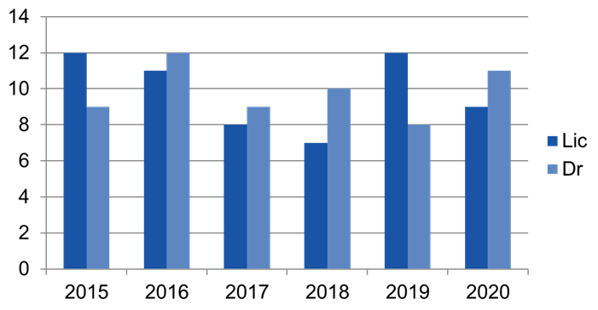 | 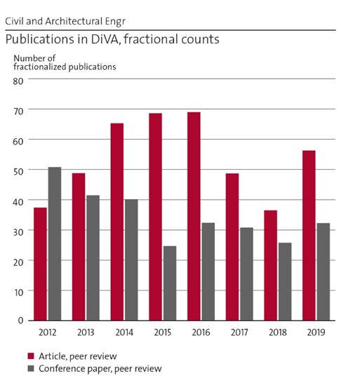
Figure 1 – Number of licentiate and PhD exams during the latest six years. | Figure 2 – Publication statistics.

As shown in Section “Other”, the number of divisions and thus employees have varied substantially during these years. Consequently, any conclusions are difficult to draw. The publications peaks during 2015 and 2016 (Figure 2). It might be due to the high number of PhD student exams (Figure 1) the very same years. A positive trend could be seen during 207, 2018 and 2019. There ought to be a phase displacement between publication and citation. However, this cannot be seen in Figure 3 (left). Figure 3 (right) shows that the Dept. has increased its co-operation with both Swedish industry & society and international universities or research institutes.
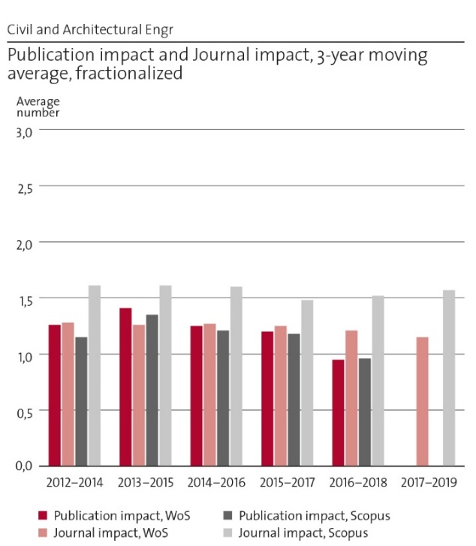 | 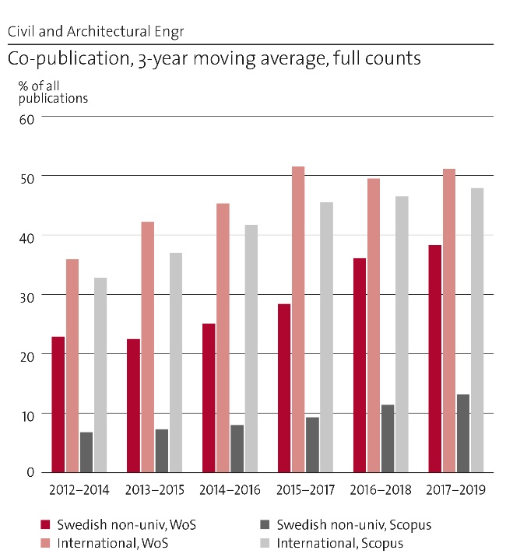
Figure 3 – Bibliometric data
Examples of excellent publications during recent years:
Balieu R & Kringos N (2015): “A new thermodynamical framework for finite strain multiplicative elastoplasticity coupled to anisotropic damage”. Int. journal of plasticity, Vol. 70, pp. 126-150 (ISSN 0749-6419, E-ISSN 1879-2154).
Gasch T, Malm R & Ansell A (2016): “A coupled hygro-thermo-mechanical model for concrete subjected to variable environmental conditions”, International Journal of Solids and Structures 91, 143-156.
Högdahl J, Bohlin M & Fröidh O (2019): “A combined simulation-optimization approach for minimizing travel time and delays in railway timetables”. Transportation Research Part B 126, 192-212.
Laine K, Segerholm K, Wålinder M, Rautkari L & Hughes M (2016): “Wood densification and thermal modification: hardness, set-recovery and micromorphology”. Wood Science and Technology 50, 883–894.
Sadrizadeh S, Tammelin A, Ekolind P & Holmberg S (2014): “Influence of staff number and internal constellation on surgical site infection in an operating room”. Particuology 13(1), pp. 42-51.
Silfwerbrand J (2017): ”Bonded Concrete Overlays – Over 30 years of Swedish research and experience”. Concrete International, Vol. 39, No. 5, pp. 31-36. (Wason Medal for Most Meritorious Paper in ACI journals during 2017.)
Svedholm C, Zangeneh A, Pacoste C, François S, Karoumi R (2016): "Vibration of damped uniform beams with general end conditions under moving loads," Engineering structures, vol. 126, s. 40-52.
Wersäll C, Nordfelt I & Larsson S (2017): “Soil compaction by vibratory roller with variable frequency”, Géotechnique, Vol. 67, No. 3, pp. 272-278.

2e. Engagement in national and international research collaboration within academia and its outcomes
- Strong and intensive co-operation with high-ranked international universities, e.g, UPC Barcelona Tech, HTW Berlin, MIT (Cambridge), TU Delft, Univ. of Hawaii, Aalto (Helsinki), Univ. of Illinois, KU Leuven, UCLA (Los Angeles), Univ. of Melbourne, Univ. of Sapporo, Univ. of New South Wales (Sydney), INSA de Rennes, NTNU (Trondheim) & Politechnica Timisoara.
- Developed co-operation with Chalmers (Göteborg), LTH (Lund) and LTU (Luleå) through the network Swedish Universities of the Built Environment (Sveriges Bygguniversitet), not least within a Graduate School with joint PhD courses. Developed co-operation with Research Institutes of Sweden (RISE) with, e.g., several industrial PhD students.
- Centre for Indoor Climate and Energy Performance in Buildings (Centrum för inneklimat & energiprestanda i byggnader, CIEB). Innovation platform for long-lasting, multi-disciplinary co-operation for user adjusted, sustainable maintenance of buildings focusing on indoor climate and energy performance – a co-operation between KTH, Chalmers, LTH, Jönköping Univ., KI (Karolinska Institutet) and 30+ leading actors (companies etc.) in operation & maintenance of buildings.
- Centre for Traffic Research (CTR). Collaboration with LiU (Linköping) and VTI (Swedish National Road & Transportation Research Institute) on modelling and analysis of traffic processes.
- Individuals are active in international organizations such as American Concrete Institute (ACI), Conseil International du Bâtiment (CIB), Fédération internationale du béton (fib), International Association for Bridge and Structural Engineering (IABSE), and Federation of European Heating, Ventilation & Air-Conditioning Associations (REHVA).

2f. Follow up from previous evaluations
The latest RAE at KTH was carried out in 2012. Among the general recommendations given by the 2012 panel, the following ones with importance for the Dept. may be cited:
In addition, the area of sustainability, as a holistic approach, needs to be lifted to a higher level in order to get a shared understanding of the concept and formulate its aspirations.
Another suggestion was to recruit more international faculty in order to maintain intellectual diversity.
Gender balance is an area where a continued effort is needed. The panels mentioned the importance of active work in achieving a more equal gender balance.
To make basic research more visible, it is recommended that KTH researchers publish more often with external partners. KTH could also consider reappraising its processes for identifying research output worthy of commercialization and that patenting and innovation activities ought to be strengthened through education and networking with industry.
During the latest eight years, the focus of the research has been towards sustainability in almost all new research projects. To apply successfully for research money without focusing on sustainability is hardly possible. Contrary, we are working with eight of the 17 SDG (cf. Section “Sustainability and the United Nations’ Sustainable Development Goals”).
We have increased publication activities with external partners during recent years (Figure 2, bottom, right). Furthermore, our research can be characterized as applied research and many of our research projects lead to innovations that are implemented in the industry or society. Patents are, however, not frequent in the construction sector. Absence of patenting traditions, difficulties to keep innovations secrets on open construction sites, and the importance of a large governmental client (Swedish Transport Administration, Trafikverket) that wants every contractor to use the very same innovations are three explanations.
For the Dept. of Civil & Architectural Engineering (Unit of Assessment, UoA), the following recommendations were stated:
For the successful future of the UoA, priorities should include close research interactions among the members of the UoA; and collaborations with the national and international construction industry, building owners and authorities, and top researchers in sustainability, reliability, infrastructure maintenance and management, life cycle cost of civil infrastructure, and optimization. The panel recommends the establishment of a research centre for green, smart, economical buildings and transportation infrastructure to establish necessary collaborations and provide access to laboratory facilities. Other recommended facility enhancements include updating and enlarging the material and structural laboratory and establishing at least one experimental facility to demonstrate innovative materials and building technologies under real-world conditions.
The Dept. has a long tradition of national and international collaborations with both industry and society so the first recommendation is somewhat difficult to interpret. We have ongoing research projects in all areas mentioned in the list.
A centre for the transport infrastructure – Road2Science – was established in 2012. It has been very successful with research application activities (see Section 6e and “Impact Cases”). Road2Science has changed its agenda recently and is now working, e.g., with a Graduate School within its field together with Nordic universities.
The laboratory has been reorganized for a strong focus on paving materials with a tomography as the most advanced equipment. Some resources related to thermal properties, like a big climate chamber, was removed after being found to be outdated and also because the demand for tests was very limited. The laboratory has been recognized as a KTH research infrastructure (laboratory). Laboratory works are not limited to a certain building. A few years ago, the Div. of Structural Engineering & Bridges bought an equipment for making dynamic tests on bridges. Besides the traditional engineering laboratory, the Dept. has invested in a laboratory for Building Information Modelling (BIM) together with primarily the Dept. of Real Estate & Construction Management.

Viability

3a. Funding; internal and external
The Dept.’s total revenue is 166 Million SEK (2020). The research is totalling 102 MSEK. It consists of faculty funding (32 MSEK), external governmental funding (64 MSEK) and external commission works (6 MSEK). Since 2012, the Dept. has received significantly less governmental grants (Figure 4). This has, at least partly, been compensated by increased external research money (“collaboration research funding”). Please, note, that the size of the Dept. has changed over time due to division moments from one department to another one, see last section “Other”.
The largest external funding sources during 2020 are tabled below. Trafikverket is the predominant funding agency and has been that during several years.
Largest funding agencies (kSEK) | 2020 | 2019 | 2018
Swedish Transport Administration (Trafikverket)** | 33 855 | 28 380 | 27 352
Swedish Energy Agency (Statens energimyndighet, STEM) | 6 360 | 3 782 | 5 381
Energiforsk AB (coordinates energy-related R&D) | 6 283 | 4 002 | 3 239
Sweden’s innovation agency (Vinnova) | 4 206 | 2 828 | 3 203
European Union* | 2 742 | 3 367 | 1 564
* A large part of the money from Trafikverket is also EU-funding, but distributed through Trafikverket.
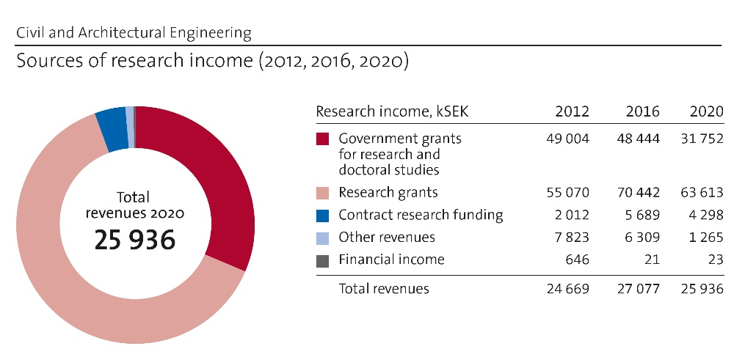
Figure 4 – Economic development 2012 – 2020.

3b. Academic culture
Research matters are discussed in a formal way at four different types of meetings: (i) research project meetings, (ii) division meeting, (iii) meetings in the Counsel of Professors and (iv) Dept. workshops, but more important are the unnumbered informal and spontaneous meetings. Most PhD projects and several other research projects have regular reference group meetings every semester. The reference group consists of the PhD students, the supervisor and the co-supervisors, and representatives from industry and society (e.g., Trafikverket). The divisions arrange division meetings and progress in ongoing research projects is often on the agenda. The Counsel of Professors meets every second week focusing on one specific issue, not rarely research and research quality. In August every year, all employees at the Dept. are invited to a two-day workshop on a hotel venue in greater Stockholm. In the 2018 workshop, publication and citation strategies were discussed. One year later, research co-operation, interaction between research & education and department aims were discussed.

3c. Current faculty situation
Currently, the faculty at the Dept. consists of 9 full professors, 8 associate professors, 3 assistant professors and 13 lecturers (Figure 5). Two professors, one associate professor and four lecturers will have reached the age of 65 (since long ago the traditional retirement age in Sweden, but employees may now continue to work longer) in 2024.
Among the 33 teachers, seven are women (21%) which is much less than the share of female students on Master level (approx. 30%). However, during the latest three years (2018-20), the amounts are more even. Five women and six men have been recruited showing that we are approaching a more even gender balance. Recruiting is the primary tool for improving the numerical balance between women and men.
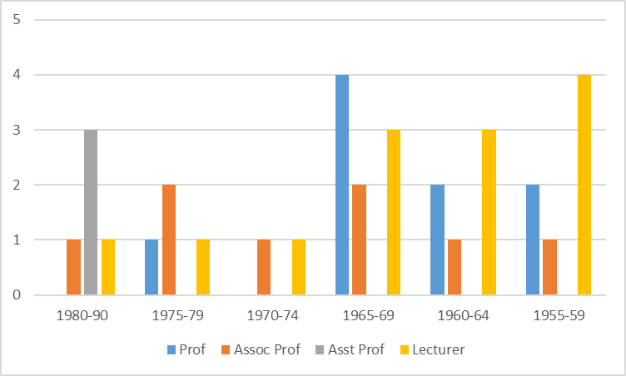
Figure 5 - Birth year of faculty members, the situation in March 2021.
Figure 6 shows the variation in staff and the various employee categories between 2012 and 2020. The large oscillation is primarily dependent on division moments from one department to another one, see the last section “Other”. Concerning PhD students, the total number is rather constant and equal to 60-65 during the entire studied period. The categorization in employed “doctoral students” and “externally employed doctoral students” (= industrial PhD students) may be erroneous.

3d. Recruitment strategies
Any recruitment strategy has to follow the KTH regulations. That means that the degrees of freedom are limited, especially concerning faculty positions. Before being able to recruit full, associate and assistant professors, we need to show that we have a sufficient amount of faculty funding. Duties in education and external funding are not sufficient. Since the entire ABE School is lacking faculty funding, the reader of this document may understand the difficulty in this very important task. Not even in case of retirement, there is a guarantee that we will have funding for recruiting a successor. By dividing the faculty funding that the Dept. has, we have been able to recruit two associate and three assistant professors since 2016. Some of these have later on received additional faculty funding from the School. The strategy for prioritizing subjects and divisions for these new positions has mainly been based on a combination of needs and economic possibilities.
The recruitment of lecturers is easier since the Dept. has a large volume of education duties and the lecturers almost exclusively teach. Here, we have had a lot of retirements and dropouts to the industry. The recruitments can be regarded as replacements.
There is another possibility to recruit and that is to positions as researchers. These positions do not need any faculty funding and are financed by external research money. The Dept. has nearly 20 researchers, of which many also work part-time at various companies. Without the work done by these people, the Dept. would not be able to carry out its many research projects. Researchers are also involved in the supervision of PhD students. Some of these have received the Docent title enabling them to act not only as co-supervisors but also as main supervisors.
However, the Dept. has a long-term goal to enlarge its faculty. Almost all divisions are in need of new faculty positions to share the research and education duties. As shown in Figure 5, most of the professors are born before 1970. There will be a severe shortage of full professors in the 2030s, if the Dept. does not succeed to hire new faculty. The coming recruitment need can simultaneously be turned in something positive; it gives the Dept. the possibility to make the gender balance more equal.

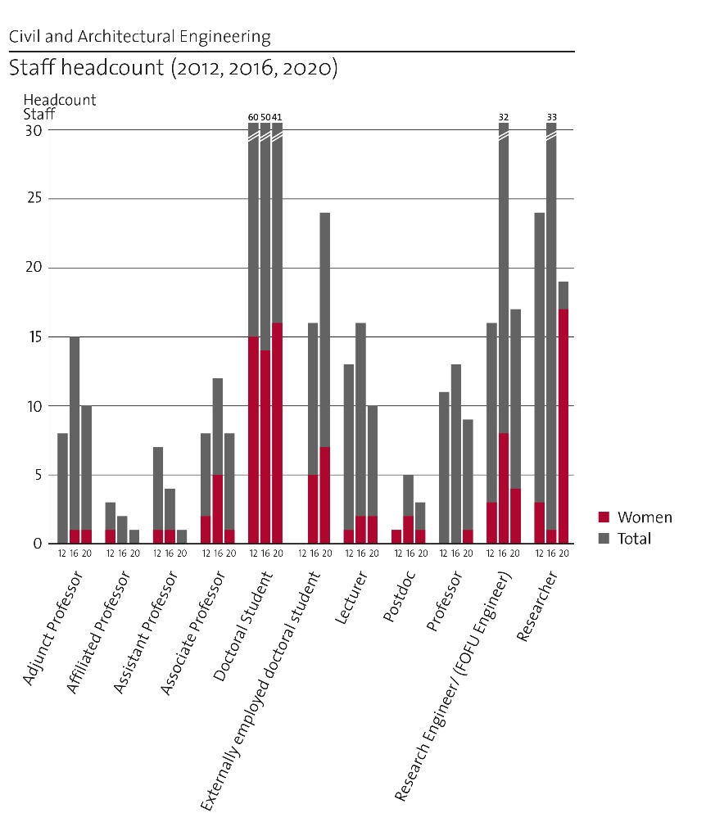
Figure 6 – Historical data concerning staff including PhD students.
Here, it can be added that the Dept.’s centre Road2Science organizes the Gender Gap conference in May 27, 2022, in collaboration with many SIPs, Centers, Vinnova and Formas. The aim of the conference is to raise the awareness of decision-makers about the urgency to deal with gender data bias within the transport infrastructure.

3e. Infrastructure and facilities
The Dept. is located in two neighbour buildings at the main KTH Campus, Brinellvägen 23 and Teknikringen 78. The Dept. rents a sufficient number of office rooms, seminar rooms, coffee rooms etc. At Brinellvägen 23, the Dept. rents laboratory halls. The laboratories contain the following parts and equipment:
• Minor laboratory for strength testing (using a minor MTS machine) of material samples and small test specimens.
• Laboratory for production, testing and analysis of material samples in asphalt and concrete.
• Computed X-ray tomography for analysing materials with possibilities to temperature control and simultaneous loading of a test specimen.
• Inverse gas chromatography (IGC) equipment for surface energy analysis of particulate and fibre materials.
• Two major MTS machines located at Drottning Kristinas väg 26 and co-used of the Dept. and the Research Institutes of Sweden (RISE).
• Equipment for dynamic loading of bridges in-situ and measuring equipment for assessment of bridges.

Strategies and organisation

4a. Goals for development 5–10 years ahead
The research has double aims: (i) to enable an education on a high level and (ii) produce research results implementable in the industry and the society. The education should attract good students and give them training to become employable meeting both current and future industrial and societal needs. The research should maintain its depth and width spanning over the entire area of civil and architectural engineering. The Dept. should be the first choice for problem owners like the Swedish Transport Administration (Trafikverket) and an attractive partner for European universities and research institutes searching EU funding.
The link between research and education is essential for any university. We need to educate PhD students to doctors, doctors need to be hired as assistant professors that successively can be promoted to associate professors and finally to professors. The three categories of professors have different roles and tasks but are all important in the education of BSc, MSc and PhD students. Today, a large part of the teaching is conducted by researchers and visiting teachers. They are important but in the long run, we need to enlarge our faculty to be able to conduct our teaching both pedagogically and close to the research front. Since the Swedish government has decided to increase the continuation education (“life-long learning”) with 20 percent on top of the ordinary education volume, this will be even more important.
The development goal is to renew and strengthen the faculty in order to continue its research and educational tasks concerning the engineering parts of the built environment and meet the future challenges regarding climate change, digitalization, an elderly population and urbanization.

4b. Congruence with university-level goals for “A leading KTH” as set out in KTH´s “Development Plan 2018-23” (page 5)
KTH’s current development plan contains the following headings:

1. A leading KTH
2. An integrated KTH
3. A visible KTH
4. An open KTH
5. An increasingly digitalised KTH
6. A more sustainable KTH
7. A more international KTH
8. An equal-opportunities KTH

The most important message could be summarized in the following quote: “A leading KTH /…/ is characterised by digitalisation, sustainable development, internationalisation and equal opportunities.” Sections “Central research questions and themes”, “Summary statement on contributions of department on impact” and “Engagement in national and international research”, respectively, show how the Dept. strives to reach the first three prestige words. In our leadership and organization, we try to provide equal opportunities for everyone independent on gender, background etc. However, KTH seems to evaluate equal opportunities through equal results in the case of gender. Our work to improve the gender balance is described in Sections “Current faculty situation” and “Recruitment strategies”.
The ABE School’s development plan contains strategic aims concerning four parts: (i) education, (ii) research (“visible research that makes difference”), (iii) co-operation (“natural partner”) and (iv) the employees. RAE 2021 focuses on research and co-operation. The Dept.’s acridity clearly support these goals. For research, see Sections 1b, 2c and 6. For co-operation, see Sections 1b, 2e, 3a, 6a and 6b.

4c. Leadership structure and collegial structure
The Dept. is led by its Dept. Head and Deputy Dept. Head. Each division is led by a Division Head. All these leaders are composing the Leading Group (LG) also containing the Administrative Head, the Director of Studies and the Laboratory Manager. LG meets six times annually and deals mainly with economy and HR matters. Besides, there is a Counsel of Professors (CP). It meets every second week and discusses a specific issue. It prepares decisions to be taken by either the Dept. Head or the LG. Besides, there is a Teaching Staff Meeting (inviting all teachers at the Dept.), chaired by the Director of Studies, discussing education matters and a Research Education Board, chaired by the Program Director, discussing research education matters.

4d. Strategies for high quality
Almost all research projects rely on external funding which is won in national (most frequent) or international (EU projects) competitions. This is a quality recognition of both the previous research (cited in the application) and the outline of the upcoming research project. The majority of the research is conducted by PhD students. Almost all PhD students are writing compilation dissertations. The dissertation is usually containing four or five scientific papers, published or submitted to international scientific journals with referee system. In some cases papers from international conferences with referee systems can be included. Furthermore, all PhD theses are reviewed prior to publishing. Usually, this review is carried out by a colleague at a neighbouring division. This co-operation across the division borders contributes to maintaining a high and even scientific level within the Dept.

Interaction between research and teaching at all three levels (BSc, MSc, PhD) of education

5a. Interaction between research and teaching at all three levels (BSc, MSc, PhD) of education
Most of the Dept.’s teachers are active in both teaching and research. The BSc program Byggteknik & Design (Constructing Engineering & Design) is an exception where a considerable part of the teaching is done by lecturers (who usually do not research). In the MSc program, the number of lecturers is small. The teaching and supervision of PhD students are led by either professors or associated professors and researchers with Docent title. The connection between research and teaching increases in more advanced courses and in the MSc thesis works. Most of the Dept.’s research is carried out in PhD student projects. That means that the interaction between research and teaching at the PhD level is obvious.

Impact and engagement in society

6a. Relevance of research to society at large
The Dept.’s research is almost unexceptionally applied research which is carried out with external funding. That means that the research funding is obtained in competition with other applicants. Relevance to society is usually one of the criteria that the research councils are considering when selecting research projects. As shown in Section 3a, the largest funding agency is the Swedish Transport Administration (Trafikverket). Here, it is impossible to receive research funding for research projects without high relevance for the Administration that has a rigorous process in evaluating the relevance of potential research projects.

6b. Research dissemination beyond academia
The main channel for dissemination of research results is through the examination of MSc and PhD students. Another important channel is through adjunct professors (the Dept. has 10), researchers with employment at both KTH and a company and industrial PhD students (approx.. 40). Some faculty members combine the KTH employment with carefully selected side-line jobs. Both faculty, researchers and PhD students are active at national and international conferences and write a decent number of popular science papers annually. Some employers participate in international committee work, pre-standardization and standardization, these or others write debate articles, participate in media, contribute to development of handbooks and develop response to governmental investigations and proposals.
Another possibility to disseminate research results is networking. The Dept. leads two KTH Centres – Road to Science (R2S) and Centre for Traffic Research (CTR) – and is very active in a third one – Centre for Construction Efficiency (CBE).t

6c. Sustainability and the United Nations’ Sustainable Development Goals (SDG)

Goal 4: We are running a pilot project on how we can connect education levels (from primary [two primary schools and a secondary school] to higher education [KTH]), industry facilities and communal sustainability challenges to each other.
Goal 5: Led by the Highway Engineering Group, we try to (i) increase the visibility of a variety of female role models to our students, (ii) increase the number of female students and female academic staff and (iii) raise the awareness, as well as actively develop activities to diminish the risk of the gender data gap in the transport infrastructure sector.
Goal 7: Research on water power stations and dams.
Goal 7.2: Methods for maintaining Swedish water power stations and dams.
Goal 7.4: Risk based design methods for hydrogen gas storage in rock shelters (in co-operation with the steel industry).
Goal 8.5: Methods minimizing risks for a safe working environment in construction in rock and soil.
Goals 9, 11-13: An increased proportion of renewable biobased building materials in the building sector.
Goal 9: Enhance (through, e.g., digitalization) scientific research that will lead to an upgrade of the technological capabilities of the transport infrastructure sector as well as encourage innovation
Goal 9.1: Minimizing material and natural resources promoting sustainability in infrastructure construction.
Goal 9.4: Updating and prolonging the service life of civil engineering structures, e.g., dams and tunnels.
Goal 11.1: Safe and affordable housing.
Goal 11.1: Sustainable stepwise renovation.
Goal 11.2: Development of cost-efficient construction in rock and soil facilitating the construction of urban public transports in turn improving availability. Shifting mobility from private cars to public transport.
Goal 11.6: Reduce environmental impact of cities.
Goal 11.6: CIEB (see Section 2e).
Goal 13: Reducing climate footprint from concrete structures through reducing cement content, utilizing industrial by-products, optimizing cross sections, LCCA and LCA, improving maintenance and repair.
Goal 17: International research co-operations (see Section 2e).

6d. Structure for increased impact
As shown above, the Dept. has already rather extensive impact activities. Further increase should rather focus on increasing its intensity than its extent. This can be done by a more careful selection of dissemination channels. The Dept. has hired a person responsible for information and she is continuously working with improving the Dept. web www.byv.kth.se and other modern tools.
At Dean’s office, an external consultant will be engaged to further develop the School’s strategy for communication, dissemination, and co-operation with the society focusing on messages, aim groups and modern channels to reach the various aim groups. This will, of course, also be of importance for the Dept. of Civil & Architectural Engineering.
Regarding impact cases, KTH is currently highlighting the importance of the documentation of the impact or success of impact cases. That means that the researchers need to carefully document the progress of major research projects during the performance phase, publish the results both academically and popularly and follow up how the results are received and implemented in the society.

6e. Impact cases
The Dept. has selected two impact cases for the evaluation: (i) The research program “InfraSweden 2030” and (ii) “Concrete Dams and Thermal Cracking”. The selection has been made based on the requirement of documented success. If you set less weight of documented success, the Dept. can provide a much larger number of impact cases. Another five examples are:
- Bus Stops. A novel method for the calculation of capacity in bus stops & terminals. The new formula is used by the Traffic Administration in Stockholm.
- Cleaning Swimming Pools. Chlorination alternatives, with blue light & photo catalysis, reduce the need for chlorination to less than half. It will now be implemented in a regular pool at Västertorp-Stockholm.
- Controlling Vibratory of compacting tools for highway construction. Automatic frequency optimization has been implemented for vibratory rollers & is available on the market from 2019.
- Öland Bridge (6 km long). Based on our investigation, Trafikverket issued a decision to allow higher axel load on the bridge.
- Resilient Energy Systems for Remote Environments. Securing the sustainable & robust energy supply for the Islands of Maui, Molokai & Lanai (Hawaii) as part of the sustainable development strategy for the State of Hawaii

Other (optional)
The Dept.’s organization has changed several times during recent years (below). This makes long-term comparisons of faculty size, economy, and publication volumes complicated.
Year | Acquisition (January 1st) | Loss (January 1st)
2015 | Highway Engineering (25)  Architectural Lighting & Design (3) | -
2017 | - | Architectural Lighting & Design (3)
2018 | Transport Planning (25) | River Engineering (10)
Footnote. The numbers in () are the approximate numbers of employees at the time of re-organization.

Department of Philosophy and History
Self-evaluation
Head of Department: Associate Professor Sabine Höhler

Included divisions:

Division of Philosophy
Division of History of Science, Technology and Environment

Department of Philosophy & History

1. Overall analysis and conclusion; strengths and development areas

a. Limited SWOT-analysis
 | Strengths | Weaknesses
Research | 1. Multidisciplinary, multinational and well-integrated research environment  2. Excellence in acquiring external funding, incl. several large EU-funded projects  3. Strong publication record  4. High societal relevance and impact, capturing important themes of social and environmental sustainability  5. Successful PhD training | 1. Lack of funds to replenish and develop faculty to sustain the growing research operation  2. Limited research collaboration within the school and the organization
Organisation | 1. Diverse and collegial work environment, visible and attractive to international colleagues and guests  2. Transparent and flat leadership, frequent meetings and exchange  3. Strong engagement in societal debate, serving multiple audiences  4. Outstanding international collaboration | 1. Unbalanced and uncertain funding situation due to low core funding, low returns on education and large dependence on external funds  2. High university overhead costs, high co-funding demands  3. Unbalanced size of divisions  4. Low degree of collaboration between the divisions

Development Areas, top 5
- Humanities at KTH: Develop the presence and significance of the humanities at KTH and ABE according to KTH Development Plan 2018-2023. Work towards the recognition of the humanities’ importance in the education and future professional engagement of engineers in society, to build responsible leadership. A Masters program would be an obvious step.
- Cooperation: Explore fields of cooperation in and beyond the department, to be sustainable at ABE and KTH. Pool research interests and competences and reach out to new partners in and outside of academia.
- Beyond Philosophy and History: Continue working towards inter- and transdisciplinarity to contribute to sustainable transitions. Continue to reflect on the affordable scope of multidisciplinarity in a department limited by funding uncertainties and risking to dilute core competences.
- Funding: Develop a more stable funding situation. Aim to acquire more basic funding from KTH, as well as long term platform grants and donations from private funders.
- Faculty Development: Build a solid faculty that can meet generational shifts and stabilize core operations while hosting temporary researchers and research projects. Reflect on and, when indicated, adjust the balance between the number of faculty members based on limited core-funding and a growing number of researchers relying on soft money.

b. Summary statement on contributions of department on impact, infrastructure and sustainable development
  - Impact: High societal impact and visibility through informing and engaging civil society, participating in societal debate, giving policy advice and affecting policy changes. Influence on research policy; university governance; climate, media and energy policies.
  - Infrastructure: The Environmental Humanities Laboratory (EHL) and the Posthumanities Hub have built up highly visible collective research networks with outreach and impact beyond academia, utilizing nontraditional media for scholarly publishing.
  - Sustainability: High-profile work on environmental philosophy, history and humanities aiming at analysis, achievement and improvement of SDGs; research and initiatives on energy transitions, climate change, environmental governance, behavioral change, emission goals, engineering solutions, and engineering ethics.

2. Research profile

a. General information of the department
The Department of Philosophy and History is composed of the Division of Philosophy and the Division of History of Science, Technology and Environment. The department is one of six departments at ABE School of Architecture and the Built Environment, one of five schools at KTH. The department is also the place at KTH and ABE where research in the humanities is most concentrated and distinct.
At the end of 2020 the department had ca. 70 employees of which ca. 1/3 were employed at Philosophy, 2/3 at History. The department is led by the Head of Department/Prefekt (currently from History, with the Deputy-Head of Department from Philosophy) who represents the department in ABE’s steering council. The two divisions maintain largely separate operations led by the Heads of Division. The divisions’ economies are also separate. The shared economy part concerns the overhead budget which covers common departmental functions and infrastructures. Partly joint departmental functions are leadership, administration, directing undergraduate studies and directing graduate studies. The latter function concerns running the joint departmental PhD program “Studies in the Humanities and Social Sciences of Technology, Science and the Environment”, where leadership alternates and where collaborative meetings occur regularly, including both subject fields.

b. Central research questions and themes, knowledge gaps addressed, main research activities
Research at the Division of Philosophy covers a broad variety of topics, questions and themes, but its main overall focus is philosophical aspects of technology and its role in society. Research areas include
  - Philosophy of technology
  - Philosophy of risk
  - Ethics of technology, particularly social and environmental aspects of the built environment, biotechnology, climate mitigation, artificial intelligence, sustainability
  - The ethics, methodology and epistemology of institutional decision making
The division also has a strong presence in more theoretical areas of philosophy:
  - Philosophy of science, particularly in the methodology and epistemology of scientific modelling
  - Logic and formal semantics
  - Formal epistemology
  - Decision theory and the philosophy of economics
This mixture of applied and theoretical themes is the division’s hall-mark. Although a fairly small philosophy division, the competences are broad. Apart from the core competences of philosophy, faculty and research staff members have degrees or long working experience in law, civil engineering, toxicology, computer science, environmental science, risk analysis, and cognitive science.
A substantial portion of the research at the division is multidisciplinary and is done in collaboration with researchers from other areas, as well as decision makers in the EU, the Swedish government, and Swedish municipalities. Ongoing projects collaborate with researchers specialized in traffic safety, genetics, molecular biology, climatology, geol­ogy, clinical medicine, computer science, and environmental economics, as well as with decision makers at The Swedish Transport Administration and in several municipalities. For instance, the project SEA-RIMS (PI Per Wikman-Svahn), which addresses ethical aspects of mitigating sea-level rising due to climate change, is performed in col­laboration with the Swedish Geotechnical Institute, the Council of the Baltic Sea-states, two regional governmental bodies, and six municipalities. Another example is Ethics in Biodiversity Offsetting which addresses ethical and legal aspects of biodiversity offsetting, which involves collaboration with environmental lawyers, NGOs as well as decision makers at national and local level.
Philosophy is traditionally a male-dominated subject which comes with a myth of the philosopher as the “male-genius”, often fostering a rather aggressive culture. The division actively tried to counterbalance this image in recruitment and in fostering a more inclusive culture. The non-traditional focus on applying philosophy to problems that are of direct relevance to society may attract more female researchers. Of the 7 researchers currently employed, 3 are female. Among the 7 PhD students, 3 are female. At the level of faculty there is room for improvement. Among the 4 faculty of 4 members, 1 is female. The division has 2 professors, both male.

Research at the Division of History of Science, Technology and Environment addresses scientific, technological and environmental developments in their social and cultural contexts and impacts in the modern period, with a focus on the 20th and 21st centuries:
  - Sustainability studies/Anthropocene history/Science history and politics of climate change
  - Environmental humanities (since 2012) and Posthumanities (2018-2021)
  - History of natural resources, resource extraction & management
  - History of infrastructures & large technical systems, including data processing and media systems
  - Cultural/industrial heritage studies, industrial archaeology
  - Arctic and Polar history
  - Energy, water, waste – their historical sciences, technologies, politics and governance
  - Environment and migration – their cultural and social histories
  - Urban ecology, urban studies
  - (Environmental) media technology and communication, film and visual environmental studies
  - Research policy, higher education studies & innovation studies
With a unique combination of strong research cores arranged around broad contemporary questions of human-environment relationships the division has furthered a broad humanities research agenda for sustainable development. Research approaches are integrative, informed by Science and Technology Studies (STS), political ecology, cultural theory and media studies. Research is cross-disciplinary with a transnational or global historical perspective.
Since 2012 the division has experienced a considerable growth in external funding and in the numbers of co-workers, beginning with the founding of the Environmental Humanities Laboratory (EHL) in 2011, enabled by a private donation. The EHL helped launch the participation in the new international field of the environmental humanities. The division contributed actively to shape this field while maintaining its historical focus. Participation in the Marie Curie ITN “Environmental Humanities for a Concerned Europe” (ENHANCE) (2015-2019), together with Leeds University, the Rachel Carson Centre in Munich and the Deutsches Museum in Munich, brought four PhD candidates with backgrounds other than history (environmental humanities anthropology, sustainability studies) to the department’s PhD program. Multidisciplinarity has benefitted the division also in the field of polar research, which combines history of technology, environmental history, social and cultural history and industrial heritage studies. The division became the hosting partner of a Nordic Centre of Excellence in Arctic Research, funded by Nordforsk (Oslo) and in collaboration with 14 other partners in eight circumpolar countries (2016). In 2015, the program Making Universities Matter (MUM), funded by Vinnova and in close collaboration with Lund University and Technopolis Group Ltd (UK), invigorated research policy as a core area of investigation, with the appointment of a guest professorship in Research Policy. The successful broadening of environmental issues is demonstrated by three ERC grants on environmental, energy and polar research that researchers at the division received between 2016 and 2018.
The division’s research focus on environmental sustainability and justice attracts international scholars, both women and men. At the turn to 2021 the division counts close to 50 co-workers pursuing a total of 50 research projects (of various size) and with a turnover of 45 MSEK (2020), of which some 10 % is KTH core funding, 5 % is funding based on research performance, publications and PhD education, and 10 % is competitive funding KTH provides as co-funding for ERC projects. Hence, 80% of research income is from external sources. All faculty members and nearly all researchers lead research projects, some individual but most involve several colleagues across career levels, including postdocs and, if funding allows, PhD students. The division has become increasingly more multinational and multilingual. Roughly 50 % are born outside of Sweden and about 40% are women. The division attracts a growing number of guests and visiting scholars from all over the world.

c. Contributions to the advancement of the state of the art within the research fields of the department
The Department of Philosophy and History differs from a traditional humanities department. At an institute of technology, the divisions specialize in scope, focus and expertise. We comment on modern science, technology and their societies, built environments and socio-technical infrastructures, targeting present-day societal problems. Our research is of high societal relevance and impact, capturing important themes of social and environmental sustainability, e.g., climate, resources, energy, and bioscience. Our work is inter- and transdisciplinary, and we believe it is also transformative: it transforms others, ourselves and the humanities more broadly, and it contributes to societal transformations. Research is situated at the edge of our traditional disciplines, which we advance by developing new research fields and methodologies, e.g., the environmental humanities, posthumanities, Anthropocene history, and the ethics of traffic safety or radiation protection.
The Division of Philosophy is heavily focused on publishing research in international journals that employ the system of peer-review, to contribute to the international state of the art within the research fields of the department. For instance, PhD-students do not write monographs, but are instead expected to produce a dissertation consisting of 4-6 articles that are published, or at least are publishable in such journals. This has been successful, roughly around 75% of the articles included in the PhD dissertations have been published by the time the PhD student is finished. The division strives to publish research both in traditional philosophical journals (e.g., Ethical theory and Moral Practice, Philosophical Studies, Analysis, Journal of Philosophical Logic) but also – importantly – in non-philosophical journals so as to reach researchers outside of philosophy (e.g., Journal of Risk Research, Energy Policy, Artificial Intelligence). In all, publications cover more than 100 articles and papers between 2016 and 2020, including 21 by PhD students. In addition, in this period researchers at the division produced five edited books (the latest a handbook on Vision Zero – so named after the goal of zero dead in traffic – the first comprehensive treatment of Vision Zero in public policy) and two monographs.
The Division of History has developed integrated humanities research in defining and transformative ways. Through widening of scope, diversifying and increasingly claiming stakes in education, society and politics, the division works strategically to carve out a way forward for humanities scholarship in a school of technology facing the Agenda 2030 decade. Since RAE2012 the division witnessed profound internationalization and successful grant acquisition, paralleled by an increasingly global scope of its research and collaborations. The division enhanced research diversity while maintaining its core focus in history, which has led to novel and often quite unique combinations of approaches and research outputs, e.g. in integrated polar research that draws on political science and material cultural studies; in the climate humanities that range from climate monitoring to climate migration studies; or in the visual environmental humanities including film, art and activism. Collaborations with KTH Water Center, KTH Sustainability, KTH Energy Platform, StandUp Strategic Energy Research, Architecture, and Learning are close. The publication record has grown stronger and more diverse while retaining strength in Swedish publications. The division increased engagement and influence in its wider international academic communities, closest academic networks, e.g., Tensions of Europe, and societies, e.g. Society for the History of Technology (SHOT) and European Society for Environmental History (ESEH). Since 2012 the division offered a venue of exchange by organizing and hosting several large conferences (7th Tensions of Europe meeting 2015; political ecology conference “Undisciplined Environments” 2016; environmental humanities conference “Streams” 2020 and 2021).

d. Quality and quantity of contributions to the body of scientific knowledge
The department’s publication profile is only partly discernible in the bibliometric data for RAE2021. It treats philosophy and history as one although they have different publishing traditions and track records. Moreover, RAE bibliometrics does not pay necessary attention to the publication outlets and formats and the circulation and citation of published material in the humanities.
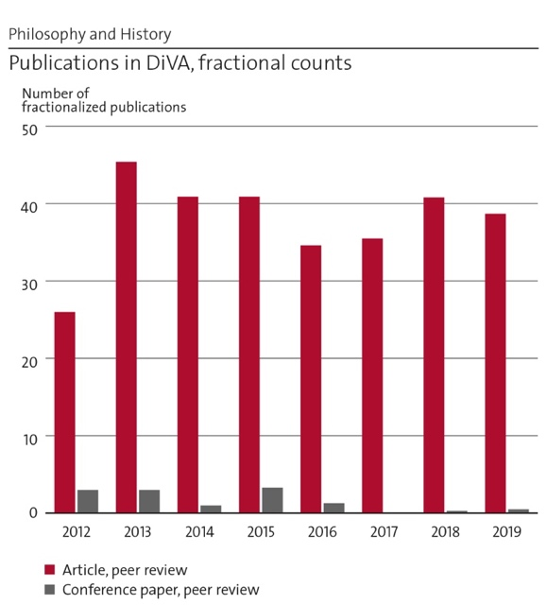 | Implications: i) Only a limited portion of our publications, those listed in WoS and Scopus, are included in our citation count. ii) All data are absolute numbers which obscures the relationship between research output and core funding. Our estimated peer-reviewed research output is comparatively high in relation to core funding (10% as per above). High is also our external research income which enables us to, nonetheless, maintain an intense publishing pattern. iii) Our publishing style is a mix of co-authorship and individual authorship. The latter is necessary to build a career in the humanities and we maintain it in multiple ways as part of our quality work. Hence, the indicator for co-authorship as a proxy for ‘collaboration’ is misleading for our department. Collaborate we do, but mostly in other ways than writing papers with our non-academic partners.
Figure 1. Publications in DiVA

Consequently, we have no good coverage of our citation patterns. Google scholar gives more adequate information than WoS or Scopus data. This notwithstanding, based on WoS data we have individual researchers ranking among the top ten scholars in their fields according to the Stanford standardized citation metrics ranking (Ioannides et al 2020, https://doi.org/10.1371/journal.pbio.3000918), one in History, one in Philosophy (these two humanities scholars are in fact the highest ranked in KTH). Compared to Swedish philosophy and history departments, our (admittedly not detailed) impression is that the department fares well in research volume, visibility, and impact from research. We pay attention to patterns and strategies of publishing to enhance circulation and impact. We train PhD students and postdocs to select formats and outlets carefully.
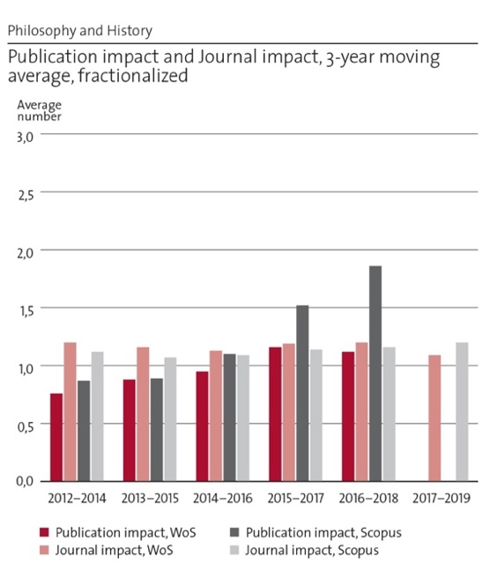 | 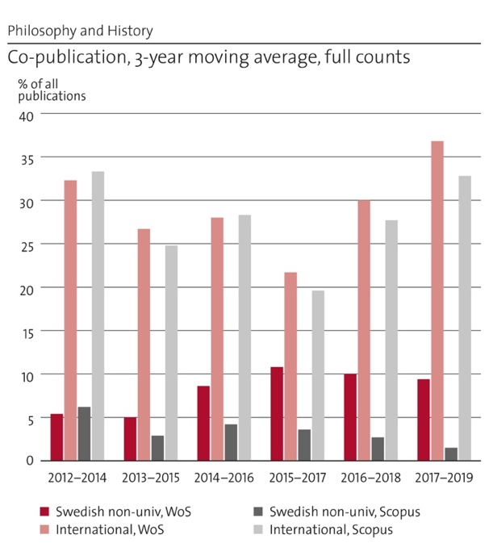
Figure 2. Publication impact and journal impact | Figure 3. Co-publication

Sample publications Philosophy:
Zetterberg, C. and K. Edvardsson Björnberg (2017) “Time for a new EU regulatory framework for GM crops?”, Journal of Agricultural and Environmental Ethics 30(3): 325-347.
T. Grüne-Yanoff and R. Hertwig (2016) “Nudge versus boost: How coherent are policy and Theory”, Minds and Machines 26 (1-2): 149-183.
S. O. Hansson (2017) “Science denial as a form of pseudoscience”, Studies in History and Philosophy of Science, 63: 39-47.
J. Cantwell (2018) “Making sense of (in)determinate truth: the semantics of free variables”, Philosophical Studies 175(11): 2715-2741.
T. Sandqvist (2018) “Preservation of Structural Properties in Intuitionistic Extensions of an Inference Relation, Bulletin of Symbolic Logic 24(3): 291-305.
Since RAE2012, the Division of History has gradually moved towards publishing scientific articles in international journals and university press books. This is in line with a general trend in Swedish humanities, although far more pronounced. Outlets include broad-spectrum high-impact journals such as Science, Nature, Nature Climate Change, Climatic Change, Global Environmental Change, as well as disciplinary flagship journals such as Isis, Technology & Culture, History & Technology, Environmental History, Environment and History, and cross-cutting thematic journals, e.g., Social Studies of Science, Energy Policy, Polar Journal, Minerva. In the previous decade, the output of peer reviewed journal articles, books and book chapters (combined) by division members grew from 9 in 2010 to 83 in 2019. At the same time, division members maintained a high profile of publishing in Swedish for wider audiences, policy, and public and civic discussion.
Sample publications History:
Marco Armiero & Richard Tucker, Environmental History of Modern Migrations (London and New York: Routledge, 2017).
Per Högselius, Arne Kaijser & Erik van der Vleuten, Europe’s Infrastructure Transition: Economy, War, Nature (Palgrave Macmillan 2016, published as one of six volumes in the award-winning Making Europe book series).
Sabine Höhler, Spaceship Earth in the Environmental Age, 1960-1990 (London: Pickering & Chatto 2015).
Will Steffen, Katherine Richardson, Johan Rockström, Sarah E. Cornell, Sverker Sörlin [et al], “Planetary boundaries: Guiding human development on a changing planet”, Science 347(2015): 6223, pp. 736-746.
Sverker Sörlin & Nina Wormbs, “Environing Technologies: A Theory of Making Environment,” History & Technology 34(2018):2, pp. 101-125.

e. Engagement in national and international research collaboration within academia and its outcomes
The department is engaged in a number of large, mostly international, projects and programs, often as lead or hosting institution. We organize much of our work in broad multi-year projects, sometimes with considerable ‘deep’ interdisciplinarity, sometimes with non-academic institutions, and with experimental and outreaching formats for mobilizing public and stakeholder participation and presenting results.

The Division of Philosophy cooperates e.g. in the project Mistra Biotech with the Swedish Agricultural University, Lund University, and Umeå University. As part of the Stockholm Centre for Health Care Ethics, CHE, the division works with Stockholm University and Karolinska Institutet. In the project Modal modelling in Science, the division works with the University of Vienna, University of Stirling, and LSE. In the project Boosts vs nudges, the division collaborates with the University of Helsinki and the Max Planck Institute for Human Development in Berlin.

The Division of History cooperates on various levels. On a strategic level the division cooperates with crucial players in the field of the environmental humanities, such the Rachel Carson Center in Munich and the Center of Culture History and Environment in Wisconsin; the Max Planck Institute for the History of Science in Berlin which runs the Anthropocene Campus and Curriculum, a worldwide multi-year collaboration supporting engagement in the Anthropocene debates since 2014. Strategic cooperation collocates the division’s research environment on the global map. The division upholds capacity building cooperation where it is involved in supporting the development of research environments elsewhere, as e.g. the Roma Tre University and the Swiss Environmental Humanities Hub, or the project CHEPIS (Center for Higher Education, Policy, and Innovation Studies), a SIDA funded five-year advanced postgraduate training program with seven PhD students (two enrolled at the division) and one postdoc pursued in collaboration with U Eduardo Mondlane, Maputo, Mozambique and U of Western Cape, South Africa. Societally engaged cooperation has led division members to work closely with non-academic partners, such as grassroots organizations, local authorities, cultural institutions and governmental institutions, e.g., CLISEL, a Horizon 2020 project involving U Bern, U Lancaster, U Cagliari, and the Association of Local Authorities of Sardinia region. Societal cooperation has a cyclic dimension; it transfers scientific knowledge to societal actors, and it changes the ways in which knowledge is co-produced. Finally, the division engages in instrumental cooperation in relation to research projects which require specific knowledge and expertise. This cooperation is limited to projects but may lead to stable collaborations. An example is the division’s engagement in the NordPlus-funded project Bringing Research Into Green Humanities Teaching (BRIGHT), a collaborative teaching initiative involving partners across the Northern and Baltic regions hosted by the Greenhouse at U Stavanger.
Members of the History division have conducted research visits as fellows at Institutes for Advanced Study (or similar), often with considerable impact on the research profile and output of scholars during and after their visits. Among those are IAS Princeton; the Princeton Environmental Institute; Rachel Carson Center, Munich; KRITIS at TU Darmstadt; CAS at the Academy of Sciences, Oslo; Peder Wall Center, UBC Vancouver; Netherlands IAS in Wassenaar (now Amsterdam).

f. Follow up from previous evaluations
In RAE2012 and RAE2008, our department was evaluated as a unit combining the Division of History and the Division of Philosophy. Our research unit was ranked excellent/AAA, together with 14 other excellent units at KTH, which resulted in more core research funding to both divisions.
The assessment panel’s recommendation to “develop a long-term strategy on how to maintain this very high level of performance in the light of the problem of the medium-term succession of several of their key leaders” has posed an ongoing challenge, especially the aim of faculty renewal and long-term faculty stability. Philosophy has not recruited new core faculty since 2012 and lost 2 faculty members during this time. History recruited 2 associate professors in environmental history but lost 3 faculty members, one because of retirement. We are presently recruiting an externally financed assistant professor to the Division of History, and we hope to recruit 2 associate professors (1 in Philosophy, 1 in History) and 1 assistant professor (History) to the department, on a mixed funding of internal and external sources.
Another recommendation in both RAE2008 and RAE2012 was for KTH to find ways to utilize the expertise of these two divisions in undergraduate and master level teaching. This recommendation has been left unheeded in KTH, despite efforts from the department to energize the process. Despite a couple of examples to the contrary, the predominant trend has been a downward one: instead of strengthening our position in KTH’s engineering programs, our courses have on multiple occasions been sacrificed in the context of restructuring of programs – also by departments in our own school.

3. Viability

a. Funding; internal and external
The department receives its research funding from external sources in Sweden and the EU (as yet little from funders beyond Europe). We have a marked profile towards the most competitive theoretical and high end (‘basic’) research funders, notably the Swedish research council (VR), Riksbankens Jubileumsfond, the Swedish Agency for Sustainable Development (FORMAS), the Swedish Foundation for Strategic Environmental Research (MISTRA), and increasingly the European Research Council.
Broader calls are more common, and interdisciplinary competencies in demand. Given our narrow core funding for research and teaching we have over the last 15 years explored a conscious strategy to broaden our expertise in the adjacent humanities (and to some extent social sciences and artistic research) in order to tap into these sources. We have built efforts to shape research teams and craft proposals with a mix of internal and external scholars. We have developed processes for assessing external proposals for collaborations, thereby broadening our networks and our base of expertise and competitiveness, and enhancing our opportunities to learn from others.
The more successfully our strategy works, the more precarious the relation has become between core funding and competitive grants. The critical factor is the lack of mechanisms with which to acknowledge and support excellent research performance and link it strategically to a conscious effort to build the presence of humanities and social sciences at KTH. Despite our large access to external funds, we experience a lack of freedom to use resources pragmatically, which constrains, in our view unnecessarily, for example our ability to co-fund PhD students on their 4-year full-time positions. | 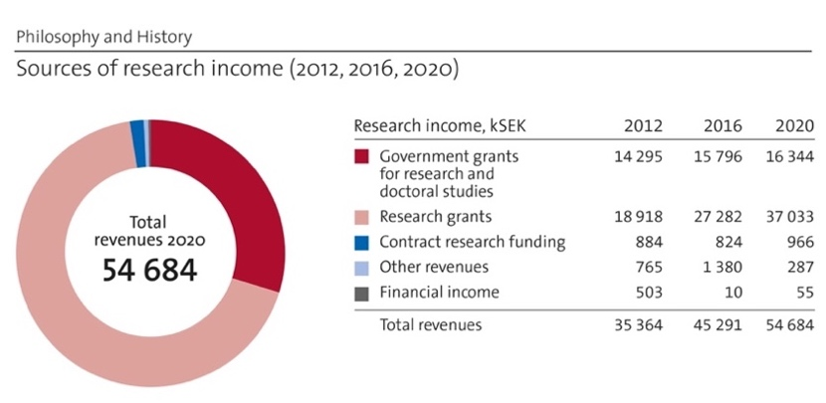  Figure 4. Sources of research income (2012, 2016, 2020)

b. Academic culture
The department works towards openness and inclusivity by fostering a multiplicity of disciplinary perspectives and identities. We can still improve on gender balance, and we remain a rather white Northern and European environment. We are improving at the PhD and postdoc levels with co-workers from Asia and Africa, but wish to work more on global inclusiveness. To the annual division retreats, typically 1-2 days per year, all co-workers are invited, including fellows and guests. These well-attended gatherings provide opportunities to discuss work environment and division strategies.
The department trains research integrity and research ethics and fosters integrated research. Both divisions hold research coordination meetings, typically once every term, and aim to meet new research grant calls across the individual backgrounds and subdisciplines of our researchers. The focus of these meetings is on communicating and sharing approaches that enable identifying new topical constellations. Both divisions also run a colloquium series to discuss new research, hear thought leaders in our core fields, and to integrate PhD students and postdocs into a critical and understanding community of scholars. We work actively with the quality and the variety of our staff. We foster competence-building of our young and mid-career scholars, to meet the constraints of postdoc and temporary researcher employments (e.g., teaching experience; language, pedagogical and management training). Development talks and performance reviews are offered annually to all our co-workers. Both divisions maintain a collegial leadership structure. Our steering groups are composed of representatives of all levels of employment, faculty, postdocs/researchers, PhD students and administration. Meetings are held two to four times every semester.
The Division of History drafts five-year strategic plans since 2005, so far 2007-2012, 2012-2017, and 2017-2022. Conscious, democratically anchored strategy work has helped to think deeply and collaboratively on what the division can become, and what difference it can make, to historical knowledge, to society, to KTH and to the department as a leader of intellectual and institutional development in the humanities. History also regularly reports on its activities in inclusive biennial division reports (most recently Defining Humanities. Report 2017-2018, published 2019). The 2019-2020 report is currently in preparation.

c. Current faculty situation
Current faculty at the Division of Philosophy consists of 2 full professors (male) and 2 associate professors (1 male, 1 female). A full professor (male) retired in 2018. Age-wise, the span is 47-53. The female lecturer can be expected to be promoted to full professor within 1-2 years. Given the age profile, the division needs to recruit younger researchers.
Current faculty at the Division of History consists of 3 full professors, 1 in Environmental History (M 1956, retiring in one to four years), 2 in History of Technology (F 1968, M 1973), and 2 associate professors, 1 in Science and Technology Studies with Historical Orientation (F 1966), and 1 in Environmental History (M 1966, also director of the EHL).
The department’s current faculty is unbalanced with regard to gender, a situation which we aim to relieve through promotion and conscious recruitment. The faculty provides skills and capacity to maintain supervision, research leadership and abilities to think and act strategically. However, these capacities rest more on individual properties of our small faculty than on its collective size, which is modest in relation to the total staff of 77 employed through 2020, including 18 PhD students, 24 researchers, 9 postdocs, 9 research engineers, 2 guest professors, 1 adjunct professor and 4 administrators. We have tried to compensate for this imbalance by hiring guest professors to the department (4 in the past 5 years), and by affiliating professors (1 in the past 5 years) and adjunct professors (2 in the past 5 years).
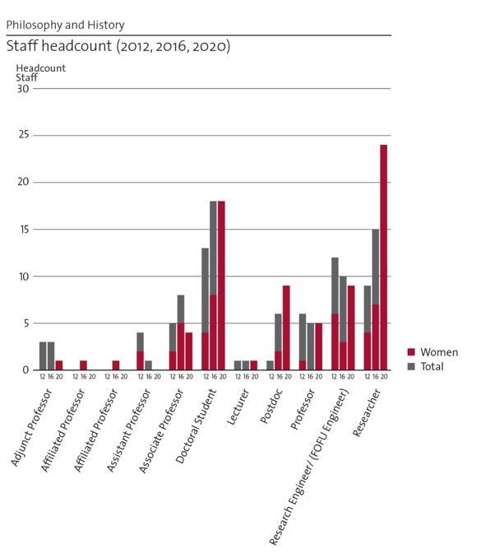 | We are presently recruiting an assistant professor in the History of Media and Environment, based entirely on external funding (WASP-HS The Wallenberg AI, Autonomous Systems and Software Program – Humanities and Society). We plan to apply for permission to open permanent positions in Ethics, in History of Science, and in Environmental Humanities with Historical Orientation, on the assistant and associate professor levels, to renew our faculty and continue building capacity according to our needs and strategic visions. The process for hiring new faculty rests largely on the amount of long-term core funding and the amount of long-term teaching commissions – none of which we have to a considerable extent. It is typically not considered desirable to hire new faculty members based on external funding, nor is there a substantial relationship between growth of external competitive funding and the size of core funds.
Figure 5. Staff headcount (2012, 2016, 2020) | OBS: Figure needs updating!

d. Recruitment strategies
Recruitment of PhD students follows KTH’s formalized procedures which ensure that principles of diversity and equality are maintained. Recruitment committees are formed by a gender-balanced and position-balanced group of colleagues. For new faculty, recruitment follows a strictly prescribed process based entirely on external evaluation. Post-docs and researchers are exclusively project-funded. To avoid imbalanced hiring to projects we involve larger circles of colleagues in the selection process. Project leaders are informed and aware that a hiring process must have a balanced committee in place, often including non-project members for the interviews of short-listed candidates.

e. Infrastructure and facilities
The KTH Environmental Humanities Laboratory (EHL) (founded Dec 2011) is embedded in the research organization at the Division of History. The EHL brings humanities and social science research to bear on socio-ecological challenges and fosters just sustainability. The Lab fosters transdisciplinary public engagement and has become a global player in the rising field of the environmental humanities, with an international network of academic and societal collaborations, now across all continents. Areas of action include research on environmental change and social innovations, environmental justice, ecological democracy and environmentalist movements; co-publishing the International Journal of Environmental Humanities (Duke Univ. Press); training in environmental humanities, political ecology and visual studies; and outreach activities involving students, civil society organizations, policy­makers and the public. Initiatives include the annual Stockholm Archipelago Lecture; the CrossCuts Film Festival; the organization of two large conferences (> 500 participants); and the public environmental humanities projects on climate change in the city and toxic autobiographies. Some thirty scholars have spent research stints with the Lab.
The Posthumanities Hub joined the Division of History from 2018 to 2021 as an experimental effort to break new ground in integrative humanities. The Hub linked to artistic research & design, with strong outreach; it used nontraditional formats, like film and fiction, stakeholder engagement, and interaction with social, popular movements; it worked to supplement the profile and brand of KTH as a technical university, to enhance attractivity, especially among potential female students, and create new pools of talent.
The Lab has been growing organically, mainly through external funding. It was made possible by a private donation and is now supported by KTH core funding. The Posthumanities Hub was funded through a three-year guest professorship by KTH and external grants. The Lab is a significant innovation, but financially vulnerable. It needs infrastructures, internal organization, event coordination, communication and web maintenance.
The Division of Philosophy closely collaborates with KTH Live-In Lab, a full-scale test environment for advanced technologies in the home. Many modern IT-solutions involve potential conflicts with privacy and integrity and a relatively controlled environment provides a setup for examining to what extent these conflicts are realised.

4. Strategies and organisation

a. Goals for development 5–10 years ahead
The department’s short-term goals are to develop its faculty and to solidify its funding base, including expanded EU funding. In order to strengthen our collaboration between the divisions and within ABE and KTH we aim to increase our strategic efforts of identifying possible connections to establish cross-disciplinary cooperative modes of climate, environmental and sustainability research at KTH. Our medium-term goal is to work towards an increased role of the humanities at KTH; both in research, through an established platform of humanities and social sciences, and in undergraduate teaching, through a Masters program in the humanities developed in collaboration with our partners at KTH.
The Division of Philosophy aims to grow and to increase national and international interdisciplinary collaborations with an eye to wider outreach and societal impact. The division aspires to strengthen its position to be the leading Scandinavian hub for technology-centered philosophy.
The Division of History follows its current strategy: managing growth and consolidation; build up faculty and plan for a generational shift; work towards implementing multi- and postdisciplinarity while maintaining its profile; maintain strength, output, visibility and impact; increase cooperation with non-university partners; develop the publication strategy; sustain external funding flows (by increasing the share of EU funding); tap into new funding sources for the EHL; strive for a larger role in undergraduate education in cooperation with KTH partners, e.g. by opening up fields connecting science/technology to the wider field of integrated humanities; and continue to build the case for humanities knowledge as a key element in meeting societal challenges.

b. Congruence with university-level goals for “A leading KTH” as set out in KTH’s “Development Plan 2018-23” (page 5)
KTH’s Development Plan 2018-2023 envisions an “integrated KTH”, “strengthened by the fact that all study and research programs are collected under a common scientific faculty that, in addition to classic technical fields, also covers natural sciences, life sciences, architecture and design as well as the humanities, social sciences and learning” (p. 6, our italics). “Among technical universities, KTH in particular has the potential to contribute in the field of sustainability, having the conditions for taking a holistic view and systematic approach” (p. 12).
The strategic vision for our department is predicated on the clear articulation of humanities and social sciences as part of the future KTH, utilizing our strengths in the fields of sustainability, gender, diversity, and ethics research. Department members have collaborated in the presidential initiative HUMSAM@KTH that worked towards implementing humanities and social sciences research and teaching at KTH (a first report was delivered in November 2018). This ongoing conversation needs venues where a more advanced articulation of the presence of non-technical fields of knowledge can be pursued. It also needs leadership and direction. In our understanding, the future of the humanities and social sciences at KTH should be considered an overall strategic interest for the university. It should also be a core feature of the strategic vision of the ABE school which is the natural home for humanities at KTH.

c. Leadership structure and collegial structure
The department is led by a head from one division and a deputy-head from the other division. Leadership alternates between the two divisions, as does responsibility for the PhD program. There is no advisory group on the departmental level; each division has a steering group with wide representation. Monthly work-place meetings are held on the division level, as are the division retreats, research and strategy meetings. PhD students are organized on different levels with a focus on the division level, and with representation in accordance with KTH recommendations. Although line management is strong, the divisions’ steering groups work to form consensus that the heads of division use for decision-making. In practice, a collegial steering structure exists at the department.

d. Strategies for high quality
The department is situated in an academic environment and a research (funding) structure in which both research and publication quality control is performed externally, through peer review, since all our research is externally funded. We have worked on publication strategies on the division level, and we aspire to publish our work in highly ranked journals, and open access. OA is now facilitated by KTH centrally, through funding by the KTH library. Our PhD education comprises regular course evaluations and annual supervisor colloquia. We maintain evaluation routines of mid-term and final seminars in PhD education, inviting external reviewers. The publication formats of PhD theses are tailored to the topic and student in History where the compilation has become more common, but remains a minority. The compilation thesis is mandatory in Philosophy. History never hires its PhDs, a reform instituted about a decade ago. This has probably contributed to the high influx of new talent on the early career level and likely to the strong track record by KTH History PhDs as they have moved on to other universities at an early and formative stage of their careers.
The Division of Philosophy’s main quality strategy for research and research dissemination is its emphasis on publication in international peer-reviewed journals. The weekly research seminar is an important part of the quality process as most research papers pass through the seminar. Each semester the researchers meet to discuss upcoming projects and funding calls, with the ambition to provide support and to find common interests.
The Division of History has institutionalized work with project preparation and review, to secure maximum transparency and participation and to allow for coordination of ideas and external networks. This work includes an element of continuous monitoring and self-assessment and is led by a designated Officer of research planning and coordination, currently also deputy-head of Division. Some small core funding pays for extraordinary costs in preparing grant proposals. A vetting form ensures that projects are acceptable for submission. Internal quality work on texts has decreased over the years since the division diversified considerably and invited more international guests to its colloquium series. The division aims to better organize text-work internally, paying attention also to organized application-writing.

5. Interaction between research and teaching

a. Interaction between research and teaching at all three levels (BSc, MSc, PhD) of education
The department teaches comparably little on the undergraduate level, neither BSc nor MSc. We teach mostly elective and only few mandatory courses. Only a few courses are part of programs. Accordingly, student numbers are rather low in most of the elective courses. Having no undergrad teaching base to recruit from makes hiring processes cumbersome but probably enhances quality since we constantly supply our research environment with experiences and ideas from the outside.
Philosophy teaches engineering ethics, research ethics, philosophy of risk, decision theory, and philosophy of mathematics. Its course Theory and Methodology of Science (TaMoS) is mandatory in most master programs (ca. 1300 students per year). All the courses are closely tied to the area of specialization of the teacher. History teaches basic courses in history of science and technology and environmental history, informed by current STS and environmental humanities perspectives. Special thematic focus courses are e.g., Gender & Technology and Energy & Society. The course Swedish Society, Culture and Industry in a Historical Perspective is an elective but extremely popular course offering knowledge among exchange students on their new country of residence, its history, society, culture and other features (ca. 350 students per year). Parts of History’s teaching (e.g., Energy & Geopolitics; Media, Technology and Culture; Science Goes Fiction; Energy Systems in Society; Computer History) are tightly connected to ongoing research. Examples are taken straight from empirical and theoretical work published by the teaching staff. An example of how teaching fuses with research is the textbook for the Energy & Geopolitics course (Energy and Geopolitics by Per Högselius, Routledge, 2018), which integrates teaching preparations with research results from the division’s energy research. Accredited courses are relatively fixed; contents change according to course responsible teacher’s expertise, while the intended learning outcomes are updated more rarely. The History Division established new courses according to research expertise (political ecology, environmental humanities, Environment and Society in a Changing Arctic).
Doctoral training and supervision are provided entirely by core-funding and sometimes by project funding (for fully-funded PhD students), which entails that teaching is closely related to research, including extracurricular summer schools etc.

6. Impact and engagement in society

a. Relevance of research to society at large
The department engages in societal debate by communication and outreach, collaboration and policy advice. We work with civil society at large, less so individual sectors, industry or companies. We employ and foster the bottom-up perspectives of activists and communal/regional stakeholders and we work towards communal, national and international policy change. Our teaching directly impacts the future engineers who choose our courses.
A great portion of the Philosophy Division’s environmental research is of direct relevance to environmental policy and decision-making. This applies not the least to research conducted within the projects Sea-Rims (Formas, 2017-2021), Ethics in biodiversity offsetting (Naturvårdsverket, 2018-2020), Mind the Gap (Formas, 2016-2018), and Environmental co-benefits (2018-2019). A central aim of Sea-Rims (Formas) is to produce ethical analyses and tools that can be used to assist municipalities and county administrative boards in their climate adaptation decision-making. The project “Environmental co-benefits” resulted in a review article synthesizing the rapidly expanding knowledge of climate co-benefits that can improve decision making in the direction of increased sustainability. A core aim of “Mind the Gap” was to build knowledge among environmental decision-makers of how denial of scientific evidence and knowledge can be used to deliberately slow down the environmental policy-process.
The Division of History has been increasingly active in current environmental and Anthropocene media debates, adding a humanities perspective to questions of climate change, individual and collective consumption patterns, or resource extraction industries. Research includes stakeholder perspectives of e.g., NGOs and local and indigenous peoples (e.g., Mistra Arctic Futures; REXSAC; Toxic Biographies). The EHL and the Posthumanities Hub highlight performative research in formats of art, museum exhibitions and activism. The Making Universities Matter (MUM) platform (Vinnova) continues the research policy work that Mats Benner (KTH/Lund U) and Sverker Sörlin (KTH) conducted in the Swedish Research advisory board. A most tangible outcome of such policy advice was the 2016 research bill with its current scheme of flexible, integrative calls from the Swedish research councils. Sörlin is one of eight members of the Climate Policy Council, an expert public agency installed in 2018 with the mission to evaluate annually the government’s policies to reach the zero CO2-emission goals 2030 and 2045.

b. Research dissemination beyond academia
The department contributes debate articles and popular-science essays in the (Swedish) media, radio, TV, public panels and seminars. Topics are e.g., research and education policies, science skepticism, science/climate denial and current Anthropocene challenges.

c. Sustainability and the United Nations’ Sustainable Development Goals (SDG)
Several of the Philosophy Division’s research projects directly address sustainability and the SDGs. Mistra Biotech is an eight-year interdisciplinary research program focusing on the use of biotechnology in crop and livestock breeding, including regulatory and ethical aspects of GMO introductions. One of the core aims of Mistra Biotech is to contribute to a more sustainable and competitive agriculture, contributing to several of the SDGs, perhaps most notably SDG 2 (zero hunger) and SDG 15 (life on land). Crucially, not only the ecological aspects of sustainable development are covered by the division’s research. Social sustainability aspects are addressed in several of the PhD projects, perhaps most clearly in a project funded by the Swedish Road Administration focusing on Vision Zero in road traffic safety (SDG 3, good health and well-being) and a project conducted in collaboration with the Swedish Defence University focusing on gender aspects in defence systems (SDG 5, gender equality). One faculty member (Edvardsson Björnberg) and two senior researchers (Wikman Svahn, Karlsson) have environmental and climate related issues as core research. Most of the externally funded projects (> 80%) relate directly to SDGs.
The majority of the History Division’s research addresses social and environmental sustainability, not least since the foundation of the EHL in 2011 as a direct response to the increasing need and attention for broader environmental research. The EHL led an international team of researchers from Brazil, the United States, Turkey, Italy, and Sweden to investigate social innovations developed by civil society organizations and municipalities in five metropolitan areas in the Formas-funded project Occupy Climate Change (OCC!) on societal responses to climate change. In 2020, the project The Mediated Planet: Claiming Data for Environmental SDGs received funding in the new Formas program “Realising the global sustainable development goals”. The division acts as ABE’s representative in a research project on KTH’s climate framework of carbon reduction. The division carries out projects on natural resource access and use, e.g., Arctic mining and sustainable development, or water management research linked to the KTH Water Center. Most of the externally funded projects (> 80%) relate to SDGs.

d. Structure for increased impact
We aim to expand our work with non-academic partners (communities, local authorities, governmental agencies, NGOs, and companies). To strengthen collaboration on the faculty level we aim to adjunct and affiliate partners from the non-academic sectors.

e. Impact cases
1) ROBUSTA Robust decisions to manage climate risks in Sweden
2) CHAQ Creating Cultural Heritage in Antarctica/CHAQ2020 Argentinean-Swedish expedition

7. Other

a. Specifics that the department wishes to mention and describe
Current and future challenges should stand at the heart of any large university. They require contributions in the humanities and social sciences, not least to support the teaching of students. We take the opportunity to emphasize that good technical universities, and especially the very best in the world, have a solid presence of the humanities and social sciences. They cultivate these fields according to a strategic vision, and they demand knowledge of these fields of their students to build responsible leadership. Our model to contribute to this vision for KTH is to cultivate the integrative humanities smartly adapted to KTH structures and needs. The department’s position limits strategic planning to this effect unless it is coupled with the implementation of KTH’s Development Plan.

Department of Real Estate and Construction Management
Self-evaluation
Head of Department: Docent Inga-Lill Söderberg

Included divisions:

Division of Real Estate Planning and Land Law, with Head of Division: Professor Peter Ekbäck
Division of Real Estate Economics and Finance, with Head of Division: Docent Abukar Warsame
Division of Real Estate Business and Financial Systems, with Head of Division: Dr Andreas Fili
Division of Construction and Facilities Management, with Head of Division: Professor Tina Karrbom Gustavsson
Division of Geodesy and Satellite Positioning, with Head of Division: Associate Professor Milan Horemuz

Department of Real Estate & Construction Management

1. Overall analysis and conclusion; strengths and development areas

1a Limited SWOT-analysis
The Department of Real Estate and Construction Management consists of five divisions, each with specific strengths and weaknesses. The research at the department is applied and problem oriented. Knowledge gaps are identified in relation to both new and traditional societal and industry challenges, and to technology developments that are relevant for this field.

 | Strengths | Weaknesses
Research | - Multidisciplinary research environment working with applied topics  - Research with high relevance to the built environment and society  - Sustainability considered in all research projects  - Positive trend in publishing  - Strong national and international cooperation in research  - Membership in international field-oriented associations | - Slightly negative trend in external funding of research  - Journals of applied research are often not the highest ranked  - Too few doctoral students for some years (but new ones now recruited and more planned for)  - Small research groups, vulnerable to retirements and sick-leaves  - Few EU-projects
Organisation | - Researchers that teach / teachers that do research  - Experienced faculty  - Process of moving to a new office and reorganizing almost finished which gives synergy effects  - Recruiting new faculty, thus in a positive flow to rebuild and rebalance the organization | - Small units within different disciplines (a minimum size is important)  - Imbalance between teaching and research  - Skewness in positions and resources  - Recruitment lagging behind need (and more retirements in coming years)

DEVELOPMENTS
Among the most important development areas for the Department of Real Estate and Construction Management are:
- Balancing the operations: between teaching and research; between different kinds of financing of research; and for better equality within the group of employees (in the sense of gender, age and different roles and responsibilities).
- The possibility to reduce the effects of loss of faculty (due to retirements) by recruitment, as well as a structured planning for new recruitment in a longer perspective. This process needs to be in constant flow not to harm the balance between research output and the large teaching duties of the department and this is hopefully recognized by all parts of KTH management.
- Development of more financing of research by more and continuous applications for external grants.
- Financing and recruitment of more PhD-students and post docs.
- Development of individual skills in managing larger research projects.
- Further development of national and international cooperation to submit applications on solid research ideas and receive larger grants and EU-funding.

1b Summary statement on contributions of department on impact, infrastructure and sustainable development
The Department of Real Estate and Construction Management has a long and well documented tradition of collaboration with industry, Swedish authorities and other organizations as well as the public, in matters concerning development of the built environment.

The main research infrastructure consists of different databases and a number of geodetic instruments mostly used in teaching but also for research purposes. The department had – until 2018 – a local BIM-lab, but now uses common lab services of the ABE-school.

Several of the sustainable development goals are dealt with in the research of the department and its publications. According to the bibliometrics, the goals that are present in the highest number of publications are SDG 11, 9, 3, 10, 7 and 12, i.e. Sustainable cities and communities, Industry, innovation and infrastructure, Good Health and Well-being, Reduced Inequality, Affordable and Clean Energy and Responsible Consumption and Production. It is estimated that 40-60% of the department’s research is related to sustainable development, or somewhat higher in specific research groups.

2. Research profile

2a General information of the department
The Department of Real Estate and Construction Management is one of the smallest departments at the school with in total 44 steady employees and a yearly revenue of approx. 72 million SEK with about 55% generated by teaching activities and 45% from different kinds of research funding. The department divisions are all working with applied research concerning the built environment but have employees mostly trained within different academic disciplines.

The Division of Real Estate Planning and Land Law engages in teaching and research with a main focus on how rights associated with land use and real property can be established and/or adapted in order to facilitate desirable societal development, for example the construction of buildings with complementary infrastructure, or the protection of valuable natural areas.

The Division of Real Estate Economics and Finance delivers teaching and research concerning economics and finance applied to the thematic areas of building and real estate. Research is mainly based on economic theory, but also takes into consideration the interaction between different markets related to the thematic areas as well as macroeconomic variables.

The Division of Real Estate Business and Financial Systems engages in teaching and research applied to the thematic areas of building, real estate and the function of financial systems. Research at the division is mostly based on theories and traditions within the field of business studies. Main focus of study is the unit of the firm as well as consumer studies.

The Division of Construction and Facilities Management performs education and research in project management, collaboration, communication, information management, procurement, and construction logistics. The research field covers the organization and management of the entire construction process, from concept and design to production and maintenance.

The Division of Geodesy and Satellite Positioning delivers teaching and research that includes both theoretical and applied areas of geodesy. Priority areas are applied geodesy with specialization in surveying – including surveying for cadaster and for map production – as well as regional geoid determination and processing/analysis of space geodetic observations from various satellite systems, e.g. for climate related research.

The department also hosts the Centre for Construction Efficiency (CBE). This is a platform for collaboration and development between institutions, industry and society. CBE creates a cross-disciplinary and internationally renowned research environment, as well as conducts research and development projects. The projects contribute to safer working environments, effective construction processes and strengthened international competitiveness.

In 2021, a new competence centre was established at the department. The Sustainable Finance Lab is a consortium consisting of six universities and research institutes together with representatives from the industry, in which sustainable development researchers aim to create a world-leading centre of excellence for sustainable financial markets. The Sustainable Finance Lab will focus on reformulating the concept of risk, sustainable development standards and policies along with transformation, technology and innovation.

2b Central research questions and themes, knowledge gaps addressed, main research activities
It should be noted that from now on the structure of the information is given not according to organization of division and centres at the department. Instead, the information structure is illustrating main disciplinary research focus, as this is what constitutes strong research co-operation in different research groups at the department. Therefore, the subject areas of economics, finance and business studies have been described together below.

Real estate planning and land law:
The subject area comprises formation of real property units and real property systems together with associated structures of land use and developments. Focus of the research is on society's demands for rational and appropriately designed property units and other land-based property rights systems, as well as methods for transforming property division and property rights systems. A general description can be broken down into two sub-areas: property division and property rights systems; and land development processes. In recent years the subject area has developed towards focusing on institutional rules for land-related rights – and transformations of these rights.

Real estate economics, finance and business studies:
The research profile includes real estate economics and finance, housing economics, real options, and construction economics as well as real estate business focusing on the unit of the company and its stakeholders. The research focuses on commercial real estate markets and housing markets. Furthermore, the research studies both direct and indirect real estate markets. In the area of real estate, housing, and urban economics, there are a large number of social challenges for a more sustainable development. It concerns questions about the functioning of the housing market, housing affordability and shortage, over-indebtedness, and how the real estate sector should respond to the climate threat.

Construction and facilities management:
The main focus has been on change, innovation and sustainability, in particular how client/owner driven innovation and change can support a more efficient and sustainable built environment. Within the field of construction and facilities management, interdependent “drivers” for innovation, organizational change and increased efficiency and sustainability have been explored. Most research has taken the perspective of the public client/owner. However, also contractor, consultant and societal perspectives have been addressed, including consumer/tenant perspectives.

Geodesy and satellite positioning:
The profile includes research in both theoretical and applied geodesy contributing to the climate change related studies and digitalization of the planning and building process. The main topics are monitoring geodynamic phenomena (land and sea level rise), geoid determination, development of methods for precise positioning, collection of geographical data using terrestrial and satellite sensors and realization of geodetic project adapted reference systems. Main research activities are mainly theoretical and numerical analyses, to smaller extent experimental collection of data (measurements).

2c Contributions to the advancement of the state of the art within the research fields of the department
Due to the ambition to respond to emerging challenges, developments and needs in society and industry, new empirical phenomena are continuously being explored with the different disciplinary tools used at the department and often in cooperation in projects combining specializations. This “in-house” possibility to take a multi-disciplinary approach to applied research of the built environment is a unique strength of the department. Below, each main field of applied research is commented upon briefly.

Real estate planning and land law:
Several contributions have been achieved in the field of digitalization of land development, in the legal dimension regarding the material and procedural provisions in real property law. These are early and initial outcomes in the first phases regarding legal reforms of real property law as requirements for digitalization. Recent research indicates more accentuated connection to theories in the interfaces between law and microeconomic theory (law and economics), as well as between law and theories of distributive justice (law and philosophy). In addition to these two approaches, there is also more traditional legal research (legal dogmatic method).

Real estate economics, finance and business studies:
A significant contribution has been how to measure price dynamics in the owner-occupied property market. Several articles on price index construction have resulted in what is today considered the official housing price index in Sweden, the HOX index that has been constructed at KTH, produced by the company Valueguard AB and distributed by NasdaqOMX. A major contribution is also to expand and integrate multiple theoretical research areas into applied real estate and banking research.

Construction and facilities management:
Novel and well-recognized research is ongoing in the fields of innovation, business networks, knowledge integration and procurement. The department was early in performing research on the implementation of digital technology, collaborative work practices and inter-organizational integration, fields that have increased in attraction. Due to recruitment and reorganization, our research in the fields of innovation and procurement has substantially developed during the last few years, creating a strong, growing and promising research group. The senior researchers are among world leaders within their fields.

Geodesy and satellite positioning:
The researchers have developed: a) a method for precise geoid determination (the KTH method) based on least squares modification of Stokes’ formula by combining global gravitational models, ground gravity measurements, high resolution digital terrain model and GNSS-levelling data; b) a method to determine a gravimetric land uplift model using satellite gravity missions (GRACE). The model plays an important role in present day’s processes related to the Earth system; c) a novel gravimetric approach to determine different Earth’s interior parameters such as: crustal thickness depth, density, upper mantle viscosity and density; and d) methods for improved GNSS positioning and navigation, as well as improved applications of high accuracy GNSS positioning and also estimation and characterization of hardware biases in GNSS code and carrier phase observables.

2d Quality and quantity of contributions to the body of scientific knowledge
The quantity of publications from the department can be illustrated by the figures (1-3). In short the figures show a positive and stable movement towards more publications and co-publications but also the effects of retirements. To counteract this new recruitment is planned for in 2021 and the following years. Given the limitations of staff, a vast amount of internationally and nationally high-quality articles, conference papers, research reports, books etc. are produced. We also note that publication impact and journal impact is something to give more focus. The different research areas covered by the department are also commented on.
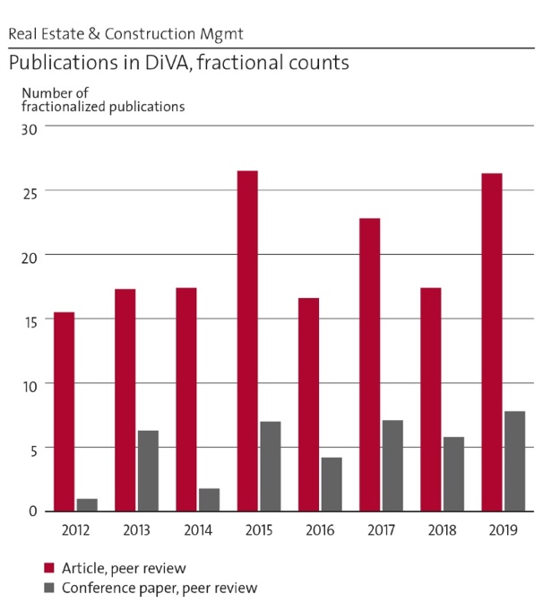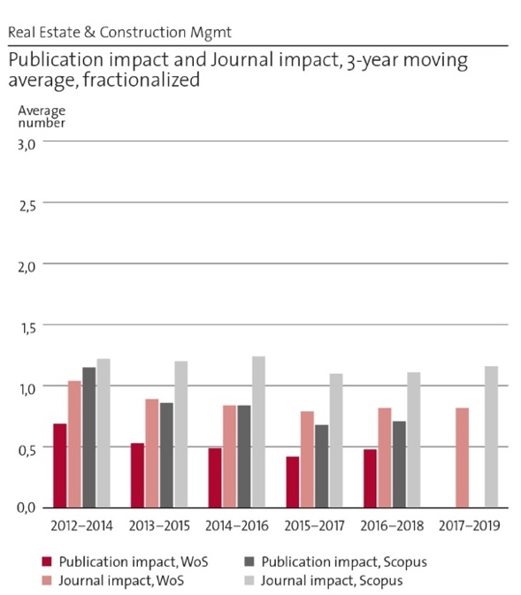
Figure 1. Publications in DiVA. | Figure 2. Publication impact and journal impact.

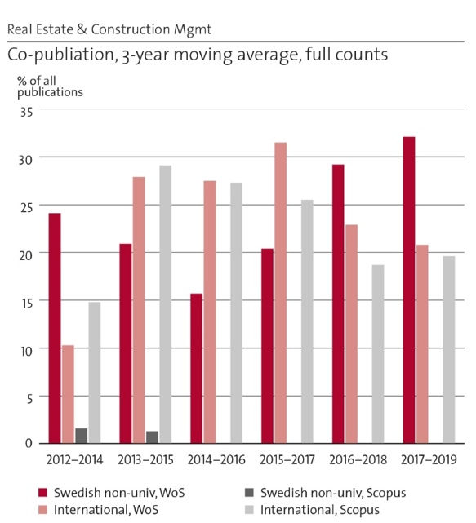
Figure 3. Co-publication.

Real estate planning and land law:
Much of the research output within real estate planning and land law is not captured by the applied bibliometric tools, with journal impact and citation indexes. Firstly, the legal domain is by its very nature specific and defined on a national basis, a fact that is particularly true for the area of real property law. This results in that publications are not delimited to articles in international journals. A large portion of the output is in the form of reports and books. Secondly, the standard language for research publications within the legal discipline is Swedish. Examples of publications:

Ekbäck, P. & Riekkinen, K. (2020). A Digitalized Property Formation Process? Comparative study of legal qualifications in Finland and Sweden. In: Hepperle, Erwin et. al. [Eds] Methods and Concepts of Land Management. Diversity, Changes and New Approaches, pp. 73-91. European Academy of Land Use and Development. Hochshulverlag AG an der ETH, Zürich.
Sabel, L. (2019). Public control over real property division. Past, present and the future. [In Swedish] Doctoral thesis, KTH.
Granath Hansson, A. (2019). City strategies for affordable housing: the approaches of Berlin, Hamburg, Stockholm, and Gothenburg. International journal of housing policy, 19(1), 95-119.
Grigoryan, A. & Paulsson, J. (2017) Legal aspects of management of commons within residential urban space: Comparative review of Western European and former Socialist experiences. Der öffentliche Sektor - The Public Sector, 43(1), 75-86.
Kalbro, T. & Paulsson, J. (2014). Development of Swedish Legislation regulating Compensation for Compulsory Acquisition: A Law and Economics Perspective. European Property Law Journal, 3(3), 215-230.

Real estate economics, finance and business studies:
The quality of the research articles published in real estate economics, finance and business studies during the period has been good, but the quantity could be increased. There has been a generational shift in recent years involving the retirement of faculty affecting this knowledge area. Because of a somewhat slow recruitment process, many researchers at the department are involved in teaching. New recruitment (2 associate professors and a lecturer in 2021) is planned for and this will balance the duties of research and teaching in a better way, giving necessary time for more studies, applications for research funding and publishing of the research. Examples of publications:
Wilhelmsson, M. (2019). Energy Performance Certificates and Its Capitalization in Housing Values in Sweden. Sustainability, 11(21), art nr. 6101.
Armerin, F. & Song, H-S. (2018). Valuation of real options in incomplete models – An implied yield approach. Fuzzy Economic Review, 23(1), 19-32.
Casady, C., Eriksson, K., Levitt, R. E. & Scott, W. R. (2018). Examining the State of Public-Private Partnership (PPP) Institutionalization in the United States. The Engineering Project Organization Journal, 8, SSRN: https://ssrn.com/abstract=3317770
Carlsson Kanyama, A., Carlsson Kanyama, K., Wester, M., Snickare L. & Söderberg, I-L. (2018). Climate change mitigation efforts among transportation and manufacturing companies: The current state of efforts in Sweden according to available documentation, Journal of Cleaner Production, 196, 588-593.
Steininger, B. I., Pommeranz, C., Ong, S.E. & Green, R.K. (2018). "Regulation of Managers and Investment Vehicles". Routledge Companion to Real Estate Investment. Routledge, 43-69.
Muyingo, H.G. (2017). Analysis of factors influencing reported housing maintenance costs in Sweden's public and private rental sectors. International journal of strategic property management, 21(3), 284-295.
Berggren, B., Fili, A. & Wilhelmsson, M. (2017). Does the increase in house prices influence the creation of business startups?: The case of Sweden. Region, 4(1), 1-16.
Donner, H., Song, H.S. & Wilhelmsson, M. (2016). Forced sales and their impact on real estate prices. Journal of Housing Economics, 34, 60-68.
Zalejska-Jonsson, A. (2014). Stated WTP and rational WTP: willingness to pay for green apartments in Sweden, Sustainable Cities and Society, 13, 46-56.

Construction and facilities management:
Research in project communication, construction project management and facilities management are published as scientific articles in reputable journals and conference papers, but there is improvement potential. Due to the applied focus, some important research pieces have primarily been published as reports in Swedish. In addition, significant impact has been made in the standardization work, including standards for open BIM/Building SMART/IFC and Collaborative business relationship management (SS ISO-44001). This reflects a tension between the demand for results that gain societal impact (and the research funding sources) and the academic publishing ambitions. Examples of publications:

Baraldi, E., Havenvid, M.I., Linné, Å. & Öberg, C. (2019). Start-ups and networks: Inter-active perspectives and a research agenda. Industrial Marketing Management, 80, 58-67.
Eriksson, P. E., Volker, L., Kadefors, A., Lingegård, S., Larsson, J. & Rosander, L. (2019). Collaborative procurement strategies for infrastructure projects: a multiple-case study. Proceedings of the Institution of Civil Engineers-Management, Procurement and Law, 172(5), 197-205.
Kadefors A., Uppenberg, S., Alkan Olsson, J., Balian, D. & Lingegård, S. (2019). Procurement Requirements for Carbon Reduction in Infrastructure Construction Projects – An International Case Study. Construction Climate Challenge. Report. Stockholm, KTH.
Vass, S. & Karrbom Gustavsson, T. (2017). Challenges when implementing BIM for industry change. Construction Management and Economics, 35(10), 597-610.
Karrbom Gustavsson, T. (2016). Organizing to avoid project overload: The use and risks of narrowing strategies in multi project practice. International Journal of Project Management, 34(1), 94-101.

Geodesy and satellite positioning:
The research team has succeeded to publish in many well-known and high-impact journals and national and international conferences. In addition, the publications attracted many audiences and several workshops (about BIM) and five successful international summer schools about geoid determination were organized. In the period 2012 – 2020, the researchers have published almost 100 peer-reviewed scientific articles and six PhD students successfully completed their studies. Examples of publications:

Gido, N.A.A., Bagherbandi, M., Sjöberg, L. and Tenzer, R. (2019). Studying permafrost by integrating satellite and in situ data in the northern high-latitude regions. Acta Geophysica, 67, 721–734.
Uggla, G. and Horemuz, M. (2018), Geographic capabilities and limitations of Industry Foundation Classes. Automation in Construction, 96, 554-566.
Sjöberg, L.E. and Bagherbandi, M. (2017). Gravity Inversion and Integration: Theory and Applications in Geodesy and Geophysics. Springer. ISBN 978-3-319-50298-4.
Håkansson, M., Jensen, A.B.O., Horemuz, M. and Hedling, G. (2017). Review of code and phase biases in multi-GNSS positioning. GPS Solutions. 21, 849-860.
Mehdi, S.J., Sjöberg, L.E., Bagherbandi, M. (2017). Use of GRACE data to detect the present land uplift rate in Fennoscandia, Geophysical Journal International, 209(2), 909-922.

2e Engagement in national and international research collaboration within academia and its outcomes
Real estate planning and land law:
Initiator and coordinator of a Nordic network for collaboration in research and research education, involving Aalborg University (Denmark), Aalto University (Finland), Lund University (Sweden), and Norwegian University of Life Sciences (Norway).
A number of researchers take part as members of the European Academy of Land Use and Development (EALD). (https://www.landuseacademy.org/)
The ADLAND project – Advancing collaborative research in responsible and smart land management in and for Africa – coordinated by the Technical University of Munich (TUM).
The COST Action “Public Value Capture of Increasing Property Values” is funded by the European Cooperation in Science & Technology. (http://www.puvaca.eu/)
Partner in the EU-funded SUSDEV-project (Lifelong Learning for sustainable development). (https://susdev.eu/)
Involved in VERITAS (Structural development of the third cycle based on Salzburg principle), a Tempus-funded project launched in 2013 and ended in 2018.

Real estate economics, finance and business studies:
Research collaborations within the field of Real Estate Economics and Finance with three Chinese universities: Shanghai Jiao Tong University (SJTU), Beijing University Chemical Technology (BUCT) and Tsinghua University Beijing.
Research collaborations within the field of Real Estate Business with: Stanford University (USA), National University of Singapore (Singapore), Oslo University (Norway), and Åbo University (Finland).
Collaboration in European networks: European Real Estate Society (ERES), European Regional Science Association (ERSA) and European Network Housing Research (ENHR).
Collaboration in international networks outside Europe: American Real Estate Society (ARES); Pacific Rim Real Estate Society (PRRES).
National collaborations are numerous, and most research projects involve several other Swedish academic institutions, among those not mentioned elsewhere are: Lund university, Högskolan i Gävle, the Centre for research on Economic Relations (CER) at Mitthögskolan in Sundsvall.
A consortium comprised of KTH (the consortium leader), IVL the Swedish Environmental Research Institute, Luleå University of Technology, the Stockholm Resilience Center, the Royal Swedish Academy of Sciences and the University of Gothenburg and industry representatives have resulted in the Sustainable Finance Lab.
Construction and facilities management:
National Strong Research Environment ProcSIBE (Procurement for Sustainable Innovation in the Built Environment, 2014-2020) funded by Formas (see Impact cases). This includes a Nordic research collaboration around procurement in the built environment and participation in the EU network NETLIPSE on large infrastructure projects.
The division is related to the IMP Group (www.impgroup.org). One of our researchers is a board member of the IMP Group.
Researchers are related to a European network studying innovation in the construction industry – ENRIC (European Network of Research on Innovation in Construction).
Large international ProcSIBE project: Implementation of Procurement Requirements for Sustainable Collaboration in Infrastructure Projects (Impres), a part of the Construction Climate Challenge, an initiative hosted by Volvo Construction Equipment, co-funded by the Mistra Carbon Exit program.

Geodesy and satellite positioning:
KTH Geodesy participates in research co-operations with other universities in Sweden, e.g. Lund University, Chalmers University of Technology and also the Swedish mapping, cadastral and land registration authority.
Cooperation within the framework of the Nordic Geodetic Commission (NKG), as well as the International Association of Geodesy (IAG) and Nordic Institute of Navigation, where KTH staff members participate in, and contribute to, committees, working groups, workshops, research schools etc. KTH Geodesy cooperates with e.g. University of Stuttgart in Germany, École Polytechnique Fédérale de Lausanne (EPFL) in Switzerland, and the Technical University of Denmark (DTU) on research projects and applications for e.g. EU funding.
EU Erasmus+ Program: cooperation with geodetic institutions in Austria, Spain, Italy, Albania, Bosnia, Serbia, Armenia, Moldova and Ukraine, and Central Asian countries.

2f Follow up from previous evaluations
The latest RAE at KTH was carried out in 2012. At that time, the department was formed differently and included the divisions Building and Real Estate Economics, Real Estate Planning and Land Law, and Project Communication. In addition, the Centre for Banking and Finance (closed in 2017) was evaluated as belonging to the Unit of Assessment. The Centre focused only on research and the staff is now relocated. The Division of Geodesy and Satellite Positioning joined the department in 2018, but has a long history at KTH.

For the Dept. of Real Estate and Construction Management (Unit of Assessment, UoA), the following recommendations were stated in the RAE 2012:
”In some of the divisions there is insufficient willingness to take structured, coordinated steps towards increasing the research budgets. Whilst there was a commitment to supporting individual researchers and collaborative research projects, the UoA needs to develop a clear vision for the future and a clear strategy for its achievement. To strengthen its international profile, the UoA should consider recruiting international researchers to support both the newer research areas as well as to strengthen the better-established expertise.”

The department has since 2012, and in particular in recent years, worked with structuring and coordinating the research budgets. Divisions have been added to the department and collaboration between the divisions has increased. Divisions with a large amount of teaching have received more of both internal and external research funding. In recent years, recruitment of international researchers has been made, and more international PhD students and guest researchers have been added to the department. Research collaboration with international partners has also increased in projects and publications.

3. Viability

3a Funding; internal and external
The department has a yearly revenue of approx. 72 million SEK with about 45% from different kinds of research funding (figure 4).
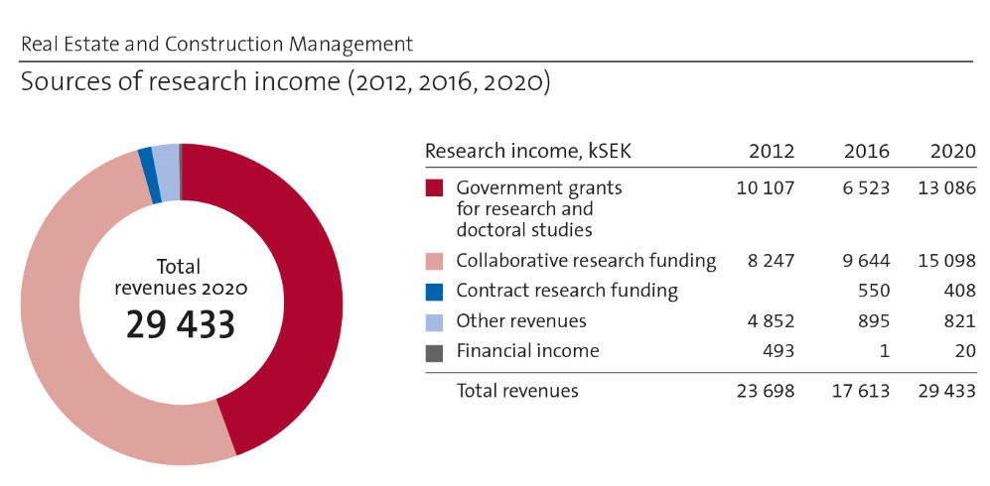
Figure 4. Sources of research income (2012, 2016, 2020).

The largest external funding sources for the department are tabled below.
Largest funding agencies (kSEK) | 2020
Trafikverket (Swedish Transport Administration) | 5 990
Formas (Government research council for sustainable development) | 3 406
Fastighetsägarna Stockholm (The Swedish Property Federation Stockholm) | 724
Samhällsbyggarna i Sverige AB | 720
Other foundations from private sector | 706

Among external funders of research in the requested period are governmental funding agencies: Formas, Vinnova, SBUF (construction industry research and development fund), The Swedish Transport Administration, The Swedish Construction Federation, ERDF European Regional Development Fund, The Swedish Foundation for Strategic Environmental Research (Mistra) and Swedish Energy Agency (Energimyndigheten). A recent industry funding initiative, involving more than 20 actors from the sector, has focused on housing (16 MSEK, Bostad 2.0), where most projects are dealing with real estate economics, finance and business studies.

Government funding to the built environment has increased, both due to awareness of the high impact of this sector on sustainability and a united industry initiative (IQ Samhällsbyggnad). There is also direct funding from housing companies and municipalities. A professorship in real estate management (2016) is funded by a total of 10 MSEK by a group (20) of real estate owners. This funding is available until 2023.

Within some of the research fields, e.g. real estate planning and land law and geodesy, there are limitations of the possibilities to obtain external funding. For trade and industry, the findings and results from research in the field are rarely commercially exploitable. For research in geodesy, the topic falls in between the field of natural science and the field of technical sciences. Public authorities and organizations do not have a government mandate to use resources for funding research in the domain at hand. This results in that the research projects undertaken to a large degree have to rely on internal funding. However, research funding has been obtained e.g. from the cooperation with the Swedish mapping, cadastral and land registration authority on industry doctoral students, and during recent years the Division of geodesy and satellite positioning has been successful in obtaining funding for projects in fields which are not classical geodetic fields.

3b Academic culture
The academic culture has been developing since RAE 2012 with a strong and systematic focus on research, publications and funding, as well as a more elaborate focus on replacing retiring colleagues by recruiting in international competition. Changing staff also makes culture change, and an earlier focus on reports and production published in Swedish is replaced by publishing in international peer-reviewed journals. The department has established relations to strong international research communities in all of its disciplinary areas.

3c Current faculty situation
In 2020 the department had 44 full-time steady employees of different titles. The main faculty is illustrated in figure 5 and the table below.

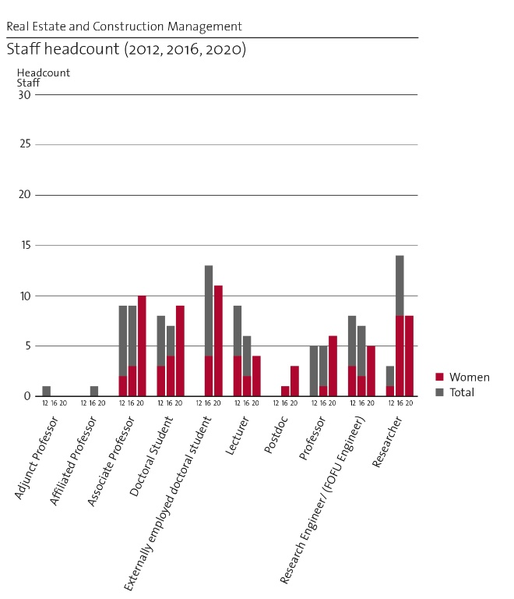
Figure 5. Staff headcount (2012, 2016, 2020).
This illustration is wrong (2020 only women displayed) and should be replaced!

Faculty | Men | Women | Sum
Full professor | 4 | 2 | 6
Associate professor | 7 | 3 | 10
Lecturer | 2 | 4 | 6
Sum |  |  | 22

The department also hosts three full professors (one man and two women) as guest professors and one full professor as adjunct professor (a man, financed from the industry). They contribute in research as well as in teaching and is an important part of the senior capacity of the department. The department had during the assessment period no assistant professors employed, but is now planning to introduce that category, as part of the tenure track system.

Out of the associate professors, three men and one woman (4 persons) will have retired in a five-year period along with one lecturer (woman) and one researcher (woman). The department has a balanced gender distribution among employees, as well as among PhD-students and undergraduate students. However, as we see in the table above, the distribution between men and women among full professors and associate professors is skewed. The guest professors are a strategic way of handling this situation, so that the culture can stay mixed.

If, on the other hand, we broaden the perspective inter-sectionally and include ethnicity, we find that most full professors and associate professors were born in Sweden. This aspect should therefore be highlighted, as it signals that the recruitment strategy of the department has not fully been in line with KTH objectives and that equality needs to be considered in future recruitment of faculty.

3d Recruitment strategies
For the following five-year period, the main strategic focus is on balancing the staff with regard to the amount of personnel for teaching and research. The department has still not fully handled the large group of faculty retiring, indicating that an important task is the systematic recruitment of skilled faculty in international competition. Another important strategic choice is to restructure the staff. The scarcity of faculty (as a direct effect of retirements during the recent years and present structure for faculty funding) in relation to the departments’ teaching assignment has a possible negative effect for research output and a more traditional staffing structure is to be aimed for. To reach this balance, recruitment is necessary.

3e Infrastructure and facilities
The department is located within one and a half floor in a building at the main KTH Campus, Teknikringen 10B, where the department rents office rooms, seminar rooms, kitchen, etc. On the ground floor in the same building, the department has access to seminar rooms for teaching, meetings, etc. The building was recently constructed and facilities and equipment are therefore modern and in good working order. There are possibilities for video conferences as well, making remote teaching more convenient.

The main research infrastructure consists of different databases and a number of geodetic instruments mostly used in teaching but also for research purposes. The department had – until 2018 – a local BIM-lab (Building Information Model), but this was shut down as the School of Architecture and Built Environment supported the development of a new joint Digital Lab available for all KTH. The Department will from now on use this resource for teaching and research.

4. Strategies and organization

4a Goals for development 5–10 years ahead
The department has a clear objective to increase the number of publications each year. We start at department level with focusing on more publications/citations and will in the coming year also focus on higher ranked journals. The opportunities to produce more publications in the short term are entirely dependent on opportunities to recruit, also including new PhD students. At department level, the priority in the short run is to include the entire base of research staff on a shift towards more publications. We will also strive for increased co-publishing of various kinds and a higher degree of open access publishing. In the short run, a rising trend in publications is thus expected. In the longer perspective, a progressively higher citation rate, increased co-publication and publications in "better" journals are expected where possible. However, it is difficult to foresee the effects of the current pandemic situation on the research output, and it might affect the number of publications, international collaboration, conference papers, etc.

4b Congruence with university-level goals for “A leading KTH” as set out in KTH’s ”Development Plan 2018-23” (page 5)
KTH Development Plan 2018-23 indicates the overall goals for the university. The goals defined at department level are compatible with a general university-level goal of excellence in research, education and industry collaboration. Research is done as an integral part of education and industry collaboration. The department is striving for a development of all three activity dimensions, however the development of a stronger research culture is prioritized in line with the goal of a leading KTH.

The department can in itself be regarded as an example of the strategy of integration, as it hosts different research traditions and fields of study with a common applied interest in real estate and construction management. The KTH goal of a higher visibility of research and other activities could inspire the department to further development and the aim is for this to be made easier in a five-year period when new recruitments have replaced colleagues that have retired.

Open, digitalized, sustainable, international are all key words that are an integral part of our development plan at a department level. They inspire the daily work and are reasons for structured revisions of the yearly output at, for example, the department conference. The KTH goal of equal opportunities is in special focus of attention of recruitment of new faculty due to the defined present need to change in-balances in distribution of gender and ethnicity among department staff. A large part of the department’s research is related to digitalization, sustainable development and gender equality, and is carried out in international teams, often carrying out international comparative studies.

4c Leadership structure and collegial structure
The leadership structure is traditional flat Scandinavian collegial leadership. The department is led by the Head of Department and there is also a Deputy Head of Department. Each division is led by a Head of Division. All these (7 in all) compose the Heads Group, which has meetings every second week. There is also a larger Department Management Group, in addition consisting of education Program Directors, Director of Studies, HR representative, Financial officer, Head of Administrative Group, and doctoral student representative, which meet about five times per year. There is also a Council of Professors and a Research Education Board.

4d Strategies for high quality
The quality work is done by publication of good research in high-ranking international research journals. All PhD theses are reviewed prior to publishing and most of them write compilation dissertations which consist of scientific papers published in, or submitted to, scientific refereed journals. A large part of the research projects relies on external funding, which is won in competition and thus a quality recognition of both the previous research and the outline of the applied research project. All recruitment at the department is done in international competition.

5. Interaction between research and teaching

5a Interaction between research and teaching at all three levels (BSc, MSc, PhD) of education
Most of the staff from the department are active in both teaching and research. Also staff employed as researchers participate to a large extent in teaching. The staff teach in courses given by the department and outside of the department, as well as do research within the subjects that they teach in, which means that research and teaching are closely connected. Teaching is done in courses at all levels, BSc, MSc and PhD level, as well as in commissioned courses for people already working in the field. Knowledge and results from research are included in the contents of the courses and used as examples and cases. The level of research-connected teaching increases in the courses on the advanced level and courses at the MSc level are intended to prepare students for research. Research articles and papers, both by the department staff and by other national and international researchers, are used as course literature. The degree projects are sometimes connected to research projects at the department. Teaching in PhD courses as well as supervision of PhD students are led by staff from the department. Parts of the research at the department is carried out by PhD students.

6. Impact and engagement in society

6a Relevance of research to society at large
Social relevance in our research is essential. The department is to a large extent engaged in applied research and has a great deal of dependence on external financiers, mainly from the industry. Many of the employees in the department hold positions with institutions in society, such as funds, committees, and they also produce many reports to the government on industry matters. It is also common for the department staff to be present in media.

Results are also relevant for municipalities and the national policy level. Several of the research reports and articles produced by the department have resulted in legal reforms, with direct impact on society. Some key external stakeholders that are in focus are public clients of urban development and infrastructure, such as The Swedish Transport Administration and Stockholm municipality, as well as private and public client/owner organizations. The department has ongoing research cooperation with the Swedish mapping, cadastral and land registration authority around physical geodesy and improved GNSS positioning, and with the Swedish Transport Administration (Trafikverket) on high accuracy GNSS positioning in construction projects.

6b Research dissemination beyond academia
An important channel for dissemination of research results is through the examination of MSc and PhD students, as well as through adjunct professors, guest professors also working in companies, and industrial PhD students. Research is also disseminated through networking within competence centres, such as the Centre for Construction Efficiency and the Financial Sustainability Lab. Other forums where the department is active are industry professional’s networks, co-creative arenas, boards and councils, and reference groups where clients/developers, contractors, real estate owners, etc. share knowledge, develop guidelines and make policy impact.

An important research output directed to society is that the department is consulted for Government referrals regarding feedback and suggestions on legislative proposals within the research field at several instances every year. For some legal reforms, researchers from the department have been involved as experts, academic investigators and secretaries. Several of the research reports and articles produced by the department have resulted in legal reforms.

As other examples of research dissemination beyond academia can be mentioned a professorship in real estate management funded by a group of real estate owners, and a similar funding initiative focused research on housing (Bostad 2.0).

6c Sustainability and the United Nations’ Sustainable Development Goals (SDG)
Several of the sustainable development goals are dealt with in the research of the department and its publications. According to the bibliometrics, the goals that are present in the highest number of publications are SDG 11, 9, 3, 10, 7 and 12, i.e. Sustainable cities and communities, Industry, innovation and infrastructure, Good Health and Well-being, Reduced Inequality, Affordable and Clean Energy and Responsible Consumption and Production. The presence of SDGs in many of our publications is related to the multidisciplinary research fields of the department.

It is estimated that 40-60% of the department’s research is related to sustainable development, or somewhat higher in some of the research groups. Here some examples:
SDG 2 Zero hunger is related to research in developing countries, where land conflicts over ownership and other property rights are frequent. Real estate planning and land law deals with issues of land titling and registration. SDG 5 Gender equality is related to women’s access to land, which is often an obstacle in developing countries. In real estate planning and land law, two doctoral thesis projects concern this topic. Several research projects have been dealing with SDG 9 and the responsibility and financing of infrastructure. A current international project concerns the issue of public value capture. Several projects have studied problems and solutions regarding informal settlements and slums in developing countries, related to SDG 11. Regarding access to safe and affordable housing, several projects have been completed and a number is currently ongoing.

An example within construction management is studies on negotiations on sustainability requirements and horizontal collaboration for innovation in urban development in collaboration with Stockholm municipality and private housing developers (SDG 7, 9, 11, 12 and 13), from the national procurement program ProcSIBE (SDG 9, 11 and 13), and by the longitudinal studies on horizontal integration and collaboration for innovation in urban development (SDG 9, 11, 12 and 13). Several goals are addressed in facilities management as well, e.g. energy, Green Building, indoor climate, digitalization, knowledge transfer from use to construction, innovation management (SDG 3, 7, 12), social sustainability in disadvantaged areas, innovation management, digitalization (SDG 10, 11), as well as digitalization, innovation management, maintenance and outsourcing strategies (SDG 9).

A large part of the research carried out in geodesy is related to the monitoring of climate change, which is an important part of the SDG 13. When glaciers are reduced or diminish, one of the effects is that the land masses rise as they are freed from the weight of the ice. Also, the research carried out within the fields of GNSS, Geodata quality and geodetic aspects of BIM is relevant to the SDG in terms of contributions to e.g. sustainable agriculture (SDG 2), sustainable economic growth (SDG 8), more resilient infrastructure (SDG 9) and sustainable cities and communities (SDG 11).

6d Structure for increased impact
The department was recently (in 2020) restructured to gain the most possible output from multidisciplinary collaborations in different forms. With a solid focus on the built environment, the combination of research within the disciplines of geodesy, planning and land law, economics, business studies and management give vast possibilities for solving problems defined together with other parties in society. At a department level, structured joint activities are arranged to give every employee a better overall picture of the differences and communalities of different disciplines and research approaches. A common interest in developing skills in methods is also promoting cooperation. The long-term strategic goal of these activities is to form better multidisciplinary teams for applications of research funding, as well as for solving applied research problems identified within the built environment.

We have been introduced to the tool Altmetric, which is an online tool that provides a quantitative measurement on how many times a published article or other scientific report or output has received a ‘mention’ in the form of tweets, Facebook posts, Wikipedia articles, blog posts etc.

7. Other

7a Specifics that the department wishes to mention and describe
The department would also like to highlight some issues that would have an impact on the development possibilities:
The asymmetric distribution of faculty funding in relation to the dimension of teaching assignment between KTH schools is a problem to highlight, as this hinders both the balancing of research and teaching for already employed staff (thereby negatively affecting possible publications output), but also is a negative attribute when trying to attract new talents for faculty positions at KTH in some areas of knowledge. Young potential future stars are looking for a balanced life and possibilities for development and stable base of research funding. To get the best new colleagues in international competition, KTH needs to offer competitive terms.
There is still an insufficient administrative and legal support on a KTH-level in relation to methods for and ethics around storage of research data, digital and other, also concerning big data and AI.
While the support for research applications and international contacts has significantly improved since the last RAE (2012), there is still room for improvement of different support activities. Digital planning tools for project planning, crew planning, financial planning as well as time planning are still in the need of development on a KTH-level. The development of such instruments for a more efficient management of staff, finances, courses and projects is planned for by KTH leadership, however, the lack of this support is mentioned here as it has had important negative effects on the operations during the RAE-period 2013-2020.
We also wish to emphasize that the departments’ strength in applied research should not be seen in isolation. Publishing a report in Swedish does not count much towards bibliometric journal rankings, but it may be important to maintain and develop relationships to industry, government, and agencies. Our strategy is not to cease publishing reports, since this is important for impact and to secure co-funding by society and industry, but to ensure that almost all research is also published internationally.
As mentioned elsewhere in this report the balancing of different aspects of the daily operations as well as of long-term strategic development is of top priority for the department management. This includes searching for new solutions to issues of funding and recruitment. We would appreciate ideas on how this can be developed further with regard to:
  - How to attract more research funding using the multi-disciplinary environment as a strength
  - How to attract new faculty in international competition for present and future announced vacancies (what are the main strengths to highlight)
  - How to develop ways to make national applied studies in cooperation with the industry as well as important participation in referrals in government investigations of use also in evaluations of the work of the department (how can we highlight this impact)
  - How to balance – in the best of ways – the double tasks of teaching and research.

Department of Sustainable Development, Environmental Sciences and Engineering (SEED)
Self-evaluation
Head of Department: Associate Professor Maria Malmström

Included divisions:

Division of Sustainability Assessment and Management
Division of Strategic Sustainability Studies
Division of Water and Environmental Engineering
Division of Resources, Energy and Infrastructure

Department of Sustainable Development, Environmental Sciences and Engineering (SEED)
This self-evaluation is the result of a collaborative effort. Two workshops to formulate strengths and weaknesses were organized (February and December 2020). A survey to all senior staff about their research activities was sent out during Spring 2020. During Autumn 2020, a RAE writing group was formed. This group included the Head and Deputy Head of department as well as seven members of faculty representing different divisions and research areas. All SEED:ers had the opportunity to give feedback on the text. The Deputy Head organized the work and was editor of the report.

1. Overall analysis and conclusion; strengths and development areas

1.a Limited SWOT-analysis
Research strengths
- A multi-inter-and transdisciplinary, problem-oriented, impact-based and mission-driven research environment.
- Research that covers many sustainability areas, taking a systemic perspective, including a diversity of competences in natural, social and engineering sciences as well as interdisciplinary research fields.
- Research that contributes to the understanding of, and transition to, a sustainable society.
- Researchers that attract substantial external funding, are well-cited, and that maintain excellent networks within academia and non-academic actors.
- Researchers that coordinate, and are part of, large society-changing projects ensuring good outreach and impact.

Research weaknesses
- Lack of time and incentives to cooperate more within the department.
- Slow process of integration between research fields after the department was formed in 2013, not reaching SEED’s full potential.
- No up-to-date lab and no storage for field equipment in the new office building SEED moved to in 2017.
- Some researchers and members of faculty are not part of well-functioning (informal) research groups.

Organizational strengths
- A multi-cultural work environment that is fairly well-balanced in terms of gender.
- A good discussion climate, helpful colleagues and a nice social atmosphere when people come together.
- Aiming to create transparent decision-making processes and routines.

Organizational weaknesses
- Lack of willingness or availability for leadership positions (e.g., head of division, director of studies).
- Lack of government grants for research for installing new (needed) faculty positions.
- Lack of administrative support from the school (mainly in the economy function) to make strategic choices as to budgeting and work plans.
- High overhead costs.
- Extensive undergraduate teaching that takes time from research for some faculty members and researchers.

Based on this limited SWOT analysis, SEED has identified these development areas:
- Improve level of academic discussion and knowledge of each other’s areas of expertise.
- Bring on board all SEED staff for discussions about collaboration, publication strategies, research quality, faculty development, leadership functions, the heart and soul of SEED.
- Continue to attract external funding for research and PhD positions, and create incentives for SEED:ers to apply for such funding in new constellations.
- Further clarify administrative routines and organizational processes, including the support functions at the school level (economy)
- Explore ways to improve lab environment (work with other labs, details of what needs SEED has)

1.b Summary statement on contributions of department on impact, infrastructure and sustainable development
Impact: SEED has a dedicated, well-connected and skilled group of staff that is successful in obtaining research grants, publish and have an impact on society. SEED has an impact through research dissemination, collaborations with public, private and civil society actors as well through education. Impact is created in the co-creation of knowledge, and by dissemination to wider audiences via numerous channels. Examples of impact include contribution to new climate legislation, methods and tools for more sustainable resource uses, development of industrial processes, as well as innovations in planning.
Infrastructure: Besides office space and computer resources, some of SEED’s research depends on chemical lab environments and field measurement equipment. The standard of the lab is not up to date and there is not sufficient storage and maintenance space for the equipment.
Sustainable development: SEED’s research is multi-inter and transdisciplinary and cover most of the sustainable development goals from natural, social and engineering science perspectives. All of SEED’s research is concerned with sustainable development (80-100%).

2. Research profile
2.a General information of the department
SEED conducts research and education focused on the sustainable development of society. SEED gathers a broad range of interdisciplinary expertise to conduct research that covers a wide field within environmental, engineering and sustainability issues. The department was established in 2013 as part of KTH’s ambition to be a leading technical university in the field of environmental science and sustainable development. Three organizational entities from three different departments with distinct research and organizational cultures were joined together to form SEED. These were: Industrial Ecology, Environmental Strategies Research, and Land and Water Resources Engineering. Since a reorganization in 2017 SEED consists of four divisions:

Sustainability Assessment and Management develops and applies assessment methods and analyses the effects of decisions from a social and environmental perspective. The research covers areas such as renewable energy, urban planning, construction and management, information and communications technology, new materials and technologies, circular economics, energy policy and planning, transport and infrastructure planning, land and water management and future scenarios. The areas of expertise include life-cycle assessment (LCA), quantitative spatial assessment and modelling, environmental impact assessment (EIA), strategic environmental assessment (SEA), social life-cycle assessment, environmental justice, sustainability assessment tools for buildings and the built environment, and environmental labelling declarations.

Strategic Sustainability Studies works interdisciplinary and with stakeholder cooperation in order to influence societal development. The division takes an interest in all sectors of society and studies areas such as consumption, food and water, transport, digitalization, waste, energy, and urban and rural development. It also studies policy and planning processes. Through interdisciplinary methods and theories, it analyses these areas from a sustainability perspective. The fields of research and theories include futures studies, environmental and rural sociology, policy analysis, design research, social practices, environmental justice, resilience thinking, and planning and transition theories. This division (co)hosts the MISTRA Sustainable Consumption and MISTRA SAMS Sustainable Accessibility and Mobility Services programs.

Water and Environmental Engineering conducts research to increase knowledge and improve the use of natural and technical systems for managing water, land and geological resources. By using modern laboratory, field and modelling methods, the division develops new understanding and innovative technical solutions for a more sustainable future. The pilot-scale laboratory facilities at Hammarby Sjöstadsverket are used for some of the research and education. Methods used are interdisciplinary and based on collaboration with the private and public sector and stakeholders at all levels. The key competencies include ecology, water and soil chemistry, hydrogeology, geology, water and wastewater technology, environmental technology, environmental and ecological economics, industrial ecology and blue growth. The newly founded Blue Food Centre is an entity based on research conducted in this division and provides a link to Kristineberg Center for Marine Research and Innovation, of which KTH is a part.

Resources, Energy and Infrastructure conducts research on biology, physics and geoscience processes, technological applications in water and energy, as well as various theoretical methods, such as system analysis and data models for geophysical flows. Technical solutions may be directed at biochar, analysis of energy systems, hydroelectric energy, groundwater pollution, waste management, erosion and pollution to waterways, and dam safety. The division also conducts research into resource-efficient, sustainable cities. SEED leads the Strategic Innovation Program (SIP) Viable Cities, a gathering of stakeholders from industry, city and municipal councils, research institutions and academia. The purpose of Viable Cities is to contribute to the transition to more sustainable cities, with digitalization and citizen engagement as strong driving forces.

WaterCentre@KTH is based at SEED. The Water Centre’s mission is to bring about water innovations for sustainable development and is a wide collaborative effort.
Professors and associate professors cover the following topics: water supply and wastewater technology, water resources engineering, environmental management and assessment, river engineering (2), industrial environmental protection, groundwater chemistry, environmental strategies and futures studies, industrial ecology, spatial and environmental systems analysis, chemical engineering with focus on chemical environmental technology, life cycle assessment (2), environment and natural resources economics, hydraulic engineering, sustainable urban development (3), environmental strategic analysis and engineering geosciences.

2.b Central research questions and themes, knowledge gaps addressed, main research activities
The research at SEED is multi- inter- or transdisciplinary to match the complex nature of the various real-world challenges at hand. Research covers and combines diverse aspects of environmental science and engineering innovations for sustainable development. This multi-inter- or transdisciplinary perspective is the key to success and implementation of research results. The research fields cover all the dimensions of SEED’s ambition to: (1) understand and support decisions that lead to the sustainable development of society by analyzing the effects of decisions from a social and environmental perspective; (2) work in a transdisciplinary way with stakeholders in order to influence social development; (3) promote sustainable production and consumption practices; and (4) increase knowledge and innovations for use of natural and socio-technical systems for managing water, land, and other natural resources.
The knowledge gaps addressed cover issues found at the research front in the quest for a sustainable society. For example, the need to develop new, improve, or challenge existing decision-making tools or approaches, participatory processes at different decision-making levels, or how to tackle the knowledge-behavior gap (e.g., how more sustainable practices can be encouraged among consumers). The research activities range from social sciences over natural sciences and on to engineering science. As a consequence, methods ranging from in-depth qualitative interviews to quantitative analyses and modelling of measurements and large data sets as well as laboratory and field investigations are found at the department. Research is often done in multi- inter- or transdisciplinary research projects, including co-creation processes, where knowledge is developed together with stakeholders. It also involves collaboration with other research groups or authorities and interaction with practitioners.
Some research teams at SEED are strong and well-established, although informal, and are writing new grant applications together and collaborate on several projects. Other researchers, outside these informal groups, are either mostly collaborating with external researchers or with different colleagues at SEED depending on the specific project at hand, or act as solitaires. Thus, the divisions do not mirror research teams, even if existing, informal groups are mostly within the same division. This is something SEED wants to work with by increasing the level of knowledge of each other’s research areas and provide platforms at SEED for academic exchange.
SEED’s view is that gender is of importance in research topics, team composition and collaboration with various stakeholders and that any working environment benefits from a multi-cultural and gender balanced structure. Wicked sustainability challenges of today require recognition of multiple knowledge spheres, where experiential and practical knowledge are treated as being as important as scientific/expert knowledge. Therefore, the inclusion of a wide diversity of knowledges is a key principle in the research team composition, where diversity is a source of creativity and innovation. Efforts are made in projects run at SEED to have gender balance. Gender perspectives are relevant for many projects when studying social practices, design of technology and just transformations towards a more sustainable society where gender equality is one criterion for the social dimension of sustainability. While SEED is gender-conscious, women dominate on the leadership positions, both in the line organization and the academia. SEED experiences this as problematic, as this is likely to hinder career development of female researchers/faculty.
2.c Contributions to the advancement of the state of the art within the research fields of the department
SEED have made strong contributions towards realizing society’s demands for the sustainable and efficient use of natural resources. The department's scientific expertise combined with technical knowledge ensures that robust methodological developments are made in various areas, such as sustainability assessment, which are at the cusp of worldwide state-of-the-art methods to better represent the sustainability impacts of human activities. The particular research areas in which SEED has made robust scientific contributions include life cycle assessment, the circular economy, the bioeconomy, energy systems, food systems, water systems, urban systems and climate change mitigation and adaptation. This is demonstrated by high-impact publications, as well as with the development of operational methods that better represent the sustainability of the above-described systems, which are subsequently used by scientists/researchers as well as industry and policy-makers, e.g. climate-change impacts of biofuels in Sweden and the European Union.

2.d Quality and quantity of contributions to the body of scientific knowledge

Figures 1-3 present bibliometric data for SEED during the assessment period. The number of peer reviewed articles increased during the period. There is a variability in the number of published conference papers and reports as well as doctorate and licentiate theses over the time period of assessment. While articles are automatically included in DiVA, other types of reports and papers need to be included manually. Thus, the variation in these categories may be the result of individuals failing to report their publications to DiVA. SEED values all types of publications, but most highly PhD theses and peer-reviewed articles. Also, published peer-review articles were to a large extent published in journals with a high impact in terms of citations.
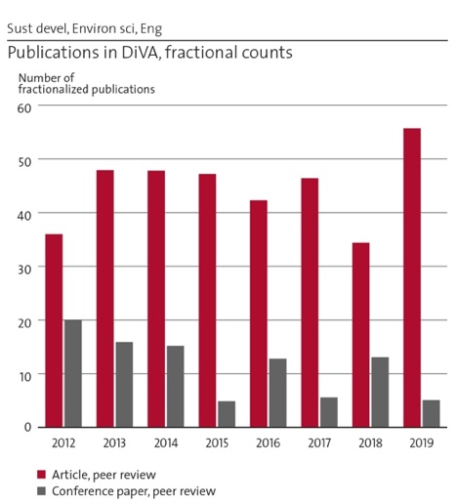  Figure 1. Publications in DiVA | 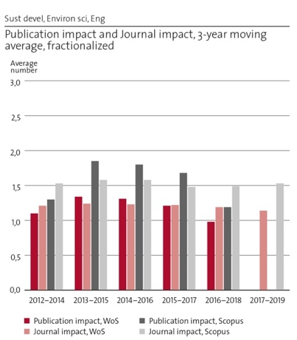  Figure 2. Publication impact and journal impact
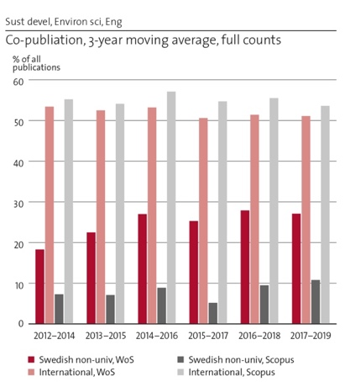
Figure 3. Co-publication

The high rate of co-publication reflects SEED’s large research networks. The variation between the years also reflects variation in numbers of active senior and junior researchers, that fluctuate with available external funds. This said, SEED aims for an increase in PhD theses and to keep up the contribution to the body of scientific knowledge.

Six researchers from SEED are ranked among the top 2% researchers within their respective fields (Environmental Sciences or Environmental Engineering) in the updated science-wide author databases of standardized citation indicators (Ioannidis et al. 2020). This indicates a high scientific impact of research from the department.

Examples of publications from the assessment period:
- Freitas, F.L.M., Sparovek, G., Berndes, G., Persson, M., Englund, O., Barretto, A., Mörtberg, U., 2018. Potential increase of legal deforestation in Brazilian Amazon after Forest Act revision. Nature Sustainability 1: 665–670.
- Boano, F., Harvey, J. W., Marion, A., Packman, A. I., Revelli, R., Ridolfi, L., and Wörman, A. 2014. Hyporheic flow and transport processes: Mechanisms, models, and biogeochemical implications, Reviews of Geophysics. vol 52 ISSN: 1944-9208.
- Gustafsson, J. P. 2019. Vanadium geochemistry in the biogeosphere –speciation, solid-solution interactions, and ecotoxicity, Applied Geochemistry, vol 102 ISSN 0883-2927.
- Hasselström, L., Thomas, J., Nordström, J. et al. 2020. Socioeconomic prospects of a seaweed bioeconomy in Sweden. Nature Sci Rep 10, 1610. https://doi.org/10.1038/s41598-020-58389-6
- Umair, S, Bjorklund, A, Petersen, EE 2015. Social impact assessment of informal recycling of electronic ICT waste in Pakistan using UNEP SETAC guidelines. Resources Conservation and Recycling, vol. 95 ISSN:0921-3449.
- Zou, LC, Jing, LR, Cvetkovic, V 2015. Roughness decomposition and nonlinear fluid flow in a single rock fracture. International Journal of Rock Mechanics and Mining Sciences, vol. 75 ISSN:1365-1609.
- Hossain, M., Bhattacharya, P., Frape, S.K., Jacks, G., Islam, M.M., Rahman, M.M., Hasan, M.A. & Ahmed, K.M. 2014. Sediment color tool for targeting arsenic-safe aquifers for the installation of shallow drinking water tubewells. Science of the Total Environment 493: 615-625 https://doi.org/10.1016/j.scitotenv.2014.05.064
- Kramers, A., Höjer, M., Lövehagen, N., Wangel, J. 2014. Smart sustainable cities: Exploring ICT solutions for reduced energy use in cities, Environmental Modelling & Software, ISSN: 1364-8152.
- Palm, V., Wood, R., Berglund, M., Dawkins, E., Finnveden, G., Schmidt, S. and Steinbach, N. 2019. Environmental pressures from Swedish consumption – a hybrid multi-regional input-output approach. Journal of Cleaner Production, 228, 634-644.
- Svenfelt, Å., Alfredsson, E.C., Bradley, K., Fauré, E., Finnveden, G., Fuehrer, P., Gunnarsson-Östling, U., Isaksson, K., Malmaeus, M., Malmqvist, T., Skånberg, K., Stigson, P., Aretun, Å., Buhr, K., Hagbert, P. and Öhlund, E. 2019. Scenarios for sustainable futures beyond GDP growth 2050. Futures, 111, 1-14.

2.e Engagement in national and international research collaboration within academia and its outcomes
About 25% and 50% of SEED’s articles and reviews registered in WoS for the period 2013-2019 were co-published with non-university partners and with international universities, respectively. This is slightly above the average for the ABE school. SEED looks favorably on the mix of co-publishing. The co-publication with non-academic partners reflects a high degree of applied research, which is in line with SEED’s goals. SEED works extensively in national and international networks. Some examples of collaborations coordinated by SEED researchers and faculty members with budgets over 20 mio SEK include: “Beyond GDP” (2014-2019, financed by Formas), the centre “Blue Food” (ongoing, Formas), the “Centre for Sustainable Communications” (CESC), (2008-2017, Vinnova Excellence Centre), Mistra – “SAMS”, part 1 and 2 (ongoing), Mistra “Sustainable Consumption”, part 1 (ongoing), “Seafarm”, (2013-2017 Formas), “Södertörnsmodellen” (2013-2019, Vinnova), “TRACS” (2010-2014, Vinnova), “Viable Cities” (ongoing, SIP). Two international examples include “GRASS EU” Interreg (2019–2021) and “SUBMARINER” Interreg. Project 2010-2013. On top of this, SEED’s researchers are part of many other major consortia, led by other organizations.

2.f Follow up from previous evaluations
In the RAE 2012, it was concluded that the Division of Industrial Ecology, the Division of Environmental Strategies Research as well as the Department of Land and Water Resources Engineering - that now make up SEED - were doing good quality research and outreach, with high ambitions on impact and with deep commitment to work with practitioners. They were partly assessed to be cohesive groups despite the diversity of research topics. Areas of improvement included to better integrate research across clusters, to recruit social scientists and to increase collaboration within KTH. As a result of this assessment, as well as the wish at KTH to make sustainability science more visible, SEED was established. By doing this, a mix of natural scientists, social scientists, engineers and interdisciplinary research fields were joined together to focus on sustainability research. However, joining three different research and organizational cultures takes time and this process is ongoing.

3. Viability

3.a Funding; internal and external
During the assessment period, between 60 and 70% of SEED’s research funding came from external funding sources (Figure 4).
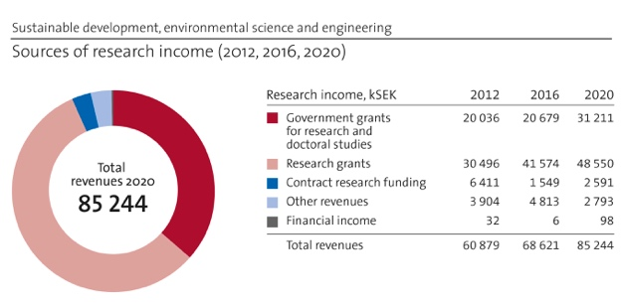
Figure 4. Sources of research income. Note: the numbers for government grants for research are misleading since the manner of calculation has changed over the assessment period. Available funds for SEED to dispose stays around 20 mio SEK.
In general, the five most important funding sources were the Swedish Energy Agency, Formas, Mistra, EU and Vinnova. These types of funding often have a longer scope over time and concerns larger amounts, which SEED sees favorably. However, SEED is challenged by the fact that some of this funding needs co-funding from the department (due to the fact that some funders to do not pay full overhead costs), which needs to be taken from the government grants for research or by synergies with other external projects. Government grants for research is currently used to fund 25% of each faculty’s salary and 10% of permanently employed researchers’ salary, giving faculty and researchers some freedom in research, which is needed for advancing the research fields as well as maintaining its position in society. However, for most faculty and all researchers, there is also an implicit need to bring in external funding to cover part of the own salary, in addition to the full salaries for postdocs and PhDs.

3.b Academic culture
SEED has an inclusive community of staff that includes a diverse representation overall. In addition, there is reflexivity about equity issues and potential gender imbalances. There is collegiality in terms of respect, interaction, and mutual guidance, but it could be improved. In order to support collegiality, an annual SEED day is organized every year. This is a day when research, collaboration and strategic issues are discussed jointly by SEED’s staff. There is also the SEED council: a platform for academic development (discussing suggestions from the management group and bringing forth suggestion of its own). The council consists of all docents and staff with management assignments. Seminars are used to bring colleagues together to learn from each other and to develop academic culture; There is s SEED-seminar series that aims to broaden knowledge of what colleagues do. There is also a PhD seminar series where PhD students discuss current work with senior discussants. However, all PhD students are not involved in this seminar series (due to different PhD programs) and there is need for more academic discussion and development beyond existing structures. Many informal research teams provide strong research environments. It seems that such informal research teams, conferences, research projects groups, and external partners are where the majority of academic discussion occurs and this could entail a lack of continuity when projects end.

3.c Current faculty situation
As of February 2021, SEED employed a little more than 100 persons on full or part time. Of these, about 30 were employed as researchers, 8 as professors, 12 as associate professors, 2 as lecturers, 5 as administrative staff (Figure 5). Thus, the majority of seniors are employed as researcher, making this category very important for SEED’s research; they, along with PhD students and Postdocs, stand for the majority of the conducted research, and a very substantial part of the external research funding. SEED also employs post docs (8) and PhD students (18), research engineers and FoFU-engineers, mostly on short-term contracts. In addition, SEED hosts scholarship PhD students, industrial PhD students, affiliated faculty, adjunct professors and professor emeriti.

Figure 5. Staff head count. Correct illustration still missing
Three of the eight professors are in a stage where recruitments are necessary (after potential reformulation or redistribution of positions over subjects). A number of faculty retired but have not been replaced with new positions. Men dominate the professor category (75%) while women dominate among associate professors (66%). Three of the associate professors applied for promotion to professor earlier this year. Such a promotion would rejuvenate the professor category, and also contribute to a better gender balance in both categories. New recruitments of associate professors are needed to fulfil SEED’s work load in teaching, and particularly examination.
3.d Recruitment strategies
Today, SEED’s faculty recruitment is driven by SEED’s teaching portfolio. Over a number of years, the faculty has decreased (due to retirements and staff with faculty positions leaving KTH) and is now critically low. The main obstacle to recruiting new faculty is the KTH rules for installing faculty positions, requiring substantial government grants for research, which SEED has limited access to. SEED’s strategy is to recruit at the assoc. prof. level in the tenure track system since this category is expected to contribute much more to teaching (50-60%), than assist. profs (20-30%) and profs. (around 30%). Researchers can teach up to 20%. Another part of the recruitment strategy is to recruit more lecturers (80-100% teaching and no requirement of government grants for research). In the near future (0-2 year(s)), SEED prioritizes to recruit one associate professor in Water and Wastewater Treatment Technology (replacing retiring professor), one lecturer in Environmental Geology (as part in replacing retiring professor), one or two assistant/associate professor(s) in Industrial Ecology / Environmental Technology / Sustainability Science (as part in replacing retiring lecturer; focus being discussed), and one lecturer in Industrial Ecology (focusing on Environmental Technology / Sustainable Development; as part in replacing a retiring lecturer; focus being discussed).

In a somewhat longer time perspective, SEED investigates appointments replacing professors in Water Resources Engineering, and Environmental Management and Assessment. SEED must also decide whether to recruit an assoc. prof in Environmental Management, replacing a person that left KTH in 2019. To maintain and develop the scientific qualities and ambition to contribute to a more sustainable society, SEED would prefer to recruit the faculty based on more balanced consideration of teaching and research needs. Today, SEED does not have a strategy for recruiting researchers, post-docs and PhD students, but employs an approach where needs of externally funded research projects identify positions to be announced. The main approach to enroll PhD students are external grants. The strong demands on funding (four years) makes PhD positions hard to install (not due to lack of interest by young people or low supervisor capacity). Already now, SEED actively works to recruit affiliated faculty and adjunct professors, as well as retaining professors as prof. emeritus after their formal retirement, and this effort will be continued. SEED is currently recruiting two male adjunct professors, one female and two male affiliated faculty members, some of which will start working with SEED during 2021.

3.e Infrastructure and facilities
SEED has the infrastructure needed in terms of office space, computer hardware and software, library resources, and meeting room facilities. The video conference infrastructure and the communication support are being improved, but further efforts might be necessary. The high overhead cost for premises is a problem since it decreases competitiveness in attracting funding. SEED has a lab on KTH campus that is used in research and teaching (equipped for geological (mainly soil) and chemical analyses but also small experiments). Some old equipment in the lab is now being replaced, but the entire facility and much of its instrumentation is in need of modernization. A SEED researcher is employed 20% to operate this lab. However, much of chemistry/soil/rock/hydrology lab and field-related research cannot be performed there. Also, when the new office building was built for SEED it did not contain any facilities for laboratory experiments and only a minimum of storage facilities for field equipment. To keep the field geophysical equipment up to date, there is a need for investments. To somewhat mitigate this situation SEED is also involved in, and has access to, the Hammarby Sjöstadsverket facility for tests of advanced equipment and processes in water and waste water treatment, as well as the Kristineberg Center for Marine Research and Innovation.

4. Strategies and organization

4.a Goals for development 5–10 years ahead
SEED has set four long term (strategic) goals:
1) Position SEED as a strong and highly respectable academic institution within KTH, regionally and internationally in the area of sustainable development, environmental sciences and engineering. Means to achieve this goal include: dissemination of research and impact cases, high profile research projects and collaborations, and improving internal and external collaborations.
2) Attract, install and keep the most competent staff in SEED to support excellent research and education in the area of sustainable development, environmental sciences and engineering. Means to achieve this goal include: recruitment of new faculty members to make up for retirements, install new faculty positions, welcome researchers with relevant projects and high impact. Sharing of government grants for research between all faculty and permanently employed researchers. Support career planning toward docent and/or promotion in the tenure track system. Engage affiliated faculty and adjunct professors.
3) Develop SEED into a stimulating, well balanced and yet diverse work environment, with a culture of equality, openness, critical thinking and debate in the area of sustainable development, environmental science and engineering. Means to achieve this goal include: use the SEED council to discuss academic culture and quality issues, develop SEED seminars, organizing a SEED day every year, work on organizational development, have a broad representation in SEED Management Groups, invite SEED:ers to take on formal and informal academic leaderships, two researchers are appointed to cover equity issues.
4) Combine and integrate social and natural sciences and engineering disciplines, detailed and systems-level studies and technologies, for innovative solutions that facilitate a transition to sustainable development. Means to achieve this goal include: encourage increased research cooperation within SEED and continue to cooperate within our current networks, develop PhD education, and engaging our appointed impact responsible.

4.b Congruence with university-level goals for “A leading KTH” as set out in KTH´s “Development Plan 2018-23” (page 5)
SEED is a leading research department within sustainable development, and as such also very well aligned with the KTH goals according to the Development plan. All divisions at SEED are highly interdisciplinary and there is a widespread competence in working side by side even if you were trained in different disciplines. SEED takes part in many international research collaborations and has an international staff. Thus, the internationalization target is also supported by SEED. When it comes to gender equality, SEED has a tolerably mixed group of researchers and faculty, and more or less equal amounts of male and female PhD-students. SEED researchers are involved in several projects on digitalization and sustainability and we managed the forced transfer to virtual teaching and research well, even if the amount of work in some cases, especially for teachers, got overwhelming. SEED is also working in line with the statement that “teachers are researchers and researchers are teachers”. This is important for both research and teaching at SEED and both faculty members and researchers are involved in collaboration activities outside academia.

4.c Leadership structure and collegial structure
Each division has a head of division. Together with the Head of department and the Deputy Head of the department these heads make up the “management group”. This group meets bi-weekly to discuss short term and long-term issues connected to staffing, economy, organization and strategies. SEED’s four directors of undergraduate studies take part in every second management meeting. SEED also has three directors of PhD studies. The PhD programs are currently being reviewed and a new program will most likely be launched during 2021. This will gather all SEED PhD students into one joint program with three subjects largely corresponding to the divisions that once formed SEED. The head of administration, directors of undergraduate and PhD studies, heads of divisions, and other staff with leadership functions (e.g. members of school collegial group, school equity group, impact responsible etc.) make up the “extended management group”. This group meets twice per semester to share information and discuss current issues. The SEED HR and head SEED economist, employed at the ABE school, are also invited to these meetings. In 2019, the SEED council was introduced. The council consists of docents and managers and has a chairperson who plans and leads the meetings. The purpose of the council is to discuss strategic issues (positions, vision, goals, academic culture and quality) in a broader group. Each head of division hosts a division meeting at least once a month. The Head of department and the Deputy Head of department hold informal department morning meetings 3-4 times per semester to give updates and capture new developments in the department. Seminars are organized for PhD students in one of the PhD programs and in some topic areas. There is also a SEED seminar series. SEED notes that many of the management responsibilities are taken by women. It would be desirable to appoint these positions more evenly.

4.d Strategies for high quality
SEED researchers generally publish in high ranked scientific journals and also take leadership roles in editorial boards, review PhD theses and work as experts in grant boards, etc. SEED follows the quality assessments work plans at KTH. PhD theses are normally compilation theses which includes several papers that have been published in peer reviewed journals. Due to the specific history of SEED, there are still different PhD programs (now under revision) and differing ways to work with quality in research and PhD education. More work needs to be put into the integration of these research cultures. Generally, SEED strives for open access publication and a livelier seminar culture at the department.

5. Interaction between research and teaching at all three levels (BSc, MSc, PhD) of education
The research at SEED has profound implications in the courses and programs taught at BSc, MSc and PhD levels. The research outcomes are shared among our BSc, MSc and PhD students. In this way, SEED equips students to deal with societal sustainable development issues. Undergraduate students contribute in some courses directly to the research, through e.g. small “research pilots”. This applies particularly, but not exclusively, to BSc and MSc thesis courses. Through supervision, PhD students and seniors expose their research projects to BSc and MSc students.

Course materials are constantly being updated to reflect recent developments in relevant research fields. It is of ultimate importance that the research in sustainable development is being reflected in the educational programs and courses at SEED and KTH. SEED teachers participate in developing and running the pedagogy course for KTH teachers to integrate sustainable development in all courses at KTH. At the same time, SEED teachers are conducting research in education for sustainable development, including the questions of reflexive learning, motivators for education in sustainable developments and transversal skills of sustainability change agents.

6. Impact and engagement in society

6.a Relevance of research to society at large
SEED’s focus on sustainability gives a high societal relevance. Most of the research projects are conducted in collaboration with practitioners, which makes the research relevant and useful to society at large and to specific actors. No specific key external stakeholders or end-users are prioritized or focused on. As most of SEED’s funding is external and one of the criteria of funding agencies is relevance to society, SEED projects can be argued to be highly relevant to society at large.

6.b Research dissemination beyond academia
SEED researchers use numerous channels to communicate research beyond academia. Examples of these include: conferences and workshops with industry, NGOs and public sector; popular scientific books and articles; podcasts, webinars and short films; exhibitions; opinion pieces; and participation in radio and television. Research conducted at SEED was reported in >100 media articles or opinion pieces in 2019. Links to the articles are continuously presented in the newsletters from the ABE school and at the SEED webpage. As examples: during 2019 a SEED researcher was part of the production team of a new TV-series, “Report from 2050” on achieving climate targets. Furthermore, the Swedish minister of housing invited himself to the Mistra SAMS’s Living Lab about reducing mobility needs to learn from the project’s experience. Visualization tools have been developed, such as visualization of development of several sustainability indicators for all base areas within the Stockholm Region 2000-2019 (project Södertörnsmodellen), a tool for mapping resource flows in Stockholm City in order to create incentives to contribute to a more resource-efficient society; and a digital sediment color tool for targeting arsenic-safe aquifers for the installation of shallow drinking water tubewells is under development. Several of the larger research programs led by SEED researchers have designated communicators.

6.c Sustainability and the United Nations’ Sustainable Development Goals (SDG)
Sustainable Development and SDGs provide intentionality and directionality for the whole body of research at SEED, and is a source for the values to which the institution as a whole and the individual researchers and PhD students aspire. The combination of a multidisciplinary research environment that brings together researchers in engineering, natural and social sciences, and scholarship in systems thinking, modelling, governance and sustainability transitions prerequisites the breadth and depth of sustainability research at SEED. Currently, the research spans across sustainability science providing theoretical and critical grounding for sustainable development; sustainability transition and futures studies aiming at understanding and shaping strategies for sustainable pathways; sustainability assessment methodologies; and developing new methods, tools, policies, planning processes, practices and solutions to sustainability challenges related to urban and rural development, food, water and waste, energy and mobility systems, digitalisation and consumption. The most frequently addressed SDGs include SDG 6 - Clean Water and Sanitation, SDG 7 - Affordable and Clean Energy, SDG 9 - Industry, Innovation and Infrastructure, SDG 11 - Sustainable Cities and Communities, SDG 12 - Responsible Consumption and Production and SDG 13 - Climate Action.

SDG17 – Partnerships for sustainable development, is yet another central theme for SEED research. One of the main guiding principles of the research strategy at SEED is to ensure that the department’s research contributes both to theory and practice, meeting requirements of scientific rigor and societal relevance. This is manifested in the growing number of transdisciplinary research projects and a number of large research and innovation programs and centres that involve many societal stakeholders, often in quadruple-helix (public sector, industry, academy and civil society). SEED strives to further strengthen its capability of shaping and driving sustainability transition of the society through supporting transdisciplinary research, new faculty positions and extended external funding within the sustainability domain. For example, the faculty positions in sustainable urban development were filled in 2020.

6.d Structure for increased impact
A lot of impact is carried out through the collaborative projects SEED researchers are part of. Thus, networks of public, private and civil society actors are used to disseminate results. This can be represented by the large projects mentioned elsewhere in this report, as well as the Water Centre, the newly granted MISTRA sports and outdoor program, as well as EU-projects SEED are part of. One example includes GrowSmarter, that was a broad coalition of research, industry and cities. In addition, SEED is active in utilizing KTH’s strategic partnerships with IVL, SEI and City of Stockholm to create leverage for research dissemination and formulate new projects. SEED also has a leading role in the Senseable Stockholm Lab (SSL), which is a collaboration between KTH, MIT, and the City of Stockholm. SEED strongly supports that researchers and faculty members take part in national media. Another tool for increased impact SEED uses is the use of affiliated faculty and adjunct professorships. SEED seeks to expand this group and currently has a handful of applications in the system.

6.e Impact cases
“Contribution to new legislation on embodied carbon in buildings” and “Birth of a new industry - macroalgae for a bio-based society”.

Department of Urban Planning and Environment
Self-evaluation
Head of Department: Associate Professor Maria Håkansson

Included divisions:

Division of Urban and Regional Studies
Division of Transport and System Analysis
Division of Geoinformatics

Department of Urban Planning and Environment

Overall analysis and conclusion; strengths and development areas

Limited SWOT-analysis

 | Strengths | Weaknesses
Research | - A truly multi- and interdisciplinary research environment  - Research themes addressing contemporary academic and societal challenges and knowledge gaps – e.g. sustainability transformation and digitalisation  - Internationally competitive and well-reputed researchers in their specialisations  - Strong academic networks, with national and international collaborations  - Research with high societal relevance and impact, in close collaboration with public, private and civil sectors | - Do not fully use the potential of being a multidisciplinary environment  - Sometimes missed opportunities to cultivate research themes and formulate competitive proposals and strategic collaborations due to lack of time and funds  - Do not use our potential fully to contribute to gender and justice aspects within our fields – academic and societal impact  - Bibliometric data do not reflect fully our research on sustainability  - Many small projects and increased competition for funding in our areas, e.g. consultancy companies, research institutes and regional universities
Organisation | - Open-minded and friendly culture  - Stable success rate of external funding  - Well established arenas for dissemination of results beyond academia  - Successful recruitments with many well merited applicants  - Good gender and age balance | - Still a young departmental configuration, need for consolidation, more internal exchange and collaboration to shape a shared understanding and research profiles, to utilise potentials better  - Too few major long-term projects  - Depending in too high degree on external funding, creating stress and missed opportunities  - Uneven distribution of internal funding per faculty position  - Lack support for data security/GDPR and ethical aspects at university level

Developments
- To better utilise the strengths of a multidisciplinary research environment, creating stable and stimulating meeting places and encourage increased exchange and collaboration
- To increase awareness of publication strategies and academic impact – quantity vs. quality
- Strengthening strategies for attracting research funding to use our resources in the best way
- To improve our research communication externally and internally at KTH
- To continue strengthening our position as a strategic knowledge and competence hub for practice in our fields

Summary statement on contributions of department on impact, infrastructure and sustainable

development
Impact: The research is to a high extent carried out in close collaboration with societal partners from the public, private, and civil sectors. Impact is created both within the projects, in the interaction between academy and our partners, with co-production of results, and by dissemination of results to a wider audience, e.g. education for professionals, public debate, film, social media and radio/TV contributions, seminars and popular science publications. The main contributions are improved practices and procedures, improved methods and new tools, increased knowledge and awareness.
Infrastructure: In our research, we mainly need computing capacity for data processing. This is met by shared resources at university or national level. We require more support for data management and security, as well as ethical aspects.
Sustainable development: A high share of the research at the department concerns sustainable development (80-100%). By combining social, economic and environmental issues to support sustainable solutions by improvements in knowledge, policies, planning processes and decision-making, tools and methods, we contribute to the transformation to a sustainable society.

Research profile

General information of the department
The department consists of three divisions (in order of size in number of staff, from largest): Urban and Regional Studies, Transport and System Analysis, and Geoinformatics. The department’s allocation of funding is in average 80% research and PhD education and 20% undergraduate education during 2012-2020.

Central research questions and themes, knowledge gaps addressed, main research activities
The research at the department is multi- and interdisciplinary to its nature. Knowledge gaps addressed are to a high extent related to sustainable development. Gaps are identified in connection to societal challenges and problems perceived in practice, in relation to the state of art in the research fields. The range of issues is broad, however with a clear connection to the built and natural environment. In short, the research profile can be characterized by research addressing sustainability and spatial matters with respect to development of concepts, methods and models; policy, decision-making and planning aspects; and qualities, behaviour and use of the built environment.
Research activities include a mix of projects ranging from small - one or a few researchers, to mid-size - in collaboration with other universities and/or other partner, to large projects - national and, most time, international partners, both academic and non-academic ones. There is a mix of research methods and methodological approaches. We reach from AI and big data, geospatial analysis, modelling and experiments to document analysis, surveys, interviews and on-site observations.
The divisions can be seen as the main research environments, rather than having specific research groups. Internal teams for projects thus are formed based on the available competencies at the department, often in collaboration with external academic partners. A researcher can be part of several teams in parallel. We can also find some cross-collaborations between the divisions.
Some projects have a direct relevance for advancement of knowledge on gender issues, and others have a potential to be further developed in this respect. Gender is not an outspoken strategy for formation of teams, but the gender balance is fairly good and therefore teams often consist of blended groups.
We cover the five main science categories (Statistics Sweden 2011): Social Science, Engineering and Technology, Natural Science, Humanities and the Arts, and Agricultural and Veterinary Science. We perceive this as a strength, and a consequence of being a planning focused department. We benefit from the composition of knowledge and competencies, and a future task is to use this asset even better.

Contributions to the advancement of the state of the art within the research fields of the department
For the period of assessment 2012-2020, we can identify a broad range of contributions. They are exemplified within three main categories of advancements:
Theoretical contributions: The theoretical contributions are advancement and further development of theories, based on combining existing theories in novel ways or based on empirical findings. Contributions to the field of planning theory and/or urban theory are amongst other: advancement with importance for dilemmas relating to the concrete operationalization of the concept of sustainability, sharing and circular economy; social capital; innovation and business life; rural development understood in the light of e.g. a post urban paradigm and sustainability; new approaches to the analysis of postpolitical tendencies in planning; further progress of the discussion on the gap between theory and practice; on urban place and its use, and problematizing fashion concepts as smart cities and growth.
We have theoretically developed novel frameworks for multiscale analysis in monitoring urbanisation and assessing its environmental impacts; a variety of combinatorial optimisation models and algorithms associated with raster space and graphs; and new theories related to trajectory-based transport resource utility and optimisation.
We can also find interdisciplinary theoretical progressions, and many of the frameworks, models and methods that we developed are in the intersection of transport science, urban and regional planning, geoinformatics, computer science (AI, data mining, data bases), and environmental science. Other examples are expanding on the relation of the built environment, crime and perceived safety; to combine theories from science and technology studies (STS) with human geography and planning studies to better capture planning practice; urban morphology; how to evaluate mobility and more.
Methodological and technological contributions: Developing behavioural models is an active research area, in particular dynamic discrete choice models in the field of transport science have been developed and used in many research groups around the world. Applications include agent-based simulation methods and activity-based demand models. Another area is detection and monitoring change, which includes e.g. novel, automatic and globally applicable change detection methods for continuous urban change detection and near real-time wildfire monitoring using Earth Observation (EO) big data and machine learning/deep learning; a variety of novel, EO-based algorithms and methods for urban mapping, urbanisation monitoring and environmental impact analysis at local, regional and global scale; a variety of novel algorithms for movement data processing, pattern discovery and management, visual analytics, data compressing and anonymization; novel methods and evaluation framework for transport mode segmentation of trajectories. Many of the methods developed are open sourced.
Empirical and practice-based contributions: In many research projects, we work closely with end-users to develop methods and products based on their needs and requirements. Some examples are models for monitoring emissions, empirical grounds for understanding effects of green vehicle interventions; land politics and property market; empirical, and theoretical, understanding d public space; urban mobility, sustainable consumption, also including e.g. policy experiments; water governance practices in differing political context;, on planning practice and decision making in complex and conflictual situations; urban regeneration and renewal; a critical empirical understanding of smart cities and sustainable development, amongst others.

Quality and quantity of contributions to the body of scientific knowledge
The scientific contribution of the department is manifested in its scientific publications. The contribution of the department can be found in a broad range of scientific outlets, reflecting the multidisciplinary research environment. We also have members in several editorial teams and boards of major journals of our subfields. Bibliometric data are shown in Figures 1-3.
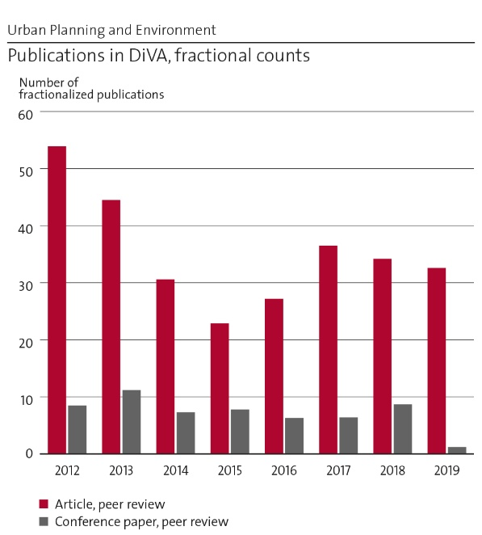 | 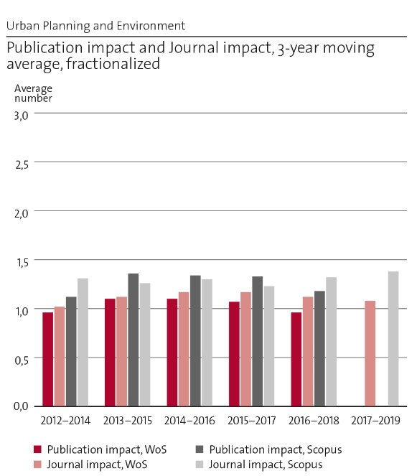
Figure 1: Publication in DIVA, fractional counts | Figure 2: Publication impact and Journal impact, fractionalized

Regarding the count data on publications and citations, they are difficult to comment, since it seems that publications may have been attributed to different organizational units over time. The errors are not in any way uniformly distributed, following numerous reorganizations during 2013-2018.
The average data should, however, not be affected to the same extent by these uncertainties and merits further comments. First, we note that, as a department, we publish in top-ranked international journals, as reflected in the percentage share of top 20% journals. We believe that there is a scope for improvement in this respect. This is related to an on-going discussion within the department (as KTH in general) on the relationship between quantity and quality. This discussion is also highly relevant for the PhD-education, as many papers are published within the scope of compilation theses.
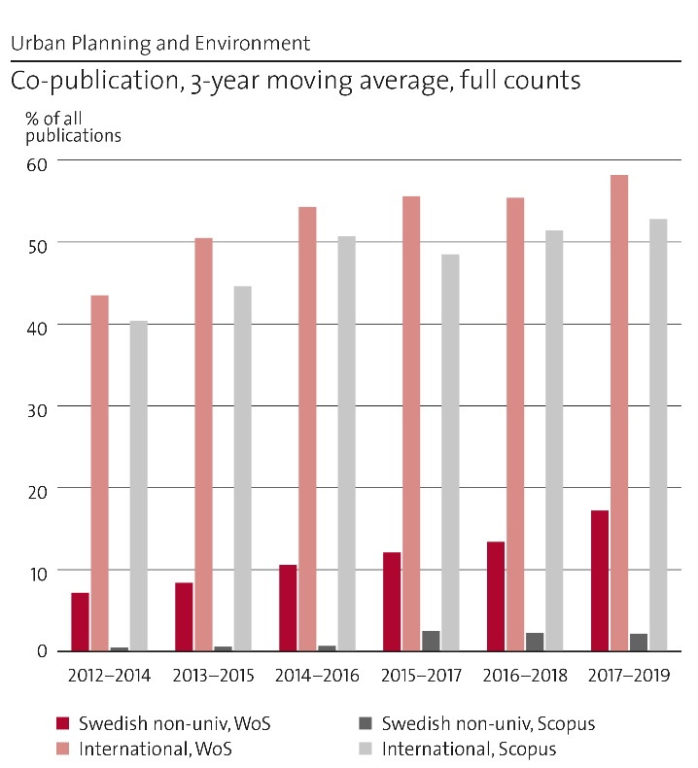 | Figure 3: Co-publication, 3-year moving average, full counts
Looking at the individual publications, we have selected ten publications to reflect theoretical [1], methodological [2] and empirical [3] contributions:
Y. Ban, A. Jacob, P. Gamba, 2015. Spaceborne SAR Data for Global Urban Mapping at 30m Resolution Using a Robust Urban Extractor. ISPRS J. of Photogrammetry & Remote Sensing, 103:28-37. [2, 3]
M Börjesson. J Eliasson, MB Hugosson, K Brundell-Freij, 2012. The Stockholm congestion charges – 5 years on. Effects, acceptability and lessons learnt. Transport Policy 20:1-12 [3]
V Ceccato 2017 Women’s transit safety: making connections and defining future directions in research and practice Crime Prevention and Community Safety, 19:276-287 [3, 1]
M Fosgerau, E Frejinger, A Karlström, 2013. A linked based network route choice model with unrestricted choice set. Transportation Research Part B: Methodological 56:70-80 [1, 2]
J. Haas and Y. Ban, 2014. Urban growth and environmental impacts in Jing-Jin-Ji, the Yangtze River Delta and the Pearl River Delta. International Journal of Applied Earth Observation and Geoinformation, 30(1):42–55. [2, 3]
A Karvonen, F Cugurrullo, F Caprotti (eds), 2019. Inside smart cities: Place, politics and urban innovation. London:Routledge. [3]
J Metzger, P Schmitt, 2012. When soft spaces harden: the EU strategy for the Baltic Sea region. Environment and Planning A, 44(2): 263-280. [1, 3]
T. Shirabe, 2016, A method for finding a least-cost wide path in raster space, International Journal of Geographical Information Science 30(8):1469-1485. [1, 2]
Haas, T. and Westlund, H. (eds) 2018. In The Post-Urban World: Emergent Transformation of Cities and Regions in the Innovative Global Economy (Regions and Cities). New York:Routledge. [1, 3]
O B Västberg, A Karlström, D Jonsson, M Sundberg, 2019. A dynamic discrete choice activity-based travel demand model. Transportation Science 54 (1):21-41 [2]

Engagement in national and international research collaboration within academia and its outcomes
The department has several national and international networks and research collaborations. Co-publications, broader dissemination of results in academia and interdisciplinary contributions are valuable outcomes. Guest visits for both faculty and PhD-students are another outcome.
In Sweden, we collaborate with universities e.g. Chalmers, Gothenburg University, Karolinska Institute, Linköping University, Luleå University of Technology, Lund University, Stockholm University, Swedish University of Agricultural Science, Södertörn University and Uppsala University; and research institutes as IVL (Swedish Cleantech), NORDREGIO, RISE (Research Institute of Sweden), SEI (Stockholm Environment Institute) and VTI (The Swedish National Road and Transport Institute). We have research collaboration with one or more of these in different configurations, both in national and international projects. For example, the department is lead in a Strategic Research Area within Transport, funded by the government. This is a collaboration between KTH, Linköping University, and VTI. We are also part of Digital Futures, a cross-disciplinary research centre based on long-term support of a governmental Strategic Research Area. This is a collaboration between KTH, SU and RISE.
International collaborations are both within Swedish funded projects and international programs as JPI Urban Europe and Horizon 2020. International projects mainly concern Europe, China, South-East Asia and Africa. A selection of international universities and academic bodies we collaborate with in ongoing or recent projects are e.g. Academy of Science of Mozambique, Beijing Normal University, University of Cambridge, City University New York, University of Cologne, ETH, University of Lisbon, University of Manchester, Michigan State University, MIT, Indian Institute of Technology Madras, Nanjing University, University of Pennsylvania, Polytechnical University of Milan, University of Sapienza, TU Eindhoven, UC Berkeley, UCLA, UCL Bartlett, Wuhan University. We have also several engagements in the EIT Urban mobility consortia. Nordic collaborations and networks with for example Aalborg University, NMBU and Aalto University are fruitful ground for development.
Most of the faculty and researchers are active in international associations and networks in our research areas. We are well represented over time in the main ones with positions, e.g. as presidents, committee and council members. These engagements support collaborations, co-organised conferences, seminars and symposia, applications and co-publications.

Follow up from previous evaluations
In RAE2012, the current department was part of two, and therefore in two different units of assessments, focusing urban planning and transport, respectively. Those assessments include other environments. Still, the development trajectory can be discerned as relevant for today’s situation. Both areas were assessed as very strong – both with highest scores for word-leading research output and research environment. The impact and engagement with society were ranked high, highest scores (5) for transport and next to (4) for urban planning. In the current department, we combine our strengths and continue to build on them. The focus is strong on applied research with high societal relevance, addressing issues of fundamental long-term importance to society. By combining social, economic and environmental issues, we support sustainable solutions by improvements in policies, planning processes and decision-making, tools and methods, aiming for greener, smarter and safer society. We contribute to strengthening the academic field with development of conceptual frameworks and empirical insights.

Viability

Funding; internal and external
The allocation of the departments entire funding is 80% research and research education and 20% education. Figure 4 shows the division of research funding. The numbers for the development 2012-2020 are largely influenced by organisational changes during the period. We will mainly focus on 2020.
The reorganization 2018 is clearly reflected in Figure 4, as the new division brought a high share of internal funding with them, including SFO (about half of the department’s received internal funding). The internal research funding (Government grants) consists for us of four categories: permanent funding (30%), funding linked to academic production (21%), temporary support (19%), and strategic national funding (SFO) (30%), the latter designated for transport research (percentage based on allocation 2021). For the SFO, it is important to understand that we as PI send a share of this funding included in Figure 4 to other environments, both within KTH and outside each year (around 4,5 MSEK ). However, large part of the research is dependent of external funding. For Research grants (external funding) we in 2020 transferred around 5,3 MSEK to our research partners. In total, the research income used within the department is around 46 MSEK (2020).
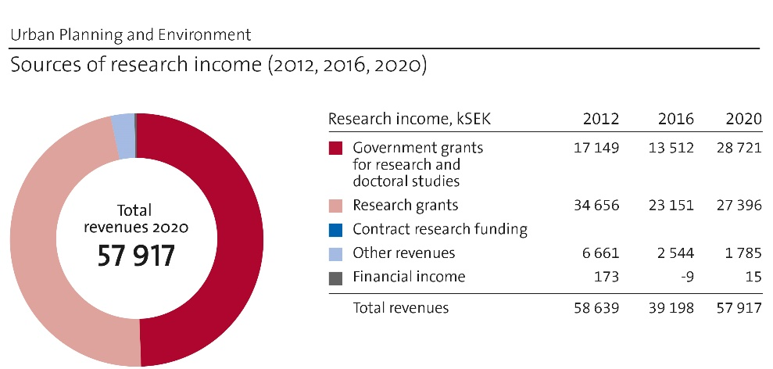
Figur 4: Sources of research income
The sources for external funding are mainly from national funding agencies (Formas, VR, MISTRA), state authorities (e.g. Swedish Energy Agency, Swedish Transport Agency, Swedish Space Agency) and foundations (mainly Ax:son Johnson Foundation). The share from different funders varies over the years. Ax:son Johnson Foundation has been a top-5 contributor the last 5-year period, financing the research centre Future of Places (CFP). CFP reaches the end of the period of external funding 2021, which will turn this trend and decrease the total external funding for the following period.
A majority of the projects is in the range 2-3 million SEK in total, running 2-3 years. We have also shorter projects with lower funding, e.g. pilots or minor collaborations. A trend is an increase of participation in larger and longer projects, including national funding (e.g. MISTRA with a shared project 4+4 years on sustainable consumption) and money for research on digitalisation and European funding, e.g. JPI Urban Europe and EU Horizon2020.
A challenge is the in average low share of internal funding of positions, with some exceptions. A high share of faculty lack entirely permanent internal funding in their positions, while a few have a high share. This reflects the uneven share of internal funding/faculty at university level, and the in average low share at our school. Time for applications and new collaborations needs often to be done within other projects. Another challenge is the rising share of funding calls with requirements for internal co-finance. We navigate by aiming for a mix of projects, and by continuing to develop strategies for when co-finance from the department is most fruitful. A growing challenge is to secure finance for PhD-students, with a study time of four years (employments). Universities, in line with the Higher Education Ordinance, is still not adjusted to the Bologna-process, while the funding agencies in general give 3 years. However, we do well in relation to our means.

Academic culture
The academic culture strives to be open and sharing. Activities are often organized so both senior staff and PhD-students take part and can share experiences and knowledge. The department is re-configured from January 2018 and from autumn 2018 shares the same building at campus. Small-talks in the kitchen should not be underestimated. A core for the daily discussions on research matters is within research projects and in the supervision situation, including co-written papers. Moreover, traditional seminars are crucial in the academic conversation and development of our research environment. They are typically kept in each division and in relation to the doctoral programs. At least twice a year, research-oriented activities are held at department level. E.g. in connection to this RAE we have had several meetings and activities with focus on different aspects of our research. Supervisors moreover participate in collegial discussion for experience-sharing within the PhD-education.

Current faculty situation
In April 2021 we have 16 persons with a faculty position: 5 Professors (3m, 2f), 1 Adjunct Professor (20%) (1f), 9 Associate Professors (5m, 4f) and 1 Assistant Professor (1m). Other staff with a PhD is 12 Researchers (7m, 5f) (whereof 11 permanent employment) and 5 Post-docs (1m, 4f), with duration 1-2 years. We today have 37 (17m, 20f) active PhD-students at the department, 20 in PhD-positions (employment), 17 industrial PhD:s and 2 other employments. In Figure 5, the numbers for 2020 do not include the two newly recruited faculty positions and half amount of the PhD-students.
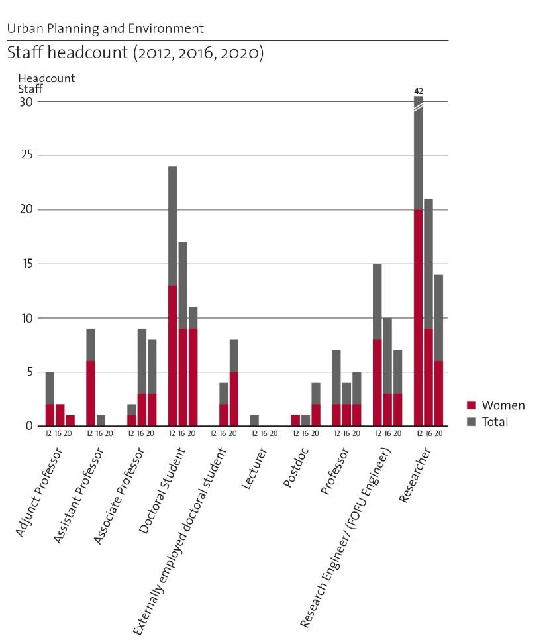
Figure 5: Staff headcount 2012, 2016, 2020, adjustments for numbers 2020, see text.
After a generation-shift, the age structure is fairly balanced, with few close to retirement (next 2026), and a good spread for faculty positions between 30 and 55 yrs. The recruitment strategy mainly focuses on adding early career faculty, to keep a continuity in staff structure. The gender balance is acceptable even in all categories. With the upcoming promotions the balance will probably be somewhat changed. The promotions will have large impact on the balance of faculty categories, with a growing number of Professors and fewer Associate Professors.
Project teams are composed by one or more senior staff members from the department, and one/ a few PhD-students. Most projects include external academic partners, from KTH and/or other universities.

Recruitment strategies
The recruitment strategy is based in the yearly Competence and Faculty Development Plan reflecting changes, resources and needs. A leading principle is that the faculty positions are carefully defined in the recruitment process, and we engage actively in a search process to attract the best candidates in international competition. Visibility and search processes are paramount in the recruitment process. We believe that we have been quite successful in recruiting new faculty in international competition. As KTH is following a tenure-track system, most recruitments take place at the Assistant Professor level, but recruitment at the Associate Professor level has also taken place. We also recruit researchers. One principle is to achieve a robust and viable competence profile in terms of subject, level and age.
A challenge is the availability of faculty funding needed for recruiting new faculty. We estimate about five faculty recruitments the following 10-15 years. Our aim is to balance the profiles, to be able to meet needs in teaching and the capacity of developing relevant and innovative research.
The recruitment of post-docs for 1-2 years has increased and will probably stay at a level of about 2-3 per year. For PhD-students, we believe in an open and active recruitment process, to attract the best candidates. They are mainly recruited based on external project funding. Most positions have high number of applications: several calls in the last five years have had around 150-200 applications including a high number of well merited and excellent applicants. The trend is that recruitment from our own master programs is low, given an international competition for each position.
For most of the existing faculty, and researchers, the funding situation varies over time and between individuals. Being too heavily dependent on external funding creates stress on individual level, and e.g. missed opportunities in creating new collaborations at department level.

Infrastructure and facilities
The main need for research infrastructure is computing capacity (i.e. CPUs, GPUs). We use resources on the national level (SNIC), as well as at the KTH level (VIC). We are dependent on their continued long-term availability. Facilities for safe storage and archiving of data are increasingly needed. It includes for example storage of sensitive personal data, which could include data sets, material from interviews, images, videos and other material produced in projects. Furthermore, support for GDPR concerns in general and ethical aspects are as well increasingly needed.

Strategies and organisation

Goals for development 5–10 years ahead
- Continue to produce leading research of high impact and long-term relevance for society
- Continue to perform research meeting current and future challenges to support a transformation to a sustainable society
- Continue to develop a research environment supporting leading research with creativity and curiosity, characterised by openness and equal opportunities
- Strengthen us as a strategic knowledge and competence hub for policy and practice actors
- Obtain a balanced composition of funding sources, with more long-term projects and fewer small, short-term projects
- Further develop our research to a higher extent including gender and justice aspects in our research fields
Our current staff is our main asset in fulfilling the goals. Therefore, we need to continue to build capacity as department, by strengthening structures for sharing knowledge and experiences, and to identify synergies and avoid unnecessary risks. A more even distribution of internal funding at university level would facilitate. We should utilise the support system set up at university level and by the school in the best way, and prioritize between different projects in relation to their balance between cost and benefit in relation to our development. Further, we need to allocate the internal funding as smart as possible, and navigate within the given frames. Another important mean is the existing collaborations and networks, both within academia and with societal actors.

Congruence with university-level goals for “A leading KTH”
Our goals, following the school’s development plan, are well aligned. The research at the department can overall be categorized as application-oriented research, due to the research fields, but carry within a need for elements of basic research. We argue that much of our more applied research still is curiosity driven as well, in identifying areas and needs for theoretical and methodological development, and ongoing search for new understanding of relations and patterns.
Sustainable development is a core in our research, from as well environmental, social and economic aspects. Here we contribute with as well research on preconditions, planning and decision-making, design, use and behaviour, methods and models and impact of different development alternatives in transforming society in a sustainable development.
Digitalization is an existing and growing part of our research - as tools for research; as research to develop digital applications and methods within our fields; and research to critically study implementation and impacts of digitalization for individuals and society at large.
Internationalisation of research is a natural part organised by many strong networks and fundamental research collaborations, dissemination of result by international publishing, recruitment of faculty and PhD-students in an international context. Several projects involve case studies in other countries and produce results relevant and valid in an international context. The research profile has a core in a Swedish-Nordic context that will be retained as a strength.
Gender equality is of importance as a component in our research environment – to be able to keep a gender-blended faculty. In our research, we have a potential to advance knowledge of gender equalities in relation to planning, design, management and peoples use of built environment and transport systems, as well in relation to development processes and policy-making.

Leadership structure and collegial structure
The formal leadership structure consists of three Head of Division, whereof one is Head of Department. The group meets at least 2-4 times a month, for practical and strategic discussions, depending on issues to be handle. The managers are also faculty and take part in the collegial discussions, in addition to the managerial administrative tasks. In research, individuals or groups can take the initiative and formulate their research topic, and anchor application and projects with their managers to secure that there are enough resources to fulfil the project (potential needs of co-finance, staff, administrative needs and so on). Ideally, this is an ongoing conversation in the research environment.

Strategies for high quality
The quality work follows and utilises the quality system at the university with annual assessments. Furthermore, the quality of our work is evaluated and reviewed by regular academic procedures, for example in recruitments, the funding applications and publishing procedures.
Several strategies are related to PhD-education, besides supervision, e.g. by using external opponents at seminars during the education and to appoint international well-known faculty opponents and members to the examination board. A mandatory internal quality review before the dissertation is an important checkpoint. Collaboration between supervisors, sharing experiences, is another.
Publishing in international journals and books with international collaborations with peer review is a central element. Here we can continue to increase the awareness of individual publishing strategies, and balancing quantity and quality, balancing publishing in journals with reach to peers and potential to develop the areas vs in other journals, which might have higher impact.
An area for further development is to strengthen the awareness and routines in relation to both ethical considerations and GDPR – from formulation of projects, implementing projects, to collect, use, storage and archiving of data. We believe this to be an important area for improvement, including more support from the university level, in addition to training and activities at the school and department.

Interaction between research and teaching at all three levels (BSc, MSc, PhD) of education

Interaction between research and teaching at all three levels (BSc, MSc, PhD) of education
The approach is that all education, at all levels, is well connected to research. All senior staff, including Full Professors, is engaged in education. Our research is an important base for content and pedagogy. In courses, examples from research are used. On BSc level the degree project (15 ECTS) train basic research skills in formulating problems, aims and research questions and carrying out a minor project with supervision. At the MSc level, the training includes more complex challenges - both theoretically and methodologically. The degree project (30 ECTS) can be connected to research projects. The PhD-education is closely integrated to the ongoing research. We encourage the PhD-students to take part in national and international scientific conferences and our activities as research environments, to train all parts of the skills expected from a researcher. The interaction with senior researchers is an important tool to fulfil this. The PhD-students in general teach or assist in education.

Impact and engagement in society

Relevance of research to society at large
The research at the department is of high societal relevance, approaching current and future challenges in society related to preconditions for the development of urban and regional built structures and transport systems including social, economic and cultural aspects and the interaction with the natural environment, all of importance for sustainable development and life quality. Public sector and policy-makers are central end-users, due to the research areas close interlinkage to public authority’s responsibilities and to policy. We collaborate with many municipalities, regions and public authorities. Nevertheless, civil society, organizations, companies and citizens are likewise important.
Our research is, and can be further utilised, in favour of gender and equality matters in society. We work with themes closely connected e.g. participation processes, accessibility, urban safety, housing market, visions for future development, which can be a base for reduced inequalities. The public sector is the main end-user here, in regards to policy-making, management and development processes.
For now, regarding joint positions, we have one Adjunct Professor, aiming to recruit one more the coming years. Three affiliations are formally established during spring 2021. On regular basis, we recruit industrial PhD-students, sharing about 50/50 time at university and their workplace. This is in general a good opportunity to develop contacts and disseminate research results.

Research dissemination beyond academia
Output of our research beyond academia is covering a broad spectrum. It includes e.g. improved tools and methods, policy briefs, contributions to the public debate, handbooks and recommendations, besides increased knowledge and insights. The contributions are utilised on local, regional and national level. There is also an international reach. The later can be exemplified by several collaborations with UN-bodies (e.g. in areas as urban change detection, urban safety, public places and housing).
The dissemination takes several forms. Part of the dissemination happens within projects, in the interaction and in co-production of knowledge, in form of workshops, test-beds, pilots and policy experiments and so on. Another channel is educations directed to practitioner, and by public seminars and networks. Films, blogs and newsletters are other examples. Many staff members takes part in public debate and/or popular science publications, often directed to practitioners and policy-makers, but can also be targeted for companies and the public in general.
Today there is no unified strategy of dissemination directed at society. We use our collaborations, the university webpages and are active in seminars and debates on regular basis. Digital tools are used, but not to their full potential. We are part of the development of a research communication strategy at the school level, starting during spring 2021. We also aim to develop the department’s webpages.

Sustainability and the United Nations’ Sustainable Development Goals (SDG)
We estimate that 80-100% of our research projects relate to sustainable development. A high share relates to processes and support to decrease resource use and environmental matters, on individual and societal level, e.g. consumption and management of water, energy, greeneries and other nature resources; to detect and monitoring changes in environment and other aspects of environmental concerns; and improved practices and policies. Social and economic concerns of urban and regional development are covered in may project, including justice, consumption and travel patterns, behaviour and values, urban safety, labour markets and rural development. Our research also includes studies of practices, procedures, policies and politics and their implications for sustainable development.
The SDGs is not as such a starting point for identifying research problems, and we may not address them as clearly as we could in publications. From the bibliometric information 2013-19 (Scopus), we have publications for all SDGs, with a main peak in SDG11 Sustainable cities and communities (fractional 109,4), followed by SDG 9 Industry, Innovation and infrastructure (20,4), SDG8 Decent work and economic growth (17) and SDG7 Affordable and clean energy (16,2). The bibliometric identifies SDGs in total 372 publications (222,2 fractional). Our bibliometric performance can thus be improved based on our existing research with relevance for sustainable development, with a more strategic package of publications (titles, keywords etc). Besides publications in scientific journals, disseminations and contributions are made in interaction with societal actors, by popular science publications, seminars, education and contributions to public debate and policy formation.

Structure for increased impact
A high extent of our projects is conducted in close collaborated with end-users, and often includes co-production of e.g. knowledge, products and tools. We utilise our networks and collaborations for dissemination. We encourage staff to be a part of the public debate. An essential instrument for structured increased impact and channel for dissemination of results is formal centres, labs and network collaborations. These forms a structured long-term collaborative framework. In particular, CTS, CFP, InfraSweden2030, and SafePlaces-network are hosted at the department, strengthening interaction academia with companies, public sector, professionals and policy-makers. We also have a leading role in the Senseable Stockholm Lab (SSL) (chair), a collaboration between KTH, MIT, the City of Stockholm. The ITRL centre is a KTH collaboration of importance, as well as Viable Cities and Digital Futures. Other channels important for us are the two strategic partnerships between KTH and the City of Stockholm and the Region of Stockholm, respectively, which give opportunities to collaboration and dissemination, and serves as an arena for identifying needs and knowledge gaps.
An essential mean for impact is education - engineer students, master students, PhD-students and courses for professionals. We have also a tradition of industrial PhD-students from government/public authorities. During the period of assessment from e.g. Swedish Transport Agency and Region of Stockholm. This offers a good contact and secure feedback to practice.

Impact cases
Below we present two selected cases, well embedded in long term research of the department.

Case 1: Continus change detection – tools for a sustainable future

Case 2: Co-creation of better planning practice – life-long learning and capacity-building

