 | Report |  | Date |  | Place
 | Periodic review of research 2012-2020 |  | 2021-03-22 |  | Stockholm
 | Created by:
 | Panel 3

Panel 3 Chemistry and Materials
  - Research Assessment Exercise (RAE) 2021,
self-evaluation
Created by:
Coordinator: Prof. Christofer Leygraf
Vice-coordinator: Prof. Minna Hakkarainen

Organisation

Organisation schedule
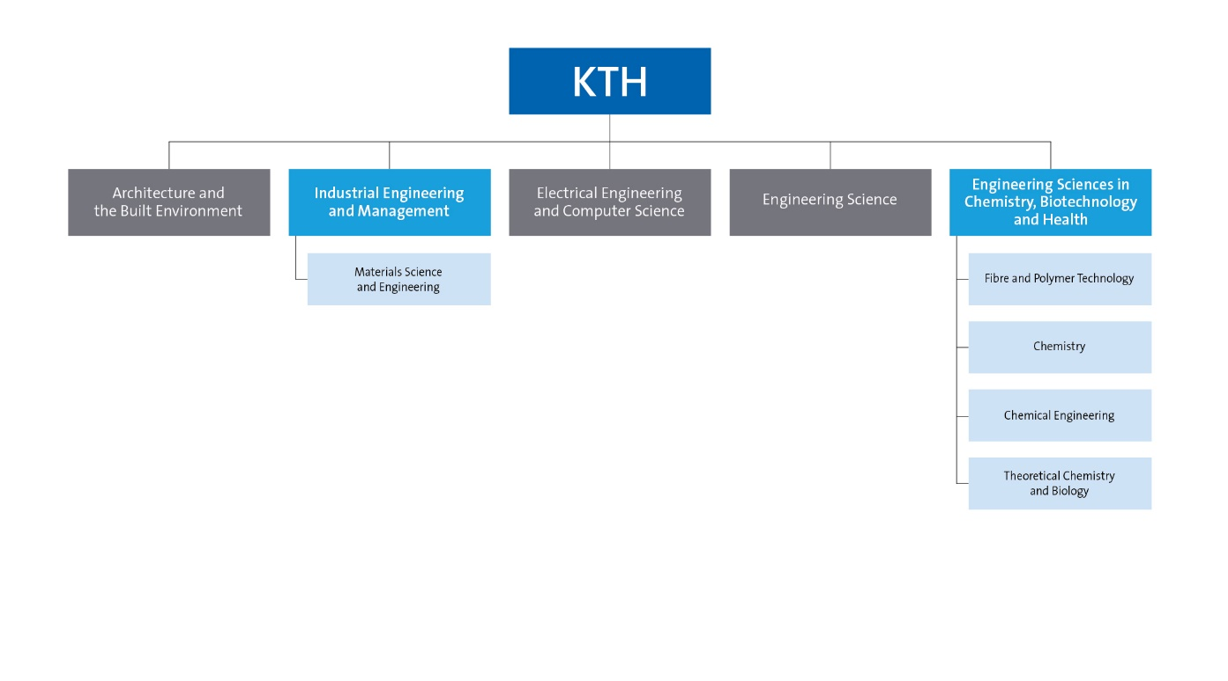Figure 1: Panel’s position in KTH’s organization.

Involved units
- Schools
School of Engineering Sciences in Chemistry, Biotechnology and Health, with Head of School: Prof. Mikael Lindström https://www.kth.se/en/cbh
School of Industrial Engineering and Management, with Head of School: Prof. Pär Jönsson, https://www.kth.se/en/itm
- Departments and Divisions
Department of Chemistry, with Head of Department: Prof. István Furó https://www.kth.se/che
Division of Applied Physical Chemistry, with Head of Division: Assoc. Prof. James Gardner https://www.kth.se/che/tfk
Division of Glycoscience, with Head of Division: Assoc. Prof. Francisco Vilaplana https://www.kth.se/che/glykovetenskap
Division of Organic Chemistry, with Head of Division: Assoc. Prof. Peter Dinér https://www.kth.se/che/orgkem
Division of Surface and Corrosion Science, with Head of Division: Prof. Per Claesson https://www.kth.se/che/surface

Department of Chemical Engineering, with Head of Department: Prof. Carina Lagergren https://www.kth.se/ket/chemical-engineering-1.784196
Division of Applied Electrochemistry, with Head of Division: Prof. Göran Lindbergh
https://www.kth.se/ket/electrochem/division-of-applied-electrochemistry-1.30912
Division of Process Technology, with Head of Division: Prof. Lars. J. Pettersson
https://www.kth.se/ket/process-technology/division-of-process-technology-1.30911
Division of Energy Processes, with Head of Division: Assoc. Prof. Stefan Grönkvist
https://www.kth.se/ket/energy-processes/division-of-energy-processes-1.30908
Division of Resource Recovery, with Head of Division: Assoc. Prof. Kerstin Forsberg
https://www.kth.se/ket/resource-recovery/avdelningen-for-resursatervinning-1.673772

Department of Fibre and Polymer Technology with Head of Department: Prof. Mats Johansson https://www.kth.se/sv/fpt
Division of Biocomposites, with Head of Division: Prof. Lars Berglund https://www.kth.se/fpt/biocomposites
Division of Coating Technology, with Head of Division: Prof. Eva Malmström
https://www.kth.se/fpt/coating-technology
Division of Fibre Processes, with Head of Division: Prof. Daniel Söderberg
https://www.kth.se/profile/dansod
Division of Fibre Technology, with Head of Division: Prof. Lars Wågberg
https://www.kth.se/fpt/fibre-technology/division-of-fibre-technology-1.18714
Division of Polymeric Materials, with Head of Division: Prof. Mikael Hedenqvist
https://www.kth.se/fpt/polymeric-materials
Division of Polymer Technology, with Head of Division: Prof. Minna Hakkarainen
https://www.kth.se/fpt/polymer-technology
Division of Wood Chemistry and Pulp Technology, with Head of Division: Prof. Monica Ek
https://www.kth.se/fpt/woodchem/division-of-wood-chemistry-and-pulp-technology-1.18841

Department of Materials Science and Engineering, with Head of Department: Prof. Annika Borgenstam https://www.mse.kth.se/
Unit of Processes, with Head of Division: Assoc. Prof. Björn Glaser https://www.mse.kth.se/process
Unit of Structures, with Head of Division: Assoc. Prof. Joakim Odqvist https://www.mse.kth.se/structures
Unit of Properties, with Head of Division: Prof. Levente Vitos https://www.mse.kth.se/properties

Department of Theoretical Chemistry and Biology, with Head of Department: Prof. Patrick Norman https://www.kth.se/tcb

Table of Contents
Organisation 1
Organisation schedule 1
Involved units 1
Part A: Introduction of panel 5
Description of the research field of the departments included in the research panel 5
Description of the self-evaluation process for the research panel 6
Identified research panel synergies 6
Part B: Report for each department 7
Department of Chemistry 9
Overall analysis and conclusion; strengths and development areas 9
Research profile 13
Viability 19
Strategies and organisation 22
Interaction between research and teaching at all three levels (BSc, MSc, PhD) of education 23
Impact and engagement in society 23
Department of Chemical Engineering 26
Overall analysis and conclusion; strengths and development areas 26
Research profile 27
Viability 34
Strategies and organisation 37
Interaction between research and teaching at all three levels (BSc, MSc, PhD) of education 39
Impact and engagement in society 39
Department of Fibre and Polymer Technology 43
Overall analysis and conclusion; strengths and development areas 43
Research profile 45
Viability 54
Strategies and organization 57
Interaction between research and teaching at all three levels (BSc, MSc, PhD) of education 58
Impact and engagement in society 58
Department of Materials Science and Engineering 61
Overall analysis and conclusion; strengths and development areas 61
Research profile 63
Viability 70
Strategies and organisation 74
Interaction between research and teaching at all three levels (BSc, MSc, PhD) of education 75
Impact and engagement in society 76
Department of Theoretical Chemistry and Biology 78
Overall analysis and conclusion; strengths and development areas 78
Research profile 83
Viability 89
Strategies and organisation 91
Interaction between research and teaching at all three levels (BSc, MSc, PhD) of education 93
Impact and engagement in society 93
Other 94
IMPACT CASES 95
Impact cases - Chemistry 96
Impact case 1 – Environmental and health risks related to metals 96
Impact case 2 – Mucus engineering for women’s reproductive health 98
Impact case 3 – Downstream bioprocessing makes medicines 100
Impact cases – Chemical Engineering 102
Impact case 4 - Electrification of the transport sector 102
Impact Case 5 - Efficient hydrocarbon reforming in biomass gasification conversion processes 104
Impact cases – Fibre and Polymer Technology 106
Impact case 6 - Transparent wood 106
Impact case 7 - Spin-off companies and products from FPT 108
Impact cases – Materials Science and Engineering 110
Impact case 8 - Towards fossil free high temperature processes through circularity and resource efficiency 110
Impact case 9 - Software tools for industrial materials design 112
Impact cases – Theoretical Chemistry and Biology 114
Impact case 10 - Software development for quantum molecular modeling in high-performance computing environments 114
Impact case 11 - Energy storage catalysis – Modeling of complex reaction environments. 116

Part A: Introduction of panel

Description of the research field of the departments included in the research panel
Since the foundation of KTH the research area defining Panel 3, Chemistry and Materials Science, has played a profound role in education and research at the university. Two of the four oldest professional schools at KTH are Chemical Technology and Mining & Metallurgy with a history that dates back at least 150 years. Through all societal and environmental challenges and demands, and through all progress in experimental and computational tools, and the current strong focus on sustainable development in the society, the research in chemistry and materials is highly relevant today and continues to develop, as reflected in the research summary below of the five departments in Panel 3: Chemistry, Chemical Engineering, Fibre and Polymer Technology, Materials Science and Engineering and Theoretical Chemistry and Biology. We start with a general description of each department, followed with more detailed information in Part B of this self-evaluation.
KTH’s Department of Chemistry represents strongly the fundamental science of chemistry both within the university and outward towards society. A recent widespread and unambiguous societal trend is to shift science funding from fundamental sciences to more applied projects and as a consequence the department has changed focus to address both fundamental and applied research questions. Today, significant contributions are being made in the areas of health, energy, materials, and the environment – all subjects related to sustainable development.
The research at the Department of Chemical Engineering is directed towards three major application areas; energy, environment, and chemical engineering in new processes. Within these main themes the research embraces a number of different subjects, such as catalysis, thermochemical conversion of biomass, energy processes, electrochemical energy converters, resource recovery of waste and transport processes in different systems. In the research, fundamental chemical knowledge is combined with engineering tools in order to bring new products and processes on the market. An important component of the research is the link between experimental activities and advanced modelling.
The Department of Fibre and Polymer Technology (FPT) is the largest academic institution on native and synthetic polymers in Sweden. The combination of the traditionally separate fields of natural and synthetic polymers is unique and allows FPT to address several important issues such as future demands on a sustainable material use in society. The vision of the department is to provide the society with “Sustainable Macromolecular Materials – from Molecules to Macroscopic Assemblies and Devices”. The research spans over the whole length scale ranging from molecular-, and nano-, to micro-and macrolevel.
The Department of Materials Science and Engineering has strong competence in modelling based on thermodynamics, kinetics and ab-initio calculations combined with experimental expertise on different length scales for determination of thermophysical and thermodynamic properties as well as for a range of advanced microscopy techniques. Research and teaching are conducted on metallic and ceramic materials; from construction materials to functional materials. To a large extent, the choice of materials reflects the needs of Swedish industry, and includes advanced steels, cemented carbides and high temperature alloys.
Driven by collaboration with experimental research, the Department of Theoretical Chemistry and Biology conducts theory and method development, program implementations for execution in high-performance computing environments, and, not least, numerical simulations of chemical processes and light-matter interactions. The overall goal is to contribute to the microscopic understanding of molecular and electronic processes (often dynamic and induced by interactions with light) and to achieve a rational design of molecular systems used as biomarkers, catalysts, and materials.

Description of the self-evaluation process for the research panel
Throughout the self-evaluation process there has been continuous interaction between the coordinators and the heads of the five departments. It started in early 2020 with individual meetings between the coordinators and each department head to define the conditions and the intent of the whole process. It then continued with several common meetings in which the coordinators and all heads participated in order to compare and judge different policies and ways to describe important issues. Between these meetings there have been ample possibilities of discussion through email. Due to the pandemic situation the self-evaluation has actually evolved in two steps. The first version was completed in 2020 and was then refined further to be finalized in 2021. In all, it should be emphasized that the conversational tone and degree of consensus between the departments and coordinators during the whole self-evaluation process has been very constructive and positive.

Identified research panel synergies
An important common aim for all five departments within this panel is research in chemistry and materials science towards finding solutions that enable sustainable development and circular (bio)economy. As is evident from Part B, a majority of projects are already related to sustainability aspects in one way or the other. In addition, all departments are aware of and clearly strive towards more collaborative efforts with partners within and outside the departments of the panel. Just to mention a few: the Department of Chemistry sees obvious possibilities to interact further with the Department of Chemical Engineering on energy storage and conversion or with the Department of Fibre and Polymer Technology on macromolecular materials. Antibacterial properties of metallic and non-metallic materials is another evolving topic which would benefit from stronger interaction between the Departments of Chemistry, Fibre and Polymer Technology and Materials Science and Engineering. Furthermore, the Department of Theoretical Chemistry clearly sees the potential of closer research and also educational activities within all other departments of the panel. In this way, all departments can benefit by learning more from the use of theoretical tools in different research areas. New insight and competence can also be gained in experimental techniques through various collaborative efforts between departments of our panel and strategic alliances with synchrotron radiation-based facilities, such as DESY in Hamburg and MaxIV in Lund.
Fossil-free hydrogen produced by electrolysis of water is one example of interdisciplinary research crossing borders from our panel to other panels. It is seen as a key component for the electrification of the transport sector as well as for the decarbonisation of various industrial processes. This development generates a number of new issues that require interdisciplinary research collaborations across subject boundaries, such as how the electrolyser copes with possible power fluctuations in the electricity grid, or where in the system to best place and integrate the electrolysers and the storage of hydrogen. Discussions on joint research projects within KTH have begun between the Department of Chemical Engineering and some departments in other panels.
Despite all new initiatives and visions aimed at improving academic competitiveness, it must be acknowledged that the financial foundation of all five departments continues to weaken and has now reached a level that is so critical that the future competitiveness of the departments in research and the well-being of the employees are seriously threatened. The reason can be found in the increasingly heavy administrative costs, salary costs and rental costs that are constantly increasing while the allocated faculty funds only increase marginally or hardly at all. To illustrate this, we have chosen to compare different forms of costs and revenues since 2008, when the first Research Assessment Exercise was implemented at KTH, and to this day. A majority of numbers presented are based on only three of the departments involved in the panel forming the previous School of Chemical Science and Engineering (CHE), but the situation is similar to all five department, and for that matter probably for the whole KTH.
 | 2008 | 2019 | Change
Costs of premises (SEK) | 71 779 000 | 137 204 000 | + 91%
Salary costs inclusive social cost fee (SEK) | 325 398 000 | 527 737 000 | + 62%
Staff (number) | 885 | 966 | + 9%
PhD candidate 4th year monthly salary (SEK) | 27 300 | 34 500 | + 26%
Yearly cost for PhD candidate 4th year¹ (SEK) | 757 000 | 956 000 | + 26%
Number of registered PhD candidates | 486 | 376 | - 23%
New registered PhD candidates/year | 92 | 64 | - 30%
Examination money for PhD exam (SEK) | 900 000 | 530 000 | - 41%
Typical grant size from VR (SEK) | 800 000 | 830 000 | + 0-4%

 | 2012 | 2017 | Change
Faculty funding from KTH (SEK)² | 102 672 000 | 105 480 000 | + 2,7%
The numbers for 2008 are for the three schools CHE, BIO and STH unless otherwise stated.
¹ Includes salary, social cost fee, overheads, cost for premises
² Research funding to Departments of Chemistry + Chemical Eng. + Fibre & Polymer Technology
In 2010 basic faculty funding from KTH at the CHE school was increased to cover approximately 40% of a salary for a professor with additional 20-25% coverage from teaching activities, a situation that was at that point far worse than at most universities in Sweden or abroad. Since then work has been done to increase the amount of basic faculty funding instead of, e.g., co-financing external projects. However, due to the increased salary and other costs, a professor in 2019 still has only about 45-50% of the salary covered by basic faculty funding. For younger faculty beyond their possible starting grant, the situation is at least as challenging. The effort to increase basic funding is positive, but any nominal increase has been eaten up and more by increasing costs and decreased co-financing from KTH to external projects. Any faculty is, thus, forced to seek funding for all doctoral students, postdocs, cost of premises, experimental costs and also to large extent for full financing of own salary. Unfortunately, it must also be noted that the administrative routines, e.g. for hiring new employees or admitting new graduate students, only continue to grow in complexity at KTH and that the possibility of funding doctoral students via scholarship has been reduced and is almost non-existing. The complex administration has lead to a situation where KTH has about as many administrators as faculty, yet administrative workload for the faculty has increased.
The fact that the system nevertheless worked so well in the past is due to the solidarity and hard work of many employees. However, we have now reached a point where our competitiveness is seriously threatened. One immediate consequence is that the number of newly admitted doctoral students per year in our research area has decreased by 30% since 2008, and at the Department of Chemistry by as much as 70% with Swedish PhD students becoming a rarity. These dangerous trends are going to continue if no radical changes are made.

Part B: Report for each department

Department of Chemistry
Self-evaluation
Head of Department: Professor István Furó

Included divisions:

Division of Applied Physical Chemistry, with Head of Division: Assoc. Prof. James Gardner
Division of Glycoscience, with Head of Division: Assoc. Prof. Francisco Vilaplana
Division of Organic Chemistry, with Head of Division: Assoc. Prof. Peter Dinér
Division of Surface and Corrosion Science, with Head of Division: Prof. Per Claesson

Department of Chemistry

Overall analysis and conclusion; strengths and development areas

Limited SWOT-analysis
 | Strengths | Weaknesses
Research | - A culture of scientific excellence that leads to outstanding research productivity and impact and a commitment to maintain the integrity of a cornerstone discipline.  - A balance between novel, fundamental and applied research, the development of new instrumentation and methodologies, providing unique competence and attracting global partners.  - Scientific breadth, diversity and originality, and a tradition of persistence, determination, and agility in addressing a broad range of challenges and application areas.  - Strong coupling between extensive and multidisciplinary teaching in multiple programs and the multidisciplinary, fundamental and applied research.  - Active collaboration with national research institutes, national and international networks/large scale facilities, and industries. | - A topical heterogeneity that arises from representing a complete scientific discipline and a discipline-based structure not congruent with large, application based grants favored by current funding trends.  - As custodians of a discipline that supports essentially ALL application areas, we are not perceived as “owners” of specific applications. This can result in an opportunistic selection of research directions and/or marginalization.  - A recruitment history designed largely to support our extensive teaching portfolio (ironically, also a strength).  - Atomized and fluctuating external funding leading to atomized and fluctuating effort.  - Absence of internal funding leads to the inability to perform “Proof of principle research” to support novel initiatives.
Organisation | - A highly competent, independent and internationally well-recognized staff in a non-hierarchical internal structure.  - Strong ethos for internal collaboration directed toward cross-disciplinary research.  - A broad selection of instrumentation for chemical and biochemical studies, currently being gathered into a joint research infrastructure with a dedicated manager and scientific director.  - An inclusive and supportive culture.  - A resilient and adaptive structure capable of complex integrational changes. | - An age structure that is weighted towards older faculty and a poor gender balance.  - Lack of resources to attract and foster the development of younger faculty or to acquire PhD students.  - Declining number of PhD students that threatens research integration in undergraduate teaching.  - A bare-bone faculty, with no technical support personnel and with a suboptimal administrative support, and aging instrument park.  - A division-based structure that is spread over 3 locations limiting regular interaction.

Development areas
Insufficient resources at the Department are a severe threat to its viability in both the short and long terms and if uncorrected will have dire consequences. Directly or indirectly, the majority of the organizational weaknesses are coupled to our lack of resources. The first 2 development areas (described below) are to address the problem of limited resources. Faculty funding is, and has been, grossly insufficient for a long-time; thus, an internal redistribution of resources is not a realistic option when all of our resources are already committed. While this threat is not strictly a part of the analysis above, it is central to any future development. The remaining avenues for our development are our research topics and our organization, a general willingness to cooperate, and the departmental atmosphere that remains friendly and inclusive.
Common Research Areas: Our first development area is to strive to establish at least one research area that is simultaneously: (i) societally relevant by advancing sustainability in a significant manner, (ii) well-funded by external organizations, (iii) would benefit from our collective knowledge and expertise, (iv) challenging, and thereby (v) has the potential to unite a large fraction of the department behind a joint purpose. Such a goal is not without its intrinsic challenges. As a disciplinary department we are constrained to maintain scientific breadth, whereas many challenges require application specificity, which by definition limits adaptability to future changes in research needs. We have identified several possible candidate areas such as molecular organization of biomaterials (synthetic or natural as in plant cell walls or protein plaques), chemical sensors geared for health or environmental monitoring, glycoengineering (akin to protein engineering), solar energy and/or fuel, ionic materials for energy, environment and health, sustainable food - processes, materials and interfaces - and molecular tools and mechanisms that enable both the mining renewable resources and recycling in a circular economy.
Local Collaboration: The second development area is to establish more productive, deep, and conscientious involvement with our potential research partners within KTH. We have knowledge, expertise and tools, and we must demonstrate to our potential partners the mutual benefits of collaboration and resource effectivization, from conception through joint grant to high-impact results. (Ironically this has short term resource implications for both partners; it is thus often easier to find such collaborations outside KTH.) Smaller, tangible joint projects seem the best way to initiate. We can most clearly make contributions in scientifically broad and relevant areas such as energy storage and conversion (Chemical Engineering) and macromolecular materials (Fibre and Polymer Technology). To that end, we are involved in centres such as the Wallenberg Wood Science Centre and Treesearch – the Swedish National Infrastructure for New Materials from Trees. We have an ongoing initiative supported by the CBH School (two postdocs) where together with partners at Chemical Engineering, we jointly address interfacial phenomena in electrochemical systems. The point to be proved is that combination of systems knowledge and molecular expertise generates exemplary, and useful, science.
Consolidation. A distant consequence of the previous RAE is that support was secured to adapt our central premises to accommodate one of our remote divisions (Surface and Corrosion Science SCS) at the main Chemistry building. This issue became even more apparent with the incorporation of a new division (Glycoscience GLY) at yet another detached location (Albanova). Besides relocation of SCS, a new laboratory (Molecules and Materials at Interfaces, 2MILab) was conceived and given some basic support. It is now a dedicated KTH infrastructure and will function as a concentration of research expertise supported by a globally competitive instrumental facility. Instrumentation ranges from routine and commercial, to home-built state-of-the-art tools. After a long and tortuous path marred by building and design issues, all relevant processes are now in progress and we envision 2MILab as a complementary vehicle to achieve departmental unity of purpose. We are determined to make 2MILab a success story, a platform for collaboration with a broad range of external and internal actors; academic, Institute and industrial. It will attract new funding and new industrial collaborations as well as establishing our campus, together with co-located research institutes as the leading global partner for innovation around interfacial challenges. In particular it addresses a perceived industrial need for a single contact portal to connect with interfacial expertise.
Divisional structure. Is our divisional structure appropriate for our needs? While we have no ready answers, neither do we have preconceptions. It will be easiest to address this point when we have a larger proportion of the department under one roof (202?). This also highlights the integration of GLY into the departmental structure. We have identified common research strategic areas, but integrational support is needed to capitalize our synergies in the most effective way. The outcome of the RAE will be determining for how we move forward here.

Summary statement on contributions of department on impact, infrastructure and sustainable development
Impact
- Excellent research output in high-impact journals: e.g. Nature Chemistry, Nature Communications, Angew. Chem. Int. Ed., J. Am. Chem. Soc., Adv. Mater., Adv. Energy Mater., PNAS, Chem. Comm, Nanoscale Horizons, in science and technology; Licheng Sun has been many years on the Thomson Reuter/Clarivate list of Highly Cited Researchers.
- Strong collaboration with a large variety of industries ranging from Sandvik (steel, corrosion) to GE Healthcare (bioprocessing) to L’Oréal (hair, skin and touch): Contract work, joint projects externally or industry-funded, and even part-time employment in industry and adjunct professors (Sandvik, Jernkontoret, Nanologica).
- Powerful interaction between research and education by integrating recent trends in energy conversion and storage, catalysis, green chemistry, biomass mining for novel materials and building blocks, and atmospheric chemistry at all educational levels.
- Innovation by turning scientific discoveries into new products, ranging from contraceptives to scientific instrumentation, via spin-off companies.
- Chemistry staff appointed as visiting/adjunct staff at leading international universities, at RISE and at companies. Ralph Nuzzo from UIUC, recently chose our research environment to affiliate to at 20% and he became one of KTHs most highly cited researchers.
- Multiple leadership roles in Swedish Chemical Society.

Sustainability
Our strategic research areas are related to many of the SDG in the areas of materials, energy, environment and health. A tenet of our approach is that the complexity of successful sustainable research requires the ability to integrate advanced scientific knowledge with state-of-the art instrumentation. Sustainable energy production/consumption also requires considerable (not always glamorous) supporting innovation as the following reveals.
- The demand for cheap energy with low CO2 emissions is inescapable. The next generation of safer, resource efficient nuclear powerplants will be lead cooled which places new demands on the steel used for the construction. Researchers at the Chemistry Department have recently patented a novel steel alloy designed to permit this goal.
- A significant proportion of all energy generated/consumed worldwide is lost due to friction and wear; combined with Corrosion they are also responsible for the demise of innumerable machines. Smart lubrication and Corrosion research are actively pursued and our department is leading in both these fields.
- Strong research in fundamental science underpinning solar energy and solar fuels, catalytic processes
- Ionic materials are widely touted as e.g. “green” solvents due to low vapour pressure, high thermal stability and low toxicity (in general). They can also be made exclusively from biomaterials. Two divisions are actively researching this frontier.
- Addressing the fate of particulate pollution in, and on, the body
- Active research into the chemistry of nature’s building blocks (e.g. carbohydrates and glycoproteins) - via genetic engineering, enzymology and green chemistry - sets a path towards food security, improved health and the design of multifunctional bio-based materials and products.
- In analytical chemistry: sensors for health and the environment provide a sustainability technology framework
- Recent appointment of an (ERC AdvG) professor in Environmental Physical Chemistry

Infrastructure
Our focus on instrumentation, development and methodologies has led to many of our breakthroughs, and indeed industrial partnerships since in a global marketplace, global companies choose unique competence capable of solving cutting edge problems – which by definition, conventional methodology is incapable of.
We have an extensive instrument park with the capabilities and specialized expertise to address the broad spectrum of our research. We prioritise maintaining good instrumentation standard despite the meagre resources for mid-size infrastructure.
- 2MILab is an excellent example for this. There we intend to achieve synergy by concentrating instrumentation and expertise. We are now registered as a dedicated KTH infrastructure. A recent, significant addition to our list of unique instruments is a Nano-IR instrumentation (externally funded) that permits chemical mapping of interfaces with 10⁻⁸ m resolution. We have also secured funding for an XPS instrument. Both Nano-IR and XPS are intended to strengthen our drive toward our first two development goals, see above.
- Among existing instrumentation, we a have a particularly strong cluster of NMR instruments (6 spectrometers, two of which are relatively young by being only 5 years old) suitable for liquid-state and solid-state experiments and for NMR microimaging and augmented by unique locally-developed instrumentation (electrophoretic NMR).
- High-level biochemical facilities in close cooperation with other bio-oriented departments of the CBH School but also by re-directing current instruments (e.g. state-of-the-art mass spectrometric instrumentation) towards biochemical applications.
- We have close ties to Nanolab (Physics) where we were instrumental in aquiring a modern AFM/nanotechnology park with a representative on the steering committee.
- Avid users of larger national and international facilities, such as advanced X-ray sources (MaxIV, other synchrotron sources in Europe, XFEL), neutron scattering facilities, the Swedish National Microscopy Infrastructure, or the Swedish NMR Centre for high-field NMR investigations.

Research profile

General information of the department
As a consequence of the widespread and unambiguous shift in science funding from disciplinary to application, the department has adapted to address both fundamental and applied research questions while maintaining disciplinary integrity. Significant contributions are being made in the areas of health, energy, materials, and the environment – all subjects related to sustainable development. Groups and projects with strong fundamental character have declined while those with more applied directions have maintained their current size or grown. Further consolidation and integration are in progress to move the surface and corrosion science division to the chemistry building, as part of the vision of a joint instrumental facility, 2MILab, for surface science studies; recently designated KTH Infrastructure. We have identified those societal challenges where molecular and interfacial expertise can be exploited best across the divisions. These include the design of ionic materials for energy, environment and health; food processes- including materials and interfaces; sensors. The philosophy is to address challenges that allow the discipline of Chemistry to flourish sustainably.
The department is constituted by four divisions that are, in order of approximate size: Applied Physical Chemistry (APC), Glycoscience (GLY), Surface and Corrosion Science (SCS) and Organic Chemistry (ORG). APC and SCS are themselves conglomerates of previous small divisions, often organized around classical generic topics like analytical or inorganic chemistry. Since they were created over 10 years ago, they are now commonly accepted as defining entities. GLY joined the department only 2 years ago, yet we have managed to arrange a satisfactory modus operandum which would nonetheless benefit from further integration. This integration is going to be most difficult in teaching where previous experience is rather disparate. Integrated research initiatives already exist, but require expansion and consolidation. While APC and ORG are at our central premises (“Kemiblocket”), SCS is some 400 m away in another building while GLY is located at the AlbaNova University Centre, where it shares basic infrastructure and facilities with another division in the area of Biotechnology.

Central research questions and themes, knowledge gaps addressed, main research activities
Our central questions and themes are centered on molecules. We calculate them (computational chemistry), make or break them (synthesis including a broad range of subtopics like organic- and bio-synthesis, metabolic engineering and radiochemistry), organize them (surface chemistry and material chemistry), measure and detect them (physical and analytical chemistry including chemical sensors and bioavailability and toxicology), and put them into use (catalysis, corrosion protection, solar cells, improved lubrication, biomaterials for energy and health). Our molecules come in many forms; many are biomolecules with a large emphasis on carbohydrates like cellulose and hemicellulose. Our research is primarily directed at being better in all those tasks with particular attention to sustainability. Hence, via our insights we seek processes and materials based on durability, renewable resources, fossil-free access to, and reduced use of, energy. Our emphasis on molecular aspects distinguishes us from our panel neighbours who concentrate more either on processes or on highly specific molecules and materials. Conversely, the same emphasis shared over the department permits us to form collaborative teams with the same problems addressed from widely differing perspectives.

Contributions to the advancement of the state of the art within the research fields of the department
Our excellence in research has led to several advances that we consider significant, we provide illustrative examples slightly biased towards ones achieved in a collaborative manner by several divisions. Hence and for example, research from within APC and ORG has led to the development of the company Dyenamo AB, which produces and sells chemicals and instruments for the testing and development of dye-sensitized and perovskite solar cells. These same researchers are world leaders in the fields of dye-sensitized, perovskite, and quantum dot solar cells. Research at APC is highly diverse. Besides the above, it also includes quantum chemical modeling of both materials and biomolecules with emphasis on catalytic performance, development of NMR spectroscopic methods and the application of advanced NMR tools to both applied material research and basic physical chemistry, making and characterizing biomaterials, both classical analytical chemistry and the design and applications of chemical sensors, and radiation-induced processes.
Most of the research at ORG is related to green or sustainable chemistry. The unit has a high research output with over 50 papers per year, many in excellent journals. The largest group focuses on artificial photosynthesis, including new generation solar cells, catalysts for water splitting, catalysts for CO2 reduction and catalysts for N2 fixation, with the aim to accelerate fundamental research to drive a conceptual transition from fossil fuel-based energy systems to solar energy conversion systems. Another strong field of research at the division is sustainable chemistry in organic synthesis using photoredoxcatalysis and electrochemistry.
GLY integrates competences in molecular biology, biochemistry, and material science to tackle fundamental and applied questions on carbohydrate engineering with impact on materials, health, energy and environment. The glycoengineering toolbox includes metabolic engineering, enzymology, analytical biochemistry, surface modification and supramolecular chemistry. The fundamental understanding acquired by GLY of plant and fungal cell wall structure and biosynthesis enables the development of biological strategies for pest control in aquaculture and food crops. GLY applies sustainable processes, including the production and characterization of enzymes, to mine the diversity of glycans in terrestrial and marine biomass. These glycan components are afterwards engineered towards high-value products for bioplastic, food, cosmetic and biomedical applications. GLY is heavily involved in national centres (e.g. WWSC and Treesearch), large EU projects and collaborations with the Asia-Pacific area.
Research at SCS is focused primarily on interfacial processes; particularly molecular and local effects on corrosion, wear and lubrication are addressed. This encompasses research on localized corrosion of metal alloys and new materials for high-temperature energy conversion, environmental and health aspects of corrosion, drug delivery, the relation between friction, surface composition and ensuing tactile perception (pyschotribology), ionic liquid lubricants, bio- and biomimetic lubrication, nanocomposite coatings for corrosion protection and their local degradation by UV-radiation and wear. Advanced spectroscopic techniques, such as vibrational sum frequency spectroscopy and NanoIR and other scanning methods are key, and often implemented together with large scale facility data; SCS is actively preparing for ESS. SCS enjoys many collaborations with research institutes (e.g. RISE), the Karolinska Institute the European metal industry and associations, and L’Oréal.

Quality and quantity of contributions to the body of scientific knowledge
Our publications have generally high impact and our bibliometric performance is very good by international standard as is shown by statistics enclosed below including the consistently high impact (Figure 2-3). Here we mention that, beside original research publications, in-depth review articles have a strong positive role in advancing a field. The field-normalized citation and impact trends either point upward or remain at a high level. In particular, we have a high and increasing level of international cooperation (see Figure 4) where we exploit exactly that aspect, our broad range of expertise, that we wish to capitalize more upon even within KTH and within the department.
As illustrative of recent high-impact publications we list the following ones:
- E. Tyrode, S. Sengupta and A. Sthoer, Identifying Eigen-like hydrated protons at negatively charged interfaces, Nat. Commun. 11 (2020) 493. https://doi.org/10.1038/s41467-020-14370-5. The exciting result is that the hydrated proton, one of the most ubiquitous of all ions in aqueous solution, adopts a specific structural configuration next to charged interfaces.
- A. Kamada, N. Mittal, L. D. Söderberg, T. Ingverud, W. Ohm, S. V. Roth, F. Lundell and C. Lendel, Flow-assisted assembly of nanostructured protein microfibers, Proc, Natl. Acad. Sci. 114 (2017) 1232-1237. https://doi.org/10.1073/pnas.1617260114 Creating the prospect of "silk from milk", it is demonstrated for the first time that protein nanofibrils can be assembled into microfibers without any chemical additives.
- J. Berglund, D. Mikkelsen, B.M. Flanagan, S. Dhital, S. Gaunitz, G. Henriksson, M.E. Lindström, G.E. Yakubov, M.J. Gidley and F. Vilaplana, Wood hemicelluloses exert distinct biomechanical contributions to cellulose fibrillar networks, Nat. commun. 11 (2020) 1-16. https://doi.org/ 10.1038/s41467-020-18390-z. Editor’s highlighted article in 2020 for Materials science and chemistry. We identify the distinct contributions of wood hemicelluloses (mannans and xylans) on the biomechanical properties of cellulose networks in compression and tension, related to their molecular structure, their multiscale assembly in rigid and flexible phases, and their distinct interfacial properties.
- J. Stenlid Halldin and T. Brinck, Extending the sigma-Hole Concept to Metals: An Electrostatic Interpretation of the Effects of Nanostructure in Gold and Platinum Catalysis, J. Am. Chem. Soc. 139 (2017) 11012-11015. https://doi.org/10.1021/jacs.7b05987. A physical rationale is provided for the well-known nanostructural effects in gold catalysis and a first-principle computational procedure is presented to be used in design of efficient catalysts.
- M. Eriksson, M. Tuominen, M. Järn, P. M. Claesson, V. Wallqvist, H.-J. Butt, D. Vollmer, M. Kappl, J. Schoelkopf, P. A. C. Gane, H. Teisala and A. Swerin, Direct Observation of Gas Meniscus Formation on a Superhydrophobic Surface, ACS Nano 13 (2019) 2246-2252. https://doi.org/10.1021/acsnano.8b08922. Use of advanced microscopy ends speculation about the bubble-forming mechanism. It exemplifies industry collaborations that yield high-quality publications.
- K. Yao, Q. Meng, V. Bulone and Q Zhou, Flexible and responsive chiral nematic cellulose nanocrystal/poly (ethylene glycol) composite films with uniform and tunable structural color, Adv. Mater. 29 (2017) 1701323. https://doi.org/10.1002/adma.201701323. Photonic structures that are responsive to stimuli and can operate in the entire visible spectrum have been prepared from cellulose nanocrystals (CNCs).
- F. Zhang, Z. Yao, Y. Guo, Y. Li, J. Begstrand, C. Brett, B. Cai, A. Hajian, Y. Guo, X. Yang, J. Gardner, J. Widengren, S. Roth, L. Kloo and L. Sun, Polymeric, Cost-Effective, Dopant-Free Hole Transport Materials for Efficient and Stable Perovskite Solar Cells, J. Am. Chem. Soc. 141, (2019) 19700-19707. https://doi.org/10.1021/jacs.9b08424. Polymeric materials in electronic applications are often too complex for practical applications. This motivated a more facile, rational design with both low cost and excellent optoelectronic properties.
- Q. Meng, B. Zhang, L. Fan, H. Liu, M. Valvo, K. Edström, M. Cuartero, R. de Marco, G. A. Crespo and L. Sun, Efficient BiVO4 photoanodes by postsynthetic treatment: remarkable improvements in photoelectrochemical performance from facile borate modification, Angew. Chem. Int. Ed. 58 (2019) 19027-19033. https://doi.org/10.1002/anie.201911303. Creating a superior material for photoelectric applications.
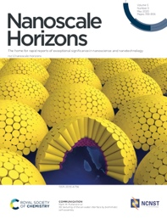
- E. Bergendal, R.A. Campbell, G.A. Pilkington, P. Müller-Buschbaum and M.W. Rutland, 3D texturing of the air–water interface by biomimetic self-assembly, Nanoscale Horiz. 5 (2020) 839-846. https://doi.org/10.1039/C9NH00722A. The work abolishes the current paradigm of the flat water surface and presents a molecular route to bending it - leading to facile nanopatterning
- D. Kärkäs, Electrochemical Strategies for C–H Functionalization and C–N Bond Formation, Chem. Soc. Rev. 47 (2018) 5786–5865. https://doi.org/10.1039/c7cs00619e. A well-received and well-cited review of an important field by a young faculty member.

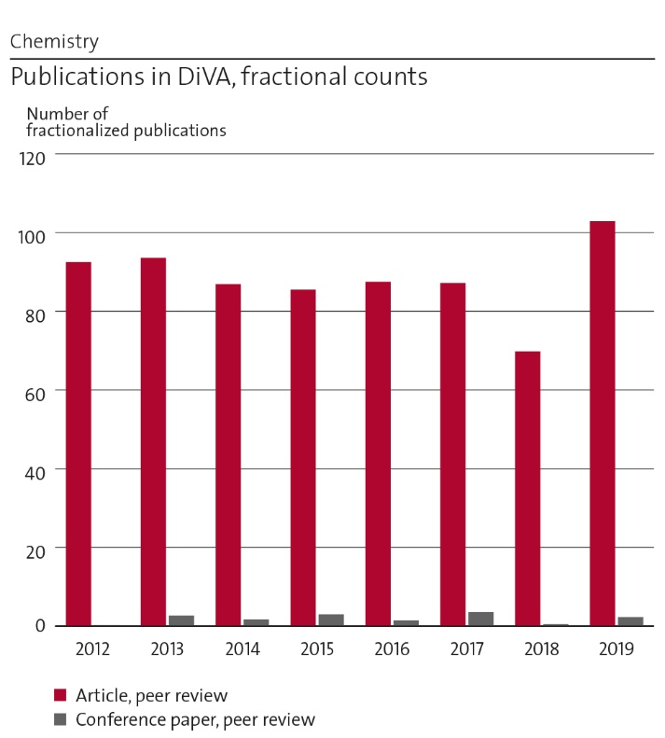
Figure 2: Number of fractionalized publications 2012-2019.

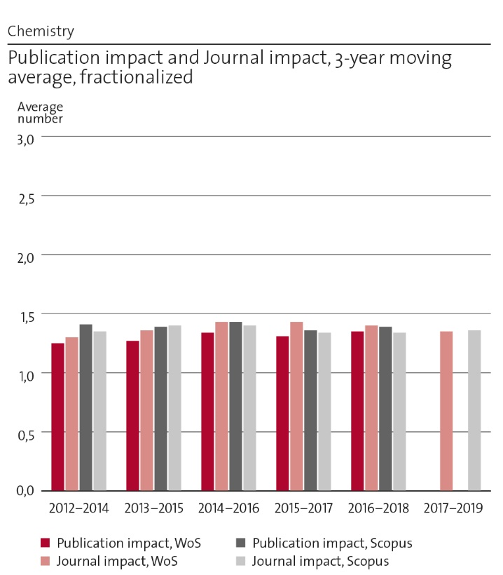
Figure 3: Publication impact and journal impact.

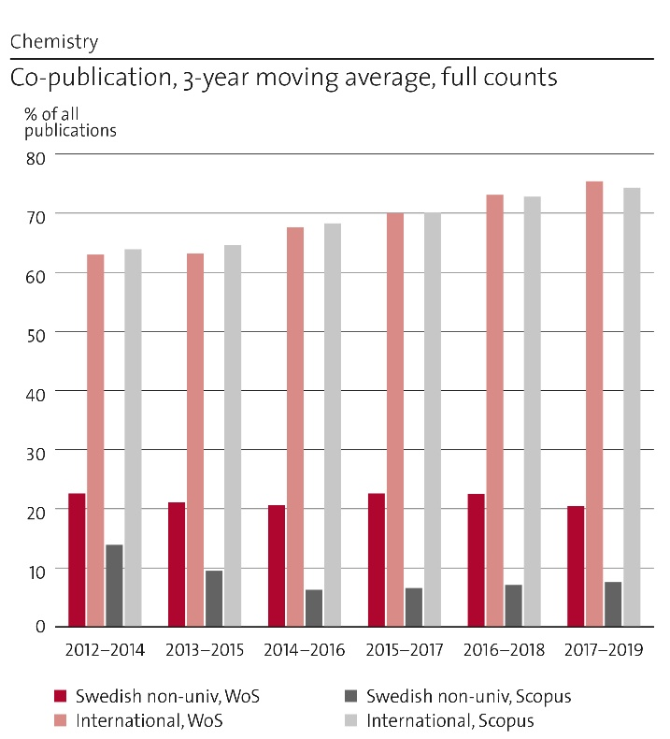
Figure 4: International and national co-publication.

Engagement in national and international research collaboration within academia and its outcomes
We have an enormous number of collaborations and 72 % of our papers 2016-2018, were achieved through international collaboration. Regarding centres and networks: A number of PIs at several divisions are involved in the Wallenberg Wood Science Centre that is hosted at the Department of Fibre and Polymer Technology and Treesearch (the Swedish Infrastructure for New Materials from Trees). This has resulted in a beneficial symbiosis with a number of highly impactful publications. In the field of solar cells, several PIs participate at the national research collaboration with Uppsala University in form of the Centre of Molecular Devices (CMD) and STandUP for ENERGY (SfE) that is a government-initiated research collaboration (~55 MSEK/year, ~200 people involved) between KTH, Uppsala, SLU, and LTU, and an international research collaboration with Dalian University of Technology (DUT) within the DUT-KTH Joint Research and Education Centre on Molecular Devices. Moreover, the Sun group has national research collaboration with Uppsala University in form of the Center of Artificial Photosynthesis (CAP). SCS participates in a strong national collaborative network over ionic liquids and their applications to lubrication, supported by the Knut and Alice Wallenberg Foundation (KAW) in the forms of the ILEAP project and by the Swedish Foundation for Strategic Research (SSF) in form of the REFIT project. APC is involved in several research networks including one supported by the EU project on the digitalization of medicine where they contribute by their unique chemical sensor technology. Several PIs at SCS participate in a large number of research networks and collaborations regarding metal corrosion and, specifically, its environmental impact (release, bioavailability, toxicology). PIs at GLY have strong involvement in research centres in the Asia-Pacific region (e.g. Australia, Taiwan) in the area of glycoengineering. A unique network initiative directed at protein-based materials is driven by PIs from GLY, APC and Protein Science who organized conferences funded by VR and Formas and seeded research collaborations. Several of our senior staff also have formal associations to other, leading universities.

Follow up from previous evaluations
We received an excellent evaluation (15 out of 15) in the previous RAE, namely: “The research performed in this unit is outstanding. It ranges from fundamental science to applications, and is highly acclaimed internationally. The research of the UoA has a strong impact on industry, on governmental policy and is of considerable importance for the general public. The research is impressive both in quality, diversity and breadth, ranging from advanced synthetic methodology to nuclear waste topics.”
The recommendation we received was “Thus the potential for achieving future goals is high. Nevertheless, some improvements are possible, including providing incentives and environments for enhancing internal collaboration within KTH, and ensuring that the present balance between basic and applied science remains. In addition, it appears that the current research topics are mostly promoted by professors or associate professors, and new research topics independently developed by young assistant professors are lacking.” While internal collaborations have increased significantly there is room for improvement. 2MILab is a promising vehicle for this of which we have high expectations. Regarding the balance between basic and applied science; that advice was easy to give and we agree that it is constructive. However, it proved difficult to follow for a unit that is (i) dominantly financed externally and (ii) exists in a funding environment that increasingly ignores disciplinary research. Finally, we have recruited several people at the Assistant Professor level and have ensured that their role is not that of supporting actors for seniors. This strategy yielded positive results. Hence, we had recruited two Assistant Professors (though Gaston Crespo was promoted to Associate after barely 3 years) in the field of chemical sensing who successfully established well-funded and most independent research fields towards medical and environmental directions. One of the two, Maria Cuartero, recently obtained both an ERC Starting Grant and Starting Grant from the Swedish Research Council, VR. Associate Professor Ute Cappel has also received a Starting Grant from VR and also the prestigious Göran Gustafsson Prize for Young Researchers while Assistant Professor Markus Kärkäs has received start-up funding from FORMAS and substantial funding from Wenner-Gren and Olle Engkvist foundations.
At the time of the previous RAE our current division GLY had its own UoA Materials Biotechnology where it was highlighted that “This unit demonstrated research output quality that is world-leading for the majority of the UoA …; however, the UoA is at significant risk, because key personnel have been recruited by competing institutions without replacements being promised by KTH… The sustainability of the excellent research environment of the unit is questionable as a result of the lack of investment in new appointments to the division.” In the past period, 2 junior faculty positions (Assoc Prof Francisco Vilaplana + Assist Prof Yves Hsieh) and 1 promotion to Professor (Qi Zhou) have materialized. A move in the recommended direction has been made albeit insufficient. GLY hosts promising young researchers who have secured large grants (SSF, VR, Formas, Energimyndigheten), but without any central support.

Viability

Funding; internal and external
Our regular internal funding (see Statistics in the Panel introduction) is abysmal and in relation to costs it is actually decreasing. Regarding research funding, starting grants and PhD bonuses add to the standard allotment and, on average, faculty research funding contributes to cover roughly half of the total salary costs of the faculty – yet nothing else. Funding from teaching covers, roughly and on average, another 15 % of salary costs. Everything else is supposed to be covered by external funding. This is indeed a critical factor that we must single out for our viability.
External funding has been, on average, rather constant but turned sharply upward in 2019 (Figure 5). It is too early to single out specific reasons. As a general trend, funding from the Swedish Research Council VR decreased in importance while funding from previously un- or under-exploited sources like Formas (a national research council directed specifically at sustainability) or private foundations (Olle Engkvists Stiftelse or Åforsk) has increased. The contribution of EU project funding is important in niche applied areas (e.g. GLY) but this poses also inherent threats since they require internal co-funding (which is limited) and intensive administrative efforts with insufficient support.
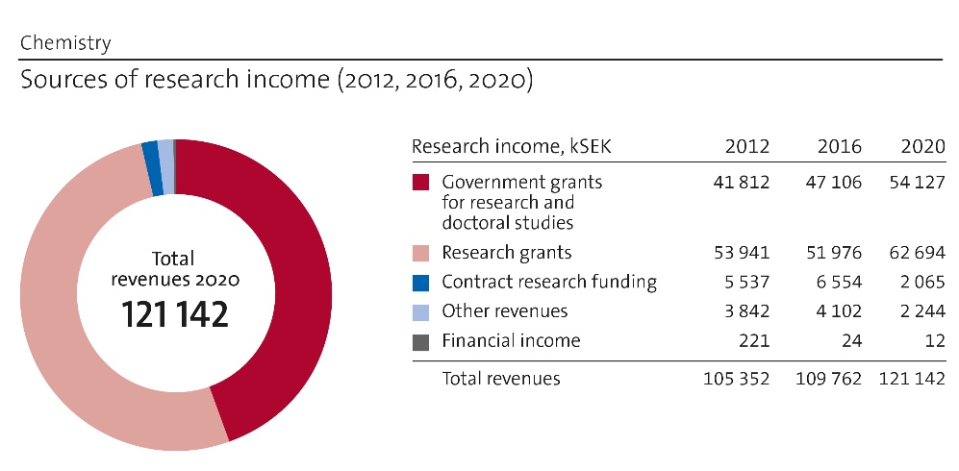
Figure 5: Comparison of research income in 2012, 2016 and 2020.

Academic culture
Our academic culture is characterized by the pursuit of excellence in an inclusive fashion. We have both formal (division meetings e.g. Glycoclub, seminars, thesis defences) and informal (of course, the coffee room) ways of interacting. One trend to note is the visibly increased stress, both for those in leadership positions (bureaucratic/administrative demands) and for younger faculty (concerning their future long-term excellence with grossly insufficient faculty funding). A consequence of this is the loss of important informal channels in both directions that, in the long term, leads to alienation and loss of trust and, consequently, lower quality. It is truly ironic that a lot of the increased stress arises from administrative duties of which the stated purpose is to improve quality. A number of rules and regulations that drive up our costs also purport to do this.

Current faculty situation
Three associate professors (1 woman / 2 men) and three full professors (1 woman / 2 men) will reach retirement age within 5-10 years. Faculty renewal is conducted by coordination within the CBH School and it depends a lot on resources available for starting grants. We hope to have positions at Assistant/Associate Professor levels to be announced in 2021 and 2022 to help fill the expected retirements. In the category Researcher/Research Engineer, a majority of employment contracts are not permanent, but short term. See Figure 6 for more details.

Recruitment strategies
While PhD students are still recruited, the wisdom of this is being increasingly questioned. There are several factors such as (i) the very high cost per PhD student, (particularly for industrially funded PhDs on an international market - where salaried course work adds 25% to already prohibitive costs) (ii) the increasing administration of the PhD process, (iii) the move towards less individual-oriented PhD programs, and (iv) a perception that the supervisory process is becoming increasingly untenable. For postdocs moving on the global market, the local conditions such as salary and housing matter greatly – in this context we applaud the major improvements due to campus housing and the work done by KTH Relocation. Regarding faculty positions, we are not in an economic position to offer competitive working conditions, especially for faculty financing/starting packages. Indeed, we have been unsuccessful at recruitment of leading international talents at full (or associate) professor levels. Hence, a strategy is to recruit exclusively at Assistant and Associate Professor levels where we may focus sufficient resources.
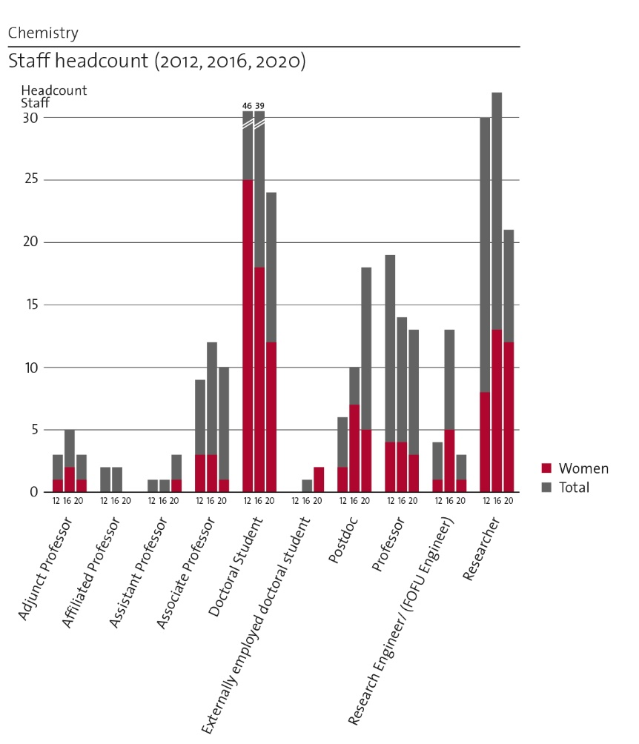
Figure 6: Comparison of staff development in 2012, 2016 and 2020.
Special attention is paid to identifying and encouraging female candidates to apply. Four of the eight most recent recruitments are women, which improves the current departmental average (19%). Once again, this is an easy problem to identify but difficult to solve, especially with our persistent and significant lack of faculty funding. Some of our faculty are involved in encouraging women’s involvement in science (http://womeninscience.se and www.kth.se/blogs/wop/2019/02/welcome/ ). In the last years we have identified a recruiting strategy dilemma between prioritizing candidates with prestigious external grants (e.g. ERC) in well-funded niche areas, or pursuing candidates in areas internally identified as strategic based on both education and research. While it is revealing that such successful scientists target our department as their first choice, and we agree that both strategies are required, we perceive that there is a resulting internal imbalance. Researchers face an acute problem. Typically, and historically, they have been employed in externally well-funded areas but recent decreases in faculty funding and the fluctuating nature of external funding makes their situation unviable in the long-term. Since only few faculty positions are expected to be created, we shall not encourage people to see employment as researchers as long-term career opportunities.

Infrastructure and facilities
As already discussed, we have a wide and varied infrastructure base as well as instrumental expertise. We very much wish to maintain this and one clearly identified facilitator for this is 2MILab. Regarding its viability, we see several potential problems. One is the current trend of clumping high-end instrumentation into national facilities. That may work for large-scale synchrotron sources but is less suitable, due to different operational praxis, to methods like NMR spectroscopy and dedicated mass spectrometry for biological materials. A connected issue is the drastically decreased state funding for instruments in the 1-10 Mkr range. Finally, we rely on methodologies but also on people who are experts in methodologies and their development. In general, scientific advances occur as a direct result of the methodological advances that permit their investigation. Yet, such methodological research directions are seldom perceived as directly influencing applications and societal challenges, and are therefore inherently less financed. Long-term, this creates a lack of suitable methodological support for all science. Two remedies to pursue are (i) to apply for the limited instrumentation funding at private foundations (our Nano-IR and XPS instruments are examples) and (ii) internal collaboration where methodological advances work as added value in applications directed at more funded societal goals. iii) that local government, university and institute leaders recognise that Stockholm is geographically suited to concentrated, high quality facilities with dedicated support and that there are enormous gains to be made in efficiency by providing state of the art facilities for the region as a whole.

Strategies and organisation

Goals for development 5–10 years ahead
Our goal is to maintain our quality of research and education performance in both absolute and relative terms. As outlined in the first section, the lack of faculty resources directs us to internal KTH collaborations as the only realistic strategy. To achieve this, we need to integrate the excellent research by different groups at the Department towards solving strategic scientific and societal challenges. We shall also aspire to remain attractive international partners and to maintain cutting-edge research as part of our soul. Our plans for strategy sessions to identify synergistic research areas across the divisions/disciplines tackling important societal challenges have been delayed in 2020 but will be prioritized and materialize in the near future, to guarantee the development and competitiveness.

Congruence with university-level goals for “A leading KTH” as set out in KTH´s “Development Plan 2018-23” (page 5)
We strive to make KTH more sustainable, more international, and more diverse. In as much that (i) KTH aims to be a leading technical university and (ii) that leading position plausibly arises from the research and teaching excellence demonstrated at individual departments, then our vision to remain strong, successful, and well-recognized is completely congruent with that vision.

Leadership structure and collegial structure
Our leadership structure is quite typical in academic terms. The department is divided into four divisions with one division head for each. The Head of Department is the liaison between the school and the department and is ultimately responsible for the economy, personnel, and for any departmental level decision. Those decisions are typically preceded by extensive discussions involving at least the division leaderships, in the regular meetings of the Head, deputy head and 2 representatives of each division. The primary role of the heads of division is to mediate discussion and interactions between the department and the individual researchers within the divisions and help facilitate discussions between researchers within division. Despite being a linear organization, the department has in practice a very flat structure. The main influence of departmental and divisional leadership is often advisory as negligible resources are allocated at either the department or divisional levels. Other important aspects are encouragement of internal and external collaborations and, at both leadership levels, mentoring of younger faculty. Individual research groups are historically largely autonomous. In general, the department is a welcoming place to work and the students between different research groups mix well with each other. Collegial interaction amongst the PIs is currently limited by both topical heterogeneity and spread locations. This is an area where we must improve. How? A common strategy, common meeting places (including virtual as a consequence of the pandemic) and common instrumentation.

Strategies for high quality
Most of the departmental resources derive from competitive external grants. High research quality can only be maintained through such successful applications, where the latter outcome presupposes high quality. The result of this funding includes publication of rigorous “quality not quantity” scientific articles in some of the most prestigious chemistry journals, and a clear emphasis of this rigour in doctoral supervision and teaching. Most articles are made available through open access agreements. Each of the faculty members has a development dialogue once a year to discuss performance and development. A section of the dialogue focuses on the performance during that year. On an individual level, this provides the opportunity to receive constructive feedback on strengths and opportunities. At the departmental level, relevant related strategies have been discussed in Section 1a.

Interaction between research and teaching at all three levels (BSc, MSc, PhD) of education
The short answer is that the interaction is strong, pervasive, and beneficial in both directions. It is more challenging to specify at a detailed level, but it is characteristic of the standards of leading universities - in particular, having research and teaching in the same field conducted by the same person. A recent trend is the integration of postgraduate supervisory training with undergraduate research projects. Junior undergraduates interact with active young researchers and work on topical research to gain unusually early exposure to research and the difference between “learning” and “acquiring” knowledge. Simultaneously, the postgrads achieve merits in supervision methodology. Where possible, research questions are illustrated in BSc courses, and this becomes more systematized in the Masters Courses where most lectures illustrate principles with recent research. The integration culminates with research intense MSc diploma projects, often in close contact with a doctoral researcher. Within PhD courses research and education interact directly, but lack of direct funding for these courses is a threat to their diversity, whereas reduced PhD student numbers are a threat to integration in BSc courses.

Impact and engagement in society

Relevance of research to society at large and Research dissemination beyond academia
Indeed, we reach beyond academia and out to society. Listed impact cases emphasise only a tiny fraction of our impact cases. Our personnel collaborate extensively with the Institute sector and with industrial networks thanks both to the close scientific ties and their preferential recruitment of our PhDs. The UoA is also over-represented in leading roles of the sections of the Swedish Chemical Society during the assessment period – where societal influence and national dissemination are paramount. We participate actively in national outreach events such as “Forskarfredag”, and targeted outreach in local schools. Current regulations do not always help establishment of joint positions and direct involvement in companies (and Institutes) While spin-off companies are encouraged (and plausibly arise from departmental research) the ensuing legal arrangements to separate remaining academic and spun-off activities are often impervious, extensive, and discouraging. There are several examples of PIs limiting their out-of-KTH activities in order to not collide with KTH regulations and legal opinions. Nevertheless, spin-off companies arise regularly at our various divisions.

Sustainability and the United Nations’ Sustainable Development Goals (SDG)
We perform research directly related to United Nations’ Sustainable Development Goals 2-7, 9, 12 and 13 and indirectly to other areas (such as 14 and 15). Short-term and with directly identifiable SDG-related research aims, we estimate that roughly 50-60% of our research is related to sustainable development. Longer-term, it is difficult to see anything significant among our activities that is not a potential contribution. Indeed, all new faculty positions (Cappel (f), Cuartero (f), Crespo (m), Lendel (m), Kärkäs (m), Hsieh (m), Noziere (f), Lundberg (f)) are directly connected to at least one SDG, as are all research centres in which we participate (see 2e for examples). This reflects both internal strategy and the trends and constraints in research funding.
SDG 2: Valorized glucans (GLY), nutrient release (APC).
SDG 3: Chemical sensing (APC), environmental release (SCS, see also Impact case 1), biotribology (SCS), biopharma (APC, see also Impact case 3), Alzheimer research (APC), women’s health (GLY, see also Impact case 2).
SDG 4: All divisions, by integrating research and its sustainability connections into our teaching and out-of-campus education.
SDG 5: See Impact case 2 (GLY).
SDG 6: Water purification by protein nanomaterials (APC).
SDG 7: Solar energy and fuel (ORG and APC, see 2d), nuclear energy (APC and SCS), tribology and new lubricants (SCS), possibly routes to biofuels (GLY), de-icing for wind power (APC and SCS), better catalysts (APC).
SDG 9: All divisions, via sustainable materials. Either biobased (GLY, APC, SCS) or more environmentally benign (SCS) or longer lifetime (SCS).
SDG12. Development of biorefinery processes for mining terrestrial and marine biomass (GLY). The BIOACTIVE project for the valorization of agrowaste has been selected by IVA as a key sustainable technology with large business potential. Protein-based materials and sustainable food production (APC). Development of sustainable photo- and electrocatalytic processes (ORG). Systems for controlled nutrients delivery in agriculture (APC).
SDG 13: All divisions, by contributing to energy and materials without fossil input.

Structure for increased impact
Our faculty shows all signs of being very much aware that there are vital societal challenges, foremost of which is sustainability, where we have both a stake and a role. We guarantee the impact of our quality research by contributing to societal challenges, the significance of our industrial collaborations, the created spin-off companies and the quality of the PhD students we educate. Based on our past experience, it is generally questionable that “processes, procedures, or mechanisms” (that is, in form of an administrative approach) are of any actual and cost-effective help. We think we have a beneficial and significant societal impact and have every reason to think that we shall continue to keep it so or better.

Department of Chemical Engineering
Self-evaluation
Head of Department: Professor Carina Lagergren

Included divisions:

Division of Applied Electrochemistry, with Head of Division: Prof. Göran Lindbergh
Division of Process Technology, with Head of Division: Prof. Lars. J. Pettersson
Division of Energy Processes, with Head of Division: Assoc. Prof. Stefan Grönkvist
Division of Resource Recovery, with Head of Division: Assoc. Prof. Kerstin Forsberg

Department of Chemical Engineering

Overall analysis and conclusion; strengths and development areas

Limited SWOT-analysis
 | Strengths | Weaknesses
Research | - Very important subject areas, solving grand challenges of the society regarding sustainability  - Extensive international and national collaboration in academia and industry  - Strong links to alumni in industry  - Ability to attract external funding in harsh competition  - High number of publications of high quality  - Both fundamental and applied research strongly connected with each other  - Age distributed and international faculty with broad competences  - Cross-disciplinary collaborations | - Our research and projects are not sufficiently visible from outside  - Potential for collaborations within the department not fully utilized  - Insufficient internal funding, i.e. we need to follow research agendas set by others  - Funding opportunities are often focussed on applications and not on method development
Organisation | - All divisions of the department are in the same building  - “Teaching teams” open up for research cooperation  - Improving gender balance  - Local access to infrastructure and advanced equipment and instruments  - Positive and welcoming atmosphere. Weekly department fika  - Increasing number of faculty recruited from outside KTH | - Too slow and bureaucratic employment process  - Too high administrative burden  - The faculty is no longer trusted to be able to assess skills and competences of applicants, take decisions, etc.  - Few opportunities to buy expensive key instruments  - No strategies to get prestigious research funding. Support from KTH to administrate the application for funding is needed  - Potential to collaborate with alumni is not fully utilized  - Different sizes of divisions, some subcritical

Some of the identified weaknesses in research are directly coupled to the funding situation and not easily improved by us. However, regarding our visibility we can be much better in communicating and reaching out with our competences, and where and for what they can be used. Chemical engineering is a broad subject that is needed when tackling many of the grand challenges in society related to energy, sustainability and climate problems. A first tangible improvement is to highlight the many different projects that we are involved in on the department's website. However, we must also communicate our research better within the department. Today, internal seminars are given at divisional level, but not at department level. A suggested half day of presentations from all divisions, once or twice a year, will improve the awareness of what colleagues in other divisions are working with and will enable new and exciting collaborations.
When regarding organization, the size of the divisions differs a lot, and some are possibly subcritical. One of the small divisions (Transport processes) was recently merged with the division of Resource recovery (from 1 January 2020) in connection with a professor’s retirement. To decide whether further reorganizations are needed we will await the profile and development of two new assistant professors at the department, one recently employed, and one on the way in.

Summary statement on contributions of department on impact, infrastructure and sustainable development

Impact:
- Research with high industrial and societal relevance
- Well-educated MSc and PhDs are very attractive for industry positions
Infrastructure:
- Laboratories equipped with e.g. gloveboxes, potentiostats for battery, fuel cell and electrolysis research
- Unique equipment for thermochemical conversion of biomass (high pressure, medium scale) central for the research undertaken in Swedish Gasification Centre (SFC)
Sustainable development:
- With only a few exceptions, all of our research aims directly at sustainable development, e.g. electromobility, conversion of biomass, decarbonization of industry, recovery of waste
- Key competence in scientific fields and technologies that enable sustainable solutions, e.g. chemical and electrochemical conversions, heterogeneous catalysis, separation processes

Research profile

General information of the department
The Department of Chemical Engineering is one out of nine departments in the School of Engineering Sciences in Chemistry, Biotechnology and Health. It consists of four divisions, and one smaller research group, all briefly described below. In total the department has around 70-75 members, of whom 16 are faculty members, 5 researchers, and the rest doctoral students and post-docs.
- Applied Electrochemistry
Research is directed mainly towards secondary batteries, fuel cells and electrolytic processes. A common theme in the different research projects is the mathematical modelling and electrochemical characterisation of electrochemical systems.
Permanent staff: Prof Göran Lindbergh, Prof Ann Cornell, Prof Carina Lagergren, Prof Rakel Wreland Lindström, Researcher Henrik Ekström (20 %)
- Process Technology
The research is focussed on physical and chemical processing, from understanding catalytic reactions at the atomic scale to designing and optimizing large scale reactors and systems in close collaboration with industrial partners. Goals include improved energy efficiency, pollution control, and thermochemical conversion of carbonaceous materials towards a sustainable future.
Permanent staff: Prof Lars J Pettersson, Prof Klas Engvall, Associate Prof Henrik Kusar, Associate Prof Christophe Duwig, Assistant Prof Dan Harding, Assistant Prof Efthymios Kantarelis, Researcher Yohannes Kiros
- Energy Processes
Energy research with a chemical engineering approach from a systems perspective is conducted at Energy Processes. The activities are concentrated on energy conversion processes and process integration. The aim is to develop environmentally friendly and energy-efficient processes from a systems point of view by primarily using knowledge in chemical engineering and thermodynamics.
Permanent staff: Prof Per Alvfors, Associate Prof Stefan Grönkvist, Associate Prof Matthäus Bäbler, Assistant Prof Shareq Mohd Nazir
- Resource Recovery
The research focuses on development of novel techniques for resource recovery. This includes a number of separation processes, with a focus on crystallization processes, and the knowledge is applied in various projects focusing on recovering resources from waste streams such as waste electrical and electronic equipment. Biochemical processes for the recovery of resources from wastewater are also studied.
Permanent staff: Associate Prof Kerstin Forsberg, Associate Prof Zeynep Cetecioglu Gürol, Researcher Michael Svärd
- Nuclear Waste Engineering (administratively subordinate to Applied Electrochemistry)
The projects concern flow, transport and reactions in porous media, with a focus on natural systems such as soils and rocks. The fate and transport of contaminants in natural systems and the remediation of contaminated soils are studied experimentally, theoretically and by field experiments.
Permanent staff: Researcher Longcheng Liu, Prof Emeritus Ivars Neretnieks, Prof Emeritus Luis Moreno

Central research questions and themes, knowledge gaps addressed, main research activities
The research at the department is challenge-driven by the need to transfer to a sustainable society. By looking through the many research projects at the department, one can discern a general goal and common theme for a great many of them: the decarbonisation of industry and society. A further analysis shows that they may all be sorted under three headings: energy, environment, and new processes.
One strong theme in the research is the use of electrochemical conversion. Examples are the studies on both batteries and fuel cells for the electrification of the transport sector, but also for use in the energy sector: as electricity generators, as well as for storage. Electrochemical processes are also essential in chlorate production, and in hydrogen production, e.g. for the future carbon-free steel production.
Systems research on the decarbonisation of the industry, coupled primarily to the carbon dioxide concentration in the atmosphere is a second research theme at the department. Applications studied at present are hydrogen storage issues for the carbon-free steel production industry and bioenergy with carbon capture and storage (BECCS) for the heat and power industry including the study of policies and incentives with regard to carbon dioxide.
Research on catalysis and catalytic processes forms a third major theme. A broad range of scales is covered, from fundamental understanding needed to allow the rational design of new catalysts for renewable feedstocks to the development, characterisation and application of catalysts for energy conversion and pollution control, often in collaboration with industrial partners.
More recently also resource recovery from waste, by e.g. hydrometallurgical processes, has become an important research topic at the department. The employment of a new faculty member some years ago has contributed by adding competence in biotechnical processes for resource recovery, something that is new for the department.

Contributions to the advancement of the state of the art within the research fields of the department
Hydrocarbon (HC) catalytic reforming is a key technology for utilising thermochemical conversion processes such as gasification. A significant challenge has been the understanding of effects of raw gas impurities, such as K and S, on catalysts for HC reforming. We achieved significant progress within HC reforming, such as developing an accelerated ageing protocol and experimental procedure for studies at realistic conditions, improved understanding of K – S interactions with Ni catalysts under real conditions and enabling a bridging of the gap between theory and experimental observations.
By using cutting-edge techniques, researchers in our department have, in strong cooperation with Yale-NUS college, Princeton University, National University of Singapore, Chalmers University of Technology, Umicore Denmark ApS, Scania CV and Volvo Group Trucks Technology, correlated catalyst deactivation in the laboratory with real-life ageing. The study, which reveals the underlying mechanisms of decreased performance, provides useful information in choosing appropriate types of catalysts and exhaust system configurations for various applications. In addition, insights from this work could aid the development of more durable exhaust gas catalysts for heavy-duty trucks.
In the scope of the ongoing MENToR-project, an existing upscaling method for life cycle assessment (LCA) purposes is further developed to fit resource recovery systems in the early design stage. In this stage, laboratory scale systems are conceptually upscaled to generate life cycle inventory (LCI) data to conduct LCA using different methods, one of the methods is using advanced process calculations. In the context of the above-mentioned project, this method will be tested, further developed and verified using resource recovery cases in laboratory and full scales. The resulting method will be disseminated to researchers and LCA practitioners through publications and a web application.
The compounds found in wastewater reflect people’s life, when regarding diet, use of pharmaceuticals, drug abuse, etc., and is a potential source of information on prevalence of infections. An approach based on wastewater-based epidemiology offers a cost-effective alternative to test a large number of random individuals in the population. In the end of March 2020, in the early time of the COVID-19 pandemic, a KTH team started to work in this area and the first samples were collected already in April 2020. A method was developed at KTH, by which the first wave of cases was monitored during spring. By using the method, the second wave of the pandemic were predicted four weeks before the number of cases started to increase in autumn 2020.
For the understanding and quantification of ageing and degradation of commercial Li-ion batteries and PEM fuel cells, electrochemical evaluation supported by physics-based modelling has been a very useful tool. This, in combination with spectroscopic techniques, has set a standard for post-mortem studies of aged batteries, and on-line mass-spectrometric evaluation has added knowledge about degradation processes and influence of contaminants in air and fuels.
Structural batteries are multifunctional composite materials able to carry load while storing electrical energy like lithium ion batteries. Carbon fibres are used as the load-carrying material thanks to their excellent strength and stiffness properties, but also as the active negative electrode and allow for ion-inserting into their micro-structure, providing the battery function. Possible applications for structural batteries are chassis for portable electronics, car body panels or even in aircraft applications. The multi-disciplinary research conducted together with groups at KTH and outside has opened a new research direction on multifunctional materials.
Other examples of cutting-edge research performed at the department includes the use of cellulose in lithium-ion batteries, electrolysis in molten carbonate cells (MCEC), electrode coatings for improved selectivity for electrolytic hydrogen evolution, a new source for unwanted oxygen production in chlorate electrolysis, development of a methanol-based hydrogen storage system for application in the iron and steel industry.

Quality and quantity of contributions to the body of scientific knowledge
The most important way for us to contribute to the scientific knowledge is by publications in international scientific journals of high quality, presentations at conferences, and by examined PhDs and their theses. The department is well positioned when it comes to scientific publications. In the period 2012-2019, the number of publications per year lies on a relatively stable level, regardless of some retirements and other changes in the faculty, see Figure 7. A total of 599 peer-reviewed articles were published in good journals with high impact factors, see Figure 8. Besides, more than half of our publications are made in collaboration with international partners, a share that is above the average for KTH, Figure 9. Our subject area is closely linked to applications and to making societal benefit, and the collaborations with industrial partners are many, resulting in a very high degree of co-publications. Even in this respect we did better than average at KTH. During the actual period of time, the number of theses from the department was 69, 8 of which were licentiate theses, while the number of conference papers were around 150.
Publications we want to highlight (with short motivation below, number of citations: WoS):
- L. Hu, I. Rexed, G. Lindbergh and C. Lagergren, Electrochemical performance of reversible molten carbonate fuel cells, Int. J. Hydrog. Energy 39 (2014) 12323. (Journal impact factor: 4.9. Citations: 30) (First-ever publication on high-temperature molten carbonate electrolysis cell, MCEC)
- M. Klett, R. Eriksson, J. Groot, P. Svens, K. Ciosek Högström, R. Wreland Lindström, H. Berg, T. Gustafson, G. Lindbergh and K. Edström, Non-uniform aging of cycled commercial LiFePO4//graphite cylindrical cells revealed by post-mortem analysis, J. Power Sources 257 (2014) 126-137. (Journal impact factor: 8.2. Citations: 113) (We were early with describing aging in commercial cells. Collaboration between Uppsala University, KTH, AB Volvo and Scania.)
- J. Persson and S. Grönkvist, Drivers for and barriers to low-energy buildings in Sweden, J. Clean. Prod. 109 (2015) 296-304, 2015. (Journal impact factor: 7.2. Citations: 29) (Interviews as main method to generate data. Multi-disciplinary and system-oriented approach.)
- P.H. Moud, K.J. Andersson, R. Lanza and K. Engvall, Equilibrium potassium coverage and its effect on a Ni tar reforming catalyst in alkali- and sulfur-laden biomass gasification gases, Appl. Catal. B: Environmental, 190 (2016) 137-146. (Journal impact factor: 16.7. Citations: 22) (Paper describes a leap in the understanding of potassium – sulphur interaction with nickel catalyst surfaces under real hydrocarbon reforming conditions.)
- R. Karlsson and A. Cornell, Selectivity between oxygen and chlorine evolution in the chlor-alkali and chlorate processes, Chem. Rev. 116 (2016) 2982-3028. (Journal impact factor: 54.3. Citations: 156, highly cited) (Review article. From fundamental DFT calculations on the electronic structure of atoms to experiments and industrial experience of chlorate and chlor-alkali production.)
- H. Lu, J. Hagberg, G. Lindbergh and A. Cornell, Li4Ti5O12 flexible, lightweight electrodes based on cellulose nanofibrils as binder and carbon fibers as current collectors for Li-ion batteries, Nano Energy 39 (2017) 140. (Journal impact factor: 16.6. Citations: 37) (Example of using carbon fibres and cellulose in batteries)
- J. Neugebohren, D. Borodin, H.W. Hahn, J. Altschäffel, A. Kandratsenka, D.J. Auerbach, C.T. Campbell, D. Schwarzer, D.J. Harding, A.M. Wodtke and T.N. Kitsopoulos, Velocity-resolved kinetics of site-specific carbon monoxide oxidation on platinum surfaces, Nature, 558 (2018) 280-283. (Journal impact factor: 43.1. Citations: 34) (Approach expected to be applicable to a wide range of heterogeneous reactions and to provide improved mechanistic understanding of the contribution of different active sites, which should be useful in the design of improved catalysts.)
- R. Sadegh-Vaziri, K. Ludwig, K. Sundmacher and M.U. Bäbler, Mechanisms behind overshoots in mean cluster size profiles in aggregation-breakup processes, J. Colloid Interface Sci. 258 (2018) 336-348. (Journal impact factor: 7.5. Citations: 3) (Numerical experiments that explain, not only describe, phenomena. International collaboration.)
- R.A. Ashour, M. Samouhos, E. Polido Legaria, M. Svärd, J. Högblom, K. Forsberg, M. Palmlöf, V. Kessler, G.A. Seisenbaeva and Å. Rasmuson, DTPA-functionalized silica nano-and microparticles for adsorption and chromatographic separation of rare earth elements, ACS Sustainable Chem. Eng. 6 (2018) 6889. (Journal impact factor: 7.6. Citations: 10) (Collaboration with industry and Swedish Agricultural University, SLU.)
- M. Atasoy, I. Owuse-Agyeman, E. Plaza and Z. Cetecioglu, Bio-based volatile fatty acid production and recovery from waste streams: current status and future challenges, Bioresour. Technol. 268 (2018) 773-786. (Journal impact factor: 7.5. Citations: 94)

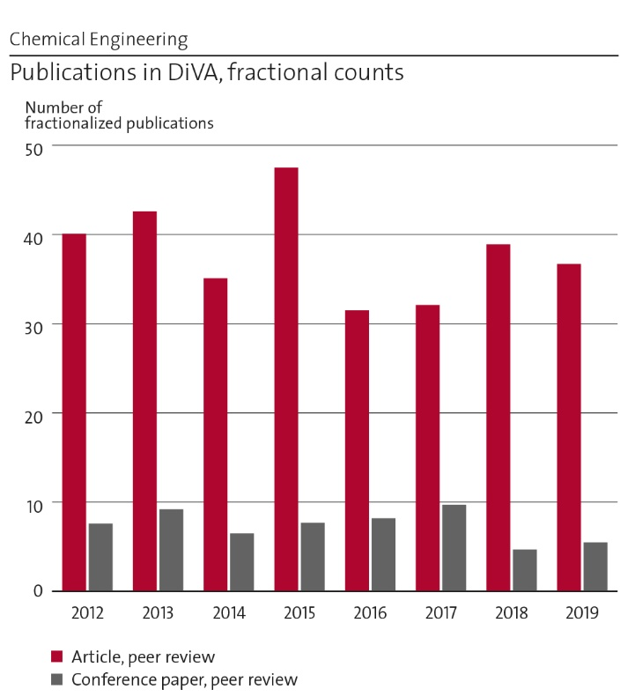
Figure 7: Number of fractionalized publications 2012-2019.
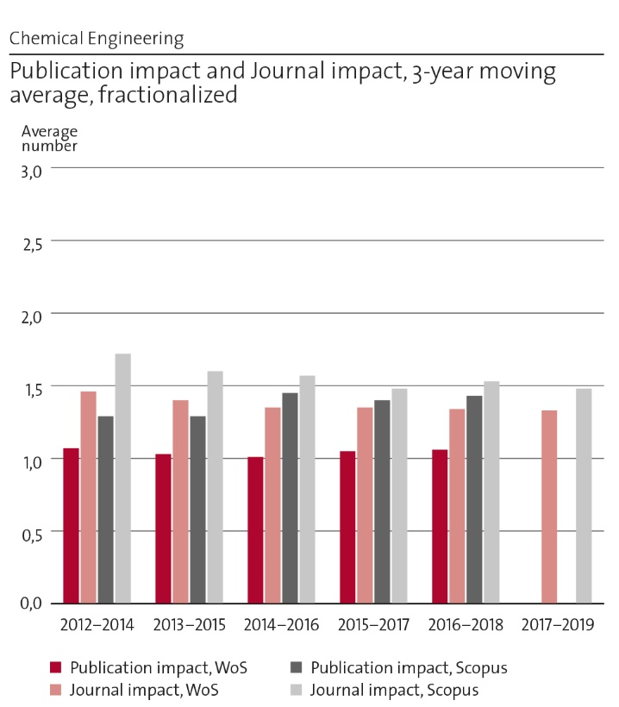
Figure 8: Publication impact and journal impact.

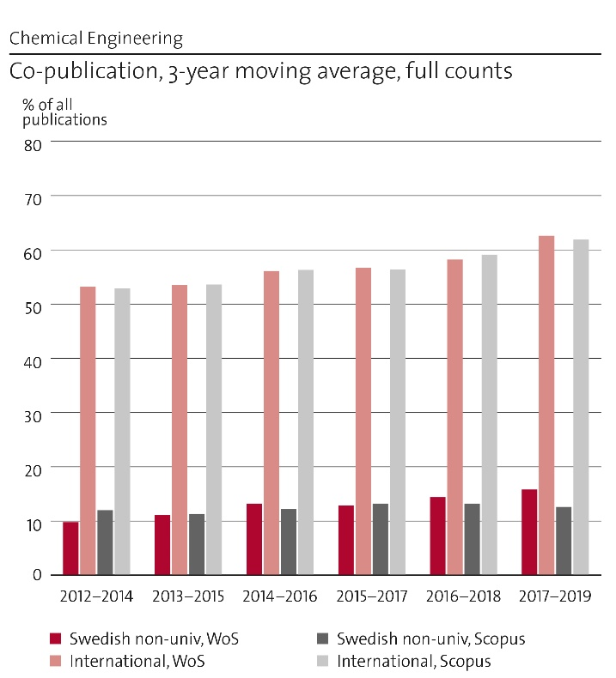
Figure 9: International and national co-publication.

Engagement in national and international research collaboration within academia and its outcomes
The department was the driving force behind the establishment of the Swedish Gasification Centre (SFC), which is organised in the form of a distributed research centre with three research nodes of equal size. The department conducts research regarding direct fluidised bed gasification, and gas cleaning and conditioning is carried out at the node SFC-Cleansyngas. KTH is the host in cooperation with Linnaeus University and Gothenburg University as academic partners. The research node includes a number of partners, e.g. E.ON, Stockholm Exergi, Cortus Energy, TENMAT, Bioenergigruppen, Växjö Energi, Phoenix Biopower, Centriair, Verdant Chemical Technologies, Hulteberg Chemistry & Engineering and RISE. The Centre is a boost for the gasification research at the department and leads the way for implementing biomass gasification technologies in Sweden.
The Swedish Electromobility Centre (SEC) is a national centre of excellence with an annual budget of 54 MSEK, co-funded by the Swedish industry, Universities and the Swedish Energy Agency. The department has a leading coordinating role in the area of energy storage including batteries and fuel cells within the centre. SEC is not only important for funding but the nationally leading research arena for collaboration between academia, industry and the society in the field of electromobility. (http://emobilitycentre.se)
The department is one of the founding partners together with UU and Chalmers in BASE (Battery Sweden), a recently started national centre of excellence on the next generation of batteries. The centre is funded by Vinnova, industry and the academic partners.
We are active partners in StandUp for Energy, a collaboration initiative between Uppsala University, KTH Royal Institute of Technology, The Swedish University of Agricultural Sciences (SLU) and Luleå University of Technology, that arose as a result of the Government's commitment to high quality energy research in areas of strategic importance to society and the business sector. (www.standupforenergy.se)
The department is a partner and one of the founding organisations of the “Swedish Knowledge Centre for Renewable Fuels”, f3 centre, a nationwide centre for system-oriented research about renewable energy carriers for transportation. Through joint efforts by the partners and a collaboration with the Swedish Energy Agency, the f3 centre has performed and will continue to perform syntheses of current research as well as supplementing research about transportation fuels, processes, plant designs, raw materials, distribution infrastructures, environmental impacts, and policy instruments. The f3 centre is composed of partners from industry, research institutes, and universities. The aim is to provide a base for private and political decision-making concerning the production, distribution, and use of renewable fuels. (www.f3centre.se)
The department is active in SwedNess, a graduate school providing research training in neutron scattering and operated by six Swedish universities, with the aim to strengthen Sweden's long-term competence and competitiveness within the area. The school is fully funded by The Swedish Foundation for Strategic Research (SSF). (www.swedness.se)
KTH and the department is also a member of the European constellation Hydrogen Europe Research, associated to the innovation programme Fuel Cells and Hydrogen Joint Undertaking (FCH JU).
We have been active in the Wallenberg Wood Science Center (WWSC), a research centre focussed on new materials from trees. Li-ion battery components, as electrodes and separators, were built from nanocellulose composite materials.
The department coordinates the SSF Agenda 2030 research centre PUSH (Production, use and storage of hydrogen – for sustainable energy systems). The main goal of the centre is to address scientific and technical hurdles impeding production of hydrogen by water electrolysis, the storage using liquid organic hydrogen carriers and the widespread use in fuel cells. The centre is a collaboration between four universities and a research institute.

Follow up from previous evaluations
The outcome of the evaluation of the department in the RAE2012 was very positive, and the development that had taken place since the previous evaluation was complimented. The department has continued the development much in the same direction, looked at how to further strengthen the research. A recommendation in RAE2012 was to strengthen our basic research. Now looking in hindsight, it can be seen that important measures in this direction have been taken. Many of the larger ongoing projects have been initiated together with researchers at e.g. the Department of Chemistry at KTH, as well as with Uppsala University, Stockholm University, Lund University and Chalmers, and involve close collaborations. This has also resulted in exciting results and many co-publications, and we anticipate that this will have a long-term positive impact on our research and bibliometric indicators. Looking at the recruitment of new faculty, this has also contributed to the opening of new research directions and strengthening of the connection to basic research.

Viability

Funding; internal and external
A majority of the research funding at the department comes from external sources (Figure 10), indicating that the researchers in the department are active in applying for research funding, that they are attractive as research partners and that quality of research is high. By far, the largest part of the external funding comes from the Swedish Energy Agency. This clearly reflects in what subject area most of the department's research is found. Other important external sources for research funding are the Swedish Foundation for Strategic Research (SSF), Swedish Nuclear Fuel and Waste Management (SKB), the Swedish Research Council (VR), EU and Formas. The contribution from SKB has previously constituted a significant part, but is now about to disappear completely, which can be of decisive importance for one of the researcher’s continued activities. Although fundamental research is carried out at the department, funding from VR is relatively small, probably related to the fact that our research is often considered to be too applied and that larger resources can be provided by other financiers. The amount of EU funding has varied over the period, but its proportion has decreased in the last years and efforts should be made to increase this again. The recruitment of international, new faculty, postdocs and PhD students enable us access to new contacts that we should better utilise for new research collaborations.
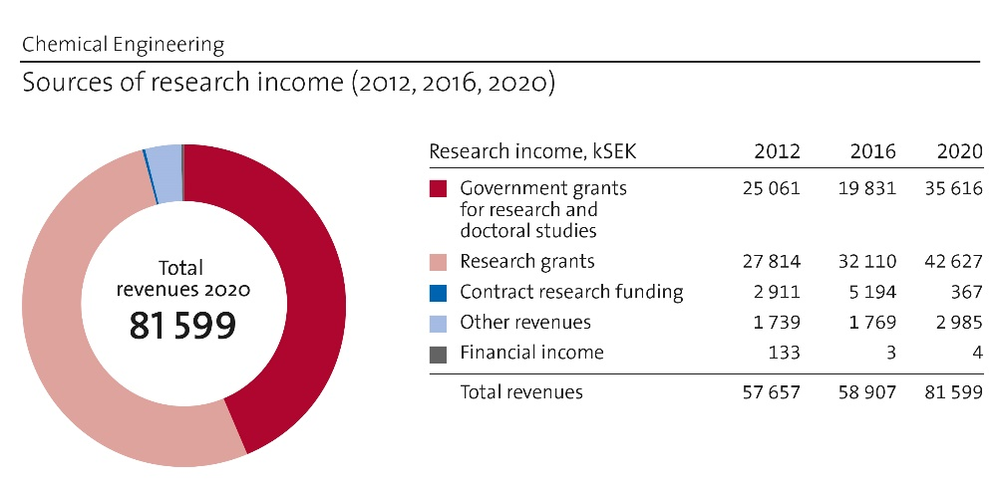
Figure 10: Comparison of research income in 2012, 2016 and 2020
That the co-workers of the department are good at attracting research funding, is of course good. However, having the major part of the research funded by external bodies makes the department vulnerable to being successful in research applications, to research-political decisions and to the economic situation in general; factors that may all vary over time. The high proportion of external funding also limits freedom in research, i.e., we need to follow applications and research trends that are set by others. As shown in Figure 10, the internal faculty funding has during the period 2012-2019, varied in the interval 34-43 %, numbers that we find far too low. A higher share of internal faculty funding is really needed. It will make the department more independent and facilitates research in novel interesting subject areas, that are not yet on the research-political agenda. Internal funding is also needed to cover high costs for overhead and premises, that are not always covered by the external funders.
Our research is done in subject areas very relevant for a sustainable society, meaning that these are only foreseen to increase in the future. More faculty and co-workers will be needed, both in the research and supervision of PhD students, but also for teaching in courses that address these important topics. Thus, to balance the expected growth of external funding, increased internal funding will be crucial.

Academic culture
When we have visitors giving lectures (e.g. faculty opponents) all co-workers are invited. At division level there are different arrangements, including regular planning meetings for the faculty. Some divisions have weekly short seminars, to keep the co-workers updated on the activities and to have a chance to discuss problems that arise, others have similar seminars more seldom. There are also subject-specific constellations that meet on regular basis.
To encourage all co-workers to meet for discussions and nice interaction, we have held the weekly “department fika” for many years. We are located at three floors in our building and the different floors of the house take turns to organise this.
The master programme “Chemical engineering for energy and environment” that is connected to the department is very popular and a large number of the courses given are closely coupled to the research we do. For a long time, we have been working with most of these courses in “Teacher teams”. This way of working gives us a strength that we want to continue to build on, as it has proven to make us less vulnerable, for example in the case of a colleague's longer sick leave. The fact that we know each other opens up for collaborations across divisional boundaries.

Current faculty situation
Today, the department has seven professors (3 female), six associate professors (2 female) and three assistant professors, see Figure 11. Together they supervise a total of about 40 doctoral students in their postgraduate education.
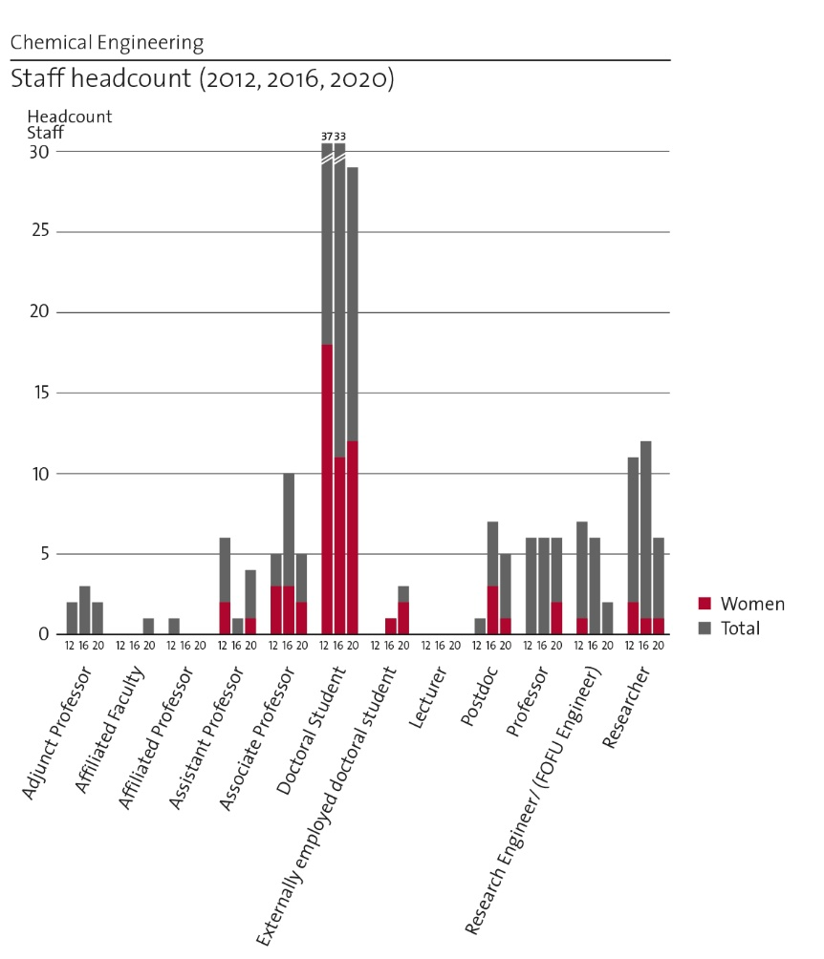
Figure 11: Comparison of staff development in 2012, 2016 and 2020.
As is shown in Figure 11, the gender balance in the faculty could be improved. Today, we have only male assistant professors, while the group of associate professors is fully balanced. All professors except one, are more than 57 years old and several retirements (men) are expected within the next few years. Therefore, the need for new faculty recruitments is both large and indispensable. In order to achieve a more even age distribution, assistant professors should be appointed in the first place.

Recruitment strategies
The School of Engineering Sciences in Chemistry, Biotechnology and Health (CBH) offers career support for assistant professors and young researchers. The vice dean at the school is responsible for the school-organised support. The career support for tenure track assistant professors is mainly to provide equal opportunities for promotion to associate professor within the stipulated time. The department also nominates senior staff for suitable centrally coordinated career programs such as PIL (Partners in learning) and MAL (“Morgondagens akademiska ledarskap”, Future academic leadership).
When regarding faculty and researchers, our aim is that all new recruitments are for teaching positions within the tenure track. The absolute majority of new faculty members at KTH is recruited as assistant professors with the option of being promoted to associate professors after 4-6 years of employment. Taking the age distribution at our department into account, assistant professors should be appointed in the first place. In order not to lose knowledge and continuity in important research areas in connection with the retirement of the faculty, our strategy is to start new recruitments in good time.
Postdoctoral fellows are important additions to the department's activities. They contribute to the development of our research and knowledge and provide tangible help to doctoral students. When funding allows, our ambition is to have a number of postdoctoral fellows at the department.
Research work at the department is found in very relevant areas, whose significance is likely to increase in the future. Besides, our newer teachers have not yet fully built up their activities, which means that the number of doctoral students at the department will gradually increase. The department uses the recruitment process to strengthen and develop strategically important research areas concerning research and supervision of PhD students, as well as getting competence and capacity for the chemical engineering courses given in different programmes at KTH. We try to hire more women, but we still see a clear over representation of male applicants for all type of positions.

Infrastructure and facilities
The entire department is gathered in one building, which is advantageous from several points of view. The department is well equipped with up-to-date standard instruments, including pressurised laboratory reactors, mass spectrometers for on-line gas analysis, various types of electrochemical equipment, glove boxes, etc. In addition, the department has the only pilot-scale equipment for high pressure fluidised bed (FB) gasification research in the world with the ability to operate at pressures up to 50 bar. This equipment is located in another part of KTH. Being part of KTH also gives good access to other advanced instrumentation.
Thanks to a number of collaborations both locally, nationally and internationally, the department has access to advanced research facilities, e. g. synchrotron facilities in Hamburg, Berlin, Singapore, Lund, Karlsruhe and at PSI. In these facilities we are performing various in-situ studies, such as X-ray absorption spectroscopy, XANES and EXAFS.
In order to strengthen the experimental activities on longer terms, it would be advantageous to build our own arsenal of advanced characterisation instruments, as well as to further develop our school’s system for joint instrumentation, e.g., 2MILab. This includes equipment for Temporal Analysis of Products (TAP), tomography for studies of porous materials and XPS for surface analyses.

Strategies and organisation

Goals for development 5–10 years ahead
Vision:
- Research and education at the Department of Chemical Engineering link science and society by addressing the grand challenges of today and tomorrow, with special emphasis on energy and the environment. We educate students of high international standards, attractive on an international labour market. Innovation is an integrated part of all activities.
In ten years from now:
- The Department of Chemical Engineering will be a leader in Sweden on research and education regarding the use of chemical processes for decarbonisation of the society, including electromobility, circular processes and the decarbonisation of the industry. We are a very attractive partner for collaboration on the national as well as international arena.
Means to reach these goals:
- Continued recruitment of well-balanced faculty concerning gender, background and competencies.
- Strengthen basic funding of the faculty, which will enable more independent and long-term research initiatives.
- Consolidation of divisions and strengthening of collaborations within the department and with other leading academic groups and societal actors.

Congruence with university-level goals for “A leading KTH” as set out in KTH´s “Development Plan 2018-23” (page 5)
Important key words in the development plan for KTH 2018-23 are that we should all be ”striving towards the leading, integrated, visible, open, increasingly digitalised, more sustainable, more international and more equal KTH”. This is well in line with how we work with the development of our research at the department, also described in this report. We also work in accordance with the action plan for CBH school, in which increased collaboration between departments, with international partners and with industry are some of the goals.

Leadership structure and collegial structure
The department consists of four divisions and one smaller group. Head of department is Prof Carina Lagergren (represents the department in the CBH management group) and vice-head of department is Prof Klas Engvall. These two, together with the heads of the four divisions and a representative from the PhD council, form the department management group that meets on a monthly basis. At these meetings, information from the CBH school management group is transferred to the department, but more importantly, all possible issues related to the department’s teaching, research, staff, economy, etc., are discussed. Similar meetings are also taking place on a regular basis on division level.
There are also larger meetings where the entire faculty gathers to discuss the strategy for the department's research or the education we conduct.

Strategies for high quality
The major part of the research undertaken at the department is done by the doctoral students. To get a high quality of our research, everything from the application for funding, via the initial recruitment process of the student and high-quality supervision, to the publication of scientific articles and thesis are of great importance. According to the regulations, all doctoral students must have more than one supervisor. Several of the doctoral projects are supervised by a group of people who all actively participate in the supervision. It is not uncommon for the doctoral projects to be closely linked to industrial interests. In these cases, there is usually an industry reference group connected to the project, which participates in our larger project meetings and provides valuable feedback on our research. A close industrial contact does not guarantee high scientific quality, but ensures that the research questions we address are relevant to the industry and society. The adjunct professors and affiliated researchers that are associated with the department also play an important role, see Figure 11.
The faculty and researchers at the department are good in attracting research funding. However, a closer collaboration between older and younger faculty would probably result in an even better quality of applications and an even higher success rate.
In order to ensure continuous quality in our research activities, it is important not to spread our work in too many areas. A group of faculty members has therefore started to work on a roadmap for the subject areas that will in future be in focus for the department's research.
The results of our research are published in, for our subjects, relevant scientific journals and in the licentiate and doctoral theses. Over the past three-year period, around 30 % of the articles were published open access (OA). So far, the cost for OA publishing has often been perceived as too high, while the quality of many OA journals has been low. However, an increasing demand will lead to more opportunities to publish open access in good journals at a reasonable cost. The Dean of CBH now financially supports OA publishing and as many as possible of the publications from the department will in the future be published with open access.

Interaction between research and teaching at all three levels (BSc, MSc, PhD) of education
The interaction between our research and teaching is strong. In our master programme “Chemical engineering for energy and environment”, a large number of the courses given are closely coupled to the research we do. Examples are Electrochemical Energy Devices, Renewable Fuel Production Processes, Environmental Catalysis, and Resource Recovery from Waste. Lectures from our researchers are also asked for in courses in other programmes at KTH. When regarding teaching at PhD level, this is even tighter connected to the research. The courses on this level are often adapted to the participating doctoral students research, or tailored-made for a specific larger doctoral research project involving several students.
Most of our research is defined and performed in close cooperation with industry and society. This results in industrial and societal relevance, which is utilized at all levels in both undergraduate and postgraduate research and education. At BSc level the students in their diploma work face competitive research assignments of industrial relevance. This could for example be to construct an energy system for an autonomous underwater vessel, or to evaluate hybrid systems for heavy-duty trucks, or to perform a proof-of-concept study of Solid Phase Micro Extraction (SPME) as a promising method for sampling of tar from biomass gasification at low concentrations. When the students perform their MSc diploma work, it is often in an industrial laboratory. Due to the versatility and multi-disciplinarity of the undergraduate education at KTH our students often are used in areas which would not be labelled as traditional chemical engineering, e.g. in the automotive industry and in the energy sector. Many of the diploma works have later become research projects of high industrial and societal relevance.

Impact and engagement in society

Relevance of research to society at large
The relevance and usefulness of the research at the Department of Chemical Engineering is manifested in different ways. The department takes an active part in KTHs work with strategic partners. Göran Lindbergh is partner director for the strategic partnership with the leading Swedish utility company Vattenfall and Lars J. Pettersson is partner director for the strategic partnership with the Swedish Environmental Institute, IVL. Dr Magnus Berg from Vattenfall has now commenced his second period as an adjunct professor at the department, while Dr Pontus Svens, Scania, is adjunct faculty.
The case studies (further below) give some very relevant examples where our research already have made difference. Two examples of ongoing research that could make large differences in the future are given here:
Chlorate is produced by electrolysis of a salt solution, in which chromate constitutes an important excipient component. Chromate is a “chemical of high concern” and its use in Europe has a time limited authorisation until 2029. Today, there are no commercial alternatives to chromate and proposals for alternative process solutions have 25-50 % higher energy consumption. During the last four years we have worked intensively on chromate-free alternatives together with Nouryon, the world’s largest producer of chlorate with >1 million tonnes NaClO3/year, and their academic partners. Our results led to a patent application and five papers, and are being developed by Nouryon aiming for full scale implementation. A viable solution to a chromate-free process would probably have an impact on legislation and authorisation regarding industrial chlorate production.
Steel is a cornerstone as a construction material in modern society but its production from virgin iron ore is also a major contributor to net global emissions of carbon dioxide. The primary reason for this is the blast furnace where iron ore is reduced with carbon from fossil sources. The HYBRIT initiative has been founded to address this issue. HYBRIT – short for HYdrogen BReakthrough Ironmaking Technology – is a joint venture between SSAB, LKAB and Vattenfall, funded in part by the Swedish Energy Agency, and aims to reduce CO2 emissions and de-carbonize the steel industry by utilising hydrogen for the reduction of iron ore in a process called direct reduction (DR). The goal of the HYBRIT project is to have a full-scale operation of DR with hydrogen by 2035 and if successful, this may induce a major shift in the iron and steel industry worldwide. The department is part of the HYBRIT project through projects linked to the storage of hydrogen and the design of the electrolysers that will be used to produce the hydrogen. In addition to the pure research-oriented results from the projects, the storage part has also resulted in a patent application for a system that uses methanol as a hydrogen carrier during storage.

Research dissemination beyond academia
Several of the faculty members at the department are, on a more or less regular basis, active when it comes to communicate the research to the general public. Some examples follow below.
During President Obama's visit at KTH 2013-09-04, the fuel cell research and development at Applied Electrochemistry (Lindbergh, Lagergren and Lindström) were exposed for a broad audience. The visit resulted in much interest from media, national and international politicians, public agencies and private companies. The group have had several visits by other prominent people, including Carl XVI Gustav and the Chinese Minister of Energy. The researchers have also been interviewed in newspapers, radio and television programs. Presentations of fuel cells, batteries and electromobility have been given on regular basis to young people in visiting gymnasium classes or events such as "Forskarfredag".
On 17-18 October 2017, KTH was celebrating its 100 years old campus, by arranging a 50 hours long series of presentations that could be followed on-line over the whole world. In the event three persons from our department contributed with lectures: Prof. Carina Lagergren, Prof. Göran Lindbergh and Assoc. Prof. Kerstin Forsberg.
An open KTH-IVL joint seminar entitled “New Engineering Solutions for a Climate-Smart Society” was organised at KTH, on 12 April, 2018. From our department, Assoc. Prof. Kerstin Forsberg (Chemical Engineering for Resource Recovery) and Prof. Rakel Wreland Lindström (Batteries and Fuel Cells for Future Transportation) were speaking.
Prof. Klas Engvall participated in two debate replies in Sweden's largest daily newspaper, Dagens Nyheter, on 13/12, 2018 (”Allt för generaliserande slutsatser om biodrivmedel” (Too generalized conclusions about biofuels)) and on 18/12 2019 (”Förgasning av skogsrester har större potential än rötgas” (Gasification of forest residues has a larger potential than digester gas))
Associate Prof. Kerstin Forsberg participates in two European projects focused on wider society learning funded by EIT Raw Materials (RAISE and RM@Schools 3.0) to educate pupils (< 18 years old) about resource recovery and the circular economy.

Sustainability and the United Nations’ Sustainable Development Goals (SDG)
Almost all the research (80-100 %) at the department falls within the categories of energy and environment, which are both closely connected to sustainability. Many of the faculty members of the department are also active on a high level in the research centres, that are listed in section 2.e. Common to almost all of these centres is that sustainability is in one way or another in focus for the work.
In the period 2012 to 2019, our published articles were related to all but two (SDG 5 and 10) of the 16 SDGs included in the bibliometric analysis. A large majority of these publications are related to SDG 7 (341 articles), followed by SDG 13 (117) and SDG 12 (56).
5 years ago, a new research direction with focus on resource recovery from primary and secondary raw materials started at the department. A new division was formed, by moving staff within the department and employing a new assistant professor, specialised in biotechnical process engineering. A new assistant professor is currently being recruited to that division.

Structure for increased impact
Our most important task for impact on society is to graduate master students and doctoral students that become attractive in the labour market. To do this, we will continue our collaboration with various universities and industries, by inviting to joint research applications, connecting people to us in the form of adjunct and/or affiliated faculty, formulating master theses work in collaboration with industry, keeping contact with our graduate engineers and PhDs, etc.
One obvious way for direct impact is to have industrial PhD students. This is nothing new to us, but we would like to increase the number of these students. When a new research project is being initialised with industry, we discuss the option of including an industrial PhD student. However, the initiative for such arrangements most often comes from the industry, not from us.
Increased participation in courses that support lifelong learning is another strategy to reach out with our knowledge and research to industry and society.

Department of Fibre and Polymer Technology
Self-evaluation
Head of Department: Professor Mats Johansson

Included divisions:

Division of Biocomposites, with Head of Division: Prof. Lars Berglund
Division of Coating Technology, with Head of Division: Prof. Eva Malmström
Division of Fibre Processes, with Head of Division: Prof. Daniel Söderberg
Division of Fibre Technology, with Head of Division: Prof. Lars Wågberg
Division of Polymeric Materials, with Head of Division: Prof. Mikael Hedenqvist
Division of Polymer Technology, with Head of Division: Prof. Minna Hakkarainen
Division of Wood Chemistry and Pulp Technology, with Head of Division: Prof. Monica Ek

Department of Fibre and Polymer Technology

Overall analysis and conclusion; strengths and development areas

Limited SWOT-analysis
 | Strengths | Weaknesses
Research | - FPT has a strong scientific culture with broad coverage of macromolecular science, including both natural and synthetic polymers. Both fundamental and applied science, both experimental and modelling research is covered.  - FPT has a critical mass to perform advanced interdisciplinary research.  - Large instrument park available for the entire department.  - Broad national and international network in academia and industry including strategic.  - Active collaborations with large infrastructures (e.g. DESY, MaxIV).  - Success in publication, both in citations and publication in highly ranked journals and conferences. (see bibliometry).  - Strong long-term external funding record.  - Very strong in fundamental research, which allows us to address applications of choice.  - Excellence of faculty: A large number of advanced research grants, nationally and internationally, has been obtained by the faculty at FPT. These include grants from EU (FET, H2020), KAW, ERC, VR, Formas, SSF, MISTRA and Vinnova. | - Difficult to support in-depth narrow research fields.  - Strong long-term external funding record. Lack of full coverage of OH on external grants erodes the faculty funding.  - The base funding for faculty members and researchers is perceived as weak. It is a constant stress for the faculty that everyone has to spend so much energy and time on how to raise a part of your salary in parallel to raising funds for PhD-students/post-doc and researchers. This takes focus from research.  - External funding in many cases limits the possibility to perform “high risk” projects.  - Expensive operational costs to maintain the unique infrastructure, difficult to acquire investment funds for upgrading
Organisation | - Flat organization, shared responsibilities; collegiality, transparency, positive spirit.  - Combines different edge-competences to broad overall competence within the field.  - A common view on research excellence culture (values) being the base of academia.  - High quality researchers as proven by prestigious career awards (ERC, Wallenberg fellows, KAW, VR etc).  - Good gender balance.  - Good balance between fundamental and applied research. | - The most important weaknesses can be attributed to external factors on a KTH and CBH level rather than internal factors at the department.  - Too lengthy faculty recruitment procedures, in which good candidates disappear.  - Non-existent administrative support on department and divisional level.  - Very weak support (non-existing?) with managerial duties encompassed with large research centres. As a consequence, faculty members have to spend too much time on administration. A devastating consequence is that faculty is discouraged to apply.  - Too slow processes to adapt facilities (laboratory renovation/adaptation) to new challenges and possibilities.  - Administration on CBH and KTH level is costly, specifically in comparison with other academic institutes in Sweden. This results in a high OH (~50%).  - Weakened faculty influence during the last years which again moves the focus on wrong tasks. Weak collegiality at KTH level.  - An administrative organization that has too much focus in not doing anything wrong, which creates extensive processes. This seriously limits the time and focus on core activities, research and education. It is well established in research on organization theory that this route of “New public management” is a disaster for most authorities and especially for academic institutions. One example is that the guide-lines for this RAE only focus on “local” department weaknesses rather than admitting the real problems outside the control of the department e.g. low base funding and high cost for premises.  - Leadership positions (Division head, Department head, etc) are not awarded and come at the cost of academic career, which has a number of negative consequences (leadership positions are often avoided; excellent researchers must choose between scientific career and leadership position instead of combining them).

Summary statement on contributions of department on impact, infrastructure and sustainable development
FPT possesses the environment, facilities (infrastructure) and competences (faculty), to perform excellent research on macromolecular materials. This includes research on all physical length scales ranging from atomistic-, nano-, micro-, and macroscale. It also covers areas ranging from chemical-, physical-, mechanical-, and modelling aspects of the field. These core competences, infrastructure, and facilities make FPT a suitable partner in application areas ranging from life science to the field of energy, with the overall goal of developing solutions for sustainable society (in a wide context). FPT has strategic alliances within KTH as well as with large Swedish and European facilities such as DESY, MaxIV, and ESS to enable excellent research. The impact of FPT can also be seen on the large number of educated PhD´s that after examination obtain good and relevant jobs both in industry and academia. The UN global sustainability goals describe WHAT has to be done and the role for FPT is to play a central role in solutions to HOW this can be done and to find enabling materials and technologies.

Research profile

General information of the department
The department of Fibre and Polymer Technology (FPT) is the largest academic institution on native and synthetic polymers in Sweden. The department comprises seven divisions; Polymer Technology, Polymer Materials, Coating Technology, Fibre Processes, Fibre Technology, Biocomposites, and Wood Chemistry and Pulp Technology. The department also hosts the Wallenberg Wood Science Center funded by KAW. The permanent staff (faculty and permanent researchers) amounts to 29 persons. The total number of employees including PhD students, post-docs, and temporary researchers amounts to ~150 persons. The research organization at FPT differs from most other research active universities and institutes in that both, polymer chemists, polymer material scientists, and researchers in the field of pulp and paper technology are located within one department. The unique niche of FPT is thus the combination of chemistry, physics and mechanics of synthetic and native polymers (mainly wood based) including fundamental science and applied research.
- Biocomposites
Nanostructured polymer composites are the focus area, where at least one of the components is of biological origin. Characterization of nanostructure, experimental mechanics and molecular dynamics simulation are important areas of competence. Bionanocomposites of the future occupy a previously empty space in material property charts, where mechanical performance and new functionalities are of particular interest. A specific topic relates to transparent wood, which has been expanded into wood nanoscience and nanotechnology. This represents a top-down approach to cellulosic nanomaterials with multiple functionalities.
Permanent staff: Prof Lars Berglund, Assist Prof Yuanyuan Li, Researcher Jakob Wohlert, Researcher Ramiro Rojas
- Polymer Technology
Design of stable and degradable polymers considering the principals of green chemistry and the whole life-cycle from raw materials to end-of-life management. Functionality and interactions of the materials in targeted applications and controlled long-term performance or programmed degradation. Design of materials for biomedical (e.g. 3D printed tissue engineering scaffolds) and environmental (e.g. membranes and adsorbents) applications, plastics, elastomers, and thermosets from bio-based resources.
Permanent staff: Prof Minna Hakkarainen, Prof Ulrica Edlund, Prof Anna Finne Wistrand, Assoc Prof Karin Odelius, Researcher Tiziana Fuoco
- Fibre Technology
The work at the Division of Fibre Technology is focused on molecular tailoring of cellulose fibres and fibrils and a fundamental characterization and understanding of the colloidal and chemical behaviour of cellulose nanofibrils. Several different modification techniques are being used with the main focus on physical methodologies which can be used in aqueous media at neutral pH and room temperature. In our work we have the outspoken strategy to link the modification on a molecular scale to the macroscopic properties of final materials and to create mutual benefits through co-operation projects with other groups at KTH as well as with world-leading experts outside of KTH.
Permanent staff: Prof Lars Wågberg, Assoc Prof Torbjörn Pettersson, Assoc Prof Mahjar Hamedi, Researcher Per Larsson
- Polymeric Materials
The Division with four senior scientists has the motto to establish relationships between structure and properties. Fundamental research, involving theory, simulation, modeling and advanced experiments and more applied programs are pursued. Current research trends are new materials based on renewable resources, polymer modeling, processing, nanostructured polymeric systems, insulating polymeric materials and long-term performance of polymeric materials.
Permanent staff: Prof Mikael Hedenqvist, Assoc Prof Richard Olsson, Assist Prof Anna Hanner, Researcher Fritjof Nilsson
- Coating Technology
The interplay between macromolecular architecture and macroscopic properties applied to thin polymer films is the main interest of the Division with five staff members. The research is synthesis-oriented with expertise in monomer synthesis, polymerizations, macromolecules with complex architecture as well as enzymology and biocatalysis. Current developments focus on renewable materials. Targeted application areas range from medical applications to engineered surfaces, adhesives and coatings.
Permanent staff: Prof Eva Malmström, Prof Mats Johansson, Prof Michael Malkoch, Assoc Prof Per-Olof Syrén, Researcher Linda Fogelström
- Wood Chemistry and Pulp Technology
Pulp technology deals with the steps involved in processing wood to pulp fibers, mainly used as raw material for paper, board and textile production. Wood Chemistry investigates the chemistry involved in the processes as well as the morphology, chemistry and biology of wood and its products. On-going work deals with the modification of the pulping processes and new ways of isolating, functionalizing and using wood polymers in materials and energy applications.
Permanents staff: Prof Monica Ek, Prof Gunnar Henriksson, Prof Mikael Lindström, Prof Martin Lawoko, Researcher Olena Sevastyanova
- Fibre Processes
Recently the department has been expanded with the new Division Fibre Processes, with the aim of strengthening research and education on processes for material fabrication from wood fibres forest resources. The research topics ranges from developments of the industrial processes for paper and packaging manufacturing, to new processes and industrial fabrication processes of novel materials based on wood-pulp fibres and nanocellulose. A central part in these developments is the use of characterization techniques based on synchrotron radiation and neutron scattering.
Permanents staff: Prof Daniel Söderberg, Researcher Anastasia Riazanova, Researcher Tomas Rosén
- Wallenberg Wood Science Centre, WWSC
Wallenberg Wood Science Center (WWSC) is a joint research center at KTH, Chalmers, and LiTU which aims to build a research program on new materials from trees. The center is funded by KAW as one of KAW´s larger efforts on research in Sweden. The program is highly multidisciplinary, and is developing technology platforms as part of the strategy. WWSC was established in 2009 with funding for a 10-year period. In 2019 was the center renewed (WWSC 2.0) for an additional period of 4+6 years with a total funding of 700 MSEK.
Permanent staff: Prof Eva Malmström

Central research questions and themes, knowledge gaps addressed, main research activities
The vision of the department is to provide the society with “Sustainable Macromolecular Materials – from Molecules to Macroscopic Assemblies and Devices”
The combination of the traditionally separate fields of natural and synthetic polymers is unique and allows FPT to address several important issues such as future demands on a sustainable material use in society. The research ranges from monomer and polymer syntheses and characterization to modelling/simulation, processing, long-term properties and material performance, degradation and functionalities. Wood derived components and biopolymers dominate, although materials and monomers derived from crops and other biomass waste are becoming increasingly important.
A series of strategic areas for current and future research have been identified. These include; Materials for life science applications, Materials for the energy sector (storage, distribution), Materials from renewable resources (all applications), Composite materials, Multifunctional materials, Materials for complex systems (devices), and Nanostructured materials.
The strong core competences within the department as described above makes the department an ideal research partner in research programs within the listed strategic areas. The department continuously strives to have a gender balance within the faculty and this has to a reasonable amount been achieved.
- Materials from renewable resources
The Swedish paper and pulp industry are at a turning point in business development. As one of the largest net export industries in Sweden it will continue to play an important role. The focus of new developments will however change from traditional uses to novel applications. The traditional Kraft pulp mill is optimized for making fibers for paper and board. A change is already taking place in adopting/modifying this and other processes to obtain other components from wood. The pulp mill is transforming to become a bio-refinery. The product stream from the bio-refinery will open up numerous opportunities to make new materials based on a renewable resource. The possibility to retrieve new raw materials from wood also demands significant research efforts on how these sources can be used and how they function in different applications. The research thus ranges from chemical processing technology to fundamental understanding of specific components.
An example of this is the production of nanocellulose where efforts are needed to improve the production process as a better understanding on how these fibrils can be modified (chemically or physically) for specific end-uses.
Renewable feed-stock based on agricultural products is also a target area for FPT. Large volumes of potentially useful monomers/polymers are available from different crops and their use has a significant potential. This could for example be wheat gluten, which currently is a co-product from bioethanol production, or vegetable oils from different oil crops.
The development in the forest and agricultural area towards a biorefinery concept also coincides with a strong demand for biobased monomers from the traditional polymer industry. This can include both monomers for drop-in bioplastics (with same or similar properties than the petroleum-based counterparts) and production of totally new types of plastics. A major challenge for many new biobased materials is durability during processing and in the intended application. The new biobased materials should also be designed for suitable end-of-life management route, such as material recycling or composting.
- Materials for medical applications
The need of new materials for medical applications increases parallel with the development of technologies and new medical treatments and is further catalyzed by the ageing population. FPT has a very strong history in designing new polymer structures and this is implemented into the field of medical technology. The applications range from targeted drug delivery using dendritic polymers to polymer scaffolds for implants and tissue engineering. Research programs in this area are ongoing and will continue in the future. The increasingly complex design of polymers to be used in biomedical application also demands strong interaction with researchers in the field of medicine. Strong collaborations exist for example between researchers at FPT and Karolinska Institute to support this.
The research on materials for medical applications in many cases also connects to other areas in the sense that relevant knowledge can be applied in both fields. One example is the research on renewable materials where studies on how to retrieve components from biomass include an improved understanding on how these components function in their original position in the plant. This knowledge is useful for studies on new materials for implants. Another example is research on anti-fouling coatings for ship hulls where minimal biological interaction with a surface is desired. These studies are relevant also for development of bioactive or bioinert surfaces in medical applications.
- Nano-structured materials
An evolving field within academic research relates to scaling factors where the nano-meter range has obtained a significant interest during the last decade. The concept of designing of structures on a nanometer scale has been demonstrated to have a significant impact on the materials performance. Several components such as inorganic nanoparticles, carbon tubes, graphene, and nano fibrillated cellulose (NFC) are now available as starting materials for making this possible to really implement this concept into new materials. FPT researchers are already active in this field and we foresee that this is an area which will grow. The combined competences at FPT allow for research to be conducted on all scales ranging from molecular design on nanostructures up to macroscopic assemblies of these components. A key structure in this area is NFC that now can be produced in large scale. It is in this area also an advantage for FPT that research competences both on synthesis, physical and chemical modification on molecular level, advanced characterization (chemical, physical, mechanical), modeling, and processing are available in-house.
- Materials for the energy sector
Energy distribution and storage are key areas in our future sustainable society. Distribution and storage of energy, will irrespectively of the energy source, be needed to obtain an efficient energy use. Improvements in both distribution and storage processes will need development of new macromolecular materials. This can range from electrical cable insulation materials to membranes for fuel cells or solid polymer electrolytes for batteries. Research is already in progress in this area and FPT foresees that this is an area that will increase in importance in the future. This area is a truly interdisciplinary area that will need collaborative efforts for success and we believe that FPT can be a strong partner in this. An advantage for FPT is here that complementary competences exist both at KTH but also in Swedish industry in the energy sector. Another area is the modelling of electric properties from ab-initio/DFT to FEM.
- Materials characterization
A key for success in the aforementioned research directions is a functioning of the instrumental infrastructure as well as competence to assess the results obtained. FPT has a well-functioning infrastructure concerning the characterization of macromolecular materials and we strive to continuously upgrade it to fulfil the demands from the research programs. This combined with expertise of the staff gives a strong platform for future research. The increased complexity in materials characterization will also mean that strategic collaboration with external partners will be needed in increasing degree. Examples of this are already implemented in collaboration within the School of Engineering Science in Chemistry, Biotechnology and Health as well as availability to specific instrumentation within project collaborations. The department has also established strategic alliances with large national and international research facilities. The faculty at FPT since 2016 includes adjunct Professor Stephan Roth on 20% who is heading one of the beam-lines at DESY in Hamburg, Germany. The department is also involved in the forest industry funded beam-line at MAXIV in Lund.
- Multifunctional materials and devices
The development in society towards more complex material systems where more and more functions are included in a device or composite material leads to a need for new materials that fulfil these demands. The concept of multifunctionality can be found in most of the aforementioned areas but is not restricted to these. Hence, it can be considered as an approach by itself.

Contributions to the advancement of the state of the art within the research fields of the department
The combination of advanced polymer synthesis with advanced characterization methods and novel applications enables sustainable material solutions. New materials are continuously developed for different application areas. The research at FPT strongly contributes to multiple fields. This can clearly be seen in the bibliometric evaluation where the data show a strong impact in an international comparison (cf 1.43, Share top 10% of 17.5 % on average between 2012-2017). A significant number of contributions to the advancement of the state of the art can be found at the department. They all relate to the vision of FPT on research on “Sustainable Macromolecular Materials – from Molecules to Macroscopic Assemblies and Devices”. One concrete example is the world leading research on nanocellulose that has been performed at FPT.

Quality and quantity of contributions to the body of scientific knowledge
The bibliometric analysis of FPT shows a very good performance both with respect to quality and quantity (Figure 12-13). A cf value of 1.43, and a share top 10% value of 17.5 % on average between 2012-2017 clearly shows that the researchers at FPT perform very well.
Selected publications
- Y. Li, Q. Fu, S. Yu, M. Yan and L. Berglund, Optically Transparent Wood from a Nanoporous Cellulosic Template: Combining Functional and Structural Performance, Biomacromolecules 17 (2016) 1358.
- A.-C. Albertsson and M. Hakkarainen, Designed to degrade-Suitably designed degradable polymers can play a role in reducing plastic waste, Science 358 (2017) 872.
- A. M. Pourrahimi, R. T. Olsson and M. S. Hedenqvist, The role of interfaces in polyethylene/metal-oxide nanocomposites for ultra-high-voltage insulating materials, Adv. Mater. 30 (2018) 1703624.
- G. Nyström, A. Marais, E. Karabulut, L. Wågberg, Y. Cui and M. M. Hamedi, Self-assembled three-dimensional and compressible interdigitated thin-film supercapacitors and batteries. Nat. Commun. 6 (2015) 7259.
- N. Ihrner, W. Johannisson, F. Sieland, D. Zenkert and M. Johansson, Structural Lithium Ion Battery Electrolytes via Reaction Induced Phase-Separation, J. Mater. Chem. A 5 (2017) 25652.
- M. Le Normand, R. Moriana and M. Ek, Isolation and characterization of cellulose nanocrystals from spruce bark in a biorefinery perspective, Carbohydr. Polym. 111 (2014) 979.
- T. Fuoco, P. Daniela, A. Finne-Wistrand, Redox-responsive disulphide cross-linked PLA-PEG nanoparticles, Macromolecules 50 (2017) 7052-7061.
- A. Boujemaoui, C. Cobo Sanchez, J. Engström, C. Bruce, L. Fogelström, A. Carlmark and E. Malmström, Polycaprolactone Nanocomposites Reinforced with Cellulose Nanocrystals Surface-Modified via Covalent Grafting or Physisorption: A Comparative Study, ACS Appl. Mater. Interfaces 9 (2017) 35305.
- K. Håkansson, A. Fall, F. Lundell, S. Yu, C. Krywka. S. V. Roth, G. G. Santoro, M. Kvick, L. Prahl Wittberg, L. Wågberg and D. Söderberg, Hydrodynamic alignment and assembly of nanofibrils resulting in strong cellulose filaments. Nat. Commun. 5 (2014) 4018.
- T. Paulraj, S. Wennmalm, D.C.F. Wieland, A.V. Riazanova, A. Dėdinaitė, T. Günther Pomorski, M. Cárdenas and A.J. Svagan, Primary cell wall inspired micro containers as a step towards a synthetic plant cell, Nat. Commun. 11 (2020) 958.

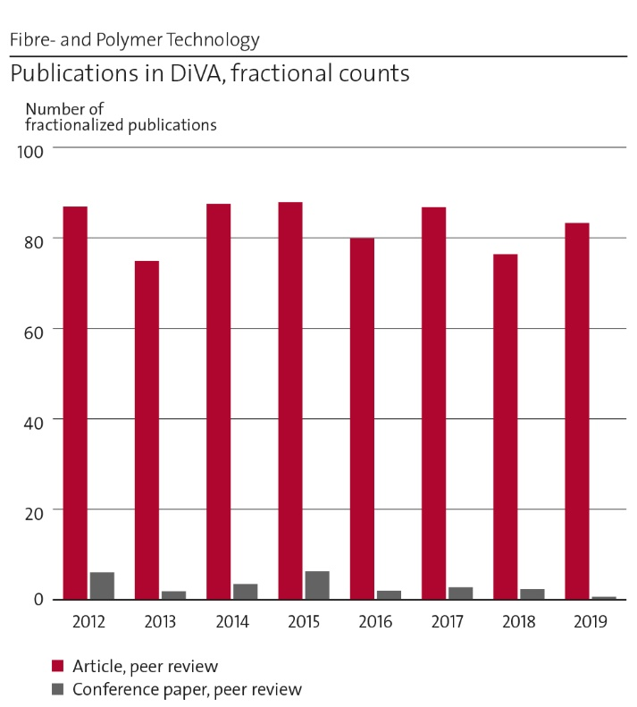
Figure 12: Number of fractionalized publications 2012-2019.
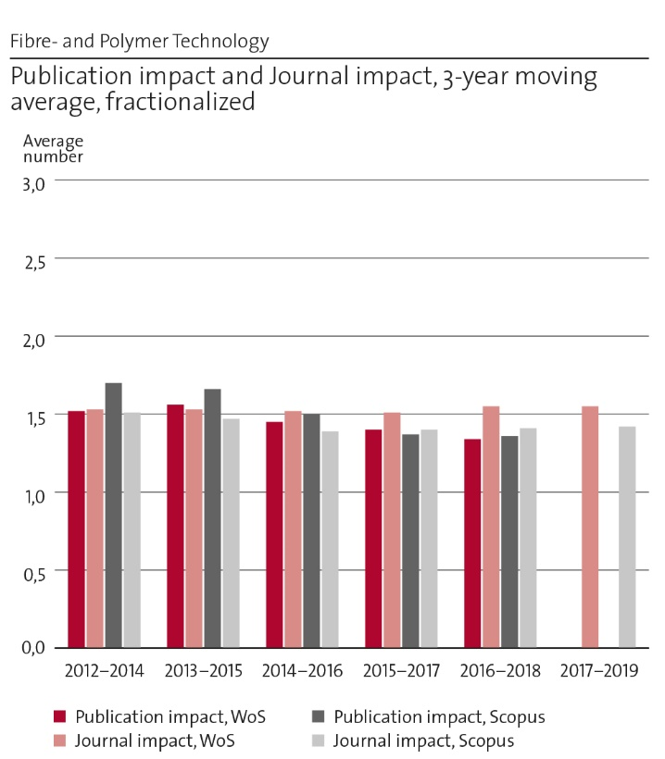
Figure 13: Publication impact and journal impact.
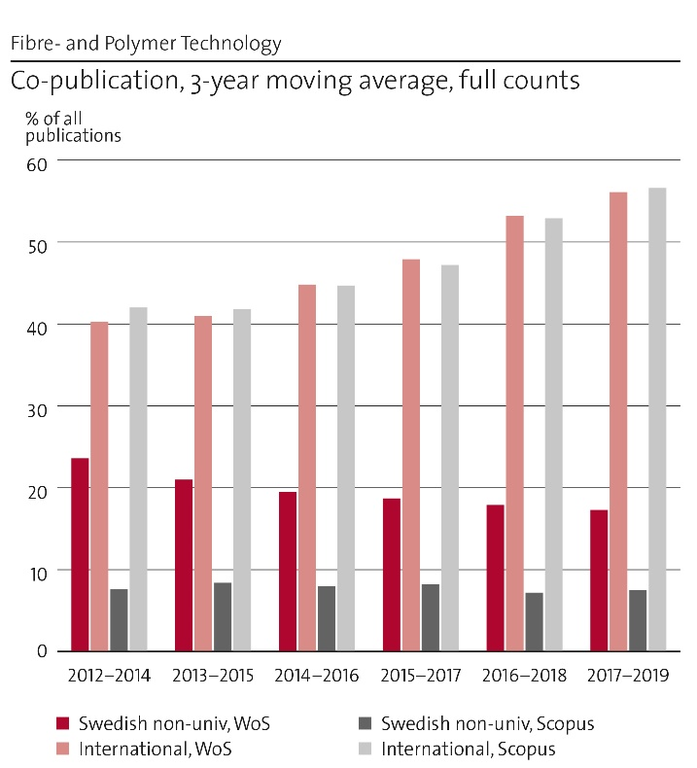
Figure 14: International and national co-publication.

Engagement in national and international research collaboration within academia and its outcomes
- Research collaboration
FPT is the largest national academic department active in the field of macromolecular materials, native and synthetic polymers. The research competences cover most areas within the field ranging from paper and pulp technology to polymer chemistry and fibre technology. This broad competence available at one place, in combination with well-equipped facilities, has made the department a very attractive partner in collaborative research projects both with industry and academia, nationally and internationally. The attractiveness of FPT-researchers can directly be seen in the increase in external funding as well as in the bibliometric data. A majority of the research projects involve collaboration with external partners either from industry and/or academia, Figure 14.
- Interdisciplinary research
One specific collaborative research program that is worth mentioning in this context is the Wallenberg Wood Science Centre (WWSC) established in 2009. WWSC was initially a joint research centre at KTH and Chalmers but it also involves researchers from other universities and research institutes in collaborative sub-projects. This centre is truly interdisciplinary in the sense that it presents an outreach from a traditional industrial area (wood-based materials) toward new uses, applications and concepts, i.e. other research fields. WWSC was in 2019 renewed into a second phase also including LiU as a core partner thus expanding the scope of the program to include more activities in devices and electronic application areas. FPT´s rapidly growing involvement in energy related research projects is another sign of true interdisciplinary work. FPT has identified five target areas where the unique competence at FPT can play a key role in future research. Developments in the fields of energy, medicine, renewable materials, nanostructured materials, and multifunctional materials and devices are all to some part related to development of new materials and concepts. This is seen in a vast number of research projects at FPT which are performed in connection to these areas.
- Other scientific engagements
The faculty at FPT is strongly involved in leadership assignments/appointments in academia. This is clearly seen on the large number of invited plenary and keynote talks, assignments as editors, memberships in research councils, learned societies, and serving on evaluation committees for research councils and faculty positions, both domestically and internationally. Leadership shown as project coordinators for research programs of considerable size is also found at FPT. FPT also hosts several highly ranked international scientific journals with FPT faculty/staff as Editor in Chief or Editor. Several faculty/staff members also serve as board members and guest editors in numerous international scientific journals.
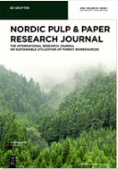

Polymer testing: Editor in Chief: Mikael Hedenqvist
Nordic Pulp & Paper Research Journal. Chair: Lars Wågberg
Progress in Organic Coatings. Editor in Chief: Mats Johansson

Recent previous engagements include journals such as Biomacromolecules (Founding editor and editor-in-Chief Ann-Christine Albertsson), European Polymer Journal (Editor Ulf Gedde), and Polymer Bulletin (Editor Eva Malmström). Faculty at FPT has also written seminal textbooks within the research field that has reached global attention e.g. “Fundamental Polymer Science”, U. W. Gedde, M. S. Hedenqvist, Springer, 2019
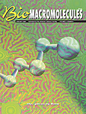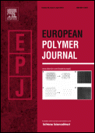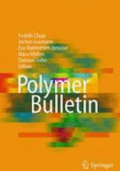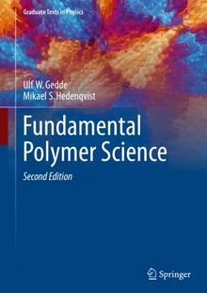

Follow up from previous evaluations (evaluator comments in italic)
The high amount of short-term funding of research is a continuous concern and some increase of the basic funding is needed. The lack of base funding is still a significant problem as discussed in other parts of this evaluation. Incentives to increase and enable more interdisciplinary work within KTH ought to be considered, e.g. specific funding of joint projects. Several large research programs have been funded during the assessment period thus enabled more interdisciplinary work. Examples are WWSC, MISTRA TerraClean, BiMac Innovation, Treesearch, FORMAX, etc. Possibilities to hire technical staff to support in maintaining and use of measurement equipment’s must be explored. This has been commenced in the field of advanced microscopy (SEM, TEM) where one scientist is allocated for this. Patenting and innovation activities ought to be strengthened through education and networking with industry. These activities have increased significantly as can be seen in the impact case “spin off companies”

Viability

Funding; internal and external
Several conclusions can be made from the distribution of funding for the department as presented in the Figure 15 below. Firstly, the overall funding scheme indicates that the department has a strong focus on research rather than undergraduate education. This impression is, however, to some extent caused by the fact that undergraduate education at KTH is heavily underfinanced on a departmental level. The second observation is that the departments research funding is very much external funding. This indicates that the researchers at FPT are very active in searching research funding and attractive as research partners and the research conducted is of a very good quality (hence a good success rate in funds applied for). The dependence on external funding is however also a risk since external funding normally is associated with larger fluctuations over time. A large fraction of FPT´s external funding however has a long-term perspective i.e. projects with a life time of 5 years or more (e.g. WWSC, ERC, KAW, etc.) which is positive. The third observation is that the department is very strong in funding from foundations (e.g. KAW) and less successful in retrieving funding from EU. This is clearly something that the department can develop further, i.e. try to get more EU-funding. A fourth and very important observation is that the already very low internal funding is eroded since the external funding (especially from foundations) does not cover the high costs for overheads and premises and the only source to cover this is the internal funding. A fifth and final observation is that these figures are irrelevant unless they are compared to the quite threatening cost development in last years as described under section A. This can also be seen in the balance between PhD students and post-docs with a decrease in the number of PhD students and a corresponding increase in number of post-docs, since the latter is less affected by the high OH-costs, Figure 16.
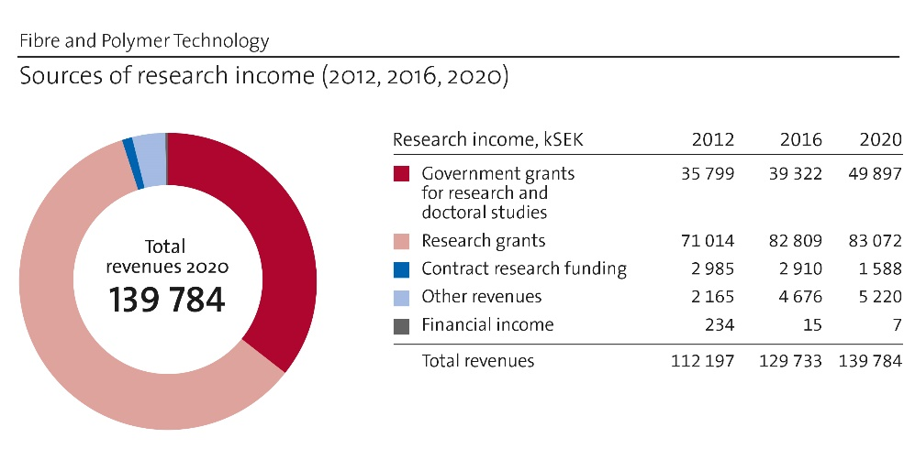
Figure 15: Comparison of research income in 2012, 2016 and 2020.

Academic culture
The academic culture is fostered by an open internal dialog within the faculty both within the divisions and the department. This is implemented in regular meetings between and within the divisions, seminar series, and regular research progress meetings. The common instrument facilities involve most of the PhD students and there are continuous discussions across the research group borders. The department has a weekly “Friday fika” as an informal meeting point where everyone is invited. The faculty also arranges PhD courses open for all students that try to address a broader perspective into the research field e.g. “Characterization techniques for fibre and polymer science”. The choice of co-supervisors for PhD students across the division boarders also promotes a suitable common cultural approach to science. Open meetings on common research themes were recently founded as a tool to promote an enhance a sound academic culture e.g. regular meetings between divisions on the field of lignin research were established last year. These informal groups are also a suitable way to reach out for collaboration outside the department.

Current faculty situation
The staff development can be seen in Figure 16 below, divided into different groups. The composition of the staff reflects the activities at the department i.e. a large number of temporary researchers and post-docs (funded by external sources) indicate a strong emphasis on research activities. The balance between professors and junior faculty shows some overweight towards professors but this can also be seen as a consequence of the KTH tenure track system which was implemented rather recently. The balance changes rather slowly due to this but this is definitely considered when opening new positions. Two senior professors in the area of cellulose and cellulosic materials are approaching retirement, which will have consequences unless new recruitment is initiated.
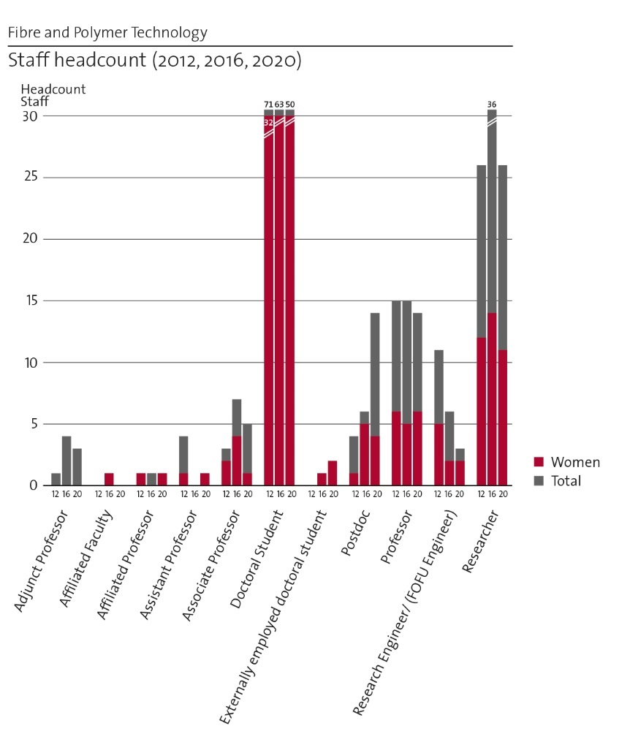
Figure 16: Comparison of staff development in 2012, 2016 and 2020.
There is a continuous discussion on the faculty development and how this should evolve in relation to faculty retirements and changes within the research fields. New positions are defined on combined evaluation of teaching demands within the undergraduate program as well as the research competences needed for the department. The recruitment of adjunct professors is seen as a strategically important way to connect complementary disciplines to the department for a more interdisciplinary research approach. These recruitments also allow for strategic alliances to be formed with external partners e.g. DESY in Hamburg. The gender balance within the department is reasonably good but there is still room for improvement. At KTH level the balance is among the best, especially considering that 3 of the 6 division heads are women. This aspect is considered in connection with new recruitments and efforts are made so that we stay on the right track towards an equal gender balance.

Recruitment strategies
FPT´s faculty is relatively balanced with respect to age structure with a mix of young and experienced faculty. The present faculty also has good coverage over the research field. A set strategy is that renewal of the faculty should follow the tenure track system now established at KTH. New positions will be externally announced in open calls and the positions defined by the needs both within research and education. There is a continuous open discussion within the present faculty on the development of the permanent faculty composition and the demands on new recruitments. This relates both to the development of the departments research area, future needs for teaching on an undergraduate level in relation to retirements and other changes in the present faculty. The department tries to connect to strategic partners via affiliated and adjunct faculty to enable collaborative efforts outside the department.
Recruitments of short-term employees such as post-docs, researchers and PhD students are more defined by the current needs and opportunities i.e. current funding situations and research programs. All new recruitments follow the general guidelines of KTH to ensure that equal opportunities for applicants are secured.
The large international visibility of FPT is also reflected in the open calls aimed to recruit graduate students. FPT´s latest adds on PhD-positions attracted 200+ number of applicants from all over the world. As a direct consequence of the increased attractiveness, FPT will be able to recruit talented graduate students based on a larger selection.

Infrastructure and facilities
The infrastructure and instrument facilities at the department are based on an instrument park available to all researchers at the department. The aim is that the FPT should be fully and well equipped with modern, state-of-the-art equipment ranging from analytical instruments to processing equipment relevant for the research area of FPT.
There are at present more than 150 different equipment’s available at the department. This instrumentation can be considered to be a facilitator for the research activities and we believe that it is crucial to retain this in the future.
The strategy to retain, or increase the quality of the infrastructure is to continuously aim at renewing and developing the composition of the instrument park. It is also crucial that there are available competences within the faculty to support the users of the instruments. An instrument responsibility group with representatives from each division is responsible to coordinate these facilities. Responsibilities for specific instruments are assigned to faculty members, technical staff, or PhD students depending on the type of the equipment. Investments in new equipment and costs related to continuous use of the facilities are covered by the department via the department overhead. This principle of a common instrument park has long tradition at the department and it has worked well. Currently, the main challenge is to try to find funding for some technical support staff and maintenance of equipment to keep the facilities running smoothly. The department also collaborates with numerous external partners within different projects where our broad instrument park has been shown to be very attractive to the partners.
Suggestion on investments in new equipment can be made from any faculty member or other staff. This is then discussed within the FPT faculty to reach an agreement of what investments that will be performed. Common efforts are then sought for to obtain funding for these investments.
Top-edge equipment’s are also becoming increasingly costly, and in many cases more demanding to operate. The increased complexity in research on materials in interdisciplinary projects increases the need for a good infrastructure but also introduces the need for other equipment not available at the department. These issues are in most cases solved within specific collaboration projects by complementary facilities from the different partners. This is however not a general solution although it works well in many projects. A step forward to improve the system has been taken at the previous school of Chemical Sciences and Engineering (CHE), now a part of CBH, by an initiative to have instrument facilities available for the entire school. FPT supports this and has taken part in the first round of collaborative efforts. More and more of the school’s instruments are now available through a web-based system called LIMS and opens also for the tenants of Greenhouse labs. In the long term we believe this will result in more cooperation with start-ups and small companies and opens for a new type of income for the school.
FPT has also established collaboration with large national and international advanced research facilities to enable availabilities to these facilities. These efforts can be exemplified by an adjunct professor from DESY in Hamburg (Prof S. Roth) and involvement in the ForMAX beam-line at MaxIV in Lund.
FPT is also connected to the national research platform Treesearch through which advanced research infrastructures throughout Sweden are made available.
One of the main challenges is to find funding for maintenance and up-grading of the present instrument park. There is also a lack of funding for technical staff to support the infrastructure.

Strategies and organization

Goals for development 5-10 years ahead
The vision of the department is to provide the society with “Sustainable Macromolecular Materials – from Molecules to Macroscopic Assemblies and Devices”. The department aims to continue to be a globally leading actor on this topic within the strategic research areas (life science, energy, renewables, nanomaterials, multifunctionality, and devices).

Central research questions and themes, knowledge gaps addressed, main research activities
The goals of the department are very much in line with the KTH development plan, especially “A leading KTH”. The department and all faculty are dedicated to providing high quality teaching and educational programs and performing leading research. However, if the trend is not turned the economical and administrative constraints are bound to start affecting the quality and motivation. The department is among the most productive at KTH in turns of scientific publications, patents, citations etc. With better base funding and less unnecessary administration, the work environment would improve and it would be possible to spend more time on what professor should do, i.e. teaching, research and outreach. This would definitely contribute to a leading and more visible KTH.

Leadership structure and collegial structure
The formal leadership at the department is organized according to a conventional line organization which does not really fit an academic institution which should rely on collegiality. This mirrors the overall KTH transformation from a faculty driven organization to a more “new public management” organization that has developed during the last decades. There is still a significant amount of collegial discussions and consensus within the faculty at the department and at present there is a will to reverse towards a traditional collegiality driven organization. A collegiality driven organization will have a stronger focus on the core business which is research and education. There is a strong consensus at FPT that this must be maintained and pursued.

Strategies for high quality
The majority of all scientific publications are published in open access. WWSC is one fundamental node and provides cohesion among large part of the researchers. We have a constant discussion with PhD-students and post-docs regarding reproducibility and detailed experimental descriptions and of course also research ethics.
Plagiarism checks are conducted on a regular level. We always strive to publish in a relevant, high-impact journals. We regularly organize international conferences to remain relevant to the scientific community and also participate in conferences as presenters or part of advisory boards and organizing committees. The PhD training also includes topics such as research ethics, how to write scientific papers, and literature clubs where a critical analysis of the literature is conducted.

Interaction between research and teaching at all three levels (BSc, MSc, PhD) of education
All faculty members at FPT are involved both in research and teaching on all levels. The research also connects to all levels of education in several ways. Teachers on undergraduate level that are active in research can bring relevant practical examples into the course material and thus up-date course content. Master theses-, Bachelor theses-, and project course students work closely with PhD-students and postdocs, often in combination with industry. PhD-students also get training in supervising undergraduate students as a part of the PhD program.

Impact and engagement in society

Relevance of research to society at large
Important external partners are the forest-based industry, polymer industry, and to an increasing extent, other users of macromolecular materials as developments in many fields depend on new advanced materials, e.g. the energy field. The strong collaboration with external partners has a direct impact on the educational program through e.g. MSc thesis works conducted in industry and internal and external PhD projects funded and co-supervised with industrial partners. The strong interaction with the surrounding society ensures that the students at both advanced and graduate level obtain relevant training for their future employments. Another route of knowledge transfer is the transfer of trained staff from FPT to the society. This is dominated by MSc´s and PhD´s that take up positions throughout society after obtaining the degree.
Another impact is the implementation of research findings outside FPT. The results are communicated within specific research programs, to the scientific society, by transfer of patent rights and knowledge, or in the form of start-up companies. Our research can contribute to required solutions to reach the UN sustainability goals. FPT conducts research that is relevant for a multitude of societal needs (energy, medtech, bio-based (sustainable) materials, transportation sector, therapeutics, nanomaterials, packaging materials …)

Research dissemination beyond academia
Personnel from FPT actively interact with high schools by hosting visits for students and teachers as well as giving talks at various high schools. Researchers from FPT also regularly give popular scientific presentations at a range of events open to the public e.g. talks at the Nobel museum, the Technical museum, “forskarfredag”, IVA-seminars, branschdagar (SPCI), and at the research school in Karlskoga. Other involvements include presentations in various media such as TV, Radio, Twitter, and Facebook. Staff members from FPT are actively participating in Tekla-days at KTH, House of Science (Vetenskapens Hus), Tom Tits, and also hosting children and youngsters as well as business leaders and innovators for study visits. School children come for their PRAO at the department. Research results from FPT is also announced via press releases aiming towards a broader audience.

Sustainability and the United Nations’ Sustainable Development Goals (SDG)
The UN global sustainability goals describe WHAT has to be done and the role for FPT is to play a central role in solutions to HOW this can be done and to find enabling technologies. This means that almost all research projects have sustainability aspects included. A significant share of all research projects is now focused on the elaboration of more sustainable materials and material concepts. New material solutions are needed in several of the UN´s goal for future sustainable societies. These range from improved Health (e.g. medical devices, implants, and diagnosis) to sustainable Energy solutions (e.g. energy storage, energy distribution, and energy harvesting), and renewable resources (e.g. forest and agricultural sources).

Structure for increased impact
Describe the department´s processes, procedures or mechanisms to achieve increased impact and engagement in society. FPT supports and endorses PhD-students involvement in societal engagements (Tekla etc). Inspiring lectures are held by successful in-house entrepreneurs and innovators to stimulate the younger generation. Researchers at FPT get support from KTH Innovation, Greenhouse Labs, and make infrastructure available at the company’s own expense. The overall infrastructure and competences at FPT is continuously up-dated to meet future challenges and allow the staff at to be a suitable partner in collaborative projects. Strategic alliances such as the collaboration with DESY and MaxIV also enhance these capabilities. The staff at FPT also participates in numerous networks to enable new collaborations and visualize the research at FPT. One example of this is participation in the national research platform Treesearch which is an arena to meet both other academia and industry within the forest related research area.

Department of Materials Science and Engineering
Self-evaluation
Head of Department: Professor Annika Borgenstam

Included divisions:

Unit of Processes, with Head of Division: Assoc. Prof. Björn Glaser
Unit of Structures, with Head of Division: Prof. Joakim Odqvist
Unit of Properties, with Head of Division: Prof. Levente Vitos

Department of Materials Science and Engineering

Overall analysis and conclusion; strengths and development areas

Limited SWOT-analysis
 | Strengths | Weaknesses
Research | - Strong, in several areas world leading, application driven fundamental research, both experimental and modelling, covering the whole process-structure-property chain for metallic and ceramic materials  - Large national and international network in academia and industry  - Strong internal and external collaboration with industry, institutes and other universities.  - Strong external funding record  - Strong collaborations with external labs providing a good coverage which is durable and cost-effective. | - Not using the full potential of the whole process-structure-property chain and neither of our width in different research areas. Some research areas within our profile need to be further developed e.g., thermomechanical treatment, mechanical metallurgy, crystallization processes, experience and reputation in thermokinetic modelling and experiments in process metallurgy are underexploited.  - Our research profile is not communicated clearly enough leading to incorrect expectations by external stakeholders.  - Our research is sometimes too influenced by the industry which may affect the impact, and sometimes also too dependent on a certain industrial sector which makes us sensitive to economic fluctuations.  - Unclear collaboration and communication strategy leading to a low visibility and weak connections to some relevant areas.
Organisation | - The department’s research profile is supported by the organization with the three units; processes, structures and properties, and the Hultgren laboratory.  - The re-organization in 2015 to three units led to increased collaboration and new interactions within MSE. It has also made it easier to communicate the department's activities externally.  - Positive working atmosphere and open discussion environment. | - The organization does not support common activities across the units.  - The gender equality is not satisfactory.  - Partly inferior premises, labs and equipment not supporting our activities and internal collaboration.  - Common duties, e.g. education, are not equally distributed leading to a too high work load for part of the faculty and researchers.

Development areas:
- Promote collaboration within the department for increased impact by gathering around a common challenge – “Contributing to the sustainable society” e.g.:
- Fossil-free metal production
- Materials for energy storage
- Development of materials for reduced CO2-emissions
- Research activities related to the chosen research focus will be mapped and funding will be applied for.
- Organization that support common areas such as experimental work and modeling across the units.
- Premises optimized to support the department’s activities and promote innovation. This includes a cost-efficient experimental lab across process – structure – properties common for the whole department with dedicated technicians but also effective office spaces and an inspiring area for formal and spontaneous meetings. Planning for re-building of labs has been initialized.
- Communication plan for research results to improve the impact and visibility of MSE as well as for individual researchers, also including how to communicate the departments profile to clarify what external partners can expect.
- Strategic plan for collaboration with external parties to strengthen external collaborations for the whole MSE.
- Support for writing funding applications, external or internal, in combination with a funding application strategy for increased success rate.
- Clarify and anchoring academic citizenship; what is expected for different positions and the responsibility for an employee at KTH leading to a more equal work load. The workload is reviewed by the unit leaders at the yearly development dialogue and the compilation is used by the unit leaders to allocate common duties. It is followed up at the salary setting dialogue.

Summary statement on contributions of department on impact, infrastructure and sustainable development
- The department’s contribution to impact is mainly through graduated PhDs, fundamental knowledge, methods and modelling know-how to be used in the metal industry, manufacturing industry, research institutes and energy sector but also through spin-off companies. An important impact from a sustainability point of view is a number of activities where research results contribute to a decreased energy consumption and CO2 emissions. Some examples are given below:
- Research on magnetocaloric materials where magnetic heat-pumps offer a low-energy demand and environmentally friendly alternative.
- Research on permanent magnets for increased efficiency of sustainable power generation and traction motor applications.
- Energy efficient and CO2- free iron production, e.g. HYBRIT.
- Recovery of energy and materials from waste including electrical and electronic equipment. In total this can lead to a 5-15% increase in overall energy efficiency and a reduced carbon foot print for metal production.
- Computational tools for materials design have been a major activity at MSE for decades and are supported by experimental investigation and characterization. These are invaluable tools for industry to design and manufacture strong and light alloys with increased strength/weight ratio leading to e.g. lighter vehicles.
We have a wide range of specialized and rare experimental facilities with which we can support and drive current cutting-edge research e.g. a state-of-the art lab for high temperature reaction kinetics for metals, wet chemical laboratory to support bio-fuel production and a lab for magnetic and mechanical testing of metals. The Hultgren Laboratory is now a so-called KTH Research Infrastructure and plays an important role in material development based experimental research through materials characterization. Much of the research activities at MSE concern calculations and simulations that require a lot of computational resources where we have a local computing cluster for small scale computing tasks and testing of configurations.

Research profile

General information of the department
The Department of Materials Science and Engineering, MSE, belongs to the ITM school at KTH. MSE consist of three units: Processes, Structures and Properties, names which highlight the fundamental importance of the processing or manufacturing step of a material for its structure (both on the nano- and micrometer level), which in turn directly affect the properties of the material. In addition, MSE consists of: The Hultgren laboratory, and two research Centers: Competence center Hero-m 2 Innovation and Center for Mechanics and Materials Design. On the educational side we have our first, second and third cycle education programs. MSE is led by the Head of the Department and a management group consisting of the unit leaders, the operations controller, the director of studies, and the directors of first, second and third cycle studies.
At MSE, research and teaching are conducted in a wide area; from engineering materials to functional materials. To a large extent, the choice of materials reflects the needs of Swedish industry, such as advanced steel, cemented carbide and high temperature alloys, but a significant part of the activities also relates to materials that can be expected to have an industrial impact in the future, such as magnetocaloric materials, high entropy alloys, metallic glasses, electronic materials and materials for solar cells. The department covers the whole chain Processes – Structures – Properties and has a strong competence in modeling on different length scales based on thermodynamics, kinetics and ab-initio calculations in combination with an experimental expertise regarding advanced characterization as well as determination of thermo-physical and thermodynamic properties. MSE plays an important role in the research of ICME (Integrated Computational Materials Engineering), which combined with experimental measurements and further developed models can lead to disruptive steps in materials production and use. One of the most successful examples of these activities is the Competence center Hero-m 2 Innovation and the former VINN Excellence center Hero-m supported by VINNOVA, Swedish industry and KTH.
At MSE expertise is shared to maximise the productivity and scientific impact. One recent example includes the design of new steels to avoid non-metallic inclusions and thereby prolong component life and contribute to sustainable development (Unit of Processes – non-metallic inclusion analysis; Unit of Structures – alloy design expertise). The coupling of different computational models also involves cooperation between the units. Combining computational fluid dynamics (Unit of Processes) and thermodynamic modelling (Unit of Structures); and the coupling of ab-initio modelling (Unit of Structures/Properties) to process modelling (Unit of Processes) are established.
An area in which MSE plans to develop the cooperation further is in additive manufacturing, in which the Unit of Structures focuses on the internal structure of materials after 3D printing, the Unit of Processes specialises in the production and characterisation of metal powder and the Unit of Properties has expertise in rapid solidification of metals and characterisation of magnetic properties. In this way, MSE offers extremely effective collaboration towards the development of additive manufacturing: a strategic research area for KTH.

Central research questions and themes, knowledge gaps addressed, main research activities
The unit of Processes focuses on raw material treatment and alloying element recycling, process optimization with respect to environmental friendly and energy saving aspects, thermodynamic and physical property of slags aiming at process optimization and recovery of valuable metals from slags and other secondary resources and development of new processes with low CO2 emissions. The research is dependent on knowledge from fundamental to practical and applied research, such as thermophysical, thermochemical and kinetic data and experimental trials are needed from lab scale to pilot and full scale. A generic modeling tool for optimization of metallurgical processes accounting for both chemical reactions and fluid flow is being developed by coupling Computational Fluid Dynamics (CFD) codes with thermodynamic databases.
The unit of Structures is composed of several research groups, focusing on: electronic structure calculations using Density Functional Theory (DFT), computational thermodynamics and kinetics using the CALPHAD approach, modelling and simulation of phase transformations and micro- and nanostructure evolution in metallic materials and hard metals in response to e.g. heat treatment and manufacturing processes like additive manufacturing (AM). The unit also has a strong activity within advanced experimental characterization of these materials. Thus, the research is truly multi-disciplinary. This is necessary for the development of models and databases to be used in the materials design methodology ICME, which is an important research theme in the unit. Another research theme in the unit is related to 3D additive fabrication for electronics and sustainable energy applications.
The unit of Properties focuses on the relations between mechanical, technological, and magnetic properties, and the composition and microstructure of engineering and functional materials both from a fundamental and applied point of view. The research activities are diverse and multi-disciplinary and encompass: Atomistic modelling of materials’ properties e.g. plasticity, yield and tensile strength, ab initio code development of e.g. the alloy theory tool (EMTO-CPA) and dynamical Mean-Field Theory, mechanical metallurgy e.g. prediction of flow stress, fatigue and creep, and modelling of hardening mechanisms, property characterization.

Contributions to the advancement of the state of the art within the research fields of the department
The unit of Processes works to increase the capability, effectiveness and sustainability of materials processes and measurement techniques, using both modelling and experiments. The great strength of the unit is to couple fundamental studies in the lab with industrial collaborators to scale findings through our partners and overcome the “valley of death” that often stops innovations being used in industry. One flagship project is HYBRIT i.e. steelmaking without fossil fuels, performed in collaboration with SSAB, LKAB, Vattenfall and Energimyndigheten, which will, if successful, reduce the Swedish total greenhouse gas emissions by 10%. Another project, which potentially could reduce the carbon footprint, concerns the improvement of the production of bioenergy and biofuels using waste products, including those from paper and pulp industry. Furthermore, the optimisation and measurement of high temperature reactions is a significant area of study, as is new tools for quality control of metal casts and measurement techniques for electric arc furnace (used in recycling of scrap steel) and argon oxygen decarburization (AOD) converter, which is a crucial step in steelmaking.
In the unit of Structures, and in the field of electronic structure calculation new methods have over the years been developed related to the ab initio modelling of alloys and magnetism, as well as different statistical methods for atomistic modelling (different types of Monte Carlo methods), which allow accurate description of bonding and phase equilibria in alloys at the atomic scale. In the field of computational thermodynamics, the unit is leading the development of new improved models for the thermodynamic properties of unary systems, which will subsequently also affect binary, ternary and higher-order systems. In the field of phase transformations, structure evolution and kinetic modelling, the unit has projects which aim at improving and further develop models for precipitation especially the classical theory of nucleation. In the field of advanced experimental characterization, the unit develops instrumentation, measurement protocols and data analysis methods for synchrotron x-ray and neutron characterization. Research on AM of metallic materials is a relatively new research theme at MSE and the current research questions, including microstructure evolution during AM specific conditions, are all contributing to this internationally very active field of research. The AM activities for electronics and sustainable energy applications contributes with new state-of-the-art tools and instrumentation.
In the unit of Properties, the focus lies on the development of ab-initio modelling in different areas of applications. A particularly interesting example is the derivation of a generic ab-initio based description of a quality control for cemented carbides, a unique example of the power of computational modelling in the field. This is the first time DFT has been used outside academia as a modelling tool to build a quality control for industry. Energy applications is another subject of interest, in particular environmentally-friendly devices based on the magnetocaloric effect: magnetic refrigerators. Ab-initio modelling, combined with measurements of magnetic entropy changes performed at the unit, has made it possible to study advanced material candidates for magneto-caloric applications. Further, in collaboration with Svensk Kärnbränslehantering (SKB), the unit has investigated the risk of a copper corrosion mechanisms that may affect the long-term behaviour of the canisters in a repository planned for spent nuclear fuel.

Quality and quantity of contributions to the body of scientific knowledge
The main way to contribute to the body of scientific knowledge at MSE is by peer-reviewed journal articles. Between 2012 and 2019 MSE had a total of 1570 peer-review articles published (the Web of Science (WoS) coverage is 95.9 %). In 2018 the highest number of published articles (224) was recorded. Another measure of the number of publications is the fractionalized count (the share of an author from MSE to a publication taken as 1/n, where n is the number of authors on that publication), see Fig. 17. As can be seen, the number of peer-review publications fluctuates around 90 for each year in the period 2012-2019. During 2012-2019 no less than 132 doctoral theses and 52 licentiate theses were presented, which we think is very good. MSE publishes quite a lot every year, but the average (fractionalized, WoS) number of citations (3.6) must be considered low, at least in comparison with other UoA’s in Panel 3. However, it is our perspective that the most important key performance indicator is the total number of citations (2246, 3-year window, fractionalized, WoS). It is common in applied research fields that the dissemination of the research is conducted in multiple forums to reach scientists, industry and policy-makers. This could be one of the reasons for the slightly lower citation score per paper and larger total citation score. Another reason could be the extensive PhD education. It is common practice to publish five papers per PhD thesis. This is excellent training for students to become independent researchers, but it will most likely lower the citation score. The impact of our publications compared to the impact of the journals (using field normalization), see Fig. 18, are somewhat different depending on the database used (WoS or Scopus), but lies a bit below 1.0 and close to 1.0 respectively when using WoS. Here we think the applied field normalization is not necessarily fair, since some of the highest impact journals we publish in have very broad scopes that attract authors from many other fields than materials science which must influence the effect the field normalization has. A comparison, to base an impact strategy on, should be with other materials science departments, both nationally and internationally, which publish in similar journals as we do. Such work has started with the bibliometric experts at KTH. Finally, Fig. 19 highlights the extensive international collaboration MSE has, leading to a lot of co-publications (between 60 and 70 % of all publications).
Publications we want to highlight:
- S. Huang, H. Huang, W. Li, D. Kim, S. Lu, X. Li, E. Holmström, S. K. Kwon and L. Vitos. Twinning in metastable high-entropy alloys, Nat. Commun. 9 (2018) 2381
- B.N. Costanzi, A.V. Riazanova, E.D. Dahlberg and L. Belova, In-situ manufacture of magnetic tunnel junctions by a direct-write process, Appl. Phys. Lett. 104 (2014) 222401
- A.S. Dobrota, I.A. Pasti, S.V. Mentus and N.V. Skorodumova, A DFT study of the interplay between dopants and oxygen functional groups over the graphene basal plane – Implications in energy related applications, Phys. Chem. Chem. Phys. 19 (2017) 8530-8540
- S. Bigdeli, H. Mao and M. Selleby, On the third-generation Calphad databases: An updated description of Mn, Phys. Status Solidi (B) 252 (2915) 2199-2208
- X. Xu, JE Westraadt, J Odqvist, TGA Youngs, SM King and P Hedström, Effect of heat treatment above the miscibility gap on nanostructure formation due to spinodal decomposition in Fe-52.85 at.% Cr, Acta Mater. 145 (2018) 347-358
- X. Zhou, M. Ersson, L. Zhong and P. Jönsson, Numerical simulations of the kinetic energy transfer in the bath of a BOF converter, Metall. Mater. Trans. B 47 (2016) 434-445
- J. Lundberg, C. Johansson, S. Jonsson and S. Holmin, Access to the brain parenchyma using endovascular techniques and a micro-working channel, J. Neurosurg. 126 (2017) 511-517
- Y. Li, C. M. Lousada, I. L. Soroka and P. A. Korzhavyi, Bond Network Topology and Antiferroelectric Order in Cuprice CuOH, Inorg. Chem. 54 (2015) 8969-8977
- J. Martinsson, B. Glaser and D. Sichen, The structure of foaming BOF-converter slag, Ironmaking & steelmaking 46 (2017) 777-781
- K. Steneholm, M. Andersson, A. Tilliander and P.G. Jönsson, Removal of hydrogen and sulphur from tool steel during vacuum degassing, Ironmaking & Steelmaking 40 (2013) 199-205
- A. Stormvinter, A. Borgenstam and J. Ågren, Thermodynamically based prediction of the martensite start temperature for commercial steels, Metall. Mater. Trans. A 43 (2012) 3870-3879

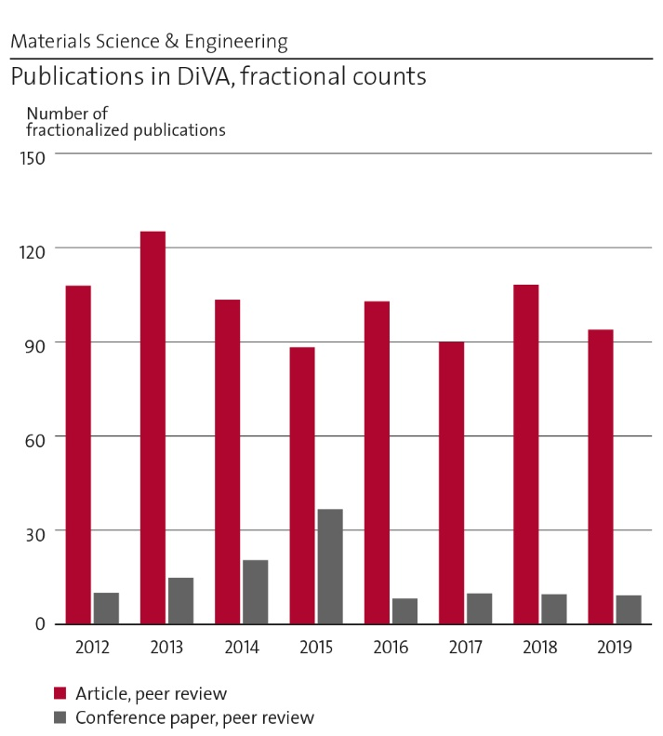
Figure 17: Number of fractionalized publications 2012-2019.
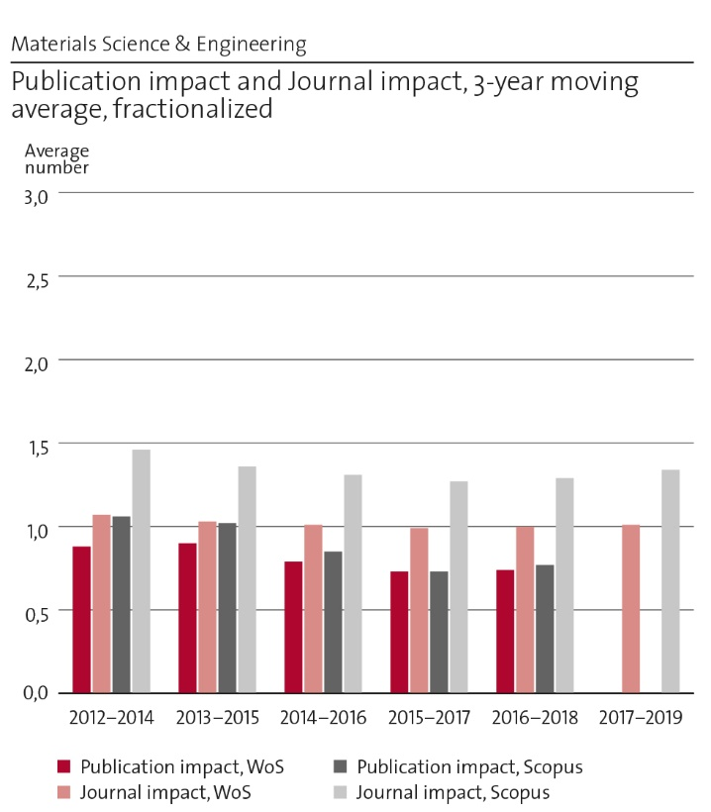
Figure 18: Publication impact and journal impact.
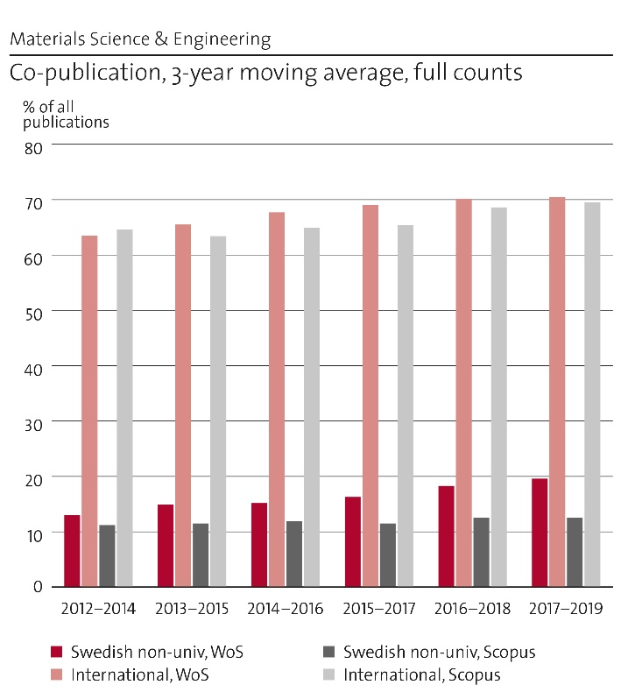
Figure 19: International and national co-publication.

Engagement in national and international research collaboration within academia and its outcomes
MSE has a very wide network of collaboration with universities, research institutes and industrial companies, both nationally and internationally. These collaborations lead to joint publications, joint supervision of PhD students and post-docs, students and faculty exchanges, master thesis projects, new projects and innovations.
Nationally, much research is performed in collaboration with Swerim AB, Uppsala University and Chalmers University of Technology in the field of powder metallurgy, stainless steels, tool steels, additive manufacturing and materials characterization. KTH is a member of European Enhanced Landfill Mining Consortium, which has led to the Horizon 2020 project NEW-MINE. Collaborations in the area of high temperature experimental kinetics and casting have been achieved through European RFCS projects. Within fossil-free steelmaking we collaborate with Luleå Tekniska Universitet in Sweden, and the South Korean universities: Hanyang University and Korea University.
Through the competence center Hero-m 2i we have extensive collaboration with almost all steel and cemented carbides companies in Sweden, and with the department of Solid Mechanics at KTH. The Center for X-rays in Swedish materials science (CeXS) based at MSE, has collaboration with the Swedish synchrotron community (including academia, institutes and companies) as well as the international community. Key international partners are, for example, DESY (Deutsches Elektronen Synchrotron) in Hamburg, Germany; APS (Advanced Photon Source), Argonne, US; and, CHESS (Cornell High Energy Synchrotron Source), Ithaca, US. Within the newly started Center for Mechanics and Materials Design (MMD) between MSE and Solid Mechanics, based at MSE, we collaborate with Swedish steel and cemented carbide companies but also with Swedish engineering industry such as Scania. Within the field of ICME we have a long-standing collaboration with Northwestern University, US, and a more recently started collaboration with MIT in the US on materials design. MSE is a member of SGTE (Scientific Group Thermodata Europe) and is leading an international team on the development of the third generation of thermodynamic databases.
In the field of ab-initio calculations and atomistic modelling we are collaborating with a large number of groups worldwide. Examples are Uppsala University, University of Science and Technology Beijing, Dalian University of Technology, Turku University, Linköping University, University of Augsburg, Institute of Metal Physics-Russia, MCL, Leoben -Austria and University of Rouen, France. In the field of process metallurgy key international collaborators are Carnegie Mellon University, Tohoku University and Colorado School of Mines.

Follow up from previous evaluations
The recommendations from RAE 2012 are given below and shortly commented upon:
It was suggested that data, both experimental and calculated, should be stored digitally in a unified format. An effort to curate materials data produced within the additive manufacturing (AM) and powder metallurgy projects at MSE and within the Swedish arena for metal AM has been initiated with the goal to make the data searchable and reusable as well as to increase awareness of the importance of proper data management among the students.
It was further suggested that collaborative opportunities with units in Chemistry should be checked. MSE has extensive collaborations with CBH. The HYBRIT project is one example of an informal collaboration. Other examples are Prof. Lyuba Belova’s close collaboration with Prof. Lars Kloo related to development of materials, methods and architectures for additive fabrication of solar cells. Assoc. Prof. Pavel Korzhavyi and Dr Claudio Lousada collaborate with Prof. Mats Jonsson on the influence of radiation at the nuclear canister surface on the uptake of hydrogen when exposed to water but also with Prof. Jinshan Pan on oxidation of Al surfaces. Dr Weihong Yang collaborate with Prof. Klas Engvall with a joint PhD student on condensation of inorganic species during cooling of product gas from pressurized biomass fluidized bed gasification. Dr. Valter Ström has a long-standing collaboration with Prof. Richard Olsson focusing on composites between polymers with enhanced functionality from e.g. magnetic and other inorganic compounds. During the period 2012-2019 it has resulted in 17 peer reviewed papers in well renowned journals.
Other examples are common usage of equipment and MSE is a member of SFC-Swedish Gasification Center led by CBH. A partnership is currently being established between DESY and KTH where MSE and CBH are both involved focusing on sustainable materials where the advanced characterization techniques available at DESY matches the fundamental and applied research needs at KTH.
It was stated that it is important that the future of the solidification field is secured and that it is a necessary to recruit new “brilliant brains” to take over when aging professors retire. There is still no faculty position in Solidification and the last recruitment effort in 2016 was unsuccessful and MSE chose to withdraw the position. Currently a researcher is responsible for the area but we will soon open up for a new faculty position, something highly requested by industry. To avoid situations like this the strategy at MSE is, since a couple of years, to identify the need to replace a position eight years before retirement to have time to recruit and establish the position.

Viability

Funding; internal and external
The largest part of the research funding at MSE is external and for 2020, more than twice of the government grants, see Figure 20. It is of course very positive that researchers at MSE are so good at attracting external funding which was listed as one of our strengths but it also makes us vulnerable to the economic situation. Since MSE has a lot of external funding as much as around 25% of Government grants is used for co-funding. Further, around 25% is used for salaries for faculties, 10% for salaries for researchers, 20% for other salaries and 20% for other expanses. We would also here like to stress that it is very problematic that the Government grants is rather small and we see a huge need in a more fair and transparent distribution at KTH.
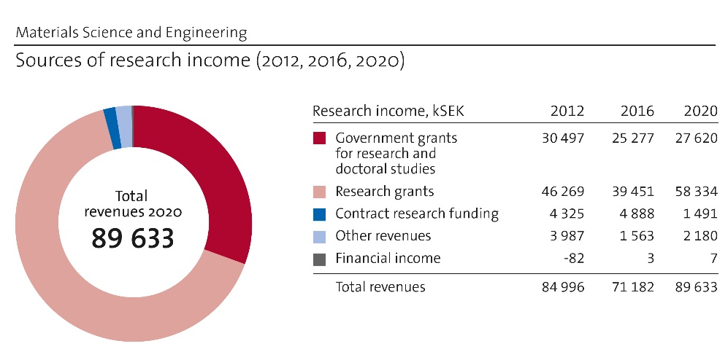
Figure 20: Comparison of research income in 2012, 2016 and 2020.
Even if the external funding fluctuates a lot, we can see a change in major funding bodies for MSE over the last years where VINNOVA by far has become the largest which is reasonable considering the applied research performed even though it many times is fundamental. We can see a rather worrying decrease in funding from VR which probably is related to the fact that even the fundamental research performed at MSE is considered being too applied. This can be questioned and should be discussed on a higher level. On the other hand, during recent years MSE has been successful in attracting large-scale funding. We can see a drop and then an increase in EU funding where the increase can be related to EIT Raw Materials. The rather dramatic increase in funding from VINNOVA can be connected to the Strategic Innovation Area Metallic Materials that started in 2013 where many calls are highly relevant for MSE.

Academic culture
Most research discussions take place in informal and formal meetings between researchers involved in a joint project. All units have regular workplace meetings where typically 2 shorter scientific presentations are given where also researchers not active in the project can come with input and suggestions which contribute to the quality. We have posters on display so that visitors and students can get a view of our activities but also to spread the knowledge internally. We lack a common area for promoting spontaneous research discussions and today we have two different lunch rooms which partly divide the different research groups and units

Current faculty situation
The staff is divided into the groups shown in Figure 21. Overall, the senior staff is 53 whereof 29 are researchers and postdocs which is a rather large part. However, it should be noted that the focus of the department is approximately 90 % on research including third cycle studies and 10 % on first and second cycles studies. Therefore, the group of researchers and post-docs financed by external funding is relatively large and there is only one adjunct focusing on teaching.
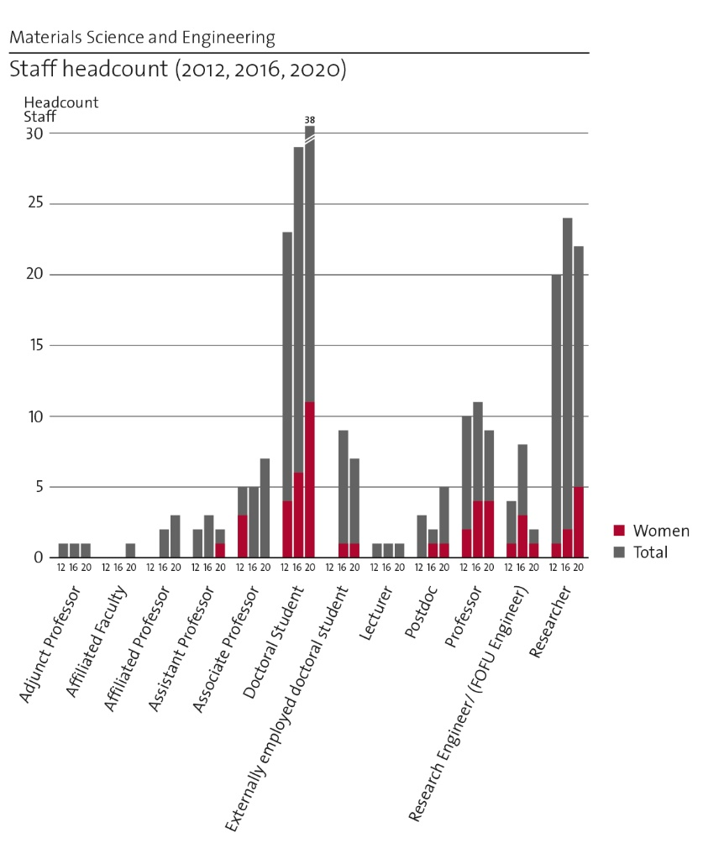
Figure 21: Comparison of staff development in 2012, 2016 and 2020.
Currently we have 5 adjunct professors and affiliated faculty (and a number of ongoing recruitments) and we consider it a very good way to strengthen and complement our faculty, and to intensify collaboration with strategically important industrial partners. We can see an imbalance in the number of faculty positions and researchers between the different units. Of course, the positions should be based on the need from a teaching and research perspective and not on organization but still we can see an imbalance towards too few faculty positions in the units of processes and properties. The vitality could be considered good with an average age of professors of 53 years. In addition, the number of associate professors is 7 with an average age of 50 years. The number of professors has decreased during the last years and within 10 years 2 more will retire but it should be noted that the number of faculty positions is rather constant even though we see a certain need for recruitment. In the long term, we also need to be proactive for upcoming retirements to ensure that we do not get gaps in certain areas as described below.
We have done a review of how teaching, research, management assignments and other common tasks are distributed to have a basis to achieve a uniform workload and to ensure that those who are assistant and associate professors are given the good conditions to qualify for promotion. We should also review any differences in given conditions between men and women. The most notable is the tilted gender distribution within all groups except the professor group. However, last time we recruited two new assistant professors, one woman and one man was employed. In planned adjuncts professorships, we also have female candidates. We have a few very strong female researchers that we try to offer good conditions to stay and make a career at MSE and we support them gaining the necessary experience and qualifications needed to be able to get a faculty position. We also have an internal group that works with gender equality issues to improve the working environment at MSE, which is important for retaining female staff. Our assessment, however, is that the environment at MSE from a gender perspective is comparatively good, but there is always room for improvement.

Recruitment strategies
The recruitment strategies at MSE vary a lot between the different units and for different type of positions. Recruitment of post-doc and PhD-students is based on external funding and difficult to plan. MSE has mainly recruited PhD-students but during the last years the number of post-docs has increased. The aim is to mainly recruit PhD students, since PhDs are one of MSEs most important deliverables, but some tasks are better suited for a post-doc who also are a good resource to support project management and supervision, important skills for a post-doc to achieve.
For researchers the recruitment strategy is rather unclear and is sometimes only a result of external funding. MSE should strive to recruit researchers based on a research profile needed to fulfil the vision of MSE. Recruitment of faculty positions is based on a research profile complementing the existing faculty to strengthen and fill gaps in MSE’s profile as stated in the faculty plan based on the vision. Eight years before retirement of a faculty, the situation must be analysed to decide if the position should be replaced and if so what recruitment should be done. We are discussing a faculty position in CO2 free metal production, a very important area from a sustainability point of view. It has a large potential and very large investments are being made and we believe that such an area will attract women. However, we will first analyse our current faculty to see if we already have necessary competence but spread on different individuals. We plan for a faculty position in crystallization processes within the next few years. As already mentioned, this position has previously been advertised and we will now broaden the profile to attract excellent applicants. In addition to metal casting, this area is important in additive manufacturing, which is a very attractive area for both men and women. For both areas there is a great need in industry and we see good opportunities for external grants.
As mentioned above the gender balance is only good on the professor’s level and it is something that is taken into account when recruiting but the efforts have to be intensified. During employment interviews, we always invite both female and male applicants, unless the difference in qualifications is very large. For future faculty positions we should map where potential female candidates currently are and also consider to withdraw an advertised position if there are no qualified female applicants. Most recruitments are done internationally resulting in employees from a large number of different countries.

Infrastructure and facilities
The research units at MSE have access to a wide range of specialized and rare experimental facilities with which we can support and drive current cutting-edge research. Strategic investments will allow us to leverage existing capabilities and target areas of importance for industry, as well as inspiring current students to continue into research at KTH and attracting students from other universities.
In the area of high temperature reaction kinetics, experiments with precisely-controlled gas flow conditions at temperatures of up to 2400 K, with the possibility of rapid quenching, can be performed. Furthermore, computational fluid dynamics is used to simulate several steps of the steelmaking process, and the associated water model verifications benefit from the highly flexible water modelling lab. An expansion of this lab would allow for simulations of atomization for metal powder production in a representative scale and geometry. Due to the strategic importance of the field of AM, powder metallurgy has become a developing research area at MSE and so is the related experimental facilities. Much of the current capabilities complement those in other partner institutions and include among other things a powder rheometer and a thin film applicator to test powder spreading. Bio-fuel production is supported by a dedicated wet chemical laboratory, with relevant analysis capabilities and pilot reactors.
MSE has an induction furnace which allows us to perform pre-studies of industrial research casting trials and studies of liquid metal properties and of solidification. Different stages of the steelmaking process can also be tested using a fleet of nine high temperature furnaces and five calcination furnaces, which are used almost continuously to study slag formation and interaction of slag with liquid metal. Furthermore, MSE has a well-equipped heat treatment lab and an arc melting machine for the manufacturing of miniature specimens to complement the manufacturing of larger casts. Mechanical testing can be performed using e.g. tensile testing machines, creep rigs, impact toughness tester, and a specialized rig for low-cycle fatigue testing of metallic materials under high temperature and different atmospheres.
The Hultgren Laboratory (HL) plays an important role in material development based experimental research through materials characterization. The equipment is: Light optical microscopes, scanning electron microscopes (SEM with EBSD, TKD, EDS, WDS), Focused Ion Beam SEM (FIB-SEM) for local sample preparation of lift-outs to be used in transmission electron microscopy or atom probe tomography as well as for nanofabrication etc., x-ray diffractometers, thermal analysis (DSC, DTA, TGA, MS), dilatometers (with ultra-high temperature and rapid heating and cooling capabilities), micro- and nano-indentation for hardness measurements, magnetometry (VSM, SQUID, etc.), atomic force microscopy and scanning probe microscopy. More specialized materials characterization tools not available in-house, are available as collaborative resources, regionally, nationally and internationally. For instance, aberration-corrected TEM is available at the Ångström Laboratory in Uppsala University, atom-probe tomography at Chalmers University of Technology and University of Rouen and laser-scanning confocal microscopy (LSCM) at Carnegie Mellon University and Tohoku University. LSCM will become available in-house at HL during 2021 The Swedish beamline at PETRA III at DESY in Hamburg is managed through the newly inaugurated Center for X-rays in Swedish materials science (CeXS). The director of CeXS is based at MSE. In addition, characterization by neutron scattering (ISIS in UK ILL in France; MLZ in Germany, PSI in Switzerland, etc.) is important for several projects at MSE.
A common challenge faced continuously is equipment maintenance and support. Currently, equipment is many times maintained by doctoral students, researchers or faculty. Doctoral students have high turnover, which means knowledge is continuously lost, while researchers and faculty often have many other responsibilities that make it difficult to invest the time needed. Similarly, costs for maintenance are a problem, currently solved on a case-by-case basis. It would be beneficial to have a sustainable solution to maintenance costs and technical support at KTH to remove the burden on researchers and faculty, while retaining knowledge in the medium and long term.
The strategy for developing the infrastructure going forward is to make use of the Hultgren Laboratory, a recognized central research facility at KTH. It is being planned to reorganize the Hultgren Laboratory to include all the current laboratories at the department. Since Hultgren Laboratory is one of 12 recognized laboratories it is deemed possible to be able to seek some general support from KTH and also Hultgren Laboratory is supported by KTH e.g. in research infrastructure funding applications to the Swedish Research Council. In order to become even more relevant as a National Laboratory the Hultgren Laboratory needs to further seek funding for and procure flagships instruments that are unique in Sweden. One such equipment is the in-situ LSCM that was mentioned before and another is a state-of-the-art Atom Probe Microscope (APM) that would truly establish the Hultgren laboratory as a key infrastructure in Sweden with the only state-of-the-art APM.
Much of the research activities at MSE concern calculations and simulations that require a lot of computational resources, and we utilize such resources both at KTH (the PDC, Center for High Performance Computing) and nationally through SNIC (Swedish National Infrastructure for Computing). However, small scale computing tasks and testing of configurations are carried out on local computing clusters at MSE. The computational resources range from workstations to computing servers. In principle, these different computational resources could be merged and form a substantial cluster, but this would require a lot of investments.

Strategies and organisation

Goals for development 5–10 years ahead
The vision for MSE describes where the department aspires to be in 10 years:
“In 2030, MSE is well recognized as a world-leading department of application driven fundamental research on metallic and ceramic materials. This means that through our outstanding experimental and computational resources (both internal and external) we are at the forefront of material processes and multi-scale material modelling, including industrial materials and their by-products, functional materials, material recycling and sustainable materials promoting innovations and contributing to a sustainable society. Our primary stakeholders are the European metal industry, the manufacturing industry, research institutes and the energy sector. On the international arena we are an attractive collaboration partner. Our main deliverables are PhDs, MScs, fundamental knowledge, methods and modelling know-how and lifelong learning. MSE's various strength areas now operate as one integrated unit and is led in a professional and equal way which secures a good working environment.”
The means identified to reach the goals summarized above in our vision are covered by the development areas in our limited swot-analysis.

Congruence with university-level goals for “A leading KTH” as set out in KTH´s “Development Plan 2018-23” (page 5)
Our vision for research as presented above together with our development areas is perfectly in line with KTHs and ITMs development plans and thus contributing in striving towards the leading, integrated, visible, open, increasingly digitalised, more sustainable, more international and more equal KTH as described in the President´s foreword to the development plan.

Leadership structure and collegial structure
Overall the leadership structure and collegial structure at MSE is working well in parallel, supporting each other. At MSE these two are divided on the formal leadership issues and on the individual research leaders. In the Unit of Processes this interaction is strengthened by regular meetings for all seniors to inform each other about ongoing activities and discuss future activities. This should be strengthened in the other units.
When faculty or researchers do not participate in common work and activities at KTH and MSE, only focusing on their own research, we get a conflict between the leadership structure and the collegial structure. By involving these researchers more in the work at MSE their contribution to the impact and fulfilment of the vision would increase. From the leadership structure at a KTH level it is experienced that the support is not enough for research applications and we believe that the impact could be improved by strengthening the support.

Strategies for high quality
Many PhDs are graduated each year at MSE and a large part of the publication record is a result of PhD projects. It is thus very important to focus on the quality of the PhD work which has been improved during the last years through a strengthened internal review process and yearly follow up meetings. These meetings, led by the responsible for the PhD-program, check the progress of individual PhD-students and initiate discussion on supervision and quality between supervisors active in different areas. It should be mentioned that informally it is regarded that 5 papers should be a benchmark for a PhD thesis. This may be a quality risk if the students and supervisors are dividing research content into several papers instead of one just in order to meet this target. It is the content of the papers that should be judged and not the numbers, something that has to be more discussed and reflected on. To keep a high quality in the future it is important to secure to have talented researchers and we will introduce career plans for our top-talented researchers. The department has a very strong collaboration with industry which is very positive but it is important to be observant to secure that the main focus is on top-quality research and not contract research where the academia becomes servants for the industry. This is a rather difficult balance and within the department there are different traditions and it has been identified that further discussions are needed to make all researchers aware of these aspects and the role we have as researchers at KTH.
A way to keep a high quality should be based on every researcher’s aim for individual high impact. To reach that it is necessary to be at the cutting edge of the research area. It is thus important to present at international conferences, engage top-level researchers e.g. to evaluation committees and as opponents at PhD defences and being active as reviewer, project evaluator etc. to get input regarding our own research as well as being updated on others. For most of the areas at the department we are able to engage top-quality researchers for e.g. evaluation committees which is a quality measure for the research performed.

Interaction between research and teaching at all three levels (BSc, MSc, PhD) of education
There is a strong coupling between the research performed at MSE and the teaching at all three levels. The teaching is first and foremost carried out by the faculty, but researchers and PhD students also play an important role. Very often PhD students act as leaders of exercises/tutorials or labs, and as supervisors for BSc and MSc level projects. This provides leadership experience and helps to develop their own work. In many courses it is considered very positive to use research results, experimental equipment, in-house or commercially available computer programs keeping the courses up to date and providing a direct link between the student’s learning activities and current research.

Impact and engagement in society

Relevance of research to society at large
The funds for the research performed at MSE are predominantly coming from external funding sources such as e.g. the governmental agency VINNOVA or the EU. In such projects it is almost always a requirement that some of the funding (cash or in-kind) comes from industrial companies. Thanks to this we ensure that the research we perform is relevant to stakeholders outside academia and to the society at large. These projects deliver not only new knowledge, and sometimes innovations, but also trained research personnel in the form of PhD students. This fact has time and time again been emphasized by most of the companies we are collaborating with, and is often considered to be the most important outcome from our projects. Examples of research results that have had an impact on society at large are the different software programs that have been developed at MSE e.g. Thermo-Calc. Furthermore, several persons of the faculty have spent time at industrial companies, either as part of an exchange program or as part time employees. The impact and quality of the research carried out at MSE is also partly reflected by the fact that Profs. Borgenstam and Jönsson are members of the Royal Swedish Academy of Engineering Sciences (IVA).

Research dissemination beyond academia
Most of the larger research projects based at MSE usually have annual workshops where industrial partners and academia meet and discuss results from research activities. Researchers at MSE also arrange scientific conferences, symposia and seminars which are publicly announced and open for the general public. Some researchers have participated as experts in Swedish radio and television, others have published popular science texts in niche magazines such as “Framtidens Forskning”, “Ny Teknik”, SCITECH and Powder Metallurgy Review, some have been interviewed and participated in films and pods in industrial partners communication channels and some have also been interviewed by regular newspapers.

Sustainability and the United Nations’ Sustainable Development Goals (SDG)
As mentioned earlier, MSE has several activities where research results contribute to a decreased energy consumption and CO2 emissions, often thorough a combination of cutting-edge modelling and experimental work. This is displayed in how our published articles relate to the United Nations’ Sustainable Development Goals. Between 2012 and 2019 MSE has published a total of 386 articles related to all but seven (SDG 1, 2, 5, 10, 14, 16 and 17) of the 17 SDG. We have most articles in SDG 7 (217), 12 (51), 13 (42) and 11 (19). As already mentioned, we are planning for a faculty position within CO2 free metal production (SDG 13) within the next five years.

Structure for increased impact
- MSE's vision should be a guiding principle for how to become stronger
- Publishing open access in journals with the highest impact factor but still reaching relevant readers
- Develop a strategy for how we communicate results and how to increase our visibility
- Analyze impact of individuals as well as groups to reflect on whether there are choices that would increase impact without compromising quality

Department of Theoretical Chemistry and Biology
Self-evaluation
Head of Department: Professor Patrick Norman

Department of Theoretical Chemistry and Biology

Overall analysis and conclusion; strengths and development areas

Limited SWOT-analysis
 | Strengths | Weaknesses
Research | - Combination of theory & software development and applications  - Coherent and collaborative work within the department  - High specialized competence in HPC  - Broad international networks (theoretical and experimental)  - High publication rate  - Competitive in seeking external funding | - Uneven spread of grant success and supervision responsibilities  - Not sufficient collaboration with KTH experimentalists  - Low societal visibility
Organisation | - Broad competence  - Very international staff  - Strong partnership with PDC Center for High Performance Computing | - Limited visibility in undergraduate teaching, prohibiting for recruitment  - Decreasing number of PhD students and zero MSc diploma students  - Gender imbalance in faculty

Opportunities:
- Organization wise, TCB is closer to chemistry after the school reorganization
- TCB has come physically closer to chemistry and PDC after office relocation
- Increased part in undergraduate teaching as to provide increased student visibility and also a complementary source of faculty funding
- Increased spontaneous interactions with experimentalists should enable networks for applied research (with grant applications), e.g. catalysis, photophysics, supramolecular assemblies
- Based on TCB software, we can form strong networks to compete for funding (European and Swedish levels)
- EuroHPC: VeloxChem may well be the one program in quantum molecular science that scales sufficiently well on the LUMI system
- Prof. Yi Luo forms a bridge between KTH and USTC and provides us with a strong and real partnership opportunity
- Recruitment to address the gender inequality

Threats:
- Retirement of highly visible scientists lowers our international recognition
- Reduced opportunity to use scholarships as means of funding reduces our number of PhD students and postdocs
- Strong dependency on external funding
The Department of Theoretical Chemistry and Biology (TCB, https://www.kth.se/tcb) stands out as unique in Sweden as it constitutes an organizational unit (beyond that of an individual research group) that in its entire is focused on molecular modeling. At other Swedish universities the late trend has been to reduce their initiatives in theoretical molecular modeling and e.g. not continue their traditions of hosting chaired professorships in theoretical chemistry but rather channel their support toward successful individuals to lead more focused research groups, typically with very applied objectives. TCB, in contrast, has a broad spectrum of competences residing in a very international staff and as such we have a better opportunity to also contribute to a more holistic development of the research field as such.
TCB conducts applied theoretical research in several important areas including catalysis, spectroscopy, nanoparticle sciences, supramolecular chemistry, and biochemistry. This research is solidly anchored in real-world activities at the research forefront through our wide network of local, national, and international experimental research groups.
With a strong aggregated competence in the underlying basic theories, we have the opportunity to develop new and adapted simulation tools and conduct studies beyond what can be achieved with public and/or commercial software. In fact, a deep understanding of basic theory is normally not sufficient to accomplish such feats as simulations of realistic model systems typically require efficient algorithmic development and implementation on today’s most advanced computers i.e. high-performance computing (HPC) clusters. TCB has therefore formed a strategic alliance with the PDC Center for High Performance Computing (PDC, https://www.pdc.kth.se/), which is a leading national HPC center located at KTH (https://www.kth.se/). This alliance includes the sharing of staff members. Most notably, TCB and PDC share the employment of two application experts that are trained in the art of parallel programming at the same time as they have completed their PhDs in the fields of theoretical chemistry and physics, respectively. This tight integrated employment model, with equal time spent also physically in the respective organizations, ensures that they stay informed about the latest developments in hardware and algorithms and they become a key for TCB to conduct successful scientific software development. As obviously beneficial as this setup may appear in retrospect, it has required us several years of strategic planning and manoeuvring in the landscape of Swedish e-science initiatives and local university infrastructure investments. The key issue here is clearly that financial means for sustainable software development are very limited as funding agencies target almost exclusively the production of tangible research results and PhD diploma. All principal investigators in scientific computing, regardless of discipline, are likely to all too well familiar with the problem of software development efforts that get stranded after the programmer leaves the group. Moreover, as a PhD student or postdoc, this programmer is typically not highly trained in the art of programming and has as main focus the development of a proof-of-principle code that as quickly as possible leads to a publication. These factors are extremely detrimental to the objective of sustainable software development and severely hamper long term objectives. TCB stands in a uniquely strong position - within Sweden not least, but this problem is very much present internationally as well - to launch a development of a software platform that reaches a level of stability and efficiency sufficient to make it attractive for widespread international usage.
Over the past four decades, the number of methods and approaches that have been developed in the field of quantum molecular modeling is vast and even if one limits oneself to consider only those that have turned out as more generally applicable and more broadly used, it goes beyond the capability of any one research organization to develop a more complete software package. In regard with this, TCB leverages its international network of nodes that conduct software development in quantum molecular modeling. Most notably, we have taken a lead position in a primarily Scandinavian network under the name of the Dalton Project (https://daltonproject.org) that has a vision and aim presented in an article published during 2020 in a special issue of the J. Chem. Phys. on Electronic Structure Software. TCB has also formed a partnership together with one of Germany’s leading groups (under the lead of Prof. A. Dreuw) in method and software development in theoretical chemistry, located at the IWR (https://typo.iwr.uni-heidelberg.de/) of the University of Heidelberg (UHEI, https://www.uni-heidelberg.de/). The word partnership (as opposed to network) here signals a tighter and stronger collaboration with a shared vision and goals, common research projects, frequent workgroup meetings, and staff exchange and interactions. As much sense as it makes, the forming of a partnership is not an easy thing to pull off as it accentuates all differences in the respective organizations. At the same time, it brings a huge potential in terms of larger aggregated competences, higher international impact, increased possibilities to attract funding from the European Union, and a stimulating environment for group members to work in.
In terms of being a department, TCB is a small unit comprising some 30 members in the categories of Professor, Associate Professor, Assistant Professor, Researcher, Postdoc, PhD student, Senior Professor, and Professor Emeritus. Averaged over the period of 2012-2018, TCB has examined 6.5 PhDs per year. A PhD in Sweden amounts to 4 years so about 25 PhD students have been active at any one point in time during this period. The collective average output of TCB amounts to 65 articles per year, only considering those appearing in international peer reviewed journals. Furthermore, TCB has published 13 book chapters and 1 book during this period. Normalized against the number of people, these publication statistics are high seen in the perspective of other units at KTH. In this respect, it is noted that TCB is successful in attracting external funding to its activities and financing somewhere in between 40-50% of the department activities.
Not surprisingly, there are also several weaknesses to be observed in TCB. When it comes to student interactions, it is clear that TCB is not sufficiently well exposed to undergraduate students. Education in general and civil engineering programs in particular at KTH are governed by and organized within the schools. TCB belonged until recently to the School of Biotechnology (BIO) that had a very low amount of basic education per faculty member and as a result the opportunities to attract courses to the faculty members of TCB have been scarce. Furthermore, the few courses that were available at the BIO school were often not suitable for the profiles of TCB’s faculty members, leaning more towards chemistry, physics, applied mathematics, and scientific programming. This limited visibility of TCB in undergraduate teaching has been decremental for the recruitment of students in later years for MSc diploma projects, which, in turn, makes it more difficult to identify and recruit PhD students of the highest quality. This may not necessarily impact negatively the quality of the produced research but it must in that case be countered by the senior staff taking on a much larger responsibility for the project lead and also the composing of articles.
In an international perspective, it is expensive to finance a PhD student to reach a degree at KTH. In recent years, alternative constructs to regular employment in terms of scholarships or visiting international student agreements have been made increasingly difficult. TCB used to have a large PhD student base from countries such as China, Russia, and Brazil, but this has changed quite drastically and the number of PhD students at the department has decreased. TCB has as a consequence discontinued its independent PhD study program and joined that of Chemistry.
As successful as TCB may be in attracting external funding, it is also clear that this success is not evenly spread among its senior members. This makes TCB more financially vulnerable and all too dependent on a few individuals. Moreover, this imbalance brings with it a situation where some faculty members are not, or to a very low degree, engaged in PhD student and postdoc supervision.
The 20 years that have passed since TCB was founded leave more to wish from the interactions with local experimental groups. Local collaborations are important to become an integrated component of the hosting university and it opens doors to be part of larger network projects and therefore also applications. It also brings a sense of belonging and can be very stimulating as to feel part of something larger than your own activity.
TCB has a low direct societal impact, as e.g. in media appearances. From a research point of view this can be explained by the nature of our work, which is typically not material for headline news. A few of our collaborative projects together with experimentalists that address important global questions related to energy and health have the potential to attract this sort of interest, but, even so, our contributions will not be in the limelight. But there are other ways to reach out and have an impact on the development of our society. We could for instance take an active role in the debate around sustainability but we do not. In fact, we have not written any argumentative texts for the broader public and we are not on the shortlist of any media companies when expert consultancy is in need.
In view of a national and international comparison in our field, TCB fares no better but also no worse than our peers when it comes to reaching a gender balance among postdocs and PhD students. But at the levels of faculty and researchers, it is a fact that TCB only had two time-limited positions filled by females (Åsa Larsson assistant professor during 2005; Kersti Hermansson guest professor during 2008-2013). We like to think of ourselves as being gender impartial and only favour scientific excellence but there is reason to reflect on this situation a bit below the surface. There may be a need to consider our selection of focus areas among the senior staff. It is a difficult question without any clear answers, but one thing is certain and that is that we are not content with the present situation.
TCB sees a number of opportunities to improve on several things. After the school reorganization in 2018, TCB became a department under the School of Engineering Sciences in Chemistry, Biotechnology and Health (CBH, https://www.kth.se/en/cbh/). From the organization perspective that brought us closer to the activities in chemistry at KTH and research groups with which we are more likely to find natural collaborations. It will also give us a chance to engage in teaching in chemistry courses (as education is school organized) and thereby address our weakness in student visibility at the undergraduate level. There is also a financial side to an increased participation in teaching as it provides a source of income for our faculty members. Faculty members at the CBH school have a university support that covers about 50% of their salaries. The remaining 50% are to be covered by other assignments (such as teaching or leadership roles) or external grants. With a low amount of teaching TCB becomes quite vulnerable to the success rate of our application to primarily the Swedish Research Council (VR, https://www.vr.se/). A failed renewal of a VR grant for any one of TCB’s faculty members has a large, even critical, impact on the department budget. With an increased total amount of teaching at TCB there would be more room to manoeuvre. A reasonable goal for TCB is to have a total amount of teaching corresponding to 2 full-time equivalents (FTEs). We have begun to leverage this opportunity to increase our share of teaching but it remains a goal of ours to further expand on education in the future.
In addition to getting closer to the chemistry departments in the university organization, TCB has successfully lobbied for getting a new office location that puts us in closer proximity to not only the former School of Chemistry (CHE) but also the PDC center. TCB changed location from Campus Albano to Campus Valhallavägen in June 2020. Once we return to a state of normality after the pandemic has been contained, we believe that this physical closeness will increase spontaneous meetings as well as mutual participation at seminars and in the end lead to new research interactions. At the end of the road, we foresee that by stimulating new collaborations with local experimental groups we will increase chances to form strong joint applications for external funding. Physical closeness to PDC emphasizes our ties with supercomputing. Shared staff members can move easier in between the two organizations, but also students and postdocs can more easily seek consultancy from both system and application experts at PDC. We believe this to provide a better environment for software development and enhance the skill set of the students and postdocs that we train in scientific programming.
A focused and coherent initiative in modern software design and implementation is a rather recent activity at TCB. We are aiming at two flagship software programs to be associated with the aforementioned partnership between KTH and UHEI namely VeloxChem (https://veloxchem.org) and Gator (https://gatorprogram.org). These software programs will enable state-of-the-art quantum molecular modeling with a flexibility for adaptation that makes us an attractive partner for theoretical and experimental collaborations at the national and European levels. This in turn should make it possible to form new and sufficiently strong networks to compete for external funding. Specifically, this software development has the concrete goal to become the leading European developer of software for quantum molecular modeling on contemporary and future HPC systems. It is the ambition of TCB to become part of the multi-billion EuroHPC project that is to advance Europe’s capability in exascale computing to promote European academia and industry alike (http://eurohpc.eu/).
The University of Science and Technology of China (USTC, https://en.ustc.edu.cn/) was established in 1958 in Beijing by top scientists in the Chinese Academy of Sciences (CAS) and moved to Hefei in 1970. USTC is one of the most important innovation centers and has long been regarded as “The Cradle of Scientists” in China. It has twelve disciplines listed in the first 1% in ESI, and is ranked between 3rd and 5th in of all universities of Mainland China, by ARWU, THE, QS, U.S. News and Nature Index in recent years. Hefei National Laboratory for Physical Sciences at the Microscale (HFNL, https://en.hfnl.ustc.edu.cn/) was established in 2003 and appointed as one of six national research centers in China in 2017 by the Ministry of Science and Technology of China (MOST). Currently, HFNL has collected the best researchers in the fields of Physics, Chemistry and Biology at USTC. Prof. Yi Luo at TCB has a shared professorship between KTH and USTC and he was formally appointed as the Director of HFNL by the MOST in November 2017. It is the ambition of TCB to leverage the unique and strong band we have with USTC and HFNL in terms of Prof. Yi Luo. This ambition encompasses both collaboration with world-class experimental activities as well as to interact with their software development initiative. It is the ambition of HFNL to become the leading software developer in China for molecular modeling. For a starter, we have a PhD student that through a so-called sandwich agreement spends 50% of his time at HFNL. We plan to extend this collaboration as to form a joint PhD agreement between KTH and USTC. Apart from the benefit of scientific exchange, TCB will use this agreement as a new means to counter the trend of a dwindling number of PhD students at the department.
In concern with the gender imbalance in TCB’s faculty, we have the opportunity during 2021 to recruit a new member of faculty at the level of Assistant Professor. We have made efforts to make this recruitment attractive to strong female candidates and we made targeted and personal announcements to identified candidates of interest. At the other end of the age spectrum, TCB is in the midst of the retirement of two high-profile professors namely Prof. Faris Gel’mukhanov and Prof. Hans Ågren. For the time being, they both remain as professor emeritus, but it is clear that we eventually risk losing international recognition once these renowned scientists decide to discontinue their work. In the longer perspective, we have to rely on the formation of new activities (some of which are already mentioned here) that at least partially occupy the void they leave behind them.

Summary statement on contributions of department on impact, infrastructure and sustainable development
- One of Sweden’s largest academic research infrastructures is the Swedish National Infrastructure for Computing (SNIC, https://www.snic.se/) with a turnover of about 200 MSEK per year. The main HPC resources of SNIC are located at the supercomputer centers in Stockholm (PDC, https://www.pdc.kth.se/) and Linköping (NSC, https://www.nsc.liu.se/) . As HPC resources constitute the primary tool in TCB’s research, and the policy in Sweden is to centralize all resources to the supercomputer centers, TCB becomes dependent on the services of the centers. TCB has developed an integrated cooperation with PDC that involves not only hardware but also personnel in terms of application experts in parallel programming. TCB contributes to the infrastructure of the forefront of method development in the field of theoretical chemistry in return for the center expertise in hardware and implementation. During 2020, TCB in addition contributed to the supercomputer center in terms of the directorship as Prof. Patrick Norman (Head of TCB) took on the role as interim director of PDC. This contribution was seen as particularly important in light of the fact that Sweden’s next major HPC cluster investment will be installed at PDC during this year.
- In partnership with a research group at UHEI, TCB develops the next generation of software for quantum molecular modeling on large-scale HPC cluster computers. These two software programs are named VeloxChem and Gator and they are released under the GNU Lesser General Public License (LGPL) license. The target goal for this project is to deliver software for Europe’s EuroHPC initiative to reach exascale computing. If successful, this will be an important impact case for TCB.
- Professors Mårten Ahlquist, Yi Luo, and Hans Ågren at TCB have all collaborated with experimental groups at KTH providing strong theoretical support for KTH research in renewable energy production.
- During years 2014-2019, Prof. Patrick Norman at TCB coordinated a Knut and Alice Wallenberg (KAW, https://kaw.wallenberg.org/) center of excellence consortium in theoretical X-ray sciences (CoTXS) as to progress the state of the art in X-ray spectroscopy simulations. By the end of this project, Norman received an invitation by Chemical Reviews to review the field, which can be seen as one sign of success and impact for the CoTXS project.
- TCB is part of NordCO2 (https://site.uit.no/nordco2/) , a Nordic university hub with member universities from all Nordic countries. The focus of this network is at the utilization of CO2 as a chemical feedstock and as a starting material for sustainable fuel production.
- Prof. Mårten Ahlquist at TCB is deputy coordinator of the KAW project Catalytic Composites for Sustainable Synthesis (CATSS). The goal of the project is to develop new catalytic composite materials for sustainable synthesis of high value products.

Research profile

General information of the department
The Department of Theoretical Chemistry and Biology (TCB) is one out of nine departments organized in the School of Engineering Sciences in Chemistry, Biotechnology and Health (CBH) at KTH. Prof. Patrick Norman is the head of the department (prefekt) and Prof. Mårten Ahlquist is the deputy head of department (proprefekt). The prefekt (or proprefekt in his absence) represents TCB in the steering group of CBH. TCB has about 30 members. Among its senior staff, TCB lists 4 professors, 2 associate professors (lektor), 3 researchers, and 2 professor emeritus. The TCB faculty consists of the 6 persons in the categories of professor and associate professor. TCB has presently no member of faculty in the category of assistant professor (biträdande lektor) but there is an on-going recruitment that is scheduled to be completed during the spring semester of 2021. The remaining staff belong to the categories of postdocs and PhD students. The various forms of service functions (human resource, economy, and administration) are school centralized and this staff spends only partially their time (physically) at the department.

Central research questions and themes, knowledge gaps addressed, main research activities
TCB has three research themes namely Software, Energy, and Light as illustrated in Figure 2.1. We are driven by experimental collaborations in Energy and Light as to steer our developments in Software. The central research question in Energy is to find solutions for future sustainable and scalable ways to produce and store energy in an industrialized society. The central research question in Light is to gain a microscopic understanding of molecular systems and materials through their studied interactions with electromagnetic fields. The central research question in Software is to improve the tools for performing quantum molecular modeling as to (i) reach ever higher accuracy to become predictive, (ii) become faster to remain in synchronicity with experimental efforts, and (iii) be able to benefit from the power of today’s and tomorrow’s extreme supercomputers to address larger and more realistic model systems.
The research activities that take place in the tree themes are sorted into seven research directions namely (i) theory and method development, (ii) algorithm and program development, (iii) catalysis, (iv) solar energy capture, (v) nanomaterials, (vi) biochemistry and supramolecular chemistry, and (vii) spectroscopy. The research directions of TCB are shown in Figure 2.1 as brown circles and each direction encompasses one or more research activities (blue smaller circles). A given activity hosts in the end multiple projects (not shown in the figure), where a project is typically an isolated task that ends with the writing of an article.
The division of TCB’s research into themes and directions has also inflicted a division of the senior staff members into research teams, not formally but informally nevertheless. Most notable there is a team of five seniors gathered around software development that meets regularly and has a coherent and common agenda. To some extent, one can also discern a team of four seniors around TCB’s efforts in X-ray spectroscopy, following the large KAW grant behind the CoTXS project. In biochemistry TCB has two separate small teams, each with two seniors, and in nanomaterials we have one team of two persons. Other research activities are run in a more conventional manner with individual senior principal investigators leading their respective teams of postdocs and PhD students.
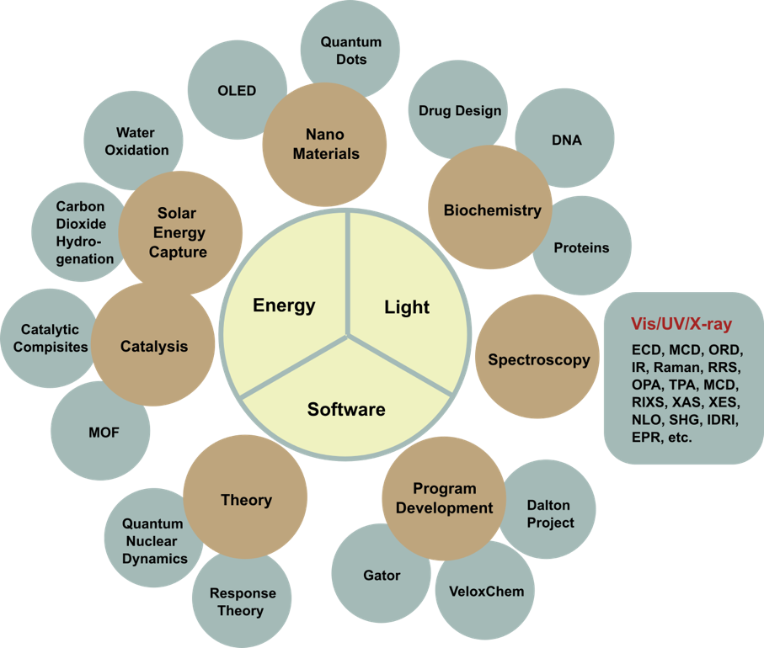
Figure 22. Overview of research activities at TCB.
Many research activities at TCB are multi-disciplinary in nature. As an example, let us consider catalysis. This is a direction driven by Prof. Ahlquist, centered around molecular catalysis on transition metal containing complexes. Historically, standard DFT methods have been used to elucidate reaction mechanisms and to identify key species in catalytic processes. Specifically, small molecule activation reactions have been in focus, including water oxidation, proton reduction, carbon dioxide reduction, and related reactions, which all relate to storage of energy and conversion of low energy compounds to chemical feedstocks. Lately, the focus has been directed towards studies of molecular catalysts in complex systems. Such systems include fully solvated systems, liquid-solid interfaces, and metal-organic frameworks (MOFs). As the system complexity increases, so does the need to have access to software programs beyond what is publicly or commercially available. Within TCB, we will respond to this need and steer our software development activities accordingly. That will bring in team members with expertise in quantum theory, applied mathematics, algorithmic development, and parallel programming. We see this as a unique strength in Swedish theoretical chemistry, that is the existence of an in-house spectrum of competences that enables multi-disciplinary collaborations to strengthen each other’s activities.
We have identified one gap in the TCB knowledge profile that we believe will become increasingly important to address in the near future as experiments reach new limits in the resolution of time and space. Ultra-fast spectroscopy does already and will even more so in the future enable the probing of non-stationary states of molecular systems and map the electronic and molecular dynamics in chemical reactions. Several groups around the world have worked already for years on the development of tools for simulations of time-resolved phenomena and it is quite unrealistic for us to start from nowhere and catch up with the state-of-the-art. We are not completely without theoretical expertise as such since the team around Dr. Victor Kimberg and Prof. Faris Gel’mukhanov has very successfully conducted quantum nuclear dynamics modeling beyond the Born-Oppenheimer approximation, but the developed software has only targeted small molecules with few degrees of freedom. To advance this direction to more generic applicability in chemistry, we will need to strengthen our competences. TCB will therefore recruit a new junior faculty member within the subject matter of quantum molecular dynamics.

Contributions to the advancement of the state of the art within the research fields of the department
Two highlights:
- Software development: VeloxChem is the first quantum chemical software that can be used on new computer architectures, where massive parallelization is necessary. The first version of the code was released during 2020. It will allow for studies of systems of unprecedented size using quantum chemical approaches, meaning that completely new areas of science can be addressed.
- Catalysis: Models based on the empirical valence bond description of a reaction has been developed for studying a range of transition metal catalysts including several Ru based systems, cobalt porphyrin, iron porphyrins in MOFs and more systems are currently under development. Ahlquist’s first study of Ru catalysts at carbon nanotube/water interfaces was the first study that addressed the effect of the support material on a key step in molecular catalysis (J. Am. Chem. Soc. 2018). A modular model for MOFs has recently been developed which allows for facile studies of MOFs using different linkers of nodes. This model is used to study phenomena such as ion-limited conductivity of electrocatalytic MOFs, which is unchartered territory in catalysis.

Quality and quantity of contributions to the body of scientific knowledge
Averaged over the period of 2012–2018, the collective average output of TCB amounts to 65 articles per year, only considering those appearing in international peer reviewed journals. Furthermore, TCB has published 13 book chapters and 1 book during this period. Normalized against the number of people, these publication statistics are high seen in the perspective of other units at KTH. See Figures 23–24 for a statistics summary.
Ten selected recent publications:
- S. Zhan and M.S.G. Ahlquist, Dynamics and Reactions of Molecular Ru Catalysts at Carbon Nanotube-Water Interfaces, J. Am. Chem. Soc. 140 (2018) 7498-7503 https://doi.org/10.1021/jacs.8b00433
- X. Li, G.V. Baryshnikov, C. Deng, X. Bao, B. Wu, Y. Zhou, H. Ågren and L. Zhu, A three-dimensional ratiometric sensing strategy on unimolecular fluorescence-thermally activated delayed fluorescence dual emission, Nat. Commun. 10 (2019) 731. https://doi.org/10.1038/s41467-019-08684-2
- S.K. Mudedla, N.A. Murugan, and H. Ågren, Effect of Familial Mutations on the Interconversion of alpha-Helix to beta-Sheet Structures in an Amyloid-Forming Peptide: Insight from Umbrella Sampling Simulations, ACS Chem. Neurosci. 10 (2019) 1347-1354. https://doi.org/10.1021/acschemneuro.8b00425
- S. Masys, Z. Rinkevicius and J. Tamuliene, Electronic g-tensors of nanodiamonds: Dependence on the size, shape, and surface functionalization, J. Chem. Phys. 151 (2019) 144305 https://doi.org/10.1063/1.5121849
- Y. Zhou, R. Zou, G. Kuang, B. Långström, C. Halldin, H. Ågren and Y. Tu, Enhanced sampling simulations of ligand unbinding kinetics controlled by protein conformational changes, J. Chem. Inf. Model. 59 (2019) 3910-3918. https://doi.org/10.1021/acs.jcim.9b00523
- S. Duan, Z. Rinkevicius, G. Tian and Y. Luo, Optomagnetic effect induced by magnetized nanocavity plasmon, J. Am. Chem. Soc. 141 (2019) 13795-13798. https://doi.org/10.1021/jacs.9b07817
- Z. Rinkevicius, X. Li, O. Vahtras, K. Ahmadzadeh, M. Brand, M. Ringholm, …and P. Norman, VeloxChem: A Python-driven density-functional theory program for spectroscopy simulations in high-performance computing environments, WIREs Comput. Mol. Sci. 10 (2020) e1457. https://doi.org/10.1002/wcms.1457
- N.H. List, J. Knoops, J. Rubio-Magnieto, J. Idé, D. Beljonne, P. Norman, … and M. Linares, Origin of DNA-Induced Circular Dichroism in a Minor-Groove Binder, J. Am. Chem. Soc. 139 (2017) 14947-14953. https://doi.org/10.1021/jacs.7b05994
- V.V. da Cruz, F. Gel’mukhanov, S. Eckert, M. Iannuzzi, E. Ertan, A. Pietzsch, … V. Kimberg, A. Föhlich and M. Odelius, Probing hydrogen bond strength in liquid water by resonant inelastic X-ray scattering, Nat. Commun. 10 (2019) 1013 https://doi.org/10.1038/s41467-019-08979-4
- J. Zheng, J. Jongcharoenkamol, B.B.C. Peters, J. Guhl, S. Ponra, M.S.G. Ahlquist and P.G. Andersson, Iridium-catalysed enantioselective formal deoxygenation of racemic alcohols via asymmetric hydrogenation, Nat. Catal. 2 (2019) 1093-1100. https://doi.org/10.1038/s41929-019-0375-7
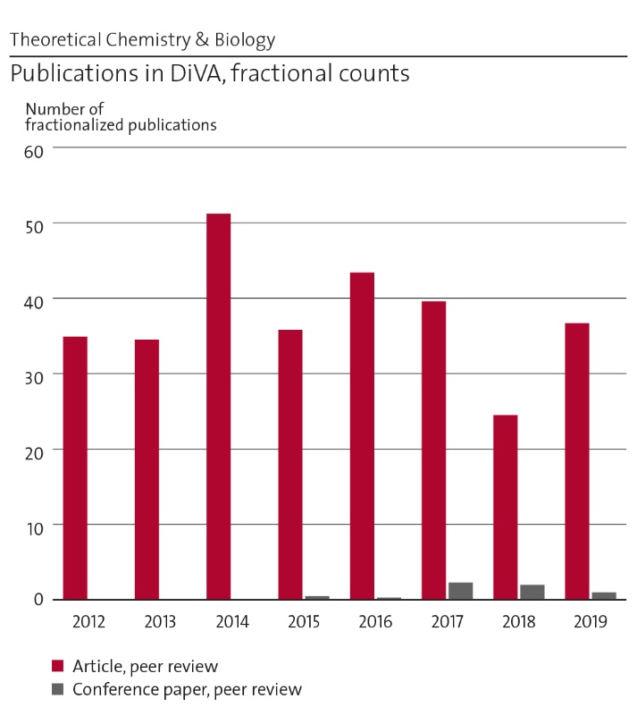
Figure 23: Number of fractionalized publications 2012-2019.

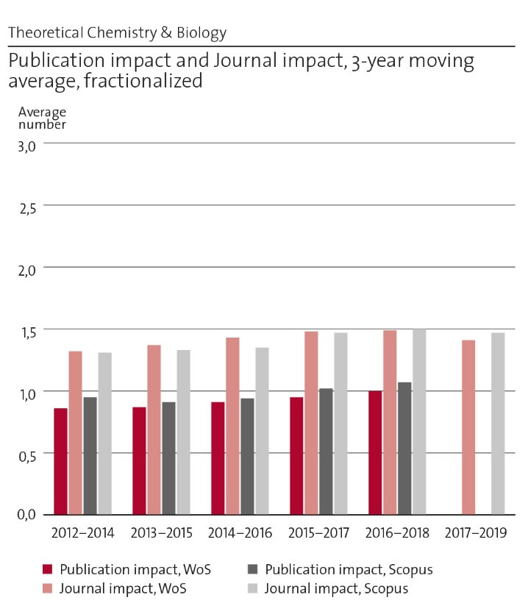
Figure 24: Publication impact and journal impact.
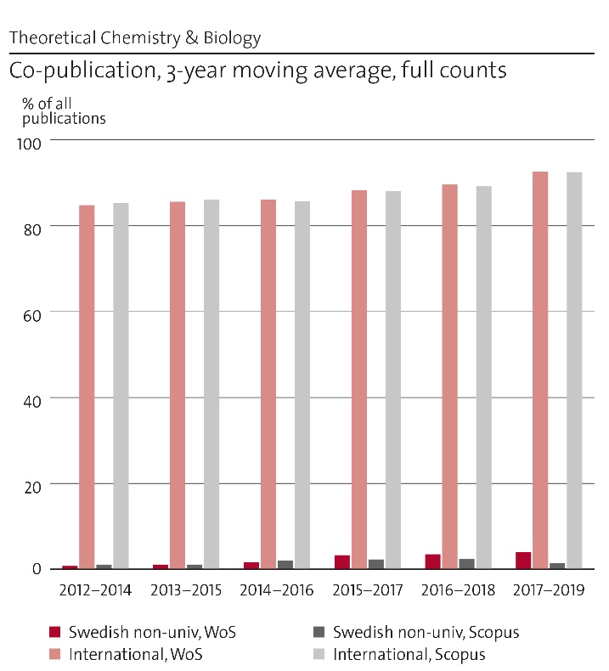
Figure 25: International and national co-publication.

Engagement in national and international research collaboration within academia and its outcomes
We have a high degree of international collaboration as reflected in a correspondingly high degree of joint international publications, see Figure 25. Presently, the most significant research collaborations include:
- CATSS: KAW project on Catalytic Composites for Sustainable Synthesis. The goal of the project is to develop new catalytic composite materials for sustainable synthesis of high value products.
- NordCO2: a Nordic university hub with member universities from all Nordic countries. The focus of this network is at the utilization of CO2 as a chemical feedstock and as a starting material for sustainable fuel production.
- COSINE: A European Innovative Training Network (ITN) on Computational Spectroscopy. We coherently train 14 PhD students at 8 leading European nodes.
- USTC: A bilateral agreement between TCB and HFNL facilitated by the shared professorship of Prof. Yi Luo.

Follow up from previous evaluations
The evaluation of TCB in RAE2012 contained the following two points:
- The potential of collaboration of the Unit of Assessment (UoA) is enormous. It may appear strange that other units at KTH, in need of modeling capacities, do not profit more from the unit of Theoretical Chemistry.
- Modeling is based on a) development of theory, b) implementation into computer programs, and c) applications. Under the contract pressure, preference is given to the latter (c). While in the past about 50% of the efforts were devoted to methodology, this share has now decreased to about 30%. This is not a recommended trend, particularly considering that there are many computational groups in other UoAs engaged in applications. Thus, in the future, the development of more efficient methodologies and their implementation should be given full attention.
The first point largely remains. We are now setting this point in focus and believe that the new school organization and TCB’s relocation to Campus Valhallavägen will improve on this point. The second point has largely been addressed after Prof. Patrick Norman became head of TCB in mid 2016. We now have a coherent initiative in software development that makes up for about 50% of our activities.

Viability

Funding; internal and external
Our level of research funding is illustrated in Figure 26. We identify three developments that affect our funding of research:
- TCB finds reduced opportunities to have international PhD students on scholarship funding, something that earlier could often be done with financing from home institute (primarily located in Brazil, Russia, and China).
- TCB should to a larger degree be part of larger research constellations at KTH as e.g. the Wallenberg Wood Science Center, WWSC.
- TCB has strategically reduced the number of researchers since Prof. Norman became Head of TCB. As the researcher position comes without internal funding, we find it difficult to maintain researchers in the long-term perspective and they add to the financial instability of the department as a whole. Countering this trend, TCB has in 2021 employed two new researchers following their successful starting grant applications to the Swedish Research Council (VR). VR wishes to provide opportunity for the most talented young researchers regardless of whether or not they are members of faculty. Given the competitive nature of these calls, institutions feel obliged to support applications from strong candidates that wish to compete for these means under the umbrella of the institution (also since it is a sign of a successful institution). But this situation is precarious as, it “forces” the recruitment of researchers without a long-term and sustainable faculty employment and the starting grant barely covers even the full salary costs of the researcher. We would wish to see that VR changes this policy and instead limit these calls to young members of faculty. This would shift the focus on the competition among young researchers from the VR call to the university recruitments of assistant professors and provide the winners of these recruitments with much better odds of receiving a kickstart in their careers. For them, a starting grant would be truly possible to leverage as project funding.
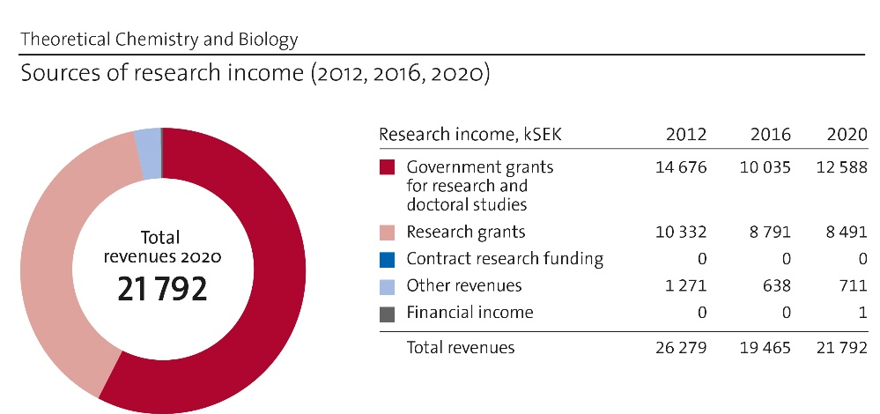
Figure 26: Comparison of research income in 2012, 2016 and 2020.

Academic culture
- Internal seminars (weekly) provide a training ground for our postdocs and PhD students to present research and to critically assess the research of others. These seminars also serve the purpose of keeping everyone informed about the widespread department research activities and broaden the horizon beyond one's own specialty.
- Invited seminars (ca 10 per year) provide the stimulus for getting new ideas and forming new projects, a bit like attending a conference but with the added benefit of being able to get in depth and engage in discussions.
- Visiting scientists and collaborators represent a way to drive collaborative projects forward. Intense, brief, and focused meetings of this sort bring momentum into the projects.

The current staff situation at TCB is illustrated in Figure 27 and compared to previous years. At present:
- All faculty members are men at the age of 40+ years.
- Junior faculty (assistant professor) is presently missing.
- A recruitment has taken place during 2020–2021 of an assistant professor and our encouraging excellent female candidates to apply did pay off, resulting in a female assistant professor starting with us during the fall semester.
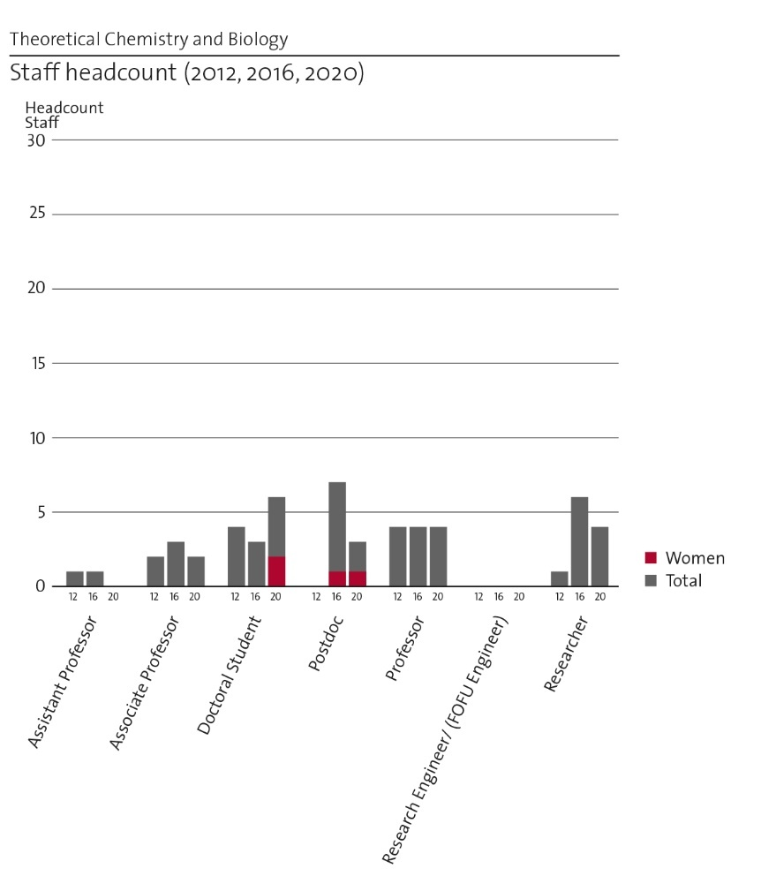
Figure 27: Comparison of staff development in 2012, 2016 and 2020.

Recruitment strategies
For recruitment of PhD students and postdocs, TCB adopts a combination of networks and announced positions. TCB has a low recruitment base from education and consequently few students with a master degree from KTH.

Infrastructure and facilities
We see the layer of permanently employed experts in parallel programming as an infrastructure and we successfully argued with the KTH leadership for this view in the 2017 call for internal infrastructure funding. This was a turning point for our efforts in software development and it has now expanded to become an integrated and strong collaboration with PDC as detailed above.

Strategies and organisation

Goals for development 5–10 years ahead
- European leading developer of software for quantum molecular modeling on HPC systems. This is carried out together with a few selected European partner organizations.
- A sustained engagement in at least two projects on the national and/or European scale.
- To have seen the junior faculty member established her/himself on the national research arena.
- To have actively started looking for the next junior faculty member.
- To have a leading position in Swedish theoretical chemistry.
- To have developed a physical and also a virtual Theoretical Chemistry Software School for an international audience to promote the spread of the developed software.
- To keep delivering an international PhD school on Molecular Properties and based on the book titled Principles and Practices of Molecular Properties (Wiley, 2018).
- To be considered as a leading European site for theoretical catalysis.
- To organize at least one international meeting in each of the subjects catalysis and/or software development.

Congruence with university-level goals for “A leading KTH” as set out in KTH´s “Development Plan 2018-23” (page 5)
In the development plan, the President declares: “Everyone connected to KTH can participate in striving towards the leading, integrated, visible, open, increasingly digitalised, more sustainable, more international and more equal KTH”. TCB tries to live up to this ambition by
- Development of electronic course in molecular modeling with TCB software
- Use of our developed research software in undergraduate teaching, e.g. in Molecular Modeling (BB2280) and Molecular Quantum Mechanics (CB2070)
- Development of international PhD course in Molecular Response Properties as directly coupled to TCB research
- Utilization of the local supercomputer center (PDC) as to train students in state-of-the-art scientific parallel programming
- Formation of two strong international research collaborations: (i) a partnership with University of Heidelberg and (ii) a joint doctoral program with the University of Science (UHEI) and Technology of China (USTC)
- TCB is strategically international in terms of collaborative networks and publication culture as to strive for high visibility
- Priority in research connected with sustainability
- Increased amount of video meetings (Zoom, Skype, …) and less traveling
- TCB actively strives to get female representation in its faculty
In regard with the CBH school development plan, TCB actively seeks new collaborations with other units within the university and CBH school as to strengthen the quality of our as well as their research.

Leadership structure and collegial structure
- Prefekt executive
- TCB steering group (prefekt is chairman)
- APT workplace meetings (monthly) with all members of TCB

Strategies for high quality
TCB adopts the following measures of quality:
- Success in international peer review publishing of articles
- Success in external grant applications
- Student course evaluations
TCB is a small department, enabling steering and assessment via daily discussions.

Interaction between research and teaching at all three levels (BSc, MSc, PhD) of education
Three important points in the interaction between research and teaching have been identified:
- The curriculum of PhD courses is designed to meet the needs in our research.
- The fact that TCB has few (presently zero) diploma projects has ramifications on our research as discussed above.
- Illustrative research presentations are made in our undergraduate teaching as to stimulate the interest of young students for modeling activities.
Presently, TCB conducts teaching in the following courses:
PhD program
- Computational Chemistry FCK3001
- Computational Python BB3110
- Molecular Response Theory and Spectroscopy FKE3150
- Multiscale Modelling in Chemistry and Biology BB3570
- Recent Literature in Theoretical Chemistry and Biology BB3480
- Research Presentation in Theoretical Chemistry and Biology BB3470
- Quantum Dynamics BB3130
MSc Courses
- Molecular Modeling BB2280
- Project in Molecular Modeling BB2285
- Molecular Quantum Mechanics CB2070
- Multiscale Modeling BB2540
BSc Courses
- Physical Biochemistry KD1500
- Programming in Python BB1000

Impact and engagement in society

Relevance of research to society at large
In general, we conduct basic science research and are not close to the device stage but we conduct some work of relevance outside academia, namely
- Collaboration with the Swedish Defence Research Agency (FOI) and the American Air Force Research Laboratory (AFRL, Dayton, Ohio) for the development of passive device protection against laser damage
- Developer of open source software for quantum molecular modeling primarily targeting academia but with an already noted interest from the pharmaceutical industry (AstraZeneca)

Research dissemination beyond academia
- We communicate our research to FOI and its U.S. partner organizations
- Initiated discussions with the modeling group at AstraZeneca in Mölndal for integration of VeloxChem in their workflow.

Sustainability and the United Nations’ Sustainable Development Goals (SDG)
It is estimated that overall some 20-40% of TCB’s activities are related to sustainable development and Energy is nowadays one out of three research themes at TCB. Lately, this part of our research has become significantly more profiled, which is reflected by the promotion of Mårten Ahlquist to become professor and vice head of department.
The work in the group of Prof. Mårten Ahlquist revolves around small molecule activation in relation to energy storage, for example via artificial photosynthesis. Models have been developed for studies of catalysts at complex interfaces that can fully account for dynamic properties relevant to the system. Much of the work is performed in close collaboration with experimental groups at KTH, SU, Uppsala University, DTU and Aarhus University. TCB is a member of two larger research networks that are fully aimed at sustainable development of chemicals and fuels namely NordCO2 and CATSS.
NordCO2 is a network of universities from all Nordic countries for utilization of carbon dioxide as a chemical feedstock and as an energy carrier via reduction. The consortium has ten nodes and is funded by Nordforsk. TCB has been the host for an open science workshop (2019) and conducted teaching at a winter school in Uppsala (2019).
CATSS involves six research groups at KTH and Stockholm university, and is funded by the KAW foundation. The aim is to develop new catalytic materials for sustainable synthesis of high value chemicals. The material is a composite of an electrocatalytic material and a non-redox active chemical catalyst. In this way hydrogenation and carbonylation reactions could be achieved using water and carbon dioxide as the starting materials.
Docent Haichun Liu and Prof. Hans Ågren utilize and advance the state-of-art in experimentation and modeling to control light and energy transfer in rare earth complexes and explore their functionality in terms of chemical and electronic structure and of extended environments. The outcome refers to new generation efficient IR-to-visible upconverting nanomaterials with a judicious control of the emission colors. It has been implemented in prototype solar cells, and was recently combined with nanolenses, leading to improved efficiency.

Structure for increased impact
TCB has no developed processes, procedures, or mechanisms to promote its societal impact. Opportunities are rare and handled on a case-to-case basis.

Other

Specifics that the department wishes to mention and describe
TCB agrees with the identified panel-wide issues of external character that are described in Section A of this report and that threatens to reduce our strength and competitiveness.

IMPACT CASES

Impact cases - Chemistry

Impact case 1 – Environmental and health risks related to metals

Summary of the impact
Metals are vital for a modern society in both traditional and novel applications ranging from e.g. energy and transport to health-care, electronics, consumer products and infrastructure. For a sustainable use of metals in the industrialized society it is essential that their environmental foot-prints are maintained at a fair level and that no adverse effects are induced on either human health or the environment. The global awareness of such risks has resulted in global commitments such as the implementation of the Globally Harmonised System of Classification and Labelling of Chemicals (UN GHS, 2015) and the implementation of the REACH framework within EU (Registration, Evaluation, Authorisation and Restriction of Chemicals) (EU, 2006).
The Odnevall Wallinder team at SCS has during the past 25 years, in close collaboration with academic partners, international metal associations and enterprises, stakeholders and environmental and health risk assessment bodies, performed both fundamental and applied research to fill knowledge gaps related to environmental and health aspects induced by metals in societal applications. Studies have been performed to correlate changes in material properties and surface characteristics to the extent of diffusely dispersed and migrated metals and their connections to environmental fate and toxicity. These efforts were initiated in response to an environmental concern over adverse environmental effects prompted by metal release and dispersion from outdoor constructions. This evolved later on, partly in collaboration with e.g. toxicologists, to other areas focusing on aspects of relevance for food, implants, medical devices, consumer products, high-touch surfaces etc.
Investigations have been performed on various kind of metallic surfaces ranging from differently manufactured massive surfaces to engineered and non-intentionally formed (nano)particles. Underlying mechanisms and relations to bioavailability and surface characteristics have been elucidated for a multitude of environments and exposure settings such as different biologically relevant fluids of varying chemistry and composition (e.g. rainwater, body fluids, food simulants, environmental waters etc.). This research has, in addition to scientific publications, resulted in a large number of novel scientifically supported findings directly applicable in risk management and assessment, as well as in the elaboration of novel methods and operational protocols and improved standards.

Underpinning research
Quantitative bioaccessibility data, linked to changes in material- and surface characteristics, has been generated for a large number of metals, alloys, metal oxides, pigments etc. and used by national and international metal consortia in the mandatory registration dossiers, required within the framework of REACH to register chemicals and products, hence regulating the use of also metals and alloys. Generated data is integrated in registration dossiers for REACH as well as in environmental and health risk assessments and managements worldwide, e.g. for Fe-Cr alloys, Mo metals, Fe-Si alloys, Ag, Sn, Sb. The provision of bioaccessibility data for groups of metals and alloys limits e.g. the need for animal testing and enables grouping, classification and labelling (CLP) of chemicals of relevance for regulatory purposes such as REACH. Increased knowledge has enabled relevant countermeasures to be taken and provided necessary knowledge for safe-by-design measures. Research efforts to estimate potential adverse health effects using only in-vitro testing culminated in collaboration with international industry represented by Eurometaux (European Non-ferrous Metals Association) and Nipera (International Nickel Institute). The KTH protocol (based on research between 1998-2016) served as a base for a standardized bioelution testing operational protocol, initially focusing on the oral/gastrointestinal route to be followed by protocols for the inhalation and dermal routes. In 2016 ECVAM, the European Union Reference Laboratory for alternatives to animal testing, agreed to assess the bioelution protocol based on the work at KTH. The submission assessment and the stage of validation were finalized in 2019, and the protocol is currently drafted as a new regulatory standard/guideline. Other examples include e.g. the research conducted together with the International Stainless Steel Forum, ISSF performing compliance tests of stainless steel as a food contact material using the CoEtest guideline, the work on reducing welding fume toxicity performed in collaboration with international industry and academic partners, and data generated to improve life cycle impact assessment of metal ecotoxicity.

Relevant research papers:
- Y.S. Hedberg and I. Odnevall Wallinder, Metal release from stainless steel in biological environments – a review, Biointerphases – special issue on Ions and Solvation at Biointerphases, 11 (2016) 018901-1 018901-17. https://doi.org/10.1116/1.4934628.
- X. Wang, J. Noel, I. Odnevall Wallinder and Y. Hedberg, Metal bioaccessibility in synthetic body fluids - a way to consider positive and negative alloying effects in hazard assessments, Mater. Design, 198 (2021) 109393.
- X. Wang, G. Herting, Z. Wei, I. Odnevall Wallinder and Y. Hedberg, Bioaccessibility of nickel and cobalt in powders and massive forms of stainless steel, nickel- or cobalt-based alloys, and nickel and cobalt metals in artificial sweat, Regul. Toxicol. Pharmacol. 106 (2019) 15-26, https://doi.org/10.1016/j.yrtph.2019.04.017.
- Y. Hedberg, Z. Wei and I. Odnevall Wallinder, Cobalt release testing from several stainless steel grades according to the European test guideline for metals and alloys used in food contact materials and articles, technical report, commissioned by the International Stainless Steel Forum, Belgium (2017)
- R. Henderson, V. Verougstraete, K. Anderson, J. Arbildua, T. Brock, T. Brouwers, Tony, D. Cappellini, K. Delbeke, G. Herting, G. Hixon, I. Odnevall Wallinder, P. Rodriguez, F. Van Assche, P. Wilrich and A. Oller, Inter-laboratory Validation of Bioaccessibility Testing for Metals, Regul. Toxicol. Pharmacol. 70 (2014) 170–181.
- H. Stockmann-Juvala, Y. Hedberg, N.K. Dhinsa, D.R. Griffiths, P.N. Brooks, A. Zitting, I. Odnevall Wallinder and T. Santonen, Inhalation toxicity of 316L stainless steel powder in relation to bioaccessibility, Hum. Exp. Toxicol. 32 (2013) 1137–1154.
- Y. Hedberg, N. Mazinanian and I. Odnevall Wallinder, Metal release from stainless steel powders and massive sheet –comparisons and implications for risk assessment of alloys, Environ. Sci. Processes Impacts 15 (2013) 381-392.

Sources to corroborate the impact
The team has published >80 scientific papers in peer-reviewed scientific journals on topics related to metal dispersion, migration and/or bioelution testing (outdoor constructions excluded), completed >50 international industry reports used in REACH dossiers and for risk management and assessment at, 9 academic theses, large no. of popular papers and presentations, see in detail at https://www.kth.se/profile/ingero/) and at selected links and research articles above.

Impact case 2 – Mucus engineering for women’s reproductive health

Summary of the impact
The Crouzier group at GLY is taking a unique approach to the fundamental and applied research on mucin biopolymers, which are glycoprotein materials (40% protein, 60% sugars) that form the mucus gels that covers our wet epithelium (lungs, gastrointestinal tract, female genital tract). By considering the mucus gel as a material that can be engineered, the Crouzier group has succeeded in the engineering of mucins towards the design of advanced biomaterials with controlled immunomodulatory responses.

Underpinning research
A mucus engineering approach currently being developed by the Crouzier group to involves a novel mechanism of action for a new class of female contraceptive. The method consists in reinforcing the cervical mucus barrier with mucoadhesive crosslinkers, providing instant protection without the systemic side effects from hormonal contraceptives. The last mechanism of action in female was developed in the 1960s with hormonal contraception, which have transformed our societies in profound ways. But the lack of innovation since has left women that wish to avoid hormonal methods with very limited options. The technology developed by the Crouzier group could lead to a new on de demand non-hormonal contraceptive that fill a clearly unmet need. Improved control of reproduction is an important point within the UN Sustainable Development Goal 5 that puts emphasis on enabling females to make their own decisions regarding sexuality and reproduction. The research conducted provided novel insights in various biomaterials fields, including the foreign body response to implanted biomaterials. Mucin-based biomaterials could improve cell transplants, probiotic treatment, and wound dressing performance. All related aspects are under investigation in partnership with Swedish and international collaborators.

Relevant research papers:
- K. Jiang, H.J. Yan, C. Rickert, M. Marczynski, K. Sixtensson, F. Vilaplana, O. Lieleg and T. Crouzier, Modulating the Bioactivity of Mucin Hydrogels with Crosslinking Architecture, Adv. Funct. Mater. (2021) 2008428.
- H.J. Yan, M. Hjorth, B. Winkeljann, I. Dobryden, O. Lieleg and T. Crouzier, Glyco-Modification of Mucin Hydrogels to Investigate Their Immune Activity, ACS Appl. Mater. Interfaces 12 (2020) 19324-19336.
- M. Marczynski, B.N. Balzer, K. Jiang, T.M. Lutz, T. Crouzier and O. Lieleg, Charged glycan residues critically contribute to the adsorption and lubricity of mucins, Colloids Surf. B 187 (2020) 110614.
- U. Schimpf, G. Nachmann, S. Trombotto, P. Houska, H.J. Yang, L. Bjorndahl and T. Crouzier, Assessment of Oligo-Chitosan Biocompatibility toward Human Spermatozoa, ACS Appl. Mater. Interfaces 11 (2019) 46572-46584.
- H. Yan, C. Seignez, M. Hjorth, B. Winkeljann, M. Blakeley, O. Lieleg, M. Phillipson and T. Crouzier, Immune-Informed Mucin Hydrogels Evade Fibrotic Foreign Body Response In Vivo, Adv. Funct. Mater. 26 (2019) 1902581.

Sources to corroborate the impact
KTH Innovation has provided important support to enable a first patent to be filed, which then led to the creation of the spin-off company Cirqle Biomedical early 2019, which has raised over €4M in investments and grants for pre-clinical demonstration and further business development. The company has hired a team of 4 researchers and has made significant advances in demonstrating the technology in large animal model (sheep). The company recently received support from the USAID development agency from the USA for its potential to delivery low-cost non-hormonal contraceptive to the developing world. Other public and private organizations have awarded funding to Cirqle Biomedical, recognizing the importance of the work, including Rhia Ventures, BioInnovation Institute, the NIH of the USA, the European Commission, and Denmark’s Innovation funds. The new scientific approach to contraception and the large commercial potential with the company have also attracted attention and featured at world-class innovation conference including Hello Tomorrow (Paris) and SXSW (USA). The Crouzier group at KTH is participating in the development of the next generation of the technology through a Eurostars project “Proof of concept for a hormone-free, easy to use, non-invasive contraceptive for women”.
Due to the large impact of the novel contraceptive approach developed by Cirqle Biomedical for public health and gender equality, this work has received special attention in general media:
https://www.information.dk/indland/2020/11/forsker-ivaerksaetter-fremtidens-praevention-vaere-hormonfri,
www.healtheuropa.eu/new-non-hormonal-contraceptive-developed/85143/, www.ottar.se/artiklar/hormonfritt-p-piller-forskas-fram-p-kth, www.ctiexchange.org/post/blocking-sperm-by-reinforcing-cervical-mucus)
https://www.eu-startups.com/2020/03/10-promising-femtech-startups-to-watch-in-2020-womens-day-special/, https://sifted.eu/articles/europe-femtech-2020/

Impact case 3 – Downstream bioprocessing makes medicines

Summary of the impact
One basic idea of modern biomedicine is remarkably simple - you just stich a gene into innocent bacteria and, voilà, there pours out those new proteins/peptides/drugs coded by the gene that cure cancer or make you thin or just let you live forever. Unfortunately, there pours out a lot more, the same being true for virtually any pharmaceutical production process. Modern (bio)pharmaceuticals all depend on one being able to separate the (tiny) wheat from the (humongous) chaff and the method that comes our rescue is called affinity chromatography. The systems may take the form of porous membranes or columns of porous chromatographic particle packs, and affinities are lent by suitable ligands decorating the large surface made available by the porous matrix. The desired molecules bind to the ligands and are retained while the rest of the mixture components pass. At the end, the desired molecules are released and collected.
Cytiva (until 2019, GE Healthcare Biopharma, in Uppsala) is a leading global producer of downstream bioprocess technologies, systems and materials for chromatography. The Furó group at APC has a longstanding collaboration with Cytiva including, for example, industrial PhD and MSc students. Joint past projects were aimed, for example, at physical structures in membranes and chromatography beads or at quantitative analysis of the concentration of ligands, absolutely essential features that have the defining impact on chromatographic performance such as molecular selectivity and throughput. Chromatography beads produced by Cytiva are based on cross-linked gels of agarose, a polysaccharide sustainably harvested form algae. Because of the biological origin, the actual gelling process is influenced by a number of variables and part of the ongoing research is aimed at understanding and controlling the effect of those material parameters whose natural variation would otherwise impact the product. As any pharmaceutical methodology, chromatographic materials must present a stringently defined reproducibility regarding their function.

Underpinning research
The research performed can be roughly lumped into three general areas (i) the behavior of the agarose- and cellulose-based matrices during production, (ii) the physical properties of the matrices produced, and (iii) the quantitative analysis of the ligand concentration of the final products. Area (i) is very broad and stretches from the effect of a wide range of physico-chemical features on agarose gelation to the structure of electrospun fiber networks as prepared and over the process of extensive chemical modification. The research performed here is not method-driven but belongs more to general physical chemistry and, typically, is not for dissemination in public domain. In area (ii), the porous network properties of the matrices were in the focus and investigated by a variety of methods the foremost of which is diffusion NMR where Furó has a considerable expertise. As diffusive transport has a major influence on chromatographic performance, any features affecting that are of interest. Hence, the effect of molecular interactions with the matrix were explored. Conversely, characterizing pore size distribution and pore interconnectivity with diffusion NMR was directed to understand and assess the final physical state of the matrices. Area (iii) was mainly directed towards quality control (QC) of the final products, an area paramount for pharma applications. In the long-going (over 5+ years) effort the main question was if the heterogeneous approach to QC (separate methods for separate products, possibly of suboptimal performance and often based on wet chemistry) could be replaced by a more uniform approach based on NMR spectroscopy. The chemical specificity of NMR and thereby its selectivity regarding ligands was never in question. Yet, it remained unclear for a long time if high-resolution solid-state NMR methods where relatively soft and heterogeneous materials are subjected to very high centrifugal forces caused by >10 kHz sample spinning can be made highly accurate. The resulting method is currently (feb 2021) in the stage of protocol transfer from R&D to QC.

Relevant research papers:
- F. Elwinger, and I. Furó, High resolution magic angle spinning 1H NMR measurement of ligand concentration in solvent-saturated chromatographic beads, Magn. Reson. Chem. 54 (2016) 291-297.
- F. Elwinger, P. Pourmand and I. Furó, Diffusive transport in pores. Tortuosity and molecular interaction with the pore wall, J. Phys. Chem. C 121 (2017) 13757–13764.
- F. Elwinger, J. Wernersson and I. Furó, Quantifying size exclusion by diffusion NMR: A versatile method to measure pore access and pore size, Anal. Chem. 90 (2018) 11431-11438.

Sources to corroborate the impact
The internal reports prepared at and for GEHC/Cytiva are confidential. Furó is also part-time employed at Cytiva AB, Uppsala as Principal Scientist (employment unfortunately on hold for 2021, so that Furó as Head of the Department of Chemistry can concentrate on administrative issues like the rebuilding of our premises and other things including, for example, this RAE) to with tasks that involve (i) advisory and internal review functions not only in R&D but also regarding Production and QC and (ii) particular advisory function in Analytical Technologies. As further evidence, a quote follows from and internal evaluation of the SSF (Swedish Foundation for Strategic Research) project that served as initiator for this collaboration:
“De aktiviteter som initerats så långt visar på en mycket lyckad integrering av lstvans roll, och hans vetenskapliga bidrag har redan skapat värde för flera pågående F&U projekt. Detta tack vare lstvans expertis och personliga egenskaper, men ocksa som en funktion den mångfald av tekniska forsksningsprojekt som bedrivs på GEHC Uppsala siten, vilket är en mycket passande miljö for denna typen av utbyte. De pågående aktiviteterna har ocksa möjliggjort for KTH och GEHC att planera för vidare framtida samverkansprojekt som examensarbeten och doktorandtjänster.” That is:
“Those activities that were initiated so far show a very good integration of [Furós] role and his scientific contributions have already created value for several R&D projects. This has been made possible by [Furós] expertise and personal attributes but also permitted by the diversity of the technical research projects pursued at GEHC Uppsala site which is a very suitable environment for this type of exchanges. The ongoing activities have also made possible for KTH and GEHC to plan for more future cooperation such as in master thesis and PhD projects.”

Impact cases – Chemical Engineering

Impact case 4 - Electrification of the transport sector
Electrification of the transport sector is one of the most important technical transitions currently underway. The furthest point in this process has been achieved for passenger cars, but buses and heavy transport now also start to be in focus. However, the change does not stop at road transport, but will in the long run also include ships, trains and aircrafts. The possibility to store electrical energy onboard a vehicle, using batteries or hydrogen gas and fuel cells, is key in this development.
Sweden is a large producer of cars and trucks, with companies like Scania CV AB, AB Volvo and Volvo Cars, but also has manufacturers of batteries and fuel cells, Northvolt and Powercell. Electromobility affects the society and total energy system and is linked to the increased use of renewable electricity production. Thus, energy companies like Vattenfall are trying to find their role in this ongoing transition.
Knowledge and persons trained in the field are limiting factors in the ongoing transition and the role of universities is central.

Summary of the impact
The impact on the society of the doctoral students examined at the department, and today key players at the companies, is far more important than the imprint in science. Just to give a few examples, former doctoral students are today boosting research and development of battery and fuel cell powered trucks and buses at Scania. Powercell, a leading European fuel cell manufacturer, established based on research conducted at the department, has KTH alumni in leading positions. The fast-growing battery manufacturer Northvolt has hired four PhDs from the department just the last two years to work with their battery development. Additionally, PhD students from the department are employed to work with battery material recycling. Most of the present and former doctoral students in electrochemistry are today involved with research and development on the electrification of the society, involving companies like ABB, Airbus, Comsol, Etteplan, Intertek, MyFC, Northvolt, Powercell, Sandvik, Scania, Vattenfall, Volvo AB, and Volvo Cars.
Research projects combining a good understanding of the applications with leading research activities on component and device level have resulted in trained PhDs with a system perspective combined with detailed electrochemical knowledge. This has proven to be a successful concept in collaboration with companies and has made us attractive as a research partner and our students attractive for employment after graduation.

Underpinning research
The current research on batteries and fuel cells started in the 1990’s but leans on an older history at the department. Large parts of the research have been conducted in collaboration with the automotive industry and other research groups and have resulted in numerous publications. The work on physics-based modelling and experimental studies on ageing in batteries and fuel cells has been especially well received. The electrochemical characterisation of new materials, e.g., catalysts and ionomer for fuel cells or electrode materials and solid electrolytes for batteries, under realistic operation conditions runs like a common thread through the projects. The modelling work has in some aspects been pioneering, e.g., the use of physics-based impedance models for analysis of performance and ageing of batteries and fuel cells. The combination of model development and careful electrochemical experiments in small specially designed cells has turned out to be extremely useful, not least in the studies of ageing of commercial lithium-ion batteries, and is today a methodology used by many research groups and companies. All the faculty members at division of Applied electrochemistry are active in this research area. The research on recovery of raw materials from used batteries is led by Kerstin Forsberg at division of Resource recovery.
Key persons: Daniel Simonsson (Prof, -1998), Per Ekdunge (Dr, -1993), Göran Lindbergh (Prof, 1992-), Göran Sundholm (Guest Prof, 1998-2003), Carina Lagergren (Prof, 2003-), Mårten Behm (Dr, 2000-2015), Ann Cornell (Prof, 2012-), Rakel Wreland Lindström (Prof, 2008-), Henrik Ekström (Dr, 2017-), Pontus Svens (Dr, 2017-), Matilda Klett (2016-2018), Åke Rasmuson (Prof, 2016-2019), Kerstin Forsberg, (Dr, 2016- )

Examples of research publications (Number of citations from Web of Science):
- P. Gode, F. Jaouen, G. Lindbergh, A. Lundblad and G. Sundholm, Influence of the composition on the structure and electrochemical characteristics of the PEFC cathode, Electrochim. Acta, 48 (2003) 4175-4187. (Number of citations: 147)
- T. Tingelöf, L. Hedström, N. Holmström, P. Alvfors and G. Lindbergh, The influence of CO2, CO and air bleed on the current distribution of a polymer electrolyte fuel cell, Int. J. Hydrog. Energy 33 (2008) 2064-2072. (Number of citations: 56)
- A. Nyman, M. Behm and G. Lindbergh, Electrochemical characterisation and modelling of the mass transport phenomena LiPF6-EC-EMC electrolyte, Electrochim. Acta 53 (2008) 6356-6365. (Number of citations: 164)
- R.W. Lindström, K. Kortsdottir, M. Wesselmark, A. Oyarce, C. Lagergren and G. Lindbergh, Active area determination of porous Pt electrodes used in polymer electrolyte fuel cells: temperature and humidity effects, J. Electrochem. Soc. 157 (2010) B1795-B1801. (Number of citations: 41)
- V. Klass, M. Behm and G. Lindbergh, A support vector machine-based state-of-health estimation method for lithium-ion batteries, J. Power Sources 270 (2014) 262-272. (Number of citations: 81)
- M. Klett, R. Eriksson, J. Groot, P. Svens, K.C. Högström, R.W. Lindström, H. Berg, T. Gustafsson, G. Lindbergh and K. Edström, Non-uniform aging of cycled commercial LiFePO4//graphite cylindrical cells revealed by post-mortem analysis, J. Power Sources 257 (2014) 126-137. (Number of citations: 113)
- K. Korkmaz., M. Alemrajabi, Å.C. Rasmuson and K.M. Forsberg, Sustainable hydrometallurgical recovery of valuable elements from spent nickel-metal hydride HEV batteries, Metals 8 (2018) 1062. (Number of citations: 9)

Sources to corroborate the impact
Contact persons:
Dr. Andreas Bodén and Dr. Thomas Tingelöf, Powercell
Dr. Pontus Svens and Dr. Verena Klass, Scania

Impact Case 5 - Efficient hydrocarbon reforming in biomass gasification conversion processes
Utilisation of residual biomass and waste by thermochemical conversion is recognised as one realizable solution with high potential to recover and introduce fossil and renewable carbon, respectively, in a future decarbonised society. An attractive technology to primarily convert a wide range of feedstocks to a raw syngas before upgrading to chemical energy carriers, is gasification at high temperature (700-1200 °C). The initial raw energy-rich gas from gasification contains considerable amounts of secondary undesired products, such as light and heavy organic compounds, which need to be removed or converted to useful syngas molecules. This has been one of the major challenges for a commercial introduction of industrial gasification-based processes for converting residual biomass and waste to chemical energy carriers on a larger scale.
Conversion or reforming of hydrocarbons in the raw syngas is most efficiently performed using a catalytic process, analogous to the well-known industrial catalytic steam reforming of hydrocarbons, where Ni-based catalysts are considered the most cost-effective choice. However, a Ni-based catalyst is exposed to a number of inorganic trace components, such as alkali (mainly K) and sulphur, as well as other trace elements present in the raw syngas from biomass and waste gasification. Especially, sulphur is of major concern due to its detrimental poisonous effect on the hydrocarbon catalytic activity of Ni, although sulphur also prevents the formation of whisker carbon above certain surface coverages. Potassium is to a certain amount added as a promoter to industrial Ni-based catalysts for steam reforming of hydrocarbons to minimize carbon formation, but, on the other hand, higher potassium concentrations reduces the catalytic steam-reforming activity.

Summary of the impact
Unique results from our research work at KTH suggests that an improved Ni-catalyst activity and an essentially carbon-free operation can be achieved in the presence of controlled amount of gas-phase potassium and high sulphur coverages on Ni. The findings are of significant importance for a stable and optimised operation of the catalytic process at high efficiency, also implying reduced maintenance cost. The findings would in the long run advance gasification-based processes and beneficiaries are technology suppliers, such as Haldor Topsoe A/S, and end users of the technology, such as petrochemical industry and pulp and paper industry.
The research activities included an initial methodology development to enable controlled experimental investigations of the hydrocarbon conversion catalytic activity of Ni-based catalysts under realistic condition using a real biomass gasification gas with a tailored gas phase content of sulphur and potassium. A combination of online gas analysis, before and after the catalytic reactor, with detailed characterisation of catalyst material samples, subsequently collected at different times during the exposure to the tailored gas, provided results to conclude on the S/K interactions on the surface and its consequence for the catalytic activity. The surface characterisation included specific surface, pore size distribution, and surface coverage of C, S and K.

Underpinning research
The starting point for the research was that previous understanding of catalytic reforming of hydrocarbons was mainly based on R&D and industrial use of Ni-based catalysts for steam reforming of fossil feedstocks, such as naphtha and natural gas. There were only very few studies of the effect of K on tar reforming catalysts and none of them were carried out under realistic steady-state operating conditions with a catalyst continuously exposed to a controlled gas phase K content together with S and Cl. Initial studies identified the significance of avoiding transient effects in catalytic performance due to catalyst sintering and S adsorption by simple methods for accelerated ageing and catalyst sulphur coverage equilibration by a pre-sulfidation procedure. This was combined with an accurate dosing of gas-phase potassium.
In conclusion, results from the studies of the Ni/MgAl2O4 showed that although K, above a certain threshold surface concentration, is known to block active Ni sites and decrease activity in traditional steam reforming, it appears to lower the surface S coverage at active Ni sites under the conditions investigated. This reduction in surface S coverage, most likely related to K-induced softening of the S/Ni bond, increases the catalytic conversion of methane and aromatics. In addition, previously unknown relevant concentrations of K during realistic operating conditions on typical Ni-based reforming catalysts, were determined for the Ni/MgAl2O4 catalyst.
Further studies painted a more comprehensive mechanistic picture of the S/K interaction with the Ni/MgAl2O4 study, and we found that the K-doped MgAl2O4 support contributed significantly to the conversion of heavy hydrocarbons, but not to the light hydrocarbon conversion. It was also established that an improved Ni/MgAl2O4 catalyst activity and an essentially carbon-free operation can be achieved in the presence of a controlled amount of gas-phase potassium and high sulphur coverages on Ni.
The research was performed in the framework of the Swedish Gasification Centre (SFC) starting 2013 and ending 2020. Preparation for applying the findings at a commercial gasification plant in Skive, Denmark, started in Spring 2020 but is still ongoing and implementation is delayed due to the pandemic situation.
Key researchers: KTH: Engvall (Prof, principal investigator), Roberto Lanza (Dr, active 2013-2015), Pouya H. Moud (Dr, PhD student 2014-2018), Efthymios Kantarelis (Dr, 2019-present), Asbel Hernandez (Dr, PhD exchange student during 2018). International collaborator: Klas J. Andersson (Dr, Haldor Topsoe A/S, Denmark)

Publications:
- P.H. Moud, K.J. Andersson, R. Lanza, J.B.C. Pettersson and K. Engvall, Effect of gas phase alkali species on tar reforming catalyst performance: Initial characterization and method development, Fuel 154 (2015) 95-106. (Number of citations: 22)
- P.H. Moud, K.J. Andersson, R. Lanza and K. Engvall, Equilibrium potassium coverage and its effect on a Ni tar reforming catalyst in alkali- and sulfur-laden biomass gasification gases, Appl. Catal. B: Environmental, 190, (2016) 137-146. (Number of citations: 27)
- A. Hernandez, K. Engvall, K.J. Andersson and E. Kantarelis, Preferential adsorption of K species and the role of support during reforming of biomass derived producer gas over sulfur passivated Ni/MgAl2O4, Energy & Fuels 34 (2020) 11103-11111. (Number of citations: 0)

Sources to corroborate the impact
Contact: Senior Researcher Dr Klas J. Andersson, Topsoe A/S, Denmark, E-mail: klja@topsoe.dk

Impact cases – Fibre and Polymer Technology

Impact case 6 - Transparent wood

Summary of the impact
A first study on transparent wood was published in 2016 (Li et al Biomacromolecules, 2016, 17, 1358) and this initiated a new paradigm in the use of wood as a substrate for advanced materials. The research was initially performed within the Wallenberg Wood Science Center (WWSC) at KTH. The WWSC initiated in 2009 has a focus on “New Materials from Trees” with large “freedom of research” i.e. totally new concepts can be studied as long as the research is of good quality. The conceptual study on transparent wood described a utilization of wood materials as designed by nature as a scaffold (or template) for totally new applications. The traditional use of forest resources as a raw material for the paper and pulp industry, forest based biorefineries, or as a construction material has thus been extended to totally new areas.
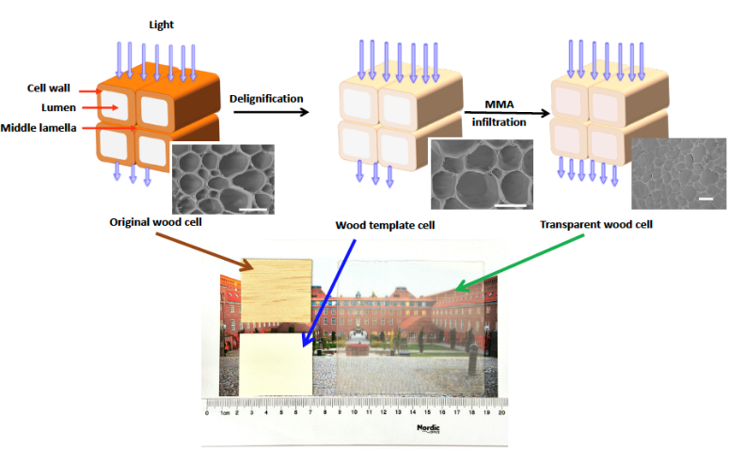
There are now more than 50 publications on the topic and the research area is rapidly expanding. A proposal on the subject also resulted in an ERC Advanced Grant (Wood NanoTech). The main research direction is currently on photonic materials: luminescent wood, a wood laser utilizing wave-guiding effects, but also transparent wood with heat storage capability. Other functional wood nanomaterials are also studied, inspired by the transparent wood materials. They are based on nanostructured wood substrates for the purpose of large-scale load-bearing structures with new functionalities. The scientific challenge is to control the nanoscale distribution of dyes, inorganic nanoparticles, specific polymers and other additives, providing new wood functionalities.
The impact of this seminal work can also be seen from the Altimetrics scoring of 566 for this first publication. The Altimetrics is a measure on the impact of this research outside the scientific community. This score is based on; news outlets, blogs, tweets, patents, and several other societal sources. More details can be found on: https://pubs.acs.org/doi/abs/10.1021/acs.biomac.6b00145.
The very rapid expansion of the field now starts show in the start of new companies and products, introduction of wood as a material in totally new applications, and a general awareness on how biobased sources can be utilized in the future towards a fossil free society.

Underpinning research
The first study on preparation and use of transparent wood in engineering applications was published in 2016 (Li et al Biomacromolecules, 2016, 17, 1358). The study has 154 citations, and altimetric of 566 and more than 34000 views (Google Scholar February 21, 20201). https://pubs.acs.org/doi/abs/10.1021/acs.biomac.6b00145
Below is a list of additional publications that has evolved from the initial research. These also show how the concept now has expanded to other areas.

References
- L.A. Berglund and I. Burgert, Bioinspired Wood Nanotechnology for Functional Materials. Adv. Mater. 30 (2018) 1704285. Web of knowledge citations 105
- C.J. Chen, Y.D. Kuang, S.Z. Zhu, I. Burgert, T. Keplinger, A. Gong, T. Li, L.A. Berglund, S.J. Eichhorn and L.B. Hu, Structure-property-function relationships of natural and engineered wood. Nat. Rev. Mater. 5 (2020) 642-666. Web of knowledge citations 24
- Q.L. Fu, F. Ansari, Q. Zhou and L.A. Berglund, Wood Nanotechnology for Strong, Mesoporous, and Hydrophobic Biocomposites for Selective Separation of Oil/Water Mixtures. ACS Nano 12 (2018) 2222-2230. Web of knowledge citations 85
- Q.L. Fu, L. Medina, Y.Y. Li, F. Carosio, A. Hajian and L.A. Berglund, Nanostructured Wood Hybrids for Fire-Retardancy Prepared by Clay Impregnation into the Cell Wall, ACS Appl. Mater. Interfaces 9 (2017) 36154-36163. Web of knowledge citations 61
- A.W. Lang, Y.Y. Li, M. De Keersmaecker, D.E. Shen, A.M. Osterholm, L.A. Berglund and J.R. Reynolds, Transparent Wood Smart Windows: Polymer Electrochromic Devices Based on Poly(3,4-Ethylenedioxythiophene):Poly(Styrene Sulfonate) Electrodes. Chemsuschem 11 (2018) 854-863. Web of knowledge citations 50
- Y.Y. Li, Q.L. Fu, R. Rojas, M. Yan, M. Lawoko and L.A. Berglund, Lignin-Retaining Transparent Wood. Chemsuschem 10 (2017) 3445-3451. Web of knowledge citations 49
- Y.Y. Li, S. Yu, J.G.C. Veinot, J. Linnros, L.A. Berglund and I. Sychugov, Luminescent Transparent Wood. Adv. Opt. Mater. 5 (2017) 1600834. Web of knowledge citations 48
- E. Vasileva, Y.Y. Li, I. Sychugov, M. Mensi, L.A. Berglund and S. Popov, Lasing from Organic Dye Molecules Embedded in Transparent Wood. Adv. Opt. Mater. 5 (2017) 1700057. Web of knowledge citations 39

Sources to corroborate the impact
One of the best ways to track the impact outside the scientific community is to use Altimetrics related to the scientific publications. Looking at the Altimetric for the initial publication on transparent wood reveals 56 news outlets, 10 blogs, 42 tweets, 2 patents, 6 facebook pages, 1 wikipedia page, etc. https://pubs.acs.org/doi/abs/10.1021/acs.biomac.6b00145

Impact case 7 - Spin-off companies and products from FPT

Summary of the impact
The research at FPT has generated a significant number of patents, products, and spin-off companies. These enterprices not only creates new business and jobs but are also a way to implement research results into society and make the gained knowledge useful for a more sustainable society. Most of the enterprises address needs that can be related to the 19 sustainability goals of the UN thus they also meet a demand from the society in general. Below is a list of companies that all emerge from research at FPT with information on their main focus and current status.

Renewcell – sustainable clothing, textile recycling 
In 2012, Prof. Mikael Lindström and Prof. Gunnar Henriksson discovered a way to decompose the cellulose in cotton and viscose, and create dissolving pulp from it. Together with two other founders, they founded Renewcell and continued to develop the innovation. In 2014 they received their first patent and today the breakthrough process is covered by five patent families. Renewcell is the first company in the world to make a 100% recycled and biodegradable raw material at this scale. By providing the fashion industry with a recycled raw material, Renewcell is closing the loop and making fashion sustainable. Full scale production sites are now under construction.
Polymer Factory – dendritic polymers 
Research on dendritic polymers has been performed at FPT for almost 30 years and faculty at FPT has established FPT as being in the global forefront of this research field. Polymer Factory has a main focus on the use of dendritic polymers for targeted advanced applications. Polymer Factory has established a route to use dendrimers as calibrants for MALDI-TOF analysis which now globally is considered as best practise. Polymer factory also utilize dendrimers in nanomedicine where the perfect structure of dendrimers used to make carriers for nanomedicines.
Cellutech - novel cellulose-based materials 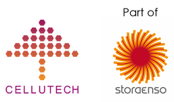
Cellutech staff are experts on cellulose technology. Established in 2013, the aim was to bring cutting-edge materials to the market by serving as a link between academia and industry. Fostering world class scientific research developed at Wallenberg Wood Science Center (WWSC) and taking these ideas into commercially successful technologies and products. In October 2018, Cellutech was acquired by Stora Enso, and is now a part of Stora Enso Innovation Centre for Biomaterials. An example of a product that has emerged from Cellutech, and from WWSC, is fibre-based packaging foams, Cellufoam^{R}, as a replacement for traditional Styrene based foams.
FineCell – cellulose microfibers and cellulose hydrogels 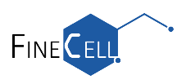
FineCell offers sustainable cellulose microfibers to help manufacturers make new products with reduced carbon footprints and differentiated properties. Products include Cellulose microfibers and cellulose fiber-based hydrogels for applications such as paints and cosmetics.

Biomedical Bonding – bone restoration 

Biomedical bonding has introduced a paradigm shift in bone restoration surgeries. A new concept of bone restoration using new photocurable fiber reinforced thermoset polymers as a new way of fixating complex bone fractures have been developed. The composite resins are formulated with benign components that selectively and efficiently react with each other in a physiological environment without affecting surrounding tissues.

Underpinning research
The start of these companies was normally initiated by research findings that the researchers found novel and possible to patent and exploit. Below is a list of scientific papers that has been starting points these enterprises.

References
- Y. Wang, M. E. Lindström and G. Henriksson, Cold NaOH pretreatment, Bioresources, 9 (2014) 7566-7578.
- Y. Zhang, O. C. J. Andrén, R. Nordström, Y. Fan, M. Malmsten, S. Mongkhontreerat and M. Malkoch Off-Stoichiometric Thiol-Ene Chemistry to Dendritic Nanogel Therapeutics, Adv. Funct. Mater. 29 (2019) 1806693.
- S. M. Grayson, B. K. Myers, J. Bengtsson and M. Malkoch Advantages of Monodisperse and Chemically Robust “SpheriCal” Polyester Dendrimers as a “Universal” MS Calibrant, J. Am. Soc. Mass Spectrom. 25 (2014) 303-309.
- J. Henschen, D. Li and M. Ek, Preparation of cellulose nanomaterials via cellulose oxalates, Carbohydr. Polym. 213 (2019) 208-216.
- V. Granskog, S. García-Gallego, J. von Kieseritzky, J. Rosendahl, P. Stenlund, Y. Zhang, S. Petronis, B. Lyvén, M. Arner, J. Håkansson and M. Malkoch, High-Performance Thiol–Ene Composites Unveil a New Era of Adhesives Suited for Bone Repair, Adv. Funct. Mater. 28 (2018) 1800372.
- N.T. Cervin, L. Andersson, J.B.S. Ng, P. Olin, L. Bergström and L. Wågberg, Lightweight and strong cellulose materials made from aqueous foams stabilized by nanofibrillated cellulose. Biomacromolecules 14(2013), 503–511.

Sources to corroborate the impact
https://www.renewcell.com/en/
https://www.polymerfactory.com/
http://www.cellutech.se/
http://finecell.se/
https://www.biomedicalbonding.com/

These enterprices not only creates new business and jobs but are also a way to implement research results into society and make the gained knowledge useful for a more sustainable society.

Impact cases – Materials Science and Engineering

Impact case 8 - Towards fossil free high temperature processes through circularity and resource efficiency

Summary of the impact
MSE has developed fossil-free alternatives to energy sources and precursors, as well as improvements to the quality of steel produced and circular economic principles have been applied to minimise materials use. This has been driven by the inescapable fact that metals processes are currently very energy and materials intensive and lead to large greenhouse gas emissions. Reduction of greenhouse gases, materials- and energy demand directly aligns with UN SDGs 4, 5, 6, 7, 9, 12 and 13. Furthermore, work performed in the past twenty years at KTH to improve the quality of steel produced in Sweden has also led to changes in industrial practice and maximised the sustainability of steel use. MSE has worked to renew the skills of workers to reflect new findings, which has helped to change practices at Swedish metals companies. Some of these companies also have facilities in other countries, to which the knowledge can spread. Knowledge proven at MSE has also led to the formation of several companies. This has a direct benefit for Swedish industry and society via the creation of jobs and reduced environmental impact of the metals, forestry, paper and energy industries.
Work in the area of circular economy and recycling has been shared between KTH, industry and the scientific community through journal articles (101), book chapters (4), PhD theses (15), licentiate theses (2) and lifelong learning. Work in clean steels as described below has been shared with industry and the scientific community through journal articles (204), PhD theses (61) and lifelong learning. This record has enabled KTH to work with the World Steel Association and the technical committee of the World Steel Producers Association.

Underpinning Research
MSE performs laboratory-scale, pilot-scale and (with strategic industry collaborators) full-scale industrial studies. This allows us to take research directly to industry and maximise impact. Examples include the use of waste material as feedstock for high-temperature processes, including the treatment of waste from electrical equipment, the production of oil from forestry by-products, the application of wastes from the paper and pulp industry in the steelmaking process and the neutralization of acidic waste water using waste from the metalworking industry. Such use of waste products minimizes use of landfill (e.g. through the project OSMet-2). In parallel, there have been many projects at MSE aimed at cutting greenhouse gas emissions from the metals industries, which currently account for large portion of Sweden’s pollution. The demonstration project Probiostål in Höganäs and BioBF, amongst others, aim to replace traditional fossil fuels for heating in metalworking with renewable biofuels. Research to remove carbon from metallurgical processes has been a large part of recent activities at MSE, through the projects HYBRIT (use hydrogen instead of carbon to turn iron ore into metal) and IRONARC (replace carbon-burning furnaces with alternatives).
Traditional “metals” research performed recently at MSE has developed clean steel with reduced energy consumption, based on the concept of “inclusion engineering” created by Prof. Wijk two decades ago. MSE has a long and distinguished record in the removal and management of contaminants in steel, which reduce service life. MSE’s impact in this field is obvious, since MSE has the most publications of any institution at ten different clean steel conferences and since the paper entitled “The effect of different non-metallic inclusion on the machinability of steels “has been downloaded 20 714 times from the journal Materials.

Relevant research papers:
- N. Ånmark, A. Karasev and P.G. Jönsson, The effect of different non-metallic inclusions on the machinability of steels. Materials 8 (2015) 751-783. Citations: 116
- J. Li et al., Co-firing based on biomass torrefaction in a pulverized coal boiler with aim of 100% fuel switching, Appl Energ, 99 (2012) 344-354. Citations: 235
- A.J. Tsamba, W. Yang and W. Blasiak, Pyrolysis characteristics and global kinetics of coconut and cashew nut shells. Fuel Proc Technol. 87 (2006) 523-530. Citations: 250
- M. Ersson, et al., A mathematical model of an impinging air jet on a water surface. ISIJ Int. 48 (2008) 377-384. Citations: 86
- K. Steneholm et al., Removal of hydrogen, nitrogen and sulphur from tool steel during vacuum degassing. Ironmak. Steelmak. 40 (2013) 199-205. Citations: 30
- Q. Zhang, et al., Gasification of municipal solid waste in the Plasma Gasification Melting process. Appl. Energy, 90 (2012) 106-112. Citations: 129
- M. Söder, P. Jönsson and L. Jonsson, Inclusion Growth and Removal in Gas‐Stirred Ladles. Steel Res. Int. 75 (2004) 128-138. Citations: 73
- J. Martinsson, B. Glaser and D. Sichen, The structure of foaming BOF-converter slag. Ironmak. Steelmak. 46 (2019) 771-781. Citations: 2; Winner of the Adrian Normanton Medal

Sources to corroborate the impact
Research in process control have twice led to the Adrian Normanton Award for the best technical paper [1] and the Stokowiec Medal (both IOM3, UK). Work on furnace technology led to the 2012 George Westinghouse Silver Medal from the American Society of Mechanical Engineers (ASME). Research on slag properties and the use of slag as a resource has been highlighted in the report by Jernkontoret (the Swedish steel producers association) and Mistra under the “Closing the Loop” program [2]. Work towards a circular economy and sustainable use of materials led to the J. Rydberg award for best PhD thesis (CTH, Sweden) [3]. Intermediate impacts have been highlighted for two important projects focusing on fossil-free production of ironmaking (HYBRIT and IRONARC). Work at MSE in the IRONARC project has continued the path to the realization of a full scale IRONARC process by the company ScanArc AB [4]. The division is also part of the HYBRIT project to make iron via hydrogen reduction [5].
- https://www.iom3.org/award/adrian-normanton-prize.html, Accessed 2021-02-08
- Report “D852: Stålkretsloppet”, Jernkontoret and Mistra, 2013.
- https://www.metalliskamaterial.se/en/facts/arets-basta-doktorsavhandling-inom-atervinning-och-cirkular-materialanvandning/, Accessed: 2021-02-08
- Report “D880: Järn- och stålindustrins Energianvändning – Forskning och utveckling”, Jernkontoret and Energimyndigheten, 2020.
- News article “Här ska Sveriges klimatmål räddas”, DN published 2020-11-17.

Impact case 9 - Software tools for industrial materials design

Summary of the impact
Mathematical modelling is an indispensable part of the research in many scientific disciplines. This is particularly true for the research at MSE, and it forms a big part of the impact that our research has on the world outside academia.
The development of theories and models for how materials respond to different processing steps such as e.g. heat treatments, and the resulting mechanical properties, have a long history at MSE. These models have often been distributed in the form of a software directly to industrial companies and research institutes as part of a project. In other cases, the models have been refined and further developed by a software company, which in turn has commercialized the models. The different software programs have been used to accelerate materials development by avoiding the time consuming and costly trial-and-error methodology dominant in materials industry.
An example of an important software program developed at MSE is the thermodynamic and kinetic software and database packages Thermo-Calc and DICTRA, which have a worldwide spread. Although these software programs were developed long ago, the research activities at MSE continuously contribute with new models and databases to them. A more recent example is the TC-PRISMA module in Thermo-Calc, for simulating precipitation reactions, which has users in more than 50 countries. Researchers at MSE contributed heavily to the precipitate growth model used in that module. The MSE spin-off company Thermo-Calc Software AB currently sells and further develops these programs. Another example is the first-principles alloy theory formulated within the Exact Muffin-Tin Orbitals (EMTO) code that is currently used by a large number of research groups in the world and also by the industrial partners such as Sandvik Coromant, Outokumpu Stainless and Sandvik Materials Technology.
Examples of how software tools developed at MSE have led to important insights to and impact on current materials related problems in industry are: Substitution of the critical raw material cobalt used as a binder in hard metals, and important contributions to the background information needed to decide on the long-term storage concept for spent nuclear fuel in Sweden. For the cobalt substitution, the quantum mechanical based quality control constructed at MSE can be used for any binder and it has increased the speed, accuracy and reliability of the development of new hard metals. This has enabled the production of new hard metals free of cobalt without the need of investing in new machinery or changes in production processes. For the case of spent nuclear fuel storage concept, the primary benefits are the containment of radiation and its non-proliferation to the biosphere with important implications for people and nature. The medium-term benefits are related to the existence of a reliable and constant energy supply that nuclear reactors can provide. The long-term benefits are related to the transition from fossil fuel to sustainable sources of energy.

Underpinning research
The research performed within the VINN Excellence Center Hero-m and VINNOVA Competence Center Hero-m 2i (led by Borgenstam and previously Ågren), as well as the FraMat and SuperFraMat academia-industry joint projects (coordinated by Bonvalet-Rolland and Lu) and a number of other projects focuses on creating new knowledge and developing new tools for industrial materials design. These projects have been a huge success, from an academic as well as from an industrial perspective.
A series of projects supported by Swedish Research Council contributed to the development of the first principles quantum mechanical tools (undertaken by Vitos, Li, Ruban, Schönecker, Östlin), which have been very important in both the cobalt substitution and nuclear fuel waste disposal projects. In addition, four academia-industry Strategic Mobility programs supported by the Swedish Foundation for Strategic Research (Vitos and Lu) have contributed to a continuous interaction between MSE and industrial partners.

Research publications:
- E. Holmström, R. Lizarraga, D. Linder, A. Salmasi, W. Wang, H. Mao, B. Kaplan, H. Larsson, and L. Vitos, A High Entropy Alloys: substituting for Cobalt in cutting edge technology, Appl. Mater. Today 12 (2018) 322-329. Citations: 20
- C M. Lousada, A J. Johansson and P A. Korzhavyi, Thermodynamics of H2O Splitting and H2 Formation at the Cu(110)–Water Interface, J. Phys. Chem. C 119 (2015) 14102–14113. Citations: 23
- M. Bonvalet-Rolland, T. Philippe and J. Ågren. Kinetic theory of nucleation in multicomponent systems: An application of the thermodynamic extremum principle, Acta Mater. 171 (2019) 1-7. Citations: 4
- M. Walbrühl, D. Linder, J. Ågren and A. Borgenstam, Modelling of solid solution strengthening in multicomponent alloys, Mater. Sci. Eng. A. 700 (2017) 301-311. Citations: 19
- M. Leetma and N V. Skorodumova, KMCLib: A general framework for lattice kinetic Monte Carlo (KMC) simulations, Comp. Phys. Comm. 185 (2014) 2340-2349. Citations: 39
- W. Xiong, M. Selleby, Q. Chen, J. Odqvist and Y. Du, Phase equilibria and thermodynamic properties in the Fe-Cr system, Crit. Rev. Solid State Mater. Sci. 35 (2010) 125-152. Citations: 153

Sources to corroborate the impact
Statement by Adj. Prof. Susanne Norgren, Group expert at Sandvik: ”more than 100 patents partly based on knowledge and models developed in Hero-m and Hero-m 2i”
Factual statement from evaluators “The Centre is achieving excellent research results. Indeed, it is in a world-leading position for development of the science-based engineering tools and their transition to industry. No other group around the world has done this so well” - VINNOVA evaluation report of Hero-m, 2011
https://www.stralsakerhetsmyndigheten.se/contentassets/b8881783acf14def9409d9d48789a0e2/201922-technical-note-ssms-external-experts-reviews-of-skbs-report-on-supplementary-information-on-canister-integrity-issues.pdf
https://qm4mat.com/case-story/quantum-mechanical-quality-control/

Impact cases – Theoretical Chemistry and Biology

Impact case 10 - Software development for quantum molecular modeling in high-performance computing environments

Summary of the impact
Molecular materials and functionalized nanoparticles take center stage in today’s technological advancements, and it appears anything but bold to predict the molecule, rather than the crystal, to be the smallest entity in tomorrow’s devices. In fact, there exists numerous evidences in the literature that this paradigm shift has already taken place, and the list of emerging nanotechnologies encompasses photonics, electronics, light harvesting, light-emitting diodes, drug delivery, sensors, surface coating, catalysis, etc.
The interplay between computer simulations and experiments represents a cornerstone in the design of complex molecular materials and the former are needed to understand the underlying microscopic mechanisms of the observations made in the latter. The last few decades have shown a staggering development in simulation capabilities, not least owing to the rapid development of computer technologies. The community of computational chemists has for a long time benefitted from faster CPUs with increasing amounts of memory, enabling increasingly accurate quantum mechanical simulations of ever larger systems. However, we are presently witnessing a paradigm change where computers reach unprecedented flop rates only by the introduction of heterogenous and complex hardware that represents a very poor fit with our developed methods and algorithms.
In 2018, we made the bold move to start re-writing our research software [1, 2], knowing that it had taken some 30 years to reach this stage with the involvement of numerous of people [3]. We formed a strategic partnership with a strong group with complementary expertise and led by Prof. A. Dreuw at Heidelberg University. We have taken great care in the software design and leveraged modern software engineering techniques as to create a platform that is highly versatile and ready to meet a largely unknown future landscape of supercomputing resources. It is our stated goal to become a leading European provider of software for quantum molecular modeling on contemporary and future high-performance computing (HPC) systems and the present pre-exascale and future exa-scale supercomputers within the EuroHPC project are targeted. Our software is released under LGPL licensing and made unconditionally available for academic and industrial usage.

Underpinning Research
There is a plethora of spectroscopies that are employed in molecular material characterization work but a selection of the most relevant ones includes magnetic resonance spectroscopy, infra-red absorption and Raman spectroscopies, visible/ultraviolet fluorescence and absorption spectroscopies, circular dichroism, ultraviolet and X-ray photoelectron spectroscopy, and near-edge X-ray absorption fine structure spectroscopy. Response theory, taking center stage in our work, provides a theoretical framework general enough to treat all of the listed and many other spectroscopies on a common ground [4]. The referenced book presents the foundations of the theory and it now serves as reference material for the software development and the training of young scientists that contribute to these efforts. Norman and Dreuw have both made contributions to the development of theory, methods, and algorithms in this field but there are of course numerous of other researchers that have provided important and seminal work over the period of the past 30 years, see reviews [5, 6].

Relevant research publications:
- Z. Rinkevicius, X. Li, O. Vahtras, K. Ahmadzadeh, M. Brand, M. Ringholm, N.H. List, M. Scheurer, M. Scott, A. Dreuw and P. Norman, VeloxChem: A Python‐driven density‐functional theory program for spectroscopy simulations in high‐performance computing environments, WIREs Comput. Mol. Sci. 10 (2020) e1457.
- D.R. Rehn, Z. Rinkevicius, M.F. Herbst, X. Li, M. Scheurer, M. Brand, A.L. Dempwolff, I.E. Brumboiu, T. Fransson, A. Dreuw and P. Norman, Gator: A Python-driven program for spectroscopy simulations using correlated wave functions, WIREs Comput. Mol. Sci. (2021), accepted.
- J.M.H. Olsen, S. Reine, O. Vahtras, E. Kjellgren, P. Reinholdt, K.O.H. Dundas, X. Li, J. Cukras, M. Ringholm, E.D. Hedegård, R. Di Remigio, N.H. List, R. Faber, B. N. C. Tenorio, R. Bast, T. B. Pedersen, Z. Rinkevicius, S.P.A. Sauer, K.V. Mikkelsen, J. Kongsted, S. Coriani, K. Ruud, T. Helgaker, H.J.Aa. Jensen and P. Norman, Dalton Project: A Python platform for molecular- and electronic-structure simulations of complex systems, J. Chem. Phys. 152 (2020) 214115.
- P. Norman, K. Ruud and T. Saue, Principles and Practices of Molecular Properties, Wiley (2018)
- P. Norman, A perspective on nonresonant and resonant electronic response theory for time-dependent molecular properties, Phys. Chem. Chem. Phys. 13 (2011) 20519–20535.
- P. Norman and A. Dreuw, Simulating X-ray Spectroscopies and Calculating Core-Excited States of Molecules, Chem. Rev. 118 (2018) 7208–7248.

Sources to corroborate the impact

Software distribution:
VeloxChem program distribution, https://veloxchem.org/
Gator program distribution, https://github.com/gator-program/gator
Dalton Project distribution, https://daltonproject.readthedocs.io/en/latest/
Dalton program distribution, https://www.daltonprogram.org/

Organization of international PhD schools on response theory:
Molecular Response Properties Summer School (2021), Stockholm, Sweden, https://bit.ly/mrpss-2021
Molecular Response Properties Winter School (2019), Bardufoss, Norway, http://bit.ly/mrpws-2019
Molecular Response Properties Summer School (2017), Virginia Tech, USA, https://crawford.chem.vt.edu/news/
Molecular Response Properties Winter School (2016), Luchon, France, http://bit.ly/mrpws-2016
Molecular Response Properties Summer School (2015), Virginia Tech, USA, https://crawford.chem.vt.edu/news/

Impact case 11 - Energy storage catalysis – Modeling of complex reaction environments.

Summary of the impact
Ahlquist’s group at TCB is involved in several national and international collaborations and consortia for storage of renewable energy and sustainable production of chemicals. They have developed methods for studying catalysts under highly complex reaction conditions such as solid-liquid interfaces. The group is a member of the Nordic university hub NordCO2, which consists of academic members from all Nordic countries with the aim of developing and disseminating knowledge on reactions that use CO₂ as a building block, rather than producing it as waste. The consortium has industrial partners from Carbon Recycling International on Iceland that implement technologies on large scale for conversion of CO₂ to methanol, by using two combined processes of water electrolysis and CO₂ hydrogenation. Water electrolysis, where water is converted to oxygen and hydrogen, is another focus area of the TCB group. The methods developed have been used to study and gain atomistic understanding in the processes of reactions where the oxygen is formed, since this is the limiting part of water splitting. The new methods have opened a new area of computational catalysis, molecular catalysts in complex environments such as liquid and solid liquid interfaces. The research has led to several publications in high impact journals and have been lifted by the editors as breakthrough publications. TCB is also involved in a related project, funded by the KAW foundations on sustainable production of fine chemicals, using water and carbon dioxide as starting materials.

Underpinning Research
Catalysts typically belong to either the homogeneous or heterogeneous category. The former is dissolved molecules that facilitate the reactions, and the latter is solid materials where the catalysis occur on the surface. Computational methods are highly developed for both systems. However, much recent development involves systems that involve molecular catalysts adsorbed or bonded to a surface. To be able to understand the reactions under such conditions TCB have developed the empirical valence bond method and used a combination of classical and quantum chemical methods. This has opened up for understanding of systems with much higher complexity than previous systems studied and has led to several publications in very reputable journals.

Relevant research papers:
- S. Zhan and M. Ahlquist, Dynamics and reactions of molecular Ru catalysts at carbon nanotube–water interfaces, J. Am. Chem. Soc. 140 (2018) 7498–7503.
- S. Zhan, R. Zou and M. Ahlquist, Dynamics with explicit solvation reveals formation of the prereactive dimer as sole determining factor for the efficiency of Ru(bda)L₂ catalysts, ACS Catal. 8 (2018) 8642–8648.
- S. Zhan, J. de Gracia Triviño and M. Ahlquist, The carboxylate ligand as an oxide relay in catalytic water oxidation. J. Am. Chem. Soc. 141 (2019) 10247–10252.
- X. Chen and M. Ahlquist, Deconstructing the Enhancing Effect on CO₂ Activation in the Electric Double Layer with EVB Dynamic Reaction Modeling, J. Phys. Chem. C 124 (2020) 22479–22487.
- S. Zhan, B. Zhang, L. Sun and M. Ahlquist, Hydrophobic/Hydrophilic Directionality Affects the Mechanism of Ru-Catalyzed Water Oxidation Reaction, ACS Catal. 10 (2020) 13364–13370.

- J. Yang, L. Wang, S. Zhan, H. Zou, H. Chen, M. Ahlquist, L. Duan and L. Sun, From Ru-bda to Ru-bds: a step forward to highly efficient molecular water oxidation electrocatalysts under acidic and neutral conditions, Nat. commun. 12 (2021) 1–10.
- J. Yi, S. Zhan, L. Chen, Q. Tian, N. Wang, J. Li, W. Xu, B. Zhang and M. Ahlquist, Electrostatic Interactions Accelerating Water Oxidation Catalysis via Intercatalyst O–O Coupling, J. Am. Chem. Soc. 143 (2021) 2484–2490.

Sources to corroborate the impact
The Nordic collaboration on CO2 conversion is described at the consortium website and the Nordforsk website [1]. The consortium arranged a virtual industry meeting in 2020 with participants from AstraZeneca and Haldor Topsoe. The studies of oxygen formation catalysts was highlighted by the editor in ACS Catalysis as an editor’s choice paper, which meant that it was displayed on the main ACS publication site [2]. A recent development of the catalysts led to the most efficient oxygen evolving catalyst to date, which was highlighted at the Nature Chemistry Facebook site [3]. The early development of the methods for studying the catalysts in complex environments was developed by the PhD student Shaoqi Zhan at TCB. His poster presentation was awarded the Dalton Transactions poster award at the first annual meeting of the Swedish chemical society [4].
- NordCO2 website https://site.uit.no/nordco2/
Annual report NordCO2 https://site.uit.no/nordco2/files/2020/12/Annual-Report-2019.pdf
Program industrial meeting https://site.uit.no/nordco2/2020/10/19/program-for-the-virtual-annual-and-industry-meeting-in-nordco2/
- https://pubs.acs.org/doi/full/10.1021/acscatal.8b02519, EC mark indicates that was highlighted as the Editor’s choice.
- Nature Chemistry highlight of Nature Communications paper:
https://www.facebook.com/naturechemistry/posts/2843880615878744
- Dalton Transactions poster award:
https://blogs.rsc.org/rscpublishing/2018/07/18/congratulations-to-prizewinners-at-the-1st-national-meeting-of-the-swedish-chemical-society/?doing_wp_cron=1613728264.4797821044921875000000

