 | REPort |  | Date |  | Place
 | Periodic review of research 2012-2019 |  | 2021-05-12 |  | Stockholm
 | Created by:
 | Panel 5

Panel 5 Intelligent Systems and Biomedical Engineering
  - Research Assessment Exercise (RAE) 2021,
self-evaluation
Coordinator: Prof. Wouter van der Wijngaart
Vice-coordinators: Prof. Mikael Skoglund, Prof. Sebastiaan Meijer

Organisation

Organisation schedule
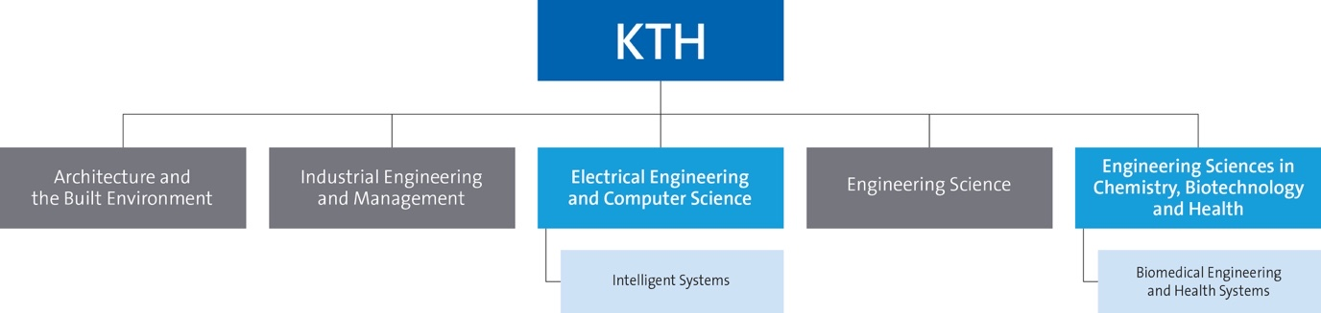
Figure 1: Panel’s position in KTH’s organisation

Involved units
- School of Electrical Engineering and Computer Science (Head: Sonja Berlijn)
  - Department of Intelligent Systems (Head: Mikael Skoglund)
    - Division of Decision and control systems (Head: Bo Wahlberg)
    - Division of Information Science and Engineering (Head: Mikael Skoglund)
    - Division of Micro and Nanosystems (Head: Göran Stemme)
    - Division of Robotics, Perception and Learning (Head: Patric Jensfelt)
    - Division of Speech, Music and Hearing (Head: Joakim Gustafson)
- School of Engineering Sciences in Chemistry, Biotechnology and Health (Head: Mikael Lindström)
  - Department of Biomedical Engineering and Health Systems (Head: Sebastiaan Meijer)

Table of Contents
Organisation 2
Organisation schedule 2
Involved units 2
List of abbreviations 4
Part A: Introduction of panel 5
Description of the research field of the departments included in the research panel 5
Description of the self-evaluation process for the research panel 6
Identified research panel synergies 7
Part B: Report for each department 10
Department of Intelligent Systems (IS) 12
1. Overall analysis and conclusion; strengths and development areas 12
2. Research profile of the Department of Intelligent systems 14
3. Viability 39
4. Strategies and organisation 50
5. Interaction between research and teaching at all three levels (BSc, MSc, PhD) of education 56
6. Impact and engagement in society 59
7. Analysis or external factors 71
Department of biomedical engineering and health systems (MTH) 73
1. Overall analysis and conclusion; strengths and development areas 73
2. Research profile 75
3. Viability 87
4. Strategies and organisation 91
5. Interaction between research and teaching 93
6. Impact and engagement in society 94
Appendix – Impact cases Dept. of Intelligent Systems 97
Appendix – Impact cases Dept. of Technology in Medicine and Health 116

List of abbreviations
CBH | KTH School of Engineering Sciences in Chemistry, Biotechnology and Health
DCS | KTH Division of Decision and Control Systems
DF | Digital Futures, a cross-disciplinary research centre focussing on digital technologies
EECS | KTH School of Electrical Engineering and Computer Science
ERC | The European Research Council who provides excellence grants to top researchers
IS | KTH department of Intelligent Systems
ISE | KTH division of Information Sciences and Engineering
IVA | The Royal Swedish Academy of Engineering Sciences
KAW | The Wallenberg foundation, which is a large research funder
KVA | The Royal Swedish Academy of Sciences
MEMS | Microelectromechanical Systems
ML | Machine Learning
MST | KTH division of Micro and Nanosystems
MTH | KTH department of Biomedical Engineering and Health Systems
RAE | KTH Research Assessment Excercise
RPL | KTH division of Robotics, Perception and Learning
SSF | The Swedish strategic research council, a national funding agency for applied research
STH | School of Technology and Health, an earlier school of KTH that has ceased to exist and which operations are now continued as the MTH department in the CBH school
SUA | The Swedish Young Academy
TMH | KTH division of Speech, Music and Hearing
VINNOVA | The Swedish Innovation Agency, the national funding agency for innovation
VR | The Swedish Research Council, the national funding agency for science
WASP | The Wallenberg AI, Autonomous Systems and Software Program

Part A: Introduction of panel
For clarity: the pronoun “we” in this document always refers to the faculty of the departments or divisions that are the focus of that specific text section.

Description of the research field of the departments included in the research panel
Panel 5 consists of two departments from two different KTH schools: EECS/IS and CBH/MTH.

The department of intelligent systems (IS) at the school of electrical engineering and computer science (EECS).
During the 2018 merger of three former KTH schools into the current EECS school, the following five divisions established the department of IS:
1) The division of decision and control systems (DCS), who research system identification, control, machine learning (ML) and optimization of dynamical systems, with applications in autonomous systems, networked systems, process control, robotics and cyber-physical security.
2) The division of information science and engineering (ISE), who research digital communication and networking, signal processing and data sensing/analysis, machine learning, multimedia processing, and the utilization of stored and real-time data for information extraction and predictions.
3) The division of micro and nanosystems (MST), who research Microsystems (MEMS) and Nanoengineering (NEMS) and their application in the fields of medicine, life sciences, information and communication technology (ICT), security, transport, biodiversity and aerospace.
4) The division of robotics, perception and learning (RPL), who research in robotics, computer vision and ML systems that provide advanced service in industry, for search and rescue operations, in medical applications or as assistants to elderly.
5) The division of speech, music and hearing (TMH), who research how humans communicate through speech, music, and gestures.
IS currently has ~300 employees and an approximate total turnover of ~310 MSEK. The department is driven by the common vision that a strong focus on research excellence must form the base for all university activities, that is, teaching, research and interaction with society. IS further believe that in Sweden, a strong research environment requires a substantial focus on raising external funding.
In EECS, all education related questions (incl. organisation, economy, etc) and faculty recruitments are dealt with on department level. All research related questions (incl. organisation, economy, etc) are dealt with on division level.

The department of medical technology and health (MTH) in the school of chemistry, biotechnology and health (CBH).
MTH has ~100 employees and seven divisions doing research: Biomedical Imaging; Environmental Physiology; Ergonomics; Health Informatics and Logistics; Neuronic Engineering; Structural Biotechnology and Technology in Health Care. The eight’ division (called Basic Science Education) is a purely educational unit.
MTH is the continuation of the earlier School of Technology and Health (STH), which merged into the bigger CBH school in 2018. In 2016, STH moved 2 of the 3 locations into one new building at the campus of Flemingsberg, putting research and education together. In 2018, the department got a new, flatter, structure, with a larger role for the department over the various parts.
The research at MTH is increasingly focussed on a limited set of themes, introduced in 2018:
1. Biomedical imaging and simulation
2. Sustainable work life
3. Digitalisation of health and care
The research is multi-disciplinary in nature and in close collaboration with stakeholders from health, health care and industry. Over the last years, MTH has developed towards a more integrated environment with students active in research, and researchers participating in education.

Description of the self-evaluation process for the research panel
This RAE exercise has been performed in separate processes at both departments involved, where the Department Head Meijer has coordinated for the CBH/MTH department and Panel Coordinator v.d.Wijngaart has coordinated for the EECS/IS department and for the integration of this document.

The process at EECS/IS:
This RAE is the first instance where IS or its divisions were asked to describe their strategy for quality for each of the specific aspects: research funding, academic culture, recruitment, infrastructure, leadership, collegial structure, interaction between research and teaching, dissemination, impact, and sustainability. For some of these aspects, IS had explicit or implicit goals, tactics or strategies; for others none.
IS started the RAE work during 2020 with a description of our operations as well as a partial analysis. During 2021, we formed four teams of younger faculty members, each containing one representative of every division. These four teams each addressed one of the four sections 3) viability, 4) organisation, 5) interaction research-education, and 6) outreach/impact/sustainability. They performed a SWOT analysis and suggested the focus for future developments.
This RAE has therefore already resulted in the following specific benefits:
- We contemplated some of the key aspects of our research organisation for the first time in a systematic and strategic manner.
- The young faculty engaged in the process has gained new research leadership competencies.
- The ties between the different divisions have been tightened through this collaboration.
- The intelligence gained by the four teams can form the basis for a continued process of self-improvement. We aim to permanent their role in the organisation, in which the teams will be asked to lead internal skill development and be advisory to the department leadership in specific aspects.
This self-assessment has been an important step in our departmental development and shows that we, in many aspects, have challenges ahead of us. The next step is - amongst all challenges and opportunities identified – to evaluate costs related to potential improvements and to prioritise our next actions.
We should further highlight that the new Head of the EECS school, Sonja Berlijn who started 2021, has already communicated new visions for the school that resonate well and go partly beyond several of the developments outlined in our assessment.

The process at CBH/MTH:
MTH is undergoing a major rejuvenation, and the RAE process is naturally connected to the strategic development work on-going. The process has been led by the Head of Department (Meijer), who shared drafts with the heads of the seven divisions included, for input and comments.
The RAE 2020 is a chance to get feedback on the change process, the priorities and ways in which we work, and the general feasibility.

Identified research panel synergies
Specific synergetic activities are ongoing within IS mainly via the Wallenberg AI, Autonomous Systems and Software Program (WASP) and Digital Futures program (DF).

Synergetic activities within IS

WASP
WASP is a major national initiative for strategically motivated basic research, education and faculty recruitment in AI, autonomous systems and software development. The ambition is to advance Sweden into an internationally recognized and leading position in these areas.
WASP was initiated in 2015 and its mandate extends to 2029. WASP has a total budget of 5.5 billion SEK. The starting point for WASP was the combined existing competence at Sweden’s five major ICT universities: Chalmers University of Technology, KTH Royal Institute of Technology, Linköping University, Lund University and Umeå University. WASP strengthens, expands, and renews the national competence through strategic recruitment, a challenging research program, a national graduate school, and collaboration with industry.
The scope of WASP is AI, autonomous systems, and software, in the context of complex software-intensive systems with the intelligence to achieve autonomy in interactions with humans. The field is a large and rapidly increasing part of the development of almost all engineering systems. Further, AI and autonomous systems are scientifically challenging, disruptive technologies that will fundamentally change society and industry. The main instruments are a research program, a graduate school, a recruitment program, research arenas and internationalization.
IS faculty hold positions in the WASP Executive Committee including co-directorship, chair of the university representative group, chair of the research management group on AI, member of the graduate school committee, chair of the international management group, member of the research management group on autonomous systems, and member of the arena management group. This work has significantly influenced the strategic work for EECS and IS, and has resulted in new junior positions on cooperative autonomous systems and machine learning. Many IS Faculty members are most active in WASP through PhD projects and teaching at the graduate school. The research projects are based on proposals and the industrial PhD program has also strengthened the IS collaboration with KTH partner companies. IS Faculty has also been most active in WASP communication, events and networking. So far WASP has funded 9 professors in autonomous systems and software, 9 Wallenberg Chairs in AI (5 full professors and 4 guest professors), 22 assistant/associate professors in AI, 337 admitted PhD students, 236 academic PhD students, 101 industrial PhD students, and 63 affiliated PhD students. WASP has collaborations and a postdoctoral fellowship program with Stanford University, UC Berkeley, NTU Singapore, and MIT. WASP has so-far funded 3 assistant professorships, 6 postdocs and 58 PhD students at IS. KTH researchers involved in WASP are listed here. Two IS faculty are members of the WASP Sweden executive management group and one of them is leading WASP KTH.

DF
DF is a cross-disciplinary research centre that explores and develops digital technologies of great societal importance. DF was jointly established 2020 by KTH Royal Institute of Technology, Stockholm University and RISE Research Institutes of Sweden, based on significant long-term support of a Strategic Research Area by the Swedish Government. DF receives annual governmental funding of about 115 MSEK with additional funding from partners through the DF Industrial and Societal Partnership Program, in total forming Sweden’s largest research environment on the sciences for the digital transformation.
DF focuses on impact domains of key societal and economic importance with research projects striving for significant and transformative contributions in these domains. The DF Strategic Research Programme is structured around the four societal contexts Smart Society, Digitalized Industry, Rich and Healthy life, and Educational Transformation. These contexts are areas in which industry and society see opportunities and face challenges at the same time. The research programme hinge upon three scientific and technological research themes: trust, cooperate and learn.
Since January 2021, DF is a partner of C3.ai Digital Transformation Institute, which is a research consortium dedicated to accelerating the benefits of artificial intelligence for business, government, and society. The Institute is coordinated by UC Berkeley and UIUC, and the other university partners together with KTH are CMU, MIT, Princeton, Stanford and University of Chicago. The Institute engages the world’s leading scientists to conduct research and train practitioners in the Science of Digital Transformation, which operates at the intersection of artificial intelligence, machine learning, cloud computing, internet of things, big data analytics, organizational behavior, public policy, and ethics. The first batch of project proposals involving DF and IS researchers is currently under evaluation. They focus on the digital transformation and AI for energy and climate security.
A major part of DF governance, projects and activities involves IS faculty. IS faculty members hold positions in the DF Governing Board, Strategic Research Committee and Executive Committee and have a significant influence of the strategic and daily development of the research environment. As an illustration of how much DF influence the cross-disciplinary research agenda of IS, it can be noted that 8 out of 9 DF Collaborative Projects, which has an average budget of about 25 MSEK, has IS faculty members as co-PIs. Most IS faculty members are also DF faculty members and many of them are active through research projects, mobility programs, talent recruitments, seminar series, industry workshops or some of the many dissemination and societal engagement activities of DF.

Synergetic activities within MTH
The joint formulation of 3 themes, instead of a wide range of research specialisations brings synergy to the groups within MTH. In 2017, before the merger, there were 13 separate units, which is now reduced to 8 and expected to further consolidate down to 6 or 7.
The entire department engages in structural reorganisation of the masters’ programmes into problem-based learning (at least up to 50%), which together with a more MakerSpace-based educational environment provides for excellent synergy between education and research. The historic mismatch between educational programs and faculty composition is mitigated, and we observe synergetic collaborations, for instance between ergonomics and biomedical sensors, and between neuronics engineering and biomedical imaging.
MTH does not (yet) have the luxury of being in the heart of large-scale investments like WASP or DF but has engaged actively with DF and got funding and / or engagement of 3 divisions. (Imaging, Technology in Health Care, Health Informatics). The forthcoming Data Driven Life Science investment by KAW opens again up for MTH engagement, providing synergy with the rest of the CBH school.

Synergies between IS and MTH
There exist areas of topical overlap between IS and MTH, specifically in medical technology, biosensors and signal processing. Opportunities lay in that the competencies at IS form a potential resource for foundations in medical technology. Today, joint activities and personnel exchange between both departments occur on an ad-hoc basis.

Part B: Report for each department

Department of Intelligent Systems
Self-evaluation
Head of Department: Professor Mikael Skoglund

Included divisions:

Division of Decision and Control Systems
Division of Information Science and Engineering
Division of Micro and Nanosystems
Division of Robotics, Perception and Learning
Division of Speech, Music and Hearing

Department of Intelligent Systems (IS)
Where possible/opportune, we describe for each of the subheadings in this self-evaluation the following aspects: 1) the status, i.e., a description of the period 2012-2020 and the current situation; 2) an analysis, and; 3) suggestions or strategic actions for improvement.
For many aspects, we have not yet performed a stringent analysis of costs, priority or potential negative correlations for these improvements. We consider this self-evaluation as a starting point for such further work.

1. Overall analysis and conclusion; strengths and development areas

Limited SWOT-analysis
 | Strengths | Weaknesses
Research | Bulleted list, in order of magnitude:  1. Internationally competitive research environment.  2. Many researchers in the international top.  3. We address topics of the highest relevance for societal challenges.  4. We train many PhDs who transfer knowledge. | Bulleted list, in order of magnitude:  1. Collaboration with external researchers and stakeholders can be further improved.  2. Collaboration across disciplines and application areas can be further improved.
Organisation | Bulleted list, in order of magnitude:  1. Collegiality and engaged faculty.  2. Healthy mix of internal collaboration and competition drives progress.  3. Shared focus on research excellence, forming the engine that drives our department.  4. Sustained success in bringing in external research funding. | Bulleted list, in order of magnitude:  1. Need for more efficient and local administrative service and support.  2. We could become better at approaching challenges that are outside our current research/education focus (diversity, sustainability, increasing impact) as opportunities.  3. Gender imbalance  4. Relatively few retirements in the next 10 years makes it hard to open up junior faculty positions.

Development areas IS
The main development areas are (details in section 4)
- To reinforce and develop our leading position in academia
- To increase our impact in industry and society
- To widen the scope of our research through multi- and interdisciplinary research engagements
- To improve gender diversity

Summary statement on contributions of department on impact, infrastructure, and sustainable development

Contributions to impact
The department performs a substantial amount of outreach to stakeholders (via skilled people, technology transfer, and providing expertise) and has also achieved good impact (see impact cases).
We can improve by a more strategic and systematic approach to improve our engagement with stakeholders. We could define clear expectations or incentives wrt outreach to society, both on the organisation and the individual researcher level. These aspects are the core focus of the EECS school impact team as of 2021.

Contributions to infrastructure
Each division takes the initiative(s) needed to build and develop the labs necessary for their research. For large external research infrastructure needed by IS researchers, it is up to each division to engage in the development of the external infrastructure and to get access to and utilize them in an efficient way. The KTH-owned cleanroom facilities Electrum Lab and the Albanova Nanofabrication Lab are of essential importance for most of the research at the Division of Micro and Nanosystems (MST) at IS. The continuous development of, and investment in, these infrastructure facilities at the KTH level is of utmost importance for this research at IS.

Contributions to sustainable development
A significant amount of research addresses the 2030 UN SDGs, mainly targeting SDG 7 (Affordable and clean energy) and SDG 9 (Industry, innovation, infrastructure), and to some extent SDG 3 (Health & well-being) and SDG 11 (Sustainable cities). A lot of our research addresses beyond-2030 goals in the areas targeted by the UN SDGs.
We can improve by targeting UN SDGs areas more strategically and systematically, specifically in areas not well targeted today (e.g., biodiversity, climate change). We could define clear expectations and incentives wrt sustainability for both the organisation and individual researchers. We could target sustainability-focused research during recruitments and more systematically address sustainability issues in our education. These issues can be addressed partly on the department level and partly on the EECS or KTH level.

2. Research profile of the Department of Intelligent systems
Because every division has its own research profile, these profiles are described in a separate section for every division.
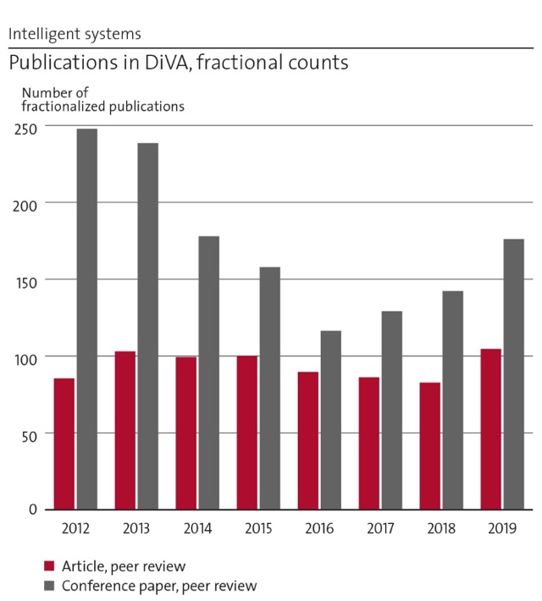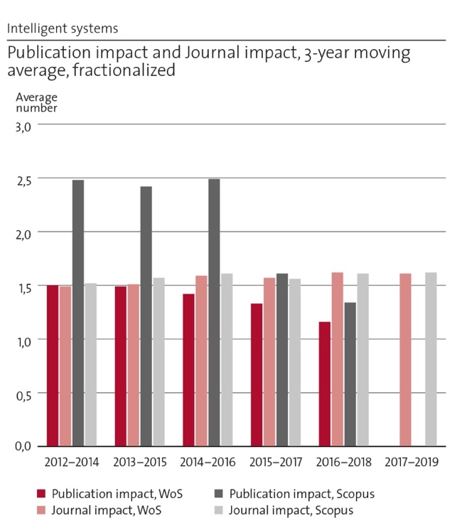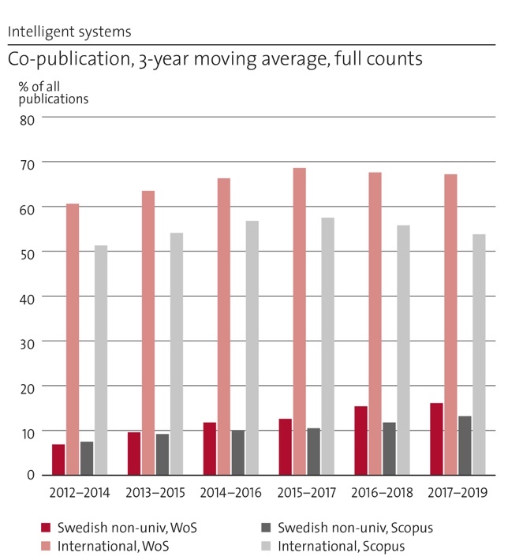
Figure 2.1. Bibliometric information of IS.
Figure 2.1 shows bibliometric data for the entire department. This data is the sum of the data from the five independent IS divisions, and rather than trying to interpret this information in its entirety, we will discuss this below on a per-division level.

2.1 Research profile Division of Decision and Control Systems (DCS)
The research activities of the Division of Decision and Control Systems focus on system identification, control, ML and optimization of dynamical systems, with applications in autonomous systems, networked systems, process control, robotics and cyber-physical security. DCS has over the last 10-15 years developed into one of the leading groups in automatic control worldwide.

a) General information about DCS
Staff: The division currently comprises 97 personnel, composed of 13 faculty, 23 postdocs, 57 PhD students, 1 administrator and 4 research engineers. Of the faculty, eight are full professors, two are associate professors, two are assistant professors and one is adjunct professor. CAGR 2012-2020: 10%.
Annual budget: current 84 MSEK; CAGR 2012-2020: 6%.
Activities: stable at approximately 85 % research and 15 % teaching.

b) DCS Central research questions and themes, knowledge gaps addressed, main research activities
The division performs research in the broad area of automation and control, learning and decision-making. In particular, our expertise is centred on networked control and robotics; ML; cybersecurity; optimization and control; control of transport systems; system identification; processing modelling and control.

Analysis
The 13 faculty of DCS cover very important scientific areas of decision and control in a wide sense. We have been fast in adapting to new research challenges like optimization and learning of dynamical systems. We have also considerably strengthened our impact and engagement with industry and society since the 2012 RAE.

Strategy
We plan to continue to strengthen and enhance our signature research areas. In the near future, we see significant possibilities to expand our activities in cooperative autonomous systems, ML for control, and other core topics of digitalisation and automation at large. Part of this development will come through the recent recruitment of the two WASP assistant professors, Stefan Bauer and Yvonne Stürz, and new cross-disciplinary collaborations within the WASP and DF initiatives.

c) DCS Contributions to the advancement of the state of the art within the research fields of the department
DCS is one of the leading groups in control, as for instance indicated by consistently high ranking for KTH in Automation and Control in Shanghai Ranking’s Global Ranking of Academic Subjects (2017-2018-2019 ranked 12-15-19). The main scientific contributions of DCS research groups are in the following areas. (DCS researchers are marked bold in the below references.)

Networked control
Wireless networked control systems emerged from the successful hardware and software developments of wireless sensor and communication networks. These control systems, with spatially distributed sensors and actuators, have to potential to drastically improve system robustness, performance, and resource efficiency. As the wireless communication medium imposes control loop imperfections, such as message delays and dropouts, appropriate modelling and analysis tools need to be developed, together with new control architectures and principles able to handle the uncertainty but also benefit from the additional flexibility. Several faculty members have contributed extensively over the last 10-15 years to this area of research and many prestigious awards and research grants have been received for the work. Representative publication: J. Wu, Q.S. Jia, K.H. Johansson, L. Shi, Event-based sensor data scheduling: Trade-off between communication rate and estimation quality, IEEE Transactions on automatic control 58 (4), 1041-1046. (341 citations in Google Scholar)

Cybersecurity
Cybersecurity in control systems is a new, rapidly evolving research field. The practical motivation comes from concerns of malicious cyberattacks against large-scale networked control systems, such as critical infrastructures (e.g., power systems). DCS has contributed with cyber-physical security metrics to localize inherent infrastructure weaknesses, and to methodology for attack-resilient monitoring and controller design. Much of the cybersecurity work is conducted within the Centre for Resilient Critical Infrastructures (funded by the MSB, led by DCS), and within the Trust area of KTH DF. The focus of our work and projects lies on security applications in civilian systems and large-scale infrastructures. Representative publication: A. Teixeira, I. Shames, H. Sandberg, K.H. Johansson: “A secure control framework for resource-limited adversaries”, Automatica 51, 135-148, 2015 (584 citations in Google Scholar)

Multi-robot systems
Our robotics research focuses on theory and application of task planning and control for autonomous (multi-agent) systems in unknown and dynamic environments. Considered platforms include mobile manipulator-endowed robots, aerial vehicles and underwater robots. Further application domains include human-machine-interaction and social networks. The theoretical results involve elements from nonlinear and robust control, decentralized systems, hybrid control and formal methods for controller synthesis. The research in this domain is funded by a number of EU (ERC, H2020, FP7) and national projects (KAW, VR, Vinnova, SSF). Representative publication: D. V. Dimarogonas, E. Frazzoli and K. H. Johansson, Distributed event-triggered control for multi-agent systems, IEEE Transactions on Automatic Control, Vol. 57, No. 5, pp. 1291-1297, May 2012. (1408 citations in Google Scholar)

Optimization and decision-making
The ability to transform data into decisions is a central aspect of digitalisation. The DCS faculty has a long tradition of research in optimal decision-making for large-scale systems. One line of work has developed distributed coordination mechanisms that allow complex systems reach their optimal operation. Examples include matching of consumption and production in smart grids or managing radio resources in wireless networks. Another line of work has focused on optimization algorithms that run efficiently on modern computing architectures. We have developed theory for asynchronous and communication-efficient optimization, tailored to the needs of large-scale ML, and introduced novel optimization algorithms with strong performance guarantees. Representative publication: E. Ghadimi, A. Teixeira, I. Shames and M. Johansson, Optimal parameter selection for the alternating direction method of multipliers (ADMM): quadratic problems, IEEE Transactions on Automatic Control, Vol. 60, No. 3, pp. 644-658, March 2015. (383 citations in Google Scholar)

Machine learning
In ML, the main activities at DCS concern areas at the intersection of control and learning theories. Specifically, we develop theoretical tools towards the foundations of reinforcement learning (RL), including the so-called bandit optimization, and their application to iterative identification and control problems. A particular emphasis is on model-based RL where an a-priori knowledge on the dynamical systems to be learnt, e.g. through its structure, may considerably speed up the learning process. Most of our work deal with systems with large but finite state and action spaces, with applications such as the design of search engines, resource allocation in networks in mind. However, recently, we have been revisiting RL problems of more classical linear systems continuous state and action spaces. Other important activities at DCS aim at deriving information-theoretical limits and efficient algorithms in clustering and change-point detection problems. Representative publication: J. Ok, A. Proutiere, D. Tranos, Exploration in Structured Reinforcement Learning, NeurIPS 2018 – oral presentation. (22 citations in Google Scholar)

Intelligent transport
The DCS faculty study many applications of connected and automated vehicles and transport systems, using a broad range of methods from classical, optimal and model predictive control, but also learning-based algorithms and graph-search methods. The research is application-driven, and we collaborate extensively with automotive and telecom industries (Scania, Ericsson). Contributions include longitudinal and lateral vehicle control, collaborative and coordinated control of vehicle platoons, motion planning, and routing and coordination of vehicle fleets. Representative publication: A. Alam, B. Besselink, V. Turri, J. Mårtensson, K.H. Johansson: “Heavy-duty vehicle platooning for sustainable freight transportation: A cooperative method to enhance safety and efficiency”, IEEE Control Systems Magazine 35 (6), 34-56 (211 citations in Google Scholar)

System identification and process modelling
System identification is a very strong research field within DCS, where several subtopics have been intensely studied, including input and experiment design, estimation under sparsity and low rank constraints (using convex and non-convex heuristics), kernel regularization and continuous-time identification. In addition to the problem of estimating linear and nonlinear dynamic models, at DCS we have also developed tools for the efficient estimation and control of hidden Markov processes and for inverse filtering and control, where the goal is to reverse engineer an existing agent acting on a Markov decision process. We have also developed applications of system identification in several fields, including bio-production and paper and pulp production. Representative publication: M. Annergren, C. A. Larsson, H. Hjalmarsson, X. Bombois and B. Wahlberg, "Application-Oriented Input Design in System Identification: Optimal Input Design for Control " in IEEE Control Systems Magazine, 37 (2), 31-56. (33 citations in Google Scholar)

d) DCS Quality and quantity of contributions to the body of scientific knowledge
The DCS scientific impact is high. For example, KTH is the 6th largest contributor to the leading journals Automatica and IEEE Transactions of Automatic Control over the last few years (the largest contributors are CNRS and University of California). Over the time period of the RAE, DCS has contributed with the fourth and eleventh most cited Automatica paper, and the tenth most cited paper in IEEE Transactions on Automatic Control.
The faculty has been able to secure a high level of external research funding from the European Commission and national Swedish funding sources. In addition to a wide range of framework and project grants, funding includes large 5-10 year individual excellence grants from VR (Distinguished Professor and Consolidator grants), ERC (Consolidator and Starting Grants) and KAW (Wallenberg Scholar and Fellow grants).
The division aims at publishing at the most prestigious venues in their respective field. Since 2013, more than 20 publications from the department have surpassed the 100 citation mark. These papers span diverse topics such as networked control, smart grids, transportation systems, optimization, robotics and planning, cybersecurity, and wireless systems. In the area of ML, we have a continuous presence at top venues such as NeurIPS, AISTATS and ICML; and several times, the division has contributed more than 50% of all accepted papers from Sweden at these conferences. We have received recognition in terms of several best paper awards since 2013, including the Best Applications Paper Award from IEEE Transactions on Automation Science and Engineering, best paper award from IEEE ICC and IEEE ICDL, and best student paper awards from IEEE CCTA, and IEEE ICASSP.
DCS faculty members are regularly invited to give keynote presentations and plenary talks. Recent examples include IEEE Conference on Control Technology and Applications; IEEE International Conference on Control and Automation; IFAC Workshop on Control of Transportation Systems; IFAC Symposium on Robust Control Design; ACM MobiHoc; ITA; Chinese Control and Decision Conference; European Control Conference; International Conference on Control, Automation and Systems; IEEE Multi-Conference on Systems and Control; Chinese Control Conference; IFAC Workshop on Distributed Estimation; WiOpt; Control in Networked Systems (NECSYS); Balkancom, ISWSC and Lunteren Conference
Another aspect of our research is to maintain deep long-term collaborations with key industries in the Stockholm region, such as Scania, Ericsson and ABB. This has resulted in joint publications, projects, patents, and knowledge transfer in both directions. For example, our joint work with Scania has led to close to 100 papers and patents, several with high impact. Over 20 of our PhDs and postdocs have taken up positions with Scania, and four faculty are currently advising industrial PhD students working at Scania. With Ericsson, our long-term relationship has enabled Dr Gabor Fodor to become an adjunct professor at DCS, and led to multiple projects, publications, and patents. 10 PhDs and postdocs from the division are currently working at Ericsson. These collaborations were instrumental in the creation of the Integrated Transport Research Lab (ITRL), co-funded by Scania and Ericsson.

e) DCS Engagement in national and international research collaboration within academia and its outcomes
The division is playing a leading role in several national and international research programs and local initiatives at KTH. DCS has developed KTH’s Smart Mobility Lab, financially supported by KTH, Scania, and Ericsson, and linked to the Integrated Transport Research Lab, which is co-directed by a DCS faculty member.
DCS is very active in WASP, with two junior faculty positions, 20 PhD students and 5 postdocs funded by the program.
The DCS faculty has taken on several leading roles in the preparation and execution of the DF environment, a government-funded initiative for future technologies for digitalisation at KTH and is heavily involved in developing the research program.
Our faculty has also been driving the development of “Digital Demo Stockholm”, a unique collaboration between the City and Region of Stockholm, KTH, Ericsson, ABB, Scania, Skanska and Vattenfall, which aims at demonstrating how digital solutions that can improve the life of the city’s inhabitants.
Faculty members of DCS have taken many leadership positions to serve the international scientific community and the research society in general. Examples of positions currently held include Vice President of the European Control Association, Chair of the ERC Consolidator Grant Panel on Systems and Communication Engineering, Chair of the IEEE Control Systems Society Fellow Nominations Committee, Scientific Council for Natural and Engineering Sciences with VR, Chair of the IFAC Awards Committee, Chair of the Swedish IFAC National Member Organisation, Member of the Portfolio Board for Natural Science and Technology for the Norwegian Research Council.
The DCS faculty includes Fellows of IEEE, IFAC, and IVA, and also an IEEE Control Systems Society Distinguished Lecturer.

f) DCS Follow up from previous evaluations
In 2012 we were evaluated under Unit of Assessment 2.1., “Information Processing, Networking and Control.” Encouraging feedback received in the final report includes (in italic):
The research program is of the highest quality; it has the potential of high impact and is conducted in an environment that is vibrant and conducive to high morale, motivation, and productivity. It is well funded, well-balanced, and effectively disseminated.
The Unit of Assessment has the potential to set the agenda of research in the field of complex systems that combine physical layer issues with control and networking. There is ample and voluminous evidence of excellent research published in the highest quality journals. The citation levels are impressive, funding is healthy and diverse, and the faculty and research staff enjoy a world-class reputation. The already excellent staff has been complemented by recent hires of superb quality. The panel was impressed also by the quality and performance of the junior research staff.
The panel was impressed by the “esprit de corps” that this unit displayed. There is ample evidence of healthy interaction among the senior and junior staff, and a collegial atmosphere is prevalent across ranks, specialty areas, and individuals. Students are encouraged to engage in long-term visits in other centers of excellence, lectures by distinguished invited speakers are frequent, and the infrastructure and facilities are adequately serving the needs of the staff.
We have embraced the feedback received and taken it as evidence that we were already on the right track. Since 2012 we have therefore continued working based on the same principles for excellence, quality, and collaboration. In particular, we have worked on to further strengthen our impact and engagement with industry and society through, e.g., WASP and DF.

2.2 Research profile Division of Information Science and Engineering (ISE)

a) General information about ISE
Staff: current 51: 8 Full Profs., 4 Assoc. Profs., 1 Adj. Prof. (Ericsson), 1 Adj. Faculty (ABB); 3 Postdocs, 34 PhD students
Annual budget: current 55 MSEK
Activities: stable at approximately 80% research and 20% teaching.

b) ISE Central research questions and themes, knowledge gaps addressed, main research activities

What are the fundamental limits in communication, processing, and learning?
We employ mathematical modelling and information-theoretic concepts, e.g., capacity, complexity, uncertainty, and error, to identify ultimate performance limits that govern communication, processing, and learning. These limits are important benchmarks to assess the performance of protocols and algorithms. They also guide us in how we can reach them.

Which communications, processing, and learning strategies allow for an efficient and (close-to) optimal utilization of resources in achieving their task?
In a large variety of domains, we have contributed to closing the gaps between the state-of-the-art performance and the ultimate performance limits by providing coding techniques and communication protocols, signal processing and optimization tools, and learning and processing algorithms.

How and under which conditions can we guarantee security, privacy, and trust by design of communications, processing, and learning techniques?
Our approach is based on concepts from information-theoretic security which lead to provably unconditional privacy and secrecy, as well as signal processing methods for intrusion detection and response.

Composition of the research group, academic sub-disciplines, and benefits from multidisciplinarity
The core of our research lies in the intersection of EE and CS, namely, networking and protocols, communication and information theory, signal processing, and ML. However, more recent research topics like privacy and learning have led to fruitful collaborations and exchanges with researchers from other domains like energy, health, biology, and security. Impact in these domains is only possible if domain competence is involved, either directly through active collaboration or indirectly.

Analysis
We pursue theoretical and basic research in a wide range of topics in information science. Our more applied work has always a solid base in the foundations.

Strategy
We will continue to look for new knowledge, expanding the scientific base. Our strong foundation will continue to allow us to engage in several different application areas. To ensure relevance and impact we will continue and intensify collaborative research activities with industry and the public sector.

c) ISE Contributions to the advancement of the state of the art within the research fields of the department

Fundamental limits in communication, processing, and learning.
We have devoted a large body of research to information-theoretic bounds and optimal characterizations in relation to (wireless) communications; We have also considered various source and channel coding scenarios; Furthermore, we investigated fundamental performance trade-offs relating to identification systems; In several contributions we developed necessary and sufficient conditions for stabilization and control over noisy networks. Some of these results were derived using techniques from networked coordination; Very recent work considers information-theoretic tools applied to ML; We have also studied distributed optimization algorithms.

Algorithms for efficient communication, processing, and learning.
A large body of work has considered transmission strategies for wireless communications. We have worked on techniques for large-scale MIMO. We have also contributed to modelling and mitigating the impact of imperfect radio frequency hardware. We furthermore worked on ultra-reliable low-latency wireless networks, non-orthogonal multiple-access, and millimetre-wave communications; We were also active in developing signal analysis methods of broad utility; Another important area has been provably optimal coding schemes and network coding for multiple users; We have also contributed to image processing with a focus on 3D / free-viewpoint communication; We have furthermore worked on problems in bioinformatics and medical data analysis.

Security, privacy, and trust.
We worked on physical layer authentication at the air interface of wireless networks; Significant contributions were also made in privacy-by-design for cyber-physical systems, and in various statistical inference and learning problems. In addition, our work on network information theory has in many cases had secure communication; We also contributed to the development of information-theoretic private information retrieval; With respect to trust, we have contributed to the development of explainable AI.

Analysis
We worked on timely and important topics and contributed to driving the research frontier in our area.

Strategy:
We continuously strive to identify and pick up new timely basic research problems, of relevance for Industry and Society.

d) ISE Quality and quantity of contributions to the body of scientific knowledge
We have published roughly 110 journal and 160 conference papers, fractionalized by the number of authors, in the interval 2013 to 2019. The division’s field normalized citation score (fractionalized, WoS) is 1.26 for the period 2016-18 and our share of top 10% publications is 12.1%. The field normalized journal impact factor (fractionalized, WoS) for our journal publications is 1.70. Since 2013 we have 20 journal publications that have surpassed 100 citations each (Google Scholar).

Quality:
For each sub-topic in our general research area, the top journal is usually an IEEE periodical. For each individual paper, we always strive for the top journal, which means that a large majority of our work is published in IEEE journals and transactions. In the area of ML and related topics, the top forum is, arguably, one of the main machine-learning conferences. In the recent couple of years, we have started to target these, while still considering IEEE journals (such as the IEEE Trans. on Inform. Theory) for longer expositions of theoretical work, also in statistics and learning. As is well known, it is hard in general to measure or even define what “quality” is in the context of scientific publications. We believe that always going for the top journal correlates very well with other metrics, such as journal impact factor or the individual citation score of each paper; when a paper is published in a well-known periodical of established high quality it is also more likely that it will receive attention from the community. In our fields of study, we argue that which is the top journal is usually “known” based on experience and implicitly established tradition in the field. Bibliographic metrics such as journal impact factor can however complement in the process of selecting which journal to submit to. As mentioned, the field normalized journal impact factor for our publications is 1.70.

Quantity:
The division has as an explicit goal to always give priority to quality over quantity. However, we feel there is sometimes tension between this goal and the fact that the typical PhD student is expected to publish a certain number of (journal) papers before graduation. The thesis advisor often feels that it can be safer to encourage the student to submit to a journal of lower standing to get “one more journal paper” than to choose not to publish a result. This since there is always an expectation that the grading committee will “count journal papers” and then relate the thesis’ quality to the number of papers.
The following ten publications are samples of our research that we wish to highlight. MST authors are marked bold:

Fundamental limits
S. Schiessl, J. Gross, M. Skoglund and G. Caire, “Delay Performance of Multiuser MISO Downlink under Imperfect CSI and Finite Length Coding,” IEEE JSAC, 2019: First work that characterizes the joint impact of queuing and channel coding delay, under the important practical assumption that some delay needs to be permitted for channel training and taking into account errors due to imperfect CSI;
A. A. Zaidi, T. J. Oechtering, S. Yüksel and M. Skoglund, "Stabilization of Linear Systems Over Gaussian Networks," in IEEE Trans. Aut. Control, 2014: First comprehensive theoretical bounds that predict whether a linear system can be stabilized over a noisy wireless network, relating stabilization to the necessary amount of directed information flow;
M. Maros and J. Jaldén, “On the Q-linear convergence of Distributed Generalized ADMM under non-strongly convex function components,” IEEE Trans. Signal and Information Processing over Networks, Oct. 2019: The paper relaxes the conditions previously needed to prove linear convergence of one of the most popular algorithms for distributed optimization to date.

Algorithms
Z. Si, R. Thobaben, and M. Skoglund, “Bilayer LDPC convolutional codes for decode-and-forward relaying,” IEEE Trans. Commun, 2013: This paper illustrates nicely how achievable schemes from information theory can be lifted by using coding theory, providing new insights into the design of nested codes in general;
A. Owrang and M. Jansson. A model selection criterion for high-dimensional linear regression. IEEE Trans. on Signal Proc., 2018: The paper extends the classical information criteria for model selection, like BIC, to also handle problems when the number of regressor variables is larger than the number of measurements;
L. Zhang, J. Liu, M. Xiao, G. Wu, S. Li and Y. Liang, "Performance Analysis and Optimization in Downlink NOMA Systems with Cooperative Full-duplex Relaying," IEEE J-SAC, 2017: This work is an early contribution to full-duplex relaying for NOMA. The paper is Web of Science Highly Cited;
H. Ghauch, T. Kim, M. Bengtsson, and M. Skoglund, “Subspace estimation and decomposition for large millimeter-wave MIMO systems,” IEEE J. Selected Topics in Signal Processing, 2016: The paper introduces one of the main state-of-the-art solutions for hybrid analog/digital implementations for massive MIMO, especially considering the combination of channel estimation and precoding design;
Z. Ma, P. Kumar Rana, J. Taghia, M. Flierl, and A. Leijon, “Bayesian Estimation of Dirichlet Mixture Model with Variational Inference,” Pattern Recognition, Sept. 2014.
Notable example for a contribution to basic learning theory.

Security and privacy
Q. Wang and M. Skoglund, "Symmetric private information retrieval from MDS coded distributed storage with non-colluding and colluding servers," IEEE Trans. on Inform. Theory, Aug. 2019: An early contribution to the recent surge of activities on information-theoretic private information retrieval.
K. Kittichokechai, Y.-K. Chia, T. Oechtering, M. Skoglund and T. Weissman, "Secure source coding with a public helper," IEEE Trans. on Inform. Theory, July 2016: The paper solves the problem of secure source coding with an honest but curious public helper (for example an unencrypted packet over the Internet). A collaboration with Stanford.

e) ISE Engagement in national and international research collaboration within academia and its outcomes
Type of collaboration: J = one or a couple joint journal papers; JM = multiple joint journal papers; P = one or a couple joint projects (externally funded); PM = multiple joint projects

Our most important international academic collaborations:
Princeton University: H. V. Poor (JM); Stanford University: T. Weissman, A. El Gamal, B. Murmann, H. Blau (JM); MIT: M. Medard (JM); UC Berkeley: I. Stoica (JM); UI Urbana-Champaign: S. Hutchinson, Y. Bresler (JM); Univ Minnesota: N. Sidiropoulus, S. I. Roumeliotis (JM); Carnegie Mellon: M. Satyanarayanam (JM); Univ. Texas Austin: T. Tanaka (JM); Univ. Maryland: J. Baras (J,PM); UCLA and EPFL: A. H. Sayed (JM); ETH Zurich: G. Hug (PM); Imperial College London: D. Gunduz (JM,PM)

Our most important national collaborators include:
Uppsala University: P. Stoica, D. Zachariah, C. Wählby, T. Schön (JM,P); LiU: E. G. Larsson (JM,PM); Karolinska: E. Herlenius, B. Önfelt (PM,JM); University of Gävle: N. Björsell, D. Rönnow (JM,PM); Chalmers: E.G. Ström, H. Wymeersch (JM);Lund: E. Gudmundsson, A. Jakobsson (J)
Analysis: We have an impressive network of collaborators both nationally and internationally, and especially in recent years the share of interdisciplinary collaborations (e.g., with KI) has grown.
Strategy: We will continue to grow the share of interdisciplinary collaborations since these will also enable us to tap into new funding sources and be more competitive.

f) ISE Follow up from previous evaluations
In 2012 we were evaluated under (UoA) 2.1., “Information Processing, Networking and Control.” Encouraging feedback received in the final report includes (in italic):
The research program is of the highest quality; it has the potential of high impact and is conducted in an environment that is vibrant and conducive to high morale, motivation, and productivity. It is well funded, well-balanced, and effectively disseminated.
The Unit of Assessment has the potential to set the agenda of research in the field of complex systems that combine physical layer issues with control and networking. There is ample and voluminous evidence of excellent research published in the highest quality journals. The citation levels are impressive, funding is healthy and diverse, and the faculty and research staff enjoy a world-class reputation. The already excellent staff has been complemented by recent hires of superb quality. The panel was impressed also by the quality and performance of the junior research staff.
The panel was impressed by the “esprit de corps” that this unit displayed. There is ample evidence of healthy interaction among the senior and junior staff, and a collegial atmosphere is prevalent across ranks, specialty areas, and individuals. Students are encouraged to engage in long-term visits in other centers of excellence, lectures by distinguished invited speakers are frequent, and the infrastructure and facilities are adequately serving the needs of the staff.
We have embraced the feedback received and taken it as evidence that we were already on the right track. Since 2012 we have therefore continued working based on the same principles for excellence, quality, and collaboration.
More concrete feedback for suggested changes received in 2012 includes:
- A more rational organizational structure within KTH that avoids duplication of programs and enhances the potential for cooperation.
- Consider a closer interaction between this Unit of Assessment and its sister program at KISTA despite the different focus and orientation of the two programs
Both these items were major motivators behind the new organizational structure at KTH, where our division is now in the same KTH School as the corresponding divisions in Kista.

2.3 Research profile Division of Micro and Nanosystems (MST)

a) General information about MST
Staff: 2021: 4 Full professors, 3 Assoc. Prof., 3 permanent researchers, 2 technicians, 5 Postdocs, 35 PhD students; CAGR 2012-2021: ~7%.
Budget: 2021: 62 MSEK; CAGR 2012-2021: ~9%.
Activities: stable at approximately 90% research and 10% teaching.

MST Staff excellence
During 2012-2020, MST hosted one ERC advanced grant, one ERC consolidator grant, one ERC starting grant, six ERC proof-of-concept grants, and one KAW Fellow grant (starting and prolongation). All but one of our current ten postdocs are funded by individual excellence grants (7 MSCA ”Seal of Excellence” of which 4 got a related grant + 2 Wennergren postdoc fellows + 1 KVA PE Lindahls stipendiefond + 1 VR international postdoc + 2 Ragnar Holm Foundation + 1 regional grant).

b) MST Central research questions and themes, knowledge gaps addressed, main research activities

Status
MST investigates micro- and nanosystems (MEMS/NEMS). Our research is highly multidisciplinary. We apply micro/nanoscale structures and functions to address novel challenges in fundamental science and applications. Specifically:
We investigate fundamentals of MEMS/NEMS: new structuring and manufacturing techniques and exploration of physical phenomena.
We develop application-focused MEMS/NEMS techniques, specifically biomedical microtechnology; micro and nanofluidics; RF microwave and THz microsystems; nanosystems; organ-on-a-chip, cell and tissue models; photonics; sensors, and; (biohybrid) soft matter.
We demonstrate how techniques could solve societal challenges in medicine, life sciences, environmental monitoring, information and communication technology (ICT), security, transport, aerospace, and (since 2021) biodiversity.

Analysis
Our research is often close to application, which forces us to continuously innovate by creating or exploring new areas where MEMS/NEMS can make a difference. This tactic has historically worked well and guarantees novelty, which is why we continuously diversify. Current societal challenges with significant growth potential include human health, environmental monitoring, energy efficiency, climate change and biodiversity. The flipside of diversifying is the increasing difficulty of understanding each other’s science (especially PhDs and postdocs face this challenge).

Strategy:
Diversifying requires broadening our competence-base. Potential avenues include 1) collaborating with key experts in other fields; 2) recruiting staff with new skills; 3) having junior staff trained by external experts. We today readily pursue such avenues, but we could further benefit from increased engagement with external experts.

c) MST Contributions to the advancement of the state of the art within the research fields of the department

Status:
During 2012-20, MST has provided significant contributions and performed pioneering work in several of the scientific areas that MEMS/NEMS technologies focus on:
Materials: biohybrid constructs (cell-based sensors, cell encapsulation, DNA-templated structures, spider silk constructs, blood-vessel mimics); soft matter (the off-stoichiometric thiol-ene (OSTE) polymer system, organic electronic materials); mechanical metamaterials; programmable matter; 2D materials.
Nanostructuring/Nanosystems: Pioneering graphene-based NEMS sensors; carbon-nanotube (CNT) based microwave devices; spider silk nanostructuring; OSTE nanostructuring; nanogap electron tunnelling devices; technologies for TEM sample preparation; nanopore sensing; nanophotonics.
Manufacturing techniques: Novel femtosecond laser 3D printing; 3D printing of glass micro- and nanostructures; micro 3D printing of MEMS sensors; polymer nanostructuring techniques (reaction injection molding, nano-imprint litography, biocompatible e-beam structuring).
Exploring new physics: nanofluidics; surface energy-governed processes (self-organising structures, capillary pumps); microstructures for THz frequencies; magnetic metamaterials; organic electronic device stability, nanodevice and biomolecule interactions.
Biomedical microtechnology: minimal-invasive medical sampling; lateral flow test techniques (capillary pumps, synthetic paper); new drug delivery modalities; biosensors.
RF microwave and THz microsystems: Pioneering the THz frequency spectrum, by novel device and system concepts enabled by micromachining; novel radar beam-steering principles for sub-THz frequencies.
Organ-on-a-chip, cell and tissue models: Novel in vitro tissue constructs; improved physiological resemblance, new insight in cellular interactions and cell-drug interactions.
Photonics: photonic sensors; photonic MEMS for reconfigurable nanophotonics
Sensors: novel nanogap and nanopore devices for biomolecule sensing and sequencing; QCM based sensing; nucleic acid-.

Analysis
Our historic success has relied on innovatively applying micro/nanotechniques to ever new challenges.

Strategy
We foresee a continued success as long as we maintain our team’s innovativeness in combination with a proactive focus on new applications.

d) MST Quality and quantity of contributions to the body of scientific knowledge

Status
Recent publications can be seen via this URL link. Since 2017, we adopted a strategy - in line with KTH incentives - to submit manuscripts to the most suitable journals with a high impact factor. This rapidly increased our field-normalised journal citation factor (JcF) and % of publications in Top20% journals. Since 2018, we have eight publications in journals with impact factor IF > 25 (in Nat Med, Science, Adv Mater), which are the papers listed below. We further have an additional 22 publications in journals with IF > 10 (in Nat Biomed Eng, Nat Phys, Sci Transl Med, Adv Fun Mater, ACS Nano, Nano Lett, Nat Commun, Sci Adv, Biosens Bioelectron). We do not yet have relevant citation data (cF, # citations) since 2017. 13 publications have Altmetric score > 100. Several of the publications that received highest attention resulted from collaborations initiated by faculty visits to MIT and Harvard.
Eight papers in journals with IF > 25, with MST authors marked in bold:
A. Abramson, E. Caffarel-Salvador, V. Soares, D. Minahan, X. Lu, R. Yu Tian, D. Dellal, Y. Gao, S. Kim, J. Wainer, J. Collins, S. Tamang, A. Hayward, T. Yoshitake, H-C. Lee, J. Fujimoto, J. Fels, M. Revsgaard Frederiksen, U. Rahbek, N. Roxhed, R. Langer, G. Traverso, “A luminal unfolding microneedle injector for oral delivery of macromolecules”, Nature Medicine, 25, 2019
A. Abramson, E. Caffarel-Salvador, M. Khang, D. Dellal, D. Silverstein, Y. Gao, M. Revsgaard Frederiksen, A. Vegge, F. Hubálek, J.J. Water, A.V. Friderichsen, J. Fels, R. Kaae Kirk, C. Cleveland, J. Collins, S. Tamang, A. Hayward, T. Landh, S.T. Buckley, N. Roxhed, U. Rahbek, R. Langer, G. Traverso, “An ingestible self-orienting system for oral delivery of macromolecules”, Science, 2019
Fan, X., Forsberg, F., Smith, A.D., Schröder, S., Wagner, S., Rödjegård, H., Fischer, A.C., Östling, M., Lemme, M.C. and Niklaus, F., 2019. Graphene ribbons with suspended masses as transducers in ultra-small nanoelectromechanical accelerometers. Nature Electronics, 2(9), 2019, pp.394-404.
Zeglio, Erica, Rutz, Alexandra L., Winkler, Thomas, Malliaras, George G, Herland, Anna, "Conjugated Polymers for Assessing and Controlling Biological Functions". Advanced Materials, 0935-9648, vol 31, issue 22, 2019.
Hamedi, Mahiar Max, Herland, Anna, Zhang, Fengling, Pei, Qibing, "Organic Polymer Electronics - A Special Issue in Honor of Prof. Olle Inganas". Advanced Materials, 0935-9648, vol 31, issue 22, 2019.
Dubois, V., Bleiker, S.J., Stemme, G. and Niklaus, F., Scalable manufacturing of nanogaps. Advanced Materials, 30(46), 2018.
Gustafsson, L., Jansson, R., Hedhammar, M. & van der Wijngaart, W.. Structuring of Functional Spider Silk Wires, Coatings, and Sheets by Self-Assembly on Superhydrophobic Pillar Surfaces. Advanced Materials, 30(3), 2018.
Dubois, Valentin, Niklaus, Frank, Stemme, Göran, "Crack-defined electronic nanogaps". Advanced Materials, 0935-9648, vol 28, issue 11, p. 2178-2182, 2016.

Quality:
Writing for broad and high-impact journals forces us to describe our work from a broader perspective. We consider acceptance in high impact factor journals a measure of the potential impact of our work. This strategy aims to improve: i) impact of our research via dissemination beyond our direct peers; ii) career possibilities of our students; iii) our attractiveness to potential collaborators; iv) chance of success of funding applications; v) recruitment of excellent candidates, and; vi) the overall ranking of KTH.

Quantity:
The volume of research we can produce is limited by i) the size of our faculty and ii) our research funding. Our budget can only significantly increase via external funding within our given funding landscape, specifically through diversifying, i.e., addressing funding opportunities in (for us) new research areas (physics, material science, medicine, etc.). We often achieve this by applying for funding with multidisciplinary consortia. Therefore, our national and international recognition is of utmost importance, as it increases our chances of being invited to such consortia. Our external funding is well-balanced between national and EU funding. We could further increase our research output per available budget through collaborations. We could pursue this through 1) hosting more visiting researchers, 2) becoming visiting researchers elsewhere (e.g., PhD student visits, sabbaticals), or 3) joining as ad-hoc experts in other research constellations, e.g., within KTH. Us realising this potential is our first step in that direction.

e) MST Engagement in national and international research collaboration within academia and its outcomes

International engagement
Most of our research occurs in large European research collaborations or through national framework grants and involves both academic and industrial partners. We collaborate with >50 academic/research institutes and research-intensive companies (kth.se/mst/research/external-partners-1.58117). MST faculty were on three sabbatical/long term research exchanges.

National engagement
MST faculty was the main PI in major prestigious national research collaborations: three SSF and two VR framework grants. Other national collaboration grants include five SSF grants. MST is/has been further active in 16 EU projects and three Marie Curie-Sklodowska ITN networks. MST are/were in an additional 11 funded project collaborations with regional and international clinicians.

Outcome
Most of the output from MST during 2012-20 directly resulted from these academic collaborations: 35 phd students graduating, 17 postdocs trained, 200 journal publications, >40 granted patents or patent applications in process, six spinoff companies, and a broad network in academia and industry.
MST is the largest academic group in micro and nanosystems in Sweden and provides the critical mass to the Stockholm Region micro/nanosystem ecosystem. Further, MST is (and has been) a leading force in establishing collaborations between KTH and the Karolinska Institute and the regional hospitals.

f) MST Follow up from previous evaluations
(Text in italic are the previous feedback comments.)
“More research which is focused on exploring the ‘bottom end’ at the nanoscale would enhance the unit’s activities. Particularly, the group should try to identify new phenomena. This increasingly competitive area necessitates strategic investment in longer-term research goals, which should include physics and new materials, as well as technology.”
We engage increasingly in research focusing on components/devices governed by nanoscale features and phenomena and explore new physics and new materials (listed above). We developed several new fabrication techniques using new materials and phenomena (listed above). This research led to several publications in, e.g., Adv Mater, Nat Phys, Adv Fun Mater, ACS Nano, Nano Lett. For nanoscale fabrication, we invested in new tools (e.g., Nanoscribe, Femtosecond Laser Workstation, e-Beam writer, HF vapour etcher).
To evaluate nanoscale phenomena, we could gain further traction from increased collaboration with nearby experts in - and with access to - advanced bio/molecular/material sensing and visualisation commodities. Workshops with external colleagues or involving external PhD student co-supervisors could be potential strategies to achieve such collaborations within existing funding frameworks.
“The panel suggests closer ties to industry. Towards that end, infrastructures such as maintaining an industrial advisory board, to provide future directions, in research and professional development would be encouraged.”
Most of our projects are in collaboration with industrial partners or involve direct industry funding, and most of our large projects now have an industrial advisory board.
2.4 Research profile Division of Robotics, Perception and Learning (RPL)

a) General information about RPL
Staff 2021: 13 faculty (5 professors, 7 associate professors and 1 assistant professors), 1 researcher, 13 postdocs, 59 doctoral students, 5 research engineers and 1 full time administrator. 5 of the faculty are female (2 professors and 3 associate professors).
Budget 2021: Around 97 MSEK
Activities: Around 80% research and 20% teaching.
Growth: Between 2012 and 2021 RPL recruited 8 new faculty members and grew from 6 to 13 (one professor retired). The number of doctoral students has also increased steadily.

b) RPL Central research questions and themes, knowledge gaps addressed, main research activities
RPL covers robotics, computer vision and perception in general, and ML and their application in areas such as production and transportation systems and medicine.

Status
The largest subfield in robotics is manipulation and grasping, with a focus on highly deformable objects such as fabrics. We also explore how to enable learning of robotic behaviours for problems where both action and sensing is uncertain and highly dynamic and how to transfer solutions generated in simulated environments to the real world. A central question in robotics is that of interaction with humans. We study the challenges connected to enabling robots that can manage efficient and engaging long-term interaction with people in real-world situations. This means that the robots must be able to capture, learn from and respond appropriately to the subtle dynamics. With the establishment of the Swedish Maritime Robotics Centre (SMaRC) in 2017, RPL has built up a large activity around autonomous underwater vehicles (AUV). Here we target several of the core SD questions. We provide the basic functions such as underwater navigation and planning that will then enable applications such are: SEA Farm Algae cultivation, surveying for offshore industrial applications such as wind farms and support oceanographic teams model the melting effects of ocean currents under the Antarctic ice to better predict ocean level rise.
We are working on correct-by-design planning, motion planning, and control for autonomous systems to enable their safer, more effective, efficient, and socially acceptable movement. Related to this, we use behaviour trees as a way to model the switching between tasks in an autonomous agent, with tools for formal analysis of robustness and safety.
In the intersection between computer vision and ML, we work on recognition and interpretation of human and animal nonverbal behaviour. Tight collaborations with researchers in speech communication and interaction design complement this.
Deep learning has become a standard tool in most fields of research. It is powerful but not yet well understood theoretically. We contribute work on several key challenges. We work on explainability in deep learning decision making processes and propose to represent the human-interpretable explanations as part of the process. This will ensure that in that representation space we have an interpretable explanation that caused the decision. We also develop methods to accompany deep network predictions with uncertainty estimates in an efficient manner and to deal with overconfident network predictions. In addition, we work on deep transform learning and domain adaptation. In another strand of work on ML we study geometric-topological ML methods. This allows for reliable, hierarchical, and efficient mechanisms for reasoning, for example, about motion. In particular, we study the gap between low-level geometric reasoning and hierarchical abstraction.

Analysis
Looking at the current formation of teams, both between faculties and faculty and students there are some indications that gender influences team composition, but given the small numbers drawing any conclusions from this is speculation.

Strategy
We believe in the power of the individual researcher picking their own direction where he/she has a burning interest to explore in contrast to forming research teams in a top-down manner based on the vision of a few. Teams are formed bottom up, driven by interest and the desire to work together. The downside of this strategy is that gathering of forces happens spontaneously rather than by coordination. However, when it happens the chances are much higher that something impactful comes out of it. We have participated in the European AI network ELLIS to influence the AI agenda in Europe.

c) RPL Contributions to the advancement of the state of the art within the research fields of the department
Below is a list of contributions to the advancement of the state of the art in the research topics at RPL.
- Sharif Razavian et al., “CNN features off-the-shelf: an astounding baseline for recognition”. In CVPR workshops (pp. 806-813), 2014, has been cited 3000+ times and highly influential in the field of computer vision.
- G. Castellano et al., “Detecting User Engagement with a Robot Companion Using Task and Social Interaction-based Features”, ICMI 2009, won the ten-tear technical impact Award at ACM ICMI 2019.
- We were the first to move the AI tool Behavior Trees into the area of robotics and have the highest cited papers on behavior trees in robotics.
- Billard and D. Kragic, “Trends and challenges in robot manipulation”, Science 364 (6446), gives a survey paper on grasping and manipulation in Science.
- In our work on correct-by-design planning, motion planning, and control for autonomous systems, we have developed maximally satisfying temporal logic-based planning algorithms and applied these in autonomous driving scenarios with road rules.
- Together with Alzheimer specialists at Karolinska Institute / Karolinska Hospital we have contributed to the detection of early signs of dementia from verbal (speech) and non-verbal (motion, face, gaze) behavior.
- Together with large-animal veterinarians at Swedish University of Agricultural Sciences / Ultuna Animal Hospital in Uppsala we have developed novel mechanisms for detection of signs of pain in horses from video of their motion and behavior.
- We give autonomous underwater vehicles enhanced navigation and perception abilities that allow them to work in application currently requiring expensive ships and crews. This includes methods to automatically interpret sonar data in ways impossible for humans to achieve.
- We predict traffic surrounding autonomous trucks and busses. These predictions include the interactions between vehicles and give multiple possible futures along with measures of uncertainty.

Analysis
Our contributions go from developing new theories, transferring theory from one domain to another to turning theory into practice and they cover many different areas. Our tools are applicable in many application domains.

Strategy
Lead the development of state of the art in some core areas defined by the faculty and follow it in a broader range of areas. Share research ideas broadly and look for collaborations at the divisions through activities such as seminars and with the rest of the community by participating and networking at conferences and targeted workshops.

d) RPL Quality and quantity of contributions to the body of scientific knowledge
The research at RPL is largely funded by external grants. We have been involved in and coordinated a large number of EU projects as well as from national framework programs. We have significant funding from all three “steps” in the Swedish funding agency setup, from basic research from VR, via strategic research from SSF and applied research from VINNOVA. Grants specifically connected to individual excellence over the last ten years come from ERC (Consolidator and Advanced Grants), VR (Distinguished Professor grant), KAW (Wallenberg Scholar grant).
The division’s field normalized citation score (fractionalized, WoS) 2.39 for the period 2016-18 and our share in top 10% publications is 20.4%. The field normalized journal impact factor (fractionalized, WoS) for our journal publications is 1.84 and our share in top 20% journals is 40.2%. Since 2013 we have 19 journal publications that have surpassed 100 citations each (Google Scholar). Only during the last six months we have received three best paper awards (ICMI 2020, IVA 2020, HRI 2021).
The following publications are highlighted for reasons defined below.
Sharif Razavian et al., “CNN features off-the-shelf: an astounding baseline for recognition”. In CVPR workshops (pp. 806-813), 2014, was one of the first papers to show how powerful transfer learning is. Highly influential in computer vision.
V. Kazemi, J. Sullivan, “One Millisecond Face Alignment with an Ensemble of Regression Trees”, CVPR, 2014, led to what is now powering Snapchat’s face tracker.
Marzinotto et al., “Towards a unified behavior trees framework for robot control”, ICRA, 2014, introduces behavior trees into robotics. They are a well-known tool in computer games. We believe that they will play an instrumental role as systems become increasingly more complex.
Billard, D. Kragic, “Trends and challenges in robot manipulation”, Science 364 (6446), 2019 in one of very few pure robotics papers in Science.
R. Vinuesa et al., “The role of AI in achieving the Sustainable Development Goals”. Nature Communications 11, 233 (2020) is an important contribution by analyzing the effects of AI on the SDGs.

Quality
We aim for the highest impact venues, but always keep the doctoral student in mind. A doctoral student has to be given opportunities to practice writing and get feedback from outside. During the first years this could mean targeting a lower ranking venue.
We have implemented a few processes to monitor quality. Each phd student is assigned two mentors among faculty and postdocs. The mentors are not supervisors but provide an outside perspective. The mentors meet with the students in connection with updating the individual study plan. Furthermore, students present their work in progress seminars to the division along the way to the finished thesis, at 30%, 50% and 80%. After each the seminar the attending faculty meets to discuss the work and supervision.
Given that the PhD students represent such a large part of the resources for research we have implemented a tight feedback loop between them and the management. This is realized via a student representative that meets with the head and vice head of division once a week.

Quantity
We are part of a system where quantity has become the main metric in almost all “first impression evaluations”. This cannot be ignored when building the foundation for a PhD student with academic aspirations.

Analysis
Most of the research at RPL are in areas where ArXiv is used to speed up dissemination and where multinational companies such as Google, Apple, Facebook and Amazon put in enormous resources. Holding back a publication for a few years to perfect it is no longer an option for most. Furthermore, ArXiv ensures that publications are available open access. ArXiv in combination with KTH’s Diva leaves very few cases where other open access alternatives are needed.

e) RPL Engagement in national and international research collaboration within academia and its outcomes
- RPL is heavily involved in WASP. WASP started in 2016 and runs until 2029 with a total budget of 5.5BSEK. RPL faculty directs the WASP AI/MLX initiative. The most important instrument of WASP is the graduate school, which currently has more than 200 doctoral students enrolled. RPL faculty represent KTH in the management boards of both tracks: i) Autonomous Systems and Software and ii) AI. WASP provides a unique network in Sweden.
- Swedish Marine robotics Centre, SMaRC, is a SSF funded project running 8 years. Partners include SAAB Dynamics, SAAB Kokums, MMT, Gothenburg University, Stockholms University, Deep Vision, as well as four divisions at KTH. There have been collaborations in SMaRC with the National Oceanographic Center in the UK, University of Porto, as well as several other groups in Europe.
- RPL has an extensive collaboration with the Perceiving Systems department at the Max Planck Institute for Intelligent Systems in Tübingen, Germany. Professor Kragic is on their Advisory Board. Professor Kjellström is an Affiliated Professor there.
- RPL has an ongoing collaboration with MIT on formal methods-based autonomous driving and with Oxford University on deployment of formal methods in long-term autonomy, with Stanford University on formal methods fused with reinforcement learning. The collaborations are strengthened by bidirectional weeks to months long research visits of PhD students and postdocs.
- RPL is involved in one of the few or first fluid mechanics and deep learning collaborations in the world. It has already resulted in a couple of papers.
- The research on social robotics has two main groups of stakeholders or lead users. First, companies developing intelligent robots such as ABB, Furhat Robotics (a spin-off from KTH) or Atlas Copco. The second group of Stakeholders is the public sector. We recently conducted a study at a school to investigate the use of robot-mediated activities to bring together children who are newly arrived to Sweden and settled groups.

RPL faculty make up the larger part of the board of the IEEE-RAS Swedish Chapter. As such we organise events like conferences on teaching RAS topics, PhD poster sessions and industry-PhD meetings.

RPL organised IEEE ICRA, the world's largest robotics conference, in Stockholm 2016, holding positions such as general chair, local chair, finance chair and exhibition chair in the organisation.

f) RPL Follow up from previous evaluations
The recommendations from RAE 2012 are included below in italics with comments.
Encourage a climate of intellectual integration of the different groups perhaps through a key hire who could bridge the two primary areas of neuroscience and robotics.
There is now a person at the division CST with a robotics background that can act as this bridge but the reorganisation of KTH has now placed RPL and CST further apart than before in the organisation. Still in the same school, but at different departments where the new departments are like the previous schools in size.
The research activities seem to depend to a great extent on obtaining external funding. This bears the risk of discouraging long term and risky research initiatives since the faculty is under intense pressure to produce results to justify additional grants. The time devoted to generating grants also seems to be quite high.
The WASP project is now a major funding source for RPL. The funding is still competitive within WASP but not as competitive as most other sources once you are inside the project. RPL has a unique position within WASP, at least at KTH given that we fit right in the middle or both Autonomous Systems and AI, i.e., two of the biggest areas in WASP. The threat with WASP is that we might become too dependent on it.
The process to hire new faculty seems to require time well above the international average, which clearly puts the institute at a disadvantage relative to competing institutions around the world.
We could not agree more. KTH is incredibly slow in the recruitment process. As a division we can help this to some degree by working proactively with the candidates, but this does not allow us to come anywhere near competitive performance in the hiring.
The most successful instrument that was implemented as a result of RAE 2012 were the so-called Small Visionary Projects (SVP) at the old CSC school. These were seed projects that encourage collaboration across division borders. They brought RPL much closer to TMH, which was part of the same unit of assessment and is now part of the same department.
2.5 Research profile Division of Speech, Music and Hearing (TMH)

a) General information about TMH
Staff: 2021: 7 Full professors, 4 Assoc. Prof., 1 Assist. Prof., 3 permanent researchers, 1 technicians, 3 Postdocs, 22 PhD students; CAGR 2012-2021: ~4%.
Budget: 2021: 45 Mkr; CAGR 2012-2021: ~8%.
Activities: stable at approximately 85% research and 15% teaching.

b) TMH Central research questions and themes, knowledge gaps addressed, main research activities
Our current research areas are: Speech and Language Technologies, Human Speech and Communication, Conversational Systems, Social Robotics, Voice Science and Technical Vocology, Music Informatics and Auditory Perception.
The research and teaching at TMH aim at an understanding of how humans communicate through speech, music, and gestures. Rooted in an engineering modelling approach, our research forms a solid base for developing multimodal human-computer interaction systems in which speech, music and gestures are used to create human-like communication. The research field is truly interdisciplinary, and is based on data collection, analysis and generation of human communicative behaviour. Central methods are obtained from speech and language technology, ML, computer animation and robotics, and combined with knowledge from linguistics, phonetics, cognition and experimental psychology. TMH have a 70-year long tradition of speech research, where the aim is to describe, explain and model human communicative behaviours. TMH also investigate how humans behave when using speech and social robotics applications, which is a multidisciplinary effort. Since the focus is on situated interaction, the understanding also takes into account visual input, and the output generation includes generation of lip movements, facial gestures, gestures and body postures. In general, our goal is to further develop the core technologies to be able to deal with conversational, naturally occurring real world speech, and to be useful in real-world situations and in real applications Our conversational systems research aims at making interactions with these systems more human-like. TMH also has well-established research areas that centre around music: acoustics, modelling and informatics. Historically, research in music acoustics at KTH has contributed significantly to understanding both instruments and the singing and speaking human voice. Currently the voice research is developing new measurement paradigms that account for the many sources of variation in human voice production, with the aim of increasing the clinical evidence afforded by objective voice measurements. Recent research in music informatics from TMH has been recognized by major awards and an ERC Consolidator Grant that centre around AI music practices, such as listening, composing, and analysis. The goals are both to develop AI methods for music and to facilitate the discussion of the ethics of AI in music, and the arts in general.

c) TMH Contributions to the advancement of the state of the art within the research fields of the department
- Spontaneous conversational speech synthesis
- Modelling multimodal, multiparty interaction
- Development of spoken dialogue frameworks
- Social robotics, e.g., development of the Furhat robot
- Generative models of human motion
- Research infrastructures for speech-centric research
- Development of scientific clinical instrumentation for voice analysis
- Critical perspectives on the ethics of AI applied to music
- Modelling the music perception

d) TMH Quality and quantity of contributions to the body of scientific knowledge
TMH aim to publish its research results at the most prominent venues in the fields its research. TMH have traditionally mainly published in conferences and journals in speech technology and music informatics. As its fields of research have broadened into multimodal interaction and social robotics, it has increased the number of publications in these areas. If we compare the periods 2004-2011 and 2012-2020 the number of TMH publication at ICMI has gone from 0 to 14, and the number of papers in robotic conferences (HRI, ICRA, IROS, ICSR and Ro-MAN) have increased from 5 to 20. Our ambition is to continue to do state-of-the art research on an international level in all areas we expand to. TMH has published a large number of high-quality publications in the period 2012-2020. Our publication strategy is to publish our work in the most prestigious Journals and conferences in our research fields. In the period we have published more than 400 papers with a journal-to-conference paper ratio of 1:2. Examples of high impact publications (TMH researchers in bold):
Al Moubayed, S., Beskow, J., Skantze, G., & Granström, B. (2012). Furhat: a back-projected human-like robot head for multiparty human-machine interaction. In Cognitive behavioural systems (pp. 114-130). Springer. . (176 citations)
Oertel, C., Cummins, F., Edlund, J., Wagner, P. and Campbell, N. (2013), D64 : A corpus of richly recorded conversational interaction, Journal on Multimodal User Interfaces 7.1-2 (2013): 19-28. (87 citations)
Eyben, F., Scherer, K.R., Schuller, B.W., Sundberg, J., André, E., Busso, C., Devillers, L.Y., Epps, J., Laukka, P., Narayanan, S.S. and Truong, K.P. (2015). The Geneva minimalistic acoustic parameter set (GeMAPS) for voice research and affective computing. IEEE transactions on affective computing, 7(2), pp.190-202. (671 citations)
Alexanderson, S., O'Sullivan, C., & Beskow, J. (2016). Robust online motion capture labeling of finger markers. In Proceedings of the 9th International Conference on Motion in Games (pp. 7-13). (best paper award)
Johansson, M., Hori, T., Skantze, G., Höthker, A., & Gustafson, J. (2016). Making Turn-taking Decisions for an Active Listening Robot for Memory Training, In Proc. of International Conference on Social Robotics (Best Paper Award).
Sturm, (2017). A simple method to determine if a music information retrieval system is a “horse”, IEEE Trans. Multimedia 16(6): 1636–1644, 2014. (IEEE Transactions Multimedia Prize Paper Award 2017)
Székely É, Henter GE, Beskow J, Gustafson J. (2019). Spontaneous conversational speech synthesis from found data., In proc. of Interspeech 2019.
Elowsson, A., & Friberg, A. (2019). Modeling Music Modality with a Key-Class Invariant Pitch Chroma CNN. In 20th International Society for Music In-formation Retrieval Conference, Delft, Netherlands, 2019. (best paper award)
Pereira, A., Oertel, C., Fermoselle, L., Mendelson, J. and Gustafson, J. (2019). Responsive Joint Attention in Human-Robot Interaction, IEEE/RSJ International Conference on Intelligent Robots and Systems (IROS) (Novel Technology Paper Award)
Kalpakchi, D., & Boye, J. (2019). SpaceRefNet: a neural approach to spatial reference resolution in a real city environment. In Proceedings of the 20th Annual SIGdial Meeting on Discourse and Dialogue (pp. 422-431) (Nominated for the Best Paper Award)
Alexanderson, S., Henter, G. E., Kucherenko, T., & Beskow, J. (2020). Style‐Controllable Speech‐Driven Gesture Synthesis Using Normalising Flows. In Computer Graphics Forum (Vol. 2, pp. 487-496). (Honorable Mention award)
Henter, G., Alexanderson, S. and Beskow, J. (2020). MoGlow : Probabilistic and Controllable Motion Synthesis Using Normalising Flows, ACM Transactions on Graphics, vol. 39, no. 6, 2020.
Engwall, O., Lopes, J., & Åhlund, A. (2020). Robot interaction styles for conversation practice in second language learning. International Journal of Social Robotics, 1-26.

e) TMH Engagement in national and international research collaboration within academia and its outcomes
TMH has a good mix of research funding sources. This leads to a mix of collaborations internationally, nationally and internally at KTH. TMH are applying for more industry- and challenge-driven research funding (EU, Vinnova, PTS, WASP AI, EIT Digital/Health). We have good contacts with international universities, companies and research environments that have offered our doctoral students internships and research visits, e.g. CMU (US), Columbia University (US), Microsoft research (US), Amazon (US), Disney Research (US), ICT-UCS (US), NII (JP), Honda Robotics (JP), Toyota Robotics (JP), Google (UK), QMUL (UK), IDIAP (CH), EPFL (CH), INESC-ID (PT), UniB (DE) and TCD (IE). EU project collaborators 2012-2019 TUM (DE), ETHZ (CH), PLUS (AT), DFKI (DE), Nuance (US), IBM (US), Daimler (DE), University of Edinburgh (UK), Heriot Watt University (UK), The University of Cambridge (UK), Pompeu Fabra University (ES), ICRAM (FR), INESC-ID (PT), CIMNE (ES), CNRS (FR), FAU (DE), University of Sheffield (UK), Université de Lille (FR), INRIA (FR), IDIAP (CH), Universität Bielefeld (DE), Athena (GR).

f) TMH Follow up from previous evaluations
This is how we addressed the three main suggestions from RAE 2012 (in italic):
- Encourage a climate of intellectual integration of the different groups
Since 2012 TMH have increased its collaboration with RPL, who were in the same group in the RAE 2012 (13.2 Applied computer science). The divisions currently have three SSF projects and one DF project together. RPL is also co-locating with TMH, and we are currently building the KTH Interaction and Robotics Labs. The labs are designed to accommodate researchers and students, as well as visitors in order to disseminate the divisions’ research.
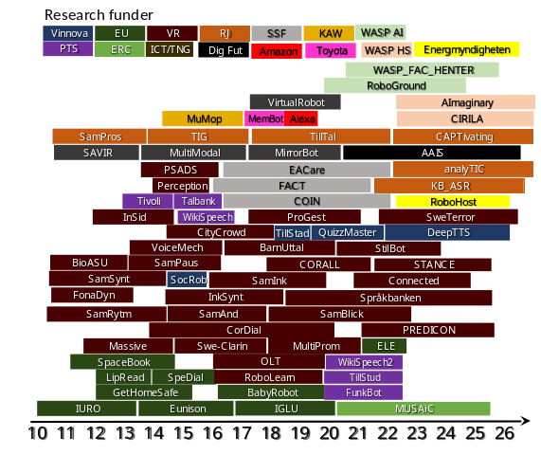
- The dependence of external funding bears the risk of discouraging long term and risky research initiatives.
The last decade TMH has had external funding for more than 70 projects from a range of sources. We have a steady number of projects funded from VR (HS and NT), while the number of projects from EU has decreased. Around 2012 we had around 10 ongoing externally projects. By widening our base of funding agencies, we have since constantly had on average 20 ongoing projects. We have also increased the number of projects with longer project durations (4-5 years) from RJ, SSF, ERC, DF, WASP and VR Infrastructure.
- The process to hire new faculty takes too long time, with the risk that the best joins another university in the meantime.
We employed four very good postdoc researchers that we encouraged to apply to faculty positions that we and WASP announces. This means that we have a better chance at getting them to apply and then wait the long time it takes to be called for an interview. Two of them applied to the WASP AI position for an assistant professor in Intelligent Systems with specialization. in ML, and both were called for an interview and one got the position with the WASP starting package. The other two have applied for and gotten project funding from both VR and RJ.

3. Viability

a) Funding; internal and external
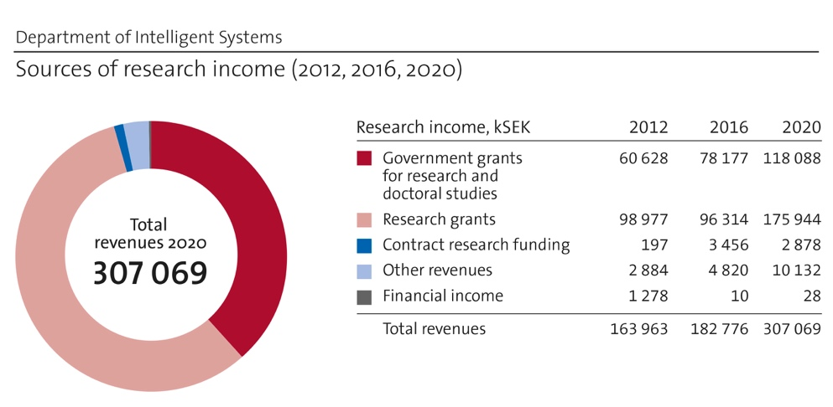
Figure 3.1. Research incomes for IS.

Status:
Research funding comprises mainly (a) Government grants (118 MSEK 2020) and (b) Research grants (176 MSEK 2020) (Fig. 3.1).
(a) Government grants comprises (i) base funding (70 MSEK 2021) and (ii) other government funding (48 MSEK 2021).
(i) Base funding is capped by the total funding available to KTH that is distributed to the schools and then further distributed to the departments within the school. The proportion of the base funding that is allocated by EECS to IS is determined by four KPIs:
1) the number of senior faculty (43.7%; 775 kSEK/professor, 345 kSEK/senior lecturer),
2) the number of PhD students graduated (24.7%),
3) the amount of external funding raised (26%; this funding covers requirements for co-funding due to our high OH)
4) bibliometry (5%; a relatively small amount, but its impact comes from the prestige associated with it).
This base funding is distributed in competition amongst all departments. IS excels in all four KPIs relative to the other departments at the school (EECS). Note that the allocated internal base funding typically covers only a smaller fraction of faculty salaries, i.e., we pay part of faculty salaries as well as all PhD and postdoc salaries with external funding.
(ii) Other government funding comprises funding from the Governmental Strategic Research Areas (DF, other) and co-funding for the Wallenberg WASP program, i.e., funding that we secured in competition.
(b) Research grants is funding from sources outside KTH, such as from Swedish national funding agencies, European funding agencies, private and state foundations, and direct funding to KTH from industry or private individuals (Fig. 3.2).
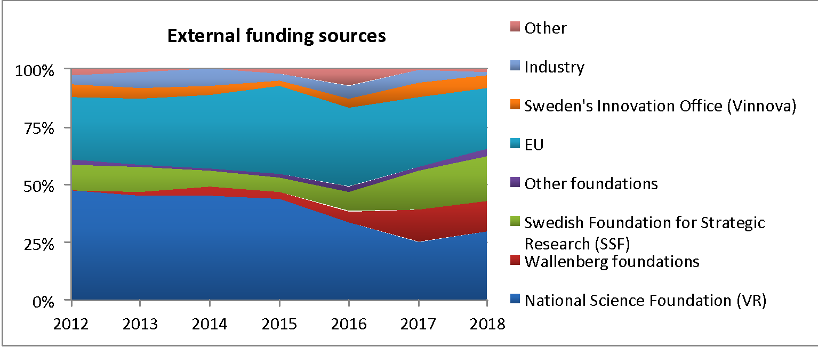
Figure 3.2. Research grant sources for IS, relative to the total amount of research grants.

Goals wrt funding:
The goals of IS with respect to research funding are to (i) obtain sustainable growth of external research grants and (ii) secure an increasing fraction of the internal base funding available at EECS and KTH.

Analysis of funding situation:
We have strong and increasing external funding (+78% during 2012-2020), where most faculty members have shown to be flexible and can act opportunistically on available funding opportunities. We have been successful in attracting substantial external funding for both basic and applied research from a wide range of sources. Furthermore, our faculty received several prestigious external grants: 2 "distinguished professors" granted by VR, 3 ERC Adv Grants, 3 ERC Consolidator Grants, 2 ERC starting grants, 2 Wallenberg scholars, 4 Wallenberg fellows.
Several of our research topics are of growing interest and considered as enabling technologies for many areas and critically important for solving many societal challenges. We can therefore hope for increased funding opportunities from stakeholders (industry and society): 1) for our core areas of research, 2) for cross-disciplinary research, enabling us to diversify towards into new areas and their related funding sources, and 3) for training future generations with key competences.
While external funding leads to research of high societal relevance, our (too?) large dependence on external research funding also leads to several consequences: 1) Long-term external financing is difficult to obtain, leading to research with short-term focus; 2) Limited self-renewal of researchers, because partly external funding is often not given to entirely new research directions, partly we have limited ability to take substantial risks; 3) Challenging to allocate funding for doctoral projects; 4) The requirements for counter-financing, both in the form of co-financing from KTH but also from the industry, further reduce our base funding; 5) We often compete with other researchers in the organisation for the same external funding.
Our solid financial base allows for strategic investments. However, when large funding has been secured, however, it has been typically spread wide, reducing risk but at the same time possible impact. Low base funding level per faculty (or: many faculty members for the given base funding) makes researchers risk-averse since researchers always need to seek follow-up funding, i.e., the very low constant base funding leaves limited room to temporarily compensate for the highly variable external funding sources. Further, high overhead (EECS imposes 12% OH and KTH central an additional 23% OH) and low base-funding per faculty limits sustainable growth of research areas.
Further considerations are that the lack of gender balance in the IS faculty can reduce our competitiveness in attracting external funding as already today the main funding agencies promote gender diversity to be a critically important parameter. Also, we have limited activities to influence research agendas of funding agencies.

Strategy wrt funding
To develop a sustainable research operation based on internal and external funding we must encourage, support, set clear expectations and incentivize the individual researchers to (i) excel in the KPIs set by EECS and KTH for distributing the internal research funding; and (ii) obtain sustained success in acquiring external research funding. Important components of this strategy are (or should be):
- When hiring and promoting faculty, evaluate their 1) track-record and practices in writing competitive research proposals and 2) capacity to renew themselves and their research area / adapt to the rapidly changing societal needs
- Encourage, support and incentivize current faculty to 1) apply for research funding from diverse sources, taking the lead in initiatives, e.g., act as coordinator and help the researcher to get proper support in this task; 2) diversify into different research/application areas to develop a broader knowledge base, diversify and extend our external funding potential; 3) develop procedures and a culture where researchers naturally support each other in securing research funding, e.g., by sharing experience or providing constructive feedback on research proposals, and; 4) apply for, and successfully secure, prestigious research grants.
For external funding an important aspect is that the total OH from the department, school and KTH remains below the level granted by funding organisations. Work towards reducing OH is crucial and should be of high priority at EECS and KTH.

b) Academic culture

Goals wrt academic culture
To pursue research (and education) of the highest international quality, to collaborate and compete with the best researchers in the world, and to continuously expand the frontiers of research and to transfer research output to key stakeholders. Our researchers aim to be visible, take responsibility, and actively provide academic service to our research communities. Locally, we aim for a collaborative, dynamic, open and welcoming research environment with an active exchange of ideas and continued renewal. Our staff is multicultural, we are highly collaborative within our divisions but also across research disciplines, regionally, nationally, and internationally, as well as in between academia and society.

Status wrt academic culture
Each of the five divisions in the department currently function as distinct “research families” with their own core research area and own culture. Within divisions, everyone knows everyone, people have workspaces in the same physical area, and we share the same lab spaces but also coffee and lunch places. Divisions have a flat organisation with research groups centred around individual faculty (7–13 faculty per divisions), and several constellations that involve multiple research groups with common or related research. Collaborations between researchers of different divisions occur increasingly frequently, often started in conjunction with funding opportunities that allow us to collaborate (e.g., WASP and DF, see Section A).
Divisions generally organise regularly scheduled seminars where PhD students or postdocs present and discuss their ongoing work, alternatively inviting external guests to present their research for the division. The regular exchanges shape a common view of quality and engineering relevance and also communicates the high expectations to every individual. Additional seminars and joint activities are organised in the research centres where many researchers meet and collaborate. Divisions are regularly visited by international guests for whom the host organises meeting opportunities with other researchers from the division or beyond.
Several researchers have close interaction with local societal and industrial stakeholders (see section 6a for details) and with researchers from Karolinska Institute and Stockholm University. Our faculty are also very active in international research communities, where we organise key conferences and perform editorial work for most important journals in our respective areas. Faculty further serves as reviewers and experts in academic assignments for graduation committees or funding bodies and give invited talks as well as plenary talks.

Analysis of our academic culture
Our main strengths are that the research environment is broad and has been among the strongest at KTH. Our department hosts several very successful and strong researchers and research leaders, and the very large majority of researchers actively contribute to the excellence of the research environment. The researchers have a strong international network to the best researchers in the world and many take responsibilities and provide academic service to the community.
Our weaknesses include that the department is newly formed and collaboration opportunities are not exploited to the largest possible extent, which is partially due to its large size. DF is, however, playing a crucial role towards this end. Furthermore, most divisions could improve in attracting international guest researchers.
Opportunity: Since all divisions in the newly formed department are strong groups with their own excellent academic cultures, we can learn much from each other to develop further our academic traditions and routines, although we do not yet do this systematically today.
A potential threat is that stimulating internal competition and high expectations that motivate researchers to the highest academic performance can quickly become destructive when fairness, collegiality, healthy work-life balance, or a minimum level of resources are lost.

Strategy to maintain and improve our current academic culture
We want to maintain, in particular, our academic ambitions on the highest international level. Support researchers to be visible, take responsibility, and actively provide academic service to our research communities and to our stakeholders. Provide the necessary resources for a collaborative, dynamic, open and welcoming research environment with an active exchange of ideas and continued renewal.
We suggest improving the academic culture at our department using a dual top-down and bottom-up strategy. The top-down strategy is driven by the department's leadership that needs to ensure that decisions and incentives on all levels are supporting our joint goals and encourage initiatives but also ensure our academic freedom and collegial fairness. Our high research goals, however, can be only achieved if all our researchers strive for excellence. Thus, the bottom-up strategy is to ensure a common understanding of our ambitious goals and joint expectations as well as everyone’s responsibility to contribute towards them. This should be achieved in open discussions in seminars, workshops, or other research collaboration. In particular, leading researchers should act as role-models for others and need to be aware of their responsibility. Since the department is newly formed by academically very successful divisions, we currently face the opportunity to learn from each other's academic traditions, which should be exploited.

c) Current faculty situation
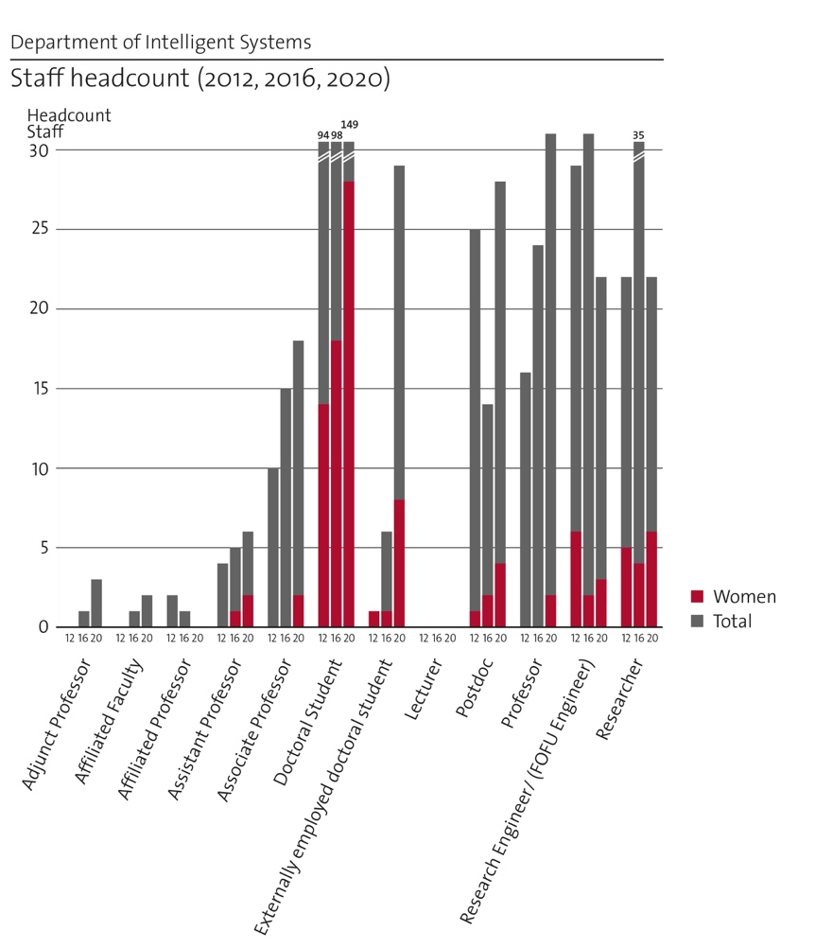
Figure 3.3. Staff of IS.
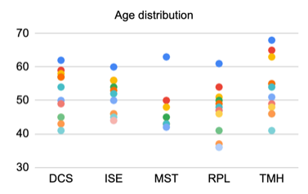  Figure 3.4. Age distribution of faculty members. | Table 3.1. Expected evolution of the number of faculty, including retirements but excluding new recruitments.
   | 2021 | 2022 | 2023 | 2024 | 2025 | 2026 | 2027 | 2028
  Prof | 32 | 34 | 38 | 38 | 39 | 40 | 40 | 40
  Assoc prof | 20 | 18 | 15 | 13 | 14 | 12 | 11 | 11
  Assist prof | 4 | 3 | 2 | 2 | 0 | 0 | 0 | 0

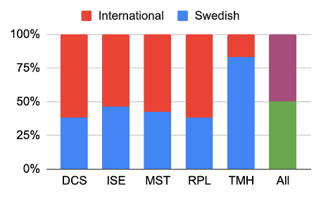  Figure 3.5. Origin of faculty members. | 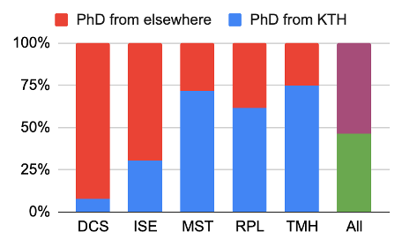  Figure 3.6. Where IS faculty members did their PhD.

Status of our faculty situation
The above plots provide quantitative data about the faculty composition.
Size of faculty: There are currently 58 faculty at the IS department (including 2 adjunct professors) plus 6 permanent researchers. The size of the faculty is driven by recruitment based on teaching need, while the number of PhD students and postdocs at individual divisions largely depends on the available (external) funding and varies significantly.
Role of faculty: Different styles in division organisation create differences in the roles of faculty within the respective divisions: at some divisions, faculty complements each other in their roles, and some focus more on teaching, some more on research, and some more on leadership; in other divisions the proportion of teaching, research and leadership time is more evenly distributed. Teaching duties are distributed among divisions of the department quite unevenly, with some divisions teaching significantly more of the large and popular courses and supervising more 1st and 2nd cycle thesis projects than others. This also affects the faculty members’ roles and their space for involvement in research.
Age distribution: Within the following 10-year period, approx. 18% of faculty will reach retirement age.
Gender diversity: Our ratio of women/total faculty is really low in all divisions, except for RPL. (# women faculty/# total faculty) for the divisions is: RPL (5/12), MST (1/7), DCS (1/12), ISE (0/12) and TMH (0/12) - very few concrete actions address this issue. The proportion of women among faculty has remained constant around 10%. For faculty, this problem was studied in the 2020 EECS faculty Diversity Initiative, which resulted in a report with 20 specific recommendations for improvement (see: tinyurl.com/y2yrecmc and tinyurl.com/vph2p58h). Four out of 20 points were already adopted in the activity plan for 2021, addressing measures to improve recruitment and work-life balance but not - yet - the risk of current women faculty leaving. The number of female postdocs and PhD students have grown from approx. 10% to 20% During the past 10 years.
Origin of faculty: Approximately half of the faculty is Swedish and half international, half did their PhD at KTH and half at other institutions.
These above proportions differ across divisions due to the traditions of the respective research fields, the existence of temporary strategic research funding in various periods of time, trends in teaching and research, and the fact that divisions did not belong under the single umbrella of the department in the past and had developed own cultures and strategies.

Analysis of our faculty situation
Our strengths are 1) the multidisciplinarity and complementarity of faculty expertise, covering broad research topics, within and across divisions; 2) the excellence of our faculty proven by prestigious career awards, with several faculty members in scientific societies (seven IEEE fellows, two KVA members, two IVA members, three SUA members, one fellow of the Acoustical Society of America) and several having received excellence research grants (VR, ERC, KAW, listed in section 3b), and; 3) our increasing collaboration with industry, reflected in our increasing external funding and increasing number of industrial PhD students.
Our main weaknesses is our overall poor gender balance that has not improved significantly in the past 10 years.
External opportunities include 1) our growing and timely area of research, which puts us currently in a good position to acquire external funding and build tighter industrial relationships; 2) to integrate climate change/biodiversity aspects into our research and teaching activities, and; 3) a trend towards increased mobility of faculty world-wide, where we should investigate how this could benefit us.
Threats include 1) the risk of losing current faculty members, especially female, because they excel scientifically and there is low support for dual career opportunities, and IS/KTH therefore faces a substantial risk that they will be headhunted; 2) the requirement of fluent Swedish to be included in leadership activities imposing more responsibility on Swedish-speaking faculty and at the same time does not allow for full engagement of non-Swedish speaking faculty.

d) Recruitment strategies
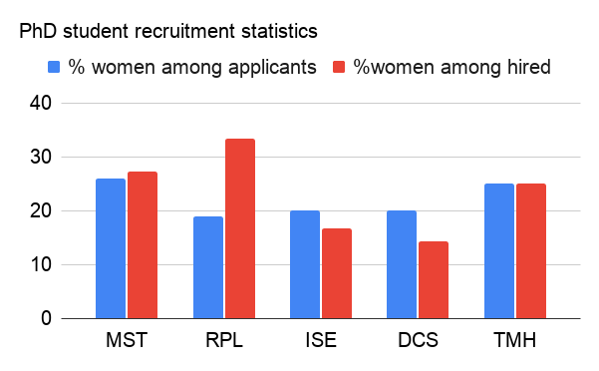
Figure 3.7. PhD student applicants and recruits at the IS divisions.

Status of current recruitment:
Recruitment happens in open competition. Recruitment of faculty is performed on a department level (but today still controlled to a large extent by the divisions); recruitment of PhD students and postdocs is done on a division level (but today controlled to a large extent by individual faculty members).
PhD and postdoc recruitment (based on the data from the last 10 recruitments of PhD students and 5 postdocs in each division): Average number of PhD applicants per position is between 80 and 90; an exception is DCS with 134 applicants per position on average. The number of postdoc applicants per position is typically around 25-30. More than 85% of the applications come from abroad, which holds for both PhD students and postdocs. These numbers indicate that the research in the department is internationally renowned and visible. The proportion of hired international PhD students ranges across divisions between 58% and 90%, which may be due that many of the international applicants are not competitive or that graduates from KTH better fulfil requirements for the position, such as, expertise in particular areas.
Faculty recruitment (based on the data from the last 3 recruitments): The number of applicants in the last three recruitments ranged between 25 and 48. Two men and one woman were hired, two of them international and one Swedish. Several candidates withdrew their applications during the recruitment process, which took approx. 8 months. The proportion of candidates from abroad (65%) and female candidates (15%) is much lower than among PhD and postdoc candidates. The reasons may be, among others: some of the applications come from international candidates that conducted their PhD or postdoc in Sweden, hence they count in the statistics as candidates coming from Sweden and not from abroad. It may also be more difficult to move to a non-English speaking country at this career stage, with a vision to stay for longer than several years, and possibly with a family. Sweden hence may look less attractive than, e.g., the US, UK, or a potential applicant’s home country. The lower proportion of female candidates may be influenced by the fact that many institutions, especially in the US, implement proactive strategies to secure female candidates early after their PhD, while the recruitment practices at KTH (and often also in Sweden and Europe) require demonstration of a certain level of one’s independence and establishment. This is, of course, balanced by the fact that in contrast to the KTH system, a high proportion of tenure-track assistant professors do not get promoted to a tenured position in the US system. Female candidates may be discouraged from applying, e.g., due to family reasons. Noteworthy is that when KTH centrally funded 12 assistant professor positions in a KTH-wide call, three ended up at IS (Herland, Leite and Tumova) and all three were women. This indicates that very broad recruitment announcements attract a much larger source of women than what is the case when we have narrowly defined faculty position announcements.

Analysis of PhD and postdoc-level recruiting:
Our main strength is that we attract excellent applicants internationally.
Our Weaknesses are 1) the relatively low number of women among PhDs and postdocs, despite this number having doubled during the past 10 years; 2) PhD student recruiting being tied to (external) funding rather than the availability of exceptional candidates, and; 3) that we cannot accept PhD students - and often neither postdocs - on scholarship, making PhD students and postdocs expensive.
An opportunity is the many strong second-cycle students at KTH, providing a strong talent pool for PhD recruitments. This is especially true in many of the digital-focused topics of relevance to the department, such as AI.
A general external threat is that zcademic career is not as attractive as it used to be, e.g., in terms of salary, where we compete with industry.

Analysis of faculty-level recruiting:
Our main strength is that we attract excellent applicants, many of them international. Out of the last seven hired assistant professors (during the last five years) three are women.
Our Weaknesses are 1) The number of female applicants is low; 2) the importance of teaching should not be underemphasized in the hiring process; 3) there is no possibility to recruit based on research need, only on teaching need, and 4) the candidate evaluation procedure is too long.
An opportunity is the core research areas of IS being very popular. We thus could recruit the top researchers and teachers at an international level, and to introduce/increase the number of teaching-only positions (adjuncts) to cover the teaching need, and adjunct and affiliated professors to strengthen ties to industry. Further, the KTH and our divisions being top at the EU level helps attracting international faculty of the highest calibre, also with respect to the current political situation and world pandemic.
External threats include that 1) competition with industry makes academia less attractive nowadays, and 2) many competing institutions are open to recruiting new faculty members directly after their PhD, possibly with a 1-year delay to gain postdoc experience, which allows them to secure excellent candidates, especially women, early on, which diminishes our chances.

Goals for future faculty recruiting:
- To recruit and retain the most excellent staff
- research excellence and ability to evolve into new research/application fields
- recruitment and retainment of female faculty
- sustainable growth to cover teaching needs, ensuring a sound age distribution.

Strategy for recruitment
Recruitment of 1-2 assistant professors annually is necessary to assure renewal of research themes, fill gaps in teaching needs after retiring faculty, and cover new teaching needs brought by a growing interest in the IS area, especially in AI and ML. Strategically, it is important that the recruitment is continuous to ensure long-term sustainability, diversification, gradual transfer of knowledge and experience from the senior faculty members to the junior ones, constant competitiveness of IS in applying for external funding specifically targeting young researchers (ERC Starting grant, VR Starting grant, KAW fellowship, SSF Future Research Leadership grant) without creating unreasonable internal competition, and also to ensure that the environment is dynamic and perceived as attractive to the most excellent staff candidates.
We further identified the following four strategic actions / suggestions for further investigation:
1) Because PhD student recruiting is tied to funding, not to the availability of exceptional candidates, we could consider reinstating internal excellence grants for PhD candidates, alternatively establishing a “PhD school” to attract excellent candidates also when there is no immediate funding. The latter could also be a tool to create a more inclusive feeling and to attract candidates with a diverse background. Such PhD school could have a single annual broad recruitment financed by myndighetskapital, a broad research education in the first year, and a narrower focus via the choice of a supervisor. This idea would be challenging to organise, however, considering our financing relying to a large extent on external project funding.
2) Encouraging more research/project-oriented master thesis projects and improving our communication about our research to our own undergraduate students would allow for better connecting to the talent pool at the MSc level.
3) Be more proactive/improve/speed up the faculty recruitment procedure as described above. The KTH CV template should be significantly shorter. On the other hand, the on-site interview should be significantly longer and involve interaction with most faculty. The involvement of the divisions could be enhanced if sufficient measures are put in place to avoid unconscious/gender bias in this process.
4) Specifically address gender balance in faculty recruitment by following the recommendations from the EECS gender diversity initiative (see: tinyurl.com/y2yrecmc and tinyurl.com/vph2p58h).

e) Infrastructure and facilities

Status of current infrastructure
The infrastructure that is used at IS consists of (a) infrastructure that is owned and maintained by one of the IS divisions and (b) external infrastructure that is used by one or several of the divisions at IS (sometimes such external infrastructure is critical for the research of these divisions). Current infrastructure important for IS is:
(a) Infrastructure owned by the IS divisions:
@ DCS: The Smart Mobility Lab (SML) is the major experimental infrastructure of DCS and provides experimental facilities which are used both for teaching and research purposes. The research involves endeavours within multi-robot systems and intelligent transportation systems (ITS). The laboratory is currently equipped with a Qualisys Motion Capture System consisting of 12 cameras that provide real-time (100Hz) pose and velocities feedback, and several robotic platforms including turtlebots, quadrotors, miniature trucks hexacopters and robot manipulators. SML is part of the Integrated Transport Research Lab (ITRL).
@ ISE: Lab with universal software radio peripherals (USRPs) and electronics labs.
@ MST: MST’s research is lab intensive, and MST runs several labs: 1) Polymer microsystems Lab; 2) Microwave frequency and THz Lab; 3) Photonics and Optics Lab; 4) 3D Nanostructuring Lab, including micro 3D-printers and 3D laser micro- and nanomanufacturing tools; 5) Cell & microbiology facilities.
@ RPL: 1) Physical robots lab with 3 Yumi ABB robots, 2 Franka arms, 1 PR2 dual-arm mobile robot with, 1 Clearpath Ridgeback mobile robot with a Baxter dual arm mounted on it, an ATRV2 outdoor platform and a wide variety of sensors; 2) A drone lab with a cage protected by nets, equipped with a 16 camera MoCap setup for positioning. We have access to a large set of off the shelf and custom-built drones, from nanodrones (Crazyflie) to > 1 m diameter outdoor drones; 3) A social robots lab with five Nao humanoid robots and a Pepper robot (wheeled) as well as many smaller robots and sensors; 4) In-house GPU server with 38 GPUs.
@ TMH:
- Språkbanken Tal is part of the Nationella språkbanken (National Language Bank) that in 2018 was funded by the Swedish Science Council’s programme for research infrastructure of national interest. The initial funding for the infrastructure runs over 7 years, over which the KTH share is in excess of 22 MSEK. Through Språkbanken Tal, KTH is the National Coordinator for the European Language Grid (ELG), which focus on infrastructure that is available to the industry. Språkbanken Tal has achieved funding for several supporting infrastructure projects, including 8 MSEK from RJ for developing ASR for audiovisual collections of the National Library, 6 MSEK from Vinnova for developing Swedish speech synthesis for long and information-rich texts, and 4 MSEK from PTS for developing a speech technology that makes lectures more accessible.
- Three recording studios for audio recordings: a large studio used in both research and teaching, a smaller studio that is used by Språkbanken Tal, and a recording pod placed in our interaction lab, to allow for daily dialogue recordings.
- Performance and Multimodal Interaction Lab (PMIL), a large motion capture lab. It is a multi-purpose facility for data collection and experiments in multimodal interaction. It currently features a 20 camera motion capture system (including 3 frame synchronized RGB cameras), 3 head-mounted gaze trackers, VR equipment and sound recording equipment.
- In-house GPU with 84 GPUs, out of which 44 are part of språkbanken Tal.
(b) External infrastructure:
Several external infrastructure is critical for especially MST: the Electrum Lab and Albanova Nanofabrication Facilities (KTH micro- and nanofabrication cleanrooms, which are key infrastructures at KTH for which detailed descriptions are available in the external infrastructure), Scilifelab (the national hub for molecular biosciences), MedTechLabs (the regional interdisciplinary centre for medical technology research, where MST Assoc. Prof. Niclas Roxhed is the director), and Biomedicum (the experimental research centre of the Karolinska Institute).
Furthermore, there is interest in using the KTH centre of high-performance computing (PDC) by several of the divisions.

The goals of IS with respect to infrastructure
Our goals are (i) to ensure that the researchers have access to well-functioning infrastructure needed for their research, and (ii) to proactive invest in strategically important infrastructure that will be critical for future cutting-edge research.

Analysis of current infrastructure
Strengths: All divisions have a decent degree of infrastructure that goes beyond their focused disciplines. There is significant research output from all divisions in direct relation to their infrastructure, and for some, the infrastructure has been instrumental to connect to industry and society and reach impact.
Weaknesses/threats: 1) We lack base funding for infrastructure and most infrastructure is supported by short term external project funding. The need for external funding and limited strategic investments in labs limits their development and could jeopardize KTH’ competitiveness in dynamic research areas. 2) We lack permanent staff for infrastructure, which jeopardizes its quality and reusability. Base funding from KTH along with permanent technical staff also budgeted from base funding from KTH (i.e., not departmental Fofu), could remedy this, although this would reduce funding elsewhere. 3) We lack formal establishment of labs at KTH, i.e., the existence of local labs or equipment is not systematically tracked at KTH.
Opportunities include linking infrastructure to larger initiatives within KTH and beyond (WASP, DF, other), in which established/recognized labs may attract large project efforts and funding and using infrastructure as a test-base for EU projects, i.e., having certain lab environments/infrastructure will be helpful (and add credibility) in attracting EU projects and funding.

Strategy wrt infrastructure
We have a decentralized strategy for developing and maintaining the infrastructure that is critical for the research of IS. This means that each division is required to take the initiative(s) to build and develop the labs necessary for their research. At the same time, the ambition is that all lab resources are available for use by other KTH researchers both from within and outside the IS department (typically for a fee). For large external research infrastructure needed by IS researchers, it is up to each division to engage in the development of the external infrastructure and to get access to and utilize them in an efficient way. It should be pointed out here that the KTH-owned cleanroom facilities Electrum Lab and the Albanova Nanofabrication Lab are of essential importance for most of the research at the Division of Micro and Nanosystems (MST) at IS. The continuous development of, and investment in, these infrastructure facilities at the KTH level is of utmost importance for this research at IS. This type of infrastructure cannot be built and maintained at the divisional level.

4. Strategies and organisation

a) Goals for development 5–10 years ahead
The following are our overall four most important goals for development. For each goal, we have formulated a specific quantitative measure.
Goal 1: Reinforce and develop the position of IS as an internationally recognized and leading research environment
Specifically, when academic colleagues in our areas list the top 3 European research environments in their field, they always have at least one IS division in their list
Goal 2: Be leading in reaching impact in industry and society
Impact concerns the value our research creates for stakeholders.
Specifically, when Industrial and Societal stakeholders, of relevance for our research areas, list the Swedish research environments they perceive as most valuable or as preferred partner/ collaborators/experts for their activities, they always list at least one of our divisions at the very top.
Goal 3: Reach considerable breadth of our research through engagement in multi and interdisciplinary research projects
Fostering a significant portion of collaborations beyond the classical fields of Intelligent Systems is a way to make our research more relevant, achieve a higher impact, and access new research funding sources.
Specifically, at least 30% of our research projects should involve researchers from different disciplines or research areas. This goal should also be reflected through cross-disciplinary co-authorship on our research papers.
Goal 4: Balanced gender diversity
We strive for balanced gender diversity at all levels (students, PhD students, postdocs, and faculty), with a specific goal to reach 20% female faculty by 2030. (See section 3d for more details.)

b) Congruence with university-level goals for “A leading KTH” as set out in KTH´s “Development Plan 2018-23” (page 5)
Our goals are congruent with university level goals in the sense that:
- We strive to and perform world-class applied research in combination with curiosity-driven basic research and cross-disciplinary collaborations.
- Collaborations with industry and society are highlighted as well as digitalisation as manifested by centres as DF. We acknowledge that major social benefits may arise through outstanding collaborations in research and that larger research grants from the EU can leverage this.
- Equal opportunity is emphasized, and we have now started to work more strategically towards a more even distribution of women and men within the organisation and on decision-making bodies
- We aim at increasing visibility by having teachers and researchers engaged in the public discourse, and generate more leading technical innovations

c) Leadership structure and collegial structure
All education related questions (incl. organisation, economy, etc) and faculty recruitments are dealt with on department level. All research related questions (incl. organisation, economy, etc) are dealt with on division level.

On department level:
IS has biweekly management meetings, including the Head and Deputy Head of department, the 5 Division Heads (or their Deputy), the Head Director of studies and faculty representatives from other divisions with high teaching load in IS. The Deputy Head of the department is responsible for teaching. The Division Heads then inform the rest of the faculty in their division about these meetings. Our plan for annual Faculty Days to foster cross-division faculty collegiality was delayed by COVID.

On division level:
the specific collegial structure varies between different divisions, but we all have in common regular (e.g., weekly or monthly) scheduled events where the entire division meets, and weekly/monthly scheduled events where division faculty meets to discuss organisation, teaching and research. Additionally, there are other activities that contribute less directly to the department collegiality, such as DF seminar series where many IS faculty attend (or speak), educational activities, e.g., in the context of large courses or degree projects, and research projects in which PIs from different IS divisions collaborate.

Suggestions for improvement:
The use of cross-divisional teams, as those who prepared this self-assessment, can be used in a continued process of self-improvement, i.e., to lead internal skill development and as advisory to the department management.

d) Strategies for high quality

Strategy to reach Goal 1 - Reinforce and develop the position of IS as an internationally recognized and leading research environment
To sustain and improve the position of IS as a leading environment, top 3 in Europe, we will encourage and support the following measures:
- We always prioritize scientific quality over quantity
- Foster international mobility through sabbaticals for our faculty for visits at top international institutions, as well as through welcoming incoming guests from top universities
- Foster additional exchange by supporting our PhD students to carry out parts of their thesis work at an international top university, as well as assisting them in getting postdoc positions at top ranked universities
- Coach younger faculty to establish their own research groups.
- Coach younger faculty to apply for ERC (starting and consolidator) grants, and corresponding career awards from SSF, VR and KAW.
- Coach our faculty to be represented on professional committees and boards (e.g., an IEEE Society board of governors)
- Coach our faculty to be represented on journal editorial boards
- Our faculty should be visible as plenary speakers (and similar)
- Coach our faculty to be visible on top conference TPCs and as being organisers of international conferences
- Stimulate excellent undergrad students to do their thesis work in excellent groups abroad and leave a good impression about KTH. (This will benefit Note that such a strategy would rather benefit KTH overall) than our specific department.
To measure the success of our strategy, we will follow the development over time (5 to 10 year time span) of the following metrics:
- The number of ERC grants (“European metric”)
- The number of Marie Curie project grants? (“European metric”)
- The number of grants from VR, SSF, KAW, and other foundations (“national metric”)
- The number of outgoing PhD student and faculty visits to top-ranked international universities
- The number of incoming postdocs and visiting faculty from top-ranked universities with own funding
- The number of paper awards
- The number of former PhDs and postdocs who get a faculty position at a top 100 university or get leading positions in industry.

Strategy to reach Goal 2 - Be leading in reaching impact in industry and society
Our impact is the value our research creates for stakeholders. We can more systematically and strategically 1) improve the transfer of our research output to key stakeholders and 2) analyse and communicate the value our research creates for those stakeholders.
Today we transfer our research results via four main channels: 1) providing skilled people, 2) transferring technology to stakeholders, 3) expert advice to the public sector, and 4) engagement in advisory boards / industrial boards / learned societies. For details, see section 6.
Activities that should be supported to reach the goal include:
- Intensify and extend strategic partnerships and work for a continuation and extension of the existing industrial PhD student and collaborative research programs with Industry and Society.
- Foster additional exchange by supporting our PhD students to carry out parts of their thesis work at international top industrial research environments.
- Outreach more systematically with the aim for our faculty members to be engaged as expert advisors.
- Be more strategic and systematic in communicating and engaging with stakeholders to increase our research output translation.
- Increase research result dissemination through education and course offerings directed toward Industry and Society.
- Increase our engagement in projects with high TRL focus, e.g., via EU, VINNOVA, WASP, DF or bi-lateral collaborations.
Comments: To systematise our communication and engagement with stakeholders, the EECS impact leaders are currently working on a plan; To increase lifelong learning, KTH is presently working on a central plan.
The following are quantitative metrics that can be followed up on regularly to measure the success of our strategy:
- The extent of our faculty members’ engagement as expert advisors in industry
- The number of requests for providing education and course offerings directed towards industry
- The number of appearances in media (to foster the general public’s view of us as experts)
- The number of graduated PhD students hired by industry
- The number of industrial PhD students
- The number of patents with IS researchers as inventors sold to / licenced by / used by industry
- The number of start-up companies founded on research results

Strategy to reach Goal 3) Reach considerable breadth of our research through engagement in multi and interdisciplinary research projects
With core competence in intelligent systems, our divisions are optimally positioned to address societal challenges that require multidisciplinary efforts. Areas such as security, healthcare and climate change all entail significant challenges where increasing opportunities will arise.
Activities that should be encouraged and supported to reach this goal include:
- Increased engagement in established research frameworks including KTH DF interdisciplinary projects, WASP collaborative projects, WASP-HS, and VR multidisciplinary research programs.
- Increased engagement with other leading players outside the immediate IS field, primarily in Sweden but also internationally, where intelligent systems may play an increasing role. Such players could include academia (Science for Life Laboratory, Karolinska Institutet), research institutes and societal or industrial sectors. Here we should more proactively investigate areas outside our current focus:
  - On a national level we can focus on leading national organisations in other research/application areas that have large - but for us - non-traditional - funding opportunities (e.g., through funding agencies such as Formas/Forte).
  - On European level, we can engage increasingly in collaborative European projects.
- Increased involvement in excellence networks like European Lab for Learning and Intelligent Systems (ELLIS). We currently have one of only two ELLIS Fellows in Sweden at IS.
- Recruit broadly in “Intelligent Systems”. Where applicable, in our future broad recruitment calls, we could systematically also highlight areas of great societal importance not well covered today (e.g., intelligent systems for climate change/biodiversity), while still being inclusive.

Strategy to reach Goal 4) Balanced gender diversity
For faculty, this problem was studied in the 2020 EECS faculty Diversity Initiative, in which 20 specific recommendations for improvement are provided.
To improve gender diversity and strive toward the quantitative goal 20% female faculty by 2030, we suggest the following:
- Always work actively to secure competitive female candidates for announced faculty positions. The aim is to always have at least 40% women on the short list for interviews.
- Work actively to increase the number of female PhD students and postdocs.
- Implement the measures to improve diversity listed in the EECS Faculty Diversity Initiative from May 2020.
- As a shorter-term measure (especially for divisions with the lowest gender balance) encourage the creation of female adjunct professor positions and international visiting scholars. This would also contribute to building tighter relationships with industry and other universities.

To support all the above goals, we will improve our communication strategy.
As outlined in detail in section 6, visibility of our researchers and research output is important to 1) increase translation of our research outputs to stakeholders; 2) attract funding, students, recruits and collaborators; 3) increase awareness of our contributions to societal development among the general public, and; 4) reach out more broadly to academic peers in related areas and thereby aid our efforts to become more multi- and interdisciplinary. Visibility further helps the individual researchers build a contact network, personal branding and potentially an increased number of citations, and KTH to improve its university ranking.
To increase our i) research impact, ii) stakeholder investments and iii) diversity of staff, a strategic and proactive communication strategy adapted to the expertise and resources of the IS faculty is essential. Such strategy includes identifying and targeting potential stakeholders and choosing appropriate channels to best explain and communicate our contributions. For researchers communicating their research (points i and ii), the strategy must be adapted to the expertise and resources of the IS faculty and IS researchers must be offered the necessary support to accomplish this.
Our more specific goals are that:
i) IS researchers are broadly engaged and visible in the public discourse.
ii) Technical innovations made by IS researchers are more visible and attributed to our research activities.
iii) IS communication strategies are adapted to achieve our goals in recruiting excellent and diverse PhD students and faculty.
iv) The (school) communication plan is further aligned with supporting the IS goals outlined throughout this document.
To increase visibility, the IS faculty should more systematically and continuously involve the EECS school’s communication group in their ongoing research work. In that way, communication activities will not be sporadic but rather a regular, natural part of the daily research activities. Some strategies to reach our goals here are:
- EECS research communication managers should regularly attend division faculty meetings to be aware of ongoing research and suggest outward communication activities and channels.
- The faculty and researchers in IS should receive training in reaching out to a broader set of society. This can include writing workshops on how to best target high-impact research journals and venues (Nature, Science, etc.), but also media training. Publications in high-impact research journals not only contribute to demonstrating our research excellence but are also much more likely to be picked up by media, and by extension thus further enlarge our recruitment base.
- The department should arrange annual IS research awareness workshops, mainly directed to KTH bachelor and master students, to inform about ongoing projects and PhD studies to attract excellent students of diverse backgrounds.

Final remarks on strategy:
The input provided in this document should be used to update the current school and department Development Plans.
We suggest nominating representatives across the divisions for each of the four goals to develop strategic intelligence in those topics. Those representatives could lead workshops to ensure goals remain updated and appropriate strategies are planned, advise the department and school leadership on those topics, and aid in implementing changes. This engagement should be aligned with the expected leadership development skills of (younger) faculty.
An ongoing exercise is looking into metrics in a more systematic way. Today we mostly measure our performance via the RAE, research funding and bibliometry. As suggested by the proposed strategies, there might be other incentives and KPIs that need to be defined (e.g., how to increase diversity, visibility, etc.).

5. Interaction between research and teaching at all three levels (BSc, MSc, PhD) of education

Interaction between research and teaching at all three levels (BSc, MSc, PhD) of education

Status:
The interaction between teaching and research is important in all three levels of education in EECS. Many courses offered involve motivating examples from current research projects of associated research faculty, e.g., lecturers of the Music Informatics course (DT2470) present work recently presented at the flagship conference. This exposes students to the culture of the local research community and provides students with new insights. Examples of this include the integration of new research in the lectures and research papers as part of the syllabus. Furthermore, direct student involvement with research in courses is often realized through student projects, e.g., in the Data Science project course (DD2430) many projects come directly from the research of supervisors. Additionally, program integrating courses such as DD2301, EH1110 and EL2220 provide a broad perspective spanning the wider connections between research, teaching and incorporate a discussion of societal questions such as the ethics of AI. Quality is maintained by course development related to the results of student course evaluations and by teacher participation in pedagogical training activities and seminars. In a few cases, students have submitted their work to peer-reviewed international conferences which have been accepted and presented, e.g., Hallström, Mossmyr, Sturm, Vegeborn, and Wedin, “From jigs and reels to schottisar och polskor: Generating scandinavian-like folk music with deep recurrent networks”. In Proc. Sound and Music Computing Conf. 2019.
At the PhD level, courses are tailored to specific research interests, e.g. FDD3353, FDT3303, and teach important theoretical concepts essential for the success of our PhD students. There exist reading group courses in a variety of domains (such as Computer Vision and Deep Learning, ML, Robotics, Speech Technology, etc.), which focus on discussion and integration of recent research work. As these technologies are all developing very quickly, it is very important to continuously update lecture material, reading material, and the tools used in labs and projects. Furthermore, several PhD courses have been turned into MSc courses, such as Reinforcement Learning, Theoretical Foundations of Machine Learning, and Cyber-physical Security of Networked Control Systems. Additionally, 109 PhD students at KTH are affiliated with WASP, which is a large research funding effort (≈70 MSEK just at KTH). These students are part of the WASP Graduate School, which currently has 293 PhD students and is aiming to educate a total of 600 academic and industrial PhD students in its funding cycle. Many KTH researchers are actively involved in both research and education as part of this effort.
Finally, researchers at EECS are collaborating with specific high-profile industries on lifelong learning initiatives. An excellent example is provided by the three-module ML course with Ericsson employees, offered for the first time in the Fall of 2020. This online course involves over 30 students from around the world learning about state-of-the-art methods and applying them to practical projects often related to their work at Ericsson.

Analysis
Strengths include that IS comprehensively covers the topic area, which includes information processing, robotics, automatic control, ML, and AI. The department's research falls subject-wise in between electrical engineering, where KTH is ranked #17 worldwide by the QS university ranking by subject, and computer science, where KTH is ranked #43. Coupled with voluminous ongoing research activities, and a relatively high researchers to student ratio, this allows us to deliver the highest quality of university education within our subject area, in particular at the MSc and PhD levels. The cross-disciplinary nature of the department also makes it well equipped to teach emerging popular topics such as ML and AI.
Another strength is that our research is often carried out in collaboration with industry, partly via large national initiatives such as WASP and now the KTH initiative DF. This created strong networks between industry and academia, which in turn can be used to strengthen education via, for example, guest lecturers from industry and student projects pitched by industry.
Weaknesses include the organisational structure of EECS in relation to IS, with a lack of a coherent strategy between the department and the educational programs for which the department’s courses are offered. This is especially important when it comes to fast-moving subject areas such as digitalisation, ML, and AI. An artifact of this is that the process of introducing new courses within our subject area becomes unnecessarily slow and cumbersome.
Another weakness is that the departments’ research activities are not well exposed to students at the BSc level. Students at KTH generally do not know what our research activities are. This reduces the divisions’ ability to help shape the school’s educational offering and hampers the ability to internally recruit students to the MSc and PhD levels in some research areas. In fact, it is plausible that a full 5-year degree program in ML and AI could be supported, but no such program exists currently. A similar weakness is our low visibility within educational programs at the other KTH schools, such as engineering physics and engineering mathematics, although students from these programs would be well equipped for MSc and PhD level studies in the areas covered by IS.
A final weakness is that although digitalisation plays a key role in environmental sustainability, we do not provide any strong course offerings within the subject area and do not have faculty well equipped to teach the topic.
Opportunities include the cross-disciplinary and industry-connected research activities of the department could allow us to increase the understanding of the relevance of our subject area to education, through better engagement of for example KTH strategic (industrial) partners in our education. This already takes place to some extent at the level of individuals but could be strengthened by strategic partnerships.
Further, we could strive to increase our visibility at the BSc level within EECS and across KTH, both to ensure better student recruitment to the MSc programs at EECS and better student recruitment to KTH as a whole.
Also, creating specific educational programs could strengthen our profile and position as a leading player in specific areas. Note that this would benefit KTH rather than our department specifically.
Threats include the high reliance on external funding for PhD education is a threat in that it reduces the stability of course offerings at the PhD level. The lack of an integrated strategy that involves both the divisions and the programs, leads to fragmentation. The lacking representation of IS teachers in the first years of the bachelor education could lead to our research activities becoming invisible.
The current hype in ML and AI could be a potential threat in that: 1) 1) the large and increasing number of students on these courses could affect course quality and the interpersonal interaction between teachers and students, thus hindering recruitment of MSc thesis students and PhD student candidates; and 2) Teaching staff planning becomes risky in times of hypes: hiring is required to meet the demand, which could pose a problem if the current hype lessens (or when other Schools are creating their own ML courses, which we now see).

Strategy, Processes, & Goals
The strategies currently applied at the department for enhancing the synergy of teaching and research can be classified according to purpose into two broad classes: strategies for improving teaching by leveraging our research and vice versa. Of course, the most successful strategies achieve both at the same time.
In the first class, the focus lies on the MSc and PhD programs. By bringing the latest knowledge from their research into the course syllabi, teachers keep the content of the courses updated and relevant. Furthermore, teachers engage their PhD students in the teaching, as lab and exercise session tutors, and as lecturers on their research topics. A concrete example is “umbrella” courses, where multiple teachers contribute with the latest research developments. Finally, the research activities at the divisions provide a fertile ground for sprouting interesting and relevant MSc thesis projects. Here, the teachers also assist students in finding MSc projects outside KTH, in industry or with academic colleagues, through their research networks. These projects often serve as portals to employment after graduation. In this way, the broad and complimentary coverage of the faculty of the research topics within the field of intelligent systems enables comprehensive and relevant MSc programs.
Although the focus here is on the MSc and PhD programs, the basic level also benefits. A specific example is in the BSc projects in the electrical engineering program (CELTE), where department's researchers supervise shorter research projects in the sprint term of the third year.
In the second class fall strategies such as recruitment of PhD students from the student pool of the MSc programs. Promising candidates are easily identified by their academic performance in courses and, in particular, their performance on MSc thesis projects. Since recruiting of competent PhD students is one of the key contributors to successful research, this benefit should not be underestimated. One aspect here is that the faculty compete for attracting the best students, and thus are motivated to deliver the best possible courses. Another successful strategy has been the use of the course assignments in advanced PhD level courses to nucleate ideas that later become funded lines of research.
We have identified a few processes that could be put in place for supporting the above strategies. First, better and more timely communications towards EECS and wider KTH BSc and MSc students, both for communicating our research and for advertising open PhD positions in a regular and systematic manner. Second, implementing more project courses to attract students to join research efforts and “umbrella” courses that can quickly adapt to the latest state of the art. An additional benefit of such “umbrella” courses is that they naturally engage teachers from different divisions, and thus break down barriers.

6. Impact and engagement in society
One of the strategic actions of the EECS school during 2021 is the creation of a strategic impact plan and to update the communication plan accordingly. This activity has been initiated but is not yet finished, and this chapter describes the current situation.

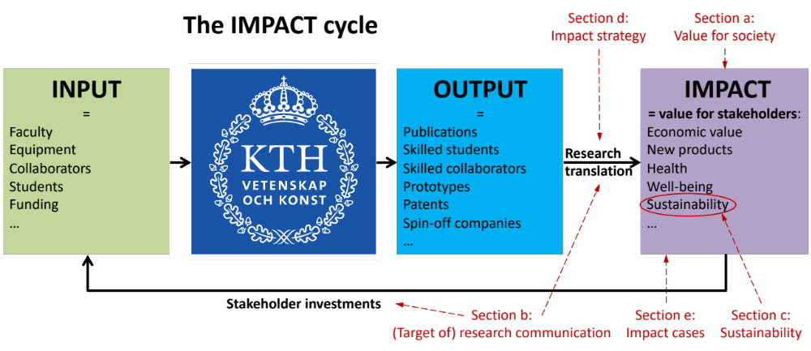
Figure 6.1. The impact cycle for KTH (coloured boxes and black arrows), and how the different sections in this chapter describe different aspects of this impact cycle (red text and arrows).

a. Relevance of research to society at large

Stakeholder needs:
We consider the research areas of IS as key components to ensure future prosperity of society and developing tools for overcoming key societal challenges. Our research outputs are relevant to society in a multitude of ways. Intelligent systems are the enabler for societal, industrial, and personal digitalisation. Software technology and algorithm development are the primary drivers in the development of future Intelligent Systems. Thus, previous advances in “computational power” are now facilitating a paradigm shift where “intelligence” is key. Our society relies on very complex systems, ranging from micro and nanosystems to large infrastructure systems. These systems are more and more digitalised, automated, and self-organising, with the possibility to make intelligent decisions based on of continuous, heterogeneous, multi-source data. We expect these systems to be safe, efficient, and reliable. Key challenges involve scalability, resilience, and safety for heterogonous autonomous systems. During the past few years, society at large has begun to react proactively to the increased importance of intelligent systems. Recent examples in the Swedish research environment are the Wallenberg/WASP initiative, DF, and the investment in digitalisation described in the 2017 research bill, and the upcoming governmental investment in continued education for AI. As a major university environment in the area, we have a crucial role to play, and our strategic duty is to stay at the forefront of this development.

Gender aspects in our research topics:
Several projects focus on health issues most prevalent in women, including research on urinary tract infection diagnosis (MST), breast cancer (RPL) and tissue models for Alzheimer Disease (MST). Another type of gender aspect may arise when working with large datasets, where care must be taken to not create gender biased systems.

Our main stakeholders are:
- Humanity, who seeks our contribution to the world’s body of knowledge.
- The (Swedish) society that seeks: skill training of citizens; increased wealth; improved health, well-being and quality of life, and; increased sustainability and biodiversity.
- Companies and other organisations who seek skilled employees and to acquire new competences and develop new products and methods.

Collaboration with stakeholders:
We have ample of collaborations with stakeholders, especially with industrial partners and societal partners. Research programs and centres like WASP and DF provide an excellent platform for collaborative research with industry and society. Stakeholders providing most funding are listed in the below table.
Table 6.1. Research collaborators providing most funding and; application areas addressed per division.
 | Research collaborators that provide most funding | Application areas addressed in our research
DCS | Scania, ABB, Tobii, Univrses, Toshiba | autonomous systems, networked systems, process control, robotics, secure systems
ISE | Swedish Civil Contingencies Agency, Ericsson, Scania, SAAB, ABB, Region Stockholm (Healthcare) | wireless systems, cyber-physical systems, multimedia, smart green and integrated transport and cities, electric power systems, biology, health
MST | Region Stockholm (Healthcare), SHL group, SenseAir, Mycronics, Silex Microsystems, Huawei | medicine, life sciences, ICT, security, transport, aerospace, biodiversity
RPL | Scania, SAAB, ABB, Univrses. Tobii | robotic systems that provide advanced services, for example in industrial manufacturing and logistics, for search and rescue operations, autonomous vehicles on ground, air, and sea, medical applications, and assistants in education, elderly care, and rehabilitation
TMH | Swedish Post and Telecom Authority | multimodal human-computer interaction systems in which speech, music, sound and gestures combine to create human-like communication
Prof. Mikael Skoglund is KTH’s strategic partner contact for Ericsson.

Spin-off companies:
We had 18 commercial spin-off efforts during 2012-19.
From ISE: R3 - Reliable Realtime Radio Communications GmbH (see impact case).
From MST: Mercene Labs, Capitainer (see impact case), Zedna, Grein Research, and CellectEve. For more information, see kth.se/mst/spin-offs-1.447465
From RPL: Volumental, Gleechi, Vantagist, DeepMed, DermAI, InfoBrain, Fellowbot, 9tails. For more information, see kth.se/rpl/spin-offs-1.966268.
From TMH: Furhat Robotics (see impact case), SynFace, Monocular, Motorica.
We have no outspoken strategy for this, but our research culture includes the following. Where relevant, we tend to apply for patents and proactively search support from KTH Innovation (a great support organisation within KTH!). Furthermore, the many spin-offs set an example/create an awareness level for others to focus on research translation. Whether a spin-off is eventually created depends of course largely on the entrepreneurial spirit of the individual researchers involved.

Need for skilled persons:
Society and industry currently experience an unprecedented shortage of engineers skilled in designing intelligent systems needed to capitalise on recent breakthroughs in this domain and needed to facilitate the transition into the service economy fuelled by increased digitalisation. Students see these needs and respond to the advancements, as evidenced by the rapidly increasing interest in course offerings. As these subject areas also currently undergo rapid development, we provide students with a strong theoretical foundation to ensure the long-term viability and competitiveness of their knowledge and to best facilitate their future development. A strong theoretical background is also needed for those who select a research career and will facilitate the next breakthroughs. To remain relevant teachers, we remain at the forefront of research.

Delivery of skilled persons
Our students that end up in industry are perhaps our largest impact on society. We produce a foreseeable stable stream of graduated PhDs. Other skill transfer occurs via our increasing number of industrial master thesis students, industrial PhDs, affiliated and adjunct faculty (see section 3).
From DCS: DCS has for many years maintained deep long-term collaborations with key industries in the Stockholm region, such as Scania, Ericsson, and ABB. This has resulted in joint publications, projects, patents and knowledge transfer in both directions. For example, our joint work with Scania has led to close to 100 papers and patents, several with high impact. Over 20 of our PhDs and postdocs have taken up positions with Scania, and four faculty are currently advising industrial PhD students working at Scania. With Ericsson, our long-term relationship has enabled Dr Gabor Fodor to become an adjunct professor at DCS, and led to multiple projects, publications, and patents. 10 PhDs and postdocs from the division are currently working at Ericsson.
From ISE: Of the 59 PhD graduates between 2010 and 2019, 26 are now with Ericsson, 3 with Huawei, 2 with Nokia, and 3 with other telecom related companies. That is, a large portion (58 %) of the PhD graduates of the division continue to work in the telecommunication industry, while most of the other graduates continue their research in post-doc positions. ISE has hosted two adjunct professors from Ericsson (Ulf Forssén 2014-18 and Bo Göransson since 2019). The division collaborated with Ericsson, including high profile European collaborative projects such as EC projects QUASAR and METIS where the division contributed to the development of the 5G mobile standard. All these collaborative efforts contributed in various degrees to Ericsson’s effort to standardize, develop, prototype, and commercialize its product portfolio in the domain of 5G network equipment. The faculties of ISE act as academic supervisor for three industry PhD students working at Ericsson funded by the WASP and SSF industrial PhD student programs.
From MST: Of the 36 doctoral graduates between 1996 and 2019, 22 are now in industry of which 4 are CEO or partner, and; 12 are in academia, of which 6 are professors and 3 assoc. professors.

Expert advice to the public sector
IS has a strong impact on the society at large by engaging in several collaborations with partners from the public sector, like Region Stockholm, the City of Stockholm, Karolinska Institutet, the Swedish Civil Contingency Agency MSB, the Swedish Defence Research Agency (FOI), Swedish Data Protection Boards, Swedish Energy Agency, and Swedish Transport Agency. Selected examples include:
- A study on Digitization of Health Care in the Region Stockholm in 2018, to which ISE contributed with expertise in wireless security. The study, in close collaboration with the Head of Innovation at Region Stockholm, helped the Region to create awareness and a better understand vulnerabilities.
- Contribution to the planning of a Health Data Centre of Region Stockholm with expert advice on privacy risks in several dedicated meetings with Region Stockholm leadership and experts from Karolinska Hospital and significant contribution to KTH response report on Region Stockholm’s referral on this issue.
- A survey on recent results and trends in information security research at KTH, carried out for FOI in 2017.
- The Swedish Energy Agency identified the issue of smart meter privacy after our outreach and included integrity in their research program.
- Several studies on cyber security for railway systems have been carried out for the Swedish Transport Agency. ISE faculty members also collaborate through the European Project Shift2Rail.

Engagement as experts in advisory boards / industrial boards / learned societies
IS staff is engaged in society and industry as representatives in many boards. Highlights include board membership at SAAB, H&M, Wallenberg’s holding company FAM, the Swedish Research Council, Swedish Foundation for Strategic Research and membership of the Royal Academy of Sciences, the Royal Academy of Engineering Sciences. More details on personal engagement can be found on the profile pages of individuals, which can be found via the “contact” or “staff” entries on the department or division websites. Our faculty engages a lot as experts in academic settings, but we are significantly less visible as experts in society.

b. Research dissemination beyond academia

The main research communication goals
Our main goals are triple: 1) to increase translation of our research outputs to ensure uptake of results by stakeholders and educate the public at large; 2) to stimulate new “input” (funding, students, collaborations) from stakeholders (industry, society), and; 3) to reach out more broadly to peers in academia for scientific dissemination, with as potential beneficial side-effects personal branding, increased number of citations and increased university ranking.

Main public communication channels used today to target specific stakeholders (Table 6.1).
Table 6.2. Stakeholders targeted vs public communication channels used.
 |  |  | Communication channels
 |  | LinkedIn |  | FaceBook | Wikipedia | Project or profile website | Mass Media | Specialised magazines
Stakeholders | Scientific peers | X |  |  | X | X |  | X
Stakeholders | Prospective recruits | X |  | X |  | X
Stakeholders | Potential collaborators | X |  |  |  | X | X | X
Stakeholders | Funding bodies/politicians |  |  |  |  | X | X
Stakeholders | Stakeholders in specific technology | X |  | X | X |  | X | X
Stakeholders | Prospective undergrad students |  |  | X |  | X | X
Stakeholders | Public at large |  |  | X | X |  | X

School communication channels include the EECS FB page (~5000 followers) and the KTH FB and LinkedIn pages (~15000 followers). LinkedIn groups targeted at key stakeholders form an underused media channel for research communication.

Status of current research dissemination
Some of our faculty members have received widespread visibility via mass media and social media. The MST news and RPL news channels gather some of those. Although there is some controversy about the ALTMETRIC score, it intends to capture online attention that is not captured by the more standard bibliometric numbers and it could be used as a complement to indicate impact. The altmetric analysis for IS shows that ~720 of the department’s scientific publications (around 15%) have received online attention (a non-zero altmetric score). 21 publications reached an altmetric score >100. Common trends among highly visible publications are that they are Nature or Science journal publications, come from a handful of faculty members (Herland, Roxhed, Kragic, vdWijngaart), focus mainly on the areas health and robotics, and result often from collaborations with MIT and Harvard.
Some researchers have a proactive strategy for communicating research results. They communicate journal publications via the KTH news website, specific news releases, Wikipedia, and social media (where LinkedIn, Facebook and Instagram allow targeting to specific audiences). However, most researchers do not follow a systematic approach for research communication, and this forms an easy area for improvement. The impact leaders provide workshops to the divisions with “Tips and Tricks” for simple but impactful improvements in personal research communication.

Research communication Analysis:
Internal Strengths include that we do perform research communication, that some researchers have a proactive communication strategy, and that we have a professional communication team in the EECS school.
Internal Weaknesses are that 1) many researchers do not recognise the value of research communication (e.g., outreach to scientific peers or increased investments of stakeholders in our research), 2) many researchers, and the department and divisions themselves, have no research communication strategy, 3) there are no expectations or incentives to improve research communication and we do not systematically measure the impact of our research communication, and 4) impact and Communication support are not integrated in daily operations and therefore often disconnected from individual divisions & researchers
External Opportunities are 1) the plenty of room for improving our research communication with limited efforts, 2) our current research focus aligns with the “hot topic” of AI, and 3) our faculty engages a lot as experts in academic settings, but we are significantly less visible as experts in society.
External threats include competing institutions having a more efficient research communication strategy.

Potential improvements (without prioritisation or consideration of cost aspects):
School Communication:
- A school research communication plan and implementation, based on current best practice from individual researchers, could streamline communication of research results - typically in conjunction with accepted peer-reviewed papers - to key stakeholders and society at large via traditional and social media.
- The regular presence of school communicators at division meetings.
- Devise a mechanism for efficient identification of "newsworthy" events (research inputs, outputs, or impact) for dissemination in EECS or KTH social media channels. As a concrete suggestion for publications, we propose to have a few short-answer questions on Diva when adding our articles, the answers to which can be regularly monitored by the communications department to identify the ones to have an article on.
- Create a newsletter where "expert articles" about a few research outputs during the past few months are written and communicated to the subscribers. “Expert” articles are to complement the current “popular” articles. The former targets the broader technical readers while the latter is for the general public.
Research Popularization: There are several ways we can popularize our research besides standard communication. Partaking in these should be considered as merits, and looked upon favourably when one is considered for promotions, etc. These include:
- Creating a publicly available on-line demo illustrating your research results.
- Publishing open-source code with documentation, data sets, trained machine-learning models, or similar resources.
- Giving popular talks in the media or being interviewed in the media.
- Organising workshops or tutorials open to practitioners outside your field of expertise.
- Internal academic talks (reading groups, seminars, etc.) can be broadcast (e.g., over zoom) for the public to audit.
New practices:
- Create internal funding for popularizing research which researchers could apply for (with some simple application procedure, similar to that of the small GRU projects at the EECS school), or which is allocated at the division level.
- 1-hour media training for each division on how to set up and participate in an interview. This could potentially be a prerequisite for being on the KTH central “expert list” that is being drafted.
- Authors add keywords to their articles that better reflect the broader areas of application and stakeholders. Currently, keywords mostly include the technical aspects of the research.
Use of KPIs and incentives: See section d) strategies for impact.

c. Sustainability and the United Nations’ Sustainable Development Goals (SDG)
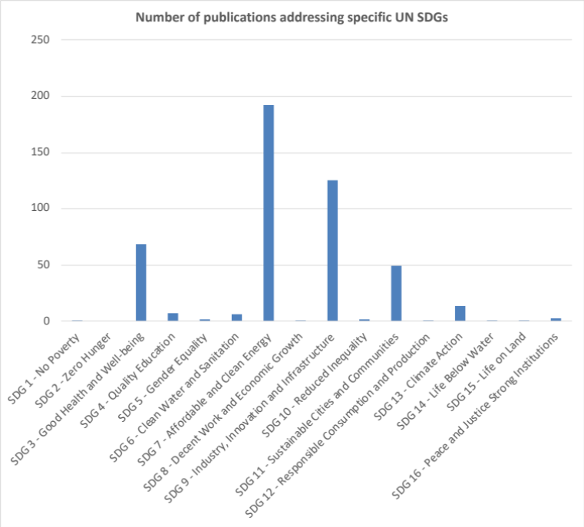
Figure 6.2. Number of publications addressing specific UN SDGs.

Status of current research addressing sustainability:
We develop key technologies that contribute in various ways to addressing the Grand Challenges of society. Our theoretical and basic research provides key technologies in our core research areas. Much of the applied research we conduct is done in collaboration with companies and the public sector. In this research, the focus is often on challenges in the industrialized world and may not address the specific targets identified under the UN SDGs. I.e., we often target goals that are beyond the 2030 UN goals.
Most of our research can potentially be used to improve sustainability, and because we are forced to provide an estimate, we state that 80% of our research has focus on sustainability.
A publication analysis shows that our work mainly targets SDG 7 (Affordable and clean energy) and SDG9 (Industry, innovation, infrastructure), and to some extent SDG3 (Health & well-being) and SDG 11 (Sustainable cities). Addressing the question of how much of the research is related to sustainable development is difficult. A large part of the research at IS focuses on AI-related technologies. Our article “The role of AI in achieving the Sustainable Development Goals”, Nature Communications 11, 233 (2020), co-authored by faculty from RPL, shows the positive and negative impact of AI on the various SDGs (Fig. 6.1).
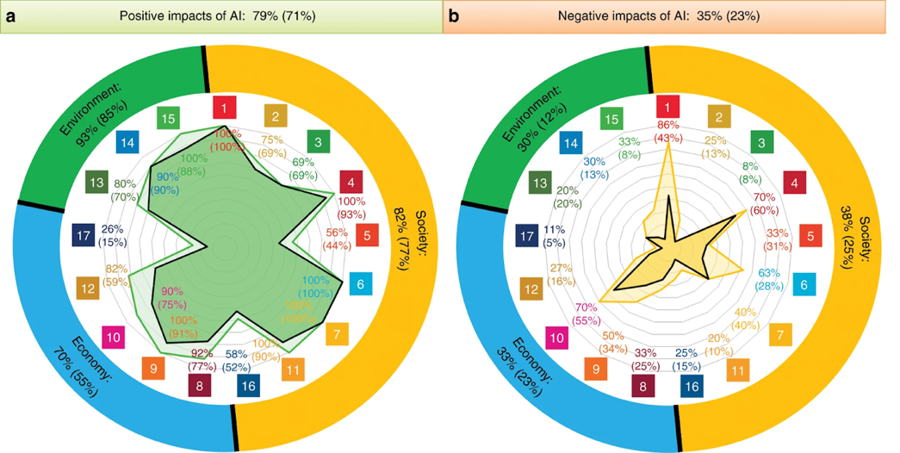
Figure 6.3. Impact of AI on the sustainability goals (Nature Comm, 2020).
Examples of applied and targeted work towards sustainable development include:
@ DCS: improving energy-efficiency in society. In addition to this broader perspective, the faculty is running several projects on smart grids, energy-efficient communications and computations, smart transport, and healthcare, to mention a few.
@ ISE: Signal processing and ML for biotech and health services. In particular, the Mabtech IRIS in collaboration with Mabtech AB contributing to SDG 3.3, and the collaboration with Karolinska on sepsis detection for preterm infants contributing to SDG3.2.
@ MST: Our micro- and nanostructures and sensors form a base for (1) better medicine; (2) the Internet of Things; (3) automation in industry and transport, and; (4) environmental sensing and monitoring. We address:
- SDG3: Roughly half of MSTs research is life science and medicine related, with specific focus on basic disease mechanisms and therapy of infectious diseases (target 3.3), cancer (target 3.4), and diseases of the nervous system. SDG targets focus mainly on health for developing countries, whereas our work addresses disease in the developed countries. We directly address target 3.4.1 (Reduce mortality cancer, diabetes, or chronic respiratory disease); other targets are addressed indirectly.
- SDG 9: We have several projects on beyond-5G telecommunication, all in the sub-THz frequency spectrum, in particular on high-data rate point-to-point communication networks for future network infrastructure. We have several remote-sensing projects exploiting THz frequencies, including a national project on space-borne earth observation environmental sensors.
- Target 11.2: We have several projects on sub-THz radar sensors for road safety, including traditional car radar but also emerging radar applications such as in-cabin monitoring and critical-road crossings surveillance.
- SDG11&13: Photonic CO₂ sensors for environmental sensing and monitoring.
@ RPL: robotics, perception and learning, for a sustainable future.
- SDG 3: Our research on breast cancer addresses UN SD goal 3. The current targets for this goal are focusing mostly on third world diseases and health issues. However, in large parts of the world cancer is one of the main causes of death.
- SDG 14: Better utilization of the oceans for food and energy are goals in the project SMaRC. By automating the monitoring of Algae farms one can produce more while using fewer resources. Better georeferencing oceanographic measurements by correcting navigation using sonar will make that data of better quality for modelling the processes of global warming.
@ TMH: The EACare project aims at detecting signs of depression and dementia in elderly people through a spoken dialogue system. The FunkBot project aims at developing navigation services for people with cognitive disabilities. Both projects contribute to SDG3.
@ DF: several IS faculty members contribute to DF whose goal is to contribute to a sustainable society.

Ideas for how to potentially improve sustainability (without prioritisation or consideration of costs):
- For some selected announced EECS faculty positions, consider it as a merit for a candidate whether they have industrial/academic experience/plan for working on real-world applications that are directly relevant for UN SDGs. The starting package for such positions could be co-funded for promoting contribution to UN SDGs.
- During recruitment, emphasize opportunities where intelligent systems can contribute to sustainability challenges with a big need / where there is lot of potential for growth, including health, climate change and biodiversity.
- Address the following questions through debate panels, study groups, etc. and adjust goals, incentives, KPIs, and strategies accordingly: What is relevant for a sustainable society? Are the UN SDGs sufficient? / What are beyond 2030 SDGs? What about access to information and computing, means to self-organise and develop common goals, access to resources (finance, material, energy, information), security of existence, competitiveness to achieve the next development step in the area of technology, health, education, energy, environment, ...?

d) Structure for increased impact

Status wrt reaching impact
Today’s four main channels for impact are 1) providing skilled people, 2) bringing methods and products to use, 3) expert advice to the public sector, and 4) engagement in advisory boards / industrial boards / learned societies.
We want to stimulate 1) research translation from output to impact, and 2) investments in input. The easiest available measurables (KPIs) relate to the quantity and quality of inputs, outputs, and communication efforts. Actual impact is much more difficult to quantitate systematically. However, the only KPIs/incentives used today are internal base funding distribution depending on the amount of external funding (= a measure of input) and our bibliometry (Cf and JcF figures = a measure of output). There are no KPIs related to research communication.
Today’s strategic work towards increasing impact is led by an impact team on school level (two faculty members @ 10-20% engagement + 1 FTE communicator) for support. Recent strategic actions to increase research dissemination by the impact team include:
- the hands-on PhD course “From research to Impact” that trains PhD students in moving ahead on the technology readiness ladder and in research communication
- a workshop “Tips & tricks to rapidly increase impact”, which was given at 3 out of 5 IS divisions.
- A communication tour of central research, communication, and innovation support units at KTH to all divisions to relay what service they can provide and receive feedback from researchers (halted by COVID19).
2021 activities focus to a large extent on creating a strategic plan for impact.

Analysis of our impact and related activities:
Internal Strengths include that we 1) are highly ranked in university rankings, 2) have several faculty members with “star” profile, 3) have rather high impact in a broad range, 4) have a new school dean with strong competence in strategic technology transfer, and impact responsibles currently working on an impact strategy.
Our biggest Weakness is that we do not strategically value how investments in technology transfer can result in increased reinvestments of stakeholders in our research. We have no impact goals or strategy, KPIs or incentives to improve. We do not know how different aspects of a potential strategy would affect the overall impact. We do not systematically focus on maintaining and improving ranking. Our impact support is not integrated in daily operations / disconnected from individual divisions & researchers. As a result, although we do have significant impact, we do not reach our full potential: we could do more demos, collaborations, increase our role as experts, etc. Moreover, we have slow/poor legal support for industrial collaborations. Furthermore, we do not target the topics climate change or biodiversity in a strategic manner in our research.
External Opportunities include that our research focus aligns with the “hot topic” AI. We further have the research potential to target climate change or biodiversity or contribute to the EU 2030 Digital Compass. We could also attract new faculty / establish or strengthen research areas that may be able to increase our impact.
External threats include that, 1) whereas we produce a foreseeable stable stream of graduated PhDs, the availability of industrial PhD students relies on a continuation of dedicated funding programs (e.g., WASP, SSF); 2) too much focus on near-time impact may lead to neglecting fundamental research with potentially much higher long-term impact and; 3) goals of any chosen impact strategy might not lead to the desired impact.

Strategy to improve our impact:
We should 1) maintain and further developed current praxis, and 2) develop a more strategic or systematic approach for outreach. To increase transfer of research output more strategically and more systematically to stakeholders we need to form an impact strategy, followed by an impact workplan and adapted research communication plan. The aim of such plan should be to systematically and strategically: i) identify key stakeholders; ii) interact with potential stakeholders; iii) communicate our research output and impact results to support the impact cycle; iv) strategically value how investments in technology transfer can result in increased reinvestments of stakeholders in our research, and communicate this value within KTH to incentivise individual researchers to invest in outreach efforts, and to our stakeholders to trigger their (re)investment in our research; v) set up a related support structure for the individual researchers, communicate expectations, and - if necessary – identify KPIs and provide incentives. Such impact strategy and related support should be delivered on EECS level. Given limitations in time and funding, we should be careful in identifying which actions can generate the most impact per cost.
Below we list potential actions, without prioritisation or consideration of cost:
- Intensifying strategic partnerships and collaborations with related industries and public organisations (e.g., through KTH DF) will lead to an increased impact, new insights into real-world problems, and new (external) funding opportunities. Researchers at the department are in strategic leading positions in national research centres and programs such as WASP and DF (among others) and scientific councils and boards of Swedish funding agencies like VR and SSF. We could steer research funding partly towards collaborative constellations that more readily allow transferring our research outputs to high industrial and societal impact. For example, new funding schemes in KTH DF (e.g., demonstrator projects) are currently geared towards creating societal and industrial impact and to intensify strategic partnerships between KTH, industry, and society.
- KTH is stepping up lifelong learning with the goal to increase the share of contractual education and continuing professional development from 1% to 20%. This effort creates new opportunities to channel recent research results into education offers directed towards industry and society. Developing a process and support at the department for seamlessly turning research results into (contract) education offerings will be of increasing importance.
- Further integrate the work of the impact team and KTH Innovation into the daily research business, including research communication to make impact part of collegial and management processes (e.g., at division meetings).
- Give the impact team at EECS the task to evaluate the outcome of a system model including putting incentives for patents, industrial collaborations, popular science communication for increasing impact. This should include studies of established system models from industry and, if available, from non-profit organisations.
- Evaluate and analyse KTH funding from non-governmental sources, i.e., industry and private foundations. Analyse and structure what past impact activities led to this funding. Then let the conclusions from these studies guide future impact activities.
- The IS department or the EECS school could establish a “Faculty Search Committee” that defines new faculty openings and conducts searches to establish or strengthen research areas that will most likely have an impact in the future. For example, such a faculty search committee could propose a position that is aligned with one of the UN SDGs.
- Increase awareness about strategic goals (e.g., EU 2030 Digital Compass, access to information and computing, means to self-organise and develop common goals, access to resources (finance, material, energy, information), security of existence, competitiveness to achieve the next development step in technology, health, education, energy, environment, ...) through debate panels, study groups, etc. and adjust goals, incentives, KPIs, and strategies accordingly.
- Create a structure for co-funding competence centres, similar to Vinnova where funding is divided ⅓ Vinnova + ⅓ industry + ⅓ university-internal funding.
- Support for “industrial” sabbaticals and other mobility: Some PhD students are given the opportunity of doing an internship in industry, but the current rules disallow pausing or changing the activity level of one’s PhD studies, except for parental leave, military service, or illness. The reason seems to be that KTH has chosen the strictest possible interpretation of Högskoleförordningen, chapter 5, §7: “Sådana skäl kan vara ledighet på grund av sjukdom, ledighet för tjänstgöring inom totalförsvaret eller för förtroendeuppdrag inom fackliga organisationer och studentorganisationer eller föräldraledighet.” We believe this policy should be reversed, and the pausing of PhD studies to pursue an internship at a company for a shorter period of time should be allowed.
- Value industrial experience in faculty recruitment and promotion.
- EECS-specific legal support, that can react a bit more swiftly to questions pertaining to consortium agreements and similar.

e. Impact cases
In appendix are 7 impact cases for IS. Four of them describe spin-off efforts (R3 Communications, The Mabtech IRIS, Capitainer and Furhat).
- DCS Impact case 1: Fuel-efficient freight transport and automated heavy vehicles
- ISE Impact case 2: Start-up R3 Communications
- ISE Impact case 3: The Mabtech IRIS
- MST Impact case 4: Capitainer
- RPL Impact case 5: Computer Vision Practice
- RPL Impact case 6: Face Alignment
- TMH Impact case 7: Furhat

7. Analysis or external factors
The above sections are introspective and describe how we can maintain or improve our research quality through internal processes. In this last section we want to highlight aspects of high importance for our research which could be addressed at the EECS school or KTH university level.
University ranking is important to attract excellent students and faculty. The fields covered by IS are traditionally categorized as electrical engineering (EE), a subject area where KTH was ranked as the 17th best university worldwide at QS. EE is the highest ranked subject at KTH. Overall, however, KTH drops in the university ranking, mainly due to too low citation scores. We would like KTH to strategically address improving its ranking position (targets, incentives, action plan).
We think that there are too few incentives for research excellence.
We have too lengthy faculty recruitment procedures, in which good candidates disappear. We hope KTH can improve this.
EECS decided that faculty recruitment should be primarily based on teaching needs rather than research excellence. This risks undermining long-term research excellence.
In terms of evaluation for promotion, the required quality of research excellence is too low (e.g., very limited demands on external research funding, which in Sweden is a necessity to sustain research).
No mechanisms address low research performance for individual senior faculty members.
There is an increased number of teaching administration positions/tasks (these are duties for faculty), now on all levels (division, department and school). Such positions were created from a quality system perspective, but these tasks consume time and lead to limited improvements in actual teaching/research quality. We would benefit from more trust, less administration. At the same time, a track record in such positions is a prerequisite for promotion.
At KTH level, strong research leaders do not take on academic leadership positions often enough. This is unlike many highly ranked universities.
Administration is costly, specifically in comparison with other academic institutes in Sweden. This is financed through a high OH (~50%) on research activities. Researchers, however, are neither in control over those costs, nor over the size and activities of the central research support administration.
KTH centralised its administration with a one-model-suits-all (?) “One KTH”. For a large part of our department, this has resulted in a substantial increase of OH, but not an increase in administration efficiency.
Cautious and bureaucratic administration - without an own stake in the results – make up new praxis, without beneficiaries, and at increased costs for research. This is a systemic problem rooted partly in the KTH administration being its own organization separated from the core research and teaching activities.
KTH, and specifically the president, advocates a strong focus on sustainable development and gender equality and KTH have outspoken goals in these areas. The KTH top management structure is geared towards these goals, each of these areas having their own vice president and administrative staff. However, lack of significant incentives on the school/department/division/individual levels have resulted in a continued gender imbalance and an increasing climate impact of the university itself.
Department of Biomedical Engineering and Health Systems
Self-evaluation
Head of Department: Professor Sebastiaan Meijer

Included divisions:

Division of Biomedical Imaging
Division of Neuronics Engineering
Division of Structural Biotechnology
Division of Technology in Health Care
Division of Environmental Physiology
Division of Ergonomics
Division of Health Informatics and Logistics

Department of biomedical engineering and health systems (MTH)

1. Overall analysis and conclusion; strengths and development areas

a) Limited SWOT-analysis
 | Strengths | Weaknesses
Research | Bulleted list, in order of magnitude:  - Agreement on three themes strengthened the research focus  - Increased autonomy in decision making through disentangling infrastructure and groups from other stakeholders, while strengthening the role in being leading in research collaborations  - New recruitments of high quality and potential that deliver (new professors) and strengthen the core focus (younger faculty). | - Historic mismatch between faculty composition and educational programs. Not all faculty equally engages in research. High teaching loads, low staffing levels  - Publications do not reach enough top journals.  - The medical sensor and signals competence has thinned out and is under reconstruction. This is a key competence area for MTH and needs urgent attention.  - The broad character of the department (while significantly reduced) makes it challenging to provide a single academic platform for scientific exchange.
Organisation | Bulleted list, in order of magnitude:  - Excellent collaborative skills with external stakeholders, as well as impact. Demand for MTH research (and education) is increasing in many areas.  - Integration between research and education in a modern facility has taken shape over the last 3 years, and the department has an important role in reaching new student groups  - Infrastructures are of good quality. | Bulleted list, in order of magnitude:  - Gender balance in the faculty and department as a whole has deteriorated, particularly at the senior level.  - Faculty funding is low compared to education and number of staff, thereby limiting much needed expansion.  - External funding is also on the low side, though at a good level for the faculty with successful project portfolios within the department.

Development areas MTH:
The first and foremost prioritized development is revitalizing the faculty composition. There is some funding available to take first steps during 2020-2021, but this only covers the most urgent needs. The window of opportunity with a massive retirement wave is closing, and with the pressure to keep education going, the risk is that we do not have the time nor funds to transform a limited number of adjunct (full time teaching) positions into faculty.
New positions announced over the last 3 years are strengthening existing competencies to build critical mass and mitigate retirements. A strategic investment is needed to break the vicious cycle of understaffed groups. A program for which the head of school and head of department lobbied heavily during 2019 has been funded by rector at 25% of the level requested. More is needed here. Recruitment of new faculty is also a great opportunity to correct the gender balance and has proven to be beneficial for the publication results too.
The external research funding per faculty member could increase significantly. A moderate increase in time for writing good applications could yield many new PhD students. Building on the increased integration of education and research, the in-house capacity for projects is increasing and could provide critical mass in forthcoming years, thereby creating a base for further externally funded applications.
The number of senior faculty with a good funding track record is limited, and some of them will retire very soon. Successful external research funding is therefore reliant on a fairly junior faculty base. MTH is highly vulnerable if any of the younger professors would leave and is currently managing the generational transition for Structural Biotechnology, Biomedical Imaging, Technology in Health Care and Environmental Physiology. Younger, promising faculty needs to get support to connect to strong KTH environments. The reorganization and the new CBH school constellation opened the health-related field within KTH for increased cooperation. Bridging the excellent research in the SciLifeLab realm with our systems approaches, imaging, and simulation capabilities fits the type of European calls drafted for Horizon Europe.
The integration with hospitals, health industry and other stakeholders needs to further develop. Engaging with the Campus Flemingsberg neighbours is ongoing but difficult with investments in Karolinska Institute and Hospital tilted towards the Northern Solna campus.
A sustained effort in internal collaboration and academic exchange should support a further reduction of the scope of MTH, without harming any of the competencies of the researchers and faculty. An example is the new assistant professor between neuronics engineering and biomedical imaging focusing on the transfer from images to simulations for head-related research. Such position strengthens both groups, while focusing the imaging research more on the head, and the neuronics engineering research more on the sources of its simulation models.
Within biomedical imaging, the critical mass and infrastructure exists to grow, particularly on the pipeline between image acquisition and processing and simulation. Funding opportunities in this area are abundant. Health systems research has found its unique edge and rapidly gains external funding. This provides opportunities for increasing long-term quality cross-disciplinary research. The broader ergonomics field has increasing focus on engineering methods and technologically leading research, thereby attracting new sources of funding but also more opportunities to collaborate.
Rental costs and other fixed costs have been more than double the level of other departments at KTH. The structurally unfair level playing field for Flemingsberg will be the end of the motivation of the leading researchers if not urgently remedied.
While not exactly the core of the biomedical engineering and health systems field, the bachelor programs in computer science and electronics that MTH teaches form an important stable funding for teaching and a student base, with many synergy effects with the biomedical engineering programs. The computer science program is the basis for the staffing in the Health Systems profile we are developing. Strategically enhancing these programs to better connect to the research would benefit students and researchers.
The fact that many other departments within KTH and the Stockholm cluster do related, and sometimes overlapping, research makes MTH vulnerable for political play with funding from strategic investments. MTH still suffers from a bad reputation and clashes of characters from over a decade ago. The location in Flemingsberg is also negative for people with a Stockholm history. The current management works daily to mitigate this threat, but it appears regularly.

b) Summary statement on contributions of department on impact, infrastructure, and sustainable development
Historically, MTH has delivered a disproportionally large number of spin-offs, and a very close interaction with societal stakeholders, particularly in the medical and health domain. Impact is achieved through commercializing new products, but even more through advice and co-development with hospitals, defence force and production industry.
The research infrastructure available in the department is of high quality but limited to biomedical imaging and environmental physiology domains. (Too) much of the infrastructure has been a service function to other stakeholders, particularly KI.
Compared to other parts of KTH, the research at MTH has a larger focus on SDGs 3 and 8 and to a lesser extent 11 and others. While the department has not been particularly good in using the keywords that are measured in the internal system, it is hard to interpret the research contributions as any other than directly contributing to the SDGs.

2. Research profile

a) General information of the department
MTH is the department of biomedical engineering and health systems. It is the second largest department within the School of Engineering Sciences in Chemistry, Biotechnology and Health and evolved from the earlier School of Technology and Health. The majority of MTH is located on Campus Flemingsberg, after moving into a new building in 2016 from Haninge and Flemingsberg. The division of Environmental Physiology is located on the campus Solna due to its research infrastructure that cannot be moved.
The department consists of 8 divisions, of which 7 are involved in research. The profile and composition of the divisions is as:

Biomedical imaging (1 Prof, 4 Assoc. Prof, 1 Adjunct, 2 researchers, 1 Postdocs, 6 PhD stud.)
This division works with imaging techniques used for clinical medicine or basic biomedical research. Research in data acquisition and image reconstruction includes novel ultrasound techniques, new ultrasound contrast media and construction of an experimental PET/CT scanner. The research group in image processing and visualization, led by the division head Prof. Örjan Smedby, focuses on solving medical research problems with image processing methods, currently mostly using advanced ML algorithms.

Health Informatics and Logistics (1 Prof, 1 Assoc. Prof, 3 Ass. Prof, 8 Adjuncts, 1 researcher, 1 postdoc, 7 PhD students).
This division is a merger between the teaching unit responsible for most of the computer science and electrical engineering bachelors, and the research unit in health care logistics which mainly consists of a methodological group in complex system simulation and gaming. Recognizing the joint interests in software, simulation and sensor information, the groups joined in 2018, while also recruiting 2 assistant professors. The group manager is Anders Cajander. The research is led by Prof. Sebastiaan Meijer, who has been developing his research in design of complex systems with participatory simulation and gaming methods towards the health care sector after joining STH/MTH in 2015. The new assistant professor in Technology in Health Care (2021) joined this group, in preparation of the retirement of Prof. Östlund 2022. One associate and one assistant professor in Biomedical Signal Processing are under recruitment.

Neuronics Engineering (1 Prof, 1 Associate Prof, 1 Assist. Prof, 3 researchers, 6 PhD students)
The word Neuronics comes from a combination of the medical term neurotrauma and the technical term mechanics. The objective of the research is to combine knowledge within engineering and medicine aimed at the improvement of prevention, diagnosis, and treatment of injury to the human nervous system. Our vision is to reduce the number of injuries to the head and neck because of external violence. Our goal is to develop new and effective technology innovations for prevention and clinical treatment, primarily within neurosurgery.

Technology in Health Care (1 Prof, 4 PhD students)
This division is working on digitization and demographic change, with regard to the shift of health care activities from hospitals to homes and mobile, from illness to increased emphasis on the individual's health and active participation in rehabilitation and health promotion. The research provides a fundamental basis for designing technological innovations in a socially conscious manner and in developing a methodology to increase relevance in the adoption of robots and AI-controlled applications and the sustainability of digital systems. Important questions are the expectations and needs of growing older generations and the innovative value of their life experiences. The subject Technology in Health Care, implemented in 2014, is multidisciplinary, based on social science and technology studies including design methodology, ethnology, sociology, and nursing. Recognizing the growing demand for this knowledge an assistant professor is under recruitment. The research is led by Prof. Britt Östlund, employed at KTH 2014, whom in the last thirty years has been dedicated to research and development in aging, technology, and design, previously at Lund University. The group will merge into Health Informatics and Logistics.

Environmental Physiology (1 Prof, 1 Assist. Prof, 4 researchers, 2 Postdocs, 4 PhD students)
This division works on the influence of environmental factors on physiological responses in humans. The subject comprises four research fields: high-altitude physiology, thermal physiology, gravitational physiology and diving physiology and is predominantly based on experimental research. Research questions may vary from basic science-related to applied, of which the latter commonly concerns the interdisciplinary area of physiology and technology, for instance development of protective equipment and strategies that will enable humans to tolerate extreme environments. The division is in Solna, where it possesses special facilities in terms of a human-use centrifuge and hyper- and hypobaric pressure chambers. The division of Environmental Physiology is predominantly financed by external research grants, from the Swedish Armed Forces, the European and Swedish Space Agencies and others. The research is since many years led by Prof. Ola Eiken. One assistant prof under recruitment.

Ergonomics (2 Prof, 1 Prof Emeritus, 1. Prof affiliated, 3 Assoc. Prof, 2 Adjunkts, 2 researchers, 10 PhD students)
This division works with the development of theories, methods, and design strategies in order to improve the physical and psychosocial work conditions. The research includes design and interplay between technology, organization, and human capabilities, to optimize health and operational efficiency in industrial and healthcare systems. Risk assessment methods with high usability and reliability is one focus, utilizing new smart technology. A master program and several courses about sustainable, attractive, and productive workplaces and products mirrors the research area of the division. The division is, since 2018, led by Prof. Mikael Forsman, who has carried out experimental and field studies, and developed technical methods in the field of ergonomics.

Structural Biotechnology (2 Assoc. Prof, 2 researchers, 3 PhD students)
We center our research around application of cryo transmission electron microscopy in biology. We have close ties to medical imaging due to our use of image analysis and biology and biochemistry due to the type of specimens we study. The work consists of 4 main research areas: The role of proteins in brain function. Chaperones in health and disease. Inflammatory proteins in the leukotriene and prostaglandin biosynthetic pathways. Improving cryo electron microscopy for biological specimens.

Basic Science Education (3 Assoc. prof, 11 adjuncts)
This division is teaching exclusively and provides the courses for the preparatory year / semester and the base courses in the bachelor programs. The three faculty persons are not doing research (within their KTH hours).
The department also has 2 centres:

Jonasson centre for medical imaging
The Jonasson Centre for Medical Imaging is an infrastructure centre based on a large donation (by Kerstin and Rune Jonasson) in 2011. The centre provides researchers at KTH, Karolinska Institute and Karolinska Hospital with access to equipment for experimental, clinical, or preclinical imaging, including radiography, ultrasound, photoacoustic imaging, magnetic resonance imaging, nuclear medicine imaging, advanced light microscopy and electron microscopy. In addition, there is a virtual reality theatre with stereoscopic projection and a server for computationally demanding AI experiments.

Swedish Aerospace Physiology Centre (SAPC)
This centre is in Solna, where it shares research facilities and personnel with the div. of Environmental Physiology. The overall aims of the SAPC are to conduct and support research, development and teaching that may act to improve medical safety in aviation and during manned space flights. SAPC research predominantly concerns different aspects of physiology but also development of technology. The research projects are commonly conducted as national or international collaborations. For instance, SAPC has, during the last 6 years, been involved in multinational studies concerning the effects of musculoskeletal and cardiovascular unloading in combination with hypoxia, conditions that are anticipated in future manned habitats on the Moon and Mars. SAPC is part of the “umbrella organization” KTH Space Centre.

b) Central research questions and themes, knowledge gaps addressed, main research activities
The department concentrates on three themes in the research. These themes have been established in 2018 during the reorganization, after a faculty process during 2017.
Below we discuss per theme the topics, and specific knowledge gaps, as well as other relevant aspects.

Theme 1: Biomedical imaging and simulation:
Three divisions contribute mainly to this theme: being Biomedical Imaging, Neuronics Engineering and Structural Biotechnology. Also, the Jonasson centre for biomedical imaging is an ingredient.
The research focusses particularly on processing of biomedical images (including AI), improvement of medical models from image capture data, the construction and validation of biomechanical models (with a focus on the head and heart regions), and the study of biological structures and their functions both at a molecular and a cellular level. The department has limited research in actual image capture but owns a large range of imaging modalities.
A relatively large part of the faculty works in imaging. It is of later years that more collaboration around this theme occurs, with the goal of establishing better pipelines from image acquisition to validated models, where multidisciplinary collaboration is of key importance.
Gender is a known issue in the research theme due to the data bias in reference data sets. The department actively tries to address this in the formulation of research projects and has some more recent efforts in maternity care around birth-giving.

Theme 2: Sustainable work life
This is the core topic of 2 divisions: Ergonomics and Environmental Physiology. Furthermore, there are contributions from Technology in Health Care, Neuronics Engineering and Health Informatics and Logistics.
The main research questions focus on how to keep workers safe under repeated stress, with the bulk of the research involving physically stressing factors. The availability of sensors to objectify strain is a growing research topic, and here there are multidisciplinary collaborations with health informatics and with technology in health care to provide IoT, organisational and sociological perspectives. Special competence exists in work under extreme circumstances, be it altitude or depth, cold or G-forces.
Gender and other diversity aspects are a natural part of this research, as individual bodies differ, and it is the diversification where sensor-based measurements can make a difference.

Theme 3: Digitalisation in Health and Care
This emerging theme is predominantly the research domain of Health Informatics and Logistics, and Technology in Health Care. The former is particularly doing research on how to model, simulate and game the existing and forthcoming large scale, distributed systems in health care. Furthermore, the question is on how to integrate IoT sensors for health in preventative and chronic health settings, with an interest in the development of home care. Technology in Health Care adds a sociological perspective to digitalization. What does it mean to age, what is the role of technology and how to organize meaningful care?
Contributions to the theme come from biomedical imaging in the form of better decision support from images to health care professionals, and from ergonomics in the knowledge on strain signals.
This theme is under development, and gender questions are very important as the systems effects of health, the phenomenon of aging, and the involvement of the health and care sector work force have massive gender biases.

c) Contributions to the advancement of the state of the art within the research fields of the department

Theme 1
Within theme ‘Biomedical Imaging and Simulation’, we have the following highlights:
- New segmentation method, developed by Chunliang Wang, that enables exact volume measurements in 3D medical images with a speed that is acceptable for clinical work. This may lay a foundation for new tools for diagnosis and monitoring of diseases such as cancer, dementia, or cardiovascular disorders.
- For estimation of the intravascular pressure in large arteries such as the aorta, where previously only invasive measurements were possible, David Marlevi has developed a method using phase contrast magnetic resonance imaging, virtual work-energy equations, and a virtual field, which gives estimates of the relative flow. This may in the future have great clinical impact.
- The Neuronic engineering division has been pioneers in computational modelling of the human head and brain where methodologies of creating detailed brain injury prediction models directly from medical images have been developed and used the last ten years. These models have been the first to be successfully validated against experimental localized brain motion, and lately also experimental brain strain. In applications of the models, it has been emphasized that angular motion must be mitigated better in design of protective devices such as helmets. One practical implication is a coming change in European bicycle testing standards which will include the addition of testing against oblique, angled impacts together with measurements of angular head kinematics. Researchers from Neuronic engineering are the convenors of this working group within CEN.
- We have developed the theory of a novel phase plate for imaging low contrast, beam sensitive specimens such as proteins in solution and cellular structures.

Theme 2
Within theme ‘Sustainable Work Life’, we have the following highlights:
- RAMP, which has been developed in collaboration with two large Swedish companies, is a risk management tool for manual handling. It is a digital assessment tool for physical ergonomics designated to assess work and provide a structure to find and take appropriate actions when needed; Three MOOCs were developed, and RAMP has now been downloaded in 89 countries. This is important to increase use of systematic methods in identifying /managing work environment risks.
- Lean Production is a strategy that is introduced in most Swedish industrial companies. It has now started to be implemented hospitals and departments affect hospital staff. With expert area in management, work health and over-all in health-care systems, the division of ergonomics have successfully studied how work conditions, health, commitment, and performance change in the short and long term, and how consequences for employees depend how Lean is being implemented. Rationalization is now in focus in the health-care sector. Previously most rationalizations have resulted in worsened work conditions, this research is important to change that trend.
- Together with Jozef Stefan Institute, the Environmental Physiology div./SAPC developed an experimental model and initiated a line of research to investigate the combined effects of hypoxia and inactivity/physical unloading on numerous physiological functions. The research resulted in multinational collaborations and generated about 40 publications for the MTH. The research was initially driven by a concern for the medical consequences of conditions envisaged in future human habitats on the Moon and Mars but has considerable impact on our understanding of the development of comorbidities associated with the combination of hypoxia and severe inactivity encountered by the growing population of individuals suffering from chronic obstructive pulmonary disease.
- The div. of Environmental Physiology has also developed an experimental technique allowing in vivo determinations of the mechanical properties (viz. stiffness/distensibility) of human blood vessels. The technique has been used to clarify how human blood vessels adapt to prolonged pressure unloading encountered by astronauts as well to repeated pressure loading encountered by pilots of high-performance aircraft. In addition, the finding that repeated exposures to high intravascular pressure increases the stiffness of precapillary blood vessels reveals an important mechanism in the pathogenesis of primary hypertension in humans.

Theme 3
Within theme ‘Digitalisation of Health and Care’, we have the following highlights:
- Technology in Health Care collaborates in the KTH project: Advanced Adaptive Intelligent Systems which is an example of Human-centred Artificial Intelligence (HAI) or Intelligence Augmentation (IA). In this project the division precede the interpretation of what can be automated in the social context of older people. The aim of the project is to develop adaptive social robots that can understand humans’ communicative behaviour and task-related physical actions and adapt their interaction to suit. The division laid the groundwork for engineering, for fluid and seamless adaptation of intelligent systems to users’ context, needs or preferences.
- The division of Health Informatics and Logistics has developed a hybrid method for mixed-evidence large-scale system models, extending the System Dynamics and Participatory Model Building methods. This has been successfully applied in system models for Mental Health, amongst others. The division also developed multiple simulations and games to explore management of Emergency Care Logistics in a regional health care system perspective.
- The HIL division also developed the world’s first Managed IoT platform for medical and health applications, and contributed multiple technologies (communication technology, coding systems) to overcome the specific issues of advanced health sensors in home care settings

d) Quality and quantity of contributions to the body of scientific knowledge
The bibliometric performance of MTH shows rather clearly what has happened between the RAE2012 and RAE2020. Firstly, the number of publications shot up in 2013 – 2015. This was during a period in which many researchers have been made redundant, and they started publishing larger numbers of mainly conference papers. Over the years, the number of employees on the research side has decreased, and with the recruitment of 3 new professors 2013-2014, the percentage of journal publications, as well as field normalized citation rate and the percentage top-10% outlets improved.
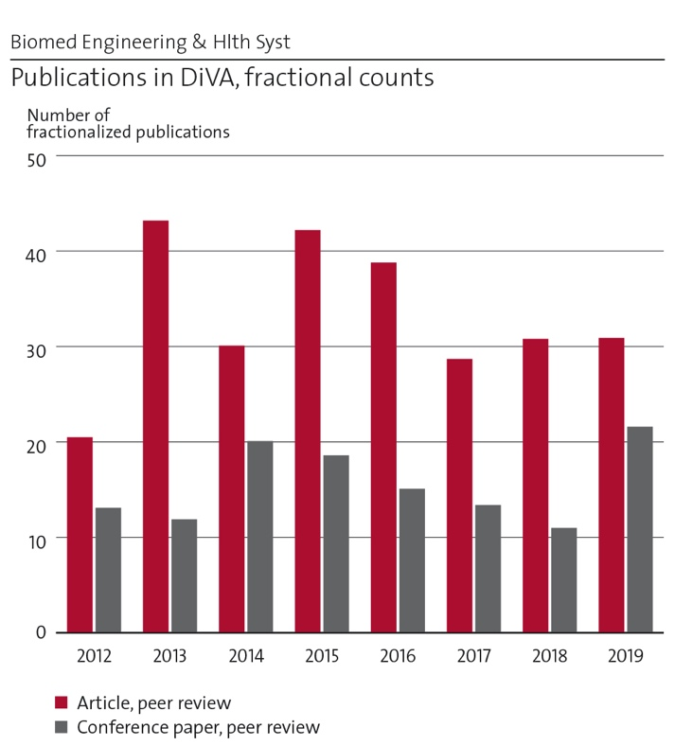
Figure 2.1. Fractional publication counts MTH.
These numbers are pointing up, but are not good enough yet, even though there is an interesting difference between the SCOPUS and WoS scores, underlining the closeness of some MTH research to the computer science domain. WoS field normalised citations (Cf) increased from 0.68 to 0.86, and journal impact from 0.82 to 0.96 (with an artefact dip to 0.90 for the last year). SCOPUS based Field normalized journal impact (SNIP) increased from 1.06 to 1.18, with a dip to 1.07 for the last year, and Average field weighted citation impact (FWCI) is around 1. The artefact for the last year is explained by retirement in the structural biotechnology group which always published in high-impact outlets. The other divisions all continue a positive trend.
Some context to the numbers:
- The percentage of co-publishing with international colleagues is relatively high, as is the collaboration with non-academic Swedish partners. Therefore, the fractional counts affect scores negatively, while doing the right thing.
- Particularly our health systems research is experimenting in areas where citation cultures are different, and where clearly established scientific communities are lacking. Here we see very promising indications now, and publishing in good outlets is getting easier.
- Our fractional journal article production of 31,8 on 17 faculty members who engaged in research in 2018, in a department with a massive teaching load is rather productive.
- MTH needs to dare to go to top quality outlets, and particularly the younger faculty is finding these paths.
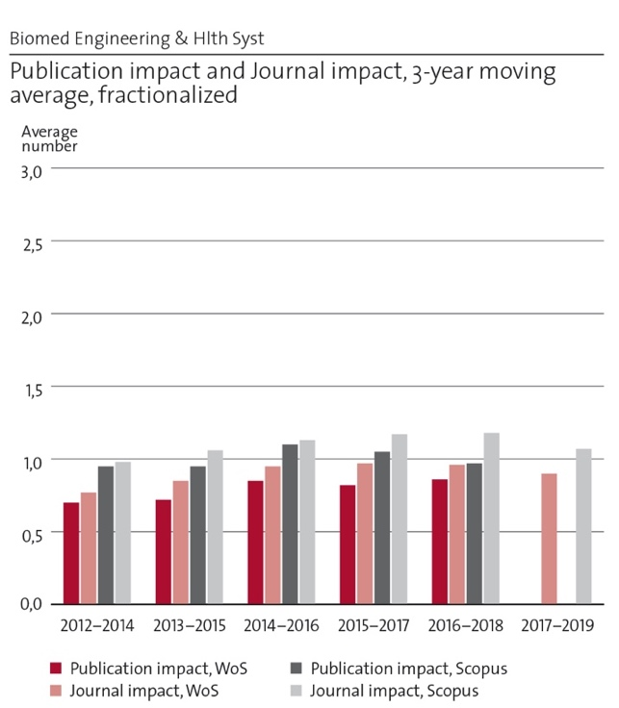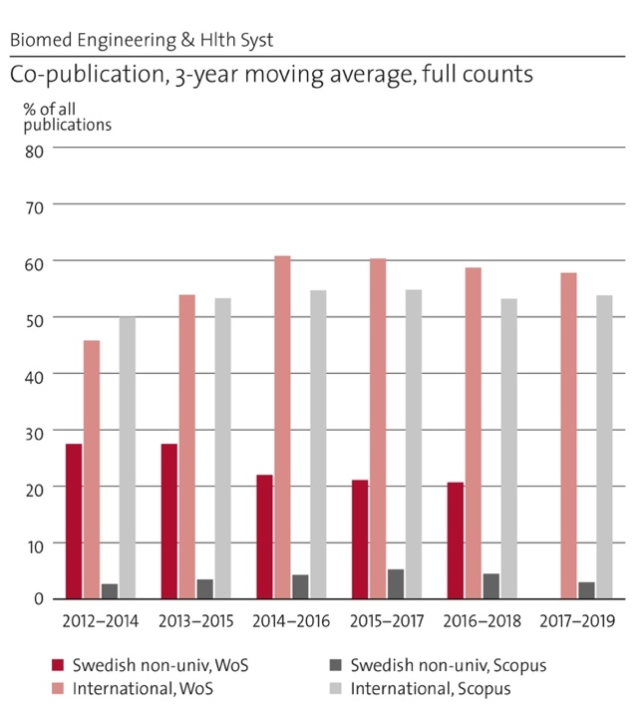
Figure 2.2. Publication impact and co-publications MTH
For a broad department, it is difficult to highlight just a few publications, but here we highlight one or two recent relevant publications from each division.
Lind CM, Forsman M, Rose LM (2020) Development and evaluation of RAMP II – a practitioner's tool for assessing musculoskeletal disorder risk factors in industrial manual handling. Ergonomics. Jan 10:1-28. doi:10.1080/00140139.2019.1710576.
Fischer, B., Peine, A. & Östlund, B. (2019) The importance of user involvement: A systematic review of involving older users in technology design" The Gerontologist Doi:10.1093/geront/gnz16
Brusini I, Carneiro M, Wang CL, Rubin CJ, Ring H, Afonso S, Blanco-Aguiar JA,Ferrand N, Rafati N, Villafuerte R, Smedby Ö, Damberg P, Hallböök F, Fredrikson M, Andersson L. (2018) Changes in brain architecture are consistent with altered fear processing in domestic rabbits. Proc Natl Acad Sci U.S.A. 115(28):7380-7385.
Marlevi D, Ruijsink B, Balmus M, Dillon-Murphy D, Fovargue D, Pushparajah K, et al. (2019) Estimation of Cardiovascular Relative Pressure Using Virtual Work-Energy. Scientific Reports 9(1).
Montanino, A., Saeedimasine, M., Villa, A., & Kleiven, S. (2020). Localized axolemma deformations suggest mechanoporation as axonal injury trigger. Frontiers in Neurology , 11, 25.
G. Kim et al.(2019) "Aldehyde-alcohol dehydrogenase forms a high-order spirosome architecture critical for its activity," Nature Communications, 10:1.
Ånell R, Grönkvist M, Gennser M, Eiken O. (2020) Evolution and preservation of venous gas emboli at alternating high and moderate altitude exposures. Aerosp Med Hum Perf. 91:11-17.
Eiken O, Elia A, Sköldefors H, Sundblad P, Keramidas ME, Kölegård R. (2021) Adaptation to 5 weeks of intermittent local vascular pressure increments; mechanisms to be considered in the development of primary hypertension? Am J Physiol Heart Circ Physiol. doi: 10.1152/ajpheart.00763.2020.
Zhang, C., Härenstam, K. P., Meijer, S. & Darwich, A. S. (2020). Serious Gaming of Logistics Management in Pediatric Emergency Medicine. International Journal of Serious Games, 7(1), 47-77.
Moustaid, E., M. Kornevs, F. Lindencrona, S. Meijer (2020). A System of Systems of Mental Health in Cities, Digging Deep into the Origins of Complexity. Administration and Policy in Mental Health and Mental Health Services Research, (), 1-11. DOI 10.1007/s10488-020-01035-0

e) Engagement in national and international research collaboration within academia and its outcomes
The number of collaborations is large and diverse, clearly reflecting the diversity of backgrounds and historical spread of the department. Here we list some research constellations that have proven meaningful.

Ergonomics
Smart workwear national research enxhange with: Scania CV AB, Volvo Lastvagnar AB, Volvo Personvagnar AB, Högskolan i Borås, Högskolan i Skövde, Högskolan i Gävle, Karolinska Institutet, Stiftelsen Fraunhofer-Chalmers Centre, Swerea IVF, Feelgood Svenska AB and Avonova Hälsa AB. Ergonomics internationally: PEROSH – Partnership for European research in occupational safety and health. Sweden is now again a member, and Prof. Mikael Forsman represents Sweden in a PEROSH-project. Assessing and improving the static workload of surgeons: Projects together with KI, Mayo Clinic, Minnesota, and Cambridge University Hospitals. Three articles have recently been co-authored; visiting research periods.

Biomedical Imaging
For Biomedical Imaging there is active exchange and co-publishing with: David Nordsletten, Div. Imaging Sc. and Biomed. Eng., King’s College London, UK; Alejandro Frangi, Centre for Comp. Imaging & Simulation Techn. in Biomedicine, School of Computing and School of Medicine, University of Leeds, UK; Matthew Urban, Mayo Clin, Coll Med, Dept. Radiol, Rochester, MN, USA; Xiaojun Chen, School of Biomed Eng., Shanghai, Shanghai Jiao Tong Univ, China; Punam Saha, Institute for Biomedical Imaging, Univ. of Iowa, Iowa City, IA, USA; Maxime Descoteaux, Computer Science, Université de Sherbrooke, Sherbrooke, Canada; Dieter Pahr, Institute of Lightweight Design and Structural Biomechanics, TU Wien, Vienna, Austria; Leif Andersson, Dept Med Biochem & Microbiol, Sci Life Lab, Uppsala Univ.; Anders Persson et al. Center for Medical Image Science and Visualization (CMIV), Linköping Univ.; Eric Westman et al., Div Clinical Geriatrics, Dept Neurobiol Care Sci & Soc, Karolinska Institute; Iuliana Toma-Dașu, Dept Oncol Pathol, Karolinska Institute

Neuronics Engineering
Karolinska Institute, Prof. Alessandra Villa (now at PDC/KTH): 4 collab. studies published involving multiscale computational modelling of axonal injuries from external kinematics to atoms. Continue with Prof. Johansson at KI to focus on biologic drugs to stabilize axonal membranes. Kath. Uni. Leuven: Prediction of acute subdural hematoma which constitute more than 50% of all severe brain injuries. Also on reconstructing some of their most well defined bicycle accidents. So far around five co-authored publications while their data have been used in around ten additional articles the last ten years. Stanford university: Prof. David Camarillo used the KTH head model for his research into concussions in Am. Football since 2013 (five co-authored publications so far and around ten additional publications by the Stanford group using the head model).

Technology in Health Care
Technology in Health Care has most collaborations within the HCI, Social robotics and Sociogerontechnology communities. International collaboration within Horizon2020 on interactive robots (a.o. Utrecht Univ.) and comparative international studies on fundamental changes in the contemporary experience of later life, the intersection of digital infrastructures, place and the experience of being connected. The division contributed to creating the growing network of “Sociogerontechnology” and in 2019 organized a workshop at KTH. Consequently, the division succeeded to publish a paper in “The Gerontologist” which is counted as having the highest impact in the gerontology field. At KTH, the division collaborates with the EECS school, the robotics department in one project funded by KTH DF and at INDEK in a project on digitization of home care. In Sweden the division is part of the National Graduate School on Ageing and Health, providing technology aspects in the context of nursing and paramedical research. It should also be mentioned that the division is well established in relevant networks at several universities such as Örebro, Umeå, Lund and Malmö.

Structural biotechnology
Structural biotechnology works nationally with: Gunnar Hansson at the Uni. Göteborg in the field of mucins and respiratory disorders leading to 4 publications in leading journals. Jan Johansson at Karolinska Institute on BRICHOS molecules as chaperones in prevention of Alzheimer’s disease: so far led to 1 paper in Nature Communications. Jens Lagerstedt at Lund University regarding structure and function of high-density lipoprotein, also denoted the “good cholesterol”. 1 paper published in Sci. Rep. Within KTH (Jonas Weissenrieder and Joydeep Dutta) to develop a prototype of our proposed phase-plate published in Ultramicroscopy. International: Ji-Joon Song at KAIST/Korea in the field of Huntington disease has so far led to 4 high impact publications. Larry Marnett, Vanderbilt University, Bruce Hammock, UCSD and Ralf Morgenstern, KI, regarding the structural interaction of two proteins in the inflammatory pathway, COX-2 and MPGES1, stabilised in nanodiscs.

The div of Environmental Physiology
The div of Environmental Physiology regularly conduct research projects in collaboration with international and national academic partners. Examples of international partners: Jozef Stefan Institute, Ljubljana, Slovenia; University of Udine, Italy; University Hospital, LMU Munich, Germany; Institute of Aerospace Medicine, German Aerospace Center, Cologne, Germany; University of Nottingham Medical School, Nottingham, UK. National partners are for example: Karolinska Institute, Stockholm; Högskolan i Gävle; Göteborgs Universitet

Health Informatics and Logistics
Health Informatics and Logistics works with several partners in EU projects, amongst others TU Delft, KU Leuven, Politecnico di Milano, Politecnico di Turino, IBM research Dublin, Danska Teknologiska Institutet, Danska Tekniska Universitet. We are part of a Health System Engineering workgroup with Cambridge, DTU and TU Delft, a.o. Within Sweden, we work mostly with GiH and Karolinska Institutet.Region Stockholm is an important partner as access to testbeds for theories and methods. Publications with these groups exist or are in the making. Recent collaboration with Skåne hospitals to get access to other datasets than possible in Stockholm.

f) Follow up from previous evaluations
MTH has seen a very challenging period following the RAE 2012. Within UoA 4.2 (Biomedical Engineering), the score on research output was average (3), but impact high (5) and research environment above average (4). The main recommendations were (in italic):
- Develop a long-term strategy.
- Intermediate age high quality faculty appointments are needed --- with an attention to research output quality and including a focus on gender balance.
- Strengthen the link between basic engineering, including other groups from KTH, and the clinical environment. Strengthen the interaction between engineers and medical doctors in the clinical environment by providing space for engineers in the hospital.
- Don’t diversify the research too much but keep it focused to a few priority areas, in which the UoA can build up a research group above critical size, attract the top research leaders in these fields and excel. Successful examples from the past have been in head injury analysis and crash helmet development and cardiovascular ultrasound imaging.
Within UoA 8.3 (Ergonomics, Health & Building), the scores for output was average (3), impact average (3) and research environment poor (2), with particular remarks on the DASH and Lighting units. The main recommendations were:
1) That the core staff mentioned above establish a dedicated effort to realise the research potential within the UoA. We suggest that in the first instance this effort is co-ordinated by Eklund as he has recent experience of developing a successful, new area of research activity.
2) That the importance of human factors and ergonomics specialists within the School of Industrial and Technology Management is evident. Other units of assessment within KTH would benefit of staff with the same type of specialisation. In addition, attention should be given to assure coordination between relevant groups within 8.1 and 8.4 that require human factors / ergonomics input. These include, amongst many, for example, the digital factory, working life and haptic devices.
3) DASH should be asked to prepare a detailed research strategy and identify a programme of research to realise this.
4) The DASH division is encouraged to enforce cooperation with UoAs 8.1 and 8.2 to make better use of modelling and design methodologies and design tools being state of the art in technical product design for application in patient care systems design. These state-of-the-art rigorous engineering approaches may bring a big step forward to the currently mainly qualitative design principles used in the DASH context.
5) to enable this unit to achieve a sustained, international profile we suggest they explore the notion of twinning with an international peer group to which they aspire. Such a twinning exercise would encourage activities that are both excellent and truly internationally relevant.
MTH predecessor STH had landed in major economic issues 2012-2014. The economic viability of well-scoring groups in biomedical engineering was low due to a significant number of senior researchers who did not bring in significant funding. Even worse was the economic situation around UoA 8.2, where on one hand the DASH and lighting groups were unfunded, and later the newly built Patient Safety group with high-profile recruit Prof Richard Cook (2011) had to be dismantled due to poor recruitment. Even other groups within the school suffered from similar issues. In summary, one can say that the aggressive expansion 2009 – 2012 has not been backed up by long-term strategy.
In 2013, groups that covered lighting and building management moved to the KTH-ABE school. During 2014, the then-new STH dean started an economic reorganisation, during which about 15 people were forced to leave and another 5 chose to leave. This has caused massive unrest, social and financial costs and led to pigeon-holing of all groups. DASH was slowly dismantled.
Meanwhile, 3 professor positions have been filled in new areas (Medical Image Processing (Örjan Smedby, 2014), Technology in Health Care (Britt Östlund, 2014) and Health Care Logistics (Sebastiaan Meijer, 2015). Smedby brought new excellence in an established domain, where Östlund and Meijer are building new research areas and delivering.
In 2016, the locations in Haninge and Flemingsberg moved into a brand-new building ‘Technology for Health’ in front of the main entrance to the Karolinska Huddinge hospital. Since then, the collaboration between teaching and research has improved.
It is a mystery as to why the RAE2012 recommendations have not been implemented earlier. It is paramount that STH was too fragmented, without critical mass, and lacked research quality in certain pockets. The department is happy that the developments of the last couple of years finally go in the right direction. There are three mechanisms that we want to highlight:
- Newly started groups and professors have taken time to get integrated. They were positioned as research-only units, where it is essential to be integrated in education and the management of the department as well. For years, a clustering existed in which professors were positioned to lead only their own research group, where management was done by competent but not research-heavy persons. The changes since the reorganization 2018 have made the structure more traditionally academic, as this is needed to increase research quality.
- Meanwhile, good research groups have been highly frustrated about the lack of prioritization of new faculty positions and investments to build critical mass. Apart from the new professors, the investments clearly followed the interests of the top management.
Good infrastructure, like the Cryo-EM facility, received financial protection because of the enormous potential. The fantastic Jonasson donation to start the Jonassons centre for medical imaging has enabled the acquisition of very expensive infrastructure. At the same time, the management to capitalize on these infrastructures has only been partially successful. Some of the Jonasson infrastructure has led to very good KTH publications, but others have not been used by KTH itself. The structural biotechnology group has consistently delivered high quality publications, but also suffered massive financial losses. The recent retirement of Prof Hans Hebert has been a great loss for this group.

3. Viability

a) Funding; internal and external
The finances of the department are grossly characterized as: 40% Education (GRU), 30% Base funding research (FOFU), 30% External research funding
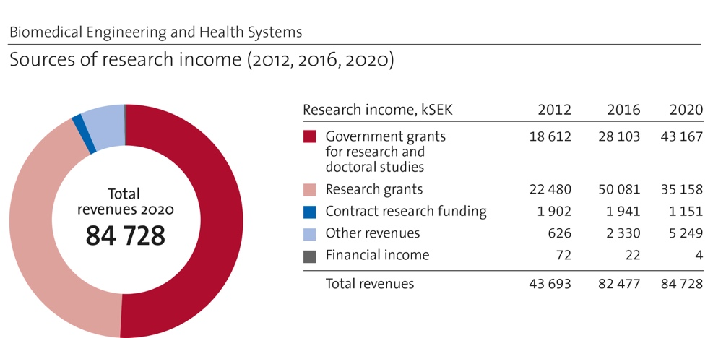
Figure 3.1. Sources of research income MTH.
The external research funding has about doubled after 2012, and while 2020 was a bit of a dip, the positive line is upwards. While at first the new funding came in particularly around the 3 new professorships, the healthy development is now broader, though vulnerable. The stagnation from 2016 can be explained by a larger decrease in the number of total persons involved in research, as well as several larger EU projects ending simultaneously. The funding per faculty member in research went up, which we see as a start of a positive movement. If the young faculty develops along the lines expected, the total amount of external funding can easily grow with some 30% - 50%
The largest sources of financing are:
- Swedish defence – with a long-term funding and intention to increase for the Environmental Physiology division.
- VINNOVA – the Swedish innovation funding agency (and to a certain extent FORTE and FORMAS), showing the close-to-implementation research ongoing
- The donation of Rune and Kerstin Jonasson – funding the Jonassons centre. In 2020, we received a last additional donation of 11 MSEK.
- EU projects, from FP7/H2020, EIT (Health), and Marie Curie.
- Region Stockholm (earlier SLL) – with start-up funding for 2 professorships, and now an increasing number of projects directly funded by them.
Furthermore, there is a portfolio of projects from the Swedish Science Foundation (VR), some international platforms like EUROSTARS and the NIH, as well as industrial projects with for instance Scania. The funding of MTH is relatively diverse and could use some increase on the purely scientific funding. Initiatives together with other CBH and KTH departments are ongoing.

b) Academic culture
MTH has for a long time been split into a research and a teaching community, except for the biomedical imaging and ergonomics units. Since the move into one building, and the subsequent organizational changes, more of an integrated academic community is being shaped. It has proven not yet possible to create a unified lecture series for the diverse department, but progress has been made in the faculty group, institutions forum, and smaller seminar series like around the Jonasson centre, Ergonomics and Technology in Health Care.

c) Current faculty situation
Currently, the faculty is composed of 7 professors, 15 associate professors, 4 (2021:5) assistant professors, and 19 adjuncts (full time teachers), with about 30% females. There are 7 recruitments ongoing at the time of writing, mainly at the assistant professor level and few adjuncts.
The MTH faculty is undergoing a massive generational shift. The last years, already 7 faculty and adjuncts retired, and another 13 persons (4 professors, 5 associate professors, 4 adjuncts) are expected to retire in the next 3 years. The aim is to correct some earlier imbalances by recruiting more faculty to strong groups who have been neglected, as well as to fill the gaps in our educational needs, which have synergies with the research areas. Education for which we need to recruit but that does not have synergy with the research is actively outsourced to other parts of KTH (Example: power electronics).
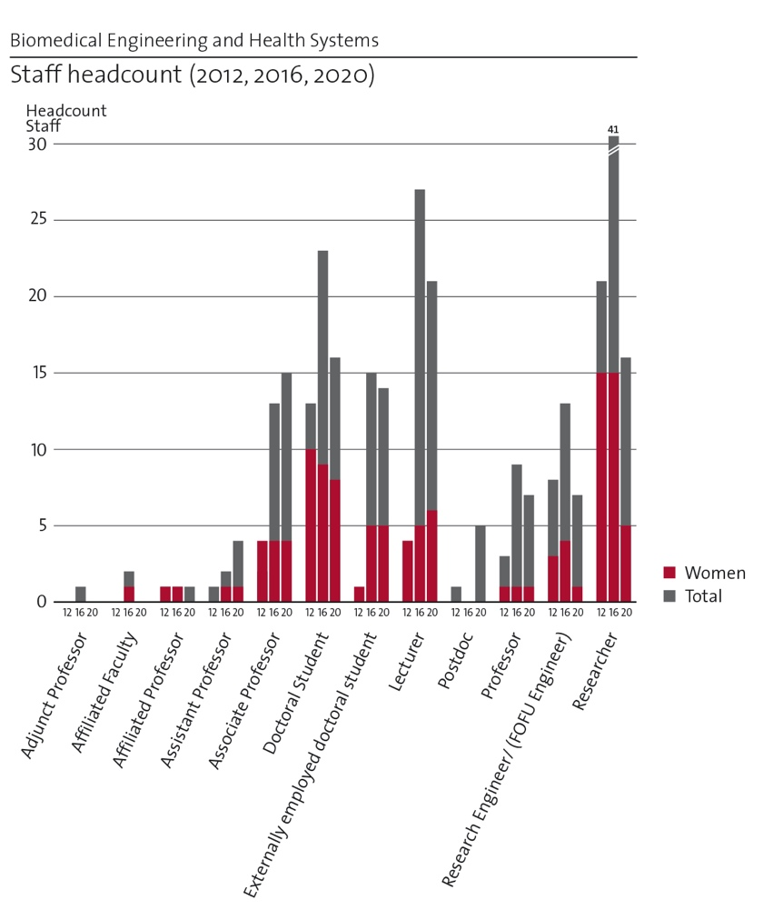
Figure 3.2. Staff headcount MTH.

d) Recruitment strategies
The recruitment strategies have been brought in line with the overall KTH strategies, which has led to a higher quality and higher numbers of applicants. The results of actual recruitments show that equal opportunities are relatively well safeguarded. The groups with a skewed gender balance have particularly not been able to recruit new senior personnel recently, though this is currently ongoing.
The school merger has brought a recruitment culture and philosophy about faculty to MTH that is much more mature and inspired by the strong biotechnology and chemistry environments.

e) Infrastructure and facilities
MTH has 1 cryo transmission electron microscope with a modern CMOS detector and a direct electron detector and all the equipment necessary for protein specimen preparation. The direct detector must be replaced or renovated at a cost of 0.5 to 1.5 million SEK to maintain high-quality imaging capabilities.
Currently a wet lab at the premises in Campus Flemingsberg is established. Rights to carry out GMM-f based work has been obtained. We aim at being self-sufficient regarding protein production as well as sample quality assessment. For this purpose, we would need a gel filtration system soon. For thorough research with publication in high impact journals methodology provided by National facilities and by collaborations will be mined however acquisition of methodology or infrastructure for biochemical / biophysical characterization may have to be considered.
The Environmental Physiology labs at Solna Campus hold special research facilities, in terms of centrifuge and hyper- and hypobaric pressure chambers as well as a climatic chamber, all designed for experiments in humans. The performance standards for these facilities are:
• centrifuge; radius = 7.25 m, max. G load = 15 G, peak G onset rate = 5 G/sec
• hypobaric chamber; volume = 23 m³, min. pressure = 3 kPa)
• hyperbaric chamber 1; volume = 10 m³, max. pressure = 15 ATM)
• hyperbaric chamber 2; volume = 5 m³, max. pressure = 5 ATM.
• climatic chamber; volume = 18 m³, operating temp.-range -20 to + 50 °C.
Although old, these facilities have been upgraded and currently have acceptable-good performance standards in an international perspective. The facilities need continuous maintenance.
In the Jonasson centre, imaging infrastructure is available as specified in the separate Centre Self Evaluation. In short:
Photoacoustic Imaging Facility The photoacoustic imaging system (Vevo LAZR, Visualsonics) incorporates photoacoustic imaging into high-resolution ultrasound. This infrastructure is located at KI and needs upgrading. It is under reconsideration.
Vivid E9 Ultrasound system from GE Healthcare, Aixplorer Ultrasound System and a Verasonics V-1 Ultrasound System
Mobile Gamma camera This is a powerful, fast, bed-side diagnostic equipment for cardiology or neurology applications.
MTH microCT – miniPET A combined CT and PET with superior spatial resolution for small animal imaging. The system has been developed by the Medical Imaging group at MTH in collaboration with ATOMKI, Debrecen (Hungary) and it is therefore fully customizable to any needs of interest.
Mobile C-arm. Ziehm Vision RFD. This has a flat-panel detector that provides high resolution, distortion-free imaging and an extended field of view.
Hermes Workstation Multi-modal, vendor-independent image processing workstation for image reconstruction, image fusion, quantification, reporting and archiving.
MRI with high-intensity ultrasound (MRI-HIFU) (Philips Ingenia 3T) The 3T MRI equipment produces high-resolution images to be used for clinical purposes and for advanced preclinical research. The integration of High Intensity Focused Ultrasound (HIFU) allows controlled therapeutic intervention under MRI guidance to be used for eliminating, e.g., tumours or pathological conduction pathways in the heart. The therapeutic effect of HIFU can be immediately monitored with continuous MRI scanning. We are currently upgrading this unit, and this is very expensive.

Also, we have a biomechanics lab including a quasistatic mechanical testing machine and a dynamic testing machine. This test equipment can be used for both biomechanical testing of biological tissues as well as prototype testing of materials used in injury preventive projects. We also have two unique test rigs for helmet testing.

The Jonassons centre is a KTH infrastructure centre, and some funding is associated with this, as well as opportunity to apply for funds. There is an amount of the donation available for further upgrades which can bring the infrastructure a few years forward. In the long term, however, this infrastructure needs a good strategy.
If the number of Cryo-EM users would increase we could aim at establishing a centre for high-contrast and high-resolution cryo-TEM based on microscopes with lower voltage than what is commonly available, 5 to 25 kV for screening specimens and initial studies and around 100 to 200 kV for high resolution studies. This might also be complemented by the matter-free phase plate if it turns out to be feasible. The initial investment for such a centre would be between 10 and 20 million SEK depending on the equipment. Microscopes with lower voltage have been shown to be advantageous for many of the specimens we commonly study and additionally they are economically more sustainable.

4. Strategies and organisation

a) Goals for development 5–10 years ahead
The overarching goal is to ‘normalise’ MTH from a splintered separate school on a decentral campus to a high-quality, integrated, and well-connected department within KTH. The work on the themes (and restructuring of the educational programs) opens for better integration, and the aim is to get sufficient critical mass to create stable research environments. An increase of external funding of 30% in the shorter term and potentially 50% in the long run is deemed possible and would further build an academic environment.
The unique MTH profile should be further developed towards being the translational research hub where fundamental research, new sensors and technologies, etc, meet the complexity of real health(care) settings. The digitalization research is expected to grow.
The infrastructure currently available gives a good start in further developing into a hub for biomedical imaging research at various scales. However, the KTH perspective needs to be safeguarded as there is historic evidence of the department turning into a service provider more than a research partner. Currently, we are looking into which infrastructures could be developed and should be invested in, as the portfolio is too large to keep up realistically in the long term.

b) Congruence with university-level goals for “A leading KTH” as set out in KTH´s “Development Plan 2018-23” (page 5)

Sustainable development
Focus on preventive health measures (Forsman, Eiken), system cohesion and mental health (Meijer) (SDG 3.4) in 2 themes. Imaging and simulation contribute to SDG 3.6 with the expansion of capacity within validated models of and devices for child and maternal care (both Smedby and Kleiven group). Improved access to good higher education and safe environments (SDG 4.3 / 4.A) for women and people with a foreign background through an open educational environment (Makerspace and restructuring master programs).

Internationalization
MTH is rapidly internationalizing through newer faculty. The current limitation lies in the teaching load and network of current employees. Networks from new faculty are important to get more outgoing students.

Gender equality
The faculty at MTH automatically becomes more equal through retirement, but problems remain in informatics and logistics. The research topics engage female students in our research. The educational environment has changed over the last years to become more research oriented and has proven to attract more females and a larger diversity in other dimensions too. The faculty development actively supports strong women to get promoted.

Digitization
MTH's profile contributes to the digitization agenda through a system perspective and focus on home care and health care and is thus different from other parts of KTH. It is also important that digital technologies do not traditionally reach healthcare: it is the most difficult (and most interesting) sector to change!

c) Leadership structure and collegial structure
In line with the general KTH structure, the department is led by a head of department (Sebastiaan Meijer) together with a vice head of department (Matilda Larsson). Meijer is also vice head of school for CBH, thereby safeguarding knowledge about the old STH structure at the new school leadership.
Every division is headed by a head of division, which is the most senior faculty person for all research groups, but for Health Informatics and Logistics which is led by an industry-experienced adjunct (Anders Cajander), since Meijer is already HoD and vice HoS. The management group consists of the (vice) head of department and the division heads and is strengthened with the Director of Education for CBH, the head of the Jonasson centre, and others where relevant. The management group met every month for the first 2 years of MTH but has now reduced to 4 meetings per semester.
The collegial structure is formalised in two fora since the 2018 reorganisation. The Faculty Group includes all faculty and meets once or twice per semester to discuss perspectives on strategic developments in research related issues and master and PhD education. The faculty group is led by the vice head of department, to facilitate for more free discussion than would happen with the head of department chairing.
The Institutionsforum includes all employees and stipends and meets once or twice per semester to discuss broader issues related to work environment, profile, and strategic developments. This typically takes an afternoon with some joint introduction, break-out in groups and summary in plenary setting.

d) Strategies for high quality
Quality assurance is first and foremost the responsibility of the senior faculty in their respective domains. Professors and leading associate professors are primarily responsible to produce the results in their research environments. Few groups have always been strong and publishing in highly renowned journals, where others have been renewed or disappeared.
The mechanisms through which quality is achieved are threefold:
  - Active encouragement of building healthy research portfolios. The mechanisms of competitive grant applications make that those who get the grants are better positioned to produce quality research. Financially, the department provides co-funding to top up larger external grants.
  - Stringent recruiting has been key to improve the quality of all types of personnel. When it comes to faculty recruitment, the merger into the larger CBH school has provided a quality boost in the recruitment process.
  - Open Access is encouraged through the CBH school since 2018, and financed centrally by the school, if not by the KTH Library. This does not yet appear in the statistics.
Importantly, quality is a culture thing. The ongoing work to slowly change the MTH culture into an active, integrated learning and research environment are therefore paying off when it comes to publications as well. We observe more of our good students doing thesis projects with our better researchers, leading to better theses, but also publications, which in its turn encourages PhD students.

5. Interaction between research and teaching

Interaction between research and teaching at all levels
MTH has a unique position in that we teach on 4 levels: preparatory year, BSc, MSc and PhD. With around 1200 students, divided over 11 programs, the integration between research and teaching is important, but also challenging.
For the preparatory year, the most important thing is to expose our students to a university environment, while teaching them preparatory courses. The new premises in Flemingsberg have given a real boost to the study environment, and the academic atmosphere. Furthermore, discussions between the teachers in this program and others have started on skills and teaching methods to prepare best for further studies. The new preparatory year towards ‘högskoleingenjör’ (Bachelor of Engineering) has a newly designed course, taught by a full professor (Meijer) on engineering and systems theory.
At the bachelor level, the programs in computer science, electrical engineering and biomedical engineering share many courses. We also teach a program in Technology and Economics. Active work is ongoing to involve more faculty in these programs. The merger of the old teaching-only unit of computer science and electrical engineering with the health care logistics group that was heavily tilted towards research has created new impulses to courses, projects and thesis topics for the computer science and electronics programs.
At the master level, the largest program in biomedical engineering is undergoing a full revision towards problem-based learning. 50% of the teaching will be a project carrier course which will be populated by projects from our faculty. In this way, the broad faculty and research profile of MTH can be utilized to provide interdisciplinary learning, instead of a splintered collection of different courses. The new programs in Sports Technology and the EIT Health labelled Health Innovation program (BHealthSy) are driven by faculty members based upon impact of their research with elite sportsman and health apps, for instance. Interesting collaborations between electronics, imaging and ergonomics are suddenly driving these developments. The revised program in Work, Technology and Health is converted from a practical program (magister) into a full masters, as to give more space to ergonomics research in the program.
At the PhD level, all students are directly engaged in research at one of the 8 groups. An integrated course Technology and Health is mandatory to provide all students with a good grasp of the width of the domain and department. Integrated lectures between senior faculty to cover a topic have been developed since 2017, with great success.
Lastly, a large investment in a research-enabling education asset has been done in 2019. The Flemingsberg Makerspace is a very well-equipped set of studios for electrical, mechanical and computer engineering, with all infrastructures available to produce prototypes that can be used for real-world tests. We observe a massive improvement of the quality of student projects, and engagement of our researchers through this environment.

6. Impact and engagement in society

a) Relevance of research to society at large
MTH research is extremely societally relevant, with major parts very close to operational reality in the health care sector, or occupational health.
The most fundamental group, structural biotechnology, studies biological structures and develops methods and technology that facilitate these studies. This should in the long run help to find cures for many diseases. All projects have gender specific aspects tied to them, e.g., the inflammatory diseases connected with prostaglandin E2 production as a mediator of pain and fever more commonly occur among men whereas rheumatoid arthritis is more frequent among women. On the other hand, much of our research is equally important for both genders. Specific fields of research we are involved in, e.g., Alzheimer’s disease, are relevant to an ageing population.
The biomedical imaging and neuronics engineering groups produce technologies that directly benefit the population. Injuries to the head and other body regions account for an enormous monetary cost and induce suffering for the individual and their family. The research at neuronics engineering aims to create research based biomechanical injury prediction tools that can be used for improved prevention of injuries in general. A spin-off in fall-preventing floors receives interests from city councils around Sweden and Europe in installing such safety floors in nursing homes since the awareness of suffering of both elderly and staff is high. Policy makers and stake holders at the national level are also getting a higher awareness about the cost and suffering of fall induced injuries although this process is slower.
Medical image processing methods developed, such as deep-learning-based segmentation, have elicited a great interest from medical practitioners and the med-tech industry as tools for assessing degree or probability of disease (quantitative imaging biomarkers).
Within the theme Digitalisation of Health and Care we address today´s challenges to health care systems and the social world. Worldwide health systems are challenged by epidemiological and demographic transitions, technological innovations, new ways of working when delivering care and not least changing population demands. Growing older populations is the biggest social change of our time together with digital transformations. Since technology is changing, it is proved that images of older technology users still prevail. The TVV division develops methods and theories to meet these challenges. The division is collaborating with investors both SMEs in Sweden and is part of international networks such as Aging2.0. Digitizing society and individuals is no longer about single applications, it is systemic change and an opening to continuous automation that affect practices as well as the understanding of what is human. The Health Informatics and Logistics division adds a simulation and informatics capability to this, so that actual organizations, particularly Region Stockholm, are concretely supported in their decision making on systemic changes. Engagement in mental health prevention policies is highly relevant and led scientifically by this division.
Since home care, characterized by being homo-social, is populated by women and engineering being male dominated, it makes gender issues present in the entire research. Our research on sustainable work life is again highly relevant to reduce work related injuries, and to keep older people longer in the work force.

b) Research dissemination beyond academia
MTH has particularly increased its presence by being part of platforms and collaboration structures, both with industry and the public sector.
Technology in Health care is part of national and international contexts to discuss digitization and later life. Britt Östlund is active in the European discussion on investments of future robotics and invited to the European Economic and Social Committee 2020. She is appointed as member of the Governmental advisory group on Health and Life Science and the advisory group on Ageing research in Sweden. The division has an active blog.
Neuronic engineering have a long tradition of working together with industrial partners such as Autoliv AB, Volvo CC, Saab Automobile and Scania on automotive safety. The computational head and neck models developed at Neuronic engineering are currently being used at those companies for development of innovative safety devices such as new airbag systems.
The division is also involved in national and European actions such as being committee member of COST Action TU1101, towards safer bicycling through optimization of bicycle helmets and usage, member of FIS working group for alpine helmets 2011-2013, and convenor for CEN/TC 158 Working Group 11 - Shock absorption including measuring rotational kinematics. The strategy is to be involved in new biomechanically based test standards committees for helmets and safety flooring ensuring soundness of such safety standards in their capability of capturing innovative protection systems that should reduce the risk of sustaining injuries in practice. Another strategy is to initiate companies based on ideas and patents with innovative protective systems.
Research by our researchers has resulted in patents and patent applications within medical image processing and development of new contrast media.
The division of Environmental Physiology and SAPC has direct impact on development or choice of safety equipment (e.g., anti-G suits, breathing apparatuses) or behavioural strategies (e.g., decompression tables, anti-G straining manoeuvres, high-altitude or heat acclimatization techniques) used by pilots, divers, and other job categories. In addition, the division regularly support industry (e.g., Saab Aerotech) and authorities (e.g., Swedish Accident Investigation Authority, Swedish Armed Forces) with knowhow, experiments/testing and/or simply by providing special test facilities (centrifuge and pressure chambers).
The division of Health Informatics and Logistics has several faculty persons (e.g., Meijer and Raghothama, and formerly Erlandsson) as part of policy advisor boards in the regional and national health care world. Meijer and Raghothama are well-integrated with the Health administration of Region Stockholm, and Erlandsson is part of the HL7 standardisation committee. The group works with administrations and politicians in Stockholm region, and elsewhere to support development of policies and engineering systems.

c) Sustainability and the United Nations’ Sustainable Development Goals (SDG)
The main MTH SDGs are 3(SDG 3: Good health and well-being) and 8 (SDG 8: Decent work and economic growth), with sideways contributions to 4, 5, 9 and 11. 80-100% of our work is related to these SDGs and therefore related to sustainability, even though the dominant CO2 perspective is not so present. Since 2015, the changes have been that the research projects acquired, the new positions recruited, and internal priorities are just strengthening this health, prevention and workplace profile. MTH is proud to have technology, social and system competences and is more and more working together to address the SDGs.

d) Structure for increased impact
The major impact for MTH to have in the future is to be even more integrated with the public health care, nursing, health prevention and work safety bodies. Many of these bodies are notoriously slow and require long trust building and collaboration before any real impact is achieved. The key strategy is therefore to be better represented where it matters, and to build deeper collaborations with Region Stockholm, Karolinska hospital, Karolinska Institute, the Red Cross University College, and other health care partners.
Since 2017, the number of bodies, reference groups, collaboration projects, etc in which MTH researchers are represented is steadily increasing. Much distrust due to old memories of STH have to be overcome, but the results are promising. When it comes to commercialization, we are proud to say that KTH Innovation has a permanent presence in Flemingsberg since the start of the MakerSpace in 2019.

e) Impact cases
MTH presents four impact cases in appendix:
1. Novamia AB
2. New Biomechanical Tools for Expert Advice in Court Cases of Shaken Baby Syndrome
3. The risk management tool RAMP and the RAMP package.
4. A new integrative strategy for Mental Health and Wellbeing: Region Stockholm.

Appendix – Impact cases Dept. of Intelligent Systems
DCS impact case 1 Fuel-efficient freight transport and automated heavy vehicles
Freight transportation is of critical importance to our society and the urbanization, population growth and expansion of global trade are continuously increasing the freight transport demand. At the same time, there is urgent need to reduce energy consumption and GHG emissions from transport in order to meet the sustainable development goals. Transporting goods on roads accounts for about 1/4 of the total energy consumption and 1/5 of all greenhouse gas emissions in the European Union, and transportation is now the only major sector in EU where CO2 emissions are still rising. The freight transport system needs to undergo drastic changes in order to meet the sustainability goals while still producing effective logistics systems that society’s demands of fast and reliable deliveries. The technological development in digitalization and automation is heavily influencing the ability to reach these goals.
Summary of the impact
DCS has made significant contributions to energy-efficient and safe intelligent road transportation. Sweden is a leading nation in automotive and transportation R&D and DCS is strongly involved in many successful initiatives bridging ICT and vehicular research. The key approaches have been: 1) transferring knowledge and skills to industry by educating MSc and PhD students, 2) research and prototype developments through collaborative industry projects with financial support from industry as well as from national and European research agencies, 3) engagement in national strategic initiatives and plans for future transportation, and 4) developing and disseminating research results through research papers in archival journals and conferences as well as national and international patents.
DCS researchers have studied how modern information and communication technologies would support a cyber-physical transportation system architecture, with an integrated logistic system coordinating fleets of trucks that travel together in vehicle platoons. From the reduced air drag, truck platoons can save about 10% of their fuel consumption. Utilizing road grade information and vehicle-to-vehicle communication, a safe and fuel-optimized cooperative look-ahead control strategy can be implemented on top of the existing cruise controller. By optimizing the interaction between vehicles and platoons of vehicles, it is shown that significant improvements can be achieved [1-3]. The current industrial focus on platooning is interoperability between truck brands and between truck operators, and to understand what services for strategic decision-making and coordination will be needed. The seminal work [1-4] in this area by DCS researchers has motivated our position in the H2020 project ENSEMBLE, together with six of the European truck manufacturers, and twelve other partner organizations. The explicit aim of ENSEMBLE is “to take the last steps of technological research before full deployment of multi-brand truck platooning”. Recent advances in multi-fleet platoon coordination are reported in [7].
In many industrial applications, such as mines, harbours, forestry, agriculture and construction sites, productivity, efficiency and safety can be greatly enhanced by vehicle automation. DCS is working closely together with Scania on motion planning and control systems for self-driving trucks and busses. One of the associated tasks is to follow a pre-defined path, which needs to be done both accurately and smoothly. Within these projects we have implemented and tested control systems that guarantee less than 20 cm deviations from the path with a 40-ton truck [5, 9]. The controller works perfectly in both low and high speeds, on asphalt and on gravel roads, and it is easily reconfigured for different vehicle types, from mining trucks to passenger busses.
As indication of the importance for Swedish industry, we can mention that more than 10 PhD graduates from DCS have been recruited by Scania, in addition to the industrial PhD students. Many of these DCS alumni have leading positions within Scania’s expanding division on Autonomous Transport Systems. Every year the DCS faculty supervise tens of MSc theses in the area of intelligent transportation and there are continuously a number of licentiate and PhD theses students enrolled directly funded from the automotive industry.
DCS faculty has been involved in the leadership of the research centre ITRL – Integrated Transport Research Lab which has received 65 MSEK of external funding from Scania, Ericsson and Region Stockholm over the last 6-7 years. The main focus of the centre is to understand the role of automation, digitalization and new services in transforming the transportation system to reach the sustainability goals. A second strong focus is experimental research and demonstrations, and as part of that work, DCS has set up a Smart Mobility Lab with miniature vehicles, simulation environments and communication and data infrastructure for studying multi-vehicle transportation solutions. The Smart Mobility Lab is an important asset within the first, second and third cycle education, for providing a motivating and challenging learning environment where researchers, students and external partners can meet.
Underpinning research
The research has been conducted over the past 10 years within several large collaboration projects with Scania and other external partners. Eight industrial PhD students at Scania [1-2, 5-6, 8-9] and 4 PhD students [3-4, 7, 10] have been and are being supervised by the DCS faculty (Bo Wahlberg, Karl Henrik Johansson, Jonas Mårtensson). Here we list the PhD and Licentiate dissertations. The research has resulted in over 100 research publications and numerous patents (oftentimes filed by the industrial PhD students and co-workers at Scania, and in several cases with DCS faculty as co-authors).
- Alam, A. (2014). Fuel-Efficient Heavy-Duty Vehicle Platooning (PhD dissertation). http://urn.kb.se/resolve?urn=urn:nbn:se:kth:diva-145560
- Liang, K.-Y. (2016). Fuel-Efficient Heavy-Duty Vehicle Platoon Formation (PhD dissertation). http://urn.kb.se/resolve?urn=urn:nbn:se:kth:diva-187350
- Turri, V. (2018). Look-ahead control for fuel-efficient and safe heavy-duty vehicle platooning (PhD dissertation). http://urn.kb.se/resolve?urn=urn:nbn:se:kth:diva-226150
- van de Hoef, S. (2018). Coordination of Heavy-Duty Vehicle Platooning (PhD dissertation). http://urn.kb.se/resolve?urn=urn:nbn:se:kth:diva-225109
- Lima, P. F. (2018). Optimization-Based Motion Planning and Model Predictive Control for Autonomous Driving: With Experimental Evaluation on a Heavy-Duty Construction Truck (PhD dissertation). http://urn.kb.se/resolve?urn=urn:nbn:se:kth:diva-233550
- Oliveira, R. (2019). Motion Planning for Heavy-Duty Vehicles (Licentiate dissertation). http://urn.kb.se/resolve?urn=urn:nbn:se:kth:diva-252537
- Johansson, A. (2020). Strategic Decision-Making in Platoon Coordination (Licentiate dissertation). http://urn.kb.se/resolve?urn=urn:nbn:se:kth:diva-275670
- Held, M. (2020). Fuel-Efficient Look-Ahead Control for Heavy-Duty Vehicles with Varying Velocity Demands (PhD dissertation). http://urn.kb.se/resolve?urn=urn:nbn:se:kth:diva-273416
- Pereira, G. C. (2020). Lateral Model Predictive Control for Autonomous Heavy-Duty Vehicles: Sensor, Actuator, and Reference Uncertainties (Licentiate dissertation). http://urn.kb.se/resolve?urn=urn:nbn:se:kth:diva-279306
- Čičić, M. (2021). Modelling and Lagrangian control of mixed traffic: platoon coordination, congestion dissipation and state reconstruction (PhD dissertation).

ISE Impact case 2: Start-up R3 Communications
Summary of the impact:
Efficient industrial automation depends on effective communication means between distributed automation equipment for autonomous coordination, for instance with respect to operations on a conveyor belt, processing sequences in production cells or the operation of multi-robot systems like AGVs in logistics. For decades this communication relied on cable-based systems, often referred to as field bus systems, more recently also referred to as industrial Ethernet. However, market pressure demands from automation equipment more and more flexibility, in particular to allow quick reconfigurations of manufacturing set-ups. Such flexibility can only be provided through wireless systems, which nevertheless have been known to be too unreliable to compete in the automation market. Research over the last decade from the ISE division, and in particular from Prof. James Gross, has been pioneering principles and systems that can provide enough reliability even in harsh industrial automation environments. After validation, the research has lead subsequently to several IP families, which are today the foundation of R3 Communications GmbH, a young company commercializing the IP in several different markets with global players in the industrial automation market.
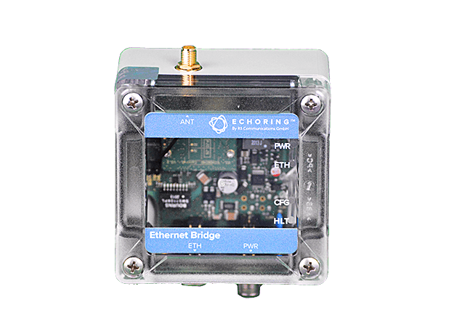
Figure 1: EchoRing Ethernet Bridge of R3 Communicatiopns
Underpinning research activities:
Fundamental as well as experimental research work conducted by J. Gross and his research team has been leading to the subsequent commercialization activities. From a communication-theoretic perspective the main contribution over the last years has been in addressing trade-offs with respect to finite-blocklength capacity models and relaying. At very short times spans, traditional capacity models overestimate the achievable rate of a communication channel, and this inaccuracy grows the shorter the involved time spans are. This leads to interesting trade-offs where for instance it is not clear if relaying (and cooperative communication in general) is still as beneficial as it has been shown to be with respect to traditional performance models. Corresponding works of J. Gross and collaborators at RWTH Aachen University have addressed these questions in relaying set-ups with respect to the AWGN case [1], the quasi-static fading channel case [2], and also with respect to fading channels with imperfect channel state information at the transmitter [3]. Surprisingly, it was shown that in the finite-blocklength regime relaying pays off even more, and this benefit increases the shorter the involved time spans are. Subsequently, we have been also investigating the multi-user case where cooperative diversity can be exploited [4].
These theoretical findings were in parallel validated through experimental research with a particular focus on evaluating different system designs for mission-critical applications. This has lead for to the EchoRing design and performance evaluation [5] [6] [7], the investigation of software development methods for wireless system implementations for mission-critical applications [8] as well as an improved wireless system for sub-1-ms application latencies [9]. All these findings were elaborated in collaboration with RWTH Aachen University.
[1] Y. Hu, J. Gross and A. Schmeink, “On the Capacity of Relaying with Finite Blocklength,” IEEE Transactions on Vehicular Technology, vol. 65, no. 3, pp.1790-1794, 2016. Citation count (GScholar, 03/2021): 57
[2] Y. Hu, A. Schmeink and J. Gross, “Blocklength-limited Performance of Relaying under Quasi-Static Rayleigh Channels,” IEEE Transactions on Wireless Communications, vol. 15, no. 7, pp. 4548-4558, 2016. Citation count (GScholar, 03/2021): 78
[3] Y. Hu, A. Schmeink and J. Gross, “Optimal Scheduling of Reliability-Constrained Relaying System under Outdated CSI in the Finite Blocklength Regime,” IEEE Transactions on Vehicular Technology, vol. 67, no. 7, pp. 6146 – 6155, 2018. Citation count (GScholar, 03/2021): 18
[4] Y. Hu, M. Serror, K. Wehrle and J. Gross, “Finite Blocklength Performance of Cooperative Multi-Terminal Wireless Industrial Networks,” IEEE Transactions on Vehicular Technology, vol. 67, no. 7, pp. 5778 – 5792, 2018. Citation count (GScholar, 03/2021): 23
[5] C. Dombrowski and J. Gross, “EchoRing: A Low-Latency, Reliable Token-passing MAC Protocol for Wireless Industrial Networks,” in Proc. of the European Wireless Conference (EW), June 2015. Citation count (GScholar, 03/2021): 39
[6] C. Dombrowski and J. Gross, “EchoRing- Meeting Hard Real-time Constraints by Decentralized Wireless Networks,” Demo Paper, GI KuVS NetSys, March 2015. Best Demo Paper Award (2nd place)
[7] C. Dombrowski and J. Gross, “Hard Real-Time Wireless Medium Access in Action: Stop the Guillotine within a Millisecond!” Demo Paper, IEEE Conference on Local Computer Networks (LCN), October 2011.
[8] C. Dombrowski, S. Junges, J. Katoen and J. Gross “Model-Checking Assisted Protocol Design for Ultra-Reliable Low-Latency Wireless Networks,” in Proc. of the IEEE Symposium on Reliable Distributed Systems (SRDS), September 2016. Citation count (GScholar, 03/2021): 12
[9] M. Serror, S. Vaaszen, K. Wehrle and J. Gross, “Practical Evaluation of Cooperative Communication for Ultra-Reliability and Low-Latency,” in Proc. of the 16th IEEE International Symposium on a World of Wireless, Mobile and Multimedia Networks (WoWMoM), June 2018. Citation count (GScholar, 03/2021): 10
Patent applications based on the research:
J. Gross, F. Bonanati and M. Bohge, “Method of operating a communication system in a time-division multiplexing technique”, US Patent 10,560,225
J. Gross, F. Bonanati and M. Bohge, “Communication Node for a Sequence-Based Communication Network,“ PCT submission, PCT/EP17190332.
J. Gross, F. Bonanati and M. Bohge, “Handover Process,“ PCT submission, PCT/EP17170773.
J. Gross, F. Bonanati and M. Bohge, “Communication System,“ PCT submission PCT/EP2017/054765.
J. Gross and C. Dombrowski, “Wireless Real-time Transmission,“ PCT submission, PCT/EP2012/056381.
J. Gross and C. Dombrowksi, “Reduktion der Ausfallwahrscheinlichkeit im Mobilfunk,” German patent submission, DE 10 2011 001 911.1.
Prizes to the company:
Oct 2019: 1st prize winner of EIT Digital Challenge
Oct 2018: Fog Tank Award to R3 Communications
April 2018: R3 Wins the 1st Prize of the Global IoT Finale of the 2nd China (Shenzhen) Innovation & Entrepreneurship International Competition
Dec 2015: R3 wins the Deep Tech Award of Berlin

ISE Impact case 3: The Mabtech IRIS - https://www.mabtech.com/iris
Summary of the impact:
ELISpot and Fluorospot are quantitative assays used to study cell cytokine production, which is important in biomedical studies of the immune response and vaccine development. Mabtech AB is a Swedish biotech company that is the world-leading developer of the monoclonal antibodies used in these assays. In 2015, Mabtech AB predicted a potentially reduced market share for ELISpot and Fluorospot to competing technologies, such as flow cytometry, largely due to the lack of quality of available analysis equipment and software for ELISpot Fluorospot, i.e., so-called readers. This led them to contact J. Jaldén’s research group at IS/ISE to discuss how to improve the technology, which led to a very successful collaboration.
Early analysis and algorithm development showed that it was possible to significantly improve upon state-of-the-art analysis software and yielded insights into how to improve analysis hardware. The promise of early results prompted Mabtech AB to ask KTH if we could develop consumer-ready analysis software to bring the research to market. While this was not within our capabilities, we facilitated contact between Mabtech AB and Qamcom, a consultancy company in signal processing, which then developed a software and hardware solution based on our research. The new analysis equipment, the Mabtech IRIS, was launched in September 2018 and is now manufactured and sold by Mabtech AB. Through this, Mabtech AB has expanded its business from only the manufacturing of monoclonal antibodies to also include the in-house production of high precision analysis equipment, a domain previously occupied by third-party reader manufacturers. A second reader model, the Mabtech Astor, was launched in 2020 to meet diversified demands.
The very first unit produced by Mabtech AB was used in a study of Malaria resistance in Kenya. An important current use case of the IRIS is the study of T-cell immunity to Covid-19 [1, 2]. J. Jaldén has also used this application area of ISE research as a basis for public outreach activities and presented the underlying research in the televised national final of the Researcher’s Grand Prix.
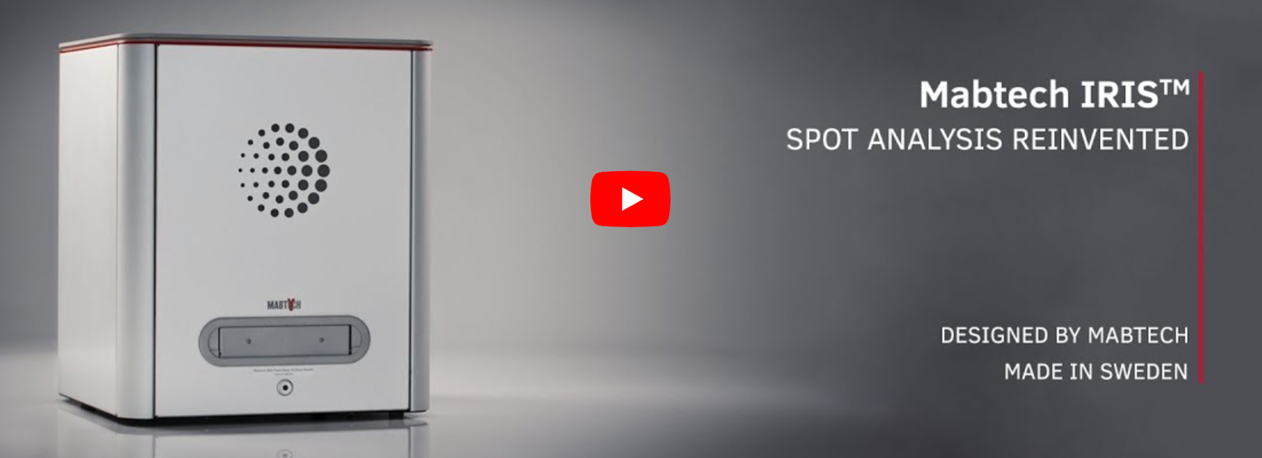
Underpinning research activities:
The spot analysis software in the IRIS is based on ongoing research into large-scale optimization methods. The basis of the analysis algorithm is a mathematical model of cytokine and antibody interactions in the assay plate that links hypothesized cytokine sources to a characteristic spot pattern observed by a camera in the reader. This forms the basis of an inverse problem over 25 million unknown variables representing potential source locations and temporal cytokine release profiles. Sparsity promoting regularization from compressed sensing ensures the uniqueness of the solutions, and GPU acceleration of proximal first-order optimization algorithms makes it feasible to solve the resulting large-scale optimization problems. This model-based analysis approach greatly outperforms prior heuristics analysis methods used in the field. It can also reveal new measurement modalities, such as the relative spot volume (RSV), which recently found biological implications [3, 4].
The project was first funded with direct industry funding from Matbech AB, while the continual development of methodology, algorithms, and mathematical analysis was funded by the Swedish Research Council (VR). Core method results have been published in [5-7], and the methodology is patented [8].
[1] Varnaitė, Renata, Marina García, Hedvig Glans, Kimia T. Maleki, John Tyler Sandberg, Janne Tynell, Wanda Christ et al. "Expansion of SARS-CoV-2–Specific Antibody-Secreting Cells and Generation of Neutralizing Antibodies in Hospitalized COVID-19 Patients." The Journal of Immunology, 205, no. 9 (2020): 2437-2446.
[2] Sherina, Natalia, Antonio Piralla, Likun Du, Hui Wan, Makiko Kumagai-Braesch, Juni Andréll, Sten Braesch-Andersen et al. "Persistence of SARS-CoV-2 specific B-and T-cell responses in convalescent COVID-19 patients 6-8 months after the infection." Med (2021).
[3] Jahnmatz, Peter, Christopher Sundling, Victor Yman, Linnea Widman, Muhammad Asghar, Klara Sondén, Christine Stenström et al. "Memory B-cell responses against merozoite antigens after acute Plasmodium falciparum malaria, assessed over one year using a novel multiplexed FluoroSpot assay." Frontiers in immunology, 11 (2020): 3788.
[4] Hu-Lieskovan, Siwen, Srabani Bhaumik, Kavita Dhodapkar, Jean-Charles JB Grivel, Sumati Gupta, Brent A. Hanks, Sylvia Janetzki et al. "SITC cancer immunotherapy resource document: a compass in the land of biomarker discovery." Journal for immunotherapy of cancer 8, no. 2 (2020).
[5] del Aguila Pla, Pol, and Joakim Jaldén. "Cell detection by functional inverse diffusion and non-negative group sparsity—Part I: Modeling and Inverse problems." IEEE Transactions on Signal Processing, 66, no. 20 (2018): 5407-5421.
[6] del Aguila Pla, Pol, and Joakim Jaldén. "Cell Detection by Functional Inverse Diffusion and Non-negative Group Sparsity—Part II: Proximal Optimization and Performance Evaluation." IEEE Transactions on Signal Processing, 66, no. 20 (2018): 5422-5437.
[7] del Aguila Pla, Pol, Vidit Saxena, and Joakim Jaldén. "Spotnet-learned iterations for cell detection in image-based immunoassays." In 2019 IEEE 16th International Symposium on Biomedical Imaging (ISBI 2019), pp. 1023-1027. IEEE, 2019.
[8] Smedman, Christian, Joakim Jalden, Daniel Pelikan, Pol Del Aguila Pla, and Klas Magnusson. "Method and system for analysing fluorospot assays." SE Patent SE543211C2, 2020-10-27.
MST impact case 4: Capitainer
Capitainer® is a start-up company in Stockholm based on research from professors Roxhed and Stemme during 2013-2016 on disposable capillary microfluidics to generate volume-defined blood samples. The technology combines capillary microfluidics with dry blood spot (DBS) technology where a blood or plasma sample is metered by the microfluidic system and subsequently transferred and dried onto a paper substrate. By storing the sample in paper, the sample is regarded as non-biohazardous and can be shipped in an ordinary envelope by regular mail and subsequently analyzed in central labs under quality-controlled conditions. This allows patients to perform blood sampling themselves at home and send samples to healthcare providers without the need of a physical visit. As oppose to conventional DBS samples, used since long in e.g. neonatal screening, the sample is volume-metered allowing the sample to by quantitatively analyzed. This makes it possible to accurately determine concentrations of for example drugs and to enroll patients in Therapeutic Drug Monitoring (TDM), to follow drug levels over time and individualize medication to the specific patient needs.
The technology has been developed in collaboration with researchers at the Karolinska Institutet and department of clinical pharmacology at the Karolinska hospital. The work has led to several well-cited publications in the field of bio analytical chemistry describing volume-controlled metering of whole blood [1,2] and volume-metering of blood plasma [3]. The technology is based on laminated structured foils, combining layers with different surface properties and other functional elements such as dissolvable valves and filtration membranes. Capitainer’s first product Capitainer qDBS® is a blood sampling card containing two independent blood sampling wells, each storing a 10 µl dried blood spot sample (figure X).
During the first wave of the SARS-CoV-2 pandemic, Capitainer qDBS was used to screen 1150 randomly selected inhabitants in Stockholm for antibodies against the virus [4]. The new technology enabled something that was not really possible earlier, namely in an easy way obtain high-quality blood samples from the population where sampling kits where distributed by mail and where participants could sample themselves in their home and send back samples by regular mail. During the early days of the pandemic this was essential as this allowed people to leave a blood sample from home without the risks of traveling or taking resources from the heavily strained healthcare system.
With the information obtained from the screening, we could show that already in April and early May 2020, approximately 12.5 % of the Stockholm population had been exposed to the SARS-CoV-2 virus. This was the first unbiased study of the seroprevalence in the Swedish population and helped to quantify Sweden’s alternative approach not employing lock-downs or school- closures. The work obtained huge media attention and was featured in both national and international newspapers, as well as national television in Sweden and in the Netherlands. The work further led to new collaborations with high-profile institutions such as the Swedish Science for Life Laboratory and Harvard Medical School.
Capitainer qDBS® is a CE-marked in-vitro diagnostics product which is sold in the EU is a medical device and pending market approval by the FDA in the US as a diagnostic device. Customers are located around the world and include hospitals, commercial laboratories and leading research institutions such as Harvard and Stanford. The company was founded 2016, now employs about 10 people and has raised 6.5 M€ in grants and venture capital.


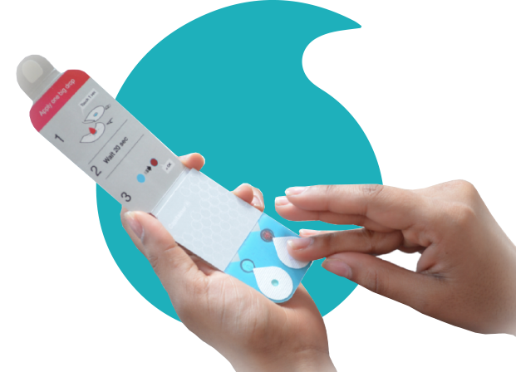
- G. Lenk, S. Sandkvist, A. Pohanka, G. Stemme, O. Beck, N. Roxhed, “A disposable sampling device to collect volume-measured DBS directly from a fingerprick onto DBS paper”, Bioanalysis, Vol. 7, No. 16, Pages 2085-2094, 2015.
- G. Lenk, S. Ullah, G. Stemme, O. Beck, N. Roxhed, “Evaluation of a volumetric dried blood spot card using a gravimetric method and a bioanalytical method with capillary blood from 44 volunteers”, Anal. Chem., vol. 91, no. 9, s. 5558-5565, 2019.
- J. Hauser, G. Lenk, S. Ullah, O. Beck, G. Stemme, N. Roxhed, “An Autonomous Microfluidic Device for Generating Volume-Defined Dried Plasma Spots", Anal. Chem, vol. 91, no. 11, s. 7125-7130, 2019.
- N. Roxhed, A. Bendes, M. Dale, C. Mattsson, L. Hanke, T. Dodig-Crnković, M. Christian, B. Meineke, S. Elsässer, J. Andréll, S. Havervall, C. Thålin, C. Eklund, J. Dillner, O. Beck, C. E. Thomas, G. McInerney, M-G. Hong, B. Murrell, C. Fredolini, J. M. Schwenk, “Multianalyte serology in home-sampled blood enables an unbiased assessment of the immune response against SARS-CoV-2”, Nature Communications, in-print, 2021

RPL Impact cases 5: Reliable, fast, reproducible and widely-used facial landmark detection in images
Summary of the impact
Vahid Kazemi a PhD student at RPL, KTH from 2011-2014 under the de-facto supervision of Josephine Sullivan resulted in a ML based algorithm for facial landmark detection in images described in the paper: Vahid Kazemi & Josephine Sullivan. “One millisecond face alignment with an ensemble of regression trees”. In Proceedings of the IEEE Conference on Computer Vision and Pattern Recognition (pp. 1867-1874), 2014.
At the time of publication, the algorithm had state-of-the-art performance on several standard datasets and ran extremely quickly relative to other algorithms with a small memory footprint. Perhaps equally important was the paper provided a clear and full description of the algorithm. This is a rarity in the application area as many algorithms are published by those with a commercial agenda and thus there is frequently a lack of transparency in all the very explicit details needed to replicate results. Due to our algorithm's clear description in the paper, many researchers were able to write their own implementation. And due the algorithm's speed, performance accuracy and robustness across faces they were bothered to do so! There is an independent open-source implementation with the dlib C++ library (http://dlib.net) which means the algorithm is accessible to a wide audience. Since 2014 the algorithm has been used, for example, by
- Google research and was in their code base as reported by KTH students who interned at Google,
- SnapChat within their facial animation apps
- by the VGG group at Oxford University, one of the most prestigious computer vision labs in Europe/world, for their work in automatic lip-reading from video see J. S. Chung, A. Senior, O. Vinyals & A. Zisserman; "Lip Reading Sentences in the Wild"; In Proceedings of the IEEE Conference on Computer Vision and Pattern Recognition (CVPR), 2017
- Nvidia research to align faces in their FFHQ dataset (a face dataset) see Appendix A of the paper: Tero Karras, Samuli Laine, Timo Aila; A "Style-Based Generator Architecture for Generative Adversarial Networks", Proceedings of the IEEE/CVF Conference on Computer Vision and Pattern Recognition (CVPR), 2019
Further evidence of the impact of the algorithm is that the article has now been cited over 2,000 times (according to Google Scholar) and continues to be cited well (~470 times in 2020) even though the deep learning revolution has also come to the field of facial landmark detection. However, the algorithms based on neural networks can be tricky to train, especially for those who are not experienced practitioners, the final models usually have quite a large memory footprint and are somewhat slow to run on conventional hardware. Also, the accuracy gains have not been huge within facial landmark detection. Thus, there is still a large use, especially for the research areas where extreme accuracy is not needed, but where one needs a reliable, robust, easy to run and fast algorithm such as in the application areas of: emotion and facial gesture recognition, gaze direction estimation and monitoring driver drowsiness.
Research area background
Face alignment a.k.a. face landmark localization is a central task in the field of computer vision. It involves detecting the outline of the full face and its facial features. Face alignment is an important building block of several downstream visual recognition tasks such as synthetic face generation, face recognition, facial expression recognition, lip reading, human-computer interaction, and several more human-centered applications of AI.
RPL Impact Case 6: Deep Representation Learning Revolutionize Computer Vision
Summary of the impact
Deep learning, i.e., ML using large (artificial) neural networks trained with equally large volumes of data points, has transformed the AI and Data Science fields. What was previously mere science fiction, such as self-driving cars and phones that let you log in just showing your face, is now reality. Deep learning is a key component.
The subject of this case study is a paper ([1] followed by a journal version [2]) which has had a key role in the development of deep learning for computer vision applications. The work has over 4000 citations and made a major mark in the computer vision field and industrial practice.
Research area background
The field of ML develops techniques that process data for learning to understand sensory information (such as face recognition), predict events (such as weather forecast), estimate quantities of interest (such as risk of an investment), or make decisions (such as driving a car) . Deep learning is one family of ML techniques where highly complex phenomena are learned between different observed variables, with the help of large so-called (artificial) neural networks. Neural networks have been around since the 50-s but it was only recently – in 2011 – that effective neural networks were developed. The key factors were that the amount of available computing power and training data became large enough to store and train the large networks needed, and that effective mathematical algorithms had been developed for fitting the large networks to the large volumes of data.
Within a few years, all previous ML techniques had been outperformed by the new deep learning methods, and the performance even surpassed human-level performance on some tasks, like image classification in large datasets. This success made deep learning ubiquitous in various industrial sectors which can benefit from automatic processing, forecast, or decision making.
The publications [1] and [2] show that when we train a neural network for one of such automatic tasks, what it learns can be extremely useful for other tasks operating on similar sensory information. More technically, [1] and [2] observed that generic image descriptors can be achieved by picking out the representation in middle layers of a neural network trained with abundance of images. This has proven to be an extremely valuable insight in computer vision – the field that studies ML for automatic understanding of visual data –, and this knowledge has been employed in a large number of other works as described below.
Underpinning research
In [1] an AI model (an artificial neural network) is first trained on a dataset called ImageNet with a simple visual recognition task where the AI model is supposed to take in an image and say which of the predefined 1000 categories the image belongs to. The categories cover a wide range of general visual classes such as man-made objects, animals, plants, and scenes. Then, through various experiments, [1] observes the surprising result that the way this trained AI model works is highly transferrable (with minimal modifications) to other visual recognition tasks. These tasks include, finding the attributes of objects in the image (such as a smiley face), activities happening in the image (such as kissing, dancing, protesting, etc.), fine-grained categories in the image (such as 200 bird species), and most interestingly retrieving other instances of a query object (such as the Statue of Liberty) across a large dataset of images. This means that the learnt AI model learns general knowledge about the visual content of an image that governs almost any visual recognition task. The model is a specific type of ML models, called deep learning. Deep learning constitutes several layers of transformation (going from the input image to the necessary output such as the category of the object). Each layer slightly transforms its input to obtain a more abstract representation further away from the input and closer to the output. [1] demonstrates that after training these transformation layers on one visual recognition tasks, most of them are transferrable to other tasks. That is to say the abstractions required for solving one visual perception task is highly relevant for other visual perception tasks. In [2] we analyzed the aspects of the AI model that improved or inhibited this transferability which led to increased performance on the downstream task by optimizing those aspects accordingly.
Details of the impact
The last sentence of the paper [1] published on March 23, 2014 on arXiv.org entry 1403.6382v1 reads: “Thus, it can be concluded that from now on, deep learning with CNN has to be considered as the primary candidate in essentially any visual recognition task.”.
The paper, the experimental results and especially this last sentence understandably raised different reactions from the field of computer vision.
Soon after, the sentence gradually proved to be a correct prediction. For instance, this is evident, in the top computer vision conferences such as CVPR that produces publications of highest impact across conferences of all fields of science (according to Google scholar metric [https://scholar.google.com/citations?view_op=top_venues&hl=en]). CVPR and all other similar conferences have not only seen most of its papers involving deep learning in one way or another but also a dramatic increase in the number of accepted papers, and attendance due to the successful application of deep learning since 2015.
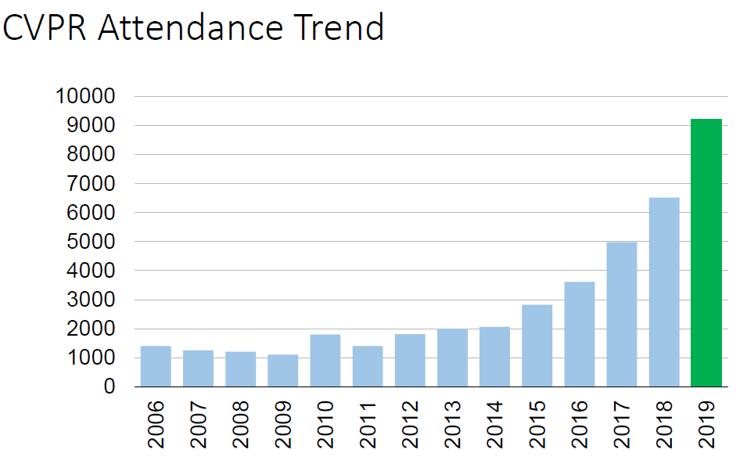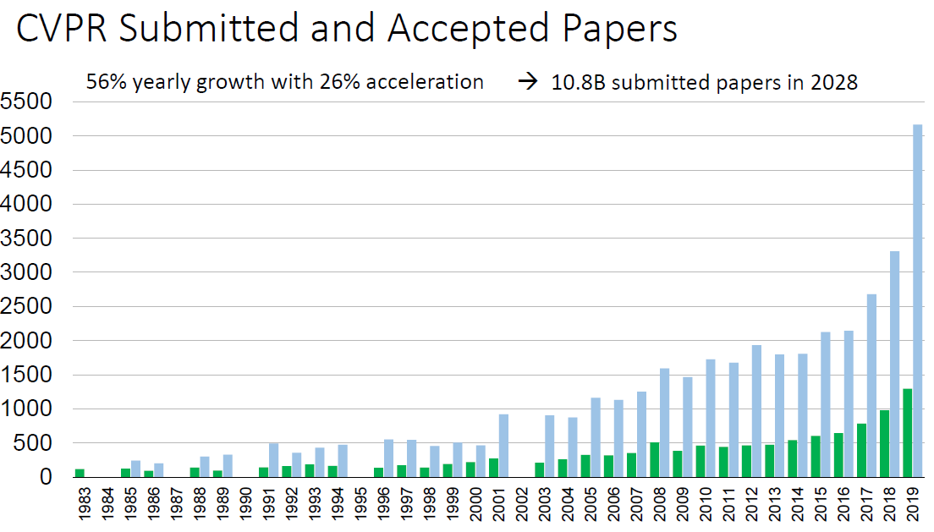
Published in Nature on May 27, 2015, LeCun et al. confirm this by indicating that: “This success has brought about a revolution in computer vision; ConvNets are now the dominant approach for almost all recognition and detection tasks and approach human performance on some tasks.”
The general impact of the paper can be summarized in 3 aspects.
- computer vision community acceptance: after the 2nd AI winter in early 90s the field of computer vision got disillusioned of neural networks. In fact, in 2012, the prominent deep learning researcher, Yann LeCun, wrote a rant letter to CVPR program chairs complaining about the negative bias of the reviewers toward feature learning methods. Our works [1,2] show a consistent improvement across most of the core computer vision tasks by replacing the tedious state-of-the-art techniques of the time with a very simple deep learning baseline. Daphna Weinshall, professor of computer science at Hebrew University of Jerusalem, a prominent computer vision researcher, among others, has recently mentioned that [1] was the paper that convinced her to believe in deep learning. Tinne Tuytelaars, another prominent computer vision researcher, told the authors of [1] in an email on April 2 2014 that “[By the way], your paper posted on [arXiv] on how astounding [neural network] features are, seems to have gone viral: yesterday three different people pointed me towards that paper and its results.”
- Transfer learning as a viable approach: transferring knowledge across specialized AI models is one of the grand goals of AI and has been the focus of much research since the early works of Pratt and Caruana. [1] demonstrated the astounding transferability of deep learning models across various visual recognition tasks. This paper among a few others made the idea of deep transfer learning (commonly referred to as fine-tuning) widespread. [2] studied the factors that affect the transferability. Recently, CVPR 2018, gave the best paper award to a transfer learning paper by Zamir et al. citing our work as the basis of their approach. The idea has further influenced the field of natural language processing (Howard&Ruder, ACL 2018) authored by Jeremy Howard, an important influencer for deep learning practitioners and the founder of fast.ai.
- deep learning-based instance retrieval: instance retrieval is a core AI problem that has many use cases including automatic search engines. Due to the perceived fundamental differences between object instance retrieval and categorization of objects, the field of visual instance retrieval was one of the latest subfields of computer vision to adopt deep learning techniques. In [1] and [2], for the first time, we show state-of-the-art results on visual instance retrieval that came as a shock to many top researchers of the field. Even, Yann LeCun, the advocate and pioneer of deep learning since 80s says about [1] that “I’m astounded myself by some of the results, particularly on H3D, and on object retrieval.”. After the publication of the paper, some leading researchers in object retrieval have communicated with the authors of [1] in surprise and doubt to check the experimental setup. State-of-the-art instance retrieval technique has since been using deep learning-based approaches by those researchers and by the community at large.
References to the research
[1] A Sharif Razavian, H Azizpour, J Sullivan, S Carlsson. CNN features off-the-shelf: an astounding baseline for recognition. In IEEE Computer Vision and Pattern Recognition Workshops, 2014.
[2] H Azizpour, A Razavian, J Sullivan, A Maki, S Carlsson. Factors of transferability for a generic convnet representation. IEEE Transactions on Pattern Analysis and Machine Intelligence 38(9), 1790-1802, 2016.

TMH Impact case 7: Conversational Social Robotics
Summary of the Impact
Robots that can interact with humans in a social way using spoken natural language, facial expression and eye gaze have applications in a wide range of areas - education, service, retail, health, elderly care, simulation, training and entertainment. Research from KTH and ICTTNG is now enabling this transformation worldwide: Deutsche Bahn is currently deploying social robots as information guides in airports and train stations in Germany and Japan to guide passengers in. Swedish recruitment agency TNG is pioneeri ng an unbiased recruitment process where candidates are being interviewed by a robot that is inherently agnostic to gender and ethnicity. MERCK is developing health screening robots to detect underdiagnosed diseases. Bandai Namco is exploring roboticized versions of their computer game characters to serve as greeters at theme parks. All of the above based on technologies originating from KTH Department of Speech, Music and Hearing by Prof. Beskow, Prof. Skantze and colleagues, since 2010 supported by the ICT TNG environment.
Research Area Background
During recent years, we have witnessed the start of a revolution in personal robotics. But as robots are entering human domains, there is a need for robots that are able to interact with humans in a socially intelligent way, using spoken language as well as non-verbal cues that humans intuitively understand. This research inherently interdisciplinary line of research encompasses robotics, natural language processing, dialogue modelling, non-verbal behavior, speech technology and more. Speech-only devices have already taken center stage in human machine interaction with massive proliferation of smart speakers and virtual assistants. Conversational social robots take the interaction paradigm one step further and aim to include all the cues and channels that humans use in face-to-face communication, which opens up for a large array of new application domains. The European Strategic Research Agenda on Robotics lists among the targets in robotics for 2020 a number of aspects central to social communication such as “To extend basic interaction capabilities to exploit gestural, emotional, and intentional cues” and “To develop interfaces that can assess the emotional and cognitive state of the user and respond appropriately.''
Underpinning Research
The speech group at TMH (speech music and hearing) has a long record of world leading research on human-robot conversational face-to-face interaction[1],[2],[3],[4],[5]. Traditionally, conversational systems have been designed to handle the exchange of speech in task-oriented dialog, such as ticket booking or weather information. In such voice-only applications, the physical space where the interaction takes place is neglected, and the visual channel is not used at all. Think Alexa or Siri – it doesn’t matter where exactly the user is standing, what direction the user is facing, or whether the user is smiling or grimacing; the system is audio only. Moreover, the system is assumed to interact with a single user and does not recognize the difference between one user speaking or several. With the Furhat system, in contrast, several users may interact with the robot in one interaction. The visual channel (such as facial expressions) and the physical situation are taken into account, and many different types of interactions can be modelled.
Details of the Impact
Furhat Robotics is a KTH spin-off company that develops conversational robots and social robotics applications. Furhat’s core product is a social robotics platform, that enables creation of engaging spoken social human robot applications. These applications can be in any conceivable domain, but most use cases target public settings (as opposed to domestic applications). When the first version of the Furhat platform was released in 2014, many of the initial customers were from academia, interested in using the robot as a research tool in human-robot interaction, psychology and other areas. Since then, there has been a shift in the clientele towards commercial companies and organisations interested in deploying social robotics technologies in their operations. Today, Furhat has customers around the world, including: ICA-gruppen, Unicef, Ericsson, Arbetsförmedlingen, TNG Rekrytering, Uppsala Universitet, Örebro Universitet, KTH, Deutsche Bahn, BMW, MERCK, KPMG, University of Glasgow, University of Bielefeld, Disney Research, Northeastern University, University of Texas El Paso, Honda Robotics Institute, Bandai-Namco Studios and more.
In 2017, Balderton Capital & Local Globe invested 20MSEK in the company and in 2019 Furhat received a 10MSEK grant through the European Union H2020 SME instrument. These funds allowed Furhat to scale up it’s robot production (currently ongoing), mature its software platform and focus on developing several strong partnerships, aiming to establish the utility of social robots in real-world applications in wildly different segments.
Selected global media coverage on Furhat Robotics in the social robotics market:
Digital Journal: http://www.digitaljournal.com/pr/4591240
EU-Startups: https://www.eu-startups.com/2020/02/10-promising-european-robotics-startups-to-watch-in-2020/
ExpressComputer: https://www.expresscomputer.in/startup/5-promising-european-startups-to-look-out-for-in-2020/48660/
Below are some of the most prominent projects outlined.
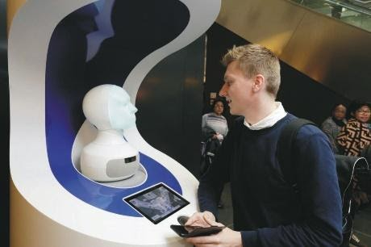 | Deutsche Bahn – FRAnny: is a robot concierge, built by Deutsche Bahn, deployed in the Frankfurt Airport. It is able to answer a wide range of questions ranging from identifying the correct gate, directing the way to places, and how to access Wi-Fi. In April 2018, Deutsche Bahn ran a pilot for a month under which the robot had 4400 passenger interactions (75% of which were rated positively by users). The trial was deemed
a success by DB management, and a more advanced version of the system was developed; this system is being piloted at Berlin central station, and trials has been conducted also at Fraport and Tokyo central station.
Selected global media coverage on Deutsche Bahn robot concierge:
EU start-ups: https://www.eu-startups.com/2020/02/10-promising-european-robotics-startups-to-watch-in-2020/?fbclid=IwAR3JZR2DIG18bP7bpehDHeHfK-WBnVPEJvC7trtp0lxVTdyz3GKPV0cFsBw
IEEE Spectrum: https://ieeexplore.ieee.org/document/8784113
Frankfurter Rundschau: https://www.fr.de/frankfurt/kuenstlichen-intelligenz-deutschen-bahn-12950674.html
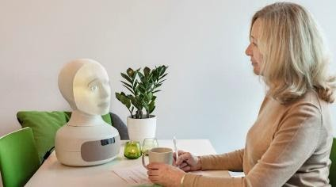 | Tengai – Unbiased Recruitment Robot: TNG Rekrytering, a Swedish recruitment agency specializing in unbiased recruitment, is partnering with Furhat Robotics on the development of the world's first unbiased recruiter robot. The vision behind the robot is to better analyze, understand and perform competency-based interviews and assessments
eliminating unconscious bias[6]. The first version of the robot recruiter was launched by TNG in May 2019.
Selected global media coverage on TENGAI Unbiased recruiter:
The Times: https://www.thetimes.co.uk/edition/world/robot-is-just-the-job-as-an-unbiased-recruiter-hnrsz9qzr
Recruiter, UK: https://www.recruiter.co.uk/news/2018/11/furhat-robot-aims-turns-turn-recruitment-bias-its-head
Dagens Nyheter: https://www.dn.se/ekonomi/snackade-med-en-robot-fick-nytt-jobb/
Sveriges radio: https://sverigesradio.se/sida/artikel.aspx?programid=103&artikel=7286017

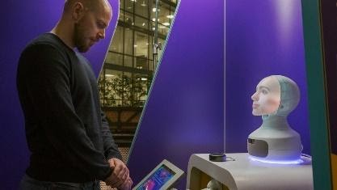 | Merck - Medical Screening: Together with MERCK Pharmaceuticals, Furhat has developed Petra, a medical screening robot. Petra will interview the user in order to discover signs of three of common, yet under-diagnosed diseases: diabetes, alcoholism and hypothyroidism. The MERCK robot is designed to be placed in public areas e.g.
shopping malls or train stations and was showcased at Epicenter in Stockholm in 2019.

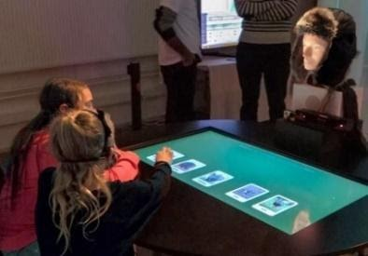 | Stockholms Stad – Robot Teaching Assistant: Furhat Robotics and Stockholms Stad collaborate on the use of social robots in schools. The aim of the project is to reduce the workload on teachers and find new ways for students to collaborate with each other. Furhat will be used as an interactive teaching assistant which can be customized by students with content such as presentations, lectures, Q&A’s and quiz games. First
pilots ran in two Stockholm schools in 2019.
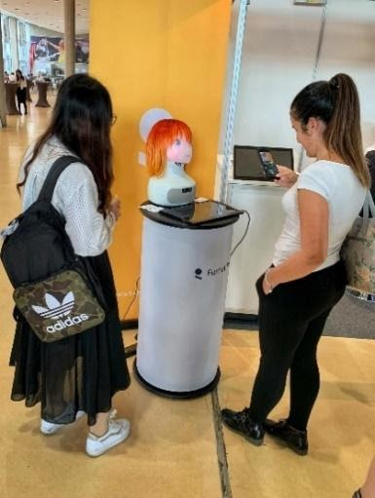 | Bandai Namco – Greeter for theme parks: Japanese game developer Bandi Namco (PAC-MAN, Tekken…) has done a pilot project with Furhat on building a greeter robot that can be deployed in theme parks or arcade halls. The robot was designed as a clone one of the company’s own characters, Mirai Komachi.
Selected global media coverage on Bandai Namco Mirai Komachi anime greeter robot:
Crunchyroll: https://www.crunchyroll.com/en-gb/anime-news/2019/08/21-1/swedish-robotics-company-teams-up-with-bandai-to-build-anime-girl
Techcrunch Japan: https://jp.techcrunch.com/2019/08/20/bandai-namco-research-furhat/
References to the Research
[1] Al Moubayed, S., Skantze, G., & Beskow, J. (2013). The Furhat Back-Projected Humanoid Head - Lip reading, Gaze and Multiparty Interaction. International Journal of Humanoid Robotics. 10(1).
[2] Skantze, G., Johansson, M., & Beskow, J. (2015). A Collaborative Human-robot Game as a Test-bed for Modelling Multi-party, Situated Interaction. In Proceedings of IVA. Delft, Netherlands.
[3] Al Moubayed, S., Edlund, J., & Beskow, J. (2012). Taming Mona Lisa: communicating gaze faithfully in 2D and 3D facial projections. ACM Transactions on Interactive Intelligent Systems, 1(2), 25.
[4] Skantze, G., & Al Moubayed, S. (2012). IrisTK: a statechart-based toolkit for multi-party face-to-face interaction. In Proceedings of ICMI. Santa Monica, CA.
[5] G. Skantze och M. Johansson, "Modelling situated human-robot interaction using IrisTK," i Proceedings of the SIGDIAL 2015 Conference, 2015, s. 165-167.

Appendix – Impact cases Dept. of Technology in Medicine and Health
Impact case 1: Novamia AB
The research of Chunliang Wang and Örjan Smedby concerning image segmentation methods resulted in a new company, Novamia AB, which owns patents for our methods and produces software products for Swedish and international Med-tech industry. The company currently has one full-time and two part-time employees.
Summary of the impact
In clinical medicine, there is a great need for image-based measurement tools to assess the degree of disease (imaging biomarkers). Often these require delineation of an anatomical structure (segmentation). Our group has developed and patented an automated segmentation method that is both accurate and fast enough for clinical use. It has been tested with image data from vessels, tumours and brain structures and shown good agreement with manual segmentation by experts. It has great potential for clinical use in early diagnosis, e.g. in cardiovascular or neurodegenerative disease, and for evaluation of therapy, e.g. in cancer. Recent research within our group has enabled us to update the patented method with the latest ML techniques.
The typical customers of Novamia are Med-tech companies within medical imaging, pre-surgical planning or implant design. So far, these customers have been responsible for the regulatory procedure as well as for marketing products to end-users among healthcare providers (medical practitioners).
The Mialab software, which includes our algorithms, is made freely available to academic users for research purposes, whereas an agreement with Novamia is required for commercialization or clinical use.
Underpinning research
One of the most traditionally well-renowned algorithms for segmentation of medical image data is the level-set algorithm, which produces very accurate results, but has a high price in terms of computation time, at least when applied to 3D (voxel) data. Chunliang Wang’s invention of level-set based segmentation using coherent propagation (Wang 2014) increased the speed of the algorithm by 30–100 times, thus making it useful for time-critical clinical applications. In competitive comparisons with alternative methods where Chunliang Wang has taken part, our method has been among the most successful ones for several medical image segmentation tasks.
During the last 3–4 years, the field of medical image processing has undergone a major paradigm shift by the introduction of deep learning and related ML techniques. Recent research in our group has integrated the level-set approach with these modern methods as well as with shape modelling methods, with encouraging results. We have also applied this approach to new problems in basic biomedical research (Brusini 2018).
Publications
Wang C, Frimmel H, Smedby Ö. Fast level-set based image segmentation using coherent propagation. Medical Physics 2014;41(7):073501. https://dx.doi.org/10.1118/1.4881315 (37 citations)
Bernard O, Bosch JG, Heyde B, et al. Standardized Evaluation System for Left Ventricular Segmentation Algorithms in 3D Echocardiography. IEEE Trans Med Imaging. 2016;35(4):967-77. http://dx.doi.org/10.1109/tmi.2015.2503890 (60 citations)
Jimenez-del-Toro O, Müller H, Krenn M, et al. Cloud-Based Evaluation of Anatomical Structure Segmentation and Landmark Detection Algorithms: VISCERAL Anatomy Benchmarks. IEEE Transactions on Medical Imaging. 2016;35(11):2459-75. https://dx.doi.org/10.1109/TMI.2016.2578680 (123 citations)
Wang C, Smedby Ö. Automatic Whole Heart Segmentation Using Deep Learning and Shape Context. In: Pop M, et al., editors. Statistical Atlases and Computational Models of the Heart ACDC and MMWHS Challenges; Cham: Springer International Publishing; 2018. p. 242-9. https://dx.doi.org/10.1007/978-3-319-75541-0_26 (29 citations)
Brusini I, Carneiro M, Wang CL, et al. Changes in brain architecture are consistent with altered fear processing in domestic rabbits. Proc Natl Acad Sci U.S.A. 2018;115(28):7380-7385. https://dx.doi.org/10.1073/pnas.1801024115 (34 citations)
Bakas S, Reyes M, Jakab A, et al. Identifying the best ML algorithms for brain tumor segmentation, progression assessment, and overall survival prediction in the BRATS challenge. arXiv preprint arXiv:181102629. 2018. https://arxiv.org/pdf/1811.02629 (453 citations)
Zhuang X, Li L, Payer C, et al. Evaluation of Algorithms for Multi-Modality Whole Heart Segmentation: An Open-Access Grand Challenge. Medical Image Analysis 2019;58:101537. https://dx.doi.org/10.1016/j.media.2019.101537 (64 citations)
Sources to corroborate the impact
- The Novamia company is presented at http://www.novamia.com.
- Mialab software downloads and instructional movies are available at http://mialab.org.
- The research on imaging biomarkers and its commercialization in Novamia AB were included in the “100-list” of the Royal Swedish Academy of Engineering Sciences (IVA) in 2019 (https://www.iva.se/projekt/research2business/100listan)

Impact Case 2. New Biomechanical Tools for Expert Advice in Court Cases of Shaken Baby Syndrome
Summary of the impact
Shaken baby syndrome (SBS)/Abusive head trauma (AHT) is defined as violent shaking only or combined with blunt impact, causing severe head injuries in infants. It’s a sad and unfortunate reality that AHT continues to be a global problem and is still the leading cause of death in children < 1 year old, with victims’ median age being 2.2 months. Diagnosing whether the observed injuries are caused by abuse or other causes is a challenge within both the medical and the legal communities. Misdiagnosis can lead to severe consequences: The infant may be subjected to further maltreatment even death, or an innocent family is broken apart with the child separated from parents accompanied by a parent/caretaker being wrongfully convicted to prison. A recent SVT “Uppdrag granskning Skakvåldet” (Feb 24 2021) reports the dilemmas of SBS diagnosis. https://www.svt.se/nyheter/granskning/ug/shaken-baby-syndrome-fran-sanning-till-ifragasatt-diagnos.
One central question to be answered is a biomechanical question: can the described history explain the observed injuries? Biomechanical models accounting for subject-specific head geometry and case-specific environment allow providing evidence for case-specific investigations. We reconstructed three well-documented suspected abuse cases using subject-specific FE head models. The results show that the skull fracture patterns in all cases of suspected abuse could be explained by the described accidental fall history, demonstrating the inherent potential of FE analysis for providing biomechanical evidence to aid forensic investigations. Increased knowledge of injury mechanisms in children may have enormous medico-legal implications world-wide to avoid misdiagnosis/overdiagnosis of SBS.
Underpinning research
- Reconstruction of two suspected abuse cases using subject-specific FE head models. Li X, Sandler H, Kleiven S (2019). Infant skull fractures: Accident or abuse?: Evidences from biomechanical analysis using finite element head models. Forensic Sci Int 294:173-82. Citations: 15.
- Detailed and state-of-the-art infant head models of different ages. Li X, Sandler H, Kleiven S (2017). The importance of nonlinear tissue modelling in finite element simulations of infant head impacts. Biomech Model Mechan 16 (3):823-40. One of the "10 Most Downloaded Journal Articles" among all papers published in Springer's mechanics journals in 2017. Citations: 25.
- We obtained two consecutive research funding from Swedish Research Council (Vetenskapsrådet). BioLEAP (2016-2120, nr. 2016-04203) and BioSAVE (2021-2024, nr. 2020-04724), which allow us to perform future research on investigating shaken injury mechanisms, developing reliable biomechanical tools to provide evidence for differential diagnosis of SBS.
- Demo website to raise public awareness of shaken baby syndrome for prevention. https://www.biosave.org/ (to be further developed)
Sources to corroborate the impact
- Expert advice in court cases with case-specific biomechanical evidence.
- Report supported legal case investigation. Li X and Kleiven S (2019). Report to Norwegian Layer regarding a forensic investigation of a 13 month-old infant skull fracture case using biomechanical simulations titled “Biomechanical evaluation of head impacts for infants – Complementary analysis based on subject’s CT images”.
- Report supported legal case investigation. Li X and Kleiven S (2013). Report to police regarding a forensic investigation of an infant skull fracture case using biomechanical simulations titled “Analys av skadeförlopp i samband med skallbensfraktur för spädbarn”.
- The research topic is among the “Priority research topics” stated in one Swedish SBU report: “Differential diagnosis…needs to be studied; Refined biomechanical models…improved understanding of traumatic shaking”. SBU assessment — Report (2016) Swedish Agency for Health Technology Assessment and Assessment of Social Services (SBU). Traumatic shaking: the role of the triad in medical investigations suspected traumatic shaking – a systematic review.

3. The risk management tool RAMP and the RAMP package
Summary of the Impact
Poor work environments lead to elevated risks for Musculoskeletal disorders, MSDs, which in turn have negative consequences for employees injured, for companies (e.g. reduced quality and productivity) and for societies (e.g. increased costs for healthcare). The RAMP tool (Risk Assessment and Manage-ment tool for manual handling Proactively) was developed to meet calls from industry for a free, systematic, globally applicable risk assessment and risk management tool to support companies in reducing MSDs. Identified beneficiaries are found at all these levels. With the RAMP website (ramp.proj.kth.se) and three massive open online courses (MOOCs) on the tool usage, it forms the RAMP Package [1], free of charge, deployed worldwide and in use in many factories. RAMP is the only MSD risk management tool and the only MSD tool supporting the whole systematic risk management process (ISO 31000).
The RAMP tool has been spread via the RAMP website to over 100 countries (over 3000 downloads). The RAMP MOOCs have had over 3500 learners from more than 135 countries, with approximately half from low- & middle-income countries and a substantial part having at the most a high school education. The RAMP Website has had thousands of visitors since the launch 2017. In a study among potential RAMP tool users [1] over 90 % of the participants agreed that RAMP is usable for risk assessment, risk management, for communication as well as a decision base for risk reduction measures. Current analyses of a survey among all who downloaded the RAMP tool during the first 28 months (Kluy et al., manuscript) show that RAMP has mainly been used in the manufacturing, health, care and OSH consulting sectors. Around half of the respondents’ state that they use the tool and about 1/3 that they plan to use it. Over 70 % agree to that using RAMP has led to a better physical work environment, to better organizational and social climate, to a higher percentage of jobs at low risk and higher productivity. At least 80 % agree to that RAMP has met their expectations, is “extremely useful”, is easy to use and has led to better awareness and understanding of MSD risks in the organisations. RAMP is used as the standard method in a growing number of companies, e.g. as a global standard method by e.g. Scania, as well as the standard method used by Avonova, one of the leading OSH companies in Sweden and recommended by the Swedish Work Environment Authority. Scania has reported higher number of jobs at low risk, reduced sick leave and improved quality, attributed to RAMP. Another example is GKN Driveline, who has reported, beside improved work environment, also using RAMP as criteria method with equipment providers to secure good work environment design in jobs where new equipment is used. The RAMP Package has been spread using a range of activates in its dissemination strategy, e.g. the large network the researches have among researchers, industry, universities and authorities, and through research publications, conferences, education and workshops.
Underpinning Research
The RAMP tool is based on over 250 research publications, mainly from the epidemiological, biomechanical, physiological and psychophysical domains as well as on assessment criteria from Global and European Ergonomics standards, provision from the Swedish Work Environment Authority and to some extent on consensus in the project’s expert group. RAMP was iteratively developed by researchers at KTH’s Ergonomics Division 2010-2017 in close collaboration with practitioners and other researchers. Over 80 practitioners have contributed in the development by providing feedback. In the development process, also usability, managerial, decision making, risk management literature and experts have been consulted. The RAMP tool has been evaluated having good/acceptable reliability, validity and usability and is the most comprehensive tool addressing relevant MSD risk factors. To enable flexible scalable learning on the tool use, three RAMP MOOCs were developed in collaboration with the KTH MOOC Team 2017-2019, using a multi-disciplinary collaborative-model. Authentic examples from several continents are included, e.g. from Sweden, Estonia, Iran, Botswana and Canada.
Publications include: [1] Rose, L M, Eklund, J, Nord Nilsson, L, Barman, L, Lind C M (2020) The RAMP package for MSD risk management – A tool and support for actions. Applied Ergonomics, 8, July 2020, 103101 - 4 citations ; [2] Lind, C M, Forsman M & Rose L M (2020) Development and evaluation of RAMP II - a practitioner’s tool for assessing musculoskeletal disorder risk factors in industrial manual handling. Ergonomics, 63(4): 477-504 - 10 citations; [3] Lind, C M, Forsman M & Rose L M (2019) Development and evaluation of RAMP I - A practitioner’s tool for screening of musculoskeletal disorder risk factors in manual handling. Int. Journal of Occupational Safety and Ergonomics, 25(5): 165-180 - 14 citations; [4] Lind, C M (2018) Pushing and pulling: An assessment tool for occupational health and safety practitioners. Int. Journal of Occupational Safety and Ergonomics, 24(1), pp. 14-26 - 13 citations; [5] Lind C & Rose, L (2016) Shifting to proactive risk management: Risk communication using the RAMP tool. Agronomy Research, 14(2): 513-524- 9 citations; [6] Lind, C (2018) Assessment and design of industrial manual handling to reduce physical ergonomics hazards: – use and development of assessment tools. Doctoral Thesis, KTH - 20 citations.
Details of the Impact
The dissemination of the RAMP tool and package has so far lead to 1 Doctoral Thesis, 5 articles in international peer-reviewed research journals, 19 international conference contributions, whereof 2 key-note presentations and numerous national conferences, seminars, etc., whereof about half a dozen as specially invited or key note presentations. In addition, it has been analysed in 6 MSc Theses. Over a dozen training workshops/courses on the RAMP use have been held at universities, municipalities, companies, authorities, etc. in Canada, Estonia, Botswana and Sweden. In addition RAMP has been presented via numerous meetings (e.g. at ministries), national conferences, and popular-style articles (e.g. in industrial sector magazines). One example is that RAMP was awarded a place on the Royal Swedish Academy of Engineering Sciences (IVA) Research-to-Business 100-list, and a presentation at IVA’s R2B summit 2019 lead to e.g. participation twice in a scientific programme on Swedish National radio, which in turn led to other ripple effects. The latest published research paper [1] was on the journals top list over most read publications within the 90 first days.
RAMP has also gained much attention from research groups around the world, including at University of Berkley, USA, Botho University in Botswana, Estonian University of Life Sciences and Ryerson University in Canada. Collaboration with these is ongoing, also in further development of the RAMP in new R&D projects, e.g. enhancing the tools application range and including KPIs, and in projects using RAMP-criteria in the development of measure-based risk assessment tools using smart work-wear. Feedback from user companies also states that RAMP facilitates the systematic work to reduce risky working tasks (assess, prioritize, act, follow up), provides a good overview of assessments and need for actions, facilitates the dissemination of good solutions, and stimulates co-operation and knowledge.
Sources to corroborate the impact
[1] Video about RAMP from AFA Insurance https://www.ramp.proj.kth.se/ramp-risk-management-assessment-tool-for-manual-handling-proactively-1.730128; [2] Avonova:”"Our mission is to support and inspire organisations to work for sustainable work environments. We call this the blue level, where people and systems feel and perform better, live longer and have more energy. One recurring need of our clients is to improve the physical environment and thereby reduce the ergonomic risks and their negative consequences. RAMP is a useful tool in our work detecting and reducing these risks. It also provides digital tools to visualize and communicate results and action plans to the companies we support. The RAMP MOOC’s and the Professional Certificate is an asset for both our staff and for our customer companies." (Unit Manager Claudia Noueched, Claudia.Noueched@avonova.se). [3] Ryerson University, Toronto: Professor Patrick Neumann: pneumann@ryerson.ca), [4] Scania: Ergonomist Lars Samuelson, lars.samuelsson@scania.com.
Impact Case 4. A new integrative strategy for Mental Health and Wellbeing: Region Stockholm.
Summary of the impact
Region Stockholm is the administration responsible for a.o. all health care and public transport in the larger Stockholm region (2.5 million inhabitants). Since 2019, the region has the mandate of a real independent region in Sweden, thereby also taking on roles to develop the metropolitan and rural areas, economic prosperity, etc.
The leading politicians of the region expressed their desire for a new policy for mental health and wellbeing. In 2018, Meijer was asked to support this strategy with systems methods.
On March 9th, 2021, the Health and Health Care Committee unanimously decided on the newly formulated policy, in the format of a so-called Integrated Governance policy. The policy will be the foundation for a mandatory perspective on mental health a wellbeing as part of all the administrations and companies that are part of Region Stockholm, as well as its subcontractors and subsidiaries. The policy is now out for comments, and will come up in the regional parliament in November 2021 as part of the budget proposal for 2022.
The policy fits with developments like Thrive London / Amsterdam / New York, and the wellbeing budget in New Zealand, but is (by far) the most systematic and far-reaching in terms of integration with regular planning processes.
Meijer and his team have been part of the preparation phase, organizing workshops, making systems models, reviewing evidence, and integrating with a pilot project with 3 municipalities (Haninge, Upplands Väsby, Norrtälje).
All figures and systemic logic are the result of the close collaboration between KTH, Stockholm University (prof. Petra Lindfors, Psychology) and the team at Region Stockholm.
Underpinning research
Meijer and his group have built the engagement on 3 sources of earlier research:
Whole-systems participatory approaches to innovation, as developed earlier for the railway sector. (a.o. Meijer, S. (2015). The Power of Sponges Comparing High-Tech and Low-Tech Gaming for Innovation. Simulation & Gaming, 46(5), 512–535. Citations: 42)
Hybrid simulation approaches, particularly agent-based, of sociotechnical systems (o.a. Nilesh Anand, David Meijer, J.H.R. van Duin, Lóránt Tavasszy, Sebastiaan Meijer (2016) Validation of an agent based model using a participatory simulation gaming approach: The case of city logistics, Transportation Research Part C: Emerging Technologies, Volume 71, Pages 489-499, ISSN 0968-090X, https://doi.org/10.1016/j.trc.2016.08.002.(citations: 28)
The role of engaging humans in engineering systems (o.a. Grogan, P.T. and Meijer, S.A. (2017), Gaming Methods in Engineering Systems Research. Syst Eng, 20: 542-552. https://doi.org/10.1002/sys.21409. Citations: 20)
A set of publications results from this work, of which some have been published already:
Moustaid, E., Kornevs, M., Lindencrona, F. et al. A System of Systems of Mental Health in Cities, Digging Deep into the Origins of Complexity. Adm Policy Ment Health 47, 961–971 (2020). https://doi.org/10.1007/s10488-020-01035-0.
Moustaid E., M. Kornevs and S. Meijer, "Sensitivity Analysis of Policy Options for Urban Mental Health Using System Dynamics and Fuzzy Cognitive Maps," 2019 Winter Simulation Conference (WSC), National Harbor, MD, USA, 2019, pp. 1055-1066, doi: 10.1109/WSC40007.2019.9004736.
Sources to corroborate the impact
A press release immediately after the political decision can be found here: (in Swedish) https://vardgivarguiden.se/nyheter/2021/mars/strategi-for-psykisk-halsa-och-valbefinnande/
Contact points in Region Stockholm, as reference: Susanne Nordling (Environmental Party, Lead politician for Mental Health), Fredrik Lindencrona (Program leader policy development)
And enthusiast LinkedIn posts by Norrtälje public servants: (in Swedish) https://www.linkedin.com/posts/sofie-ahlholm-a4697a56_psykiskhaeulsa-uppdragpsykiskhaeulsa-folkhaeulsopilot-activity-6718098874956886016-Qamh

https://www.scania.com/group/en/home/newsroom/news/2017/scania-takes-part-in-multi-brand-platooning-project.html
https://platooningensemble.eu/
The letter can be found here: https://docs.google.com/document/d/15pEKvnui48Bnst9nDffSWpLTiEPBwrIq4YENf9TdDe0/edit

