 | REPort |  | Date |  | Place
 | Periodic review of research 2012-2019 |  | 2021-05-10 |  | Stockholm
 | Created by:
 | Panel 6

Panel 6 Energy and Electrical Engineering
  - Research Assessment Exercise (RAE) 2021,
self-evaluation
Coordinator: Professor Gunnar Malm
Vice-coordinators:
Professor Viktoria Martin,
Dr. Staffan Norrga

Organisation

Organisation schedule
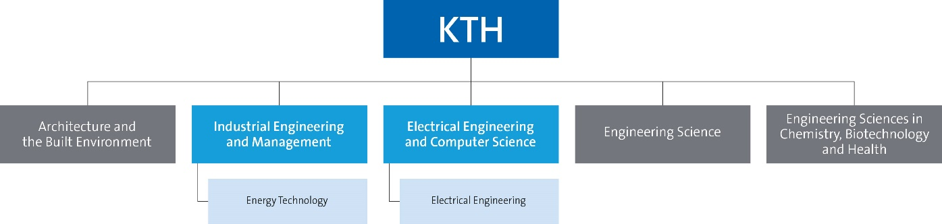
Figure 1: Panel’s position in KTH’s organisation

Involved units
List involved:
- School of Industrial Engineering and Management, Professor Pär Jönsson
  - Department of Energy Technology, Professor Björn Laumert
    - Divisions of Applied Thermodynamics and Refrigeration (Björn Palm)
    - Energy Systems (Viktoria Martin)
    - Heat and Power Technology (Andrew Martin)
- School of Electrical Engineering and Computer Science, Professor Sonja Berlijn
  - Department of Electrical Engineering, Professor Hans Edin
    - Divisions of Electronics and Embedded Systems (Carl-Mikael Zetterling)
    - Electromagnetic Engineering (Martin Norgren)
    - Electric Power and Energy Systems (Lars Nordström)
    - Fusion Plasma Physics (Per Brunsell)
    - Space and Plasma Physics (Andris Vaivads)

Table of Contents
Organisation 2
Organisation schedule 2
Involved units 2
Part A: Introduction of panel 4
Description of the research field of the departments included in the research panel 4
Description of the self-evaluation process for the research panel 4
Identified research panel synergies 5
Part B: Report for each department 6
Department of Energy Technology 8
1. Overall analysis and conclusion; strengths and development areas 8
2. Research profile 11
3. Viability 21
4. Strategies and organisation 28
5. Interaction between research and teaching at all three levels (BSc, MSc, PhD) of education 32
6 Impact and engagement in society 35
Department of Electrical Engineering 42
1. Overall analysis and conclusion; strengths and development areas 42
2. Research profile 44
3. Viability 59
4. Strategies and organisation 65
5. Interaction between research and teaching at all three levels (BSc, MSc, PhD) of education 68
6. Impact and engagement in society 70
Appendix 1: Impact cases 73
1. Enabling electricity access to the ca. 800 million people still lacking it 75
2. A global energy supply model infrastructure 78
3. Turbomachinery & Propulsion 81
4. Heat pumping technologies 84
5. KTH Live-in Lab – Testbeds for accelerated innovation 87
6. High-impact research on solar energy 90
7. Impact on first wall construction and cost reduction in future fusion reactors 92
8. Geodesic lens antennas for space applications 95
9. Electrical Impedance Spectroscopy ASIC for Skin Cancer Detection 96
10. Dynamic space processes of potential importance to space weather 98
11. Large scale integration of wind and solar power. A 100% renewable Swedish power system. 100
12. Startup Company SCiBreak AB 103

Part A: Introduction of panel

Description of the research field of the departments included in the research panel
The research field of the Department of Electrical Engineering spans over many areas within electrical engineering and electronics. Electronics spans over a very broad range of basic topics including semiconductor device technology and circuits to systems integration and embedded systems implementation. Research in the field of electromagnetics cover many aspects from antennas, advanced material modelling to design, modelling and diagnostics of electric power grid components. The power system as a whole ranges from system aspects like market mechanisms, integration of renewable power sources, power system stability aspects to more specific technology development such as power electronics, HVDC converters and electrical machines and drives with recent applications in electric vehicles. One division contributes to the realization of magnetic confinement fusion as a future sustainable power source. A further research area within the department is space plasma physics and complex plasma.
The Department of Energy Technology is conducting research and providing education for the transformation of the energy system towards a fully sustainable future with focus on environment, affordability and availability to everyone. The department has three divisions focusing on heat and power technology, thermodynamics and refrigeration and system analysis respectively. We cover all levels in technology readiness, from laboratory tests, over component and demonstration tests, towards marked introduction and retrofitting. Strength areas are system analysis and system optimization from housing level up to the scale of nation and continents; techno-economic analysis of energy technologies and infrastructure; solar technology development; heat pumps; energy storage; turbomachinery; and biomass applications. The department has a strong collaboration with industries, institutional and private stakeholders so that technologies actually are implemented and serve society.

Description of the self-evaluation process for the research panel

The self-evaluation process for both included departments started from internal workshops where SWOT analyses were compiled. This work was started late 2019 or early 2020. From February 2020 and onwards, the coordinator team assumed a project leader role and handled all practical matters around the self-evaluation report compilation and management of deadlines. The department heads were responsible for the report content and further delegation of writing. The coordinators handled data analyses and interacted with the RAE-team at KTH.
Internal feedback on the 2020 draft report was received in a series of workshops, hosted by the dean of faculty and the RAE team in fall 2020. This feedback has been incorporated in our 2021 reports and discussed in a series of meetings at panel level.
In 2021, the previous deputy coordinator Malm took the main coordinator role and coordinators Norrga and Martin continued in deputy roles.
For 2021 the interaction with panels 4 (Computer Science) and 5 (Intelligent Systems and Biomedical Systems) was emphasized since these panels are also hosted mainly at the EECS school. The panel coordinators were in close contact during the process and took part in some joint workshops around e.g., impact and publication strategy. The new school head/management at EECS took an active interest in topics such as the impact from our research. For 2021, we based the report to a significant extent on the 2020 draft while the selection and presentation of impact cases was revisited at both department and overall panel level.

Identified research panel synergies
The common research fields within the panel are energy systems, energy-related technologies and electric power engineering. Both departments in the panel are actively involved in the KTH Energy Platform. During the period 2010-present, both departments were highly involved in the development of the EIT Knowledge and Innovation Community “InnoEnergy”. Leading to a larger number of innovation projects, a PhD school and coordination of the master programs SELECT and SENSE. Today the remaining InnoEnergy activities are mainly in education. Other research fields, within the panel, electronics and embedded systems, have clear synergies to research at KTH in Panels 4 and 5, see also above.

We identified several opportunities for collaboration among the departments of the during the RAE work. Energy system analyses, integrating infrastructure for heat, cold, gas and electric power as well as various types of energy storage, in many cases require a holistic approach.

Part B: Report for each department

Department of Energy Technology
Self-evaluation
Head of Department: Professor Björn Laumert

Included divisions:

Division of Applied Thermodynamics and Refrigeration
Division of Energy Systems
Division of Heat and Power Technology

Department of Energy Technology

1. Overall analysis and conclusion; strengths and development areas

a. Limited SWOT-analysis
Figure 1 below presents a full SWOT table that has been derived as a summary of the latest strategy workshop of the department’s faculty. In the following part, we will concentrate on strength and weaknesses only with the two focal areas 1. Research and 2. Organization.
 | Strengths | Weaknesses
Research | - We cover research from basic, over technology to system perspective and we are active in the whole energy value chain  - We have a unique laboratory infrastructure with world leading facilities in strength areas  - We have developed unique modelling tools and have access to data that usually is industry proprietary  - We work multidisciplinary including social science and economics  - We lead several research centres at KTH | - We have high investments in terms of research infrastructure in relatively mature technologies. Makes us vulnerable under ongoing technology shifts.  - Lack of synchronization and collaboration with sister departments within KTH  - We have low visibility as Energy Technology Department in the national and international debate and research arena
Organisation | - We have established a well-organized management structure of department  - We have a strong network internally and to outside stakeholders  - We have established strong long term industry collaborations | - We can lack of routines for knowledge transfer and have difficulties to manage when key personnel leaves  - We are understaffed in faculty positions which makes us vulnerable keeping knowledge and quality over time  - The administrative effort for faculty is too high and negatively impacts time spent on research and teaching  - A skewed gender distribution in our faculty with only one female professor and no female in the tenure track
Figure 1 SWOT-Analysis KTH Department of Energy Technology

Strengths in R&D:
The department has a capacity that covers the whole range of research and development in the field of energy technology from basic research on component design and development to applied technology demonstration, and up to systems analysis and policy derivation. This means that our basic research is actually implemented in real applications and has societal impact over time. At the same time, the systems analysis gives us feedback on where to focus our research efforts. This broad research approach is facilitated by our strong laboratory infrastructure encompassing heat transfer, heat pumps, combustion, turbomachinery, wind tunnels, storage, solar power, biofuels and integrated system test-rigs, climatic chambers and instruments like micro DSC, GC (gas chromatograph), TC (thermal conductivity), and high speed IR. Through the Live-in-Lab, we have access to a real-life test lab for buildings-related research. We have also developed a significant modelling infrastructure for techno-economic analysis, life cycle analysis, mechanical, heat pumps, refrigeration systems, heat transfer and fluid dynamics as well as geo-spatial system analysis.
The department has a number of strong focus areas comprising heat pumps and refrigeration, turbomachinery, biofuels, hot and cold storage, energy in the built environment. Also, we conduct energy systems analysis and optimization with world leading researchers and significant impact with high-level publications including in Nature and Energy. This research is embedded in a strong international network exemplified by our role as data providers and advisors to the World Bank and UN programs.

Strength in Organization:
The department consists of three units (divisions) -- Heat and Power Technology, Applied Thermodynamics and Refrigeration and Energy Systems -- that share the research foci with established research leaders in each unit. Faculty involvement and cooperation within the three divisions is good and well developed. We insure the faculty involvement at the Department level regarding strategy and future development through common strategy days with mixed group workshops and follow-up twice a year. This provides a good process and organization for managing strategies for new research foci and the identification of recruitment needs. The dominant research funding at the department is from external sources shared between national and international agency funding, see section 3a. The funding is often coupled to industrial or societal involvement and our network in this respect is strong. Our department has been adaptive to the changing priorities in the field and to its stakeholders. A new research group has successfully been built in the field of energy system analysis, and the activities in the field of energy for the built environment has been extended, now including a new center (Live-in-Lab). When it comes to support systems one of our strengths is the in-house workshops that have the capacity to build prototypes and provide instrumentation for our laboratories.

Weakness in Research:
With limits in size and shared/competing research interests between our department and sister departments in other KTH schools (e.g., the Departmens of Electrical Engineering, Chemical Engineering, and Sustainable Development, Environmental Science and Engineering) we need to better synchronize our research and activities with other departments to cover all-important topics of energy technology for the future. We have a history of strong areas in now mature technologies such as turbomachinery that still play an important role in the energy system but that might decline in importance in the future. In the field of industrial turbomachinery funding levels have decreased significantly nationally. We should also consider the possibility of cooperating with other departments on topics where our expertise could contribute to increase the quality of the research, e.g. concerning ground transport, electric applications, electro-chemical storage and digitalization of the energy system. We are in need to formulate our own goals and implementation strategy for our participation within these fields.

Weakness in organization:
A general point of concern that is true for all academic organizations is to find the right balance between individual freedom of research and academic career development, and the strength through group collaboration and sharing of knowledge and resources. At our department, the strategy days have shown that the faculty feels a lack of collaboration especially over division boundaries. This results in non-realization of potential synergies such as for example development of common modelling tools and sharing of data, sharing of industrial networks and speaking with one voice to external partners, among other things. This also hinders the build-up of an Energy Technology institute brand and instead every research group is branding their own names. A common voice would give us significantly more impact especially in the national agenda setting for policy makers, funding bodies and energy market regulators. We should also be more open to cooperation with groups outside of the department in order to create multi- or trans-disciplinary projects.
We also have weaknesses regarding faculty structure and gender balances. More details will be addressed in the corresponding chapters below.
Development:
Main development areas are
- On the research side, the department will continue the initiated strategic dialogue within the department and implement the findings in our department strategy and development plan. We have now identified six strategic research areas per division and these will be the basis for our funding efforts and staff recruitment.
- We need to implement a continuous strategy work process to avoid the mature technology traps and to adopt to the fast pace that the energy system changes now both from a technology point of view, but also from a societal point of view. This shall be done through our established workshops that we already have established with our faculty and shall be connected to a yearly updated and implemented development plan
- When it comes to group interaction, we need to focus on our internal culture and work for an open and integrating culture where we allow for personal success and development but at the same time emphasize the importance of collaboration and generosity towards others when it comes to access to information, participation in projects and sharing of experience and networks.
- Faculty and staffing is a focus development area where we need to switch competence from researcher positions to tenure track positions. And we need to improve our gender imbalance.
- We need to implement a dedicated communications and branding plan in order to increase our visibility as the Department of Energy Technology in the national and international research arena.

b. Summary statement on contributions of department on impact, infrastructure and sustainable development
The research at the Department of Energy Technology is focused on topics related to the transition of the energy system towards a sustainable future. As global warming is one important threat to society during the coming decades, it is obvious that the research within this field is expected to have a large impact on society. Several examples of this impact are given in sections 6a Relevance of research to society at large, 6c Sustainability and the United Nations’ Sustainable Development Goals (SDS), and 6d Impact cases. The main cases are related to:
- Enabling electricity access in developing countries through the use of the department’s widely used open source code OnSSET
- Water, energy and land planning in developing countries through the use of the department’s open source code OSe MOSYS
- Integration of solar power and heat pumps in the energy system
- Development of components and systems for Concentrating Solar Power
- Development of more reliable and efficient turbomachinery
- KTH Live-in Lab, a cross-disciplinary platform for accelerated innovation in the real-estate sector
As one of few at KTH, the Department of Energy Technology has been able to maintain most of the laboratory infrastructure from decades of research. These facilities include both the possibility to design and construct temporary experimental setups in the complete field of thermal engineering, and the possibility to use permanent testbeds and facilities. Three examples of permanent infrastructure are:
- The turbomachinery lab, which is considered to be world-class and has been used in several EU-projects
- The solar lab, unique for Europe, used for research related to the receivers of concentrating solar power,
- The climate chambers and related equipment. The chambers are frequently used for creating well-defined environments for testing heat pumps, refrigeration equipment, heat exchangers, energy storage equipment and insulation materials, windows etc. which can be part of a building’s envelope
The department is also performing other types of research for which the laboratory is essential. Research on phase change materials and heat transfer fluids require equipment for determining properties such as specific heat, heat of fusion, thermal conductivity, density, viscosity, meting point etc. High-class equipment for determining these properties are available within the lab. For temporary tests, the department can, with the help of its skilled staff, design, build and commission test rigs with calibrated sensors for temperature, pressure and flow. Such rigs can be used for evaluating new designs of heat exchangers, heat pumping equipment, and heat engines.

2. Research profile

a. General information of the department
The Department of Energy Technology is one of seven departments in the School of Industrial Technology and Management. The department is linked to the Energy Platform that is representing KTH energy research across schools, and is especially interlinked with the Departments of Electrical Engineering, Chemical Engineering, and Sustainable Development, Environmental Science and Engineering. The interaction between these “sister departments“ from different schools is generally speaking rather low.
The Department of Energy Technology has the ambition to provide education and perform research in diverse fields of energy technology, to facilitate access to sustainable energy in Sweden and the world. We do that in close collaboration with societal partners such as policy makers, governing bodies, national and international institutes and agencies, national and international academic collaborations as well as industrial players in Sweden and around the world. The department consists in total of around 100 researchers and teachers including PhD students and is organized in three units (divisions). The three divisions have been formed to facilitate thematic research collaboration, provide critical mass to research groups, and to facilitate line administration.
As the energy system is transforming, the Department of Energy Technology is evolving and covers today a wider range of topics compared to the last RAE. The system perspective has become an important viewpoint and forces us to collaborate more across the divisions. New management processes, such as the department wide bi-yearly strategy workshops are aiming to facilitate associated change processes.

b. Central research questions and themes, knowledge gaps addressed, main research activities
The department of Energy Technology conducts research that, from an overall perspective, is fundamental for the sustainable transition of the energy sector to sustainability. This work is, from a topical point of view, organized across three divisions:
- Applied Thermodynamics and Refrigeration (ETT), where the focus is on energy transformations in the built environment. The research targets a wide variety of applications, from users and energy flows in cities and buildings, to the design and evaluation of system components, to fluid and material properties. The division has a particular competence in heat pump technologies and refrigeration, and conducts research in its diverse experimental facility, as well as through system and CFD model development.
- Energy Systems (ES), where a broad system perspective is used to investigate energy technologies and innovation with policies for sustainable development. Methods developed include open-source optimization modelling, for the planning of least-cost electrification in developing regions, and integrated climate-land-energy-water (CLEWs) analysis for applications at city, regional, country and global scales.
- Heat and Power Technology (HPT), where research encompasses the analysis and design of critical components and systems for harnessing renewable energy (solar, wind, and biomass) in providing sustainable electricity, heat, cooling, pure water, and other energy services to single households up to entire cities or regions. Renewable energy sources along with improvements in energy efficiency drive the development for innovations in transportation on roads and in air and space. Much of our research takes place experimentally in world-class laboratory facilities.
Typically, the research work is conducted within sub-groups at each division, such that a group leader (a PhD qualified senior researcher being Professor, Associate Professor, Assistant Professor, or Researcher) works with a varying number of postdocs and PhD students. Collaboration between research groups is encouraged, but presently not developed to the extent desired (see minor SWOT). For the department’s overall research output, within and across the divisions, the following research questions have been formulated:
- How to speed up the adoption of low emission technologies with policy, innovation and business models?
- How to integrate large shares of renewable energy in supply?
- How energy systems affect, and are affected by other sectors and topics? (e.g., physical connection climate, land, water; across scales – households, cities, regions, nations; circular economy and inequalities).
- How will artificial intelligence and cyber security affect future energy systems, and potentially aid the transformation towards sustainability?
- How to use models with a high spatial and temporal resolution for understanding energy systems?
All of the above research questions benefit to a large extent from multidisciplinary relations and collaborations. Within our department, most researchers have engineering backgrounds but from a variety of fields. We thrive on forming collaborations with our extensive network of external actors (academic, industrial, government, etc.) with a wide range of expertise and experience.
For our research, gender aspects should be considered from two perspectives: i) its importance for the team composition; and ii) its importance for the research questions considered. For the team composition, gender issues must be addressed until there is a near 50/50 percentage representation among professors, senior researchers, and PhD students. This is because only then can we be sure that we have attracted available talent to the best of our potential. In order to be able to accomplish that we need to attract more female students to MSc studies and applicants to our positions. At present, this is not the case and further addressed under item 3 c and d. For our research questions, gender is not specifically considered at present. However, it is part of the UN’s sustainable development goals and we have many opportunities to develop the inclusion of gender aspects in future projects, e.g. by considering methods for more inclusive energy planning and decision-making processes; as well as in gender aspects in design of technologies. The transformation of energy systems towards sustainability requires, in addition to technical and economic considerations, the understanding of for whom we are transforming the system and who has been part of forming the knowledge based that we use for suggesting pathways of transformation.
Finally, some recent, concrete examples of research questions addressed in our work are:
- Related to Sustainable Energy Access for All
  - What metrics are appropriate for supporting energy access-and-use planning and how can techno-economic models support national strategies?
- Related to Renewable Energy Deployment in the EU
  - What are the key policy drivers of renewable energy deployment in the EU, and to what extent can flexibility through energy storage and cross-border interconnectors contribute to achieving the EU renewable energy targets?
- Related to Synthetic Liquid Fuels Production
  - How should production pathways for production of synthetic fuels from renewable energies be organized, with respect to technology integration, sub-system size optimization and operating conditions?
- Related to the Design of High Pressure, High Efficiency Turbines
  - What impact does purge flow have on the efficiency of a turbine stage?
- Related to Underground Thermal Energy Storage in Boreholes
  - How shall the thermal response of the ground in borehole fields best be evaluated theoretically, irrespective of the definition of the boundary condition at the borehole wall? How can this be incorporated into a general sizing methodology that assesses the influence of design parameters on the calculation of the total bore field length?
- Related to the Integration of Heat Pumps in Smart Grids
  - For facilitating the transition to renewable energy sources, which design parameters enable a successful integration of heat pump systems into a smart grid? In addition, which operational parameters influence the flexibility of heat pump pools?
These are all examples from recent Doctoral Dissertation, and from all three divisions ETT, ES and HPT.

c. Contributions to the advancement of the state of the art within the research fields of the department
The Department of Energy Technology’s contributions can be categorized according to research questions presented in the section above, summarized as follows:

How to speed up the adoption of low emission technologies with policy, innovation and business models?
- Production of new experimental data in key components for the enhanced understanding of transonic flow and aeromechanics in turbomachines (steam turbines, gas turbines, jet engines); and for enabling applications in polygeneration (externally fired gas turbines, Stirling engines, membrane distillation, thermal energy storage through phase change materials).
- Development of technology for natural and low GWP refrigerants, including CO2 and hydrocarbons; experimental evaluation of magnetic refrigeration; and development of systems with low charge of refrigerant.
- Development of next-generation turbomachines through advanced aeromechanical models for investigating transonic flows.
- Development and promotion of open-source modelling tools for investigating electrification scenarios in developing countries (including universal electricity access) and industrialized nations.
- Development of model-based analysis tools for promoting policy measures leading to decarbonization in the EU, as related to the Strategic Energy Technology (SET) Plan.

How to integrate large shares of renewable energy in supply and transport?
- Utilization of heat pumps in combination with geothermal energy, solar energy, and waste heat for achieving enhanced energy systems; development of technologies and strategies for load shifting through thermal energy storage at different temperature levels via sensible, latent and thermochemical energy storage.
- Development of electrical and H₂-driven aircraft engines; development of fan technology for electric aircrafts, development of inner cooling structures for H₂-fuelled aircraft engines
- Development of improved concentrating solar power (CSP) through design, construction, and testing of an innovative testing facility based on Fresnel lens technology; development of novel CSP system configurations including gas turbines for increased efficiency and lower cost of electricity.
- Promotion of feasibility studies for examining innovative system combinations involving thermochemical and biochemical conversion of 2nd-generation feedstocks (woody biomass, agricultural residues), with integration of renewables-based electrolysis and co-electrolysis.
- Development of new thermochemical conversion components via experimental determination of performance for biomass-fired combustors (non-catalytic, catalytic), externally fired heat exchangers, and Stirling engines.
- Implementation of detailed GIS-based mapping to explore scenarios for renewable energy in Africa and other locations.

How energy systems affect, and are affected by other sectors and topics? (e.g., physical connection climate, land, water; across scales – households, cities, regions, nations; circular economy and inequalities).
- Development of new approaches in agriculture and agricultural industries, including low-energy greenhouses, polygeneration in palm oil production, and biorefining in bioethanol production. These concepts lead to increases in renewables-based energy efficiency and enable delivery of improved products and services.
- Assessment of innovative energy systems with accompanying energy policy studies in rural areas of developing countries (Nepal, Bangladesh, Bolivia,).
- Development and evaluation of new energy efficient measures in the Swedish steel industry, and for utilizing district heating to drive thermally driven water purification in industrial wastewater treatment.
- Development of open-source energy modelling tools integrating water, energy, and land use planning for determining least-cost scenarios in a given region.

How will artificial intelligence and cyber security affect future energy systems, and potentially aid the transformation towards sustainability?
This research question has been identified as a crucial one for future activities.
- Initial work is underway as exhibited by a recent article in Nature Communications (Vinusa et al. 2020) concerning AI applications in assessing Sustainable Development Goals.
- Investigations involving machine learning and AI in specific energy sectors (e.g. solar) have been conducted through MSc thesis projects.
- Development of low-cost, web connected sensors for indoor climate control in Smart Buildings.
- Development of Cyber-secure systems for indoor climate control

How to use models with a high spatial and temporal resolution for understanding energy systems?
- Development of long-term energy models for investigating generational shifts in regional and national energy systems.
- Development of open-source systems analysis tools combined with geospatial information systems for forecasting future energy scenarios in Africa and other regions.
- Development of GIS models for the optimal placement of energy technologies as for examples heat pumps in China
- Development of a co-simulation platform to enable the analysis of sector coupling and its impact on energy infrastructure
- Development of new simulation and optimization tools for decentralized energy systems, and for integrating CSP in existing power grids.
- Development of simulation tools for integration of PV, thermal energy storage (boreholes, phase change materials) and heat pumps for near zero energy buildings.

d. Quality and quantity of contributions to the body of scientific knowledge
The research at the Department of Energy Technology is ranging from applied research related to the development of components and systems of equipment in the energy system, to techno- economical modelling of the possible scenarios for future energy systems of countries and regions. Some of the research therefore is highly specialized and attracting attention from a small group of specialists, while other parts of the research have direct interest to policymakers and a broader audience. The span of the research is also reflected in the types and numbers of citations and other references to the department’s work.
Independent of the type of research, all scientific publications are aimed to reach the most influential international audiences in the specific field. It is the aim of the department to publish in the most highly rated international journals. However, as participation in international conferences and congresses is important for establishing personal contacts and being exposed to the research society, PhD students are also urged to submit papers to such events having peer review process.
For the period since the last RAE in 2012, and up to 2019 (last year of statistics from the DIVA database) the number of journal articles published annually fluctuates from 4o in 2013, to 63 in 2017 (highest annual output) and down to 37 in 2019 (fractional counts). During the same period, the number of peer reviewed conference papers is also fluctuating between 20 and 40 annually as seen in the graphs below.
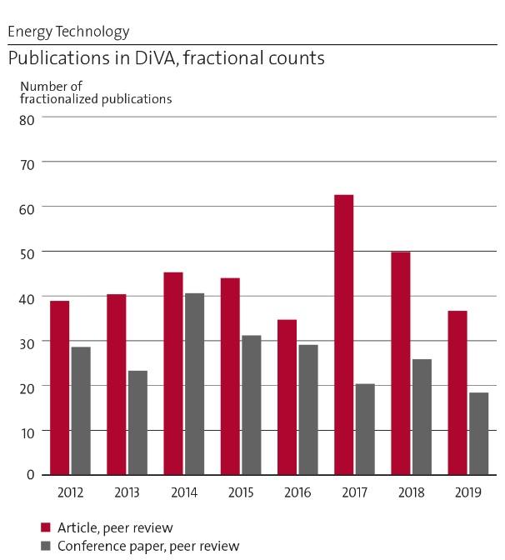 | 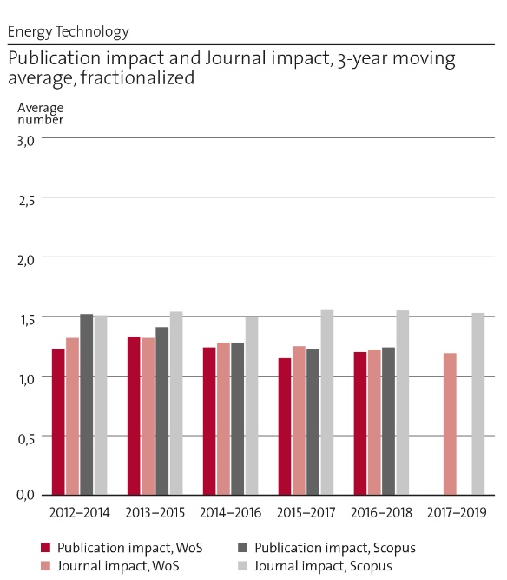

The citations rate in 3-year windows is stable, with an indication of increasing levels. The levels have been good, with values ranging from 3.7 to 7.5 citations per article, as compared to 2012, when the value was only 2.4.
The field normalized citations, and the number of Top10% are well above the world average, showing that the publications are well received and attract international attention. Likewise, the fact that the articles are published in well-known journals is shown by the Jcf score, and the relatively high share of publications in the Top20% most cited journals.
The co-publication with partners is also very well developed when it comes to our international research collaborations, see below. On the national side, the tradition is that industrial partners usually are not co-publishing to the same extent that explains the low figures in the graph.
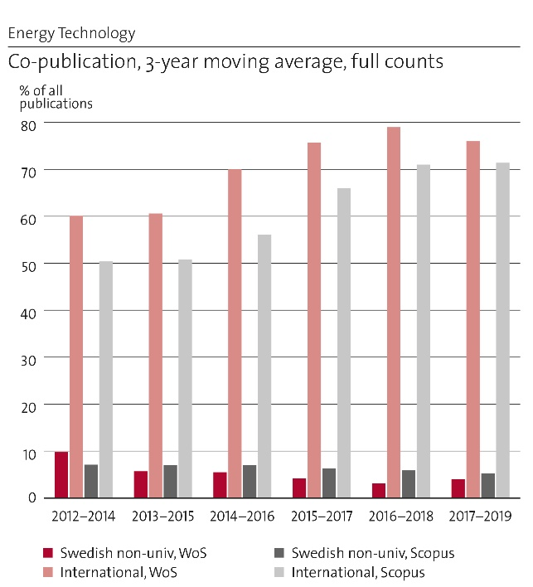
But the impact of the published articles is not only related to the number of citations in other scientific articles. Publications could also be referred to in policy-documents, news articles or in social media. A search in Altmetric reveals that the departments’ articles related to energy systems analysis for countries and regions have received high international attention.
The following articles are examples of the department’s excellence. They have been chosen among those publications that exhibit high citation and impact statistics and are linked to active research themes at the department:
- Howells, M, Hermann, S, Welsch, M, Bazilian, M, Segerstrom, R, et al (2013) “Integrated analysis of climate change, land-use, energy and water strategies”. NATURE CLIMATE CHANGE, vol 3, issue 7, DOI: 10.1038/NCLIMATE1789, (253 citations, “Highly Cited Paper” badge in WoS).
Land, energy and water are resources that, when they are exploited, all contributes to climate change. Also, the systems that provide these resources are vulnerable to changes in climate. This work discusses how the lack of integration in resource assessments and policy-making leads to inconsistent strategies and inefficient use of resources. A new paradigm for resource assessment -- CLEWs (climate, land-use, energy and water strategies) -- is presented to aid in these shortcomings.
- Nerini, FF, Tomei, J, Bisaga, I, et al., (2018) “Mapping synergies and trade-offs between energy and the Sustainable Development Goals”. NATURE ENERGY, vol 3, issue 1, DOI: 10.1038/s41560-017-0036-5, (209 citations, “Highly Cited Paper” badge in WoS)
The UN’s 17 interconnected Sustainable Development Goals (SDGs) include 169 targets to support a plan of action for people, planet and prosperity. This work characterizes synergies and trade-offs between these targets, to be considered for the delivery of the 2030 Agenda as a whole. Synergies and trade-offs are proven for three key domains affecting the ability to: realize aspirations of greater welfare and well-being; build physical and social infrastructures for sustainable development; and achieve sustainable management of the natural environment.
- Spelling, J , Favrat, D , Martin, A , Augsburger, G , (2012) "Thermoeconomic optimization of a combined-cycle solar tower power plant". ENERGY, ISSN:0360-5442, vol 41, issue 1 (85 citations, cf=4.03)
The analysis and optimization tools developed for this study serve as a foundation for future investigations. This was one of the division’s first publications in the CSP field.
- Gunasekara, SN , Pan, RJ , Chiu, JN , Martin, V , (2016) "Polyols as phase change materials for surplus thermal energy storage". APPLIED ENERGY, ISSN:0306-2619, vol 162 (53 citations, cf=3.67)
A study encompassing fundamental materials development for novel phase change material applications.
- Mohan, G , Kumar, U , Pokhrel, MK , Martin, A , (2016) "A novel solar thermal polygeneration system for sustainable production of cooling, clean water and domestic hot water in United Arab Emirates: Dynamic simulation and economic evaluation". APPLIED ENERGY, ISSN:0306-2619, vol 167 (52 citations, cf=3.56)
This study demonstrates HPT’s international outreach and ability to be instrumental in designing and implementing an innovative pilot-scale facility in solar-driven polygeneration. (Mohan and Pokhrel were former MSc students, while Kumar was a PhD student.)
- S Poppi, N Sommerfeldt, C Bales, H Madani, P Lundqvist, 2018, “Techno-economic review of solar heat pump systems for residential heating applications”, RENEWABLE AND SUSTAINABLE ENERGY REVIEWS, v. 81, part 1, pp. 22 – 32. https://doi.org/10.1016/j.rser.2017.07.041
The paper is part of a Ph.D. thesis on how heat pumps will influence the European energy system and how they can be used for load shifting and thereby facilitate the use of renewable energy. This particular paper is a review of techno-economic studies on solar heat pump systems.
- P Monzó, AR Puttige, J Acuña, P Mogensen, A Cazorla, J Rodriguez, C Montagud, F Cerdeira, 2018, “Numerical modeling of ground thermal response with borehole heat exchangers connected in parallel”, ENERGY AND BUILDINGS, v. 172, pp. 371 – 384, https://doi.org/10.1016/j.enbuild.2018.04.057
This article is an example of the output of one of several Ph.D. students engaged in projects related to geothermal energy and particularly to heat transfer around geothermal wells and geothermal energy storage systems.
- M Karampour and S Sawalha, 2018, "State-of-the-Art Integrated CO2 Refrigeration System for Supermarkets : a Comparative Analysis," INTERNATIONAL JOURNAL OF REFRIGERATION, v. 86, pp. 239-257, https://doi.org/10.1016/j.ijrefrig.2017.11.006
This article is an example of the Department’s work on developing refrigeration and heat pump systems using natural refrigerants. It received the “Very Commented Paper” award by Elsevier for 2018.

e. Engagement in national and international research collaboration within academia and its outcomes
The department’s research collaborations are to a high degree an outcome of our research project collaborations. Both international programs such as the EU Horizon2020 and national programs through the Swedish Energy Agency require consortia collaboration for project funding. At the Department of Energy Technology our main part of external funding is coming from those programs and therefore we have a very active and strong research collaboration network with partners from academia, industry, cooperatives, research institutes, governmental agencies, policy makers and governments. In quantitative terms, we collaborate with around 100 industrial and more than 100 academic partners during a five-year period.

National Examples
- Collaboration with sister departments of most technical Universities in Sweden through national programs (Chalmers, Lund, Luleå, Mälardalen, Linköping, Uppsala, etc)
- Industrial partnership with Siemens Energy AB in the area of gas and steam turbines for CSP and other applications.
- Industrial partnership with GKN Aerospace Sweden AB in the development of new components for jet engines and rocket motors.
- Industrial and academic collaboration in the program TurboPower, funded by the Swedish Energy Agency and partner companies (same as above). This program was coordinated by the Department of Energy Technology and ran until 2016. Academic partners included Chalmers, LTH, LiU.
- Industrial partnership with Alfa Laval, NIBE, Thermia, CTC, SWEP in the area of systems and components for innovative heat pumps.
- Industrial partnership with Electrolux in the development of new technology for domestic cooling applications and AC.
- IIndustrial and academic collaboration in the program EFFSYS, funded by the Swedish Energy Agency and partner companies. This program was coordinated by the Department of Energy Technology and ran until 2018.
- Project participation in aeronautics program NFFP (Vinnova, Swedish Armed Forces, Swedish Defense Materiel Administration, SAAB) and in aerospace program NRFP (National Space Agency).
- Project partnerships with the City of Stockholm, City of Uppsala, Cooperative ElectriCity, Vattenfall, Ellevio, RISE, Stockholm Exergy, EON in several projects for city and energy infrastructure development.
- Collaboration with SME’s and start-ups such as Azelio AB (energy storage, Stirling engines), Compower AB (microturbines), Scarab Development AB (membrane distillation), etc.

International Examples
- EGI’s Division of Energy Systems (former div of Energy Systems Analysis) has developed and maintains one of the world-leading open source tools for energy and integrated water-energy-land use planning: the Open Source energy Modelling System (OSeMOSYS). As part of this, we are leading a world-wide community around the tool, which has resulted in OSeMOSYS applications in developing countries, from the use in academic teaching, through to the creation of research teams, building of modelling capacity within planning units of Governments and use as science-base for development plans:
  - the use for higher education teaching in 30+ universities worldwide;
  - featuring as one of the United Nations Modelling Tools for Sustainable Development: https://un-modelling.github.io/ ; and
  - World Bank Group’s outlook on the enhancement of the climate resilience of Africa’s power and water infrastructure: https://openknowledge.worldbank.org/handle/10986/21875
- Coordination of and participation in EU research projects with relevance to heat pumps and refrigerants (NxtHPG, Green Heat Pumps, SHERHPA, NARECO2, ExpHeat, Ground Med, GeoPower, and more), to heat transfer (HENIX, HMTMIC, to biofuels research infrastructure (FP7 BRISK, H2020 BRISK2), to aeromechanics in turbomachines and jet engines (FP7 FUTURE, H2020 ARIAS), pilot-scale facilities in biofuels (Pilots4U); energy storage strategies for power and heat (PUMPHEAT, SWS Heating); Concentrating Solar Power (TESCONSOL); Energy Infrastructure in Cities (INTEGRCITY), Smart City development (GROWSMARTER, CIVIS) resource efficiency Nexus (SIM4NEXUS) and many more. These initiatives involved top European universities and industry in the respective field.
- Coordination of SELECT+, an Erasmus Mundus Joint Doctoral Program in sustainable energy (program ran 2016-2020; some PhD students finish their work 2021).
- The Department of Energy Technology has received several PhD students with funding from the Chinese Scholarship Council (CSC). A number of these students were linked to SJTU and Zhejiang University, main partners of the Department of Energy Technology in China.
- The Swedish International Development Agency has financed several PhD students from UMSS in Cochabamba, Bolivia.
- The Department of Energy Technology faculty members are influential and build collaborations in a number of key international organizations: Executive Committee, International Solar Energy Agency (Viktoria Martin); supervisory board, European Consortium for Advanced Training in Aerospace (Andrew Martin); board member of International Institute of Refrigeration (Björn Palm); national delegate in EUROTHERM (Björn Palm)

f. Follow up from previous evaluations
The assessment of the Department in the RAE 2012 by the external experts was quite positive. The assessment was divided into three areas and for each a score from 1 to 5 was given, together with a short motivation. The Research Output Quality was given the score 4 and the experts pointed out that the majority of the Department is well established and recognized internationally. They also pointed out the excellent laboratory facilities. At the time, the department had two smaller divisions focusing on Energy Systems Analysis and Climate Studies. It was suggested that these groups should be merged. In 2019, this suggestion was implemented, and a new merged Division of Energy Systems has been formed.
Impact and Engagement with Society was given the score 5 and it was recognized that “the UoA has pioneered the promotion of environmentally benign energy technologies through top-level studies on e.g. innovative combustion, gasification technologies, biomass-based energy processes, new heat pump applications such as GCHP (ground-coupled heat pumps), the use of [environmentally] friendly refrigerants including carbon dioxide, ammonia, hydrocarbons, solar-driven refrigeration, reduction of the charge inventory in cooling equipment.” and that the department “…continues to be a well-recognized world leading reference.”
The Research Environment was given the score 4 and the external experts pointed out that the staff is highly motivated and the atmosphere is forward-looking.
The panel also pointed out some areas of possible improvement. One of these was that researcher mobility both to and from the group was rather low. In general, the mobility has increased since 2012. In particular, the number of incoming students and researchers has increased. Some of these have been offered permanent positions at the department. It is more difficult to find time and opportunities for KTH researchers at all levels to go on mobility, and continued work on aiding this part is needed.
Another point mentioned was that the Department was more focused on education than on academic research. This comment is still valid as the departments’ educational programmes are still in high demand, and this is partly because of the clear link to the research in the area. Education and research go hand in hand, as it should. However, for every member of faculty, the teaching load is then relatively high which can be slowing down the person’s ability to excel in research.
Finally, we would like to refer to the statement by the chairperson of the panel, Dr Tuija Pulkkinen, cited in the magazine KTH & Co stating that “…KTH could profile itself as the world’s best energy university, with a special focus on sustainable energy and environment…. what is missing is an effort of branding…” At the Department of Energy Technology, an effort is ongoing to disseminate the many impactful research activities we are involved in. Here, we wish also that the central efforts at KTH could be more coordinated, such as through the Energy Platform. A renewed effort to be effectively included in such central measures is under way.

3. Viability

a. Funding; internal and external
The Department of Energy Technology’s sources of research funding are mainly external, resulting from positive evaluations of proposals sent to Swedish and international funding agencies. Historically, only a limited share of the research funding is internal, i.e. comes from KTH. During the period 2013 to 2020, the department has worked with 70% external funding from research grants, and contracted research – see Figure 2 on the funding structure.
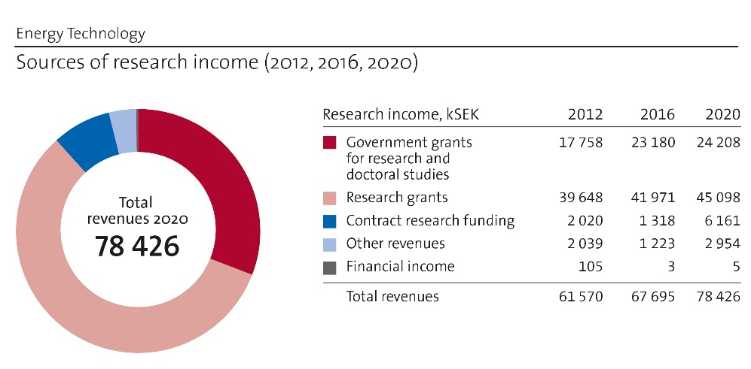
Figure 2 Full funding overview
The internal funding consists of a fixed part and a variable part, with the latter depending primarily on how many PhD students have passed examination.
The main sources of external funding are the Swedish Energy Agency, and the EU. The shares are shown in Figure 3.
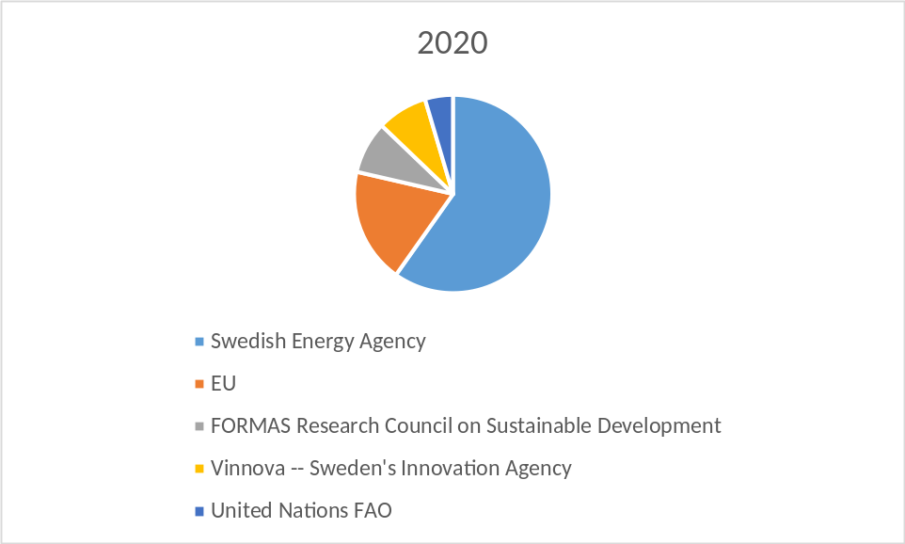
Figure 3 KTH Department of Energy Technology Sources of external funding.
Compared to RAE in 2012 we can observe: in the years 2012 to 2014, the largest contributions came from EU (50%), while in the years 2015 to 2020, the Swedish Energy Agency was the main financer (40-60%) while EU-funding has dropped to 20-35% of the funding. The funding from these two sources has varied between 75% and 90% of the total external funding since 2012.
Considering the department’s strong dependency on the Swedish Energy Agency for providing funding, it needs to also be understood that the agency’s research agenda is to a large extent influenced by political decisions. This means that the number of calls in a certain area may change with relatively short notice. For example, since the last RAE in 2012, it has become increasingly difficult to get funding for research related to steam and gas turbine technology, as this is deemed less critical for transforming the energy system to rely on renewable energy. Thus, the department of Energy Technology needs to strive to be less dependent on specific research programs within the Swedish Energy Agency, thereby reducing the risk of sudden changes in the overall external funding. Other alternative national funding bodies are Vinnova, the innovation agency, and Formas, and in recent years contract-based research funded by UN departments and the World Bank.
The Swedish Energy Agency and Formas finance applied research critical to the transition of the energy system. Many basic research questions important for this transition are difficult to get funding for from these sources. On the other hand, the Swedish Research Council that finances basic research usually considers the research applications from the department as being too applied. This gap in financing possibilities is a problem for developing high quality research.
Most external research funding is for three years. Especially in the case of international funding sources, funding is given on average for much less than three years. As the PhD education is a four year program, this means that funding for the complete period of a PhD cannot be covered within one funding period. As a second funding within the same area cannot be guaranteed, problems for the financing of the PhD student may arise when the first project ends. One solution that has been identified could be to couple long-term funding from EU Framework Programmes or Swedish funding agencies (in collaboration between several units) and shorter-term funding for the last period, for actions more tailored towards dissemination and exploitation of the work (mobility scholarships, VR funding for shorter research projects and conferences, UN funding for capacity development in the context of the SDGs).
Finally, it should be noted that internal base funding is typically used to cover the salaries for PhD students who have not been able to finalize their studies within the time period of an externally financed project, or to allow the senior researchers to write applications or do minor research tasks e.g. together with MSc students.

b. Academic culture
Most research at the Department of Energy Technology involves PhD students with each research activity organized into a team of main supervisor, co-supervisor(s), and PhD student. Within the team the supervisory work is usually divided among main supervisor and co-supervisor, with the latter often an early-career researcher. Occasionally co-supervisors from partner universities, other departments or industry are involved. Only a handful of industrial PhD students were enrolled during the period 2012-2018, although there is an expectation that the relative number will increase in coming years as industry has shown greater interest recently. There is a variation in the level of interaction of these core teams with one another. In some cases, the PhD student does not collaborate directly with other colleagues, while in other circumstances several PhD students form a larger cluster that addresses a broad research topic. Some examples of these are the groups regarding Turbomachinery, Thermal Energy Storage, Energy Systems and Data Analysis, which are made up of 3-6 PhD student and joined by senior researchers and supervisors.
The majority of projects are conducted with industry, with reference groups and other arrangements made to ensure knowledge transfer. Many projects involve national or international partners organized in consortia, which ensures regular meetings and good interaction. The Department of Energy Technology researchers and PhD students are active in international conferences, most notably ASME Power, ASME TurboExpo, ECOS, SolarPaces, ISES Solar World, International Symposium on District Heating and Cooling, Eurotherm, IEEE Conference on Control Technology and Applications, IIR conferences like Gustav Lorentzen Natural Working Fluids Conference, etc. Typically, PhD students participate in at least two international conferences during their study periods. Conference participation among researchers is moderate to high, with higher frequency shown for early-career faculty and staff. In-addition, research dissemination, collaborations and standardizing activities are realized rather often within various Annexes within the IEA technology collaboration programs (TCPs) (e.g. related to energy storage and solar heating and cooling). In these activities, PhD students play an important role, guided and backed by the support from their supervisors. The networks achieved in these activities prove the most valuable outcome, which are drivers for successful European and international collaborations. Internal seminars and presentations are important components of EGI’s academic culture. PhD students hold mid-term and final seminars in addition to the final defence. The seminars involve faculty members across the department, providing a range of feedback to the PhD student and fostering knowledge dissemination.
MSc thesis students are also an integral part of the research activities within EGI, which are often aligned to complement ongoing research activities within PhD research projects. PhD students’ supervision of these MSc theses contribute to their career skills development while enabling the MSc students to be engaged in real-time research. MSc students present their thesis work in organized sessions, a change implemented in 2018 in order to increase participation and increase awareness among supervisors and examiners. Historically the department’s three divisions, and in some cases sub-groups within the divisions, have had various arrangements for regular meetings to discuss ongoing research.
More recently EGI has organized two to four seminars per month intended for all faculty and PhD students. Career guidance is provided to all researchers via yearly performance reviews, with more frequent feedback supplied to early career researchers (postdoctors and assistant professors). The management team has a good understanding of the KTH Tenure Track system and can provide concrete guidance to involved faculty members. The ITM school organizes mentoring for assistant and associate professors under the direction of the vice-dean for future faculty.
Despite these efforts, the Department of Energy Technology researchers are not completely satisfied with the academic culture, in particular the inability to prioritize both organized and serendipitous collegial interactions. The following challenges have been recognized as obstacles towards achieving a fully flourishing academic culture:
- Faculty and staff turnover during 2015-2018 placed a higher workload for certain main supervisors than was originally anticipated. The result was a narrowed scope for collaboration outside the core team.
- Maintaining the level of interest for seminars and presentations outside immediate project activities at department level has been a struggle. Low level of participation is common.
- There is a lack of coordination in supporting lab and workshop organization, and in the development and implementation of common modelling tools. This fragmentation can hinder the generation of new and fresh approaches.
- In spite of the career development advice, it is sometimes difficult for researchers to carry these out when the distribution of tasks among administration, education and funding applications is unbalanced and leaves no space for that career development.

- Data sharing and establishment of databases is sporadic and could be improved. Transfer of the accumulated knowledge when faculty members/PhD students leave could be improved.
- Encouragement of PhD students’ collaboration within as well as particularly outside their own research groups is a key ingredient for successful research outcomes as well as skill development. However, thus far, this is not done systematically and from the beginning of the projects, and is uneven.

c. Current faculty situation
Moving into 2021, we have the following faculty situation with respect to gender and age:

Career Position | Total | Of which females | Age 60+ | Age 50-60 | Age 40-50 | Age 30-40
Professor | 7 | 1 | 3 | 3 | 1 | 0
Associate Prof | 8 | 0 | 1 | 3 | 3 | 1
Assistant Prof | 3 | 0 |  |  | 1 | 2

Regarding the faculty staff it is observed that we have a lack in senior and tenure track faculty compared to researcher positions (see figures below) which is related to historical difficulties to obtain permission to open associate professor and professor positions. This state has led to an imbalance between teaching and research for many associate professors and professors where research time has been suffering. At the same time, increasing demands on senior personnel for administrative tasks have been diminishing research time even further. We have an inclusive work environment at the department with a strong international participation. The gender balance at PhD student level is reasonably good, but is unfortunately not good in the tenure track and senior faculty positions. Especially worrying is that we do not have any female in the tenure track positions and only one female professor. This has historical reasons but is also related to difficulties to attract and retain women in the recruitment process. To improve this situation will be one of our focal areas in the coming years. Furthermore, we have difficulties to recruit Swedish-speaking faculty to teach in our Bachelor courses.
In addition to the above faculty, we do have several researchers and postdocs:
- researchers: 24, of which 7 women
- postdocs: 5, of which 2 women
These numbers improve the gender balance to 36% of all PhD-level researchers involved. It is of fundamental importance that our female researchers involved will have the opportunities to stay on in academia, should they desire to, and that we as a department can offer tenure track positions at entry levels on a continuous basis to attract talent from diverse backgrounds. Long-term funding directed towards strategic recruitment must be established.
Aside from gender, the other structural problem with current faculty is age. We have many very experienced and highly competent faculty that are nearing retirement age. We need to secure competence transfer and build-up before this body of knowledge and competence leaves us. We do have the time to act, with strategic recruitment, to compensate from most of our professors and associated professors being 50+.
Improving the gender balance in faculty positions is complicated by the fact that only a small share of the applicants are women. We need to improve in attracting talent with gender balance.

d. Recruitment strategies
In our recruitment strategies, all position openings, at all levels, are advertised through HR+ prepared advertisement procedures.
PhD positions, postdocs and researchers are most of the time fully funded by specific project financing achieved, and thus the qualifications required are very specific. This means that we have limited opportunities to recruit at these levels in a strategic manner, e.g. to build on some competency presently weak at the department. However, our strategic work is then within the application for funding phase, where we secure the funding. There is also a need to focus on assuring gender balance. All apply in competition with each other, and academic merits are central for evaluation, but what we can do better is to encourage female researchers to apply is to actively advertise within our networks of MSc-level students/alumni, linked in, and social media.
For 2020, we had one specific opportunity to recruit up to three new postdocs to aid our research around transport, industrial, and city-level. The reason is that the KTH School of Industrial Engineering and Management, to which we belong, has put forward a 4-year school overarching research investment for enabling multidisciplinary projects and innovation. This is very welcome.
As per the discussion above on current faculty situation, we have both lost a significant amount of faculty the last years and we have an “aging” group of faculty with only one woman at a faculty position. With strategically forming new faculty position at entry-level, as opposed to recruiting professors, we have the chance to remedy both aspects. In fact, in preparing descriptions for new positions to enhance competency around our central research questions (presented above) we realized that worldwide, no female candidates for professor level positions were available. We believe that a better strategy is to recruit at entry level since within the younger generation researchers there are a larger number of female young talent that KTH will hopefully be able to attract. In specific numbers, for 2021 we will advertise for two new associate professors, and shall prepare the funding for at least four new assistant professorships for 2021. Our ability to create new faculty position is controlled by external funding, as well as government funding, centrally allotted by KTH.

e. Infrastructure and facilities
The laboratory at the Department of Energy Technology, with its world-class experimental facilities, is recognized in several EU framework programs through coordination of FP7 BRISK, FP7 FUTURE, H2020 BRISK2 and H2020 ARIAS, and participation in a range of other EU-projects, such as NxtHPG, Green Heat Pumps, SHERHPA, ExpHeat, HENIX, HMTMIC, PUMPHEAT, SWS Heating, CIVIS. Our lab is also acknowledged in a multitude of other national and international projects, and is the foundation of the unit’s excellence. The department also is the founder of KTH Live-in Lab that offers something as unique as full-scale test beds with everything including a plus-energy apartment building with a multitude of sensors and a separate test area where the apartments can be changed and re-scaled easily to allow a wide range of research projects.
A pillar of our research strategy has been to nourish an excellent experimental basis interlaced with high fidelity analytical and numerical modelling. The experimental areas where the department is in the international forefront include turbomachinery, heat pumping technology, two phase heat transfer, concentrating solar power, indoor climate and thermal energy storage, where the majority of the applied research is in collaboration with industry either as program-research or as commissioned research. An external SME has located its pilot rig in the laboratory; the facility allows for production of sustainable jet fuel and other liquid hydrocarbon fuels from bio-ethanol produced from bio-waste. Another startup company, Climeon, developed their technology in our lab and has now expanded to sell their products on the world market. There are two other collaborating research groups from the KTH CBH and SCI schools present in the laboratory, to conduct experimental research in high-pressure gasification of biomass and two-phase flow research and in nuclear safety.
The existence of the test rigs requires reliable and at the same time modern and flexible infrastructure facilities such as a laboratory workshop with skilled technicians covering areas of prototype manufacturing and design, instrumentation, refrigerants, and test rig assembly. An automated gas system with a separate gashouse allows for supply of a variety of gases (up to 2 700 L combustible gases) to several users in the laboratory, with each flow controlled by one of several dedicated mass flow controllers. A PLC-controlled advanced air system supplies the various wind tunnels and test rigs with process air and exhaust with various air compressors and fans. The largest compressor is capable of supplying 5 kg/s air at 4 bar with an inlet temperature between 20 and 150°C, with 10 bar and 40 bar low flow compressors serving as a complement.
For the research related to turbomachinery the rigs span from cold-flow component tests in the transonic-supersonic region in annular and linear cascades to a rotating cascade and hot component tests. The nature of the turbomachinery aero-elasticity research includes measurements of unsteady phenomena and instrumentation, a hallmark of the group’s excellence.
Four large climate chambers á 12 m² with possible controlled temperature between -30 to +40°C are employed to study frost formation, heat pump performance etc. The chambers have flexible inner walls, which allows testing the U-values of building structures while simulating inner and outer climate; they are currently being refurbished with CO2-based refrigeration system including advanced heat recovery and ejectors. There are also two smaller chambers spanning from -80 to +180°C suitable for dynamic tests.
On the laboratory roof, a unique test rig to study heat transfer characteristics and thermal decomposition of methane at high pressure and temperature (200 bars, 1 073K) has been commissioned in 2019, for the future generation of rocket engines. Furthermore, rigs are installed for performing tests of solar and PV-panels along with heat pump testing with ground and air source heat pumps with flammable refrigerants (heating capacities up to 50 kW).
Low temperature thermal energy storage with phase change materials is tested and modelled in various test rigs at the department as well as heat exchange and heat storage related to bore holes in the ground. Research on thermal energy storage, in combination with renewable resources such as concentrating solar power, has evolved during the last years with excellence established within high-temperature storage and solar receivers. For Europe, a unique solar laboratory has been designed, built and is in operation since 2015 containing concentrating high-voltage UV-lamps in a parabolic configuration reaching temperatures above 1 600°C within a target of 1 dm² enabling solar receiver and materials research.
As part of H2020 BRISK2, two unique measurement instruments (fixed and portable) enable rapid and accurate on-line calorimetry (heating value, Wobbe index, methane number) of a wide variety of biogas mixtures. The development of these instruments and accompanying innovative measurement techniques has led to a spin-off company. A second rig in this project, the air gap membrane distillation test facility, is comprised of two single-module, semi-commercial AGMD prototypes for studying heat-driven water purification (ultrapure water quality). Both rigs are accessible to international visiting researchers through Transnational Access.
Equipment/instruments are available for establishing thermal properties of fluids such as heat capacity, viscosity and thermal diffusivity. High precision scales for different ranges, a low temperature freezer and a high temperature oven (1 600°C). Furthermore, the lab has high-speed acquisition systems for resistive type of sensors used for unsteady measurements, hotwire system, optical measurement systems for LDA/L2F and Schlieren, and a variety of pneumatic and aerothermal-probes probes for the wind tunnels. Infrared technique is frequently used and the lab has four different cameras serving different needs, including a high-speed IR camera. In addition, a gas chromatograph with FID and TCD sensors dedicated for analysis of HFC and HFO refrigerants and blends is presently being installed
In order to maintain and develop the infrastructure and measurement capabilities necessary for internationally competitive research projects, a continuous investment is needed. For example, there is a need to upgrade the control systems for process air and gas along with upgrade of unsteady acquisition systems for unsteady measurements and for gas analysis. An extension of the current roof-mounted platform is needed as rooftop space is nearly full. Such an extension will allow for experimentation with rigs that cannot be installed indoors owing to safety concerns, e.g. hydrogen-cooled heat exchangers and electrically driven ducted fan sections. Additional rooftop space is also desirable for expansion of PV test equipment and other facilities.

4. Strategies and organisation

a. Goals for development 5–10 years ahead
The department’s development goals are based on our internal strategy planning that originates from our yearly strategy days. They also take into account our SWOT analysis where we develop our strengths and try to mitigate our weaknesses.
Our development goals for the next 5-10 years period from our strategy days include the following:
- The department will continue to be world leading within the research areas turbomachinery, heat pumps and refrigeration systems, and energy systems analysis and optimisation. We will also maintain our strong research position in thermal energy storage, solar power, two phase flow and heat transfer as well as energy systems for the built environment.
- In 5 years, we shall be attractive to talent such that at least three new tenure track faculty are either female or other (intersex). In 10 years, at least another 4-tenure track faculty will be female or other, and we have obtained successful promotion of the first two recruits to at least Associate Professor.
- In 5 years, we are collaborating across divisions and with other departments/ other schools in at least 2 projects of significance respectively (i.e. supporting one PhD student and/or postdoc plus supervision and/or infrastructure capacity and senior researcher capacity) per developing research areas as follows
  - Big data/AI/Machine learning for energy research and development
  - Making full utilization of our Live-in-Lab laboratory, which means establishing it as the main demonstrator for new energy technology solutions in the built environment
  - New energy technology/energy systems demonstrators, including virtual demonstrators.
  - Energy research linked to the transport sector (sector coupling, infrastructure optimization, and solar/biomass-based fuel (co-)generation).
  - Energy storage and operational strategies in the context of electrification and renewable energy.
- In 10 years related to the above developing research areas, we have established ourselves within the areas with a significant portfolio of publications (e.g. per area, at least 3 publications with citations 10 or higher), and continued sustained funding (like 2 PhD students+1 postdoc per area).
- In 5 years, we have also significantly developed already strong research areas including the following strategic targets (per target, min 2 PhD students + 1 postdoc+20% faculty funded, 4 scientific articles per year, unless otherwise specified):
  - Our infrastructure and energy system modelling capacity, with: a) a sound programming/coding hygiene; b) a common toolbox – including forum for exchange of experiences, with large elements of open access; c) strengthened the applications in the national context. (Measured as existing toolbox with exchange forum)
  - Integrated analysis, long term planning, and techno economic optimization of a multitude of applications and system levels.
  - Electricity access for developing regions in the world– our modelling supporting linking to other infrastructural developments, business models, and data development (link to Big Data and AI above).
  - Our well-recognized solar laboratory is now established for fundamental research related to material science and solar fuels
  - Biofuels research is well visualized with experimental capacity.
  - Thermal energy storage with a now broadened research base, and international leadership in the field.
  - Heat pumping technology, international leadership and approaching new applications.
  - Turbomachinery research is broadened towards green aviation, space technology and more.
The development goals should be reached through a mix of implementation measures. First, we have established a Department of Energy Technology recruitment strategy filling our knowledge needs concerning Big Data and AI analysis as well as bio-fuels and chemical conversions. The second strategy to be implemented is to clarify our strategic research areas and to set goals and follow-up on funding applications in them. The third pillar is to utilize and prioritize our own funding to build research capacity in the strategic areas. Fourth, we need to adapt and prioritize our infrastructure support and in this context establish an infrastructure support concerning IT and software development. Finally, we will revise and follow-up our strategy work continuously and adapt our plans if necessary through our established work processes.

b. Congruence with university-level goals for “A leading KTH” as set out in KTH´s “Development Plan 2018-23” (page 5)
In the following, we address our congruence with the university level goals.

Leading Education, Leading Research, Leading Collaboration
The KTH pillars for being a leading University are implemented at department level where education, research and collaboration are closely intertwined. It is essential for us that we have state-of-the art research that is transferred into our education. We work continuously on our Master programs to reflect the research front in energy technology. We achieve this among other things through our close collaboration with both industry and other societal actors such as policy makers and representatives from the public. Almost all our research projects include collaboration with other stakeholders. In many of our courses, we have representatives from industry and society teaching. Our vision is to be the leading authority in energy technology in Sweden and this vision is forming our strategic planning.

An integrated KTH
At the department, we are well aware that we need to collaborate with our sister departments at KTH in order to have the right competence in both teaching and research available. Our collaboration in teaching is well established today where we for example provide competence for the EECS and CBH schools. We also receive competence from these schools. From a research perspective, we have a need to establish stronger cooperation between the schools in order to be able to address the more complex system integrated questions in our field. This should be part of our strategic focus in the coming years.

A visible KTH
The department is very visible in certain areas such as for example energy system analysis on the international level. Furthermore, the department is a leading voice in the research and professional community in the field of cooling and refrigeration and heat pumps. These are fields of strength that have developed over time. The department can however improve its overall visibility and should have the goal to become the go to resource for energy technology questions in the national context. We need to implement more coherent measures for our visibility.

An equal opportunities KTH, an open KTH and a KTH in a global world
KTH is aiming for to be relevant to the society and represent all parts of society when it comes to gender, ethnical background and socioeconomic background. It also aims to integrate in society both locally on national level, but also be present and integrated in a global environment. At the department we are actively working towards these goals. We have a very diverse work environment with many nationalities represented. We provide very popular international Master programs. We integrate ourselves in the Swedish development programs for developing countries concerning both research and education. We have established collaboration with international Universities and research organizations. We need however to work on our gender balance. Our faculty does not represent society when it comes to gender balance and it will be an important development focus for us.

A KTH for a more digitalized world and a KTH for a more sustainable world
As many other industry sectors, the energy sector and energy infrastructure rely to an increasing degree on sensor information and integrated data analysis from these sensors. This drives the need for big data analysis, handling of data with respect to security and integrity aspects as well as integration of machine learning elements for system analysis and control in order to increase energy efficiency. Our department is reacting to this trend and is progressing in implementing these technologies into the research areas, e.g. through advanced energy data analysis as well as AI and machine learning. We are already working with digitalisation and cyber security aspects in the built environment e.g. through projects within our Live-in-lab center.
Digitalization is one of the pillars of our future development. Sustainability on the other hand is well integrated in our research and has been for many years. All our research questions do encompass sustainability aspects in terms of both resources, pollution and socio-economic aspects of energy technology. In that sense, we are driving sustainability questions forward at KTH. We are also impactful in our work with integrated assessment of exploitation of resources, the so-called CLEWs concept (Climate-Land-Energy-Water), and its impact on infrastructure planning and policy design. Therefore, we cover most of the Agenda 2030 17 SDGs in our research, and have the competency to further elaborate sustainability from many aspects. This includes the much-needed gender and equality targets.

c. Leadership structure and collegial structure
The department follows the line organization as established by KTH, with department head as the main responsible person, and with division managers reporting to the department head. The management group is chaired by the department head and includes division managers, director for undergraduate/MSc studies, director for PhD studies, Gender/Diversity responsible and controller, with meetings held each week. School collegial representatives and PhD student representatives join these meetings once a month. Each of the two laboratories has its own manager, who reports to the respective division managers. Administration is handled at the school level although the responsibilities of project follow-up place a significant burden on the department’s project leaders. Each division hosts research groups of various size, with membership composed of faculty, researchers, and PhD students. Interaction between groups ranges from only periodic to regular. The department plans to address this discrepancy by forming “collaboration groups” spanning all three divisions, and the newly established ITM Research Initiative on Sustainability in Society (IRIS) will be one example of a way to facilitate this.
Researchers with a PhD degree are part of the department’s supervisor collegium, which meets periodically to discuss the improvement of PhD studies. This group interacts with the PhD student council. PhD supervisors interact with colleagues at the ITM School through the “Faculty Club” meetings, held about four times per year.

d. Strategies for high quality
In order to define strategies for high quality, we need to explain how our department has “internalized” the concept of quality. Quality, for us, encompasses work processes as well as research output, AND our ability to communicate our work to all societal stakeholders that can benefit from the new knowledge created. Quality is about generating new knowledge based on scientific methods and with high ethical standards, and ensuring that the knowledge is transferred with high impact. Internal quality processes (research processes, application processes, administrative processes, communication plans) support this work. A natural step is to integrate quality checkpoints along the way, in addition to the formal “check-points” mandatory at KTH (e.g., follow-up study plans, PhD defence, quality reviews, and research assessments). Here are examples of such checkpoints at our department:
- The Management Team at the department meets weekly with an agenda that covers operational as well as strategic issues, including quality review. Examples of quality issues followed up together in this context are bibliometric data and publication, funding—acquired and opportunities, recruitment, and reach-out to other research teams/industrial partners/other stakeholders.
- Each division has division meetings at least once a month with all the staff. At these meetings, information from the Management meetings as well as from KTH central is disseminated. Educational issues related to the courses for which the division is responsible are discussed. Dissemination of research, in terms of the division’s newsletter, popular science articles etc. are discussed. Possibilities for funding through new open calls are shared, and decisions on who are responsible for which applications are taken. Gender issues are raised and discussed, with examples from personal experiences or from friends/newspapers/TV/books. The faculty gathers at least once a year for the Department of Energy Technology Strategy Days – what are we doing, and why? Our vision is (re-)defined and concrete action points are defined for the year to come.
- All PhD students conduct a mid-term seminar, roughly half way through their PhD education. This is a time for consolidating the background, formulating clearly the research questions, methodology, discuss the results so far, and conclude on the work ahead. A panel of faculty, and peers, give feedback. One invited opponent, external to the department, brings fresh viewpoints on scope, methods, and results.
- All PhD students need to have at least four publications where at least two should be published in high quality journals. The thesis as a whole should correspond to four journal publications.
Our identified development opportunities, with regards to quality work, are:

- Accessing worldwide talent by recruiting entry-level faculty/assistant professor, rather than associate or full professors. With entry-level, we have higher opportunity of receiving applications also from qualified women, thus enlarging the pool of candidates in our search for the best candidates.
- We move now for publication in open access still reaching high impact journals with KTH and national funding support
- We continuously discuss ways to increase the quality of our PhD education, including the possibility to, in addition to the above mentioned mid-term seminar, have a “year 1-seminar” as well
- In this self-assessment, we identified a number of impact cases of which some are described in more detail. We are thus on our way to better understand how we impact society, and are excited about continuing to describe such impacts in order to learn from, and inspire each other.

5. Interaction between research and teaching at all three levels (BSc, MSc, PhD) of education
Teaching and research at the department are strongly interconnected and complement each other. This is reflected by work duties of staff at the department, which are typically a mix of research and teaching responsibilities. Faculty following the tenure track are required to actively seek funding for new research ideas where they supervise PhD students and manage research projects, and they act as examiners of courses on the graduate and under graduate levels. Research staff typically devote 20% to teaching duties such as lecturing within courses, serving as course leaders, and handling supervision for BSc and MSc students. In addition, the department has three lecturers (‘adjunkter’) amongst its staff members; their duties are fully devoted to teaching although they all have advanced research degrees (licentiate or PhD). Employed PhD students can be asked to spend up to 20% of their time on departmental duties (without special agreements), which predominantly comprise of teaching duties.

Undergraduate level
The interaction of research and teaching is applied in different forms at different study levels. Starting from the early years of undergraduate education where the students are taught the fundamentals, they are also presented with relevant research by inviting speakers from different departments at KTH, for example in introductory courses for students enrolled in Mechanical Engineering or Energy and Environment programs. This helps the students to relate the fundamentals they study to applied science, particularly via project work or field trips. Where appropriate, the department’s infrastructure, such as Live-in Lab, are opened up to undergraduate students. External industrial partners are engaged for various project work including creation of business models; recent examples include projects offered by Akademiska Hus, Telia, and Vattenfall. The most substantial project work involves the BSc thesis, where two students team up to tackle a specific challenge. Many students elect to study abroad through Minor Field Studies or in exchange programs. Around 20-30 projects are offered each year with supervision provided by faculty, researchers, and PhD students. These projects serve as a vital recruiting tool for the Sustainable Energy Engineering (SEE) MSc program.

Graduate level
On the graduate level, students have advanced sufficiently to allow for wider interaction between research and teaching. In our main master program in sustainable energy engineering, we have a number of mandatory courses, which aim to prepare the students to conduct research in their degree projects. The courses are MJ2475 Theory and Methodology of Science for Energy Research, Measurement Techniques in Energy Technology, and MJ2409 Applied Energy Technology – Project Course. In the project course the students work in groups within the projects defined and supervised by our teachers and PhD students. The topics are usually related to ongoing research activities at the department, or related to projects aimed at exploring new research areas. Other mandatory courses in the study profiles are problem solving oriented, applied, or of project nature. The courses typically have laboratory work, study visits, and use of several calculation tools and software that we use in our everyday research.
An example of study profile courses is MJ2380 Introduction to Energy Systems Analysis where basics of energy systems modelling (literature background, definitions, and scope of modelling) that underpin our research are taught. The students learn how to apply the modelling tool OSeMOSYS as we do in our research projects and we explain the structure of a linear program like OSeMOSYS and ask the students to reproduce it, so that a path may open to them to become developers of the tool. The students then create detailed energy systems models of developing countries, mainly in Asia and in Africa, which will form the database for all our modelling projects and capacity building activities in the same regions.
Along with the mandatory courses the students are offered several elective courses in the last semester before they start with their degree project, these courses are on advanced level and typically formulated from our research. For example, MJ2434 Advanced Refrigeration and Heat Pump Technology has an assignment where the students study and analyze the performance of energy systems in two supermarkets using field measurement data from a research project we had, they need to compare the systems and suggest improvements. Additionally, study visit to our laboratory is organized in the course to explain the relevant ongoing research projects. The small number of participants in such electives (typically 10 students per session) mean that teaching resources must be deployed judiciously, which can be done more easily through creating strong ties to research.
The master thesis project is the largest research task the students conduct individually. The following list includes two points from the intended learning outcomes from a thesis work:
- Demonstrate knowledge and understanding of the scientific foundation and best practices for the chosen subject, as well as an advanced understanding in current research and development, and in-depth knowledge of methodology.
- Demonstrate the ability to search, gather and integrate knowledge and identify their need for additional knowledge, all with a holistic, critical and systematic work approach.
For the MSc thesis, the PhD students are involved in supervision. In 2019, PhD students supervised 18 master thesis projects directly related to their research, where some of the master thesis projects led to conference or journal paper publications. Within the area of natural refrigerants alone, 1 paper based on master thesis work has been published in a conference in 2014, 2 papers in 2016, and 1 paper in 2018. All such papers were published by the master thesis students as the first author.

Effect of the interaction on teaching and research
The students benefit by seeing how the fundamentals and theoretical knowledge they learn in the classroom can be applied at higher level and what the key questions are for research for future development. This also helps the student in identifying the interesting topics they can work with in the future.
Connecting teaching to research during the graduate and undergraduate studies prepares the students for the research tasks in the degree projects, making the supervisors’ job less demanding and more interesting in terms of having more time to focus on research methodology and results.
The direct effect on research can be identified as further use of research results produced by students during project work and degree projects. All master thesis projects are published with open access at our library database, DIVA, where some of the thesis reports are downloaded hundreds of times and referred to in journal and conference papers.
The Department of Energy Technology organizes a yearly event where PhD students and researchers present their current research projects to the master students. Here researchers use the event as a ‘pitch’ to the current master students in the hope of engaging them with their own research projects either as following the study profile related to such research project or engaging them in the research project itself as master thesis student. And this event is highly appreciated by the students in the programs as this is one of the ways that they see how the courses in their programs are inter connected with the research that is being carried out in the department.
When the researchers act as teachers to present their work to the students they have to adapt their message to the audience, so it should be on a certain level of complexity and connected to the fundamentals. At the same time, the researchers have to show the value of their work in the big picture. This is usually a challenge for the researchers because research results are usually communicated between researchers at similar level of knowledge.

PhD level
The department offers a number of PhD level courses which stems from the research that are carried out. Some of the PhD courses(i.e. MJ3384 Environomical Pathways) that have been implemented belong to the Erasmus Mundus joint PhD program Environomical Pathways for Sustainable Energy Services and have been offered to PhD students both from KTH and also from elsewhere in Europe. This course had been initiated based on the umbrella topic of the joint PhD program and aimed to describe the tools, procedures useful to develop thermo-economic, and environomic optimization of complex energy systems that is the basic topic of all the PhD projects carried out in the program.
In MJ3122 Research Seminars, the objective of the research seminars is that students actively participate in the presentation of their research results as well as other PhD students and master students thesis. Students are supposed to actively participate in following:
- Presentation of their own research (all published conference and journal papers) which is corresponding to one-week workload.
- Participation of other PhD students’ presentations, corresponding to one-week workload.
- Participation of master thesis presentations, corresponding to one-week workload.
In MJ3114 Heat Transfer examples from the department’s research related to the subject area presented, e.g. development of micro channel heat exchangers, heat transfer in nanofluids, different types of enhanced heat transfer, heat transfer in boiling. The students are also asked to present their own research related to heat transfer to the rest of the students in the course. In some cases, the students have been offered supervision on selected topics related to heat transfer from their own projects, but this has not been a formal part of the requirements.
Course MJ3116 Thermodynamics is given in the form of eight seminars. During four seminars students present thermodynamic theory by reading course literature and scientific journal papers and during the three following seminars, students work with the application of thermodynamic theory to their own projects. In addition, participants are required to write a conference or a journal paper with relation to thermodynamics. In a final seminar, each of the students deepens a topic relevant to their PhD research project in the form of a 30-40 min recorded lecture.
In the course MJ3336 Educational Aspects in Energy Technology, research background, state of the art and research focuses are being made into learning materials by the course participants as final deliverable to the course. This trains the participants’ pedagogical abilities in conveying research outcome in a fashion that can be understood by all who are outside the participants’ field of research. The materials created by the course participants are furthermore utilized in MSc level teaching as course materials.
In all PhD courses, students must assess current available literature in the field of the given course and relate it to their PhD project.

6 Impact and engagement in society

a. Relevance of research to society at large
The Department of Energy Technology is focused on applied research related to the ongoing transition of the energy system from being dependent on fossil fuels to the use of renewable energy sources, including using renewables in the most energy efficient manner possible and in achieving access to renewable and clean energy for all. This transition towards a more sustainable use of energy requires increased energy efficiency in all processes, both for power generation/use and for heating purposes. We can also expect a higher reliance on electricity as energy carrier as a larger share of the energy supply will be from wind and solar. These energy sources are intermittent, and for this reason energy storage, both of heat and electricity, will be an important research topic in the years to come. The transition of the energy system is global, but the challenges and the necessary technology development may be partly different in different regions of the world. The research at the department is supporting the transition in many different ways, and is directed both towards more general questions of interest for planners and policymakers, and towards development of new technology which, in shorter or longer perspectives is of importance to different parts of the industry. In almost all projects financed by Swedish national authorities and the EU, it is a requirement that industry is involved. This means that the department is constantly cooperating with about 100 companies in the ongoing projects.
A number of impact cases are described elsewhere, and will not be repeated here. Instead, several examples of ongoing and recent research projects will be briefly described to point out the relevance of the research to the society. One aspect to highlight is the fact that the projects listed below encompass a broad span of the energy system.
Several projects at the department are based on open source software developed at the department, related to evaluation of different options for expanding the energy infrastructure in developing countries, or how to use the existing resources in terms of land, energy and water considering the climate challenges. Most of these projects are financed by governments or international organizations such as the UN, World Bank, African Development Bank or individual governments. Other projects in this group have been related to the use of city waste or residues from e.g. sugar industry for power generation, focusing more on policies and institutional hindrances than on the technology per se. Such projects have been financed e.g. by the Swedish International Development Cooperation Agency (SIDA).
Other projects have been related to policies and technology for urban mass transport systems. In particular, a relatively large project, running since several years, is focusing on bus transport in the city of Curitiba in Brazil.
Concentrating solar power has been in focus in a number of projects. These projects have been investigating both the receiver design and the possibility of high temperature energy storage in order to allow power production also during night. A large experimental facility is in operation in the lab for testing receivers. These projects are mainly financed by the Swedish Energy Agency.
Biofuels is another focus area at the department. Some projects have focused on the design of heat engines (gas turbines or Stirling engines) which can be used for small-scale power production in rural areas of developing countries. Biofuels for jet engines has also been investigated. In the lab, the company Swedish Biofuels has been allowed to set up a small pilot plant for such fuels. The Department of Energy Technology has coordinated international research infrastructure projects in biofuels via FP7 BRISK and H2020 BRISK2.
By tradition, gas turbines have been one of the most prominent focus areas at the department. The research has been performed in cooperation with large companies like Siemens and GKN and financed through the Swedish Energy Agency. The overall aim of the research has been to increase the reliability and safety, and to increase the energy efficiency of the machines.
A large share of the projects at the department are related to energy distribution and conversion in cities and the built environment. One particular topic is related to simulation of the energy network of cities, including both district heating and electricity, considering production facilities, like co-generation plants, small prosumers, heat pumps, and uses such as heating of buildings, charging of electric vehicles, electricity use in homes and offices. A key question for this and other projects is how to ensure stable power supply at all conditions, e.g. through load shifting or energy storage.
Closely related are projects on energy storage. Several such projects have been, and are being, performed at the department, mostly related to heat storage. One focus area in this field is phase change materials (PCM). Projects have been related both to fundamental questions related to new PCMs, better understanding of their properties and understanding of the heat transfer properties to/from the PCMs during phase change. Other projects have been related to the use of these materials in heating systems of buildings. Suppliers of PCMs as well as system design companies have been involved in these projects, financed by the EU or by Swedish authorities, e.g. the Swedish Energy Agency.
An area for which the department has been well recognized for decades is research related to heat pumping technology, i.e. refrigeration systems and heat pump systems. The department has close cooperation with both national and international companies within the area, such as IVT/Bosch, NIBE, Thermia, Danfoss, Electrolux. Research topics cover all areas from design of components, e.g. heat exchangers, to systems design, e.g. combination of heat pumps with solar power, to energy systems level, i.e. how to use heat pumps for load shifting. A special area is how to design systems for natural refrigerants such as CO2 and hydrocarbons. This research is typically financed by the Swedish Energy Agency and the EU, but other national sources, like Mistra, Vinnova and Formas have also been supporting the research.
Finally, research at the department looks at how energy and climate transitions affect the achievement of all sustainable development goals – including key societal outcomes on e.g. poverty and inequalities. In this field, the department has produced world-leading research, and is now collaborating with international and industrial partners (such as the United Nations Office for Project Services – UNOPS and Vattenfall) in strategies for accounting for broader sustainability perspectives in energy projects nd policies design.
The examples given above show clearly the relevance of the research at the department to the society as well as to industry, policy makers, planners and businesses. It should be pointed out that the research at the department has always been applied, and directed towards answering needs from industry and the society. However, the threat from global warming has engaged the staff and focused the research towards finding solutions leading to a sustainable future.

b. Research dissemination beyond academia
Some examples of the department’s outreach in society are listed below:
- Networks with industry and branch organization are numerous and broad. More than 100 companies, from SME to major corporations, are a part of these networks. Routes of cooperation include companies participating in national and international projects; companies tasking commissioned research or seeking advice; and researcher participation in branch organizations.
- Dissemination of knowledge to industry and society is enabled in a variety of channels: newsletters; branch journals (including a regular column in the journal ‘Kyla&Värme’); participation in seminars and conferences; webpages; webinars; publication of textbooks and tables.
- MSc and PhD graduates have found placement at key industries in Sweden and abroad. With many of our alumni we have regular contacts, resulting in common research applications and commissioned research tasks.
- Researchers have participated in writing responses to the Swedish government, and have contributed to reformulating international standards in refrigeration, biofuels, and other topics.
- Faculty members are engagement in working groups (IIR, IEA, ISES) and project workshops with the goal to raise energy issues to relevant policy-makers.
- Commissioned education for providing training to practicing engineers (e.g. Scania AB and Siemens Industrial Turbines AB, Electrolux, Sida), hosting of mid-career managers in the annual ECATA Aerospace Business Integration program.
- The high quality of experimental facilities has attracted visits from industry and society and increased visibility in public media. For example, the solar simulator has hosted visits from the Swedish Prime Minister, other government ministers, and the King of Sweden. (Press coverage accompanied these visits.)
- Researchers have been interviewed in media: Björn Laumert, Swedish television; Viktoria Martin, Björn Palm, Swedish radio.
Part of the department's research is disseminated through newsletters directed towards specific technical fields of interest. These activities are linked to individual researchers or to groups within one of the divisions. Up until now, there has not been a common strategy for communicating the department’s output to industry and society.

c. Sustainability and the United Nations’ Sustainable Development Goals (SDG)
Perhaps at no time in recent history has the world faced twin challenges of implementing more sustainable energy resource and reducing the effects of climate change without losing the quality of energy services to the society. The use of fossil fuels, together with other anthropogenic processes, has led to increased carbon dioxide content in the atmosphere and thus a warmer climate. The research within the department of Energy Technology aims to contribute to solving the above-mentioned problems, and is therefore fully, 100%, linked to sustainable development. The performed research focuses on a wide range from overall system perspective and the development of components for parts of the energy system to the studies of phenomena and processes that occur during energy conversion processes. In addition, education and research for sustainable development has been implemented in the department’s PhD programme. Such holistic thinking was rarely included in PhD studies previously, especially for PhD students with traditional engineering background.
Activities regarding sustainability at the three divisions are connected and complementing each other. The main goal is to provide knowledge of multidimensional approach towards sustainable development in order for technology, business and community to be truly sustainable. The focus is on developing new sustainable technology and on the role of technology, planning and policy measures to help enable the planet’s sustainable development from an energy perspective.
Almost all doctoral projects within the doctoral program are in some way linked to sustainable development. Moreover, this aspect is included in all courses offered within the program. In order to eliminate any knowledge gap on sustainable development, the department has prepared a doctoral course on sustainable development in collaboration of other departments at the ITM School (FMJ3388 Sustainability Perspectives for Assessing and Designing Research, Projects and Policies). This course focuses on the main interlinkages between the student's research and broader sustainable development. One of the course outputs will be on applying tools to evaluate the sustainability implications of the participant's own PhD topic. Some action items regarding sustainable development as integrated with the department’s PhD education are:
- All PhD students should be able to discuss and explain how knowledge in the field of energy technology can be used to contribute to Environmental, Economic, and social/cultural sustainability.
- All PhD students should have course(s) within sustainable development scope.
- All PhD students should check the 17 goals of SD, as provided by the UN, in order to identify the goal(s) and target(s) relevant to their project, and prepare a plan for how to address these in-depth.
Also, our impact can be described through the UN SDG targets we address in our publications. Figure 4 summarizes our reach in publications 2013-2019, based on a bibliometric analysis.
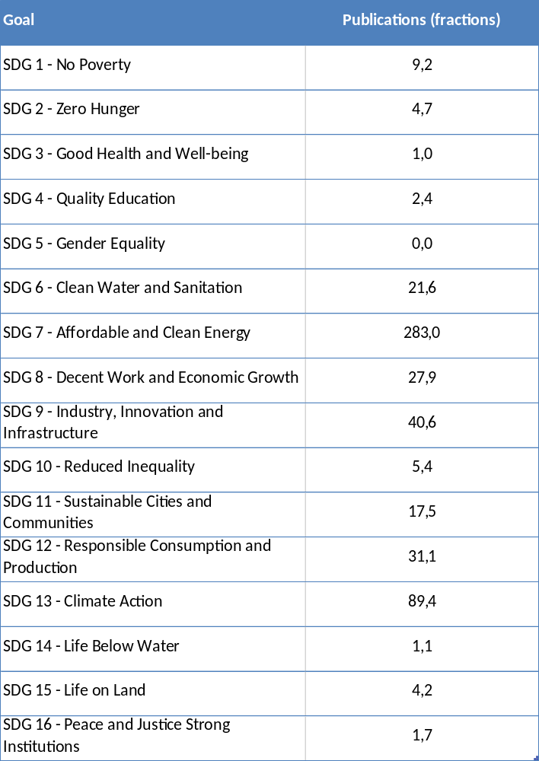
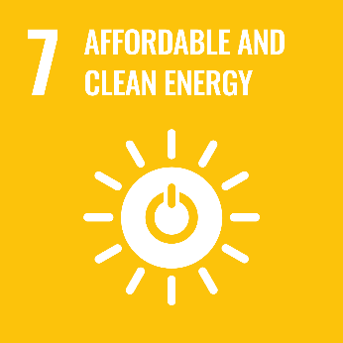
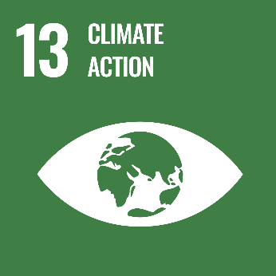
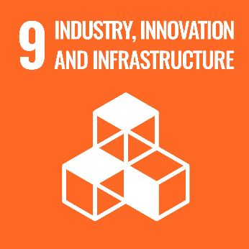
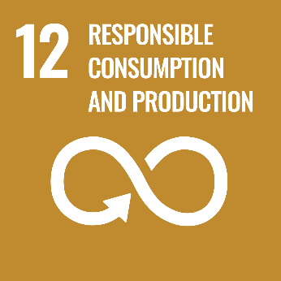
Figure 4 Department of Energy Technology publications impacting UN SDGs (please note that the SDG 17 related to Global partnerships for SD is not assessed here, in the bibliometric-based analysis of coverage)
As shown, close to 300 fractions publications impact the SDG 7 on Affordable and clean energy, 89 impacting SDG 13 Climate Action, and also significant impact on SDGs 9 and 12. The only SDG not being reflected in our publications is number 5 Gender Equality, and several other SDGs are not well represented. A significant push to analyse and understand the interlinkages and trade-offs between the many targets constituting the SDGs have recently been department researcher Nerini et al (Nature Energy, 2018, DOI: 10.1038/s41560-017-0036-5). This type of work has, aside from being impactful externally to KTH, inspired our research to continuously analyse the beneficial impacts on SDG:s but also the targets challenged by certain transformation measures in energy mix, technology and policies.

d. Structure for increased impact
Research at the Department of Energy Technology covers a wide range of societal impact, reflecting the interactions with industry, policy makers, and the society as a whole. The Department of Energy is making a coordinated effort on enhancing the creation, capturing, and communicating the societal impact of all our research activities.
To achieve higher impact and enhanced engagement with society, impact case collection will be done in a systematic way and impact cases will be published at regular basis in the department webpage and other communication channels. A dedicated outreach manager at the school level, supporting researcher in communicating their scientific work and reaching the right channels, should be considered for the systematization. Furthermore, impact beyond academia will be an important part of “Development dialogue” between faculty and their manager. Impact beyond academia can be collaboration with industries, publishing impact stories, presenting research to a broader audience through popular science articles, participating in the debate in newspapers and other public media, commenting on proposals from the government and other authorities and doing any research/educational/innovation activity beyond the regular tasks within academia, including spin-offs, entrepreneurial and policy related activities. Scientific outputs from the department should highlight societal implications.
Moreover, impact and high engagement with society will be one of the important criteria in hiring process, particularly for new faculties at the department. Impact will be a part of education for the existing researchers including the faculties, postdocs, and PhD students. Internal seminars at the department level and workshops led by external experts on societal impact of research will be a part of the educational package for all the staffs at the department.
Digitalization will play a pivotal role in our research from both content and organizational perspectives. From the research content perspective, the existing faculties are highly encouraged to get involved and lead research projects within the theme of “digitalization and energy”. Evidently, digitalization is not an aim but a tool to be applied in the energy sector, beside other sectors, in order to move us towards our ultimate goals. Those include securing the access to affordable and sustainable energy for everybody, empowering citizens, and fostering prosperity of global citizens by increasing the quality of life and decreasing the environmental impact. The research proposals and projects that are recently submitted and/or funded within “digitalization and energy” subject is an evidence of this newly established trend in the department. This trend will hopefully be continued and enhanced in the future.
Moving towards interdisciplinary and ultimately trans-disciplinary research has gained ever-growing importance in achieving higher impact in any research field. Consequently, the researchers at the department of energy are highly encouraged in leading and getting involved in more interdisciplinary research areas and projects. The department has shown a noteworthy trend of combining other disciplines such as resource management, economics, and sustainable development with engineering skills which can be detected in a considerable number of projects and high impact scientific publications. Furthermore, a few newly funded projects have gone beyond the traditional analyses by combining human behavior and behavioral economics with energy. The department plans to enhance this trend and move towards more inter- and trans-disciplinary research topics, both connections to natural sciences, other engineering sciences (e.g. materials science) and energy and social science that can consequently lead to higher research quality and higher societal impact.

Department of Electrical Engineering
Self-evaluation
Head of Department: Professor Hans Edin
Deputy Head: Professor Carl-Mikael Zetterling

Included divisions:

Division of Electronics and Embedded Systems (EES)
Division of Electromagnetic Engineering (EME)
Division of Electric Power and Energy Systems (EPE)
Division of Fusion Plasma Physics (FPP)
Division of Space and Plasma Physics (SPP)

Department of Electrical Engineering

1. Overall analysis and conclusion; strengths and development areas

a. Limited SWOT-analysis
 | Strengths | Weaknesses
Research | - Our research areas offer unique combinations of theory development, fundamental experimental research and applied research in electrical engineering fields that have societal impact (electrification and green energy)  - Long duration of very active and successful engagement in research programs, centers and space missions: Castor, SweGrids, STandUP, ITER, NASA MMS, ESA/JAXA BepiColombo  - Excellent infrastructure for: nanoelectronic fabrication at Electrum, sustainable power lab, fusion and space instruments | - Limited amount of internal or agency funding for starting up new projects with a high degree of originality or high risk  - Not proactive enough in proposing and coordinating large European projects  - The inflow of Swedish MSc students and PhD students is very weak. This may be a problem in the long term if this reflects the societal interest in the research areas covered by the department and when it comes to supplying Swedish society and industry with competence.
Organisation | - Suitable size (~200 staff) and well-organized management structure of department  - Strong long term industry collaborations | - Weak links between internal research groups. Consequence of the strong focus on individual merits (tenure track), and weak mechanisms for incentivizing collaboration.  - The divisions are located at two campuses  - A skewed gender distribution with less than 20% female co-workers
Figure 1 Limited SWOT-analysis
Overall, we believe that the SWOT analysis (Fig. 1) indicates that the department of EE is a very competitive research environment. Some suggested development areas are discussed in more detail below.

Funding
A general weakness for all research areas at our department is the lack of funding for more high-risk projects. Most funding is related to specific, clearly described projects with well-defined expected outcomes. There is very limited amount of funding, for starting up new projects with a high degree of originality. The way forward here is to encourage researchers, to formulate and write applications to ERC and the Swedish Research Council (VR). These funding agencies prioritize groundbreaking research that includes new paradigms. Some areas are sensitive to few sources for funding, some are strong on funding from science councils, and others are stronger on external funding, for example from industry collaborations. The department’s external funding comes from all possible national and European sources. Some areas can do more to get EU-projects, and there will be a focus area in the next six years to strengthen the partnership in EU-projects. A limiting factor here may be to find the necessary internal co-funding.

Skewed gender distribution
The faculty distribution is male dominated on faculty level, even if we can see improvements among younger faculty in the form of newly recruited female assistant professors, one new female associate professor and one female professor during 2020/2021. Among doctoral students, we have about 25% female students, which is also an increase if one compare with historical data. Still much can be done. A strategy for improving gender imbalance in the long run will require work with participation and visibility at many instances in society in order to enhance the interest for the subject area in general. Increased visibility within the Swedish society should then also improve the situation with low inflow of Swedish students on both MSc and PhD level. Another way to increase the involvement of female researchers is to increase the fraction of affiliated faculty and adjunct professors, something that can be worked on with our strategic partners. One recently recruited female adjunct professors is an evidence for that this may be a fruitful strategy.

b. Summary statement on contributions of department on impact, infrastructure and sustainable development

Impact
The research activities within the department of electrical engineering spans across many disciplines of electrical and electronic engineering with applications on many fields that has a direct impact on societal developments. We have examples in all disciplines. Developments within electronics and embedded systems provide new improved designs in versatile areas, such as applications for health science like methods for skin cancer detection, more efficient electronics for distributed computing applications and high temperature electronics for harsh environments such as in space applications and SiC technologies with strong impact in more efficient high current and power applications. The department contributes to many areas connected to the energy transition from fossil based to sustainable energy sources. Contributions spans from deep analysis of system aspects for large-scale wind power integration and market mechanisms to full-scale demonstrators like multilevel converter modules, protection devices, switching equipment and evaluation of new insulation systems for HVDC cables etc. - all with clear benefits and improvements in power system applications. Research in the field of antennas contributes to improved 5G applications, but also for applications in space science. The work on fusion plasmas has provided a long-term research contribution towards the realization of a full-scale fusion power reactor, for example with improved design of materials for plasma confinement. Contributions from the field of space plasma physics involves enhanced understanding of the space weather phenomena that leads to an improved space infrastructure.
For this self-evaluation, we collected impact cases from each of the five divisions. Some of these impact cases take their starting point in theoretical work and others include experimental work at KTH and in collaboration with industrial partners. We include one case that highlights a recent start-up company.
In the fusion area, we present a case, where the choice of material for the future experimental ITER reactor is based on work at KTH. In the space area, we address space weather that has potential impact on our electric grid and connected infrastructure and also emphasize the hardware that has been developed for large space missions. One impact case describes novel antenna structures that are being addressed in 5G in other wireless networks by Ericsson and other partners.
Integration of renewable energy sources in the electric grid has been promoted by several researchers at the department and was selected as an impact case. In the electronics and embedded systems area, we choose a medical application that has reached the product stage.

Infrastructure
A significant part of the research in our department is experimental and we have state-of-the-art infrastructure available. The electronics and embedded systems division is strongly connected with activities at Electrum lab, a node within in Myfab – the Swedish research infrastructure for micro- and nanofabrication. Furthermore, the Sustainable Power Lab (SPL) provides a common platform for much of the work in the department both for teaching, research and industry collaboration. Both Electrum and SPL are designated KTH infrastructures that are described in separate self-evaluation reports that are compiled by the infrastructure directors.

Sustainable development
The transition of society to mitigate climate change involves electrification of several sectors of society and transition of the electric power system to use sustainable sources of energy. In light of this overall trend, much of the activities throughout the Electrical Engineering and Energy panel are per definition critical for leading and shaping the sustainable development of society. Fusion power has potential to become a new sustainable energy source with several advantages compared to present-day energy sources, for example an almost limitless supply of fuel. The possibility of realizing fusion reactors is the driving force of a large international research programme with current focus on the ITER experimental facility in France. The research at the Division of Fusion Plasma Physics is part of the coordinated European research effort in this area.

2. Research profile

a. General information of the department

The department of Electrical Engineering (EE) was formed in January 2020. EE is one of four departments within EECS. The department organized in five divisions. The division EES is strongly connected with activities at Electrum lab, a node within in Myfab – the Swedish research infrastructure for micro- and nanofabrication. Furthermore, the Sustainable Power Lab (SPL) provides a common platform for much of the work in the department both for teaching, research and industry collaboration. Both Electrum and SPL are designated KTH infrastructures that are described in separate self-evaluation reports that are compiled by the infrastructure directors. Three divisions from the department of Electrical Engineering (EME, EPE, and FPP) are participating in the KTH Energy platform, together with the Energy Technology Department and departments from chemistry related fields. KTH's Energy Platform connects more than 450 researchers in 30 research groups and five competence centres in 17 research areas related to energy issues. The current director of the Energy platform is from the EPE division.

b. Central research questions and themes, knowledge gaps addressed, main research activities

The research questions in the field of electrical engineering can be formulated on many levels and be influenced by societal change and findings at the research front. Research in some areas follows from technological paradigm shift e.g. electrification in the automotive sector, policy shifts or changes in societal needs or trends. This applies to electric power systems, integration of renewable power sources with lack of mechanical inertia wind and solar power), electricity market deregulation, and application of new materials. The sustainable energy future on earth will to a large extent rely on the electric power system. In the near future electric power system and grid have to handle all requirements and changes that are emerging. In longer perspective, the research on fusion plasma physics may again turn the picture in the energy area.
The transition in transportation sector from fossil-based fuels to battery driven electric propulsion systems cause new challenges to handle. In this area, the collaboration between KTH and industrial partners as well as the participation in the Swedish Electromobility Center is crucial to generate a critical mass of expertise and a common agenda.
For electronics and embedded systems, their importance will only continue to increase. The digitalized and connected society is the driver here. We are addressing research topics such as energy efficiency, reliable software, hardware security, all in close collaboration with industrial partners. We are also at the forefront of future nano-electronic, power (wide bandgap), and photonic device research, as a key academic player with crucial experimental infrastructure on the European scene.
There is an expanding fleet of international spacecraft with KTH hardware contributions in the near-Earth space and in space near distant solar system objects. This allows carrying out a forefront experimental research on how solar wind interacts with the Earth and other objects and how the solar wind driving energy is further distributed in the near-Earth and near-object space. In complex plasmas, the research focusses on studying plasma-surface interaction that is of high importance for future fusion reactors and modeling of theoretically challenging non-ideal plasmas such as strongly coupled and dusty plasmas.
Some examples of central research questions from our on-going research are:
• How can custom designed electronic hardware contribute to energy efficient and high-performance artificial intelligence and brain-like computing?
• How can we synthesize reliable software for embedded system platforms?
• How do we adapt the electric power grid so that it can handle 100% renewable energy sources from hydro, wind and solar power?
• How do we ensure that electric vehicles, including commercial EVs, become competitive in all aspects against fossil-fuel vehicles?
• How can we balance the level of automation and control of power systems, needed for stability, cost efficiency and reducing climate impact with the costs and risks associated with increased computing and communication?
• How can the electric power grid become even more reliable with the utilization of on-line monitoring and diagnostic methods?
• Can we realize fusion power plants? Key research issues are tokamak modelling, confinement physics, plasma-wall interaction, first wall materials, magnetohydrodynamic stability and control, and computational techniques for fusion plasmas.
• How solar wind - magnetosphere - ionosphere couple, particularly at kinetic scales?
• How can we produce cost-effective antennas with high performance (i.e. high efficiency, high directivity and large steering capabilities) in the millimetre-wave regime?
• How can we determine the bandwidth optimal response of receivers (antennas) and scatterers (FSS, nano-particles) under constraints on efficiency, materials, field-constraints like incident-direction, front-to-back ratio, and shape changes, at arbitrary frequency bands?

Short summary of research topics on division level

Electronics and Embedded Systems (EES)
The research spans from semiconductor device fabrication to electronic systems, and includes hardware and software topics. The work on semiconductor devices focusses on novel materials that are the keys to building any electronic circuit, from nanometer scaled silicon and germanium MOSFETs to high voltage and high temperature silicon carbide (SiC) devices and photonic devices like lasers and UV-detectors. A key research direction is 3D heterogeneous integration. We are also investigating emerging devices in printed and flexible electronics, integrated photonics and quantum communication, as well as spintronic devices and circuits. Our access to a full suite of cleanroom tools is unique for an academic research group. Similar capabilities are normally only found at research institutes (e.g. IMEC, LETI, AMO, Fraunhofer) or in industrial research environments. We also have strong activities on integrated circuits and systems: VLSI design and mixed-signals ICs and systems with biomedical and health applications. On the system level, neural network accelerators and neuromorphic brain-like computing are investigated as techniques useful for machine-learning. Recent work includes a novel micro-architectural level, based on SiLago blocks, 3-4 orders larger than standard-cells, coarse grain reconfigurable and customized for specific domains. Within the area of embedded systems, the focus is on hardware architecture and software for embedded systems, including hardware security and network on chip, AI, and edge computing.

Electromagnetic Engineering (EME)
The research is focused on several areas: electromagnetic phenomena, antennas, microwave devices, metamaterials and scattering. Focus is on new hardware for future communications, like high-speed 5G, 6G (180 GHz). Theoretical challenges include physical performance bounds on antenna parameters like relations between bandwidth and parameters like gain, front-to-back ratio, efficiency, and the size of e.g. an embedded antenna. Theory and algorithms for inverse electromagnetic problems, is another research area with broad applications. Electromagnetic interference is another area that targets specific problematic tasks
Power grid components is a focused area to develop physically and electromagnetic based models, methods and material characterization with applications to high voltage insulation systems and insulation diagnostics, high voltage and high current switching devices, power system protection. Diagnostics and monitoring are of critical importance for the reliability of the power grid components and on-going research covers both experimental research as well as statistically based reliability analysis. The ability of the power grid to host all sorts of renewable energy also implies a re-thinking of several aspects on power system protection. This is a relatively new focus area for the research, as well as the recent area on power storage devices with the aim to increase the possibility of increased amount of energy storage in the power grid. Switching technologies are crucial components in a power grid, which has rendered much research around for example ultra-fast circuit breakers and polymer ablation processes.

Electric Power and Energy Systems (EPE)
The research covers many aspects of electric power and electric energy aspects. One focus area on system level is on Integration of Renewable Energy Sources with research in the area of operation and investments of power systems with large amounts of solar and wind power. In Power System Operation and Control the research have been dealing with future electrical energy networks with focus on security, reliability and asset management of energy systems, integration of renewables, integration of electric vehicles, demand side management, active networks, de-centralized control and power system operations and design for sustainability.
The power electronics research group focus on converters for high-power grid applications (like HVDC and FACTS) electronics with the aim to obtain competitive and cost-effective main-circuit designs for HVDC interconnecting links and HVDC supergrids. In SiC power electronics the focus is on creating the best possible conditions for implementing this new technology, which enables higher efficiencies, higher power densities, but maintained high reliability.
Electrical machines and drives focus the research on drives in industrial and automotive applications. Electromagnetic and thermal design as well as control and diagnostic related aspects are considered. Multidisciplinary research activities have also been carried out in order to investigate the impact of ripple currents on automotive lithium-ion battery cells. The most recent research is focusing on advantages with modular and multi-phase electric machinery when applied in automotive and industrial applications.

Fusion Plasma Physics (FPP)
The key facility in the international fusion research programme is the experimental facility ITER in Cadarache, France, scheduled for start of operation in 2025. The next step following ITER is a demonstration fusion power plant (DEMO), which is foreseen to produce net electricity for the grid of the order of a few hundred Megawatts around the mid-century. The research activity at FPP is largely integrated in the European fusion programme as implemented in H2020 by the EUROfusion consortium. One research theme is tokamak modelling, which is focused on studying wave-particle interactions relevant for fusion experiments, in particular for heating, current drive and excitation of waves by fast particles. The research results in developing numerical models and codes for studies of Ion Cyclotron Resonance Heating (ICRH), and in validating them against experiments. Another field of research is the tokamak confinement physics, with the research task of making a significant contribution to the understanding of the pedestal performance in tokamaks and specifically in the Joint European Torus (JET). The plasma wall interaction is another field of importance and current research involves a broad characterisation of plasma-facing components (PFC) from present-day tokamaks and testing of materials (beryllium, carbon-based composites and high-Z metals) including the development of wall materials and diagnostics for JET-ILW. A large experimental facility exists at KTH - the EXTRAP T2R device – and the research is focused on active magnetohydrodynamic (MHD) mode control, in particular magnetic feedback control of the Resistive Wall Mode (RWM). The aim of this research theme is to develop methods and physics understanding required for MHD control. Computational techniques for fusion plasmas is a research field related to plasma theory and modelling of extremely complex turbulent and transport processes. One research topic is on producing significantly more efficient turbulence and transport codes for interpretation, prediction and control of optimized fusion plasmas, for example development of a Generalized Weighted Residual Method – GWRM, that has the potential to enhance computational efficiency substantially.

Space and Plasma Physics (SPP)
The main research topics are in the areas of space physics and complex plasma physics. In space physics, the research is focused on controlling mechanisms of solar wind - magnetosphere - ionosphere coupling in the near-Earth space and understanding the key drivers of space weather, magnetosphere-ionosphere coupling at kinetic scales and the formation processes of polar arcs. Additional topics are focused on physics of the Earth bow shock, magnetosheath jet formation and the jet impact on the magnetosphere. A wide but central theme is to perform comparative studies of near-Earth plasma processes with the plasma processes at other solar system locations, e.g., solar wind - magnetosphere coupling at Mercury and Saturn, KH instability at Mercury, magnetic holes, and lower hybrid waves at comet. Special focus is also on the unique processes occurring at remote bodies, e.g., detection of water plumes at the Jupiter’s moon Europa. In the area of complex plasmas, the main topics deal with i) plasma-surface interactions including their effect on the global plasma properties and (ii) first-principle models of non-ideal plasmas (strongly coupled, dusty and complex plasmas). Complex plasmas research has applications in fusion devices such as tokamaks where the key topics are devoted to: understanding of dust transport, adhesion and remobilization in plasmas, macroscopic metal melt motion, emissive sheaths and vapor shielding in dense magnetized plasmas.

c. Contributions to the advancement of the state of the art within the research fields of the department

Electronics and Embedded Systems (EES)
Several research leaders have jointly established a strong competence in the area of silicon-carbide integrated circuits, for high temperature and harsh environment applications, also including space. The circuit demonstrators from KTH are now state-of-the-art, both in terms of operating temperature 500-600 °C and IC complexity. Both analog and digital circuit demonstrators, with thousands of integrated transistors, have been realized. This work builds on the expertise in SiC high-voltage device fabrication process technology that was established in the Electrum Cleanroom more than 25 years ago.
The group has continued to be active in the European nano-electronics community and is one of the few academic institutions worldwide that has an advanced SOI CMOS platform available. This platform facilitates research on 3D integrated circuits and integration of various type of nano-scale sensors for e.g. DNA-detection. We also pursue emerging technologies, such as 2D-materials (graphene) and spintronic devices. Fundamental research on fluctuations and variability in emerging device technologies is also a key topic. We perform exploratory work on ultra-compact hybrid InP-Si laser sources for direct integration on silicon wafers and the realization of telecommunication single-photon sources for quantum communication. These works rely on an extensive experience during the past 25 years with metal-organic vapor-phase epitaxy of advanced compound semiconductor device structures and related processing technologies, more recently complemented by a micro-transfer print setup that aims to allow for direct electronics-photonics integration.
Our research on custom hardware for high-performance computing is also strong. The track record, in network on chip solutions, multi core design, custom ASICs is now resulting in novel concepts for e.g. brain-inspired computing, low power edge and cloud computing solutions etc. Other hardware research includes analog/mixed signal ASICs covering a wide range of applications such as ultra-low power implantable/wearable biosensors, brain interfaces, and multi-source energy harvesters, as well as on emerging technologies. The world’s smallest bio-impedance spectrometer has been demonstrated.
Our activity in hardware and cyber security is very timely and is now in an expanding phase with strong industrial backing. In addition, we provide attractive courses in this area.
The activity in systematic design of embedded systems software is strong and the formal system design (ForSyDe) platform is explored in co-operation with industrial and academic partners. We are also participating in the CASTOR software research center, where SAAB AB and Ericsson AB are founding partners together with researchers across several departments at KTH.

Electromagnetic Engineering (EME)
In our antenna research, theoretical advances include physical performance bounds on antenna parameters. State-of-the art results have been achieved on pareto-trade off relations between bandwidth and parameters like gain, front-to-back ratio, efficiency, and the size of e.g. an embedded antenna. We also have “passivity based” bounds on array antennas. This paves the ground for automated design of optimal or near optimal antennas. Here we collaborate in different constellations, both with industry SAAB, Ericsson, Ruag, but also with different research groups including Lund University, Stockholm University and Linnaeus University in Sweden.
Furthermore, we conduct research is in the field of aperture antennas, including lenses and leaky-wave antennas. This research has been done in collaboration with the industry: Ericsson AB, Sunway Communications, Digital Metal, Satcube, Forsway and ReQuTech, co-funded by Swedish Vinnova and the European Space Agency (ESA). These collaborations have been aimed to produce efficient antennas for satellite communications, spectroscopy, smart cars and 5G/6G communications.

In our research on inverse problems, we investigate methods with potential applications to diagnostics of devices and components in the electric power grid. For example, condition monitoring of power transformers by means of microwave diagnostics and remote measurements of voltages and currents in power lines.

For optimization and suitability analysis of energy storage systems (ESS) in smart grids, a well-founded method of modelling any ESS with an equivalent circuit model has been and is the basis for much activity. In the project STOMP (financed by the Swedish Energy Agency) it has been found that people in Sweden is generally concerned (as in US and much of EU) for the privacy during use of the power profile data from smart meters but also that this can be handled by commercial ESS at reasonable costs. In addition, it has been found that hybrid energy storage systems are in many cases more suitable than single standalone ESS, but it requires evaluation of the intended use and goals of this. In diagnostics and monitoring, we have studied novel methods for insulation system diagnostics and contributed to the advancements of partial discharge analysis and dielectric response methods of high voltage power components. Within the area of switching technologies, we have contributed to the areas of HVDC circuit breakers.
In physical asset management, our research goes towards methods for maintaining and improving our power system assets and their total performance, connecting component performance with main objectives of the system. In Sweden alone, the reinvestment value is well above 500 billion SEK for a system, which plays a key role in our shift towards a more sustainable living. Current work goes toward assessing the data situation and to use the data for optimal asset management. Interestingly little has been done on the assessment of data, which is one of the key aspects for a good physical asset management. We also develop novel methods on system-component level to enable a higher utilization of components via for example Dynamic Rating, where transformers is a prioritized field. Something with an impact on the amount of renewables that can be connected to an existing network, but also important when assessing investment costs for new facilities.

Electric Power and Energy Systems (EPE)

The research within Power Systems Operation and Control has led to models and control strategies for large wind farms comprising Double Fed Induction Generators (DFIGs), and study their impact on power systems. A multi-option power flow approach for hybrid AC-MTDC grids and a convex OPF formulation for AC grids with embedded DC networks based on the new Line Flow Based (LFB) variables. A novel approach based on analytical formulation of TSA for suitable placement of series compensators in order to improve both the transient and small signal stability of power system. An OPF model with FACTS devices, compatible with the structure of most real-world electricity markets, whose objective is minimizing wind power spillage. Application of Benders’ decomposition, which allows decomposing the original mixed-integer and non-linear ac-UC problem to (i) a mixed integer linear master problem, and (ii) a set of non-linear, but continuous subproblems. DC voltage control algorithms based on MAS. These methods may rely on either local information or a combination of local and remote data. A sliding-mode control for VSC-MTDC system. Different methods that estimate the inertia of a power system. A new methodology for short-term RAS assessment. The coupling between the short-term RAS and voltage stability has been established by introducing and defining the concept of Voltage Impasse Regions (V IR). Integrating the power electronics and the corresponding electric machine into a single, compact unit means several advantages in terms of packaging and reduction of electromagnetic interference. Researchers from the Electrical Machines and Drives and the Power Electronics research groups have been investigating the potentials and limits of an integrated electric drive comprising of a number of series connected, low voltage, three-phase converter bridges. Both machine design and power electronic aspects have been taken into consideration and several experimental prototypes have been realized. The overall aim has been to present a technology able to realize an integrated electric drive that, by far, exceeds today’s state-of-the art. The work has received international attention in terms of citations where one citing paper has identified the considered converter topology as the one that can reach the highest power densities making it suitable for More Electric Aircraft applications.
An interesting collaboration between the fields of applied electrochemistry and electric drives with Scania AB as industrial partner resulted in a yearlong experimental aging study of large, prismatic lithium-ion cells clearly demonstrate that AC harmonics (ripple) do not directly affect aging negatively.
The power electronics group was one of the first research groups in the world to take on research on modular multilevel converters (MMCs). The group has made important contributions in both main-circuit designs and control of MMCs. The power electronics group has also been one the most active research groups in the world in SiC power electronics. The activities have been on main-circuit design, gate-driver design, packaging, and reliability.

Fusion Plasma Physics (FPP)

The research on tokamak confinement has contributed to a significant development in the understanding of the high-confinement mode pedestal in tokamaks. A key open issue for JET and ITER is the understanding of the effect of a metal wall on the pedestal pressure. The research team has experimentally identified a new plasma parameter that plays a key role in determining the pedestal stability; the relative shift between the position of pedestal density and pedestal temperature. The effect of the relative shift has been studied both experimentally, with Thomson Scattering data, and theoretically, with the ELITE code. It is now clear that the relative shift increases with higher recycling and fuelling producing detrimental effects on the pedestal.
Major contributions to the international programme on fusion reactor materials are:
- Research leading to decisions on reactor components: choice of ITER wall and divertor materials with significant cost saving (~300 MEUR)
- Coordination of projects on international level (leadership in EUROfusion and F4E)
- Development and implementation of analytical tools and diagnostic systems
- Education by courses, Ph.D., tutorials at topical schools and tutorial overview articles
The research on magnetohydrodynamic (MHD) mode control has benefitted greatly from the inter-disciplinary collaboration with scientists working in the automatic control area. The development of the model-based control strategy for Resistive Wall Mode (RWM) stabilization is an example of advancement of the field of MHD control, resulting from this cross-disciplinary character of the research. The collaboration has also promoted the transfer of knowledge in the other direction through presentations of fusion applications at control conferences.
Computational modelling of fusion plasmas faces a difficult challenge. Multiple plasma physical timescales, reaching from nanoseconds (particle gyration) to microseconds (magnetohydrodynamic instabilities and turbulence) to milliseconds (resistive instabilities) to seconds (energy and particle transport) prevent efficient analytical and numerical modelling. We have developed a time-spectral initial-value method (GWRM), where the physical variables are expanded not only in the spatial but also in the temporal domains by Chebyshev polynomials. The GWRM has proven efficient in a number of applications: Presently, tokamak plasma turbulence is studied and for the first time we have been able to solve the kinetic Vlasov-Poisson systems of equations using this method.
The research team focusing on radio frequency heating has recently been developing a new generation of quantitative tools for modelling ion cyclotron resonance frequency (ICRF) heating including FEMIC and RFOF, with the long-term goal of contributing to the ITER experimental program and the design of DEMO. These tools have enabled a first ever assessment of the importance of poloidal phasing of the ITER radio frequency (RF) antennas on the plasma heating and quantitative benchmark against third harmonic ICRF heating in JET. The group also contribute with state-of-the-art RF modelling at the European tokamaks JET and ASDEX-Upgrade. Detailed SELFO modelling the distributions functions of fast ions have been important in explaining both observations of enhanced confinement as a non-linear fast-ion stabilization of plasma turbulence and the impact of fast ions on the stability of MHD modes like sawteeth, Toroidal Alfvén Eigenmodes (TAEs) and Geodesic Acoustic Modes (GAMs). A novel three-ion Neutral Beam Injection (NBI) scenario for ICRF heating was developed in collaboration with Y. Kazakov.

Space and Plasma Physics (SPP)
In space physics there are important achievements both on the experimental and research side.
Hardware: The group has contributed to experimental instruments on major international space missions - NASA MMS, ESA/JAXA Bepi Colombo, ESA Solar Orbiter, ESA JUICE. The group has led the development and building of 3U CubeSat SEAM. In addition, there is an ongoing development of rocket experiments including free flying units allowing multipoint measurements in the ionosphere and multi-point measurements of the upper atmosphere (SPIDER, SPIDER-2).
Data: The group is responsible for Scandinavian Cluster Data Center, contributing to the production of ESA Cluster EFW instrument dataset. The group is also Lead Co-I on NASA MMS FIELDS instrument with contribution to operations and production of the E-field measurement data sets.
Research: Major contributions have been done to the understanding of formation mechanisms of different types of polar arcs, such as bending arc formation due to dayside reconnection, and their statistical dependence on different solar wind conditions. Another major advance has been in characterizing the physical properties of magnetosheath jets and plasmoids, and distinguishing which types are driven by solar wind and which by the bow shock processes. Finally, major discoveries have been achieved characterizing the atmospheres of the outer planet moons using telescope data. For example, it has been possible to put limits on the presence of water plumes in the Europa's atmosphere.

In Complex Plasma area, an important achievement has been the development of two numerical simulation codes that has enabled wider area of research topics.
MIGRAINe is a unique, in-house developed, dust dynamics code that encompasses all aspects of dust-plasma and dust-vessel interactions that are relevant for dust transport and survival in contemporary as well as future fusion devices, with a particular focus on the plasma regimes of the ITER reactor. MIGRAINe features state-of-the-art analytical models that describe charge, momentum, energy and mass transfer as a result of plasma absorption, electron-induced electron emission, ion-induced electron emission, sputtering, ion surface neutralization, thermionic emission, radiation absorption / emission and vaporization. MIGRAINe also features a comprehensive description of mechanical dust wall collisions. This simulation tool revealed the importance of the microphysics of electron/ion absorption in dust survival and the central role of mechanical impacts in the long-distance transport of dust in tokamaks. It is employed as a predictive tool of dust accumulation sites in ITER.
MEMOS-U is another unique in-house developed macroscopic melt motion code that quantifies material damage during fast transient tokamak events (edge localized modes, major disruptions, vertical displacement events) and is currently being employed as a main prediction tool for ITER wall deformation. The physics model of the MEMOS-U code is based on the incompressible resistive thermoelectric magnetohydrodynamic equations (TEMHD) and the heat convection-diffusion equation. The code accounts for the liquid-solid phase transition and solves the magnetostatic limit of the TEMHD system of equations within the shallow water approximation by employing the finite difference method on a rectilinear grid. MEMOS-U was recently updated with a self-consistent replacement current module and an analytical model of space-charge limited emission based on dedicated particle-in-cell simulations. The solvers were modified in order to accommodate metallic melt motion onto adjacent solid surfaces. This version was successfully benchmarked against dedicated experiments carried out in JET and AUG. The results revealed that liquid metal motion fell under an unexplored novel regime, in which the dynamics are essentially governed by re-solidification.

d. Quality and quantity of contributions to the body of scientific knowledge

The EE department has generated more than 3750 publications in the evaluation period (based on 2012-2018 data). A relatively large fraction 25% has appeared in either IEEE journals (367) or proceedings of IEEE sponsored conferences (544). These numbers indicate that we are targeting relevant journals and venues in the EE domain. About 10% of our publications are in the physics area, mainly in well recognized AIP publications and journals covering plasma physics. Some common keywords in the publication titles are e.g. plasma (385), power (843), circuit (120), [semiconductor] device (157).
The publication output in absolute numbers has decreased over the period, as shown in Fig. 2. Two components are causing the decrease. The first one is a reduced number of conference publications. During period of assessment (2013-2019) the number of journal publications has varied and the publication trend shows a peak at 2017, but with a significant decrease in the following years (2018 and 2019). Most likely, this can be explained by the move towards high impact publications in the scientific community. The second component is related to number of active faculty and PhD students. The number of enrolled students at the department has decreased from 107 in 2015 to 67 enrolled students in 2020. The decrease of PhD students is from a high level, but it is still of importance. As one example, the category of PhD students from China Scholarship Council (CSC) is declining due to changed Swedish regulation for funding of PhD students. Other reasons are due to the current phase of larger research programs. The SweGrids program is for example terminating in 2021 and no new PhD students are engaged in the end of the period.

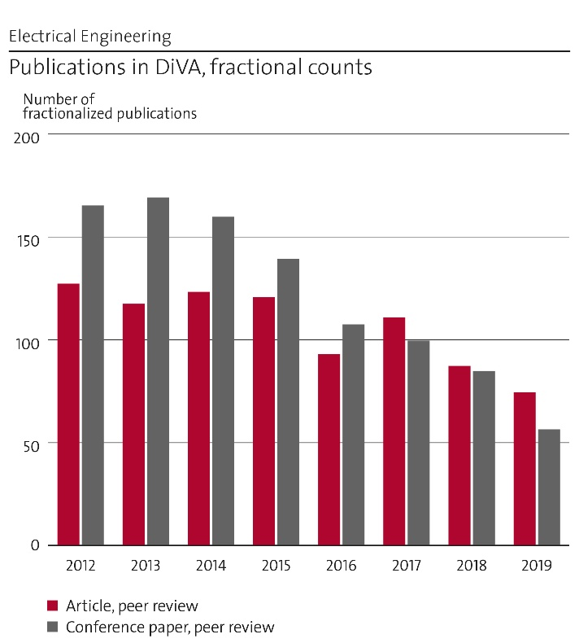
Figure 2 Publications, journals vs. conference proceedings
The impact of our published work can be judged from the so-called citation factors for articles (cf) and journals (jcf), see Fig. 3. The EE department as a whole is well above the average 1.0 baseline. Our efforts to improve the metric are further discussed in the section on publication strategy below. One possible explanation for the drop of the jcf towards to 1.0 level is a relatively conservative choice of journals. Some faculty have targeted new emerging high impact journals but some have continued to publish in e.g. the traditional IEEE journals.
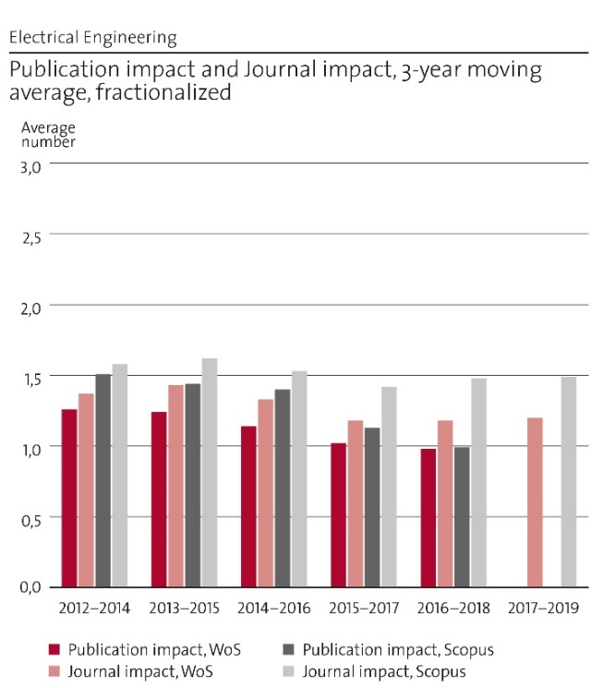
Figure 3 Citation factors for articles and journals
The department as a whole shows a rising trend for international co-publications see Fig. 4. Co-publication within Sweden has remained close to 20 % over the same period. The international co-publications are on a very high level and is a result both from collaborations in international space missions and the European activities in the fusion area but also from individual collaborations on researcher level for e.g. electronics. As the department has such a strong support and connection with industry in many fields of research it should be possible to increase the level of co-publications with industry researchers on a national level.
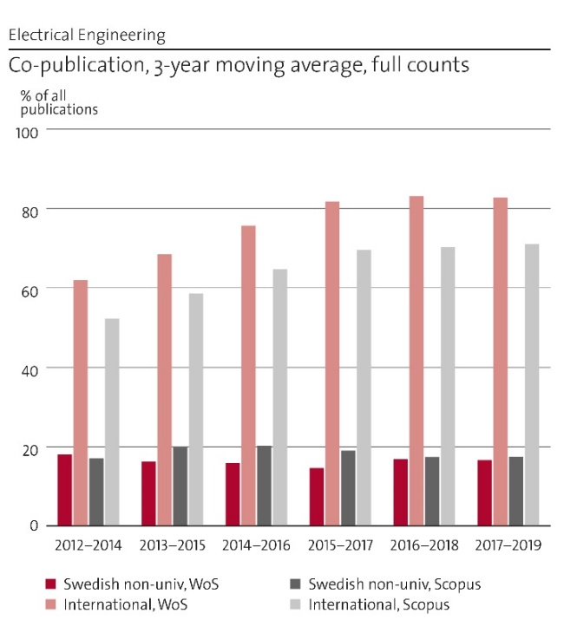
Figure 4 Co-publication metrics

Selected Publications 2012-2019

A few selected publications from each division or research field that have been selected to represent research areas that are still active or that have contributed to the formulation of new research questions. The selection is not only based on high numbers of citations, but also selected to show emerging fields of research, that by nature has not yet accumulated a high number of citations.
The number of citations in Google scholar is provided in parenthesis (GS#), citations on May 5th 2021.

[1] Jiantong Li, Fei Ye, Sam Vaziri, Mamoun Muhammed, Max C Lemme, Mikael Östling, ”Efficient inkjet printing of graphene,” Advanced Materials 25, 3985-3992 (2013), https://doi.org/10.1002/adma.201300361
Several of our key publications are from emerging areas where more junior faculty are research leaders. This paper is one of the first publications on reliable inkjet printing of graphene for electronics (more than 300 citations). (GS390)

[2] CM Zetterling, A Hallén, R Hedayati, S Kargarrazi et al, ”Bipolar integrated circuits in SiC for extreme environment operation,” Semiconductor Science and Technology, 2017, https://doi.org/10.1088/1361-6641/aa59a7
Invited article showing our pioneering work in SiC integrated circuits for extreme environments demonstrating operation at 500 C and radiation hardness. (GS25)

[3] E. Dubrova, ”Fault-tolerant design,” Springer, 2013
Widely used and well-cited text book (287 citations in Google Scholar). Used by more than 20 professors at various universities. (GS268)

[4] K. Ilves, A. Antonopoulos, S. Norrga and H. Nee, "Steady-State Analysis of Interaction Between Harmonic Components of Arm and Line Quantities of Modular Multilevel Converters," in IEEE Transactions on Power Electronics, vol. 27, no. 1, pp. 57-68, Jan. 2012. (486 citations).
The power electronics group has been successful in publishing highly cited publications in both the modular multilevel converter (MMC) field and SiC power electronics field. Our publications are not just cited in academic papers, but also in patent applications, which testify to their value for applications. This paper provides a comprehensive analytical model for explaining the behaviour of a modular multilevel converter. (GS574)

[5] Baradar, M., Ghandhari, M, “A multi-option unified power flow approach for hybrid AC/DC grids incorporating multi-terminal VSC-HVDC,” IEEE Transactions on Power Systems 28 (3), pp. 2376-2383, 2013
A multi-terminal HVDC grid (MTDC grid) has been seen as a solution to allow a massive integration of renewable energy sources in the European power system. The contributions of the group include knowledge on technical as well as techno-economic limitations and control and operational issues. In this paper, a new general unified AC/MTDC power flow calculation was proposed. (GS151)

[6] Samadi, A., Eriksson, R., Söder, L., Rawn B.G., Boemer, J.C. “Coordinated active power-dependent voltage regulation in distribution grids with PV systems” in IEEE Transactions on power delivery 29 (3), 1454-1464 (192 citations) Study on distribution grid voltage regulation in presence of large amounts of renewable generation. (GS192)

[7] Karlsson, T. et al., “On the Origin of Magnetosheath Plasmoids and Their Relation to Magnetosheath Jets,” Journal of Geophysical Research: Space Physics 120, no. 9 (2015): 7390–7403. https://doi.org/10.1002/2015JA021487. (28 citations)
Many publications are the result of KTH contributions to large international space projects, such as NASA MMS and ESA Cluster missions. The dynamic properties of magnetosheath are still one of the major unsolved topics in space science. This study, based on data from the Cluster mission, shows how different types of plasmoids form in the magnetosheath and how they relate to the magnetosheath jets. (GS36)

[8] L. Vignitchouk, P. Tolias, and S. Ratynskaia, “Dust–wall and dust–plasma interaction in the MIGRAINe code,” Plasma Phys. Control. Fusion, vol. 56, no. 9, p. 095005, Jul. 2014, doi: 10.1088/0741-3335/56/9/095005. (37 citations)
MIGRAINe is a group-made unique dust dynamics code that encompasses all aspects of dust-plasma and dust-vessel interactions that are relevant for dust transport and survivability in contemporary as well as future fusion devices. It has been employed as a predictive tool of dust accumulation sites in ITER. (GS72)

[9] P. Ström, P. Petersson, M. Rubel, G. Possnert, “A combined segmented anode gas ionization chamber and ToF detector for heavy ion elastic recoil detection analysis,”Rev. Sci. Instrum. 87 (2016) 103303 (53 citations)
The division of fusion plasma physics (FPP) has made a major contribution to the scientific knowledge in the field of plasma-wall interactions; crucial for safety and economy of reactor operation. During the period 2012-2019, over 100 papers have been published and 12 submitted on this research theme. This paper demonstrates a crucial tool for quantitative surface analysis with depth profiling of material from metal-wall fusion devices was fully developed. (GS70)

[10] Y. Kazakov et al (including T. Johnson), “Efficient generation of energetic ions in multi-ion plasmas by radio-frequency heating”, Nature Physics 13, 973 (2017). (39 citations)
A new class of ion cyclotron radio frequency heating scenarios have been developed and experimentally verified. The three-ion neutral beam injection scenario was proposed by the group in collaboration with Y. Kazakov.(GS67)

[11] O. Quevedo-Teruel, J. Miao, M. Mattsson, A. Algaba-Brazalez, M. Johansson, L. Manholm “Glide-symmetric fully-metallic Luneburg lens for 5G Communications at Ka-band”, IEEE Antennas and Wireless Propagation Letters, vol. 17, no. 9, pp. 1588-1592, 2018.
The research in electromagnetic theory, including metamaterials and antennas, is to a large extent published in IEEE journals, there gaining high citation numbers. As examples (according to Clarivate Analytics), we have co-authored the most cited article in IEEE AWPL in 2018. Glide symmetry is able to reduce the dispersion and increase the equivalent refractive index. The lens is very efficienct since it is fully metallic, with very low scan losses. This was the first lens antenna based on glide symmetry ever proposed in the literature. (GS120)

[12] Marley Becerra, Jonas Pettersson, Steffen Franke, and Sergey Gortschakow, “Temperature and pressure profiles of an ablation-controlled arc plasma in air”, Journal of Physics D: Applied Physics, Volume 52, Number 43, 2019, Special Issue on Thermal-Plasma-Material Interactions
A recent research field related to high voltage components is related to polymer-ablation due to electric arcs during current interruption, a recent example from our research with collaboration from industry (ABB). (GS2)

e. Engagement in national and international research collaboration within academia and its outcomes

During the last ten years, EE has been engaged in several national and international networks. The most important ones are described here.

STandUP – a Strategic Research Area (SRA)
STandUP (STockholm and UPsala) is a research alliance between Uppsala University, KTH, The Swedish University of Agricultural Sciences and Luleå University of Technology that from 2009 began to receive government funding for identified Strategic Research Areas (SRA) The main mission of STandUP is to reinforce research on large-scale renewable electricity production and its integration into the electricity network, and integrate electric vehicles into the electricity system. In collaboration with industry and society, STandUP contributes to the development of technology and services for a more sustainable society in line with Agenda 2030 of UN.
One outcome of STandUP was a new applied physics lab for fundamental investigations on advanced phenomena in high voltage insulation involving new materials. We studied nanofluids, engineered cellulose and influence on polymers in a polymer-ablation in arc-interruption in circuit-breaker applications. In a collaboration project with ABB, a laboratory prototype for an extremely fast switch that uses magnetic forces was developed, which has eventual applications in HV DC and AC breakers. The research on energy storage systems was also started within STandUP and collaborations with Uppsala University.

KIC InnoEnergy
KTH is an active participant in EIT KIC InnoEnergy, which started in 2010 and was together with Uppsala University, ABB and Vattenfall very active partners of the Swedish node. The whole consortia consisted of 11 partner universities across Europe and many industries. EME and EPE had a leading role in several innovation projects within KIC InnoEnergy, notable among them on Controllable and Intelligent Power Components (CiPOWER), and was a leading partner in the coordination of the InnoEnergy PhD School. Several of our PhD students were on mobility to other research groups around the world under the mobility programme of the PhD school. Since then, staff from EE is also coordinating and teaching the MSc program SENSE with six partner universities.

SweGRIDS
SweGRIDS, the Swedish Centre for Smart Grids and Energy Storage was started in December 2011, as a partnership of academia, industry, and energy agency (Triple Helix model). The main partners of SweGRIDS are the universities KTH and Uppsala University, the power equipment manufacturing company ABB, the public utilities Vattenfall, Ellevio, and E.ON, Swedish National Grid company, Svenska kraftnät (SvK), the material manufacturing companies Höganäs and FoV Fabrics, and the Swedish Energy Agency. The yearly cash funding to SweGRIDS is on average 30 million SEK. The mandate of SweGRIDS is to develop new and improved devices and methods that will help achieve Sweden’s and the European Union’s ambitious targets for greater use of renewable energy sources and improved energy efficiency. SweGRIDS brings together various disciplinary areas like power systems, electromagnetics, material, physics, and information technology for a common purpose. Flexible power systems, digitalization of power grids, controllable power components, and new materials for electric grids and storage are the main topics of research. There are currently around 30 research projects in SweGRIDS, each involving industrial and academic researchers working with a PhD student or Postdoc. SweGRIDS is primarily managed from EME. SweGRIDS also provides additional funding for its students up to 6 months research training visit to anywhere around the world.
During spring 2021, an application for a “GreenGrids” competence centre is under preparation, with a target to reach a competence centre of about the same size as SweGrids.

Swedish Electromobility Center
The Swedish Electromobility Centre (SEC) is a national Centre of Excellence, founded in 2007, for electric and hybrid vehicles and infrastructure. It unites Swedish e-mobility expertise and is a node for interaction between academia, industry and society. KTH is deeply involved in the centre from different areas within the Division of Electrical Power and Energy Systems.

CHASE and CHASE-ON
Chase and its current form Chase-On are funded by Vinnova and has been running since 2012. It is a collaboration between Chalmers, KTH, SP/RISE and a large number of industrial partners. For KTH's part, our main industrial partners are Ericsson Research, SAAB, RUAG and Keysight. The goal of our projects in Chase was on wideband arrays with large scan-range and resulted in two patents on wideband arrays with Ericsson Research. It also resulted in a number of published papers and results on array antennas, like the array figure of merit. The research in Chase-On is on highly integrated antennas in the >20GHz range. The group in EME are also participating in the SSF-project on "Complex analysis and convex optimization for EM design" for 5 years with Lund University, Växjö University and Stockholm University. This project resulted in the multi-disciplinary work between mathematics, physics and electrical engineering for optimal antennas.

SiNano Institute
Since 2008, EES is a member of the SiNano Institute. SiNano is a non-profit association established as a durable EU Network of researchers in order to form a distributed Centre of Excellence in the nanoelectronics domain, without about 20 academic partners. The objectives are to promote research, development and cooperation in order to strengthen the international impact of European activities in nanoelectronics.

Brazilian Partner Universities
In the embedded systems software area, we have connections to two Brazilian universities with strong interest from companies in the aviation industry, like Saab AB. Through this network, we have recruited several PhD candidates and postdocs. The activity also includes joint courses on the master level.

Cadence Academic Network
KTH is Lead Institution in Wireless Radio and RF Design Methodology within the Cadence Academic Network. The aim is to promote the proliferation of leading-edge technologies and methodologies at universities renowned for their engineering and design excellence. The knowledge network was established to facilitate the sharing of technology expertise in the areas of verification, design and implementation of microelectronic systems.

EUROfusion Consortium
The research at FPP and the SPP Complex Plasma Group is highly integrated in the joint programme of the EUROfusion Consortium. The Consortium implements the European fusion research program in the H2020 framework programme through a co-fund grant from Euratom. KTH is a linked third-party member of the EUROfusion Consortium through the Swedish consortium member VR (The Swedish Research Council). Through this collaboration, the Division can fully take part in the fusion research activities on the European and international arena. This mean access to a network of researchers for collaboration and expertise, access to research facilities like the large JET Tokamak, a number of medium-sized fusion facilities MAST-U, ASDEX-Upgrade, TCV, Wendelstein-7X and also to the financial support instruments of the EUROfusion Consortium.

International Tokamak Physics Activity (ITPA) and ITER organisation
The Division is contributing to the International Tokamak Physics Activity (ITPA) working groups, for example as an active member of the ITPA Pedestal and Edge Physics group, and arranged an ITPA-PEP group meeting recently at KTH. The Division has a close collaboration with the ITER Organisation on integrated modelling (T. Johnson is an ITER-Science Fellow in Integrated Modelling).

International Fusion Material Irradiation Facility (IFMIF), other Japanese and Chinese Collaborations
Researchers at the Division participates in the European-Japanese Broader Approach Work Programme with involvement in the International Fusion Material Irradiation Facility (IFMIF) Project Committee, and Material studies at International Fusion Energy Research Centre (IFERC) in Rokkasho, Japan. Recently a MoU was signed between KTH and Chinese Academy of Sciences Institute of Plasma Physics (ASIPP) for collaboration on fusion research.

Swedish Fusion Research Unit
Fusion research in Sweden is coordinated through the Swedish Fusion Research Unit, formed by VR together with the three linked-partner universities Chalmers, UU, KTH and Studsvik Nuclear in Nyköping.

f. Follow up from previous evaluations

A common remark for several divisions was the recommendation, to increase international mobility of the research staff. In our opinion, this situation has clearly improved over the time span 2012-2020. Both the junior and senior faculty have participated in mobility schemes to industry (in Sweden) and internationally through e.g. Marie Curie grants. The department as a whole is relatively strong with respect to incoming adjunct faculty. We appreciate the need for a balance of outgoing faculty as well.
The panel got the recommendation that for tenure track positions the internal promotion should be balanced by external recruiting. Four tenure track assistant professors hired so far (2012-2020), we have two external recruitments, and two internal. In addition, we have some internal recruitments at associate professor level. Additional recruiting at assistant professor level is ongoing.
Some divisions manage to fund permanent technical support staff for maintaining the experimental platforms. In these cases, the experimental platforms are organized as KTH infrastructures and some income for maintenance, salaries and tool upgrade is obtained from user fees (KTH and industrial users have differentiated rates). Projects are charged internally for the hourly use.
Experimental work in the electronics area now includes emerging 2D material (graphene) for e.g. printed and flexible electronics. This is a good complement to the strong experimental silicon-based activities in the cleanroom environment.
The organization, leadership and long-term strategies in the Electronics and Embedded Systems area have been reinforced by the merger of these units.
The RAE 2012 panel pointed out that the fusion field is heavily dependent on the evolution and future of large-scale programs, and it is important that the group positions itself clearly in the European roadmap in a 10-year timescale. On this aspect of the panel review, the Division of Fusion Plasma Physics has had a good development. During the period 2012-2019, the Division has successfully adapted its research profile to the European fusion programme, and the research is now highly integrated in multiple work packages of the EUROfusion work programme. The Division has contributed project leader for one EUROfusion Work Package in the area of plasma wall interactions (WPJET2, M. Rubel). Further, the Division collaborates today closely with ITER organisation in the area of integrated tokamak modelling.

3. Viability

a. Funding; internal and external

The funding of the departments’ research is about 55% funding agency research grants and 45% FOFU (governmental funding to KTH for research and doctoral studies), see Fig. 5. If we analyze data at division level, we find that EES, EME and EPE have roughly a 50-50 distribution, whereas FPP and SPP are more dependent on funding agency grants. Other income and industrial/external funding is a minor contribution. It is clear that the research is heavily dependent on successful applications to funding agencies. The positive side is that we manage to attract that amount of funding from external sources, but with the drawback that we easily can turn into problems in case the external funding picture will change.

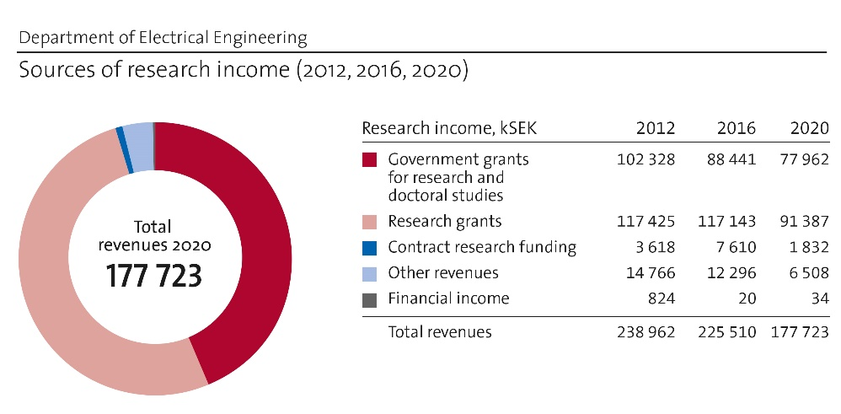
Figure 5 Total research funding at Department of EE 2013-2019.
The trend is explained by a decreasing number of PhD students in the system, due to completion of the SETS PhD program and a phasing out of the InnoEnergy PhD School that also has a connection to the SweGrids project. Also to the termination of a few larger grants during the period that has ended, for example an ERC grant and grants from Wallenberg foundation.
The sources of the external funding are provided in Fig. 6. The rough picture is that the Energy Agency (STEM) has a dominating role for the more energy related divisions (EPE and EME), FPP has a dominating part of EU funding in the form of the EuroFusion project and SPP is much dependent on the Swedish National Space Agency plus some EU funding. EES has their funding more distributed between VR, Vinnova and SSF (not shown). In general, we have a good spread in funding sources on a total level, which is good from a department point view as it stabilizes fluctuations. In general, more can be done to secure EU funding.
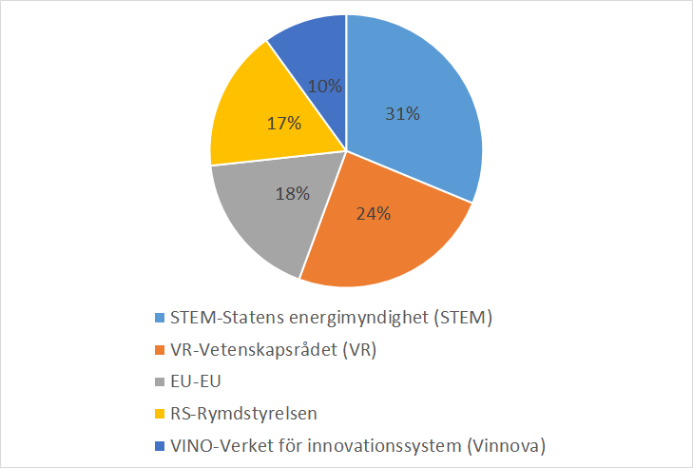
Figure 6 Relative contribution from five largest sources of external funding at Department of EE 2019

Case study on division level funding
An example of how we work around research funding is provided below for the Division of Fusion Plasma Physics. Similar strategic funding descriptions can be formulated for other divisions. It is then clear that the different research fields differ quite much in strategy, but from a department level, it is clear that we cover all possible national sources for research funding.
The Euratom funding made available to the Division of Fusion Plasma Physics through EUROfusion Consortium is in the form of a co-fund grant, where about 45% of the financing of the programme must be contributed by the Consortium members from their national sources. The co-financing of the participation of the Division has to come either from external research grants or from the KTH faculty funding. The main external funding available to the Division is research grants from VR (The Swedish Research Council). Although the researchers at the Division have been reasonably successful in the past in obtaining project grants, the dependence on a single national funding agency (VR) gives an unhealthy sensitivity in the research budget. The Division has tried to obtain funding from STEM (The Swedish Energy Authority), but with limited success. In this case, the long-time horizon for fusion research is a problem. So far, the collaboration with Swedish industry has been very limited. However, as the fusion programme moves closer to a demonstration reactor (ITER planned to start operation around 2025) this may open up new possibilities in the longer time-perspective for industry collaboration and funding from other national agencies such as Vinnova.

b. Academic culture
The academic culture is built bottom up, from the individual research group leaders and the students, post docs and technical staff that participate in the daily and weekly research and educational activities. The research groups are in general led by professor or assistant/associate professors in a tenure track position. The research groups contain commonly a number of PhD students, from time-to-time a Postdoc and sometimes researchers on external funding. MSc students that take part in research projects in form of their thesis projects is also common. Building on this faculty interaction on topics shaping the academic culture such as publication strategies, ethics, quality in education, student assessment, and grading happens in a large variety of fora ranging from division and department meetings, to course evaluation meetings and faculty workshops for planning and strategy. Regular seminars at the group or division level where ongoing research is presented and discussed is a common forum for discussion and development of the academic culture. Finally, one very important forum for quality assurance in research are the PhD defences, both in terms of the quality assurance preceding the defence, but also the discussions during and after the defence.
Several areas have also a strong tradition of industry collaborations and there are many examples of adjunct professors and affiliated faculty members that nourish the research with many ideas and industrial context.

c. Current faculty situation
The present staff and faculty situation is quantitatively described in Fig. 7. The permanent faculty consists of 28 Professors, 16 Associate Professors, 2 Assistant Professors. The faculty situation is sufficient in numbers of professors and associate professors after the recent recruitment of four associate professors and the faculty will grow more slowly in the next years. However, there are a few assistant professors, as during the evaluation period some have been promoted to associate professors. It is foreseen that the upcoming retirements will be replaced by assistant professors with an estimate of about one per year in the period 2022-2027. During the period the number of PhD students have decreased, but from an historical high number. The number of PhD students will likely increase again, but we do not foresee that we will come back to the numbers around 100 that we had around 2012-16. The number of Postdocs was high in 2012 and has since then decreased a bit. Here we have the ambition to increase to the same level again in the upcoming years.
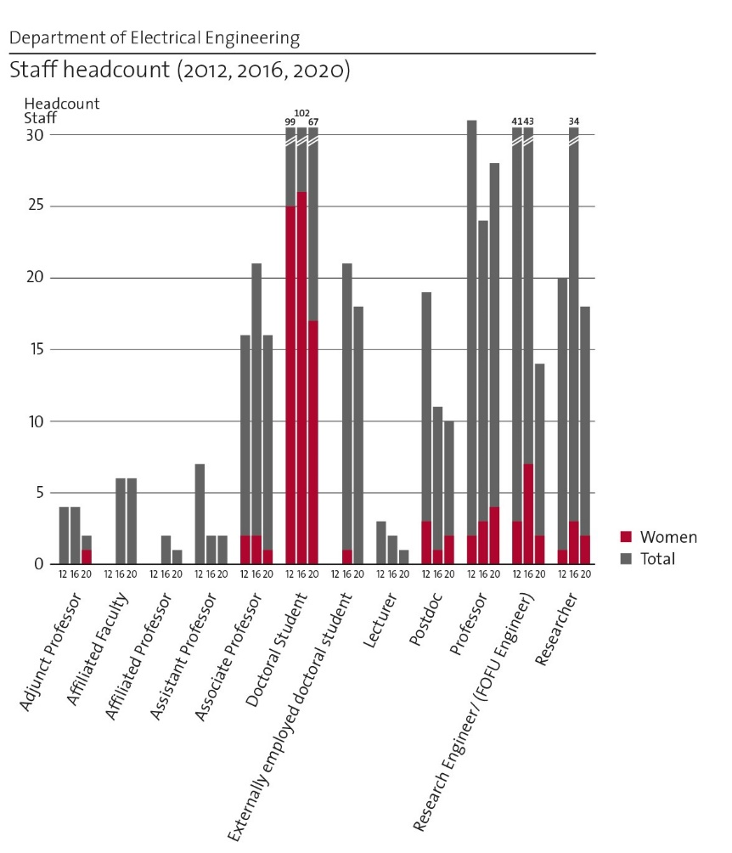
Figure 7 Staff at Department of Electrical Engineering
The average age of faculty across the department is quite high and the faculty is very unbalanced along the gender dimension. However, out of the latest eight recruitments, 50% have been women indicating a positive trend. Eight professors are due to retire within the coming 7-10 years (one female). The faculty is also tilted towards the higher ranks, with many more professors than associate and assistant professors. This is quite normal considering the tenure track system at KTH. It creates a situation with low level of flexibility and adaptability to new topics and research directions. On the positive side, it is apparent that the junior faculty – assistant and associate professors are all developing individual lines of research complementing and expanding upon the incumbent areas of the senior faculty. This holds good promise for a continuing development of the subject area at KTH.
The efforts for recruitment and career development are coordinated at the school level. Two efforts pushed from the department perspective is a high focus on recruiting female faculty – it is only through successful recruitment of women that the gender balance issue can be addressed. Second, better support for career development for faculty already at KTH, both men and women, needs to be put in place. An important tool here is education of group and division managers on topics such as coaching, gender balance and equal opportunities. Recently, a female professor was recruited, as Head of School at EECS. Her research area is within the EPE division

c. Recruitment strategies
We use open calls with as wide subject topics as possible, for recruitment at all levels and distribute announcements via as many channels as possible. The recruitment strategy has a clear focus on international recruitment of strong talents. This method not only provides the best chances of attracting the best talents, it also provides a safeguard against unconscious bias and recruitment from the immediate research environment. Second, the recruitment policies put in place at KTH for PhDs and Postdocs enforcing a second opinion and mandating written documentation of why the top candidate was selected is a concrete tool to avoid bias.
For recruitment at the faculty level, a necessary requirement to initiate recruitment is an identified present or coming need within education. The rationale being that we need to secure our ability to teach all basic and starting level advanced courses before expanding into new topics. When a recruitment has been initiated however, the top most criteria is that we recruit the candidate with the strongest research merits. Recruitment is primarily done at the assistant professor level, again according to the above strategy.

d. Infrastructure and facilities
The laboratory facilities within EE reflect the strong focus on experimental research at the different divisions. The Electrum Laboratory is a separate organisation, centre on School level, but well connected to the EES division and is also part of the national infrastructure Myfab. The research infrastructure within EME and EPE has recently been transferred into a new infrastructure – the Sustainable Power Lab (SPL). SPL will host an infrastructure for research and innovations for projects with electric power and electromagnetic implementations. The FPP divisions hosts the in-house experimental device EXTRAP T2R for production of plasmas under magnetic confinement. The SPP divisions hosts equipment for an own electronics laboratory with typical equipment for space electronics development. The department also host several computer clusters for high-performance and memory intensive computations. The four divisions (EME, EPE, FPP and SPP) located at KTH Campus also share a common mechanical workshop.

Electrum Laboratory (for more details refer to the self-evaluation report)
Electrum Laboratory at KTH, school of EECS – together with Albanova Nanolab at KTH, school of SCI – constitutes the KTH node of Myfab, the Swedish national distributed infrastructure for micro and nanofabrication. Electrum Laboratory is a resource for education, research, development, prototyping and small-scale production of a wide range of devices based on nano- and microtechnology. Electrum lab is a separate organization at the School level and receives strategic infrastructure funding from central KTH level and national infrastructure funding from VR. The renewal of tools at the laboratory is continuously driven by the explicit demands from the user groups, and financed from various sources; e.g., the user groups themselves, KTH infrastructure grants, and Swedish funding agencies. In order to maintain reproducible high quality processes, preferably refurbished industrial tools are installed, rather than standard research tools. The lab is a base for leading research groups at KTH and other Swedish universities. It plays a strategic role as a production incubator for high tech spin-off companies.
Electrum Laboratory comprises an extensive expertise and infrastructure, including complete processing lines for silicon CMOS and silicon carbide based integrated circuits, photonic device fabrication and micro-mechanical systems. Currently the efforts are directed towards the establishment of process lines for heterogeneous integration of devices. Hence, semiconductor circuits will be integrated with non-conventional device functions, such as biosensors, chemical sensors, energy harvests, and optical components, which are required to meet the demands on future interdisciplinary device research projects.

Sustainable Power Laboratory (for more details refer to the self-evaluation report)
As part of the KTH deputy president’s initiative to develop a programme for central supervision and processes for support of research infrastructures at KTH, the EE divisions EME and EPE have developed the Sustainable Power Lab (SPL). The SPL qualified as one of KTH’s 12 official research infrastructures in early 2020, which entitles the included laboratory facilities to KTH central funding and support for advanced instruments and equipment. The SPL facilities include high power and high voltage supplies for AC and DC, as well as testbenches for electric machines, facilities for power electronics component binding and packaging, and comprehensive facilities for testing and prototype development. Additionally, the SPL houses a multi-core real-time hardware simulator capable of simulating in real-time 100+ bus power systems. The SPL-lab is presently under development with setting up introductory and safety courses, and a booking/billing system.

Infrastructure at Division of Electromagnetic Engineering
Equipment for characterization of antennas and electromagnetic radiation:
Electromagnetic Anechoic chamber. There is a Vector Network Analyzer (VNA) up to 70 GHz. A high voltage laboratory with versatile equipment for studies of insulation system, arcs, polymer ablation, etc. with a multi-test system for AC, DC and impulse test up to 400 kV. Measurement equipment consists of two dielectric frequency response analysers (DFR) and two equipment for phase-resolved partial discharge (PD) measurements (PRPDA), including a shield room for low-level PD measurements. Two high speeds cameras (up to 100 000 frames/second) for control of fast mechanical evens as well as plasma diagnostics. The lab also hosts high current sources for electrical testing of contacts and breakers up to 80 kA impulses and 5 kA AC (one cycle). There is also a multi-channel optical spectrometer from spectral range between 200 to 900 nm for plasma diagnostics. For EMI investigations there are a GTEM Cell, an EFT transient generator (NSG-3040-IEC) and a UWB generator (FPG 20-1PM). Future investments: The new applications are requiring new antenna and microwave devices in sub-THz (100-300 GHz) for 6G communications. At KTH, we should start moving in this direction and upgrade our infrastructures to be able to measure at those frequency regimes.
HVDC systems becomes more and more critical, some equipment of need is equipment for characterizing space charge accumulation in solids. Electro-optical equipment for studying electrical fields in liquids and on surfaces is also of interest.

Infrastructure at Division of Fusion Plasma Physics
The in-house experimental device EXTRAP T2R operated by the Division of Fusion Plasma Physics produces a high energy density ionized gas – plasma – utilizing the method of magnetic confinement. The plasma has multiple potential uses, such as research on magnetic confinement fusion, materials research, and other plasma applications. The EXTRAP T2R device has been regularly upgraded and modified over the past years, to provide possibilities for front-line research. The most significant recent upgrade has been the installation of a state-of-the-art plasma instability control system, utilizing arrays of active magnetic field coils, enabling front-line research in the area of active control of plasma instabilities. The device is currently used as a testbed for plasma instability control system development. The device is valuable for the research education at KTH and on the national level, being the only experimental fusion device in Sweden.
The division uses and contributes to the development of the national infrastructure Tandem Laboratory at Uppsala University. We are involved in development of a tool for quantitative surface analysis with depth profiling of material from metal-wall fusion devices installed at the accelerator in UU.

Infrastructure at Division of Space and Plasma Physics
The division has its own electronics laboratory with a typical equipment for space electronics development. In addition, the division is an important user of external major infrastructure facilities, such as thermal vacuum chamber at the SCI School, SSC rocket launch facility at Esrange, incoherent ionospheric radar EISCAT, ground magnetometer networks and others.
The complex plasma group purchased a computer dedicated to exploratory numerical simulations requiring moderate computational resources (100-1000 core-hours per run). Such simulations are typically too costly for conventional workstations, but remain manageable without resorting to high-performance computing facilities such as shared clusters. Concerning large scale, high performance computing resources, the group utilizes the Swedish National Infrastructure for Computing (SNIC) for CPU-based molecular dynamic simulations, the Roskilde cluster for GPU-based molecular dynamics simulations, the ITER cluster for computational fluid dynamics and European Supercomputing Centers for plasma simulations. The use of national and international high-performance computing resources is unavoidable, but the acquisition of more advanced workstations in the near future is important.

4. Strategies and organisation

a. Goals for development 5–10 years ahead
As a newly formed department, but with roots in electrical engineering, the science that during the last hundred years has reshaped the society the most, we as organization are confident to take on the challenges for the future. The strategic decisions that need to be taken already now and that we will work on during the next 5-10 years have their overarching origin in the 17 Sustainable Development Goals formulated by the United Nations.
Some of these SDGs have a clear contribution from EE and is in-line with our strategies:
SDG 7: Affordable and Clean Energy: The world has already started a transformation from a fossil based energy supply towards a sustainable world based of hydro-, wind- and solar power, and contributions from wave power is under development.
• EE will continue to provide research of importance for ensuring that the electric power grid can host all possible energy sources and still operate under stable and efficient conditions.
• EE contributes to the development of large-scale fusion power.
The goals that contribute to SDG 7 has also an impact on SDG 13: Climate Action as the renewable energy sources emit significantly less greenhouse gases. In SDG 13 we also contribute to the electrification of the transport sector with new core knowledge and innovative solutions from several areas within EE such as electrical machines, power electronics and electronic systems. This is also a contribution to SDG 9: Industry, Innovation and Infrastructure.
Electronics and embedded systems form an area that can contribute, to many fields depending on the final implementation of the developments. Examples exists already where we contribute to health science (SDG 3, 9 and 10) in the form of innovative products, see also section 6d on impact cases. Electronics for extreme temperature conditions is an example that has an impact for space research and leads to new findings about the universe that surrounds us.
SDG 4: Quality education.
We continue to develop quality in education.
Within 5 years we have:
• Increased the number of digitalized courses
• Increased the number of specialized courses for life-long-learning and attracted industry participants to courses with course content close to research fronts
• We have increased the share of national students in electrical engineering
• We have a broad portfolio of international master programs
• We have continued and strengthened our participation in EIT programs

The means to reach the goals and contribute to the global SDGs is through a strong and competent faculty where we also continuously increase the gender balance. We further strengthen the collaborations with the surrounding industry and we increase our international research collaborations.

b. Congruence with university-level goals for “A leading KTH” as set out in KTH´s “Development Plan 2018-23”

The EE department is highly active in all possible activities for a leading KTH, this whole document is a summary of our contribution to a leading KTH and will not be explicitly summarized here, but we will reflect on the other points.
An integrated KTH: The EE department contributes with both teaching of fundamental courses on BSc level, but in particular with advanced courses on master level that over the years have been developed in close collaboration with the research. Our atmosphere is very open for students. For example, in master thesis projects we are good in connecting the students to our on-going research or with industry. We also have a sufficient infrastructure for research and teaching. We have the Electrum laboratory and we have the lab activities at Campus. We are presently taking a next step in the development of our infrastructure in the formation of the Sustainable Power Lab (SPL). We focus or teacher recruitments to emerging fields and follow the quality requirements that is expected; we also have a particular focus in all new recruitments to focus on improving our poor gender balance.
Our contribution to ‘A more sustainable KTH’ is through providing real key enablers such as advanced technology developments and deep-level understanding of system aspects that realizes the energy transition. All areas contribute in different ways, for example to provide energy efficient solutions in all aspects of electrical engineering whether it is energy efficient electronic systems, antennas or power electronic systems for high power applications. We are part of important collaborations and consortia such as STandUP, SweGrids and InnoEnergy. These initiatives have rendered many PhDs that have been hired worldwide, but also new strategic teacher recruitments.
We contribute to ‘An open KTH’ as we are highly involved in creating creative and innovative study environments (contributing to several master programs, hosting Mentorspace, CrEE-lab, REXUS student space satellite project). We can do better on teacher mobility from academia to industry, although we have a good influence from industry through adjunct and affiliated professors and a strong industrial network with much collaboration. We can do more on life-long learning and we have addressed that in our goals. Our work environment is good, but stress can be reduced among the staff that is something that we are aware of.
‘An increasingly digitalised KTH’: the roots of digitalised technology are of course within EE. When it comes to education, we follow the evolution and adapt quickly to the requests from stakeholders such as students and industry.
‘A more international KTH’ is manifested within EE in many ways: a significant portion of teachers with a background outside Sweden, a large number of international students, coordination and teaching of several master programs with a large number of international students. We have taken the leadership in the collaboration with universities in many situations, such as all partner universities within InnoEnergy and a recent agreement with IIT Madras. We are engaged in several EU-projects, but a goal is to strengthen the engagement further.
When it comes to ‘An equal-opportunities KTH’ we have to confess that we have a low number of women among the staff and the faculty. We work hard on the task and are quite successful on PhD recruitments with up to 20% female students during periods. Any new position is carefully selected in order to foresee that the field can attract female applicants.
Digitalisation: Digitalisation permeates almost all what we do. In 5-10 years, we can offer more of our teaching in well-designed courses that can be offered globally. Digitalized courses will also be a natural form of teaching subjects with a high actuality in a “life-long learning” framework. More research projects will be based on larger amount of data collected from specific situations, and in collaboration with industry and society for data access.

c. Leadership structure and collegial structure

The purpose of the formal leadership and delegation of authority within the department and divisions is to handle research, education financial, HR, and administrative matters in an efficient and transparent way. We have yearly cycles for development processes in place and the short-term operation is handled during management meetings at the department level. Within the divisions, the collegial structure has a stronger impact, where most plans and decisions regarding strategic direction, educational changes or investments require a broad consensus among faculty to be successful during implementation. Boundary conditions for research, staff and educational development are set at the department level, and much of the actual decisions and implementation is done within a collegial structure at the respective divisions. In addition to the division level collegial structure, the department also benefits from having four members on the EECS school level faculty assembly.

d. Strategies for high quality
Each of the diverse research areas within the department is trying to follow a strategic approach, some common ingredients of those approaches are given below. In future, it may be useful to have the strategies better documented. This may be helpful to identify synergies and new strategic investments.

Leveraging our experimental infrastructure

A key strategy is to utilise the existing laboratory infrastructure up to its creative limits. It is also an evident strategy, within the department, to focus on building up long-term research collaborations with larger industries and large public organisations. Such collaborations include exchange of supervision capacity from industry. The strategic collaboration is sustained by generations of educated PhDs that take on specialist and leading roles in industry and public organisations.

Regular follow-up

Our strategies for high quality follow a combined bottom-up and top-down approach. Bottom-up, much of the quality assurance is implemented via the individual researchers’ and supervisors’ ethics and desire for excellence. Quality checkpoints are e.g. internal quality reviews in conjunction with PhD defences. For the faculty and research staff individual development dialogues with division heads are mandatory and include research quality assessments. From the top-down perspective, the quality assurance is governed by regular updates of the department development plan, and follow-up of this plan within the school.

Publication strategy

Our current publication strategy is based on an exercise 2018/2019. In this project, the division level input was aggregated into a school level publication strategy. It was clearly recognized that the research topics differ in nature so each division needs to use this strategy as a guideline, within their scientific context.
The strategy covers aspects, such as quality assurance in publication, use of metrics (cf. and jcf) as discussed and illustrated above, and increase of Open Access publishing. A set of best practices was compiled under these descriptive headings:
Publication awareness, publication prudence, publication availability, publication planning, publish together, Publication PR

5. Interaction between research and teaching at all three levels (BSc, MSc, PhD) of education

The courses given by the EE department are all taught by assistant, associate or full professors or docent competent researchers. As an implication, there are high incentives that teachers can exemplify from recent research in their teaching, irrespective of course level.
Teaching on BSc level (First cycle) is on a fundamental level. The department is involved in the two, five years (300 credits) Degree Programmes in Electrical Engineering, (CELTE) and Information and Communication Technology, (CINTE), where courses from EE forms the backbone to build upon in later courses. Courses are also provided to the degree programs in Energy and Environment, (CENMI), and Engineering Physics, (CTFYS).
The department is responsible for the Degree program (högskoleingenjör) in Electronics and Computer Science at Bachelor level. This program is located at Campus Kista. The department is also involved in the degree program (högskoleingenjör) in Electrical Engineering and in particular the track towards Electrical Power.
The research methodology is for example trained and gradually built up in project courses where achieved knowledge is applied in projects and finally in the First Cycle Degree Projects (15 hp). One example is from the CELTE program where there are projects in year 1 (EH1010), year 2 (EN1020) and year 3 (degree projects) that forms a progression line with gradually more advanced themes.
As a department with a high degree of applied science, most of the teaching is on MSc level (Second cycle) level and with a natural transfer of recent knowledge into courses in the form of new assignments, project tasks etc. The advanced master courses are naturally the bridge to the master thesis degree projects, which commonly are performed in connection to industry R&D projects or to on-going research projects at some research group. PhD students are commonly involved as teaching assistants in courses on BSc and MSc levels and can there provide influence from research. Beside of that, it is common that MSc thesis projects are defined in connection to a PhD thesis project, and mutual benefit will occur. It is not uncommon that an excellent MSc thesis student then will be the best candidate for a PhD project as a continuation of the MSc thesis. The department is involved in the following (120 credits, two years) master programs: Electric Power Engineering (TELPM), Electromagnetics, Fusion and Space Engineering (TEFRM), Embedded Systems (TEBSM), Nanotechnology (TNTEM), Vehicle Engineering (TFORM). The department is also responsible for the coordination of the master programmes in Energy Innovation (TIETM), which is an umbrella program consisting of several tracks that in reality are first of second years in any double degree program within the EIT (European Institute of Innovation Technology)/ InnoEnergy masters. A particular responsibility is for the SENSE (Smart Electrical Networks and Systems) master, which is coordinated by EE. In the EIT programs, the focus is to strengthen the innovation skills rather than the research skills.
The research within EE is to a high degree connected with PhD thesis projects; pure research projects without the involvement of PhD students are less common. The connection between PhD student projects and the research activities are therefore obvious. Specific third cycle courses are provided for PhDs with dedicated advanced content. There are more than 100 PhD courses at EE with a defined course plan and about 15 of these are actually offered each semester.
In order to foster creativity – the link between existing knowledge and research/innovation – we are hosting two workshop environments for student activities:

Mentorspace in Kista campus
The Mentorspace is open to students and external organisations such as businesses and community groups to work on an idea, prototype or project in the area of electrical engineering and computer science. The space is very interdisciplinary and is frequently used by students and professionals from other disciplines as well. For example, it has been used by Konstfack, Karolinska Institutet and Stockholms Stad for various workshops and prototyping. The Mentorspace is also engaging young students to uncover their passion through hands-on workshops that include mentors from industry and the local community. The Mentorspace is free to use, and the equipment is donated by various organisations. Most of the material is rescued, repurposed and recycled electronics. We also have donated equipment, which includes two 3-D printers and a laser cutter.

Creative Electrical Engineering (CrEE-lab)
CrEE-lab is a student workshop at KTH campus with a similar approach as the Mentorspace. It is a workshop that gradually grows from an in-house workshop for student projects with the intention to become a pan-KTH student facility.

Rexus/Bexus Programme
We actively participate in the student rocket project programme as part of the REXUS/BEXUS programme (http://rexusbexus.net), which is realized under a bilateral Agency Agreement between the German Aerospace Centre (DLR) and the Swedish National Space Board (SNSB), in collaboration with the European Space Agency (ESA). The annual programme gives student teams from ESA member countries an opportunity to launch their experiment on a REXUS sounding rocket or a BEXUS high altitude balloon from Esrange near Kiruna. We support one student REXUS team almost every year.

6. Impact and engagement in society

a. Relevance of research to society at large

The impact of our research to society is mainly a long-term contribution to better welfare on earth. The contributions are in general a long-term methodical and sustainable knowledge development that contributes to improved electrical and electronic devices and systems performance. Attributes such as high robustness, efficiency, capacity, sustainability, etc. are a consequence of our research. Examples can be taken from high temperature electronics, efficient embedded electronic systems in end user applications, improved electricity market design, reliable power components, and efficient power electronic topologies for industrial as well as power grid applications, improved fusion reactor design and better understanding of the near-earth space physics.
The external stakeholders are authorities such as the Energy Agency, power grid utilities such as Ellevio and Vattenfall, technology manufacturing companies or large scale such as ABB, Ericsson, Hitachi Power Grids and Scania, or small-scale start-up companies such as SciBreak. These stakeholders form the interface between our academic research and society.
Most of the large companies have a strategic partnership with KTH. These companies participate to a large extent in our research programs and networks (STandUP, SweGrids, InnoEnergy, etc.) and can bring the research into their processes, either directly or indirectly by recruitment of our educated PhD students and Master students.
We also have a number of engagements in society networks on different levels, such as in the local Kista Science City, which forms an important network of companies in the Kista area. These actors founded the business incubator STING.

b. Research dissemination beyond academia
Some examples of the department’s outreach in society are listed below:
- Faculty at the department host seminars in the IEEE Electron Devices and Power Electronics Chapters on a regular basis. Several seminars per year.
- During the current semiconductor shortage (spring 2021) several faculty have appeared in Swedish television (SVT) as well as in radio and newspapers.
- We have well established channels to Elektronik i Norden and Elektroniktidningen.
- Video clip featuring high impact research can be found on the KAW web site https://kaw.wallenberg.org/en/research/swedish-electronics-will-overcome-extreme-climate-venus

c. Sustainability and the United Nations’ Sustainable Development Goals (SDG)
Much of what we intend to do in relation to the SDGs has been described in section 4a on strategies. One of our major outputs is the contribution to energy technologies and systems that can host all possible renewable energy sources at all system levels in the electric power grid. A concrete example is our active role in the research on new solutions for HVDC power transmission, both components and systems are addressed. In later years, the focus has shifted to the possibility of connecting HVDC links into grids. A large research area in this field is the integration of the energy from large offshore windfarms. Another important field within the department is the research of the Division of Fusion Plasma Physics, which is focused on the long-term development of fusion energy. In the United Nations report, Our Common Future (UN, 1987) it is stated that at present, no single source, or mix of sources is at hand to meet the world’s future need of a sustainable energy supply. It is noteworthy that the UN report lists fusion reactors (as well as fission breeder reactors) as a future sustainable energy source. The optimism regarding fusion energy in the UN report resonates well with the current ambitious plans of the European Commission for development of fusion reactors.
The energy related research alone will ensure that our research related to sustainable development would be in the span of 40-60%. Additional contributions to the SDGs are described in 4a. and examples can be found among the impact cases, for example a method for skin cancer detection that contributes to SDG 3, 9 and 10.
Sustainable development has been a key area in many of our research programs over the last five years. We have participated in several large programs that address sustainability, such as STandUP, SweGrids, InnoEnergy, EuroFusion and Swedish Electromobility Center. STandUP has contributed to several faculty positions. The program SweGrids ends in 2021, but during its phase III we managed to recruit 12 female PhD students out of 30, that is 40% and a good example where we locally contribute to SDG 5 (Gender equality).
In addition, our impact can be described through the UN SDG targets we address in our publications. Fig. 8 summarizes our reach in publications 2013-2019.
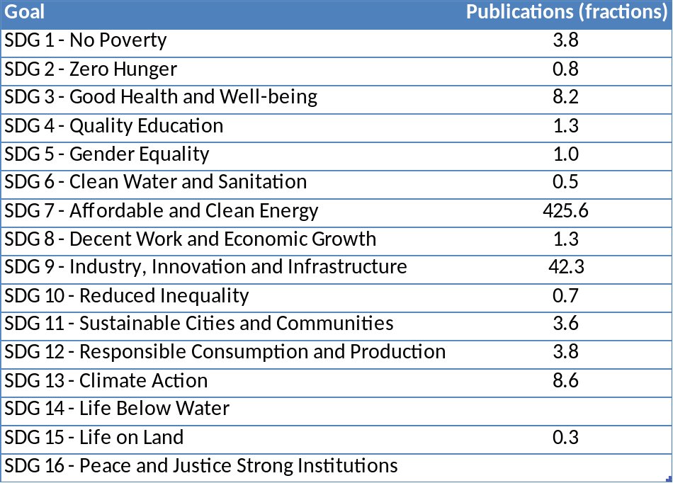
Figure 8 Department of Electrical Engineering publications impacting UN SDGs

d. Structure for increased impact

The impact of the research in industry applications and knowledge transfer to industry and other stakeholders is rather good, but the apparent visibility in society can be better in several ways. As an initial plan, we have the following action items:
- Better connection with youths in high-school level, e.g. revive and broaden the Future Friday concept that earlier was arranged at Kista Campus.
- Plan for discussions with some common activities in connection to House of Science, Tom Tits or Tekniska Museet.
- On a higher level, we should enhance our participation in technical magazines and in other daily news forum.
The department is engaged in the IEA-4E action PECTA (via STEM, Energimyndigheten).From the home page: "The overall goal of PECTA includes collecting and analysing information about new wide band gap (WBG) based power electronic devices, coordinating internationally acceptable approaches that promote WBG-based power electronics and developing greater understanding and action amongst governments and policy makers."

Appendix 1: Impact cases
Cases 1-6 are from Department of Energy Technology
Cases 7-12 are from Department of Electrical Engineering

Electricity access
to 1 billion people
OnSSET is the most used electrification tool in the world.
It is a support for government and international organizations
in their decision making when providing rural/urban areas with electricity.

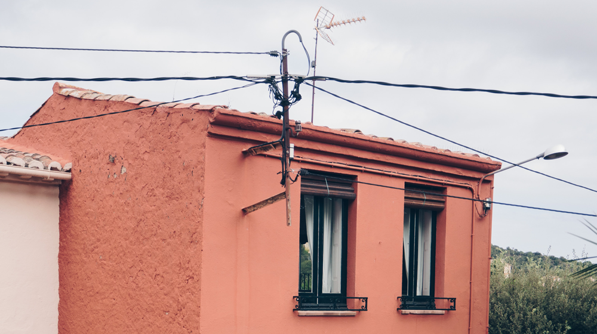

1. Enabling electricity access to the ca. 800 million people still lacking it
Around 800 Million people in the world lack access to electricity access. That lack of access affects the delivery of all the Sustainable Development Goals, including key health, educational and equality outcomes. KTH has developed one of the most used electrification tools in the world – a support for government and international organizations in their decision making when providing rural/urban areas with electricity. The “Open Source Spatial Electrification Tool” (OnSSET) makes it easy to compare electrification options for electricity access, such as on or off grid, and whether it should be powered by renewable or fossil fuels. The tool explores electrification investment scenarios to facilitate data-driven decisions to scale up electrification efforts. The tool has been used by several governments in low- and middle-income countries for electrification planning, in conjunction with a variety of international organizations, such as the UN, the World Bank and the International Energy Agency.
The tool has resulted in a number of high-level policy impacts around the world, including being at the basis of the World Bank´s Global Electrification Platform (GEP). For the GEP, the OnSSET tool was used to generate 216 electrification investment scenarios per country for ~60 countries in sub-Saharan Africa, Central America and Asia and the Pacific. This makes the GEP the most comprehensive platform available to date for data on electrification pathways. Furthermore, in total, more than 100 participants from ~30 countries have attended KTH-led OnSSET trainings, mainly coming from energy ministries and national power utilities, but also from universities and development organizations. In 2018 and 2019 KTH staff attended as trainers on the Summer School on Modelling Tools for Sustainable Development in Trieste and the Energy Modelling Platform for Africa that was held in Ethiopia in 2018 and in South Africa in 2019. These capacity-building events are part of an ongoing effort by development organizations (and KTH) to build local electrification modelling capacity. This enables long-term sustainability in electrification planning and makes planning more affordable as dependence on international consultants is reduced. As a result, several energy ministries in developing countries now use OnSSET as their electrification planning tool.
Analyses on energy access by the team have been featured in the International Energy Agency’s World Energy Outlooks (WEO) 2014, 2015, 2017 and 2019. The WEO is the IEA’s flagship publication and has a global reach - and is widely considered as ´the gold standard ‘of energy data and systems analyses. This adds to OnSSET being featured in several others governmental and intergovernmental reports as described below.

Underpinning research
Since 2014, KTH has led the development of the Open Source Spatial Electrification Tool (OnSSET). The tool was first developed in collaboration with the International Energy Agency and UNDESA. Following that, KTH led a consortium of international partners to develop the Global Electrification Platform (GEP) (electrifynow.energydata.info), funded by the World Bank. The GEP is supported by a number of international partners working with SDG 7: Power for All, Sustainable Energy for All, ESMAP, Sustainable Development Solutions Network, United Nations Department of Economic and Social Affairs, United Nations Development Programme, United Nation Economic Commission for Africa, UK Aid and Facebook Social Good. The platform enables anyone working with energy access, to engage with governments and other stakeholders to discuss strategies to increase electrification rates in ~60 countries.

The platform builds on open data and OnSSET that is an open source tool. This enables public institutions, private companies and academics to develop their own electrification analysis with significantly lower barriers than before.

Research publications
- Fuso Nerini F, Broad O, Mentis D, et al (2016) A cost comparison of technology approaches for improving access to electricity services. Energy 95:255–265. doi.org/10.1016/j.energy.2015.11.068 (Citations: 91)
- Mentis D, Welsch M, Fuso Nerini F, et al (2015) A GIS-based approach for electrification planning-A case study on Nigeria. Energy Sustain Dev 29:142–150. doi.org/10.1016/j.esd.2015.09.007 (Citations: 113)
- Mentis D, Howells M, Rogner H, et al (2017) Lighting the World: The first global application of an open source, spatial electrification tool (ONSSET), with a focus on Sub-Saharan Africa. Environ Res Lett 12:. doi.org/10.1088/1748-9326/aa7b29 (Citations: 112)
- Fuso Nerini F, Tomei J, To LS, et al (2018) Mapping synergies and trade-offs between energy and the Sustainable Development Goals. Nat Energy 3:10–15. doi.org/10.1038/s41560-017-0036-5 (Citations: 290)
- Moksnes N, Korkovelos A, Mentis D, Howells M (2017) Electrification pathways for Kenya–linking spatial electrification analysis and medium to long term energy planning. Environ Res Lett 12:095008. doi.org/10.1088/1748-9326/aa7e18 (Citations: 48)
- Mentis D, Siyal SH, Korkovelos A, Howells M (2017) Estimating the spatially explicit wind generated electricity cost in Africa - A GIS based analysis. Energy Strateg Rev 17:. doi.org/10.1016/j.esr.2017.07.002 (Citations: 10)
- Mentis D, Andersson M, Howells M, et al (2016) The benefits of geospatial planning in energy access - A case study on Ethiopia. Appl Geogr 72:1–13. doi.org/10.1016/j.apgeog.2016.04.009 (Citations: 49)
- Korkovelos A, Khavari B, Sahlberg A, et al (2019) The Role of Open Access Data in Geospatial Electrification Planning and the Achievement of SDG7. An OnSSET-Based Case Study for Malawi. Energies 12:1395. doi.org/10.3390/en12071395 (Citations: 30)

Sources to corroborate the impact
- Contributions to the IEA World Energy Outlook 2019, https://www.iea.org/reports/world-energy-outlook-2019
- Contributions to the IEA Energy Access Outlook 2017: https://www.iea.org/reports/world-energy-outlook-2017 KTH contributed to results featured in over 40 pages
- The co-developed World Bank Global Electrification Platform: electrifynow.energydata.info
- The co-developed UNDESA electrification Platform: https://un-modelling.github.io/electrification-paths-presentation
- The study providing an electricity access roadmap for Benin: https://snv.org/update/mini-grids-and-stand-alone-pv-systems-serve-millions-benin-quest-universal-electricity-access
- The study providing an electricity access roadmap for Afghanistan: https://energypedia.info/wiki/File:A_GIS_approach_to_electrification_planning_in_Afghanistan.pdf
- The study providing an electricity access roadmap for Madagascar:study: https://documents.worldbank.org/curated/en/281861547039951916/pdf/Project-Information-Document-Integrated-Safeguards-Data-Sheet-Madagascar-Least-Cost-Electricity-Access-Development-Project-LEAD-P163870.pdf
- Information on the Summer School on Modelling Tools for Sustainable Development in Trieste 2018 (http://indico.ictp.it/event/8315/ ) and 2019 (http://indico.ictp.it/event/8751/ )
- Information on the Energy Modelling Platform for Africa in Ethiopia in 2018 (http://www.energymodellingplatform.org/emp-a-2018.html ) and in South Africa in 2019 (http://www.energymodellingplatform.org/emp-a-2019.html ).

Infrastructure for a
global energy supply model
OSeMOSYS, a tool for energy and integrated water-
energy-land use planning has become one of the world-
leading open source system tools by both the scientific
community and UN agencies.
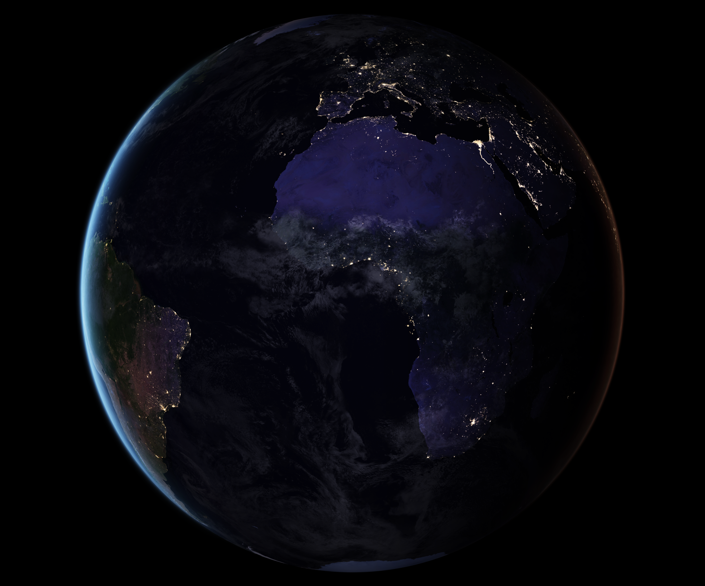

2. A global energy supply model infrastructure
Achieving the goals of the UN Agenda for Sustainable Development and the Paris Agreement requires governments worldwide to make urgent and risky infrastructure planning decisions. For this, they need the support of modelling tools they can access, own and audit. KTH has developed a tool for energy and integrated water-energy-land use planning: The Open Source energy Modelling System (OSeMOSYS). OSeMOSYS fills a gap in the analytical toolbox available to the energy research community and energy planners in developing countries. It lowered the threshold of energy systems analysis and made it accessible to analysts and governments worldwide with no upfront costs and a fast learning curve. After little more than a decade from its creation, today OSeMOSYS is regarded as one of the world-leading open source system modelling tools by both the scientific community and UN agencies.
Activities at KTH that established the academic excellence of the tool and raised its use to policy making include:
- Collaboration with the United Nations Department of Economic and Social Affairs (UNDESA) and the United Nations Development Programme (UNDP) in capacity development programmes with technical staff of Ministries of Governments worldwide (with around 200-300 trainees from Bolivia, Costa Rica, Nicaragua, Paraguay, Uganda, Ethiopia, Sierra Leone, Cyprus, Indonesia, Pakistan, India, Sri Lanka, Myanmar, Thailand, Vietnam);
- Use for model-based update of National energy and resource planning strategies:
by the Government of Bolivia for delivering its Intended Nationally Determined Contributions (link), by the Government of Cyprus for planning new gas and renewable infrastructure, by the Government of Nicaragua for training a new Integrated Planning Unit, by the Government of Costa Rica for the assessment of Deep Decarbonisation Pathways;
- Model-based facilitation of dialogues (and resolution of conflicts) in the coordinated management of water resources in the Sava, Drin and Drina river transboundary basins, by the United Nations Economic Commission for Europe (UNECE): link to final report by UNECE;
- Inclusion in the World Bank Group’s outlook on the enhancement of the climate resilience of Africa’s power and water infrastructure: https://openknowledge.worldbank.org/handle/10986/21875
- Production of a large body of open access teaching material and, more importantly, a set of essential concepts for education in system analysis and thinking. The teaching material became the common denominator between research & teaching activities at KTH and other Higher Education Institutions and ongoing national planning efforts by governments.

Underpinning research
OSeMOSYS was first presented at the 2008 International Energy Workshop and published in 2011 by Howells et al. It was amongst the first fully open source energy modelling tools and it was designed as a free, flexible and simple energy modelling tool, accessible for researchers and decision makers from developing countries, with limited (human and computational) resources and funding.
In the past decade, the division of Energy Systems Analysis (now merged into the division of Energy Systems) has improved the formulation of OSeMOSYS and its functionalities through numerous PhD studies and peer-reviewed publications, making it possible to apply it for (among others): the modelling of energy resources-to-services systems at city, national, continental and global scale; the modelling of flexible electricity supply options and demand-response technologies; the integrated modelling of Climate-Land-Energy-Water systems. This allowed for its uptake by governments worldwide, facing different types of planning issues, at several scales.
Furthermore, with an integrated and collaborative approach, the division as a whole engaged in numerous capacity development activities with the same governments. Most PhD students produced their papers and outputs through the work they did with the governments (with support by World Bank and UN Agencies).

Research publications (citations from Google Scholar)
- Howells, M., Rogner, H., Strachan, N., Heaps, C., Huntington, H., Kypreos, S., Hughes, A., Silveira, S., DeCarolis, J., Bazillian, M. and Roehrl, A., 2011. OSeMOSYS: the open source energy modeling system: an introduction to its ethos, structure and development. Energy Policy, 39(10), pp.5850-5870. (Cited by 465)
- Taliotis, C., Shivakumar, A., Ramos, E., Howells, M., Mentis, D., Sridharan, V., Broad, O. and Mofor, L., 2016. An indicative analysis of investment opportunities in the African electricity supply sector—Using TEMBA (The Electricity Model Base for Africa). Energy for Sustainable Development, 31, pp.50-66. (Cited by 86)
- Welsch, M., 2013. Enhancing the treatment of systems integration in long-term energy models (Doctoral dissertation, KTH Royal Institute of Technology). (Cited by 31)
- Welsch, M., Howells, M., Bazilian, M., DeCarolis, J.F., Hermann, S. and Rogner, H.H., 2012. Modelling elements of smart grids–enhancing the OSeMOSYS (open source energy modelling system) code. Energy, 46(1), pp.337-350. (Cited by 116)
- Sridharan, V., Broad, O., Shivakumar, A., Howells, M., Boehlert, B., Groves, D.G., Rogner, H.H., Taliotis, C., Neumann, J.E., Strzepek, K.M. and Lempert, R., 2019. Resilience of the Eastern African electricity sector to climate driven changes in hydropower generation. Nature communications, 10(1), pp.1-9. (Cited by 31)
- Taliotis, C., Rogner, H., Ressl, S., Howells, M. and Gardumi, F., 2017. Natural gas in Cyprus: The need for consolidated planning. Energy Policy, 107, pp.197-209. (Cited by 25)
- Gardumi, F., Shivakumar, A., Morrison, R., Taliotis, C., Broad, O., Beltramo, A., Sridharan, V., Howells, M., Hörsch, J., Niet, T. and Almulla, Y., 2018. From the development of an open-source energy modelling tool to its application and the creation of communities of practice: The example of OSeMOSYS. Energy strategy reviews, 20, pp.209-228. (Cited by 33)

Sources to corroborate the impact
- Mentioned by independent academic literature as one of the most mature open source energy modelling tools available: https://www.sciencedirect.com/science/article/pii/S1364032118307743
- Featured in the UN Modelling Tools for Sustainable Development: https://un-modelling.github.io/
- Used for the background analysis for the Bolivia’s INDC: link;
- Used for World Bank Group, Enhancing the Climate Resilience of Africa's Infrastructure - The Power and Water Sectors: https://openknowledge.worldbank.org/handle/10986/21875
- UNECE, Assessment of the water-food-energy-ecosystem nexus and benefits of transboundary cooperation in the Drina River Basin: link;
- Communications: https://www.nature.com/articles/s41467-018-08275-7;
- Featured by the European Commission’s Strategic Energy Technologies Information System (SETIS). Available at: https://setis.ec.europa.eu/publications/setis-magazine/energy-systems-modeling/osemosys-open-source-software-energy-modeling.
- Result dissemination by publishing 70+ peer-reviewed scientific papers (http://www.osemosys.org/publications1.html ), including publication in Nature journals (https://www.nature.com/articles/s41467-018-08275-7 )
- Use for higher education teaching in 30+ universities worldwide (https://groups.google.com/forum/#!topic/osemosys/nN5MooESn8k );

Turbomachinery and propulsion
In close cooperation with the leading industry and its
challenges, the Turbomachinery group has a widespread
impact on fuel savings, cut CO2 emissions and safer and
more reliable components.

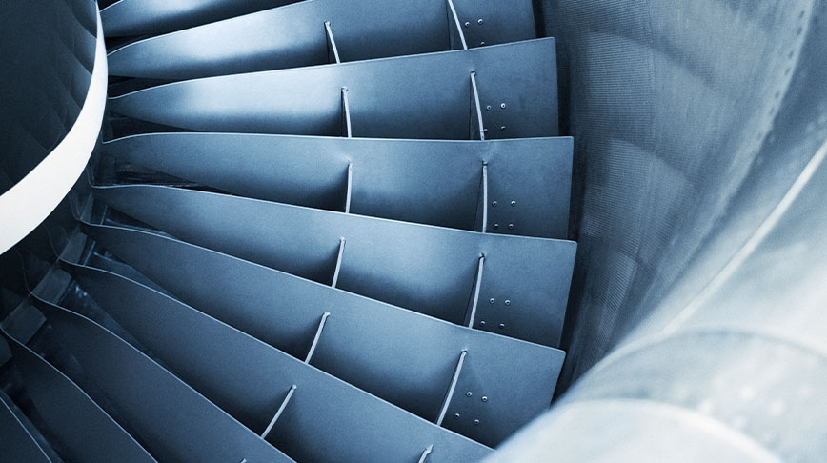

3. Turbomachinery & Propulsion
Turbo engines account for about 90-95% of the electricity generation in the world and a large part of the propulsion in the transport sector. In close cooperation with the leading industry and its challenges, the department has a widespread impact on fuel savings, cut CO2 emissions and safer and more reliable components.
Turbomachinery has been a central competence of the department of Energy Technology for several decades. The technical and scientific goals of the research create an accelerated direct impact on vibration related redesigns of current turbofan engines and the design of new more sustainable, efficient, reliable and robust engines at industry.
The applied research performed at the department have been interlaced with the challenges that the leading industry is facing within the field and thereby provided valuable data for validation generated from the experimental test rigs and numerical tools developed within the group.
The laboratory with its world-class experimental facilities, recognized in three EU framework programs through coordination of FP6 SUSPOWER, FP7 BRISK and H2020 BRISK2, is the foundation of the department’s excellence. We have successfully coordinated FP7 and H2020 project consortiums and has a strong rewarding exchange with industries and academia within the applied turbomachinery research.

Underpinning research
Activities related to steam turbines, conducted with industry partner Siemens Industrial Turbines AB (SIT), were augmented with applications towards industrial gas turbines, jet and rocket engines with SIT and GKN Aerospace Sweden AB (GKN). The department coordinated the FP7 FUTURE1 project focusing on flutter-free turbomachine blades. The department brought together jet engine manufacturers and universities in H2020 ARIAS2, a KTH-coordinated project focusing on advanced research in aeromechanics. A new test facility is currently being designed and will be commissioned in 2021.
In parallel the group designed, constructed, and commissioned a test facility for investigating methane cooling in next-generation rocket engines within the Future Launch Preparatory Program. Besides the research related to industrial gas turbines has lately been augmented into commissioned research focusing on turbine cavity purge flow in collaboration with Siemens and Bath University, UK (1). Through the national research programme NFFP projects with TRL-levels stretching from 1 to 4 are performed in the group where the higher TRL level correspond to joint research demonstrator projects SWEDEMO5 and VIND/VINK6 with GKN, KTH, LTH and Chalmers.
The department is responsible for a number of MSc. courses related to turbomachinery and rocket engines. The department is coordinating a joint master's programme in Turbomachinery Aeromechanical University Training (THRUST), which is a cooperation between KTH, Duke University, Aristotle University of Thessaloniki and Université de Liège. The programme offers education of high international standard as well as cultural experience from at least two different countries and a double degree from two universities. Department staff are active in the European Consortium for Advanced Training in Aerospace, ECATA7, and its annual executive training program.
A high research standard is ensured and measured by the number of journal publications regarding the many times complex phenomena, relevant for the research frontier within the field, here exemplified with references (1) to (10).
Research publications
- Horwood, J., Hualca, F., Wilson, M., Scobie, J., Sangan, C., Lock, G., Dahlqvist, J., Fridh, J. (2019). “Flow Instabilities in Gas Turbine Chute Seals”, ASME J. Eng. Gas Turbines Power, February 2020; 142: 021019. https://doi.org/10.1115/1.4045148
- Tian, S., Petrie-Repar, P., Glodic, N., and Sun, T. (September 23, 2019). "CFD-Aided Design of a Transonic Aeroelastic Compressor Rig." ASME. J. Turbomachinery. October 2019. Vol. 141:101003. https://doi.org/10.1115/1.4043884
- Gutierrez Salas, M., Petrie-Repar, P., Mårtensson, H., Bladh, R.,and Vogt, D. M., “Forced Response Analysis of a Mistuned Blisk Using Noncyclic Reduced-Order Models”, ASME J. of Propulsion and Power, Vol. 34(3), May 2018.
- Dahlqvist, J., Fridh, J., 2018, “Experimental Investigation of Turbine Stage Flow Field and Performance at Varying Cavity Purge Rates and Operating Speeds”, ASME J. Turbomachinery, https://doi.org/10.1115/1.4038468 , March 2018, Vol. 140 / 031001-1
- Gutierrez, M., Bladh, R., Mårtensson, H., Petrie-Repar, P., Fransson, T., and Vogt, D. M. (January 18, 2017). "Forced Response Analysis of a Mistuned, Compressor Blisk Comparing Three Different Reduced Order Model Approaches." ASME. J. Eng. Gas Turbines Power. June 2017; 139:062501. https://doi.org/10.1115/1.4035209
- El-Gabry, L., Saha, R., Fridh, J., Fransson, T., 2015, “Measurements of Hub Flow Interaction on Film Cooled Nozzle Guide Vane in Transonic Annular Cascade”, ASME J. Turbomachinery, https://doi.org/10.1115/1.4029242, August 2015, Vol. 137/081004
- Saha, R., Mamaev, B. I., Fridh, J., Laumert, B., and Fransson, T. H. (January 2, 2014). "Influence of Prehistory and Leading Edge Contouring on Aero Performance of a Three-Dimensional Nozzle Guide Vane." ASME. J. Turbomachinery. July 2014. Vol. 136:071014. https://doi.org/10.1115/1.4026076
- Saha, R., Fridh, J., Fransson, T., Mamaev, B., Annerfeldt, M., Utriainen S., 2014, “Shower Head and Trailing Edge Cooling Influence on Transonic Vane Aero Performance”, ASME J. Turbomachinery, https://doi.org/10.1115/1.4028024, Vol. 136, 111001-1.
- Fridh, J., Laumert, B., Fransson, T., 2013, “Forced Response in Axial Turbines under the Influence of Partial Admission”, ASME J. Turbomachinery, https://doi.org/10.1115/1.4007599, July 2013, Vol. 135, 041014.
- Mayorca, M. A., Vogt, D. M., Mårtensson, H., and Fransson, T. H. (October 30, 2012). "Prediction of Turbomachinery Aeroelastic Behavior From a Set of Representative Modes." ASME. J. Turbomachinery. January 2013; Vol. 135: 011032. https://doi.org/10.1115/1.4006536

Sources to corroborate the impact
- EU FP7 FUTURE, https://cordis.europa.eu/project/id/213414, Grant No. 213414
- EU H2020 ARIAS, https://cordis.europa.eu/project/id/769346, Grant No. 769346
- Vinnova NFFP, https://innovair.org/en/innovation/national-aeronautics-innovation/nffp/, research projects in NFFP5, 6 and 7
- TURBOPOWER, Swedish Energy Agency Ref.No. 2011-003525, www.turbokraft.se
- SWE DEMO, Vinnova Ref.No. 2015-06047
- VIND/VINK, Virtual Integrated Demonstrator for Turbomachinery, Vinnova Ref.No. 2017-04860
- EU ECATA Aerospace Business Integration Programme, https://cordis.europa.eu/project/id/9501066
- MSc Turbomachinery Aeromechanical University Training THRUST (Joint), https://www.kth.se/en/studies/master/thrust/msc-turbomachinery-aeromechanical-university-training-thrust-joint-1.43038
- Collaboration with industry regarding development of rocket engines with methane, joint publication IAC, https://www.mynewsdesk.com/se/gkn-aerospace-sweden/news/kick-off-foer-vaerldens-stoersta-rymdmaessa-iac-412589
- Hosting a 300+ attendee conference, https://www.euroturbo.eu/conference/etc12/

Heat pumping technologies
Of the 2 million single family houses Sweden, more than half have a heat pump. The research in the area of refrigeration
and heat pump technology have had a large and worldwide impact over the last forty years.


4. Heat pumping technologies

Summary of the impact
Heat pumps have had a tremendous impact on the use of fossil fuels in Sweden. Of the 2 million single family houses in the country, more than half have a heat pump. It is estimated that the heat pumps in Sweden deliver about 35 TWh of heat, and extract about 22 TWh of renewable energy from the environment. The dominating share of these heat pumps are designed and manufactured by Swedish industries. The development of the heat pump industry is closely connected to the research done at the Department of Energy Technology. The department has contributed in a substantial way to the development of the technology and its applications by research done throughout the last forty years.

Underpinning research
The Department of Energy Technology has a 100-year tradition of applied research within the area of refrigeration and heat pump technology. A first important impact case, in the 1920’s was the development of a refrigerator without moving parts which became one of the most important products for the development and early growth of the Electrolux company. This invention was done by two students, von Platen and Munters. As a result of the success of the Electrolux company, refrigeration technology was instituted as a separate research area at KTH and the department has since contributed to the development within heat pumping technologies through research reports, textbooks and industry cooperation. Many students from the department now hold positions in R&D departments, and other leading positions in industries and international organizations related to heat pumping technologies, with Electrolux being a prime example.
Fifty years later, in the 1970’s, following the energy crisis, the department was heavily involved in the development of heat pumps as commercial products. A key person in this research was professor Eric Granryd, who worked with product development at Thermia, one of the largest heat pump manufacturers, before taking the position as professor at KTH. Sweden still has a world-leading position in heat pumping technology, with a number of international companies, based on the work started at that time and with several students from the department having important positions in these companies. The heat pump development and the influence of the department has been treated in a Ph.D. thesis by Petter Johansson [1]
In the 1990’s the influence of chloro-fluoro-carbon refrigerants (CFC’s) on the ozone layer was realized, and since then much work at the department has been focused on the application of natural refrigerants, mainly hydrocarbons and carbon dioxide, in refrigeration and heat pump systems. Already in 2002 this resulted in the arrangement of a conference called Zero Leak – Minimum Charge, referring to the need to minimize refrigerant leakage and to minimize the charge of refrigerant to allow the safe use of natural fluids (which are often flammable) as substitutes for the ozone depleting refrigerants used at the time. Professor Per Lundqvist also participated in the IPCC work leading to the Nobel Peace Prize in 2007.
During the last ten years, other academic institutions and research labs have followed the Department’s lead and are now engaging in projects related to reduction of refrigerant charge. In parallel, large companies producing components of refrigeration and heat pump systems are realizing the need of low refrigerant charge and are developing new products for this purpose. The department is still one of few leading research institutions in this field, working on projects related to heat exchanger design as well as heat pump systems design. This work is led by professor Björn Palm and associate professor Joachim Claesson. [2] are examples, which were elected Best Papers of the Year in the prime journal in the area. A more recent example is the invited lecture presented at the UIT conference in Padova entitled Hydrocarbon Systems Designed for Low Charge [3].
The work on identifying refrigerants and refrigerant blends with low environmental impact, investigating the direct and indirect impact of these fluids, and the necessary adaptations of the heat pumping systems for these fluids has continued during the last 20 years. The research has lately been led by professors Rahmat Khodabandeh and Björn Palm. As a part of this work, a standing column on refrigerants has been published in the technical journal Kyla & Värme (Cooling and heating) eight times each year since 2016 [4].
The research on supermarket refrigeration using carbon dioxide as refrigerant is also raising international attention. Particularly, systematic work led by associate professor Samer Sawalha and Jaime Arias on developing new highly efficient system solutions, also including heat recovery to the building or to the district heating system and geothermal energy storage, has been internationally acknowledged, and such systems are now installed in supermarkets in many countries, spreading from northern Europe to other parts of the world. [5] is an award-winning article on this topic.
With the broad personal contact network to all of the Swedish (and many international) heat pump manufacturers and component manufacturers, the research at the department has had impact on products on the market, or under development. Examples of companies whose products have been directly or indirectly influenced are Nibe, IVT, Thermia, CTC, Electrolux, Alfa Laval, Copeland, Danfoss, SWEP.
The department has also been performing research on the integration of heat pumps to other parts of urban energy systems. A key parameter in this research is smart control and system integration when heat pump systems are working together with solar PV, thermal and electric storage, and local electric grids e.g. to shave peak power in the grid or reduce the operating cost for the prosumers. Considering the significant effect of digitalization on future energy systems, this relatively new research, led by associate professor Hatef Madani, is expected to have considerable impact on building energy systems in the near future. Madani has been a member of the RHC ETIP board during the last 5 years, supporting EU commission on the strategic research agenda for renewable heating and cooling. Madani is also supervising projects on application of heat pumps in the district heating networks, identifying possible heat sources by GIS. This work has also resulted in investigating the feasibility of installing large heat pumps in the district heating systems of coastal cities in northern China.
Finally, is worth mentioning the research related to low temp geothermal energy storage, where Sweden has a prominent position and the research team at the department has, through its network, influenced the work all over the world. In conclusion, the department’s long-lasting research in the area of refrigeration and heat pump technology have had a large and worldwide impact on the sustainable use of these technologies over a long period of time.

Sources to corroborate the impact
[1] Johansson, P. A. 2015, Silent Revolution: The Swedish Transition towards Heat Pumps, 1970-2015, Ph.D. thesis KTH, 2017, ORCID iD: 0000-0002-2748-7993
[2] Fernando W. P. D. et al., 2008, "A Minichannel Aluminium Tube Heat Exchanger - Part 1 - 3” International journal of refrigeration, vol. 31, no. 4, pp. 669-708, 2008.
[3] Palm, B. Hydrocarbon systems designed for low charge, Invited lecture at the 37th UIT Heat Transfer Conference, https://www.uitconference2019.it/site/symposium
[4] Articles in the journal Kyla & Värme : in English
[5] Karampour, M., Sawalha, S. (2018), State-of-the-Art Integrated CO2 Refrigeration System for Supermarkets: a Comparative Analysis. International journal of refrigeration, 86: 239-257 https://doi.org/10.1016/j.ijrefrig.2017.11.006
[6] Fisher D., 2017, Integrating Heat Pumps into Smart Grids, Ph.D. thesis, KTH, URN: urn:nbn:se:kth:diva-214444

Live-In Lab - testbeds for innovation
KTH Live-In Lab is a cross-disciplinary platform for fast
innovation in a built environment. Here academia and
industry can meet for testing and researching new
technologies and new methods in real environments.

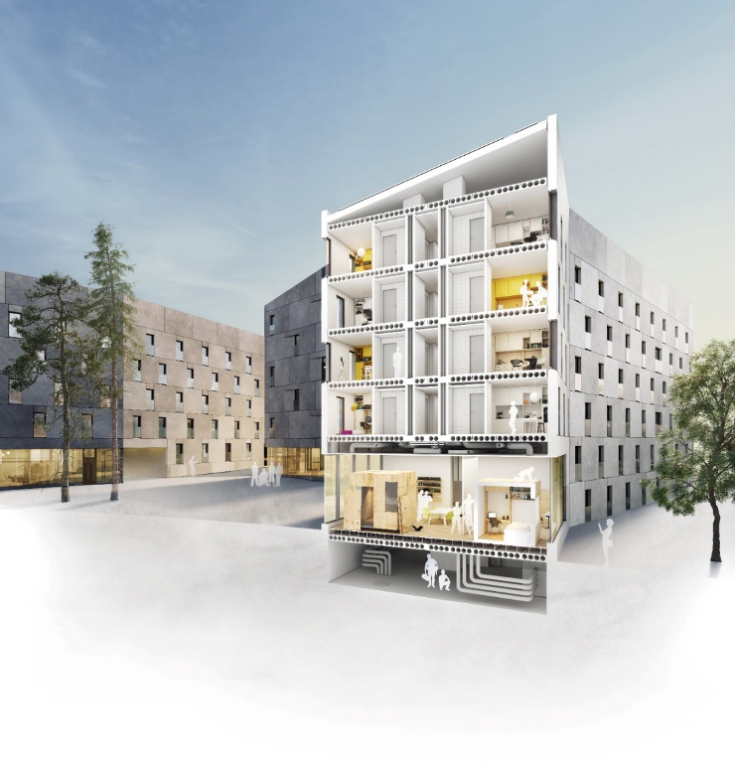

5. KTH Live-in Lab – Testbeds for accelerated innovation

Summary of impact
KTH Live-In Lab is a unique cross-disciplinary platform for accelerated innovation in the built environment, and for collaboration between academia and industry. The testbeds in KTH Live-In Lab are operated in real environments for testing and researching new technologies and new methods. The purpose of KTH Live-In Lab is to reduce the lead times between test/research results and market introduction for new technologies. In this way, KTH Live-In Lab aims to facilitate the advent of the sustainable and resource-effective buildings of the future by accelerating the rate of introduction of new competitive product and services for the construction and real-estate sectors.

Underpinning research
KTH Live-In Lab has impacted both industry and academia by providing academia and industry with an open platform for collaboration, a database for storing and sharing data and results, and physical infrastructure for running and scaling up tests and projects.
At the end of 2020, there was 70 applications to use the infrastructure managed by KTH Live-In Lab, of which 17 are ongoing and a total of 15 finished. The total value of ongoing projects starts to reach 100MSEK, mainly funded by Energy Agency, Formas, and Vinnova. Interestingly, in 2019, 9 out of 10 projects that used KTH Live-In Lab as platform got funded from different funding agencies. This is a strong proof that the concept of KTH Live-In Lab works. Table 1 summarizes the evolution of project from the start until 2020.
Table – Projects in KTH Live-In Lab
Projects | 2016 | 2017 | 2018 | 2019 | 2020 | Total
Applications | 20 | 13 | 10 | 8 | 19 | 70
Started | 3 | 2 | 9 | 10 | 8 | 32
Finished(By the end of the year) | 0 | 3 | 3 | 5 | 4 | 15
Total Ongoing 2020(whole year) |  |  |  |  | 17

The following are a few projects started 2019 and 2020 that show the strength of KTH LIL:
Co-Living and productive space usage: Investigates space usage and resource efficiency. Linda Teng at Akademiska Hus, Jonas Anund Vogel, Sara Ilstedt and more. KTH, Chalmers, KTH Live-In Lab, HSB Living Lab, Akademiska Hus, Nordic Choice, Studentbostäder i Linköping AB, Tengbom, Semrén & Månsson, Zynka BIM, Grunditz Göransson Arkitekter AB, Arkitema. Total budget 1.1MSEK funded mainly by the partners, and 0.15MSEK from HSB Living Labs research fund.
Co-Kitchen: Investigating kitchens and bathrooms in co-living apartments. Sara Ilstedt, Tove Malmqvist, Jonas Anund Vogel, Akademiska Hus, Savvy, TIP, Electrolux, Partab, Tovenco. Total budget 7.8MSEK of which 6.2MSEK funded by the Energy Agency.
Nudges and Boosts: Investigating nudges and boosts in order to decrease resource usage. Till Grüne-Yanoff, KTH Philosophy department, total budget 3MSEK funded by Formas.
A turnkey solution for Swedish buildings through integrated PV electricity and energy storage: Building, testing and optimizing combination of PVs and electrical energy storage. Collaboration project between KTH, Northvolt and Einar Mattsson. Rafael Guedez, Monika Topel, Jonas Anund Vogel, Dimitri Ottaviano (Northvolt) and Micke Dimadis (Einar Mattsson). Total budget 9.7MSEK, of which Energy Agency funds 4.7MSEK.
Sonic interaction design to support energy efficiency behavior in the household: Designing, developing and evaluating real-time digital sonic interactions as augmentations of individual appliances and aggregated smart meters' outputs, to promote energy efficiency in the household. Sandra Pauletto (PI), Cristian Bogdan, Elina Eriksson, Rod Selfridge, KTH Media Technology and Interaction Design, Björn Palm, KTH Energy Technology, Jonas Anund Vogel, KTH Live-in Lab. Total budget 4.8MSEK funded by the Energy Agency
The interest of using KTH Live-In Lab in courses and theses is big, and growing. So far, KTH Live-In Lab has been involved in courses through site visits, workshops, presentations/lectures and weekly hackathons. One example on how KTH Live-In Lab collaborates with courses and industry is the yearly challenge in the course MJ1141 - Energy Systems and Sustainability, where industry partners are invited to collaborate and formulate a case that is interesting for both the students and the industry partner. In 2020 the challenge were performed as a “LiveHackLabTM 2020” together with FM Mattson. The event was presented at KTHs homepage, FM Mattssons hompege and in the national journal Energi & Miljö.
KTH Live-In Lab has been used as parts of more than 10 courses at both MSc. And BSc. Levels. KTH Live-In Lab has over 70 collaborating partners, and 40+ involved researchers from KTH, Chalmers, Umeå University, Stockholms University, Karolinska Institute, University of Sydney, Max Planck Institute Berlin, Karlstad University. It has been visible in national TV, radio, newspapers, industry journals and scientific journal. One of the main tasks for KTH Live-In Lab is to help researchers to publish outside of scientific journals, and to help industry to be part of scientific publications.

Sources to corroborate the impact

  - https://www.liveinlab.kth.se/
  - https://www.energi-miljo.se/tidningen/kth-studenter-tar-fram-vvs-system-som-alla-har-nytta-av

High-impact research on solar energy
The Energy Technology department has developed
research in solar energy integration with buildings and
concentrating solar power, making KTH a leading
solar research institute in the Nordics.

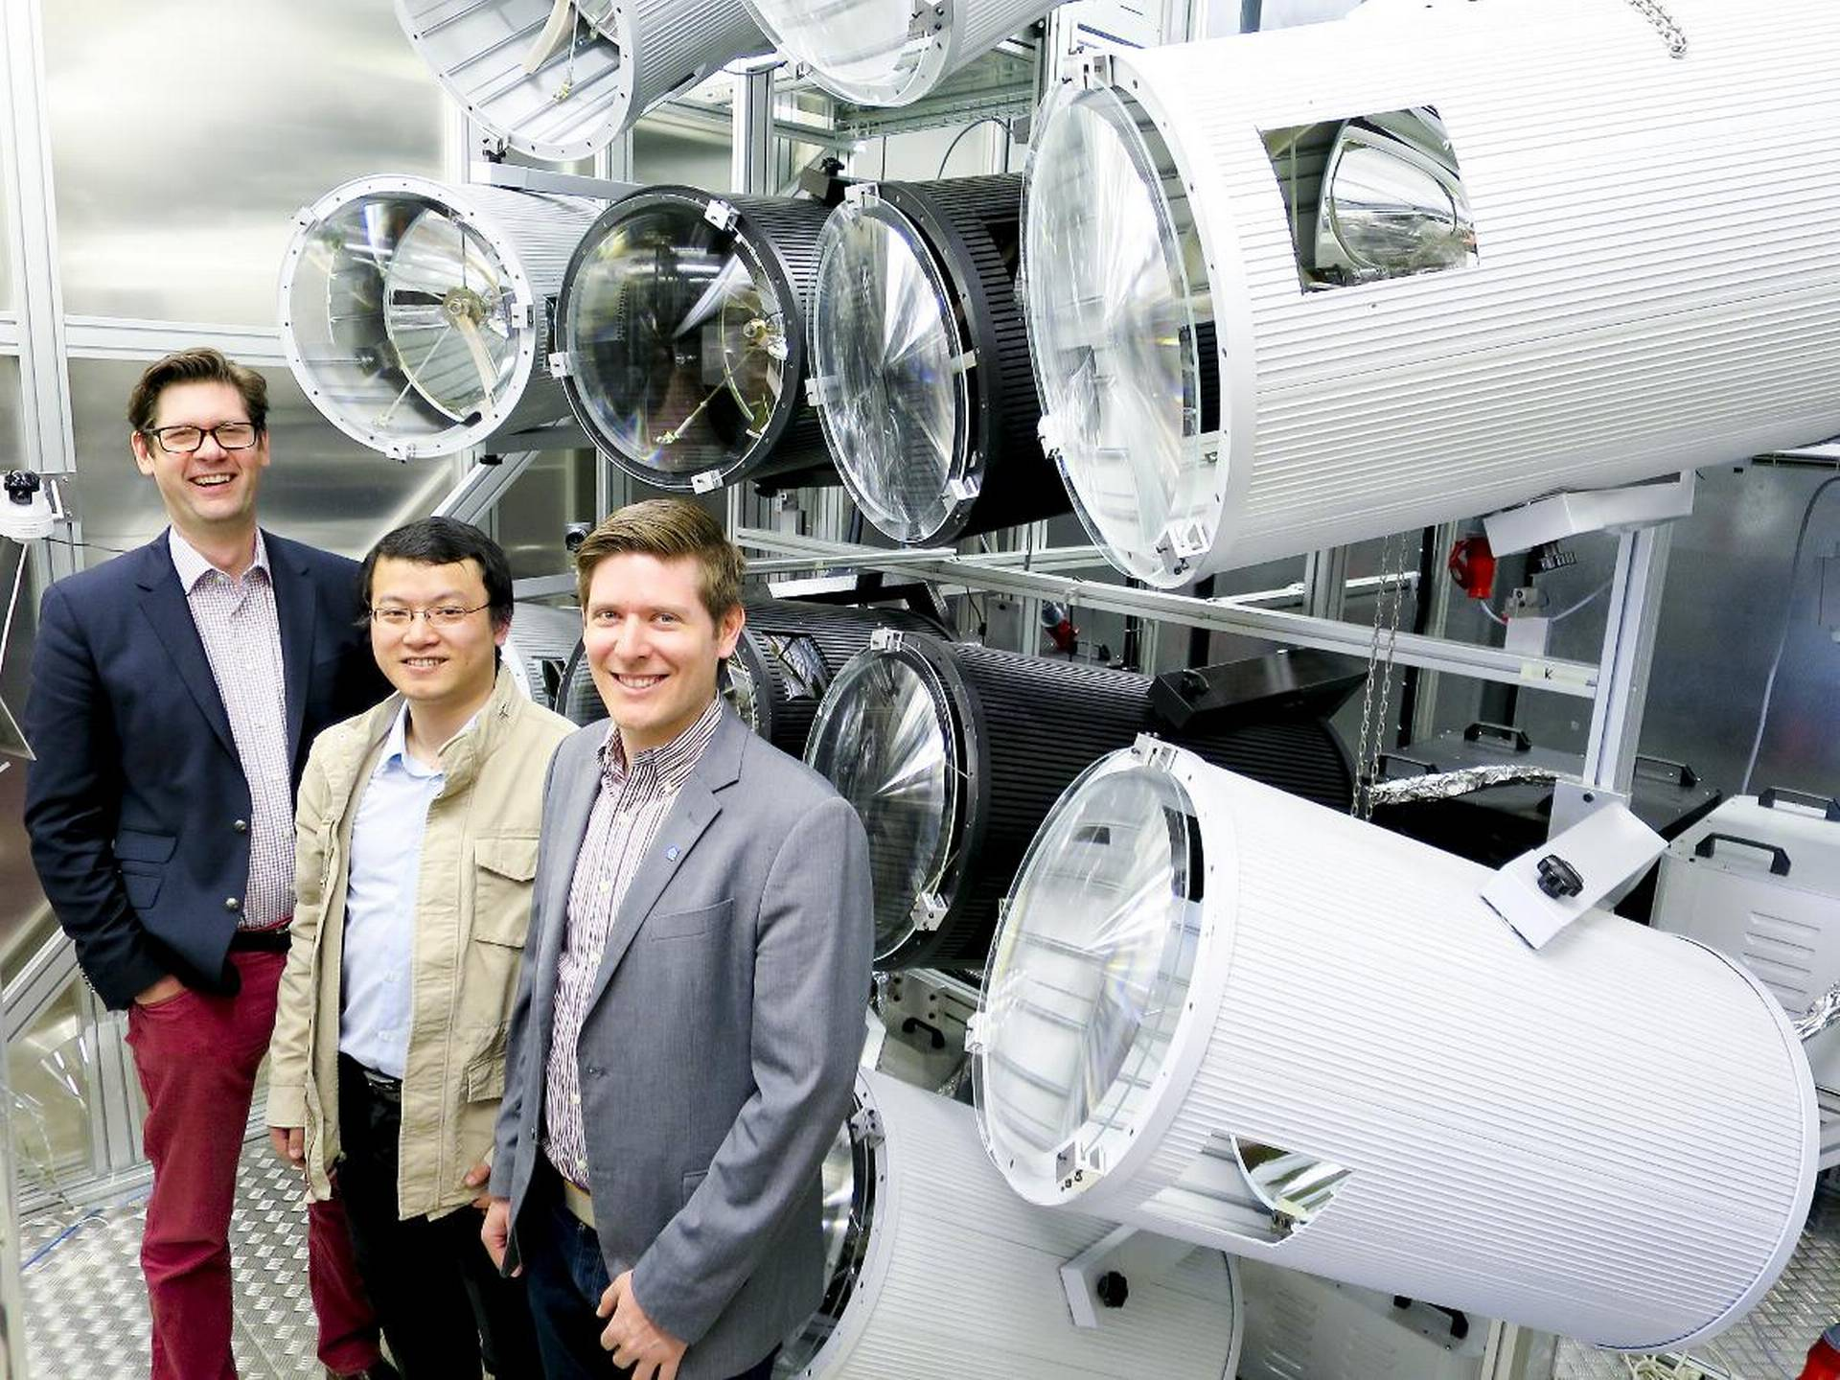

6. High-impact research on solar energy
The Energy Technology department has developed research in solar energy integration with buildings and concentrating solar power, making KTH a leading solar research institute in the Nordics. Increased interest in solar energy, from industry and public, is expected to drive continued high-impact research in this topic for the foreseeable future.

Summary of impact
Concentrating solar power integrated with thermal energy storage has the potential to offer cost-competitive renewable heat and electricity on demand in regions with high solar irradiance. To realize such potential it is of utmost importance to educate policy-makers and society, as well as to develop new technologies and to optimize their integration and combined operation in the system.
Concentrating solar power (CSP) with integrated thermal energy storage (TES) has great potential in providing large amounts of electrical power on demand, thereby enabling a higher penetration of renewables. KTH CSP research group is recognized worldwide in relation to the research done in CSP and TES, both from techno-economic simulation and new technology development.
During the past eight years, the CSP group has developed the world’s first high-flux solar simulator based on Fresnel lenses, a unique indoor facility for CSP research in the Nordic countries. The completion of this facility has attracted a lot of attention in Sweden and internationally, including visits from the Swedish King [1] and the Prime Minister [2]. The lab has been used to support the Swedish industry in the development of new technologies, and the emergence of new solar and storage technology companies such as Azelio, whom has successfully installed its system in Morocco and Middle East. By means of the solar simulator, KTH has been able to develop and validate new CSP concepts, including the novel impinging receiver [3], for which KTH is pursuing a new record in useful outlet temperature (above 1000°C), and also new solar-hybrid gas-turbine systems. KTH have also tested advanced coatings and materials for the CSP community.
Furthermore, the CSP research group has developed simulation tools for power plant performance, and power plant component design, which have been validated and used in international projects. To date KTH is the scientific coordinator of the SOLARSCO2OL project [4], one of the largest (in budget) EU-funded CSP demonstration projects within the H2020 framework, which aims to validate up to TRL7 a first-of-a-kind MW-scale supercritical CO2 cycle for solar thermal applications. Besides scientific coordination, KTH supports the work with system techno-economic model development and analysis. These in-house models have also been used in the past in the pre-feasibility and technical offer preparation of CSP project proposals in response to tenders, including techno-economic optimization of systems (design and operation) proposed for projects in Chile, USA, Australia, Morocco, Mexico, UAE, and South Africa. These projects were realized in collaboration with international firms.
Swedish rooftops could install 500 km² of solar collectors, 100x more than today, but unlocking that potential requires the interest, education, and collaboration of thousands of disparate stakeholders. Engaging and informing building owners is critical to creating positive change at energy’s end-use points towards sustainable urban energy systems.
Building owners are increasingly interested in improving the energy performance of their properties, which often includes solar energy. KTH ENSEED (Energy Systems Engineering, Economics and Data Analytics) facilitates this by making comprehensive techno-economic analyses for photovoltaic (PV) and hybrid PV/thermal systems to benefit building owners, policy makers, manufacturers, installers, engineers and researchers. A report [6] and handbook [7] on PV aimed at the public have been used by municipal energy advisors (over 5000 downloads and printed copies shared) and the techniques are being applied in online solar calculators for Sweden [8] as part of ENSEED’s ongoing research.

Underpinning Research
A comprehensive investigation on methods to design and operate CSP plants under different market and weather conditions was performed by Rafael Guédez, in collaboration with Monika Topel, James Spelling and Björn Laumert at ITM, together with industrial partners Total (France) and Naturgy (Spain), under the frame of the TESCONCOL Innoenergy project, coordinated by UPC (Spain). The project span from 2012 to 2015. Models and frameworks developed continue to be used and enhanced to date within the framework of the SOLARsCO2OL EU project, in which KTH is scientific coordinator and focuses in the assessment of new layouts and components for advanced CSP systems with s-CO2 turbomachinery and active hybridization with PV by means of electric heaters.
A comprehensive investigation into the technical, economic and social factors of PV systems in buildings was performed by Nelson Sommerfeldt and Hatef Madani at ITM, in collaboration with School of Architecture and Built-Environment at KTH. PV/thermal research has been led by Nelson Sommerfeldt and Hatef Madani including detailed systems modeling, novel PV/thermal development, and real world testing. A test facility has been developed on the rooftop of the department to test both component and system performance of combined solar heat pump systems.

Sources to corroborate the impact
- https://www.kungahuset.se/royalcourt/latestnews/2015/2015/thekingvisitskthroyalinstituteoftechnology.5.618dea114acd4fc12a11db.html
- https://www.energy.kth.se/research/heat-and-power-technology/ekv-researchgroups/csp-group/news/swedish-prime-minister-visits-1.547849
- M. Sedighi, R. Padilla, R. Taylor, et.al, High-temperature, point-focus, pressurized gas-phase solar receivers: A comprehensive review, Energy Conversion and Management, Vol. 185, 2019.
- https://www.nyteknik.se/nyheter/bygger-egen-solsimulator-pa-kth-6393659
- SOLARsCO2OL H2020 project. Information available at: https://www.solarsco2ol.eu/
- http://urn.kb.se/resolve?urn=urn:nbn:se:kth:diva-185003
- http://urn.kb.se/resolve?urn=urn:nbn:se:kth:diva-185002
- David Stoltz, Business Developer, Karlstads Energi, mailto:david.bohn.stoltz@karlstad.se; Jonas Lindberg, Division Head of Electricity Infrastructure, Tyréns, jonas.lindberg@tyrens.se

7. Impact on first wall construction and cost reduction in future fusion reactors

Summary of the impact
The reduction of wall erosion and fuel inventory in fusion reactors belong to major challenges on the way to ITER operation (joint project of China, EU, India, Japan, Korea, Russia, USA) and commercial fusion. For years, a carbon wall (C) was used in most devices and its use was planned for the ITER divertor, i.e. the high power load region. Plasma-wall interaction (PWI) studies carried out also by KTH researchers laid basis for the change of first wall components to beryllium (Be) and tungsten (W). The project “ITER-Like Wall at the JET tokamak (ILW)”, completed in 2011, resulted in a strong reduction of fuel inventory. It led to the decision of eliminating carbon in the first planned ITER divertor, saving the cost of a divertor: 300 MEUR.
Apart from the immediate and intermediate benefits for the fusion community having a large-scale novel experiment serving as a test bed for ITER-relevant operation and materials, elimination of the high cost of one divertor and the shutdown for its installation imply a shorter way to commercial fusion with society as the main beneficiary.

In ITER and future fusion reactors, the extremely high heat loads released during fast transient events make melting of metallic plasma-facing components (PFCs) a highly critical issue. The plasma-induced melt motion causes large-scale wall surface deformations and, if unstable, can generate droplets injected into the vessel. The former compromises PFC power handling and could strongly reduce the PFC lifetime, while droplets are considered as a major source of small solid dust whose amount is strictly limited by safety regulations. It is worth highlighting the socio-economic aspects of extending the PFC lifetime, from the short-term benefit of reducing the necessity for PFC replacement to the long-term benefit of rapidly affordable commercial fusion power plants. The KTH group has a world-leading role in the theoretical understanding of both processes and has developed & validated numerical tools for their reliable modelling.

Underpinning research
A challenge to be resolved for a safe and economic fusion reactor is PWI, which comprises all processes involved in the exchange of mass and energy between plasma and the surrounding wall. An economic consideration is the lifetime of the most exposed regions. A related safety issue is that tritium fuel can be deposited together with eroded wall materials. In the original ITER design, the first wall material included carbon (carbon fibre composites) in the high power load regions. However, the PWI research program, where the KTH group has played an important role internationally, has shown that carbon is susceptible to extensive erosion and fuel retention at levels unacceptable for a safe and economic reactor [1]. The conclusion of Ref. [1] comparing C and Be fluxes was: “An important implication of these observations is that, in a machine with an all beryllium first wall in the main chamber, fuel retention may be significantly reduced due to removal of the carbon source.” This long-term research led to the proposal of selecting two materials for ITER: Be on the main chamber wall (low power load region) and W in the high power load regions [2]. These materials have never been used/tested together. Therefore, to achieve conclusive progress in fusion research, the ILW Project at JET was initiated in 2004 to explore plasma performance and PWI with a full metal wall [2,3]. The KTH group was responsible for the development of (i) several types of Be components and (ii) erosion-deposition diagnostics wall including so-called first mirrors to perform tests for ITER [4,5]. All milestones and deliverables were completed on time and money.
The operation of JET with ILW started in 2011 [2] and led to the reduction of fuel inventory by a factor of 15-20 compared to the C wall. In 2013, a crucial decision has been taken by ITER: complete elimination of C wall components and start from Day 1 with a Be main chamber and W divertor. This translates to saving the cost of one divertor, i.e. 300 MEUR. Studies by the KTH group at JET on first mirrors may also result in multimillion saving on systems for in-situ mirror cleaning in ITER [4,5]. Since 2014, M. Rubel is the Project Leader for the “EUROfusion Work Package JET2: Materials for ITER and DEMO” monitoring work done in 12 EU material research labs and at the International Fusion Research Centre, Rokkasho, Japan.
The modelling effort of the KTH group has resulted in the development of two state-of-the-art numerical tools, the dust dynamics code MIGRAINe [6] and the macroscopic melt motion code MEMOS-U [7,8], based on models that have been validated against dedicated experiments in contemporary machines and employed for predictive ITER studies. To date, MIGRAINe is the only dust transport code equipped to adequately address dust-plasma interactions in the ITER regime. The MEMOS-U code has been developed from the MEMOS code (KIT, Germany) by the KTH group under an Implementing Agreement with ITER. MEMOS-U efficiently solves a melt dynamics model [8] that outputs detailed predictions of reactor wall deformations [7]. Worldwide, it is the only code capable of such modelling. MEMOS-U is presently run by the Experiments & Plasma Operation Section of ITER for predictive studies of melt damage on the upper wall panels and divertor. Both codes are included in the Theory-Simulation-Validation-Verification Task “Plasma-Wall Interaction in DEMO” of the EUROfusion Consortium. Via this task, the codes will be part of the first generation of EUROfusion-standard software products.

- M. Rubel, J.P. Coad, N. Bekris et al., J. Nucl. Mater. 313-316 (2003) 321-326. doi:10.1016/S0022-3115(02)01350-8 (Citations: 59)
- G.F. Matthews, M.Beurskens, S.Brezinsek et al., Phys. Scr. T145 (2011) 014001, doi:10.1088/0031-8949/2011/T145/014001 (Citations: 254)
- S. Brezinsek, A. Widdowson, M. Mayer et al., Nucl. Fusion 55 (2015) 063021 doi:10.1088/0029-5515/55/6/063021 (Citations: 61)
- D. Ivanova, M. Rubel, A. Widdowson et al., Phys. Scr. T159 (2014) 014011. doi:10.1088/0031-8949/2014/T159/014011 (Citations: 48)
- Sunwoo Moon, P. Petersson, M. Rubel et al., Nucl. Mater. Energy 19 (2019) 59-66 https://doi.org/10.1016/j.nme.2019.02.009 (Citations: 6)
- L. Vignitchouk, P. Tolias and S. Ratynskaia, Plasma Phys. Control. Fusion 56 (2014) 095005, https://doi.org/10.1088/0741-3335/56/9/095005 (Citations: 72)
- S. Ratynskaia, E. Thorén, P. Tolias, et al., Nucl. Fusion 60 (2020) 104001, https://doi.org/10.1088/1741-4326/abadac (Citations: 3)
- E. Thorén, S. Ratynskaia, P. Tolias, et al., Plasma Phys. Control. Fusion 63 (2021) 035021, https://doi.org/10.1088/1361-6587/abd838 (Citations: 2)

Sources to corroborate the impact

- Implementing Agreement No.1 Ref IO/IA/16/4300001384 to the Memorandum of Understanding between The ITER Organization and KTH.
- Service contract from the ITER Organization (Contract Number IO/20/CT/ 4300002230) for provision of “Simulations of Disruption Transient-Induced Beryllium Melt Splashing”.
- Projects “Modelling of plasma-surface interactions in ITER” and “Future reactor development – PWI in fusion devices” have been featured in the academic contributions to the 2020 Big Science Swedish Guide, see pages 300 and 303 of the electronic pdf version.
- EUROfusion Consortium: Task Agreement “WPJET2: Investigation of Plasma-Facing Components for ITER” (with the leading role of VR).

8. Geodesic lens antennas for space applications
Summary
The Department of Electrical Engineering collaborates in regular bases with the European Space Agency (ESA) in both space physics and technology. This consolidated collaboration is funded by Swedish Research Council (VR), the Swedish Space Agency (SSA) and directly by the ESA, in collaboration with local industry, such as SatCube, ReQuTech and Forsway.
One of the recent collaborations between KTH and ESA produced remarkable results on the field of lens antennas, in a new concept named “water drop lens”. This technology was demonstrated to possess noteworthy features which are ideal for satellite communications and space exploration. For example, this technology could alleviate the costs of implementation for the new Low Earth Orbit (LEO) satellite constellations in Ku- and Ka-bands for future broadband communications.
After the publication of the first results on this technology by ESA and KTH, Ericsson AB stated its interest in transferring this knowledge from space technology to ground communications, such as 5G and beyond. In particular, this technology could make millimeter-wave 5G base stations more cost-effective. In 2020, KTH started a new project in collaboration with the ESA and Ericsson AB to produce a proof-of-concept.
KTH is also exploring to transfer this knowledge to the Swedish automotive industry. The use of water drop lenses could reduce the costs of high-frequency radars in cars, enabling higher accuracy in these systems and leading to smarter cities.

Underpinning Research
In the Division of Electromagnetic Engineering, we are world-leading the research on geodesic lenses and its applications for antennas. More specifically, we are conducting fundamental research in the development of analytical and computational techniques to model the propagation in non-Euclidean shapes. This research is funded by the Office of Naval Research (ONR) and the Swedish Research Council (VR). Additionally, we are piloting antenna designs in this technology for space applications. For example, our designs are aimed to cover intersatellite links and radiometer/altimeter for exploration missions. Also, these antennas will be used satellite communications, drones and high-altitude platforms. These activities are funded by the Swedish Space Agency (SSA) and the European Space Agency (ESA).
As a proof of the impact of our research in this specific topic, our work on the “water drop lens” was selected in January 2020 as the technological image of the week by the ESA. One of the prototypes designed in collaboration between KTH and ESA was advertised in Twitter, Facebook and Instagram:
https://twitter.com/esa_tech/status/1214829250999717888?lang=en
https://www.facebook.com/EuropeanSpaceAgency/photos/this-novel-water-drop-antenna-waveguide-lens-developed-by-a-researcher-pair-from/10157915387155667/
Additionally, the use of these antennas is being investigated for 5G/6G in collaboration with Ericsson AB and funded by the strategic innovation program Smarter Electronics System - a joint venture of Vinnova, Formas and the Swedish Energy Agency.
More information about this collaboration can be found in the following scientific publications:
- Q. Liao, N. J. G. Fonseca, O. Quevedo-Teruel “Compact Multibeam Fully Metallic Geodesic Luneburg Lens Antenna Based on Non-Euclidean Transformation Optics”, IEEE Transactions on Antennas and Propagation, vol. 66, no. 12, pp. 7383-7388, Dec. 2018.
- N. J. G. Fonseca, Q. Liao, O. Quevedo-Teruel, "Equivalent Planar Lens Ray-Tracing Model to Design Modulated Geodesic Lenses Using Non-Euclidean Transformation Optics", IEEE Transactions on Antennas and Propagation, vol. 68, no. 5, pp. 3410-3422, 2020.
- N. J. G. Fonseca, Q. Liao, O. Quevedo-Teruel, "Compact Parallel Plate Waveguide Half-Luneburg Geodesic Lens in Ka-Band", IET Microwaves, Antennas & Propagation, 2020.

9. Electrical Impedance Spectroscopy ASIC for Skin Cancer Detection

Summary of the impact
Melanoma is one of the fastest growing cancers globally and in many countries such as Sweden it is the fastest growing cancer. The lifetime risk of contracting melanoma in the US is 1 in 24 and this risk is predicted to continue to worsen for some years. Early detection is critical and survival rates fall quickly to 50% or below if a melanoma is not detected at an early stage and treated. Existing melanoma detection methods are visual and subjective with poor accuracy, so new techniques are needed. SciBase AB is a Swedish company that has developed revolutionary technology for detecting skin cancer by using a non-invasive method which is based on Electric Impedance Spectroscopy (EIS). This technology was developed and patented at Karolinska Institute, Stockholm, and it is currently being marketed worldwide with the SciBase flagship's product “Nevisense”. The Nevisense consists of a processing unit which contains a display with the user interface, electronics circuits, and a probe for performing measurements directly on the skin. The electronic circuitry of Nevisense is implemented using off-the-shelf commercial components, and therefore, it occupies considerable space (a box of approximately 35 cm by 28 cm by 14 cm) and has a weight of 4 kg. In addition, the power consumption of these circuits (around 30 W) requires the Nevisense instrument to be powered from the mains or a Li-ion battery pack that lasts for approximately 4h during regular operation.
The idea behind this join project between Integrated Circuits and Systems group, Division of Electronics and Embedded Systems, KTH and SciBase AB was to take advantage of the latest advances in the Microelectronics field and integrate, in a single Sytem-on-a-Chip (SoC) solution, a large part of the electronic circuits used in Nevisense. Our final goal was to fully integrate all the Electric Impedance Spectroscopy circuits in an ASIC so that most of the electronics in the Nevisense can fit inside a CMOS silicon die of around 2 mm x 3 mm. The integration of all these circuits by using modern CMOS technology resulted in a ‘disruptive’ technology for clinical detection of skin cancer. In particular, the developed technology has a strong impact on Sustainable Development Goal (SDG) 3 “Good Health and Well-Being” and SDG 9 “Industry, Innovation, and Infrastructure”. Not only the size and weight was dramatically reduced to just a few mm², and grams respectively, but also the power consumption dropped from 30 W to just a few mW. These results enabled a complete new skin cancer device to be integrated in a battery-powered, pen-like modular device as shown in Fig. 1(a). This device can communicate wirelessly with a computer, tablet, or mobile phone running a graphic user interface (GUI). Such portable device is much more simple, flexible, and user-friendly compared to the current Nevisense. Furthermore, replacing most of the off-the-shelf components with a single CMOS ASIC made the skin cancer diagnose method so inexpensive that the whole system can potentially become disposable. This is very important because it opens this diagnose technology to patients that otherwise could not have afforded the costs (SDG 10 Reduced Inequalities). The technology has been fully transferred to Scibase AB and it is currently in industrialization phase (Fig. 1(b)).

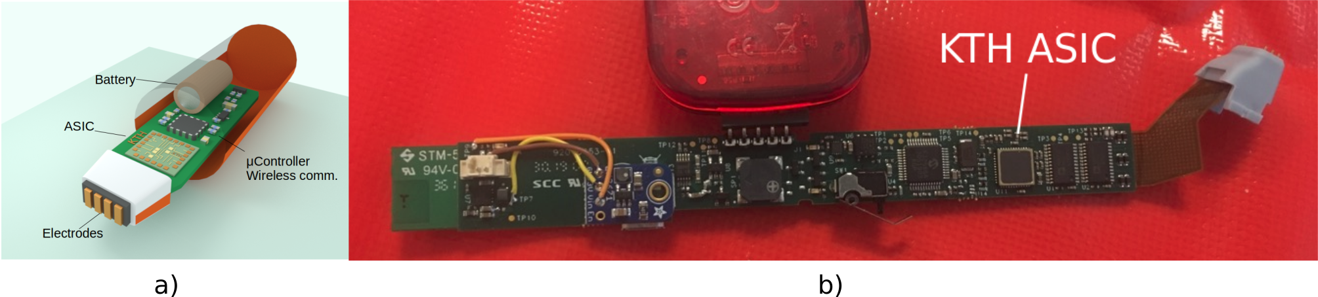
Figure 1, a) Skin cancer detection device, b) product prototype (reproduced with permission of SciBase AB)

Underpinning research
The Integrated Circuits and Systems group has been working in biomedical electronics since 2011 in strong collaboration with Karolinska Institute (KI), Karolinksa Universitetssjukhuset, Sveriges Lantbruksuniversitet (SLU) and medtech industry. The group has made breakthrough research in bio-implantable EIS technology [1]⁠[2][3] with members of the scientific community referring to our work as “disruptive technology which opens new clinical paradigms” [4].⁠ While the group has always being striving to publish excellent scientific results in the biomedical field, the main driving force has been from the very beginning to move the resulting intellectual property (IPR) to the medtech industry and then to the health care system where the real society impact is created. A natural precondition for this is to protect the IPR since no medtech company would be interested in manufacturing and commercializing a product that can be freely copied by a competitor. Accordingly, we have protected the IPR of our EIS technology with patents in many countries, covering the most important markets around the world [5] ⁠ [6] ⁠.
It is with this solid background in EIS technology that we started our Vinnova Project “Electrical Impedance Spectroscopy ASIC for Skin Cancer Detection” under the Smartare Elektroniksystem program 2015-2017. This was a joint project with SciBase AB [7] ⁠, which already had a product using EIS technology on the market and had vast experience in medical product development. This is a very good example of the synergy that can be created by merging two actors with complementary competences: a leading company with breakthrough medical instrumentation technology and a leading research group in Microelectronics. It is thanks to this synergy that the project was a complete success and that it produced results that are clinically important for society, namely by making accurate and early melanoma detection tools accessible and affordable.

[1] S. Rodriguez, S. Ollmar, M. Waqar, and A. Rusu, “A Batteryless Sensor ASIC for Implantable Bio-impedance Applications,” IEEE Trans. Biomed. Circuits Syst., vol. 10, no. 3, pp. 533–544, 2016.
[2] N. Ivanisevic, S. Rodriguez, and A. Rusu, “Impedance Spectroscopy Based on Linear System Identification,” IEEE Trans. Biomed. Circuits Syst., vol. 13, no. 2, pp. 396–402, 2019.
[3] R. Onet, A. Rusu, and S. Rodriguez, “High-Purity and Wide-Range Signal Generator for Bioimpedance Spectroscopy,” IEEE Trans. Circuits Syst. II Express Briefs, 2018.
[4] B. Sanchez and S. B. Rutkove, “Electrical Impedance Myography and Its Applications in Neuromuscular Disorders,” Neurotherapeutics, vol. 14, no. 1, pp. 107–118, 2017.
[5] A. Rusu, S. Rodriguez, and S. Ollmar, “Implantable Sensor and Method for Such Sensor,” AU2015206084B2, CN106028926A, CA2936458A1, MX2016008954A, KR20160108531A, EP3094246A1, JP6549154B2, WO2015107040A1, 2015.
[6] A. Rusu, S. Rodriguez, and S. Ollmar, “Health Monitoring System,” US10357180B2, CA2936487A1, AU2015206086B2, MX2016008956A, JP6486964B2, CN106061378A, KR20160110477A, EP3094245A1, WO2015107042A1, 2015.

Sources to corroborate the impact

SciBase AB, https://scibase.com

David Melin, Director Product Development SciBase AB,
david.melin@scibase.com

10. Dynamic space processes of potential importance to space weather

Summary of the impact
The technological infrastructure in space is growing and with it is also growing the dependence of modern society on the space infrastructure[1]. This infrastructure can be affected by environmental space processes such as magnetic storms, coronal mass ejections, solar energetic particles and others. Also, some of the ground infrastructure can be affected by the processes in the space environment. All this motivates the increased importance of making significantly improved real time space weather predictions that can be possible only with better understanding of the fundamental space processes of importance to space weather. KTH has contributed with the research studies of such dynamical processes as magnetosheath jets that can impact Earth magnetosphere, large plasma jets in the magnetotail called bursty bulk flows and at magnetopause called flux transfer events impacting inner magnetosphere. With the multi-spacecraft missions of European Space Agency (ESA) Cluster (launched 2000) and NASA Magnetospheric Multiscale (MMS) launched 2015 it has become possible to make major advances in resolving the dynamics of some of the key processes that can be of importance in space weather. KTH has had an important contribution to the designing, building, operations and data analysis of both missions. On the hardware side KTH has made a major contribution to the design, building, testing and operations of the electric field instrument[2]. The electric field is responsible for plasma particle acceleration and its high-quality measurements are of high importance for understanding of many fundamental plasma physics processes.
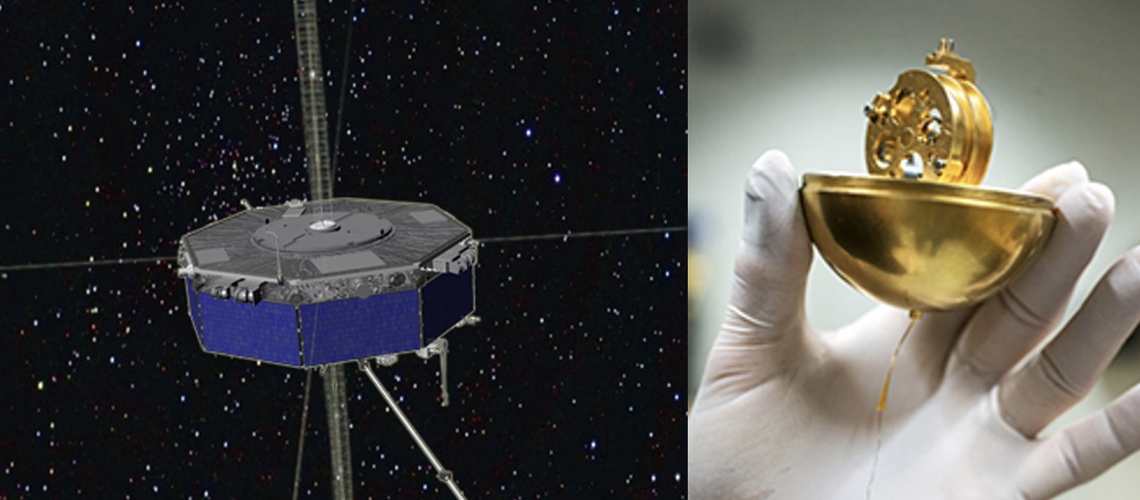
Figure 1 Artistic picture of one of the four spacecraft of the NASA MMS mission. KTH has participated in the building the electric field instrument, including the electronics, electric field sensor (in picture) and design of the wire boom deployment unit.

Underpinning research
The fundamental research of basic plasma processes in the near-Earth space is important for the space weather science, and can make an large impact on the long-term improvment of our understanding and predictions of space weather. The multi-spacecraft missions, ESA Cluster and NASA MMS, have opened new possibilities in studying complex dynamic processes varying in space and time. MMS has been in orbit for more than 5 years, while the Cluster spacecraft have been operational for twenty years. KTH has contributed to more than 130 published studies in refereed journals, based on data from MMS. The scientific focus of these studies has covered a wide range from magnetic reconnection to turbulence, shocks, boundary physics, wave-particle interaction and others, many of which are of importance for space weather. Similarly, during the reviewed period KTH has participated to tens of studies involving Cluster data, particularly KTH has continued to keep a leading role in Cluster auroral research [3]. Aurora is the most visible magnetospheric processes. It is intrinsically related to space weather processes as its generation is caused by strong currents driven by dynamic processes in the outer magnetosphere. However, other types of magnetospheric dynamic processes area also important with respect to the space weather. Here we highlight a few studies addressing three different dynamic processes with potentially high impact on space weather. Firstly, in the past decade it has been discovered that at the Earth bow shock forms localized dynamic magnetosheath jets and their potential impact on magnetosphere (triggering reconnection and opening Earth magnetosphere to the solar wind, as well as driving currents into the ionosphere) is a research topic that is currently actively studied internationally. Our studies have suggested the cause mechanisms of the magnetosheath jet formation and the intrinsic structure of those jets [4,5]. Similarly, the opening of Earth magnetosphere to solar wind due to magnetic reconnection process is a very dynamic process, with formation of jets along magnetopause called Flux Transfer Events (FTEs). FTEs are of high importance for driving the solar wind access to the Earth magnetosphere. Our studies [6] have suggested the main causes responsible for the appearance of single FTEs in contrast to series of multiple FTEs with a subsequent impact on how the energy is transferred from the solar wind to the near-Earth space. Finally, one of the key elements driving space weather in near-Earth space are fast plasma jets forming in the Earth magnetotail and impinging the near Earth dipolar field, so called bursty bulk flows. They are the key element in plasma energization in the Earth magnetosphere, they contribute to the injection of high energy particles into the inner magnetosphere. These particles can have large effects on the space infrastructure, they are responsible for driving strong currents down to ionosphere generating auroral as well as inducing large currents in the ground infrastructure (e.g. power grids and pipelines).
Underpinning hardware development and instrument operation
All the previous studies require high quality payload on multiple international spacecraft missions. KTH is actively involved in the development and building of such payload hardware, particularly electric field instruments [2]. Building payload for NASA MMS has been for the division a major project for the past 10 years. Additionally, electric field instrumentation has also been developed for the Japanese/ESA mission BepiColombo that is on its way to Mercury, as well as free flying units on sounding rockets studying the ionosphere. For MMS our group has designed the spin-plane electric booms based on the new design developed for BepiColombo [2]. During the past 10 years of the Cluster project, KTH has continued: 1) to act as Chairman of the Cluster Wave Experiment Consortium (comprising 5 of the 11 instrument teams), for coordination of instrument operations and science efforts, 2) to operate electric field instrument in collaboration with IRF-U, 3) to act as Project Scientist for and host of the Scandinavian Data Centre, with analysis and distribution of the EFW data to other Cluster data centers, 4) to contribute to the Cluster Active Archive, with 20 years of unprecedented data.

References

[1] Schrijver, Carolus J., Kirsti Kauristie, Alan D. Aylward, Clezio M. Denardini, Sarah E. Gibson, Alexi Glover, Nat Gopalswamy, et al. 2015. “Understanding Space Weather to Shield Society: A Global Road Map for 2015–2025 Commissioned by COSPAR and ILWS.” Advances in Space Research 55 (12): 2745–2807. https://doi.org/10.1016/j.asr.2015.03.023.[2] Lindqvist, P.-A., G. Olsson, R. B. Torbert, B. King, M. Granoff, D. Rau, G. Needell, et al. “The Spin-Plane Double Probe Electric Field Instrument for MMS.” Space Science Reviews 199, no. 1 (March 1, 2016): 137–65. https://doi.org/10.1007/s11214-014-0116-9.[3] Alm, L., G. T. Marklund, and T. Karlsson. “In Situ Observations of Density Cavities Extending above the Auroral Acceleration Region.” Journal of Geophysical Research: Space Physics 119, no. 7 (July 1, 2014): 5286–94. https://doi.org/10.1002/2014JA019799.[4] Karlsson, T., A. Kullen, E. Liljeblad, N. Brenning, H. Nilsson, H. Gunell, and M. Hamrin. “On the Origin of Magnetosheath Plasmoids and Their Relation to Magnetosheath Jets.” Journal of Geophysical Research: Space Physics 120, no. 9 (2015): 7390–7403. https://doi.org/10.1002/2015JA021487.[5] Karlsson, Tomas, Ferdinand Plaschke, Heli Hietala, Martin Archer, Xóchitl Blanco-Cano, Primož Kajdič, Per-Arne Lindqvist, Göran Marklund, and Daniel J. Gershman. “Investigating the Anatomy of Magnetosheath Jets – MMS Observations.” Annales Geophysicae 36, no. 2 (April 23, 2018): 655–77. https://doi.org/10.5194/angeo-36-655-2018.[6] Kullen, A., S. Thor, and T. Karlsson. “The Difference Between Isolated Flux Transfer Events and Flux Transfer Event Cascades.” Journal of Geophysical Research: Space Physics 124, no. 10 (2019): 7850–71. https://doi.org/10.1029/2019JA026629.
[7] Karlsson, Tomas, Maria Hamrin, Hans Nilsson, Anita Kullen, and Timo Pitkänen. “Magnetic Forces Associated with Bursty Bulk Flows in Earth’s Magnetotail.” Geophysical Research Letters 42, no. 9 (2015): 3122–28. https://doi.org/10.1002/2015GL063999.

11. Large scale integration of wind and solar power. A 100% renewable Swedish power system.

Summary of Impact
After many years of research concerning the development of methods for the integration of larger amounts of solar and wind power, a number of studies were conducted during the period 2012-2020 in order to estimate the consequences of a nearly 100% renewable power system in Sweden. The studies were based on simulations of details including wind and solar power varying availability.
In 2014 this was the first time in Sweden when more than 30 TWh of wind power was studied in detail in Sweden. Currently a 100% renewable electricity system is under discussion in Sweden and because there is more than 60 TWh of nuclear power much more than 90 TWh of wind power can be needed. This option has been studied in these reports.
The reports have had a major impact. They have been downloaded more than 9000 times, referred to in the debate articles, cited in parliament, referred to in various future studies etc. This is currently an important technical basis for the extensive discussions on a future electricity system based on 100% renewable electricity.

Underpinning research
The purpose of a power system is to continuously maintain the balance between production and consumption and to keep the voltage. Since electric power is transported with the speed of light, this is a great challenge and extra challenges are added with larger amounts of variable power production since there is no direct storage in the power system. Exactly when the generated power from wind or solar power plants varies, these changes are balanced somewhere. There are several challenges here which have been studied over the years in various KTH-EPE projects and in other places where the results formed the basis of the reports dealt with a Sweden with up to 100% renewable power supply.
The research has been mainly financed by the Swedish Energy Agency, Swedish power companies and the EU. It has been conducted by graduate students and seniors at KTH-EPS. Leading researchers were Professor Lennart Söder, Associate Professor Mikael Amelin and Professor Mehrdad Ghandhari.
The research is based on a combination of fundamental theoretical challenges in system modeling of various phenomena and application to real systems, such as the study of the possibility of system balancing in the Swedish hydropower system consisting of 256 different plants with hydrological river couplings and consideration to legal and technical constraints. Other examples include studies of wind power impact on the risk of power system oscillations studied in a simplified model of the Nordic power system. Other examples are again the ability to control the voltage in the solar power inverters in order to, despite large amounts of solar power, obtain an acceptable voltage for all customers in distribution networks. Here grid data from real grids are used.
The overall results from different areas include:
- Wind turbines have a different type of generators than hydro and nuclear power plants. This changes the power system dynamics. Relevant methods for studying these phenomena have been developed.
- Swedish hydropower consists of a large number of reservoirs, turbines, generators, flow time between power plants, court decisions on constraints, etc. In order to make studies, a detailed model of the Swedish hydropower system has been built up.
- Transfer Limits on the transmission network must be set by using margins considering what could happen, and with more variable power generation, these margins must be adapted to the situation. Methods of how this can be done have been developed.
- When there are network limitations, local hydro can balance the local wind power. Methods of how this can be done in the optimal way have been developed.
- There are situations with high power consumption and low wind or low consumption and high wind and everything in between. One cannot, however, in a simple way, have only wind and solar power due to grid stability and back posture mm. Methods of how these situations can be handled have been developed together with the different ways to handle situations with risk of capacity deficit.
- Further out in the electricity grid, at lower voltages, there is a risk of excessive voltages at large solar production and low consumption. Methods have been developed for how the solar power inverters can be controlled to minimize this problem.
- The studies done so far have not identified any significant technical barriers that would prevent the implementation of a 100% renewable power system.

References
Amelin M. Comparison of Capacity Credit Calculation Methods for Conventional Power Plants and Wind Power. IEEE Transactions on Power Systems. 2009;24(2):685-691. (Sponsors: NEPP = North European Power Perspective = Power Industry + Energy Agency)
Elkington K, Ghandhari M. Non-linear power oscillation damping controllers for doubly fed induction generators in wind farms. IET Renewable Power Generation. 2013;7(2):172-179. (Sponsors: Vindforsk = Power Industry + Energy Agency )
Holttinen H, Söder L., Tuohy A, Milligan M, Lannoye E, Silva V, Müller S, et al. The flexibility workout : Managing variable resources and assessing the need for power system modification. IEEE Power & Energy Magazine. 2013;11(6):53-62. (Sponsors: Vindforsk + foreign partners)
Lindgren E, Söder L. Minimizing regulation costs in multi-area systems with uncertain wind power forecasts. Wind Energy. 2008;11(1):97-108. (Sponsors: Vindforsk)
Matevosyan J, Söder L. Short Term Hydro Power Planning Coordinated with Wind Power in Areas with Congestion Problems. Wind Energy. 2007;10(3):195-208. . (Sponsors: Vindforsk)
Olsson M, Perninge M, Söder L. Simulation of real-time balancing power demands in power systems with wind power. Electric power systems research. 2010;80:966-974. (Sponsors: Elektra = Swedish Power Industry + foreign partners + Energy Agency)
Samadi A, Shayesteh E, Eriksson R, Rawn B, Söder L. Multi-objective coordinated droop-based voltage regulation in distribution grids with PV systems. Renewable energy. 2014;71:315-323. (Sponsor: EU-SETS Joint PhD program)
Scharff R, Amelin M, Söder L. Approaching wind power forecast deviations with internal ex-ante self-balancing. Elsevier; Energy. 2013;57:106-115. (Sponsor: Elektra)
Söder L. Analysis of Pricing and Volumes in Selective Capacity Markets. IEEE Transactions on Power Systems. 2010;25(3):1415-1422. (Sponsor: NEPP)
Söder L, Holttinen H. On methodology for modelling wind power impact on power systems. International Journal of Global Energy Issues. 2008;29(1-2):181-198. (Sponsor: Vindforsk)

Sources to corroborate the impact
Annika Helker-Lundström, earlier CEO for Svensk Vindenergi, numer av regeringen utsedd nationell miljömålssamordnare för näringslivet, tidigare: annika.helker.lundstrom@svenskvindenergi.org
Lars Joelsson, Vattenfall AB, lars.joelsson@vattenfall.com
Bo Normark, Ingenjörsakademin-IVA, Smart-Grids-rådet och Power Circle, bo.normark@powercircle.org
Professor Tomas Kåberger, Chalmers, f.d. GD för Energimyndigheten, tomas@kaberger.se
Svante Axelsson, Naturskyddsföreningen, svante.axelsson@naturskyddsforeningen.se
Isadora Wronski, Greenpeace , isadora.wronski@greenpeace.org

12. Startup Company SCiBreak AB

Summary of the impact
SCiBreak AB is a spin-off company from the power electronics group at KTH founded in 2014, and it currently employs seven persons. The company management and key persons have all either studied or worked in the group. SCibreak develops ultrafast circuit breakers for medium and high voltages based on a patented technology that radically reduces cost compared to competing solutions. It is based on combining power electronic converters and vacuum interrupters in an intelligent fashion. This reduces the requirements on the power electronics, thus reducing the amount of expensive power semiconductors needed. Three patents protecting the technology have been granted, and several are pending. SCibreak has been part of the standardization of HVDC breakers and their testing procedures. This has been made together with the large incumbent manufacturers ABB and Mitsubishi Electric within the Horizon 2020 Project PROMOTioN. In 2020 a SCiBreak-manufactured 80 kV /15 kA breaker was successfully tested at the well-renowned KEMA laboratory in the Netherlands, within the framework of the same project.
The company got its first major order in 2019, of 38 MSEK, to deliver protection equipment for the Swedish Transport Administration. The Swedish railway system is seeing increased passenger streams, which calls for more railway traffic. To make this possible also the power supply needs to be upgraded. This, however, may cause the fault currents to exceed allowable limits, which is risky and therefore no allowed. One option is to upgrade the entire downstream network, but this is extremely expensive. However, with the SCiBreak's ultrafast technology for fault current interruption the problem of excessive fault currents can be mitigated. Thus, the equipment will allow for a needed capacity increase in the railway power supply system at acceptable cost.

Underpinning research
The impact is related to the successful research in high-power electronics carried out at KTH during many years, which created an environment where innovations of the kind exploited at SCiBreak could be spawned. Key persons were Lennart Ängquist and Staffan Norrga. Some relevant publications are listed below.
- L. Ängquist, A. Baudoin, S. Norrga, S. Nee and T. Modeer, "Low-cost ultra-fast DC circuit-breaker: Power electronics integrated with mechanical switchgear," 2018 IEEE International Conference on Industrial Technology (ICIT), Lyon, France, 2018, pp. 1708-1713. (3 citations)
- L. Ängquist, S. Norrga and T. Modéer, "A new dc breaker with reduced need for semiconductors," 2016 18th European Conference on Power Electronics and Applications (EPE'16 ECCE Europe), Karlsruhe, Germany, 2016.(7 citations)
- N. Ahmed et al., "Efficient Modeling of an MMC-Based Multiterminal DC System Employing Hybrid HVDC Breakers," in IEEE Transactions on Power Delivery, vol. 30, no. 4, pp. 1792-1801, Aug. 2015. (73 citations)
- S. Norrga, Xiaoqian Li and L. Ängquist, "Converter topologies for HVDC grids," 2014 IEEE International Energy Conference (ENERGYCON), Cavtat, Croatia, 2014, pp. 1554-1561. (20 citations)

Sources to corroborate the impact
SCiBreak web page Video by KEMA labs about PROMOTioN testing of an 80 kV SCiBreak VARC HVDC circuit breaker.Article in the leading Swedish weekly about technology Ny Teknik about the order from the Swedish Transport Administration awarded to SCiBreak.
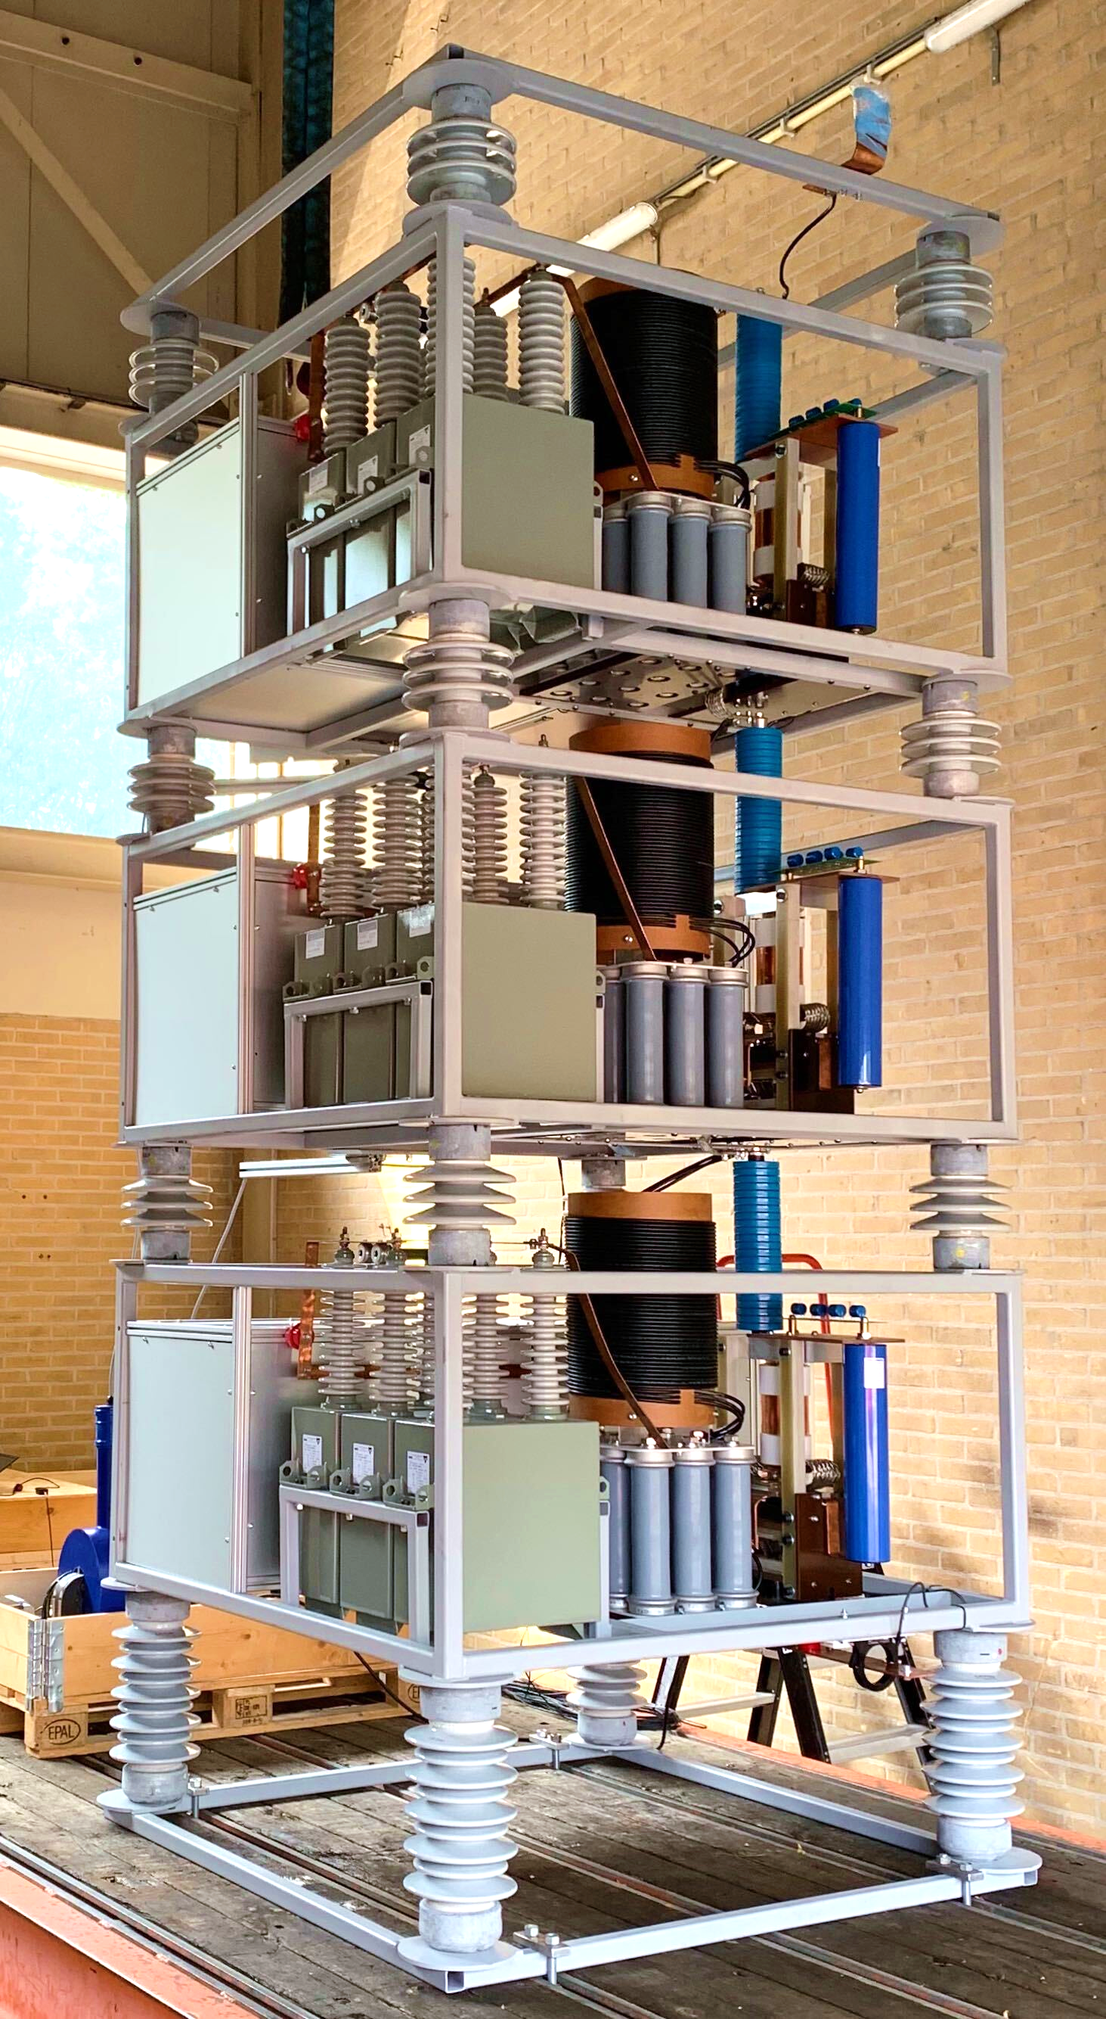 | 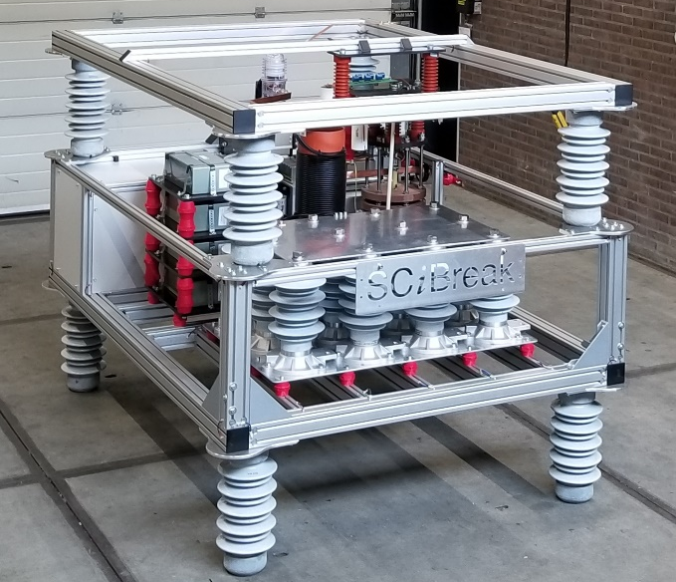
80 kV modular HVDC breaker | Rendering of a 320 kV HVDC breaker  by SCiBreak. with residual current switch.
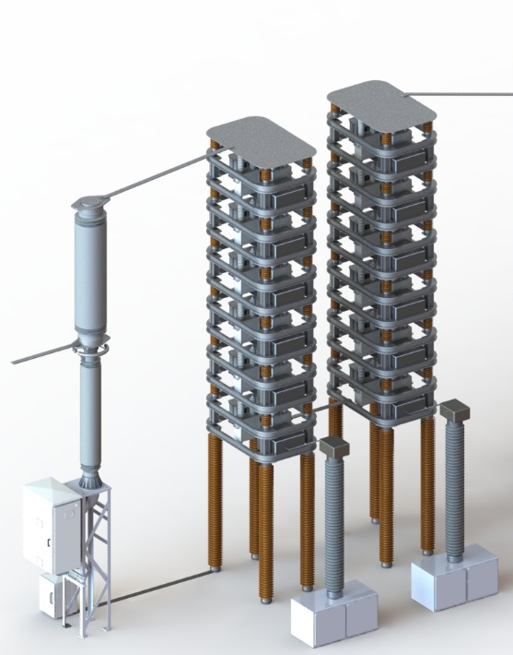
SCiBreak HVDC breaker module

Fuso Nerini, Francesco, (2016) Sustainable Energy Access for All : Initial tools to compare technology options and costs. KTH Doctoral Dissertation: ISBN:978-91-7729-073-5.
Shivakumar, Abhishek, (2018) An analysis of factors influencing renewable energy deployment in the EU’s electricity sector. KTH Doctoral Dissertation: ISBN:978-91-7729-787-1
Samavati, Mahrokh, (2018) Design and analysis of solid oxide electrolysis-based systems for synthetic liquid fuels production. KTH Doctoral Dissertation: ISBN:978-91-7729-807-6
Dahlqvist, Johan, (2017) Cavity Purge Flows in High Pressure Turbines. Stockholm:KTH Royal Institute of Technology. KTH Dissertation: ISBN:978-91-7729-626-3
Monzó, Patricia, (2018) Modelling and monitoring thermal response of the ground in borehole fields. KTH Doctoral Dissertation: ISBN:978-91-7729-667-6
Fischer, David, (2017) Integrating Heat Pumps into Smart Grids. KTH Doctoral Dissertation: ISBN:978-91-7729-503-7

