Homework 1 in EL2620 Nonlinear Control

Name 1
Person Number
e-mail address
Name 2
Person Number
e-mail address

Problem
Describe the problem in your own words and break it down into subproblems, unless the problem was already broken down into subproblems in the description of the homework. In each subproblem you should define a set of questions or tasks which gradually lead you to a solution of the overall problem. The problem should be described in detail, so that the reader can understand it without reading the description of the homework. For an example, see Problem 1.

Solution
Solve the subproblems in succession and give the solution to the overall problem at the end, followed by a sentence or two about what you learned from solving the problem. You should lead the reader through a detailed solution where you motivate every step, state every theorem, and verify that the assumptions are fulfilled. The presentation should be detailed yet clear and concise -- for example, see Solution 1. You should provide a reference (including the page number) for every theorem and result, except the ones that you are using from the course book [1]. Any engineering student with a bachelor's degree should be able to understand and reproduce the results based on your report alone. You may not copy and paste any text, theorems, or figures except the figures used in the description of the homework. Only include figures and tables if they fosters the understanding of the solution. Each figure and table should include a caption, and all the figures and tables should be associated with a reference in the text and placed at the end of your report -- for example, see Figure 1 and Table 1. Each equation should only be written once and referred to by reference later when needed -- for example, see (1). Equations that you do not refer to later may be left unlabeled. You are not allowed to have any appendix nor attach any MATLAB or other code.

Problem 1 -- Behavior of a nonlinear system
Study the behavior of the system
 | $$\frac{\text{d}x}{\text{d}t}=y,$$ |  | (1a)
 |  | $$\frac{\text{d}x}{\text{d}t}=-2x-2y-4x^{2},$$ | (1b)
with regard to its initial value and assess if the system is globally asymptotically stable. We have chosen a solution strategy based on the phase portrait and broken down the problem into the following three subproblems:

Draw the phase portrait of the system.
- How many equilibrium points does the system have, where are they located, and what type of equilibrium points are they?
- Is the system globally asymptotically stable? That is, do all trajectories lead to the same equilibrium point?

Solution 1 -- Behavior of a nonlinear system
- The phase portrait of the system described by (1) is shown in Figure 2.
- The system has two equilibrium points, $(0,0)$ and $(-0.5,0)$. They were computed by setting the right hand side of (1) equal to zero
$$\begin{matrix}y=0 \\ -2x-2y-4x^{2}=0\end{matrix}⇒ \begin{matrix}y=0, \\ x\left(1+2x\right)=0.\end{matrix}$$
Both points are marked by large dots in Figure 2.
Let us now characterize the equilibrium points. The Hartman-Grobman theorem [2, p. 288] states that the behavior of a nonlinear system near a hyperbolic equilibrium is qualitatively the same as its linearization at the equilibrium point. An equilibrium is by definition hyperbolic if the real part of the eigenvalues of the Jacobian matrix are all non-zero. We will therefore linearize the system (1) around both equilibrium points, calculate the eigenvalues, check if the points are hyperbolic, and determine the type of the equilibria based on the eigenvalues.
The linearization of an autonomous nonlinear system $\dot{x}=f(x)$ around an equilibrium point, given by $f\left(x_{0}\right)=0$, is $\dot{\tilde{x}}=Ax̃$, with $\tilde{x}=x-x_{0}$ and the Jacobian matrix $A={∂f/∂x\left(x\right)|}_{x=x_{0}}$. The Jacobian matrix is calculated to be
$$\frac{∂f}{∂x}\left(x\right)=\left[\begin{matrix}0 & 1 \\ -2-8x & -2\end{matrix}\right],$$
which for the two equilibrium points turns out to be
$$A_{(0,0)}=\left[\begin{matrix}0 & 1 \\ -2 & -2\end{matrix}\right], A_{(-0.5,0)}=\left[\begin{matrix}0 & 1 \\ 2 & -2\end{matrix}\right].$$
The eigenvalues of the Jacobian matrix are given by the characteristic equation
$$\det\left(λI-A\right)=0.$$
The characteristic equation of the system linearized around $\left(0,0\right)$is
$$λ^{2}+2λ+2=0,$$
which gives the eigenvalues $λ_{1,2}=-1±j$. The characteristic equation of the system linearized around $(-0.5,0)$ is
$$λ^{2}+2λ-2=0,$$
which gives the eigenvalues ${ λ}_{1}= \sqrt{3} -1≈ 0.73$ and ${ λ}_{2}= -\sqrt{3} -1≈ -2.73$. Both equilibrium points are hence hyperbolic and we can characterize them based on the eigenvalues of the Jacobian matrix of the linearized systems. The eigenvalues tell us that we have a stable focus at $\left(0,0\right)$ and a saddle point at $(-0.5,0)$. This is easily verified by looking at Figure 2.
- Only trajectories starting within the shaded region and its extension above the part of the phase portrait shown in Figure 2 leads to the stable focus. It is therefore obvious that the system is not globally asymptotically stable.
Answer: The system has two equilibrium points; a stable focus at $\left(0,0\right)$ and a saddle point at $\left(-0.5,0\right)$. It is not globally asymptotically stable.

We have learned how to analyze the behavior of autonomous nonlinear systems with two states by drawing the phase portrait and characterizing the equilibrium points of the system.

References
- Hassan K Khalil. Nonlinear systems. Prentice Hall, Upper Saddle river, 3. edition, 2002. ISBN 0-13-067389-7.
- Shankar Sastry. Nonlinear systems: analysis, stability, and control, volume 10. Springer, New York, N.Y., 1999. ISBN 0-387-98513-1.

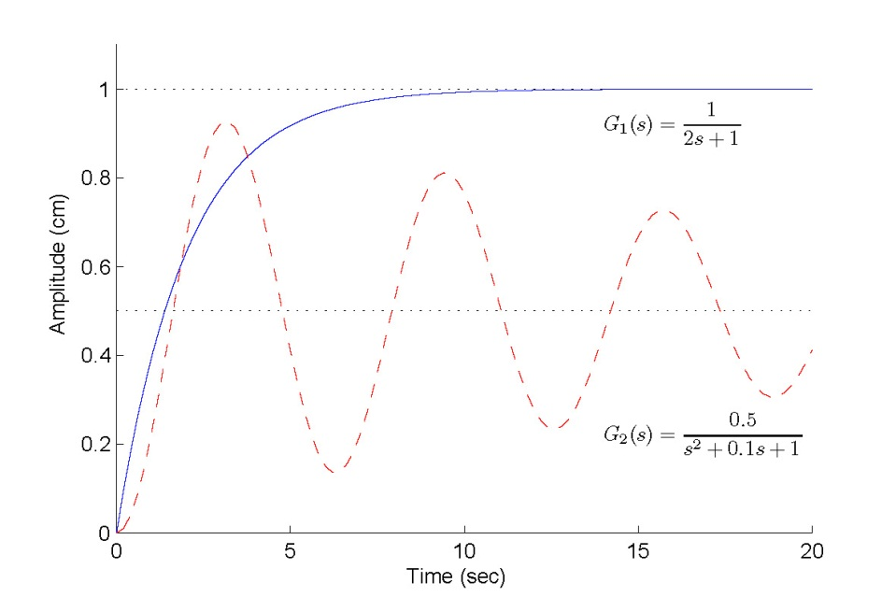
Figure 1: Step response of the two systems. The figure should have a caption that briefly explains what it shows. The color, symbol and line type should be selected such that the lines can be distinguished when printed in black and white. The lines should be annotated either in the plot, in a legend, or in the caption. The axis should have a label in which the units are given. The figure should be sufficiently large, clear, easy to understand, and only contain essential information.

Table 1: Jacobian matrix matrix $A$ of the linearized system $\dot{\tilde{x}}=Ax̃$. The table should have a caption that briefly explains what it shows.
Equilibrium Point | Jacobian Matrix
$$(0,0)$$ | $$A_{(0,0)}=\left[\begin{matrix}0 & 1 \\ -2 & -2\end{matrix}\right]$$
$$(-0.5,0)$$ | $$A_{(-0.5,0)}=\left[\begin{matrix}0 & 1 \\ 2 & -2\end{matrix}\right]$$

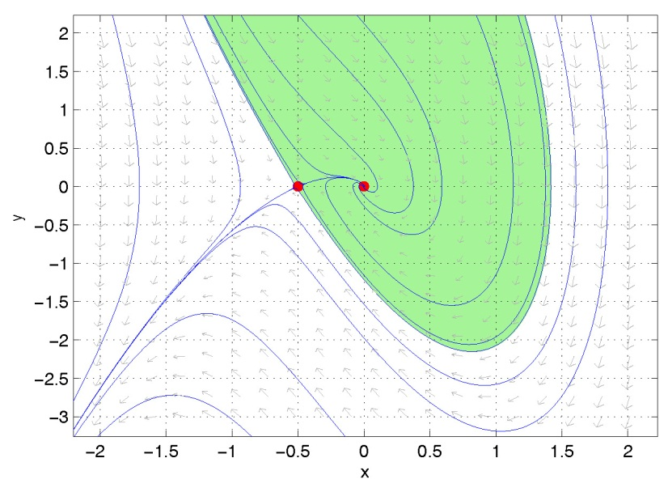
Figure 2: Phase portrait of the system in (1), which has a stable focus at $(0,0)$ and a saddle point at $(-0.5,0)$. Both equilibriums are marked by large dots and selected trajectories are marked by solid lines. Trajectories starting within the shaded region end at the stable focus. This figure was generated in MATLAB (http://www.mathworks.com) using pplane7 (http://math.rice.edu/~dfield/dfpp.html).

