Project 3: Choosing between multiple Plans
Objective of this project is to make an application where Agent can choose between more than one plans available. We will add two plans namely SayHello and SayGoodbye and make the event Hello handled by both of these two plans. When the event is posted the relevance of each plan is checked in its relevant method and one a decision is made accordingly.
We start the project from exercise 2:
- Add a new plan
– Use the design tool to add a new plan SayGoodBye in the design diagram.
– Add a uses link from the agent to the new plan.
– Add a handles link from the event to the new plan. Your design diagram should be
similar to the following:
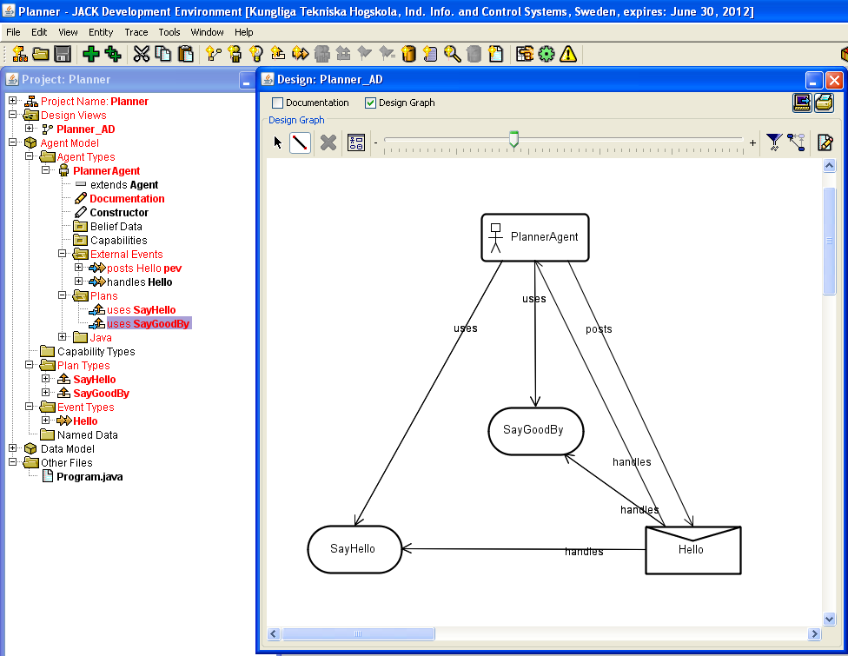
Figure1. Adding new plan and appropriate links
2. Use the Edit as a JACK File option to modify SayHello plan so that its relevant()method performs a test whether the event has been posted to say HelloWorld greeting
static boolean relevant(Hello ev)
{
return (ev.hello_Message.equals("HelloWorld"));
}

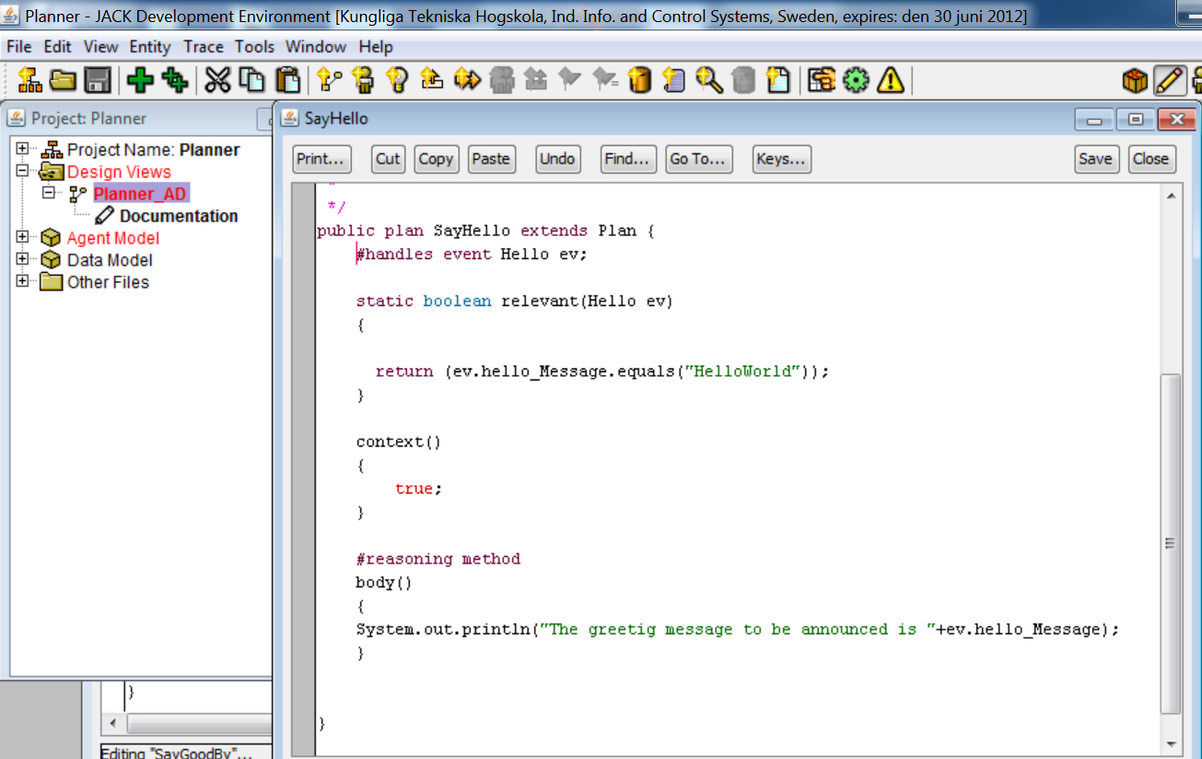
Figure2: editing the first existing plan file
3. Use the Edit as a JACK File option to modify SayGoodBye plan so that its relevant()method performs a test whether the event has been posted to say GoodBye greeting
static boolean relevant(Hello ev)
{
return (ev.hello_Message.equals("GoodBye"));
}
In the body part of this plan add a print statement for printing the relevant message.
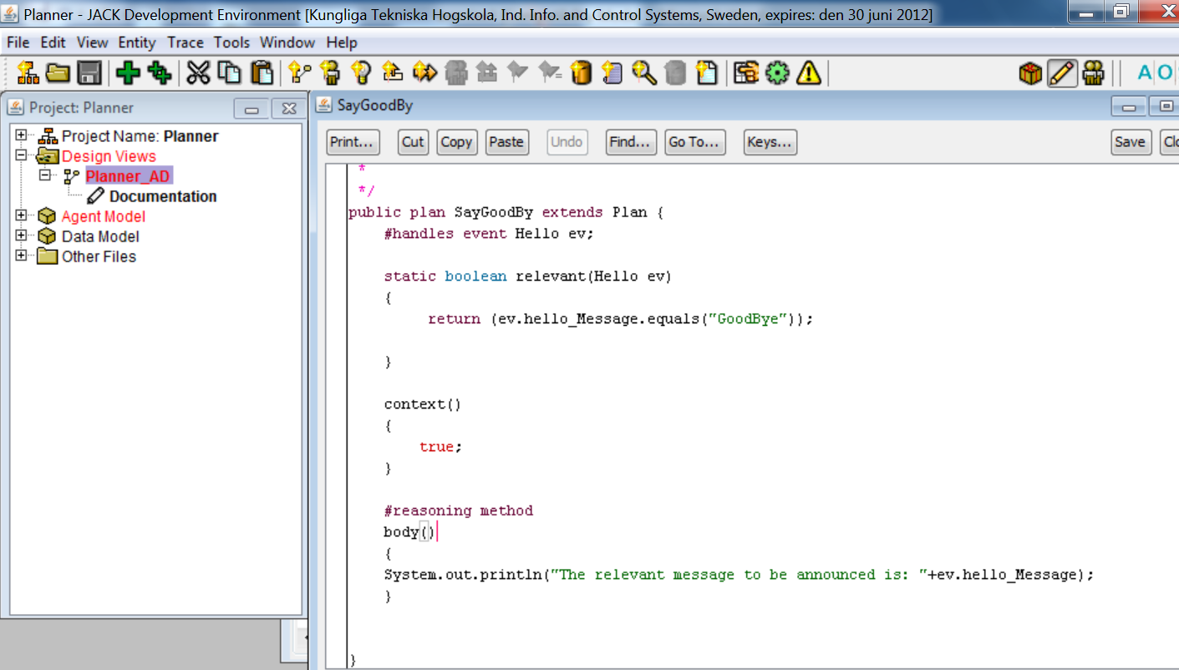
Figure3: editing the newly added plan

4. The #uses plan SayGoodBye declaration should appear after the SayHello plan declaration. Check the order by editing the Planner agent.
If necessary swap the declarations via the project browseror by editing the ﬁle as a JACK ﬁle.

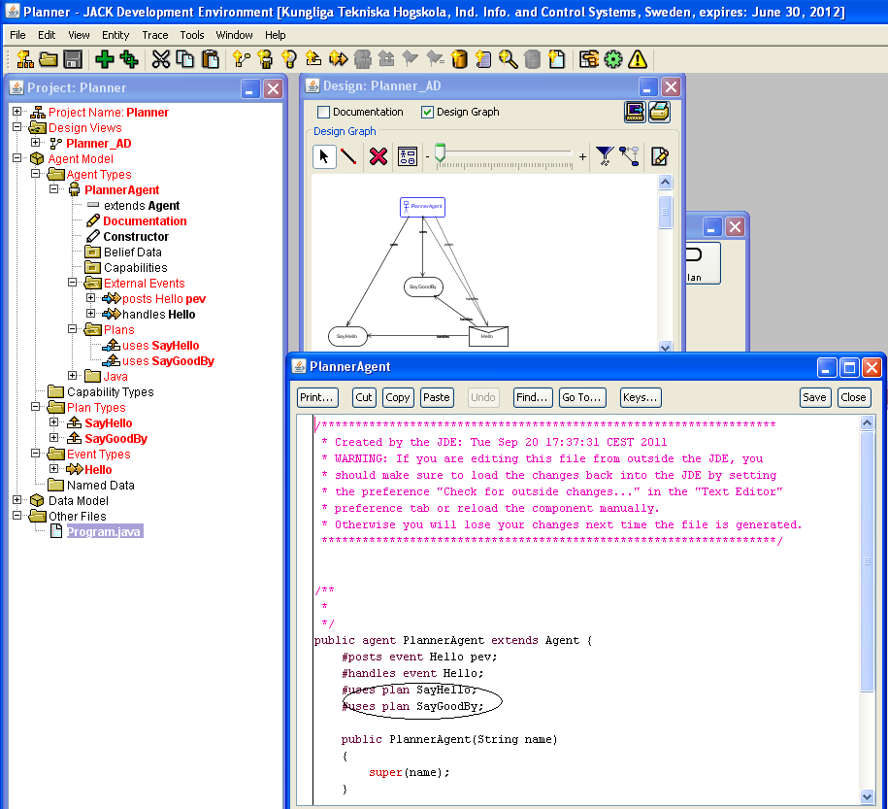
Figure4: checking the plan declarations in agent file

5. Edit the Agent and modify its postHelloEvent() method so that it now takes a String argument
(the relevant greeting message) and passes it to the posting method
public void postHelloEvent(String c)
{
postEventAndWait(pev.paint(c));
}

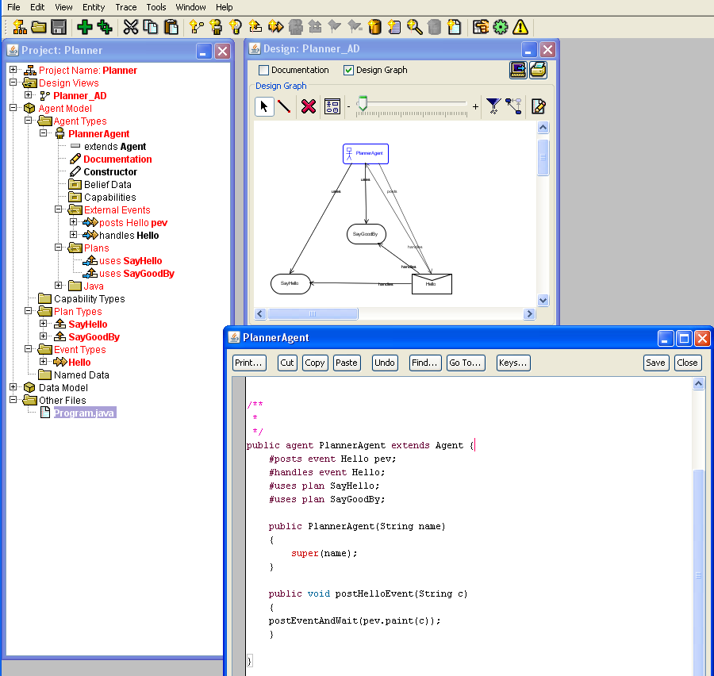
Figure5: editing the post event of agent class

6. Edit the main() method inProgram.java, so that the postHelloEvent() method is invoked with
the program argument provided by the user
agent1.postHelloEvent((args.length==0) ? null : args[0]);

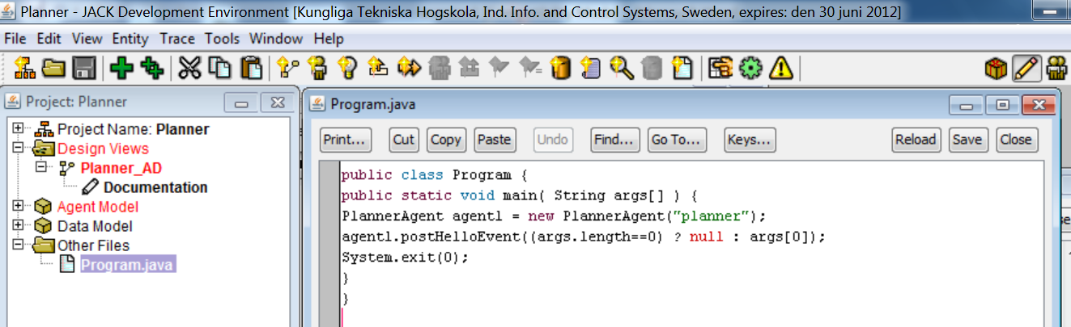
Figure6: editing the main Program file
7. compile the application
8. Run application first with user argument HelloWorld and then with GoodBye
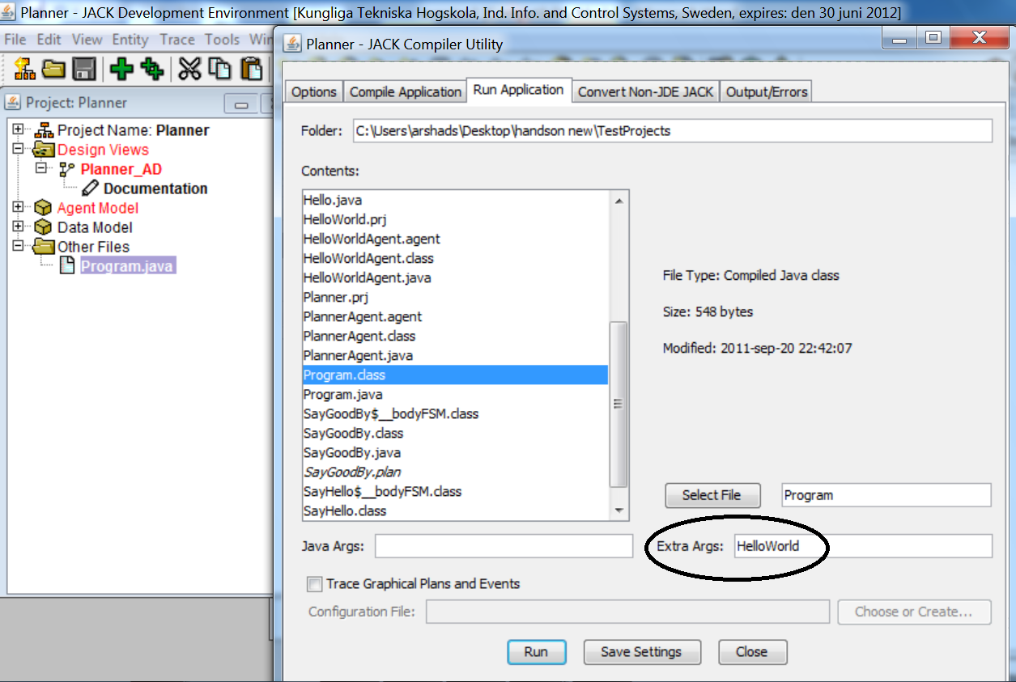
Questions:
Make a sequence diagram showing flow of execution of this application in both cases
Add a new plan StaySilent which displays a message “Nothing to say” when application is run without any parameter

