Exercise 4: Multiple Agents, Plans and Events
In this exercise we will learn how more than one agents can work together interacting using sending Message Events.

- Make a new project named SAAutomation.
- Add a new design view named SA_AD
- Make a design so that the final diagram looks like following:

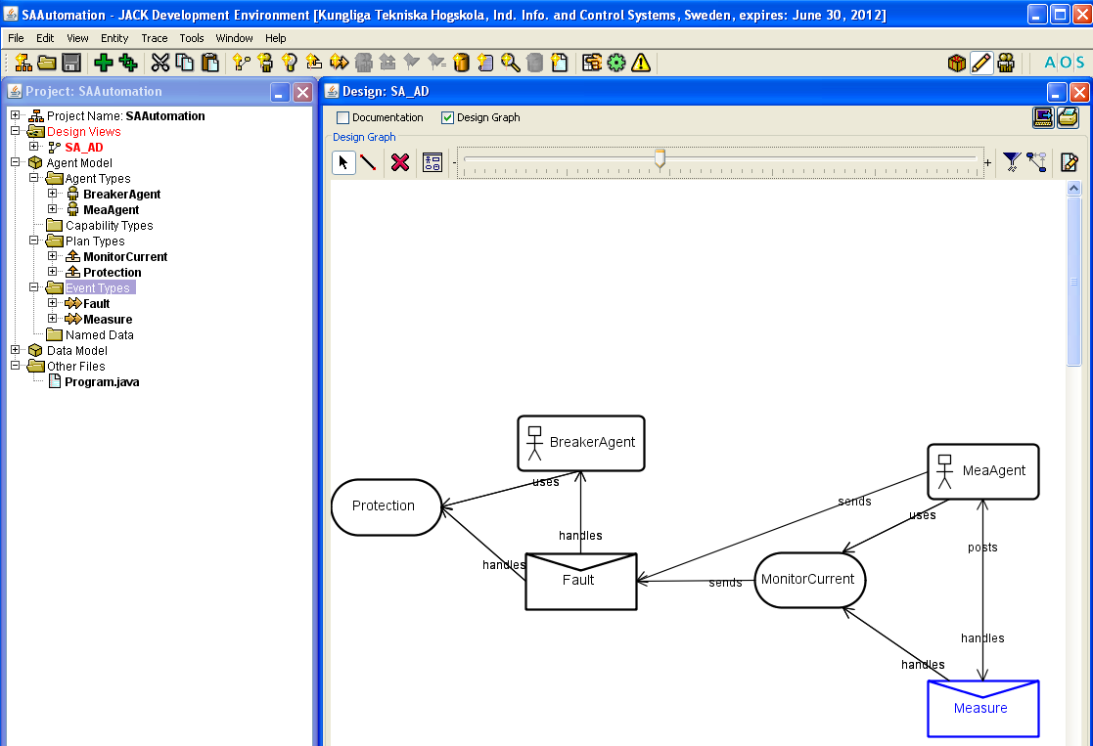
Figure1: Design diagram

- The different components in this diagram and their functionality are as follows:
MeaAgent Agent:
It is an Agent responsible for handling the event measurement. It posts the event Measure and uses the plan MonitorCurrent in order to handle the event Measure

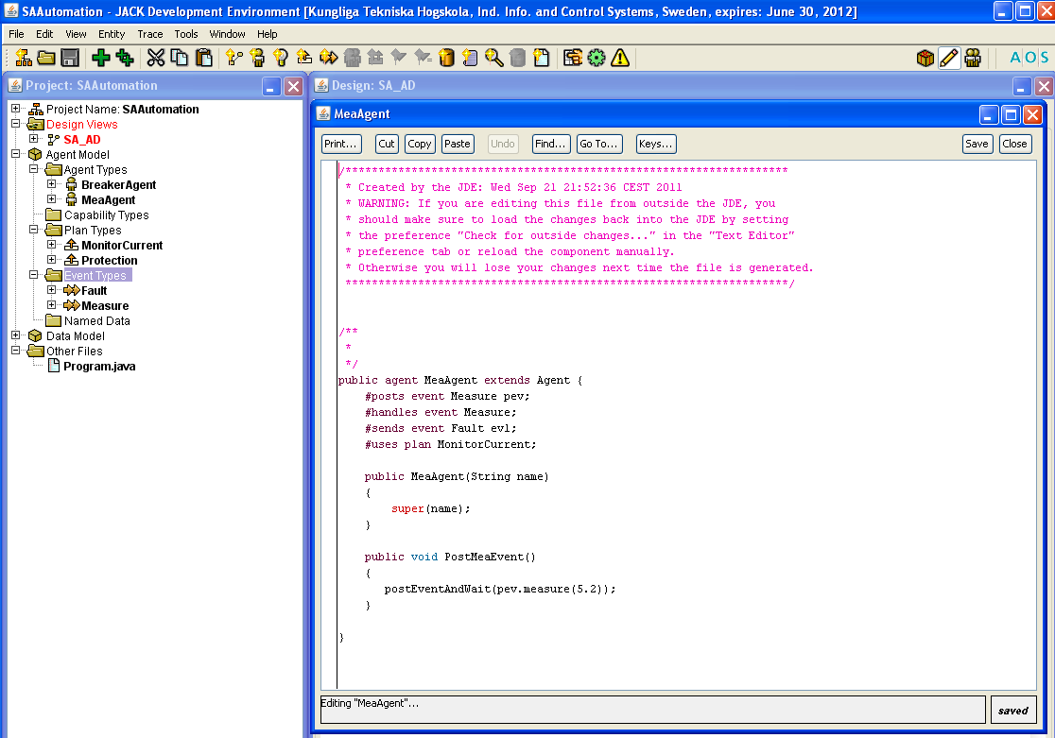
Figure1: The MeaAgent

Measure Event:
This is an Event representing the event of collection of a measurement. It is posted and handled by the agent MeaAgent

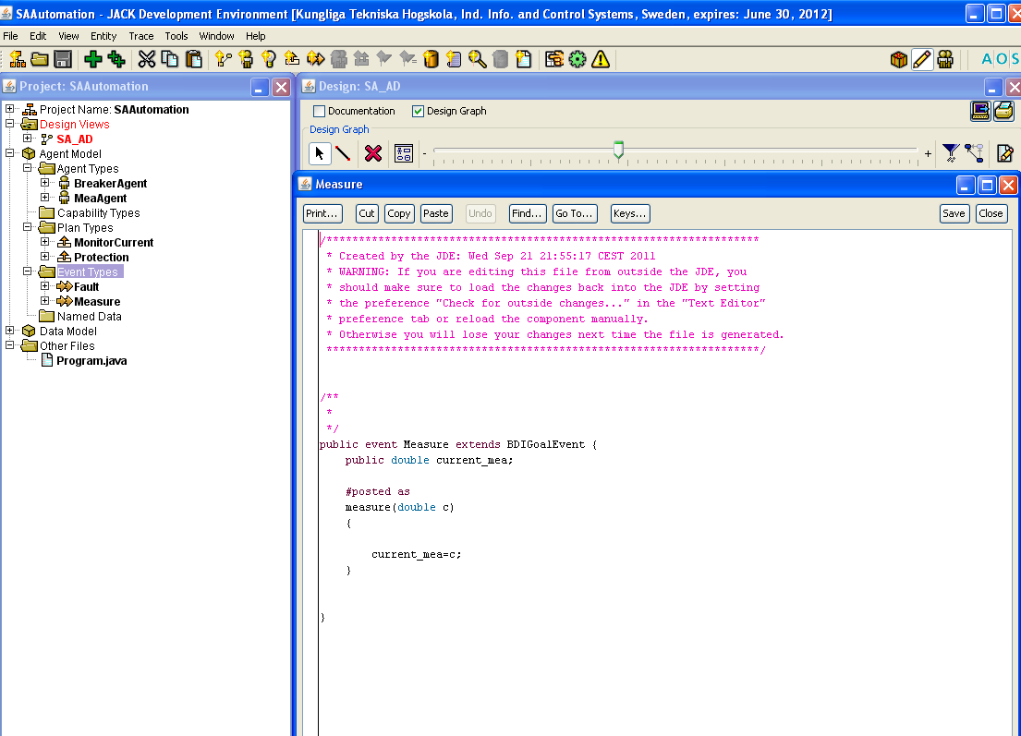
Figure3: The Measure Event

MonitorCurrent Plan:
This is the plan that MeaAgent uses to handle the Measure event. It is used to monitor the current measurement and send a MessageEvent Fault to BreakerAgent if there is a fault.

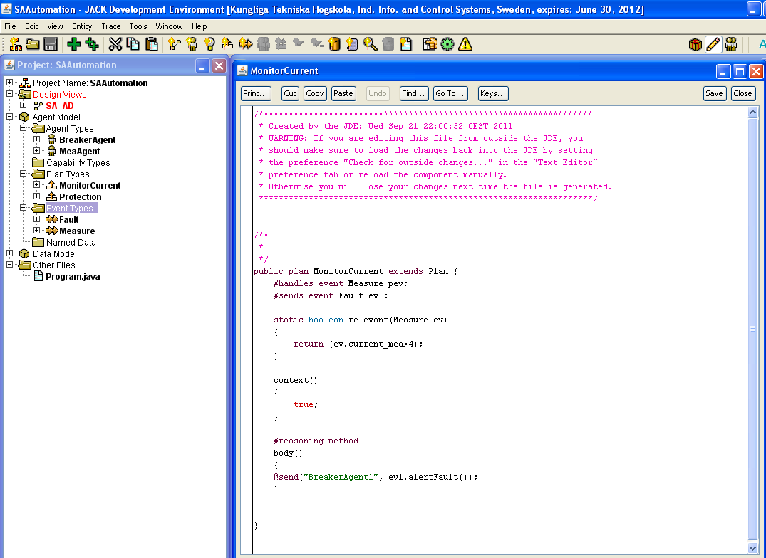
Figure4: the MonitorCurrent plan

Fault Event:
It is an event of type MessageEvent. Occurrence of this event represents existence of a fault. It is handled by the agent BreakerAgent using a plan Protection.
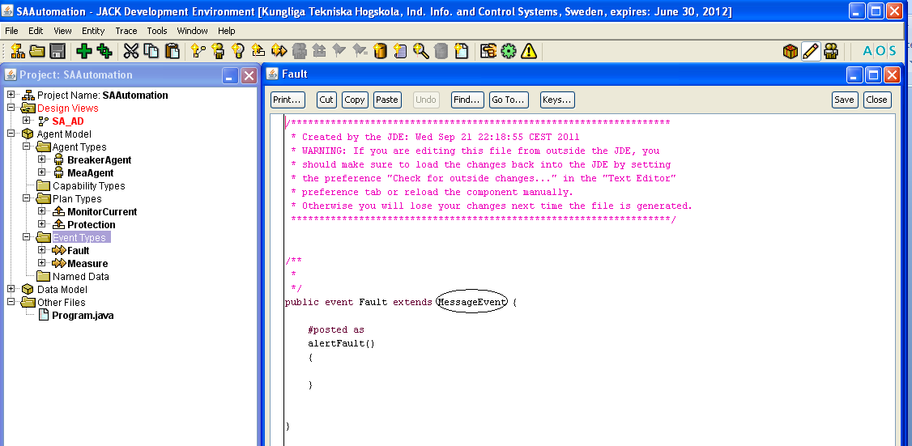
Figure5: The fault event

BreakerAgent:
Breaker agent handles the event fault and uses the plan Protection for doing this.
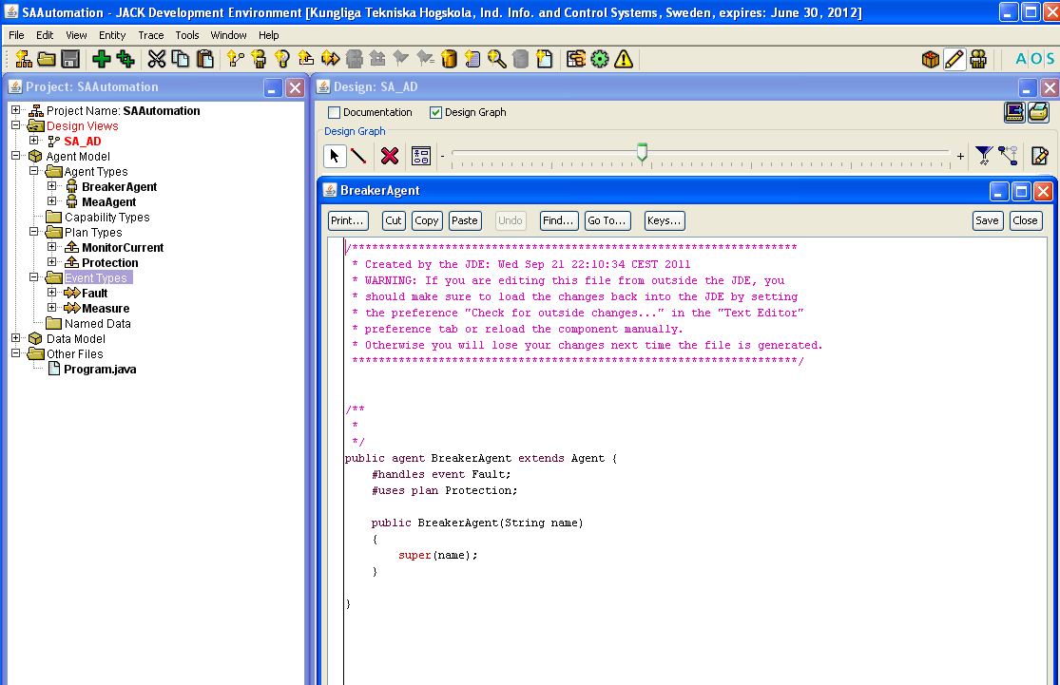

Figure6: the BreakerAgent

Protection Plan:
This is the plan the Breaker agent uses to handle the Fault event. For now it just displays a message of handling of the fault.

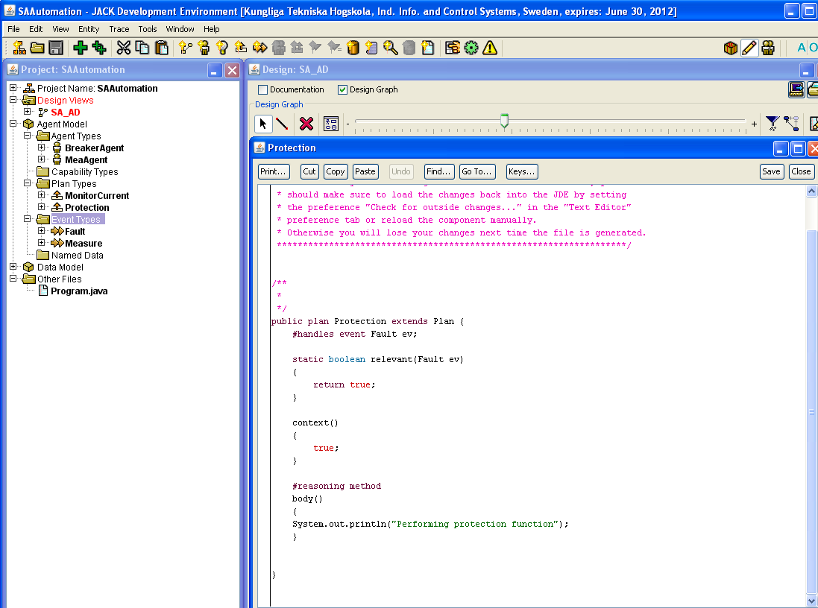
Figure6: the Protection plan

- Add the appropriate links as shown in the design diagram
- Add the main main program (Program.java) as follows:
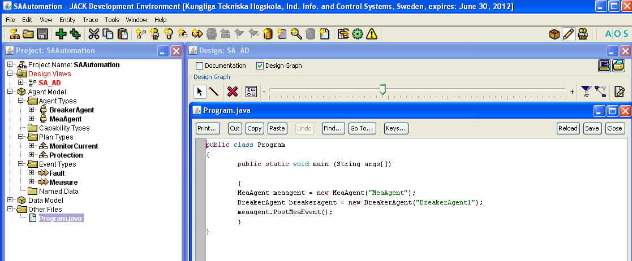
Figure7: The main Program

- Compile and run the the application.
- Answer following questions:
Questions:
1: How is a decision made on the existence of fault? And who does this?

2: remove the current plan Protection and add two plans overcurrent_protection and distance_protection. Depending on how the event Fault has been posted only one of the the two plans should be executed. This has to be decided in the relevant part of each plan.

3: take the inputs as arguments and based upon this the nature of fault should be decided.

