Exercise 5: ICS Village

In this exercise we will connect to the ICS village and perform a protection. A current measurement will be read from the village (Enemåla substation, feeder 2) send relevant protection operation will be performed.
1: Make a new project named ICSVillage.
2: Make a new design diagram ICSVilage_AD that looks like the one below:

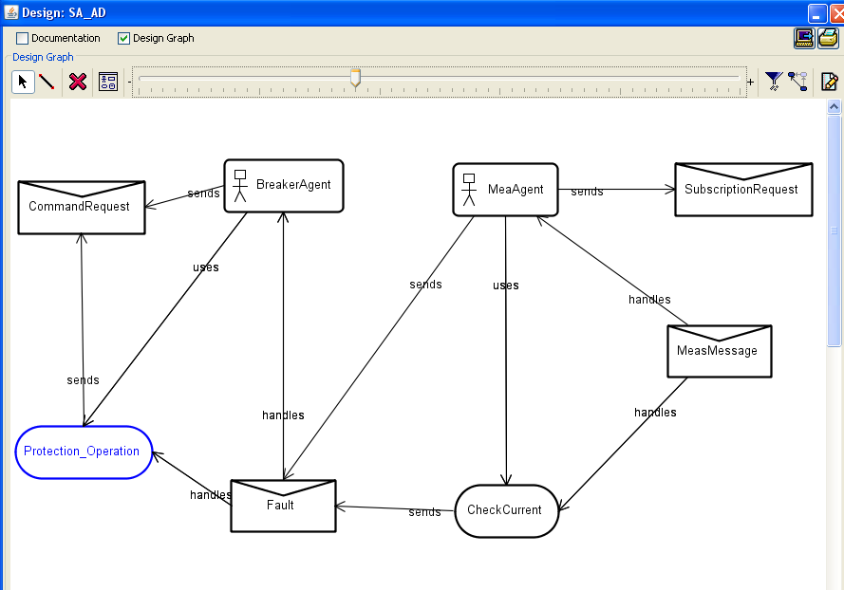
Figure1: design diagram

2: In this case we will import three of the MessageEevents (SubscriptionRequest, MeasMessage and CommandRequest) from an existing project named VillageExample. For this, right click on Event Type in left menue and choose ’ import event type’ . Add the three events mentioned above.
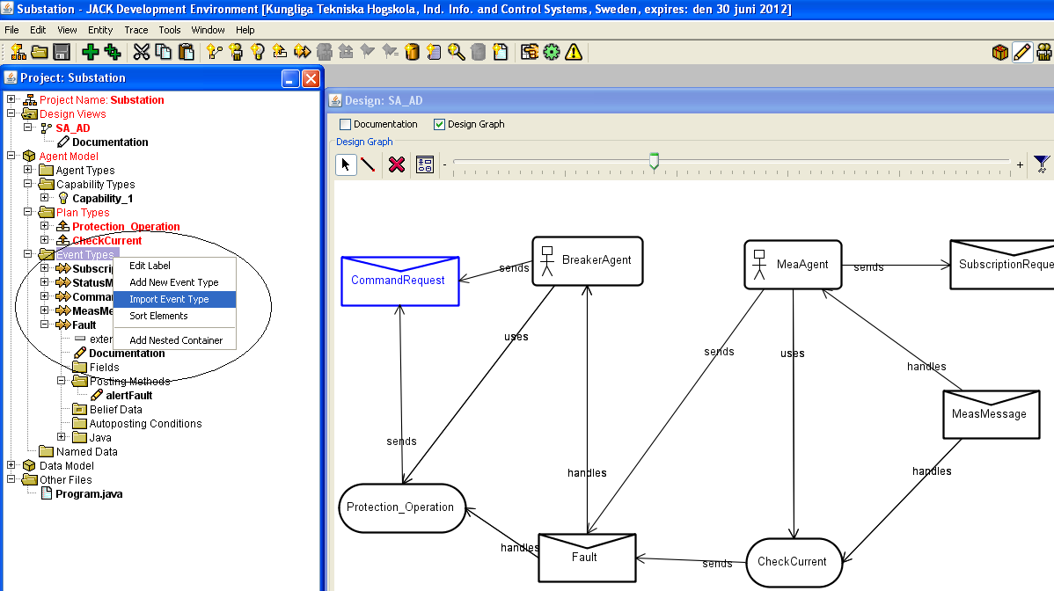
Figure2: Importing exisitng message types

The rest of the componnets on the digram and the links are to be added in normal way.
3. The componenets and their functionality is as follows:
MeaAgent Agent:
It is an Agent responsible for handling the event measurement. It subscribes to a specific measurement on ICS Village, handles the event MeaMessage, uses plan CheckCurrent and sends a MessageEvent to BreakerAgent.
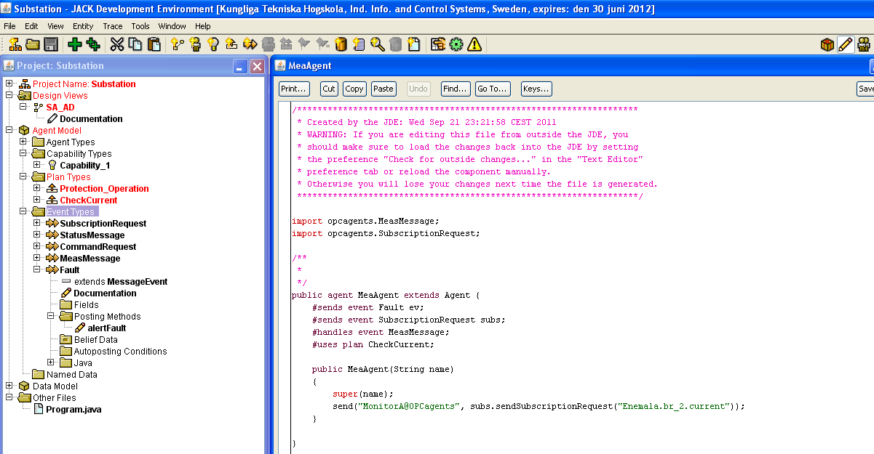
Figure3: the MeaAgent

CheckCurrent Plan:
MeaAgent uses this plan to handle the MeaMessage event and to send Fault event to the BreakerAgent.
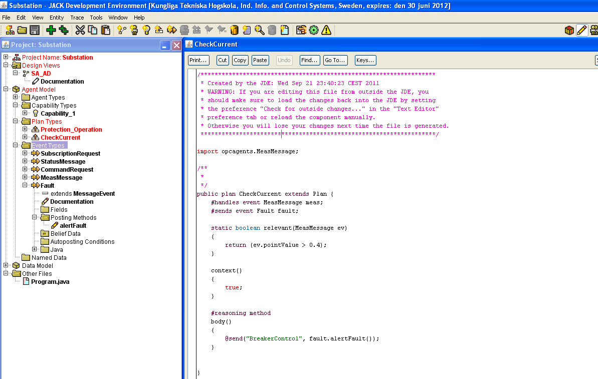Figure4: the CheckCurrent Plan

BreakerAgent:
This agent uses the Protection_Operation plan to handle the Fault event. It also sends a message event called command request in order to send control commands to the ICS Village.

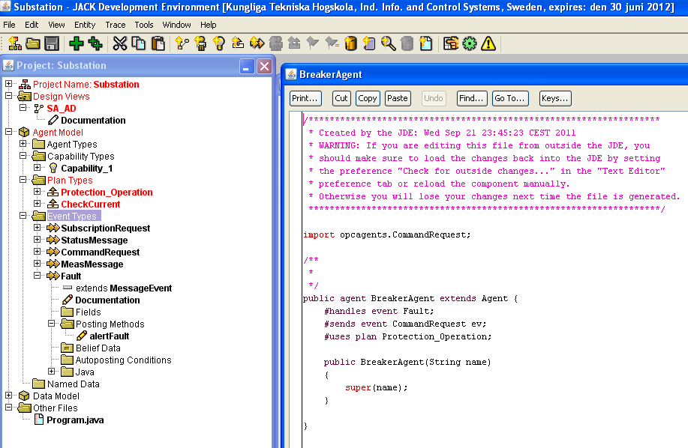

Figure5: the BreakerAgent

Fault Event:
This event represents the existence of fault . It is handles by the BreakerAgent using the Protection_Operation.
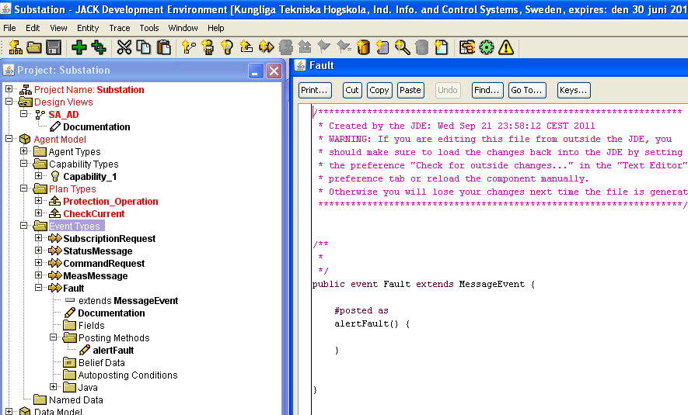
Figure6: The Fault Event

Protection_Operation Plan:
This is the plan used be by the BreakerAgent ir order to handle the event of Fault. It sends switching command to the ICS village using the CommandRequest Message Event.

4. compile the application
5. Run the application:
We will run application with special program arguments in order to produce the agent interaction
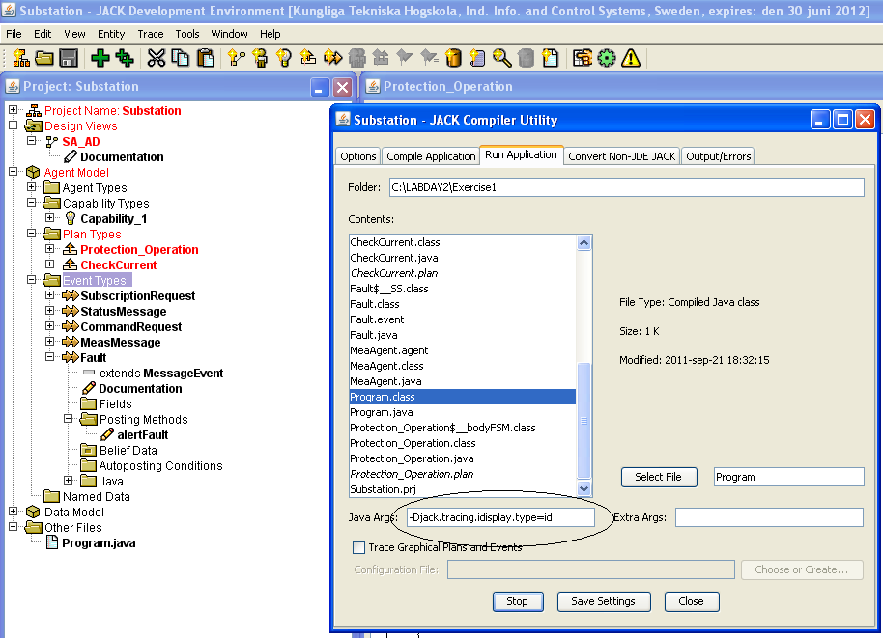
Figure7: running the application for special arguments

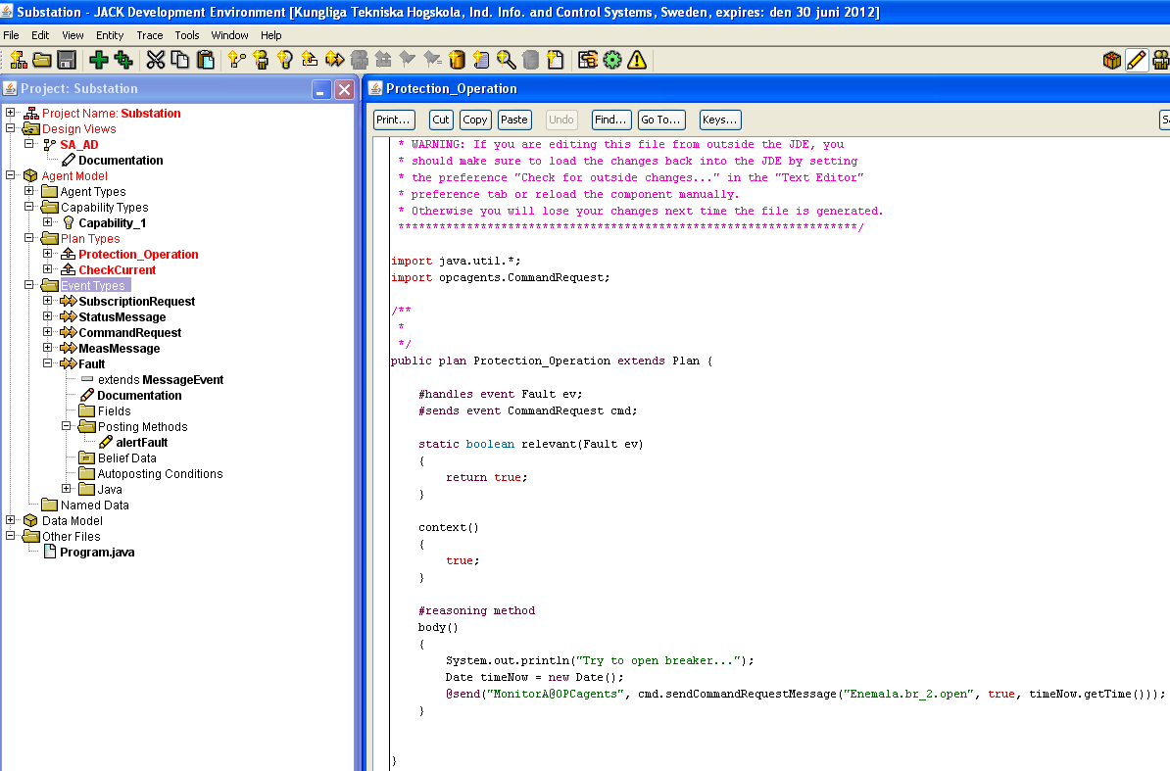

Figure7: Protection_Operation plan
c

